* IMPORANT for EXAM
* It uses certificates to communicate with the other nodes, kubectl does it automatically.

kubectl api-resources

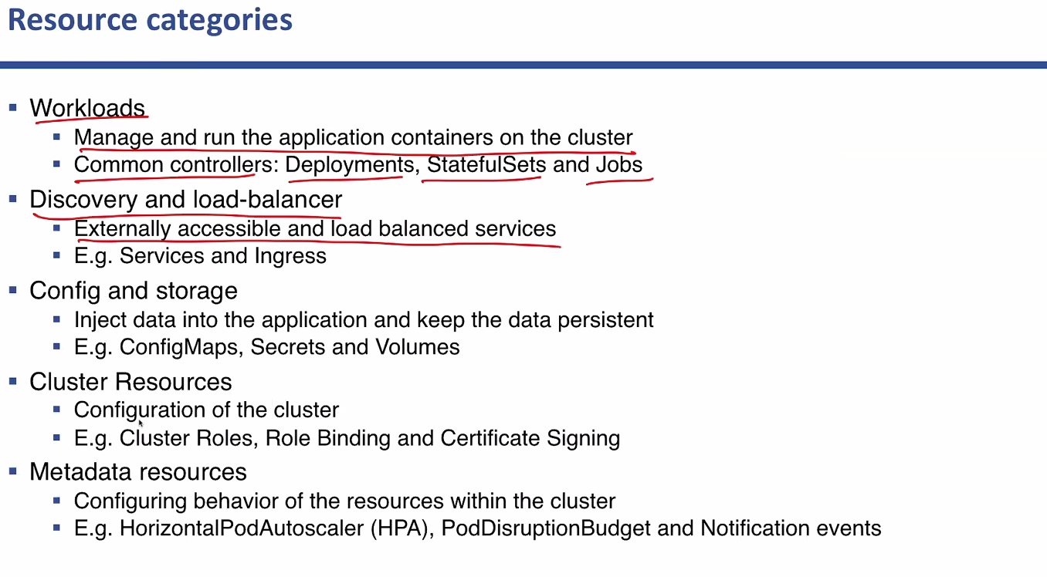

Kubectl api-versions

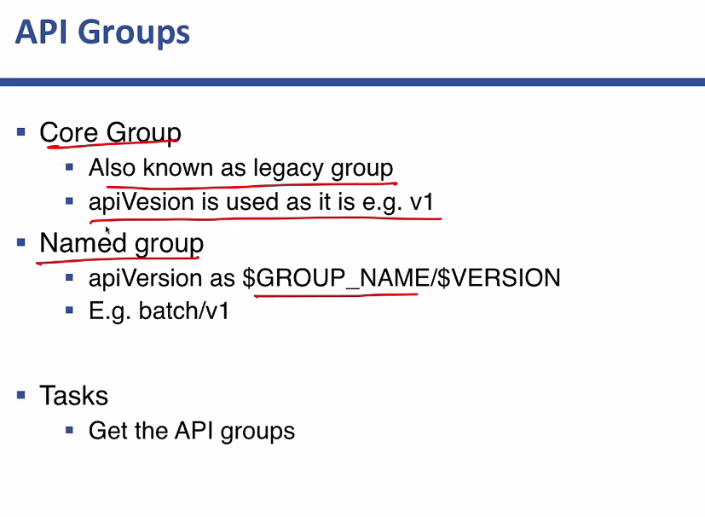

Where api groups not listed are core group and where it is listed it is named group.

* 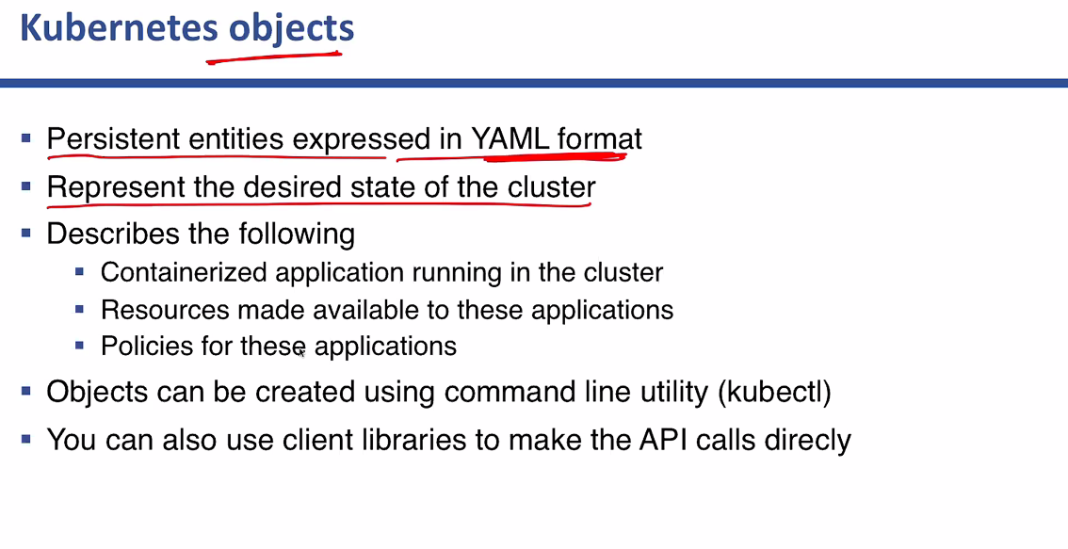

YAML Basics:

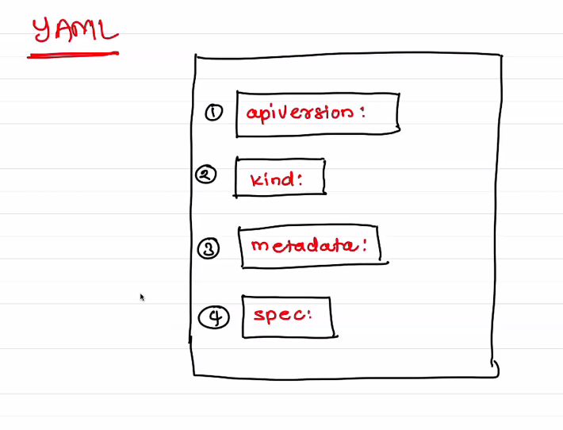

we can remember as (akms): api version, kind, metadata, spec

Yaml format to define each resources within the yaml file.

Can use nano and Kubernetes docs page for using cheat sheet

Pod Creation:

kubectl create -f pod1.yml

Basic commands:

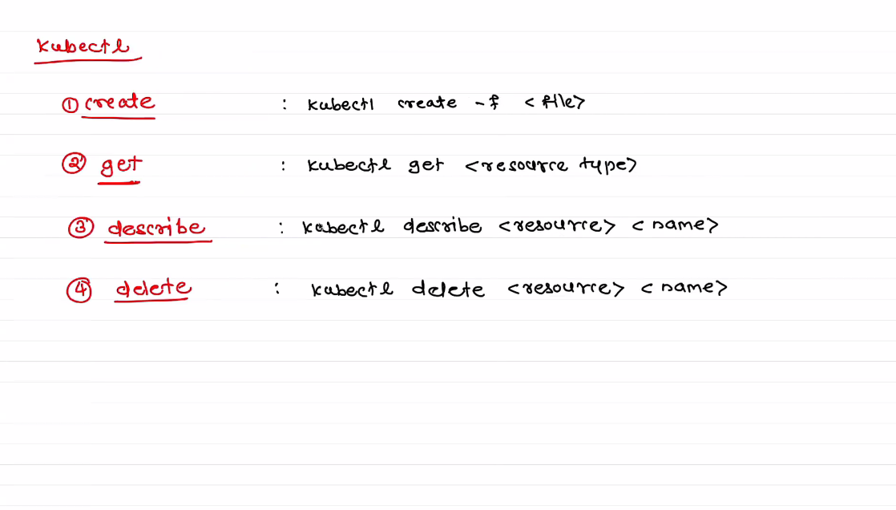

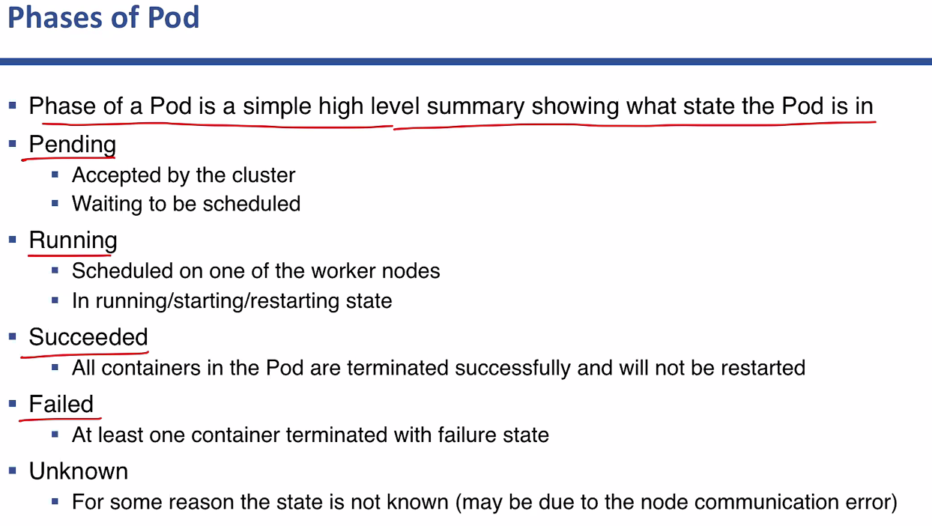

* watch -n 1 kubectl get pod

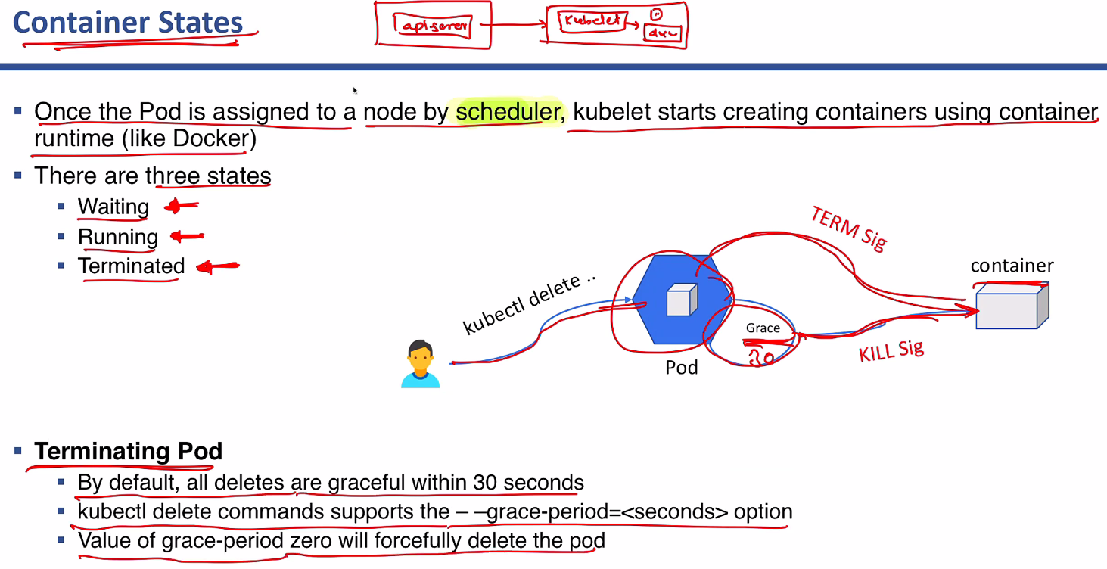

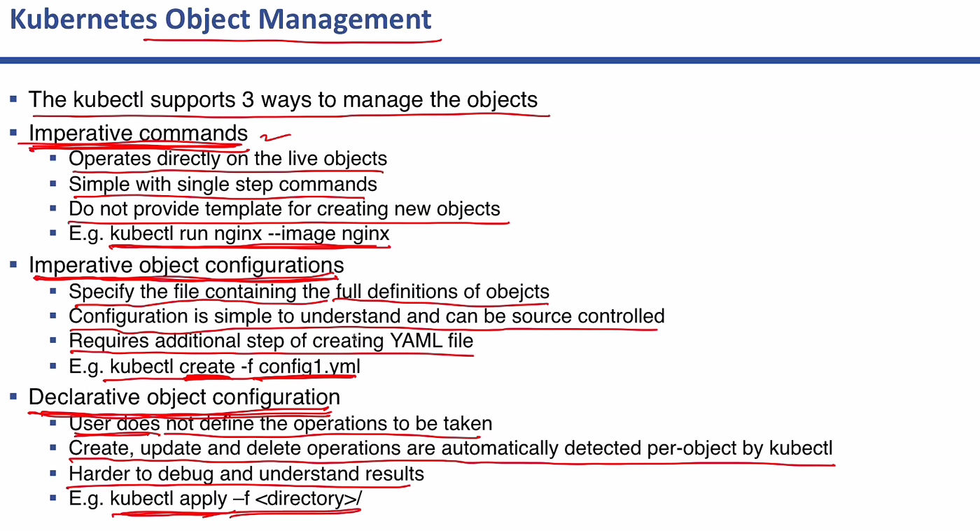

* Kubectl apply -f pod6.yml
* Apply is used to check and apply the changes made in the pod file.

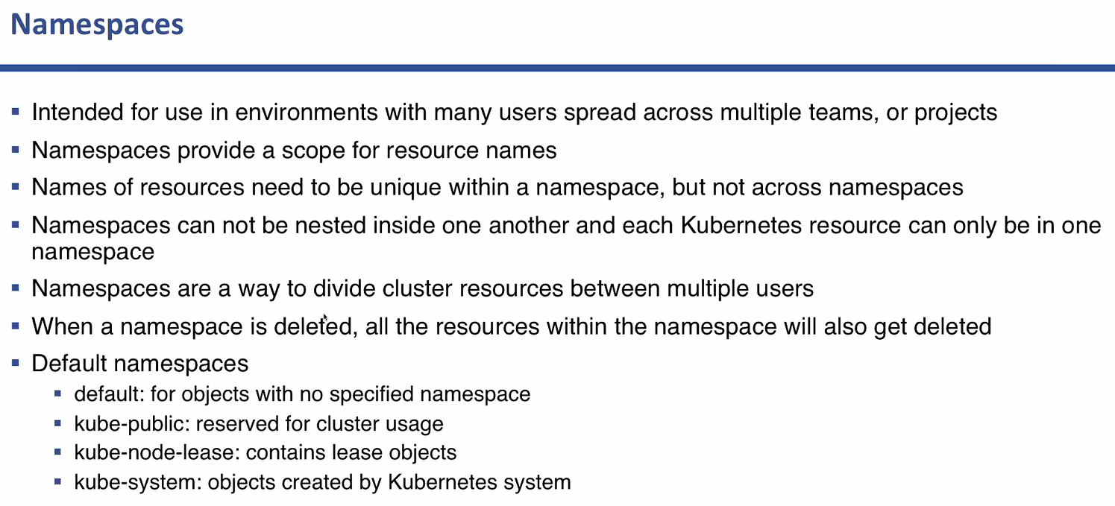

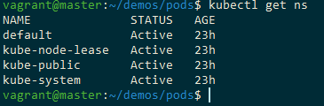

* Kubectl get pod --namespace kube-system -o wide
* kubectl get pod --namespace <name-space-name>
* kubectl create ns ns1
* kubectl get ns
* kubectl get pod -n ns1
* kubectl create -f pod1.yml -n ns1