Step1: Start the bootstrap instance

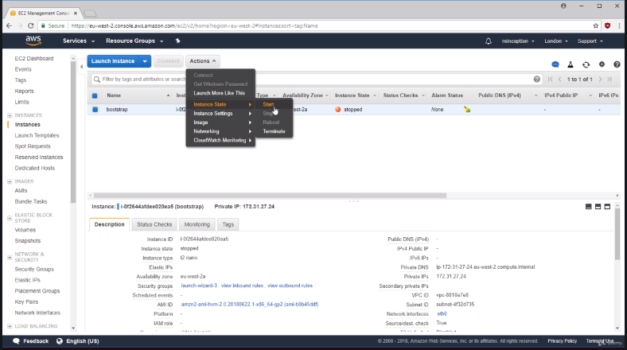

Step2: go into security groups inbound tab and edit it to my IP.

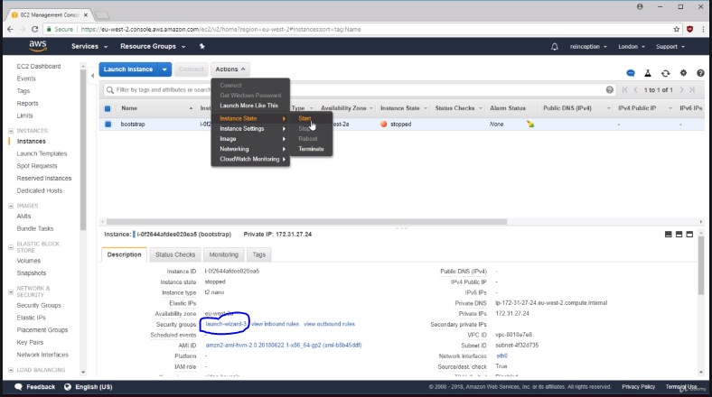

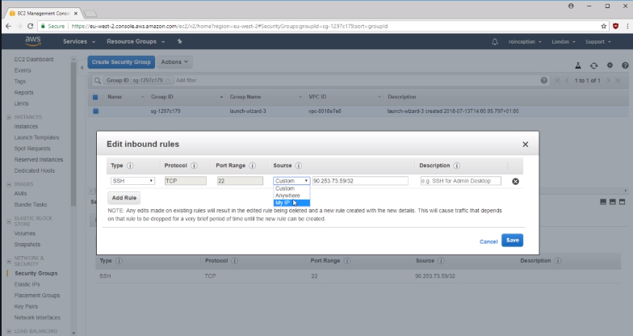

Step3: SSH into the instance

ssh -i video-keypair.pem ec2-user@100.26.0.49

and grep all the precious commands by

history | grep export

Step4: !<command number> to rerun the command setting the NAME and KOPS_STATE_STORE

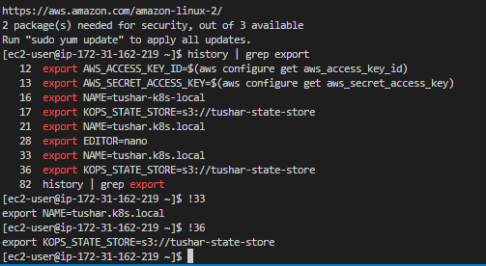

Step5: Hit CTL-R to search the commads and run : **to create the cluster**

Kops create cluster **** on it

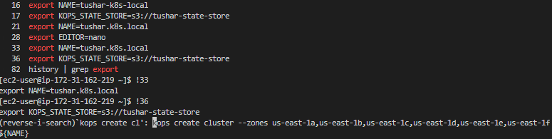

Step6: do

kops edit ig --name=tushar.k8s.local nodes

and change the nodes min=3, max=5

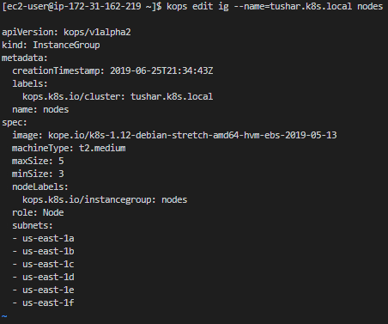

Step7: Hit CTL-R to search the commads and run- **to update the cluster**

Kops update cluster **** on it

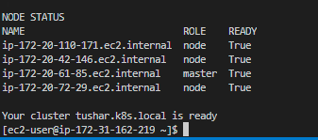

Step8: Apply all the files.

kubectl apply -f .

