1. Go to this link

<https://github.com/helm/helm/releases/tag/v2.14.1>

1. Copy Linux amd64 link and do

wget <link> in ec2

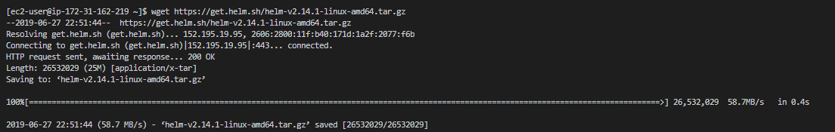

1. Run this command

tar zxvf helm-v2.14.1-linux-amd64.tar.gz

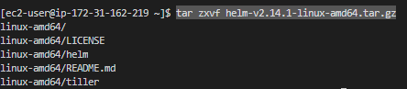

1. Move with this command

sudo mv linux-amd64/helm /usr/local/bin/

remove with

rm helm-v2.14.1-linux-amd64.tar.gz

rm -rf ./linux-amd64/

1. Check if helm is working, type helm
2. Do

helm init

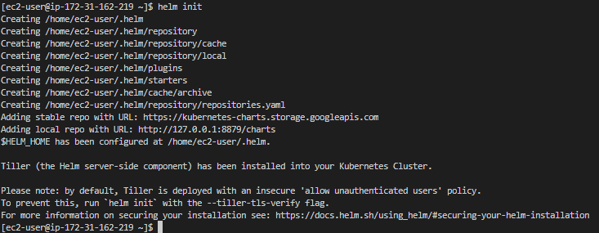

1. Check tiller pod with this command

kubectl get po -n kube-system

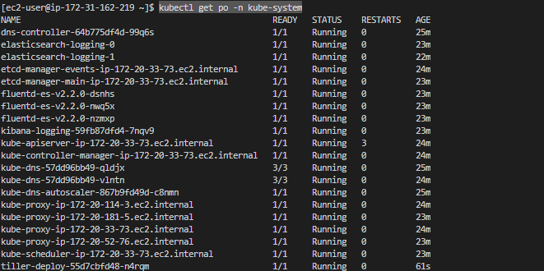

1. Do

helm version



Installing Helm charts

1. Run Command: helm repo update
2. Run these 3 commands to add privilege to the tiller pod.

kubectl create serviceaccount --namespace kube-system tiller

kubectl create clusterrolebinding tiller-cluster-rule --clusterrole=cluster-admin --serviceaccount=kube-system:tiller

kubectl patch deploy --namespace kube-system tiller-deploy -p '{"spec":{"template":{"spec":{"serviceAccount":"tiller"}}}}'

1. Then do

helm install stable/mysql --name my-special-installation --set mysqlPassword=password

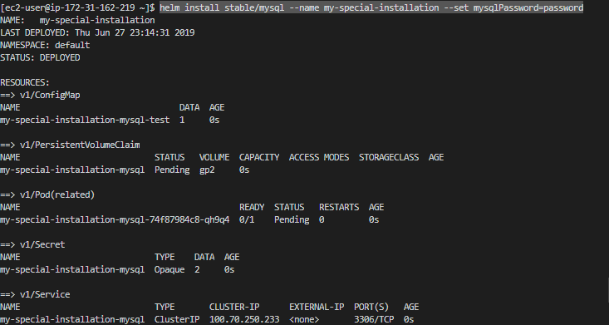

1. To delete this helm pod

helm delete --purge my-special-installation

1. Prometheus Operator:

<https://github.com/helm/charts/tree/master/stable/prometheus-operator>

run this command

helm install --name monitoring --namespace monitoring stable/prometheus-operator

1. To check the resources created by helm run command:

kubectl get all -n monitoring