1. 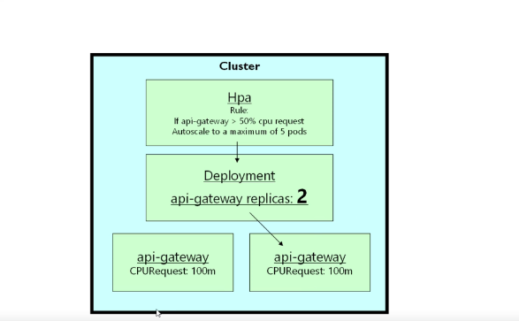
2. Command to autoscale

kubectl autoscale deployment api-gateway --cpu-percent 400 --min 1 --max 4