Setting up basic Jenkins

1. Clone the repo locally and go into it.

Git clone <https://github.com/my-tushar-org/jenkins.git>

1. Run these following commands to configure your shell

eval $(minikube docker-env)

export DOCKER_TLS_VERIFY="1"

export DOCKER_HOST="tcp://192.168.99.100:2376"

export DOCKER_CERT_PATH="C:\Users\tusha\.minikube\certs"

1. Do docker image ls, to check if you can see all the docker images
2. Build this docker file with command:

docker image build -t myjenkins .

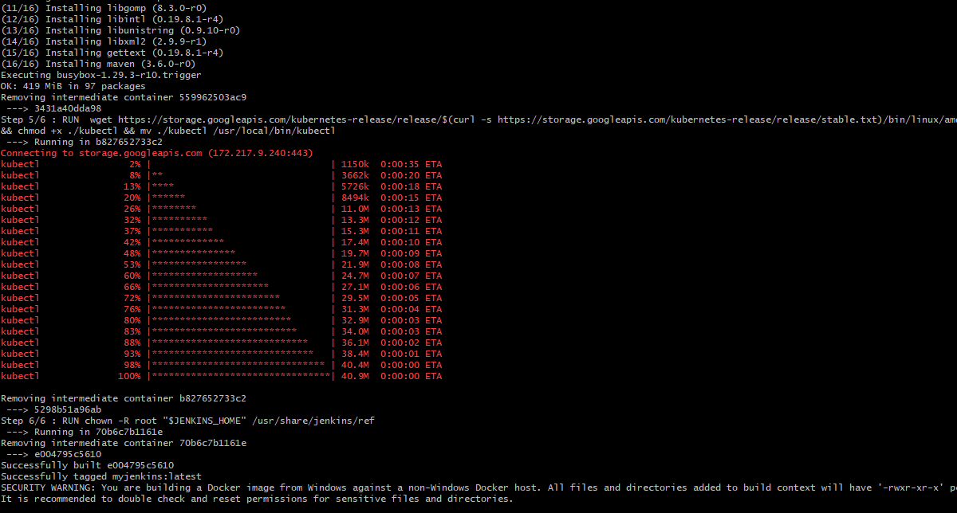

1. Run this image by this command:

kubectl apply -f Jenkins.yaml

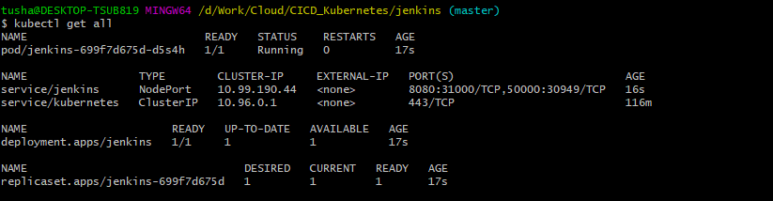

1. Check browser minikube ip and port 31000L 192.168.99.100:31000

