1. Click on credentials System

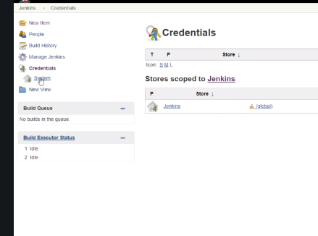

1. Click on Global credentials

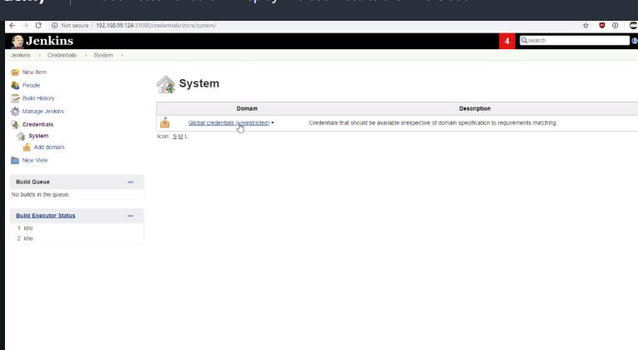

1. Click on Add credentials

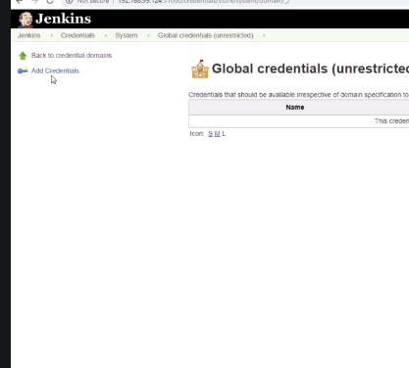

1. Add GitHub in ID 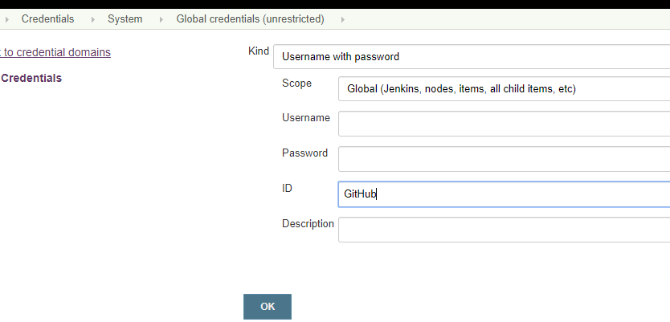

Setting up environment variable in Jenkins

1. Click on Manage Jenkins

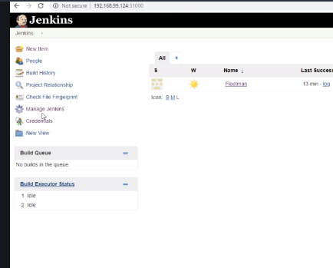

1. Then click Configure System

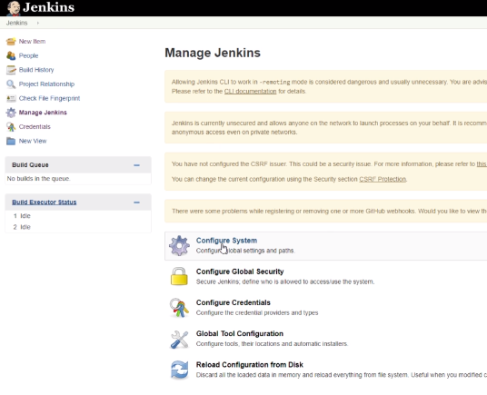

1. Check on Env variables

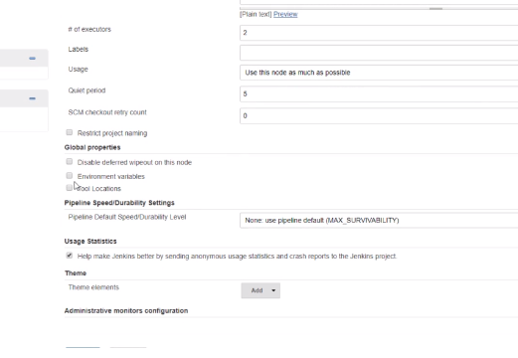

1. Then add two env variables in the boxes

ORGANIZATION_NAME : [my-tushar-org](https://github.com/my-tushar-org)

YOUR_DOCKERHUB_USERNAME : <Any Random String>