1. Click on new Item

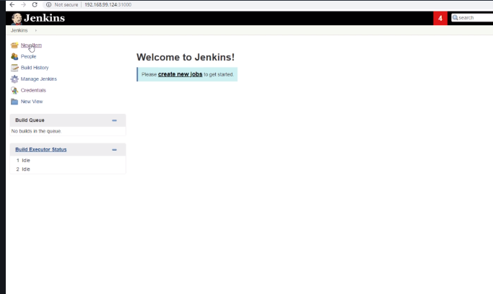

1. Select Multibranch Pipeline

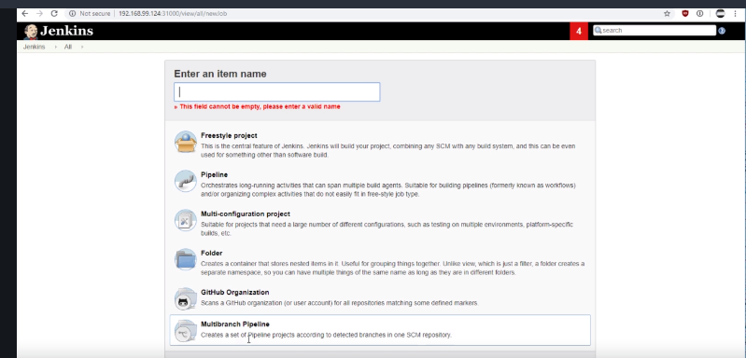

1. Enter the name os the project and click on ok just once

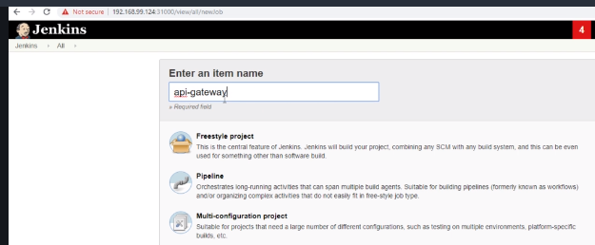

1. Enter display name

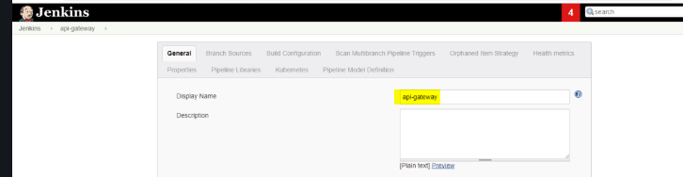

1. Add source github

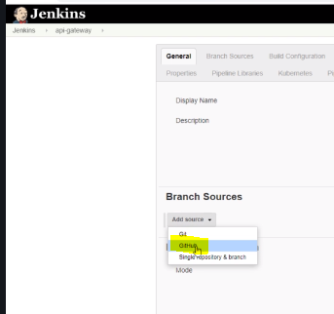

1. Add and select api gateway

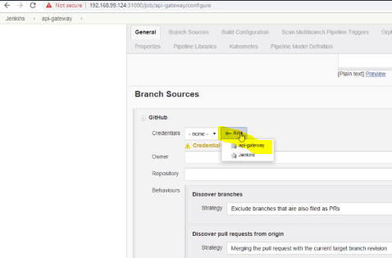

1. Add username password and ID like this and press add

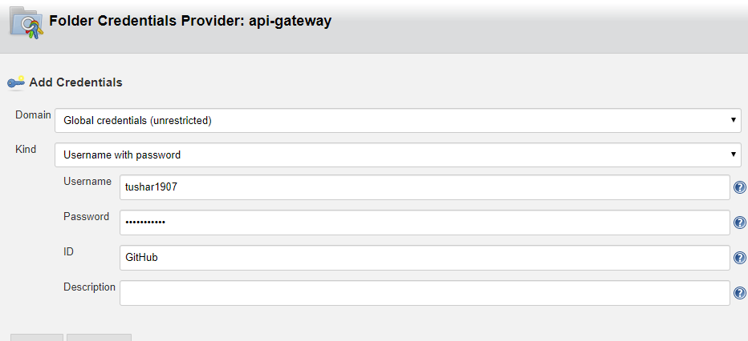

1. Enter owner as your organization name

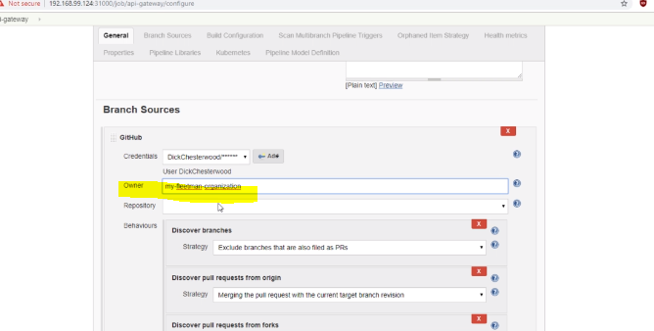

1. Select appropriate repo

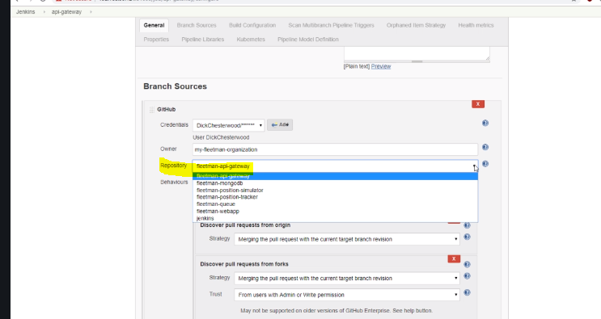

1. Then click save at the bottom and see the magic!!

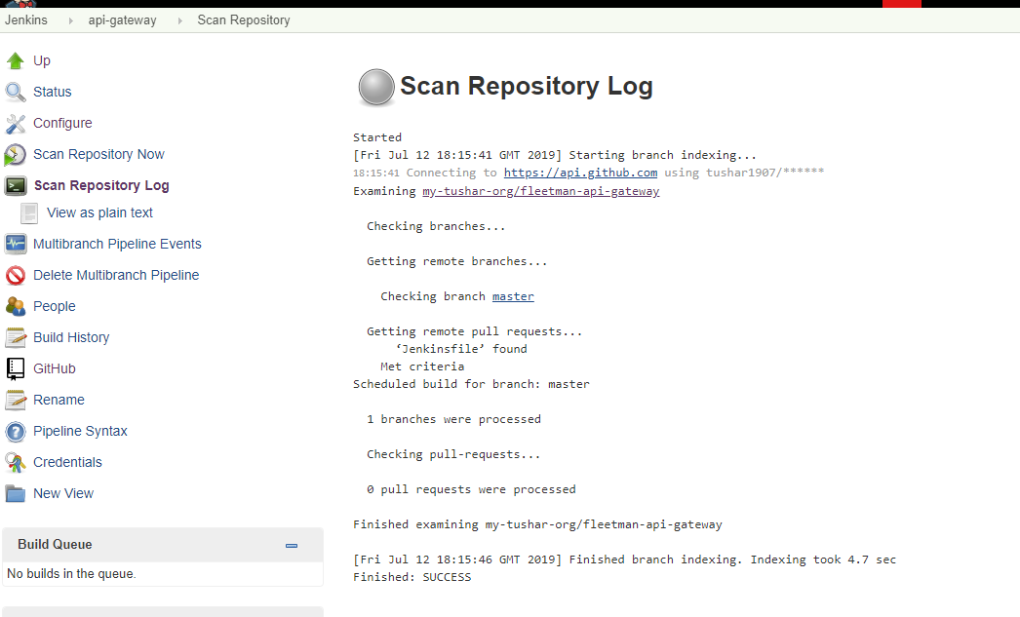

Review your builds here

<https://www.udemy.com/kubernetes-microservices/learn/lecture/14727868#overview>