Accessing the command line:

1. 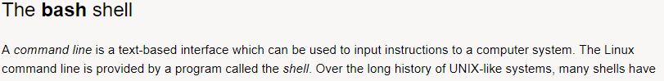
2. 
3. 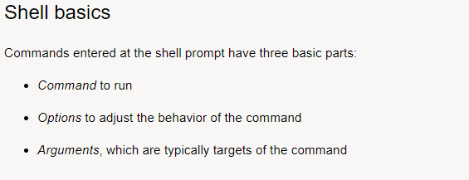
4. 
5. 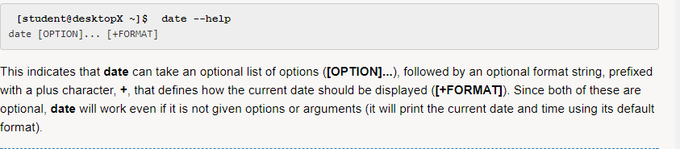
6. 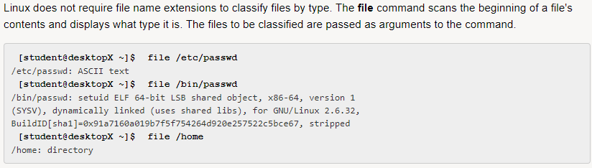file
7. 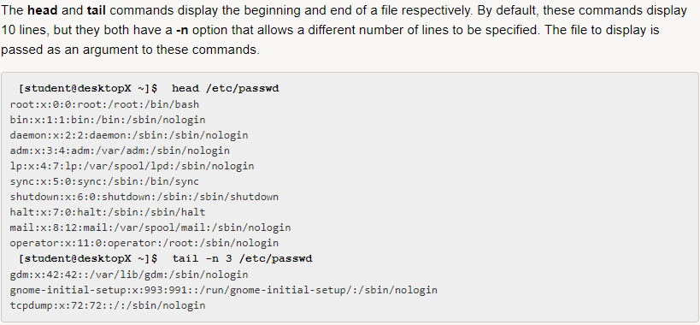head tail
8. Word counr: wc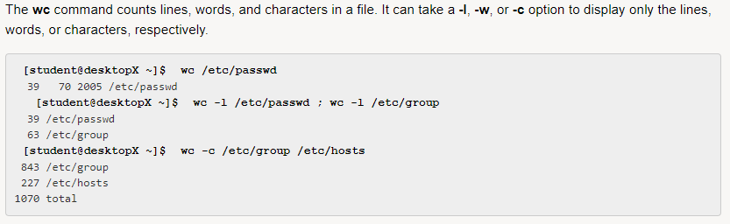
9. history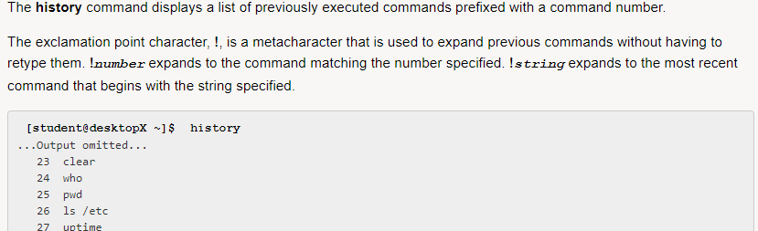
10. Arrow keys