1. Important directories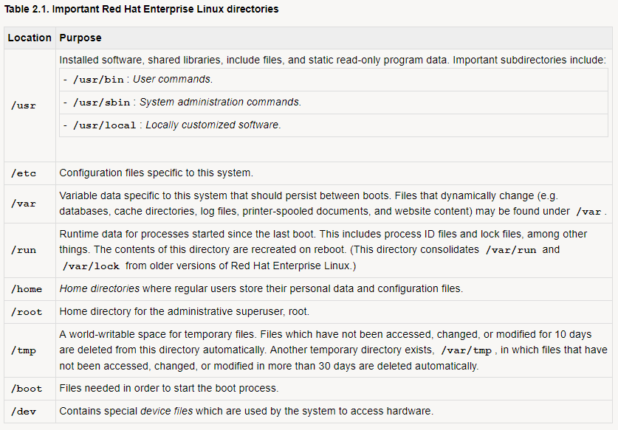
2. Hierarchy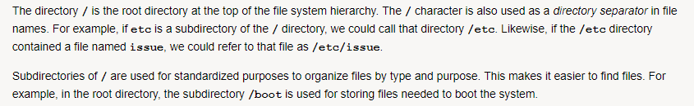
3. ------------------------c2l2