On completion of this hands-on, you should be able to:
- Setup your personal web site for course work assessments;
- Develop a simple Java Application without IDE;
- Familiarize yourself with NetBeans IDE;
- Create JApplet Project and write simple Applet;
- Deploy a Java Applet on the web

Please place your work on the following URLs:

- http://personal.cs.cityu.edu.hk/~< studentID>/cs4280/tut1/Addition.java
- http://personal.cs.cityu.edu.hk/~< studentID>/cs4280/tut1/Addition.class
- http://personal.cs.cityu.edu.hk/~< studentID>/cs4280/tut1/HelloWorldJApplet.html

I. Setup your personal web site for course work assessments

- Create a subfolder “cs4280” under folder “www” of you home drive. This folder will be used to publish all your tutorial exercises and assignments for assessment.

- Under the folder “cs4280”, create 13 subfolders for each tutorial (tut1, tut2, tut3……tut13) and two subfolders for the assignment (asgp1, asgp2).

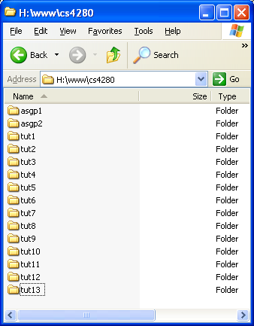

- Markers will go to these folders and look for a specific file to review your tutorial works if needed. Failed to setup a correct path and file may obtain a zero mark on the corresponding course work. Redirect page outside designed server (i.e. personal.cs.cityu.edu.hk) or to other student’s account without permission is not allowed. Found case will be graded zero or lost all the marks of coursework.

- Files’ names for each tutorial will be given on each tutorial sheet. Please make sure your work is ready on date announced. Late submission will not be considered.

II. First Java program – Welcome4
To write a Java application, you will need a Java SDK and a text editor. You can download the JDK from Sun Developer Network. JDK 1.8.0 Update 17 has already installed in CSLab’s machines. You can find it in C:\Program Files\Java\jdk\.
Follow the steps below to create your first Java program:
- Create a source file. Use a text editor (e.g. Notepad) to create a H:\www\cs4280\tut1\Welcome4.java with following content (You can also find this source code from slide 38 of lecture 1’s note):
import javax.swing.JOptionPane;

public class Welcome4 {
public static void main( String args[] )
{
JOptionPane.showMessageDialog(
null, "Welcome\nto\nJava\nProgramming!" );
System.exit( 0 );
}
}

- Compile the source file to a .class file.

- Open the window command prompt (Press Window + R key, then type “cmd”).

- Compile the java program by entering following commands in command prompt:
H:
cd www\cs4280\tut1\
javac Welcome4.java

if there is a problem in javac, plz run the following code:
"C:\Program Files\Java\jdk\bin\javac.exe" Welcome4.java

- A Welcome4.class will appear if there are no compilation errors.
- Run the java program. Enter the following commands:
java Welcome4

- You should see a message prompt like:

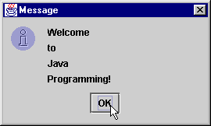

III. Run your Java program in Linux – PrintfDemo
The procedure of running a Java program in Linux is similar to Windows. PrintfDemo is an example to use printf() to display formatted data from Herb Schildt's Java Programming Cookbook. Follow the steps below to run PrintfDemo in Linux.

- Create a source file. Use a text editor (e.g. Notepad) to create a H:\www\cs4280\tut1\PrintfDemo.java with following content:

import java.util.*;

public class PrintfDemo {
public static void main( String args[] )
{
System.out.printf("Two decimal digits: %.2f\n", 10.0/3.0);
System.out.printf("Use group separators: %,.2f\n\n",
1546456.87);
System.out.printf("%10s %10s %10s\n",
"Value", "Root", "Square");

for(double i=1.0; i < 10.0; i++)
System.out.printf("%10.2f %10.2f %10.2f\n",
i, Math.sqrt(i), i*i);

System.out.println();
Calendar cal = Calendar.getInstance();
System.out.printf("Current time and date: %tc\n", cal);
}
}

- Log in to Linux environment.

- From the CS Lab Menu, double click the ‘Xterm (MobaXterm 7.7)’ entry to start Client.

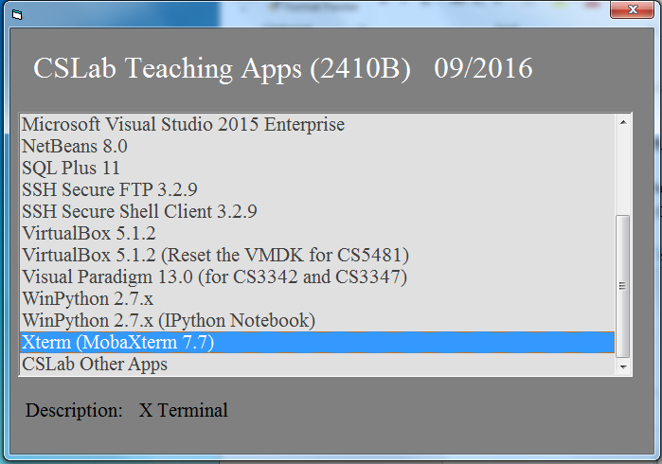

- Click “Session” and you can find a new window as shown in the following. Click the “SSH” button.

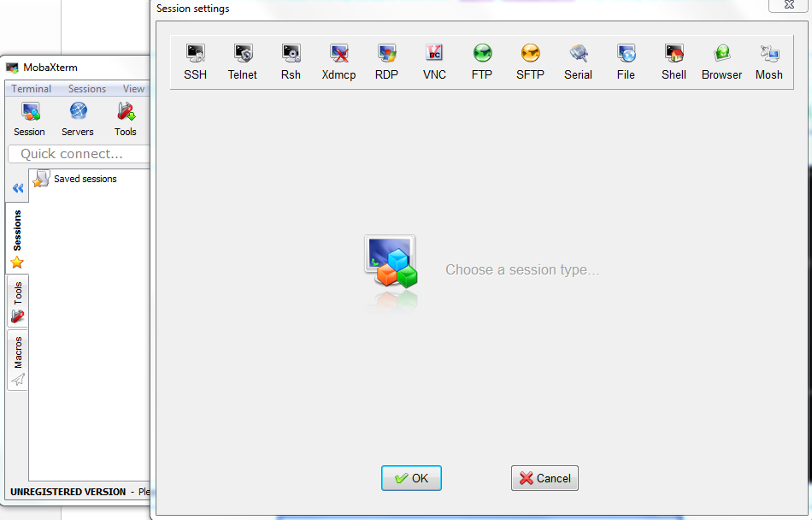

- A Logon Information window appears. Enter cs4280-01.cs.cityu.edu.hk in the remote host field, tick the Specify username, and enter your CS Lab login name (EID/SID) in the user name field.
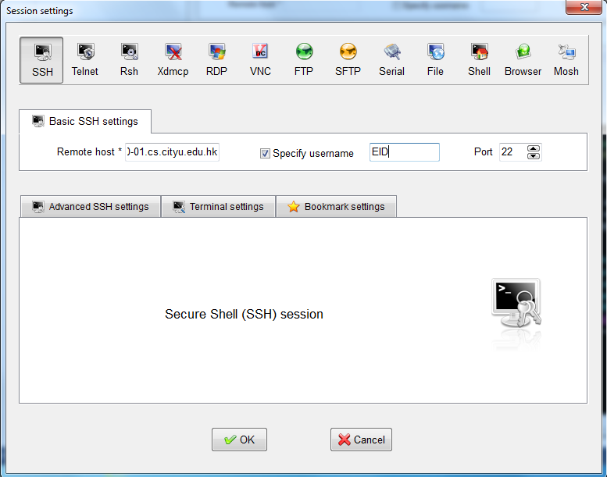

- Type your password in the corresponding filed.
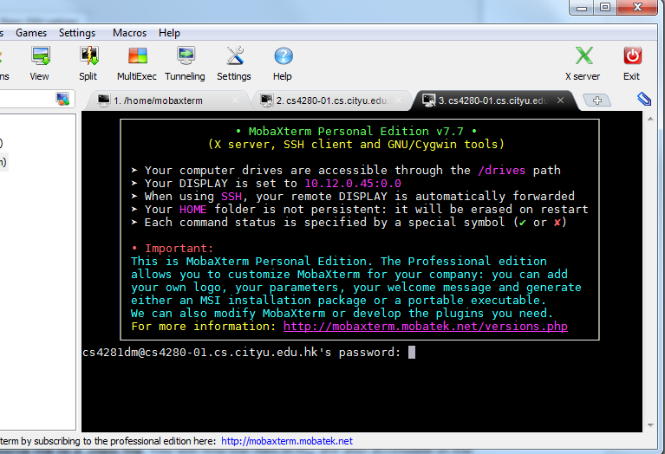

- Compile the source file to a .class file. You will find the files in H:/ are also accessible in the Linux environment. Enter the following commands to compile the source code:
cd ~/www/cs4280/tut1
javac PrintfDemo.java

A PrintfDemo.class will appear if there are no compilation errors.
- Run the java program. The command syntax is similar to what you did in Windows. Enter the following command:
java PrintfDemo

You should see the following output:
Two decimal digits: 3.33
Use group separators: 1,546,456.87

Value Root Square
1.00 1.00 1.00
2.00 1.41 4.00
3.00 1.73 9.00
4.00 2.00 16.00
5.00 2.24 25.00
6.00 2.45 36.00
7.00 2.65 49.00
8.00 2.83 64.00
9.00 3.00 81.00

Current time and date: <Current Time>

<Current Time> is the time of running the program. E.g. Fri Jan 16 19:13:14 HKT 2017

IV. Java program with user inputs – Addition
In the slide 40 of the lecture 1’s note, there is a Java class Addition. Follow the requirements below to make it work in the Linux server cs4280-01.cs.cityu.edu.hk.

- Create and save your work to H:\www\cs4280\tut1\Addition.java by using the source code from slide 40-41 of lecture note (Introduction to Java).

- Modify the program to read the program arguments and print the output to the system console instead of using JOptionPane (i.e. Do not use JOptionPane in the program).

- Compile the program.

- Run the program and input the parameters in cs4280-01.cs.cityu.edu.hk by following commands:
java Addition 45 72

- You should see the following output:
Enter first integer: 45
Enter second integer: 72
The sum is 117.

[Hints]
- You do not need to import javax.swing.JOptionPane anymore, as JOptionPane is not needed in the program.

V. NetBeans IDE and JApplet Project
NetBeans is a Java IDE gives you value-added visual tools (e.g., syntax highlight, auto-completion, etc.) to develop and debug a Java program. It saves you time managing the files and compilation work. The drag-and-drop features make creating GUI a lot easier.

- Press on your keyboard to start Windows Explorer.

- In Windows Explorer, navigate to H:\ and create a NetBeansProjects directory. H:\NetBeansProjects will be the NetBeans project location used in this hands-on.

- Then, from the CS Lab Menu, double click the ‘NetBeans 8.0’ entry to start NetBeans IDE 8.0. If you the “Invalid jdkhome specified” window or “Confirm Import Settings”, type ”Yes” and “Yes”.

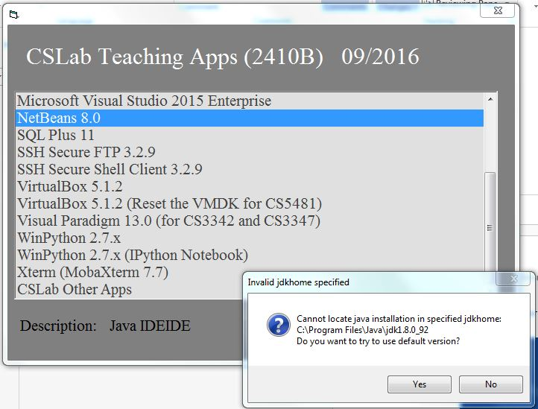

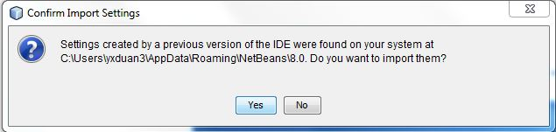
It takes a few moments for NetBeans IDE 8.0 to load. A splash screen appears while NetBeans IDE 8.0 is loading.
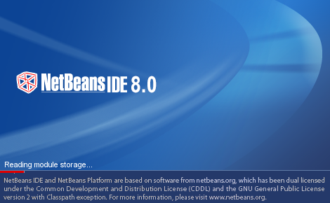

- When NetBeans IDE finish loading, a Registration Reminder window may appears.
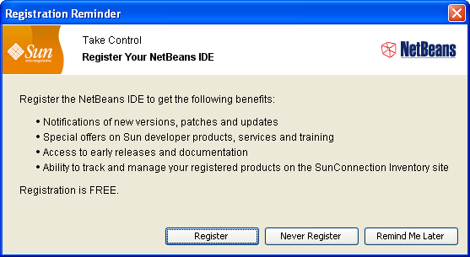
Click the [Never Register] button to close the Registration Reminder window.
- The NetBeans IDE is layout into several windows.
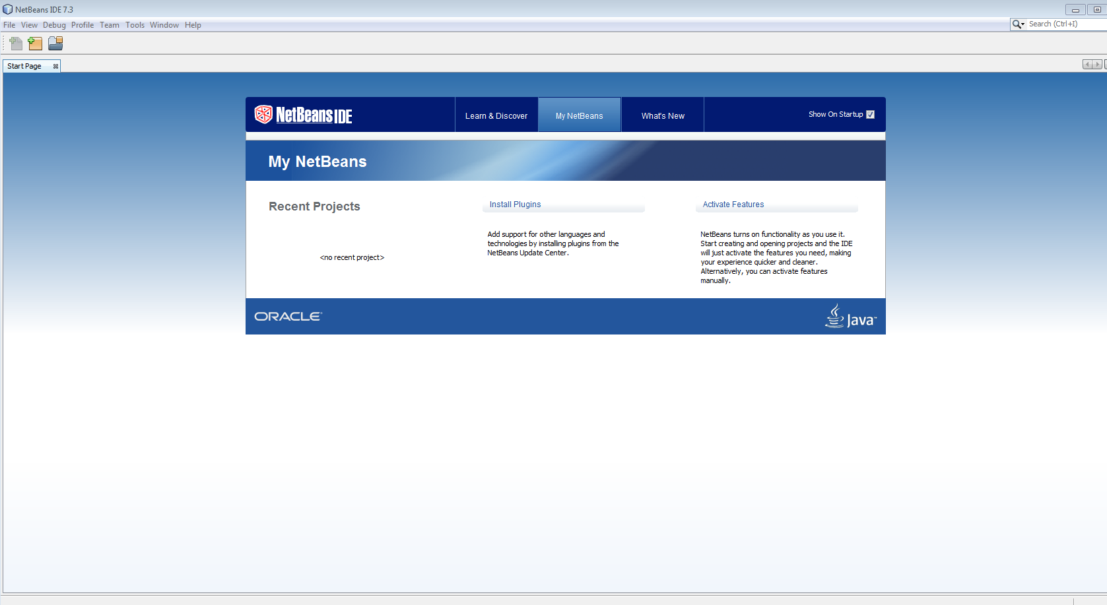
Welcome screen
The IDE with a project is shown as follows:
Main menu
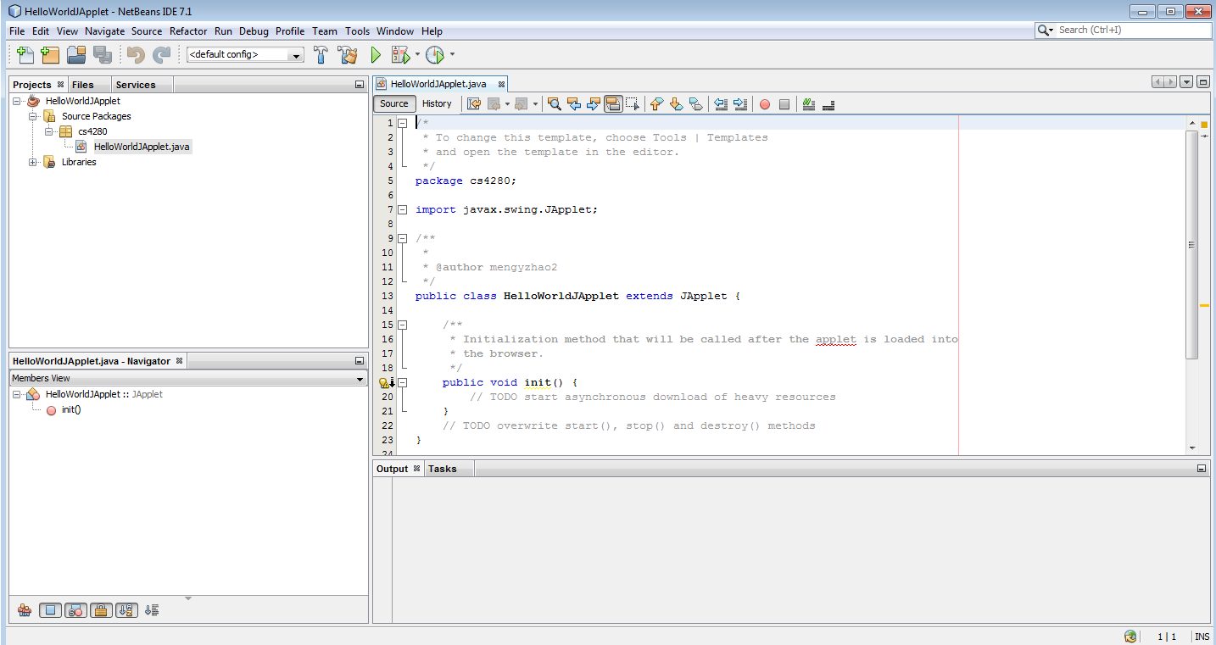
Toolbar
Projects, Files, and Services window
Navigator window
Output window

- Project window
Displays all the currently opened projects. Information organized in project-based manner.
- Files window
A normal file-based view of open projects.
- Services window
Place to access HTTP servers, database servers, etc.
- Navigator window
Display the methods, constructors, and fields in a class in a traditional list view or as an inheritance tree.
- Output window
Display compilation output, Java program stdout output, etc.
- From the NetBeans IDE main menu, select File ➔ New Project…. A New Project wizard appears.
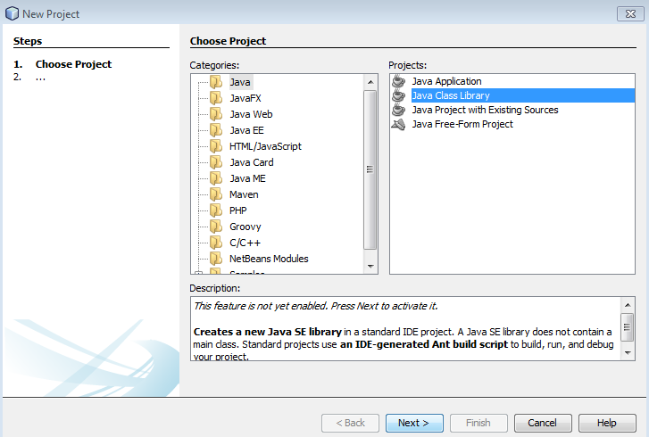

- In step 1 of the New Project wizard, select Java from the Categories tree in the middle. Then select Java Class Library from the Projects list on the right.
Click the [Next >] button to go to step 2 of the New Project wizard. A New Java Class Library window appears.

- In the New java Class Library window, enter:

Project Name: | HelloWorldJApplet
Project Location: | H:\NetBeansProjects
Project Folder:
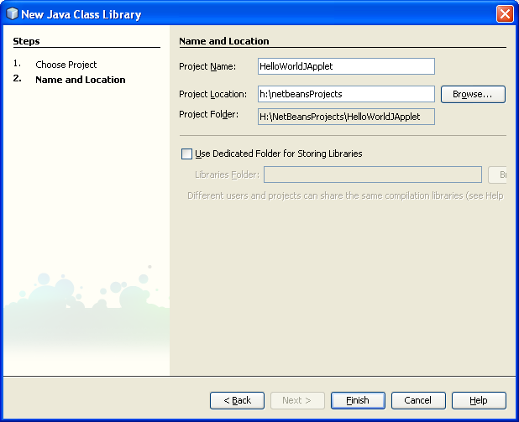

- Click the [Finish] button to add new project HelloWorldJApplet to NetBeans IDE’s Projects window.
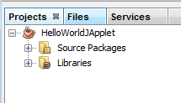
NetBeans IDE organize source code files and project-related files in a tree. The files are represented as nodes in the tree.

- In the Project window, right click the Source Packages tree, select New ➔ Other… from the pop-up menu.
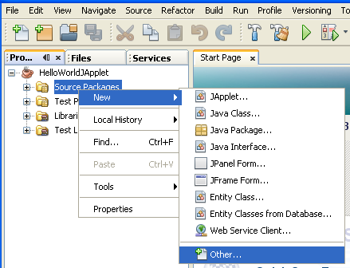
A New File wizard appears.

- In step 1 of the New File wizard, select Java from the Categories tree in the middle and JApplet from the File Types list on the right.
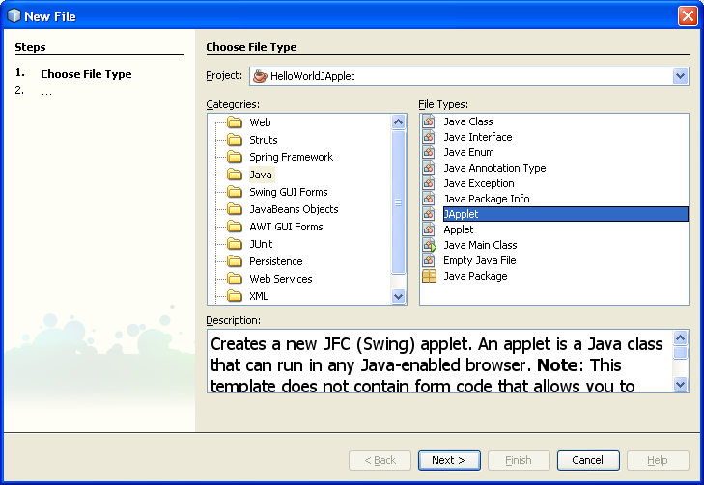
- Click the [Next >] button to go to step 2 of the New File wizard. A New JApplet Form window appears.
In the New JApplet Form window, enter:

Class Name: | HelloWorldJApplet
Location: | Source Packages
Package: | cs4280

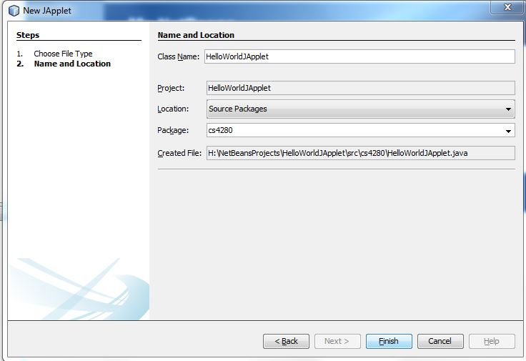
- Click the [Finish] button to complete the New File wizard. A cs4280/HelloWorldJApplet.java is added to the Source Packages subtree. The source code of cs4280/HelloWorldJApplet.java is opened in the Source editor on the right.
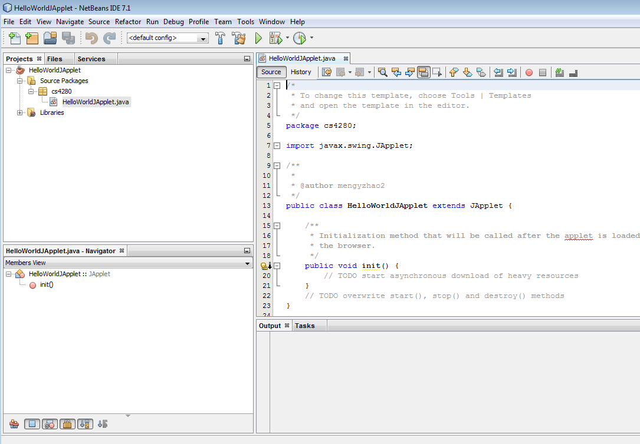

- From the NetBeans IDE main menu, select View ➔ Show Line Numbers so NetBeans IDE displays line numbers in Source editor.
- Enter the following in the body of the init() method.
public void init(){
add(new JLabel("Hello World!"));// add a new JLabel to the JApplet
}

- Use classes in swing package by adding the following statement after import “javax.swing.JApplet;”

import javax.swing.JApplet;
import javax.swing.*;

That is:
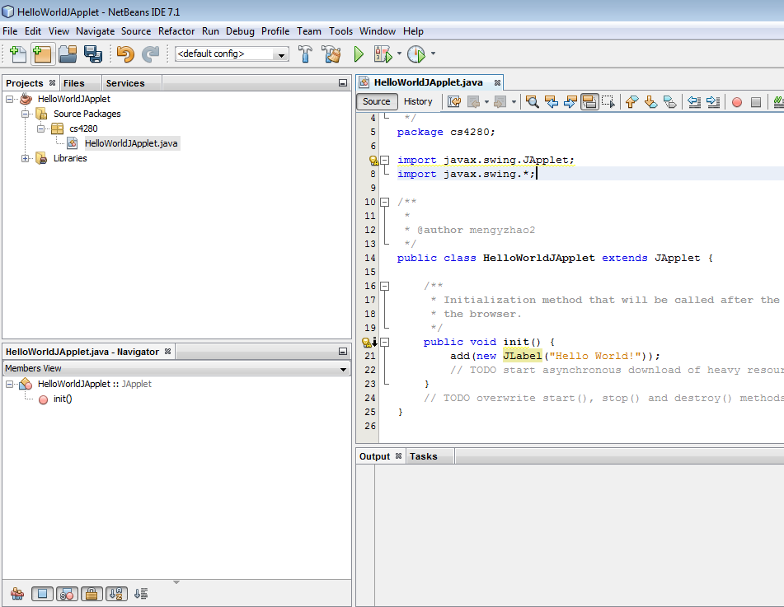

- From the Projects window, right click HelloWorldJApplet.java, select Debug File to debug HelloWorldJApplet in NetBeans IDE.

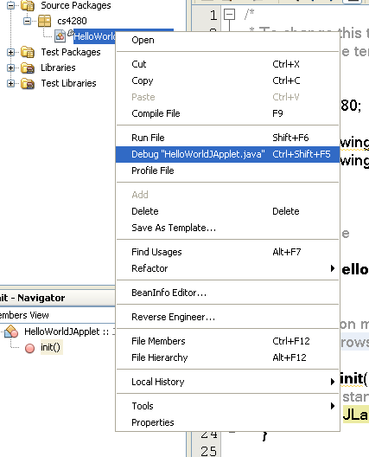

NetBeans IDE automatically saves the source code of HelloWorldJApplet.java and compiles it to bytecode.

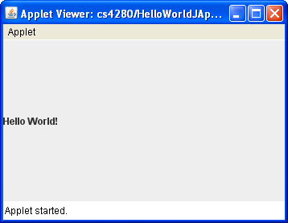

- In Applet Viewer, select Applet ➔ Quit to close the Applet Viewer.

- Return to NetBeans IDE. In the Project window, right click the HelloWorldJApplet project, select Close from the pop-up menu to close the HelloWorldJApplet project.

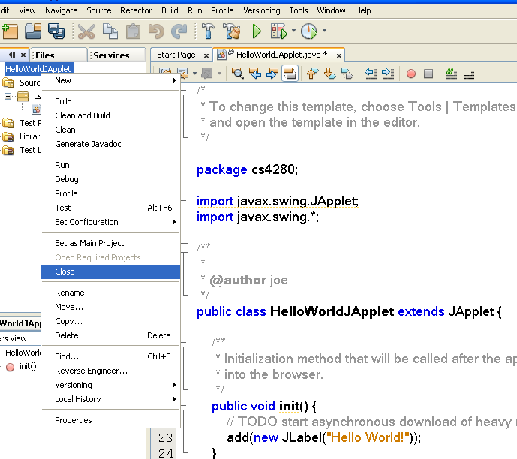

[Tips]
- Breakpoint can added by click the edge of the source editor
- In debugging, press “F8” to step over program statement

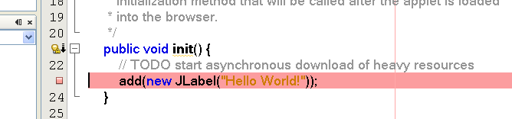

VI. Deploy Java Applet on the Web
- Using window explorer to locate your project folder e.g. h:\NetBeansProjects\HelloWorldJApplet.

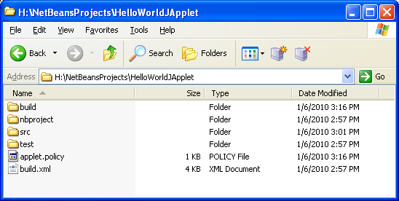

- Go to the folder “build “

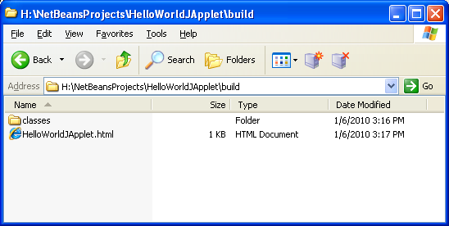

- Copy the html file “HelloWorldJApplet.html” and folder “classes “ to your web directory, e.g. h:\www\cs4280\tut1

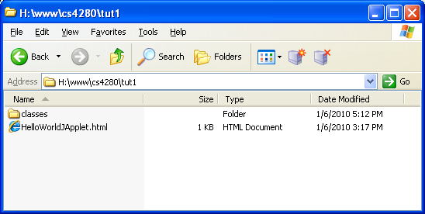
- Open IE web browser.

- Access the applet in the IE web browser, the URL should be http://personal.cs.cityu.edu.hk/~<your student ID>/cs4280/tut1/HelloWorldJApplet.html

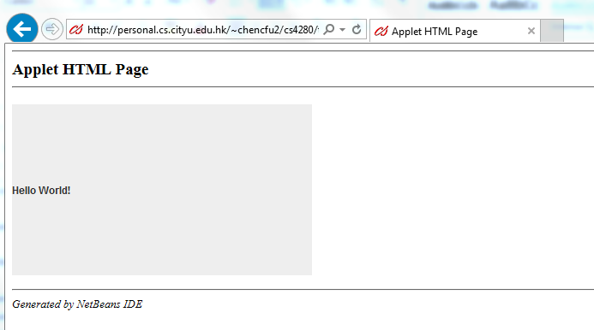

If a window appears to ask you update Java as follows, click “Later”.
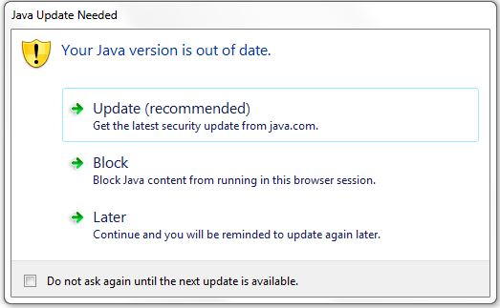

If your applet is blocked as follows:
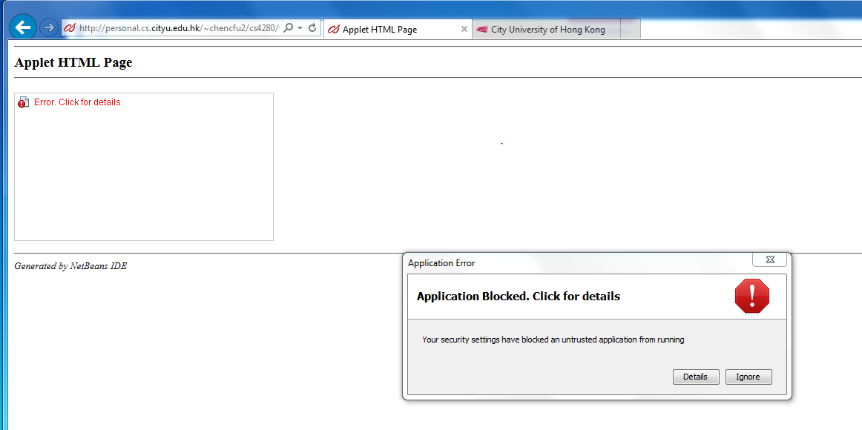
please include your website to the “Exception Site List” under Java Control Panel in order to change the security setting by the following steps:
- Go to control panel:
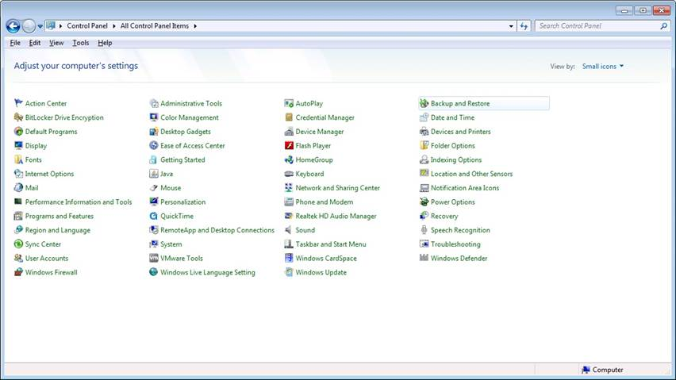

- Select Java:
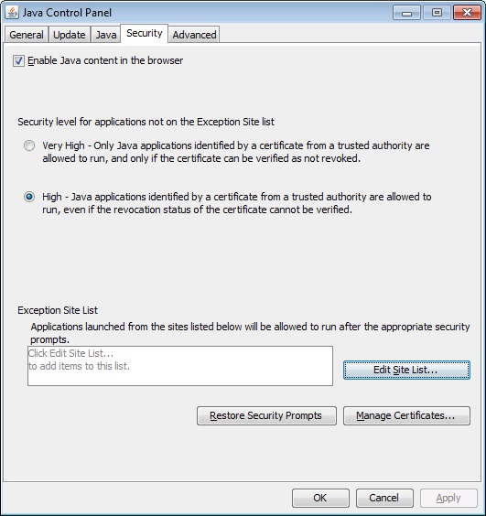
- Add the website that hosts your applet (e.g. http://personal.cs.cityu.edu.hk/~<your student ID>/cs4280/tut1/HelloWorldJApplet.html)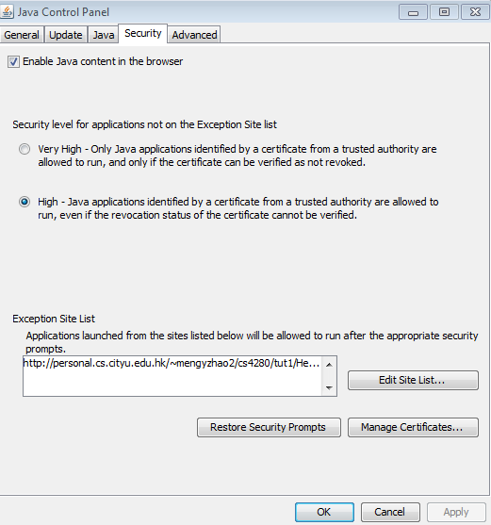
- Restart the web explorer to open http://personal.cs.cityu.edu.hk/~<your student ID>/cs4280/tut1/HelloWorldJApplet.html.

References
- Patrick Keegan, et. al. (2006). NetBeans IDE Field Guide: Developing Desktop, Web, Enterprise, and Mobile Applications. Prentice Hall.
- David Flanagan. (2004). Java Examples in a Nutshell, Third Edition. O’Reilly.
- Richard G. Baldwin. (2008). C++, Scratch/Alice/C#/Java/JavaScript/XML Programming Tutorials. Retrieved December 16, 2008 from http://www.dickbaldwin.com/toc.htm
- Herbet Schildt. (2008). Herb Schildt's Java Programming Cookbook. McGraw-Hill

