On completion of this hands-on, you should be able to:
- Write a Java Applet with event handler;
- Use different Java packages; and
- Convert data between different data types.

Please place your work on the following URLs:

- http://personal.cs.cityu.edu.hk/~< studentID>/cs4280/tut2/GraphJApplet.html
- http://personal.cs.cityu.edu.hk/~< studentID>/cs4280/tut2/BarChartJApplet.html

I. Graph Applet – GraphJApplet.java
This section requires you to build a JApplet to draw lines based on user inputs (x and y).
- Open ‘NetBeans 8.0’ from CS Lab Application Menu. If there appears “Invalid jdkhome specified” window or “Confirm Import Settings”, type ”Yes” and “Yes”.

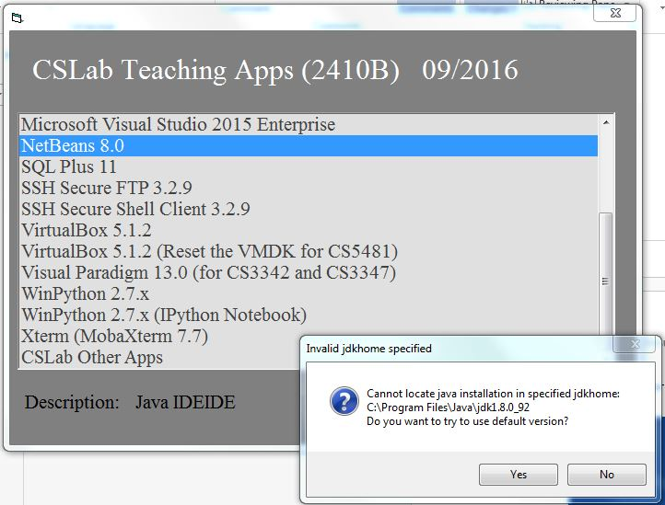
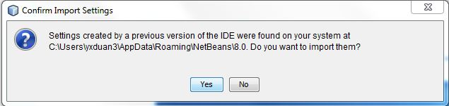

- Create a new Java Class Library project (see Tutorial 1 if you forgot the steps):

Project Name: | CS4280T02
Project Location: | H:\NetBeansProjects
Project Folder: | H:\NetBeansProjects\CS4280T02

- Create a new JApplet:

Class Name: | GraphJApplet
Location: | Source Packages
Package: | cs4280

- Add the following code into the GraphJApplet.java.

- Import additional packages to the class:
- Swing GUI: javax.swing.*
- Event Handling: java.awt.event.*
- Graphics Drawing: java.awt.*
- Implement ActionListener to the class.
- Declare following variables to be used anywhere in the class.
JLabel xLabel=new JLabel("x");
JLabel yLabel=new JLabel("y");
JTextField xValue=new JTextField(5);
JTextField yValue=new JTextField(5);
JButton addButton=new JButton("Add");
JButton resetButton=new JButton("Reset");
final int maxPoint=50;
int pointCount;
int xData[]=new int[maxPoint];
int yData[]=new int[maxPoint];

- Add following codes in init() function.
public void init() {
// TODO start asynchronous download of heavy resources
JPanel inputBar=new JPanel();
inputBar.setLayout(new FlowLayout()); // use flow layout to arrangement GUI objects
inputBar.add(xLabel);
inputBar.add(xValue);
inputBar.add(yLabel);
inputBar.add(yValue);
inputBar.add(addButton);
inputBar.add(resetButton);
setLayout(new BorderLayout());
add(inputBar,BorderLayout.NORTH);
addButton.addActionListener(this);
resetButton.addActionListener(this);
pointCount=0;
}

- Add actionPerformed() and paint() functions to the class.
public void actionPerformed(ActionEvent e){
if (e.getSource()==addButton){
if (pointCount>= maxPoint)
pointCount=0;
xData[pointCount]=Integer.parseInt(xValue.getText());
yData[pointCount]=Integer.parseInt(yValue.getText());
xValue.setText("");
yValue.setText("");
pointCount++;
}else if (e.getSource()==resetButton)
pointCount=0;
repaint();
}
public void paint(Graphics g){
super.paint(g); // call the super class to draw other GUI objects
for (int i=1;i<pointCount;i++){
g.drawLine(xData[i-1],yData[i-1],xData[i],yData[i]);
}
}

- Debug the Applet and add the following points, you should see a line likes the following:
Point 1: | X: 60 Y: 100
Point 2: | X: 100 Y: 60
Point 3: | X: 140 Y: 100
Point 4: | X: 180 Y: 60
Point 5: | X: 220 Y: 100

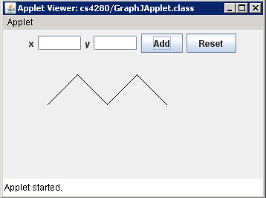
- Deploy your work to H:\www\cs4280\tut2\ (detailed steps are described in Tutorial 1).

- Set sufficient privilege for the web server.

- Select ‘Xterm (MobaXterm 7.7)’ from CS Lab Applications Menu.

- Log in to Solaris machine sparc1.cs.cityu.edu.hk with your CS Lab login name and password.

- Set the file permissions by following commands:
setfacl -r -m u:nobody:r-- ~/www/cs4280/tut2/GraphJApplet.html
setfacl -r -m u:nobody:r-- ~/www/cs4280/tut2/classes/cs4280/*

This commands effectively set read privilege for the web server only. Other people cannot read your files.

- You should be able to access the applet in IE web browser by http://personal.cs.cityu.edu.hk/~<your student ID>/cs4280/tut2/GraphJApplet.html.
(Detailed steps are described in Tutorial 1).

II. Another Graph Applet – BarChartJApplet.java
BarChartJApplet is similar to GraphJApplet in Section I. It draws bar charts based on user inputs. Follow the requirements below to finish this exercise.

- Create a new JApplet called BarChartJApplet in cs4280 package within the same project.

- Draw bar charts based on user inputs.

- The width of each bar should be equal to the width of the applet divided by no. of bar drawn. Set the applet width and height to 800 and 600 respectively (You can edit the file “BarChartJApplet.html” by opening it with Notepad, setting the applet width and height, and saving it).

[Hints]
- JavaSE 6 API – java.awt.Graphics documentation.

- Deploy the applet to H:\www\cs4280\tut2\.

- Set sufficient privilege for the web server.

- Select ‘Xterm (MobaXterm 7.7)’ from CS Lab Applications Menu.

- Log in to Solaris machine sparc1.cs.cityu.edu.hk with your CS Lab login name and password.

- Set the file permissions by following commands:
setfacl -r -m u:nobody:r-- ~/www/cs4280/tut2/BarChartJApplet.html
setfacl -r -m u:nobody:r-- ~/www/cs4280/tut2/classes/cs4280/*

This commands effectively set read privilege for the web server only. Other people cannot read your files.

- You should be able to access the applet in IE web browser by http://personal.cs.cityu.edu.hk/~<your student ID>/cs4280/tut2/BarChartJApplet.html.

Input the following bar data, you should able to see a bar chart like:
Data 1: | 20 | Data 10: | 20
Data 2: | 50 | Data 11: | 10
Data 3: | 30 | Data 12: | 50
Data 4: | 80 | Data 13: | 400
Data 5: | 200 | Data 14: | 250
Data 6: | 250 | Data 15: | 260
Data 7: | 500 | Data 16: | 350
Data 8: | 400 | Data 17: | 450
Data 9: | 150

