On completion of this hands-on, you should be able to:
- Setup an Apache Tomcat instance for web applications development on Linux;
- Locate and examine the Apache Tomcat log files;
- Troubleshoot an Apache Tomcat instance;
- Locate the compiled bytecodes of JSP; and
- Create your first Java servlet.

Please place your work on the following URLs:

- http://personal.cs.cityu.edu.hk/~< studentID>/cs4280/tut4/HelloWorldServlet.war
- http://personal.cs.cityu.edu.hk/~< studentID>/cs4280/tut4/HelloWWW.java
- http://personal.cs.cityu.edu.hk/~< studentID>/cs4280/tut4/HelloWWW.html

I. Setup the Apache Tomcat Container
This hands-on aims to assist you to set up your own instance of Apache Tomcat. This instance of Apache Tomcat will be part of your web applications development environment for the coming hands-on tutorials.
The entire web applications development environment would be:


Computers in CS Lab

Apache Tomcat running on cs4280-01.cs.cityu.edu.hk





Internet
Microsoft SQL Server running on w2ksa.cs.cityu.edu.hk
Computer at home

In the coming hands-on tutorials, you will run your own Apache Tomcat 6 on cs4280-01.cs.cityu.edu.hk. The following steps will guide you through the ways to setup your own Apache Tomcat on cs4280-01.cs.cityu.edu.hk. The directory structure of an Apache Tomcat distribution:

apache-tomcat-6.0.20
|__bin | Binary executable files
|__conf | Configuration files (such as passwords)
|__lib | JAR files available to Web applications
|__logs | The server’s log files
|__temp | Tomcat temporary files
|__webapps | Directory for Web applications
|__work | Scratch directory for holding temporary files

A copy of Apache Tomcat 6.0.20 has been put in /public/cs4280/apache-tomcat-6.0.20. It is 11 MB large. You do not need to copy everything.

Follow the instructions to setup your Apache Tomcat.
- Environment preparation.

Create the following directories:
H:\tomcat\
H:\tomcat\logs
H:\tomcat\temp
H:\tomcat\work

- Log in to Linux environment.

- From the CS Lab Menu, double click the ‘Xterm (MobaXterm 7.7)’ entry to start Client.

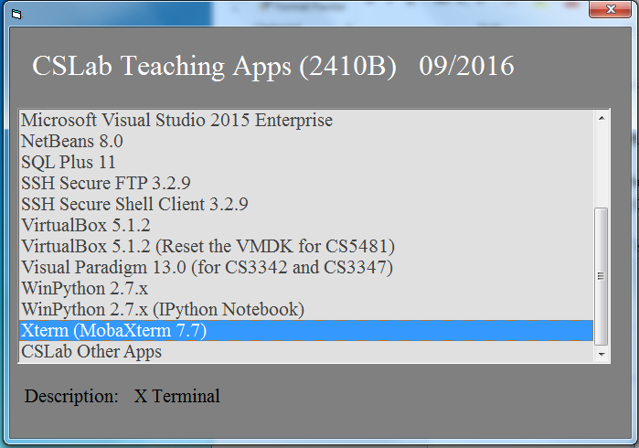

- Click “Session” and you can find a new window as shown in the following. Click the “SSH” button. A Logon Information window appears. Enter cs4280-01.cs.cityu.edu.hk in the remote host field, tick the Specify username, and enter your CS Lab login name (EID/SID) in the user name field. And then type your password.

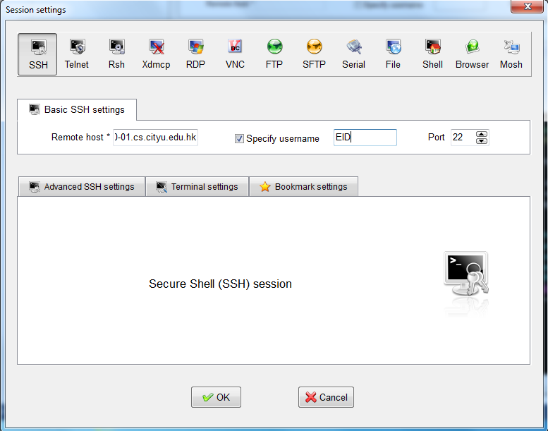
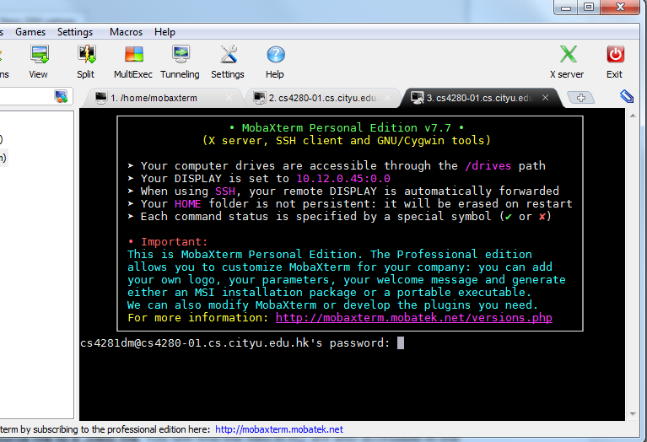

- Create symbolic links. In the SSH Secure Client window, type the following two commands to create two symbolic links in ~/tomcat directory.
ln -s /public/cs4280/apache-tomcat-6.0.20/bin/starttc.sh ~/tomcat/starttc.sh
ln -s /public/cs4280/apache-tomcat-6.0.20/bin/stoptc.sh ~/tomcat/stoptc.sh

~/tomcat/starttc.sh is used for running Apache Tomcat on cs4280-01.cs.cityu.edu.hk while ~/tomcat/stoptc.sh is used for stopping an Apache Tomcat instance on cs4280-01.cs.cityu.edu.hk. We will use Java SE 1.6 located in /usr/local/jdk1.7.0 for the coming hands-on tutorials.

- Prepare remaining files. Copy conf, and webapps directories to your tomcat directory. In the F-Secure SSH window, type the following commands:
cp -R /public/cs4280/apache-tomcat-6.0.20/conf ~/tomcat
cp -R /public/cs4280/apache-tomcat-6.0.20/webapps ~/tomcat

- Modify the server configuration.
- Backup the original server configuration. Copy H:\tomcat\conf\server.xml to H:\tomcat\conf\server.xml.bak. The backup will be useful when you do something wrong that cannot be recovered.

- Use a text editor to open H:\tomcat\conf\server.xml. This file is an XML file. It controls which ports Apache Tomcat use. You will have a set of port numbers dedicated to you to prevent crashing with others who may want to use the same port numbers.
Please come to ask tutors during tutorial sessions to collect your own port numbers.
If you fail to attend the tutorial, please sent email to yxduan3-c@my.cityu.edu.hk to ask for your port numbers.
You cannot use any other ports other than those assigned to you.
Please well save your port numbers, which will be used many times in the following tutorials.

- The <Server> element represents the entire Apache Tomcat container.
<Server port="8005" shutdown="SHUTDOWN">

The port attribute names the TCP/IP port number to which the server listens for a shutdown command. Change its value to the shutdown port value assigned to you.

- The <Connector> element defines the component that does the actual managing of requests and responses to and from a calling client.
<Connector port="8080" protocol="HTTP/1.1"
connectionTimeout="20000"
redirectPort="8443" />

The port attribute names the TCP/IP port number on which the connector listens for requests. Change its value to the HTTP port value assigned to you.

- The AJP Connector element is for integrating Apache Tomcat into an existing Apache web server installation.
<Connector port="8009" protocol="AJP/1.3" redirectPort="8443" />

Comment it out:
<!-- Connector port="8009" protocol="AJP/1.3" redirectPort="8443" / -->

- Locate the lines:
<Host name="localhost" appBase="webapps"
unpackWARs="true" autoDeploy="true"
xmlValidation="false" xmlNamespaceAware="false">

Change the unpackWARs attribute to false:
<Host name="localhost" appBase="webapps"
unpackWARs="false" autoDeploy="true"
xmlValidation="false" xmlNamespaceAware="false">

By setting unpackWARs to false, Apache Tomcat will run a web application from a web application archive (*.war) file without first unpacking to Apache Tomcat’s webapp directory.

- Save the changes you made to H:\tomcat\conf\server.xml.

- Open H:\tomcat\conf\context.xml in text editor. Locate the lines that read:
<Context>

Replace it with:
<Context reloadable="true" cachingAllowed="false">

This will enable Apache Tomcat to automatically reload a servlet if change is detected. The good thing is that you do not need to restart Apache Tomcat after making changes to your web applications. The drawback is Apache Tomcat runs a bit slower.

Save the changes you made to H:\tomcat\conf\context.xml.

II. Running Apache Tomcat for the First Time
After setting up your own Apache Tomcat, it is time to run it for the first time. You will also learn how to check if your Apache Tomcat is really running on Linux. Follow the steps to run your Apache Tomcat.

- Log in to the cs4280-01.cs.cityu.edu.hk using Xterm. Run the script to start Apache Tomcat on cs4280-01.cs.cityu.edu.hk by following command. Then, Apache Tomcat will run in background.
~/tomcat/starttc.sh

- Apache Tomcat creates some log files in the H:\tomcat\logs directory. H:\tomcat\logs\catalina.out contains messages output by Apache Tomcat, while localhost.YYYY-MM-DD.log contains messages output by a web application.
If Apache Tomcat has successfully started, the last few lines of catalina.out should look like this:
Nov 7, 2008 12:52:01 PM org.apache.catalina.startup.Catalina load
INFO: Initialization processed in 609 ms
Nov 7, 2008 12:52:01 PM org.apache.catalina.core.StandardService start
INFO: Starting service Catalina
Nov 7, 2008 12:52:01 PM org.apache.catalina.core.StandardEngine start
INFO: Starting Servlet Engine: Apache Tomcat/6.0.20
Nov 7, 2008 12:52:02 PM org.apache.coyote.http11.Http11Protocol start
INFO: Starting Coyote HTTP/1.1 on http-18080
Nov 7, 2008 12:52:02 PM org.apache.catalina.startup.Catalina start
INFO: Server startup in 979 ms

Notice the port number Apache Tomcat is using from the log. In this case, Apache Tomcat is listening on port 18080. Yours should be the same as that assigned to you.

- To check if Apache Tomcat is running, use the ps command to query active processes. Type the following command in the SSH Secure window (everyone can use the parameter 65536).
ps -f --width=65536

The output should contain a /usr/local/jdk1.7.0/bin/java command:
UID PID PPID C STIME TTY TIME CMD
50987654 6006 1 1 12:52 pts/0 00:00:06 /usr/local/jdk1.7.0/bin/java -Djava.util.logging.manager=org.apache.juli.ClassLoaderLogManager -Djava.util.logging.config.file=/home/bsft06/50987654/tomcat/conf/logging.properties -Djava.endorsed.dirs=/public/cs4280/apache-tomcat-6.0.20/endorsed -classpath :/public/cs4280/apache-tomcat-6.0.20/bin/bootstrap.jar -Dcatalina.base=/home/bsft06/50987654/tomcat -Dcatalina.home=/public/cs4280/apache-tomcat-6.0.20 -Djava.io.tmpdir=/home/bsft06/50987654/tomcat/temp org.apache.catalina.startup.Bootstrap start
The second column is the process id of the Apache Tomcat running. In this case, 6006. Yours may be different.

Double check if the Apache Tomcat process is listening on the ports specified in server.xml by using lsof.

lsof -i 4TCP -n -P -V

The output has nine columns.
COMMAND PID USER FD TYPE DEVICE SIZE NODE NAME
java 6006 50987654 98u IPv4 50930618 TCP 127.0.0.1:18005 (LISTEN)
java 6006 50987654 35u IPv4 50930024 TCP 0.0.0.0:18080 (LISTEN)

The ninth column is the IP address and port number, and socket state of which the process is listening at while the second column is the process of that process. Make sure the port numbers are the same as that specified in your server.xml file and the process id is the same as that reported by the ps command.

- Go to http://cs4280-01.cs.cityu.edu.hk:<Your Apache Tomcat HTTP port> in your web browser. You should see a web page like the following:
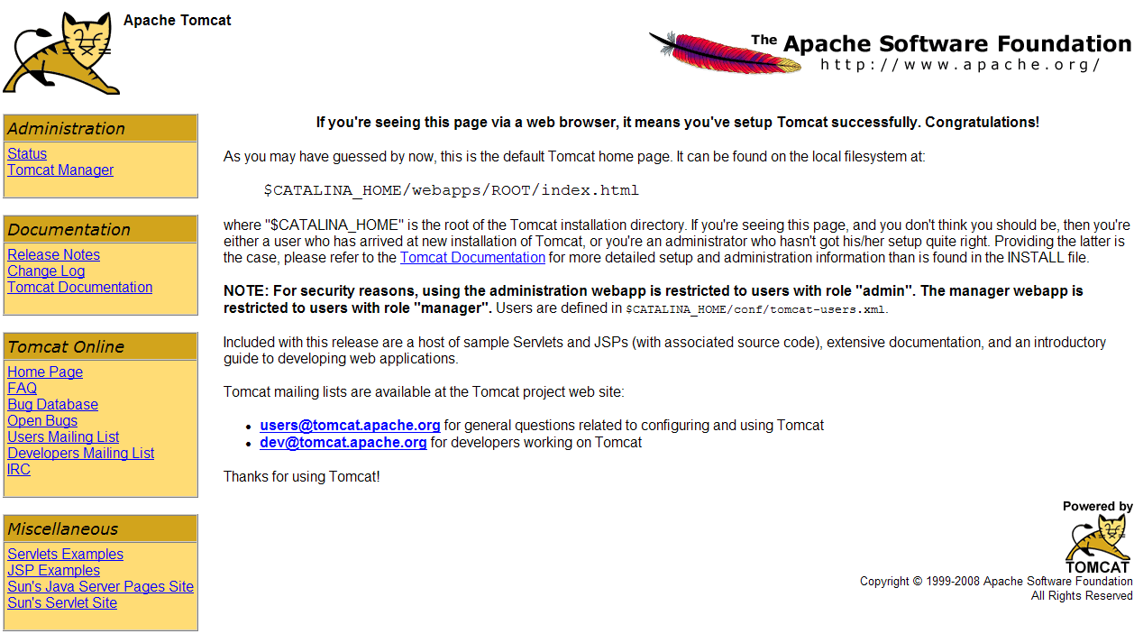

It is the web application in H:\tomcat\webapps\ROOT. The index.html file inside this directory is exactly the same web page you see.
- Click the Servlets Examples link near the bottom left corner. The Servlet Examples with Code web page is loaded. It is the example web application in H:\tomcat\webapps\example.

- Click the Execute link beside the Hello World servlet example.
A message ‘Hello World!’ is displayed in the web browser.

- Edit H:\tomcat\webapps\examples\WEB-INF\classes\ LocalStrings_en.properties in a text editor.
Locate the line that read:
helloworld.title=Hello World!
Change it to:
helloworld.title=Hello the World !!!
Save the file after making this change.

- By default, Apache Tomcat look for changes in the WEB-INF/classes and WEB-INF/lib directories every 15 seconds or so.
Wait a few moment, say one minute, for Apache Tomcat to pick up the changes. Reload the Hello World servlet example in web browser. The new message is displayed.

- Return to the first page. Click the JSP Examples link below the Servlets Examples link.

- Locate the Snoop JSP example. Click the Example link.
The following output will be displayed in web browser. Yours may be different.
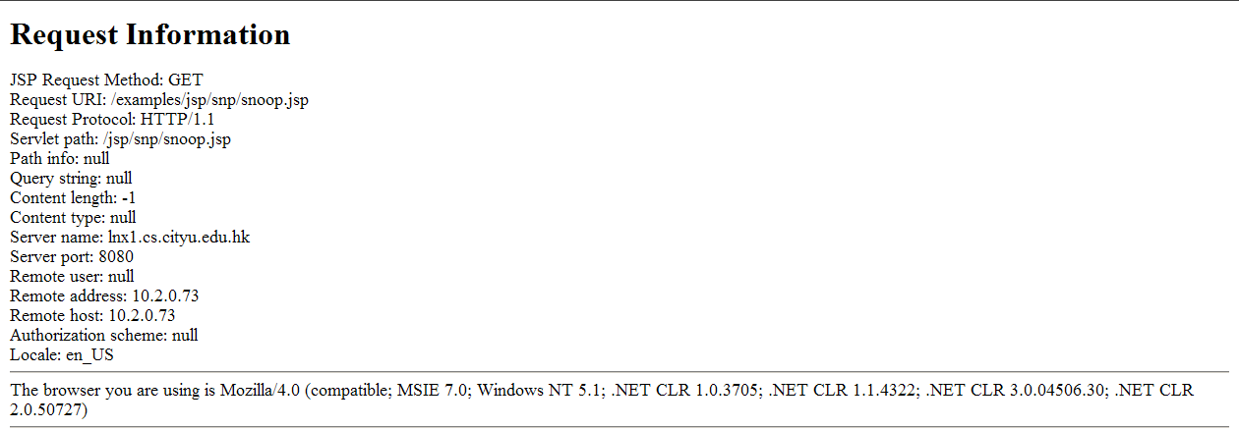
- Open a Window Explorer and go to the H:\tomcat\work\Catalina\localhost\examples\org\apache\jsp\jsp\snp directory. This directory contains the compiled bytecode of the JSP, i.e. snoop_jsp.class. If you delete snoop_jsp.class and snoop_jsp.java, Apache Tomcat will recreate these files the next time you run the Snoop JSP example.

- After using Apache Tomcat, it is a good practice to shut it down to save some space for other users on cs4280-01.cs.cityu.edu.hk. To stop Apache Tomcat, type the following commands in SSH client window:
~/tomcat/stoptc.sh

Sometimes, you may have hard time shutting down Apache Tomcat properly. You need to use the Linux kill command to kill the Apache Tomcat process.

kill -KILL <Your Apache Tomcat process id>

III. Building your First Java Servlet with NetBeans IDE

- Open NetBeans 8.0 from the CS Lab Applications Menu.

- Create a new project and choose ‘Web Application’ from ‘Java Web’ category.

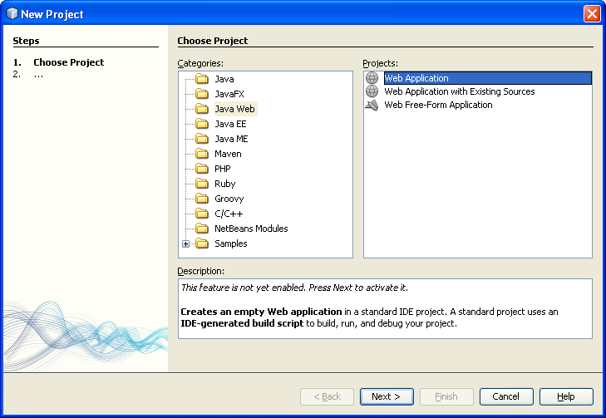

- Click ‘Next’ and enter the following for the project properties:
Project Name: | HelloWorldServlet
Project Location: | H:\NetBeansProjects
Project Folder: | H:\NetBeansProjects\HelloWorldServlet
Use Dedicated Folder for Storing Libraries | Leave Unchecked
Set as Main Project | ✓

- Click ‘Next’ button, and select:
Server: | Apache Tomcat 8.0.3.0
Java EE Version: | Java EE 5 (important!)
Context Path: | /HelloWorldServlet

- Click ‘Finish’.

- Delete index.jsp in ‘Web Pages’ folder.

- Right click ‘Source Packages’ and to create a new Java package with name ‘cs4280’.

- Then right click ‘Source Packages’ again to create a new Servlet:
Class Name: | HelloWWW
Location: | Source Packages
Package: | cs4280

- Click ‘Finish’ button. A HelloWWW.java is created under the package cs4280.

- Modify the code in processRequest() method to print a html. Right click the “HelloWWW.java” file and click “Debug File”. The printed html should like:

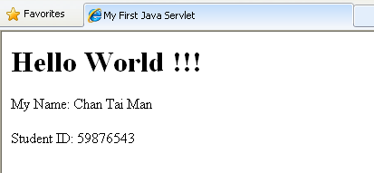

You should show your real name and student ID in the page.

- Right click the project and click ‘Clean and Build’. You should find the distributable at H:\NetBeansProjects\HelloWorldServlet\dist\HelloWorldServlet.war

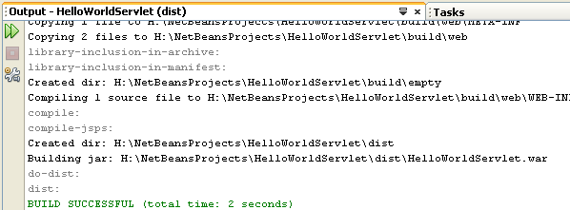
- Copy the HelloWorldServlet.war to H:\tomcat\webapps\.

- You should be able to view the content at http://cs4280-01.cs.cityu.edu.hk:<Your assigned HTTP port number>/HelloWorldServlet/HelloWWW

[Note]:
- Make sure you have started the Tomcat server on cs4280-01.cs.cityu.edu.hk

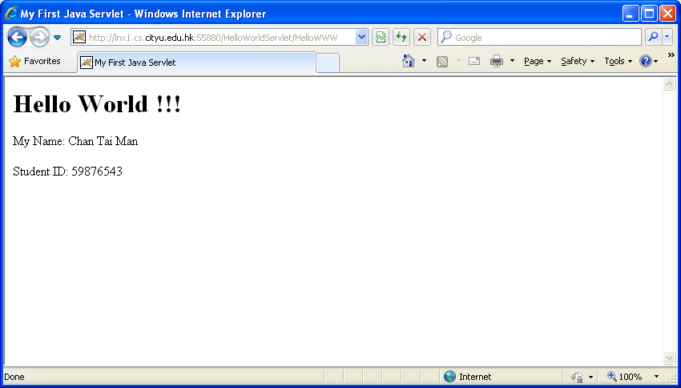

- Copy HelloWorldServlet.war to H:\www\cs4280\tut4\ HelloWorldServlet.war

- Copy HelloWWW.java to H:\www\cs4280\tut4\HelloWWW.java

- Create a simple HTML page H:\www\cs4280\tut4\HelloWWW.html that redirect the visitor to http://cs4280-01.cs.cityu.edu.hk:<Your assigned HTTP port number>/HelloWorldServlet/HelloWWW
<html>
<body>
<a href="http://cs4280-01.cs.cityu.edu.hk:<Your assigned HTTP port number>/HelloWorldServlet/HelloWWW"> CS4280 T04 Java Servlet </a> <br/>
Name: <Your Name><br/>
Student ID: <Your Student ID></br>
</body>
</html>

- Access the following link through IE web browser, the URL should be http://personal.cs.cityu.edu.hk/~<Your EID>/cs4280/tut4/HelloWWW.html
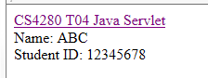
- Shutdown your Tomcat server before leave.
~/tomcat/stoptc.sh

References
- Martin Bond and Debbie Law. (2003). Tomcat Kick Start. Sams Publishing.
- Kief. (2006). Running multiple Tomcat instances on one server. Retrieved November 6, 2008 from http://www.azeditech.com/tomcat/multiple-tomcat-instances.html
- Emmett Dulaney and Naba Barkakati. (2008). Linux All-in-One Desk Reference For Dummies, 3rd Edition. Wiley.

James Goodwill. (2002). Demystifying Tomcat 4’s server.xml File. Retrieved November 7, 2008 from http://www.onjava.com/pub/a/onjava/2002/07/31/tomcat.html?page=1
The shutdown port always listens at 127.0.0.1 and there is no way changing it.

