On completion of this hands-on, you should be able to:
- Write a Java servlet on Linux;
- Configure the URL of a Java servlet;
- Differentiate between a GET request and a POST request;
- Debug a Java servlet with NetBeans IDE; and
- Use of HTTP request header, HTTP response header and HTTP status code.

Please place your work on the following URLs:

- http://personal.cs.cityu.edu.hk/~< studentID>/cs4280/tut5/svlt.war
- http://personal.cs.cityu.edu.hk/~< studentID>/cs4280/tut5/NewServlet.java
- http://personal.cs.cityu.edu.hk/~< studentID>/cs4280/tut5/svlt.html

This hands-on aims to give you an overview of writing and deploying a Java servlet on Apache Tomcat. In addition, this hands-on guides you how to debug a Java servlet using NetBeans IDE.

I. Creating your Java Servlet on Linux

Apart from creating Java servlet in IDE like NetBeans, you can also do it in Linux. A Java servlet is an instance of javax.servlet.http.HttpServlet that can be loaded dynamically into and run by Apache Tomcat. Java servlets interact with clients via a request-response model based on HTTP.




HTTP Request
Java servlets
HTTP Response

Web Browser
Static Content
Apache Tomcat

There are seven HTTP methods:
- GET: sends a limited amount of information in the request in form of a query string;
- PUT: place documents directly to a server;
- POST: similar to GET, but can send large amount of data in the body of the request;
- TRACE: for debugging;
- DELETE: delete a document on server;
- OPTIONS: ask the server what methods and other options it supports;
- HEAD: request only the headers of the response.
In practice, only GET and POST and used. The other HTTP methods are seldom used.

In short, the basic steps of creating your Java servlet on Linux:
- Create a directory structure for your application.
- Write the servlet source code. Your Java servlet need to extend the javax.servlet.http.HttpServlet class.
- Compile your source code.
- Create a deployment descriptor XML file and deploy on Apache Tomcat.
- Run Apache Tomcat.
- Call your Java servlet from a web browser.

Follow the following instructions to start programming and running your Java servlet.

Step 1. Create a directory for your application.

[Reminder]
- Make sure that you have already setup your Apache Tomcat properly in the previous hands-on tutorial.

- Use Xterm from CS Lab Applications Menu to login the cs4280-01.cs.cityu.edu.hk Linux host.

- Create a cs4280 directory in the ~/tomcat directory, type the command in the SSH Client window:
mkdir -p ~/tomcat/cs4280

~/tomcat/cs4280 will be used as your main working directory.

- In the SSH Client window, create directory structure in the ~/tomcat/cs4280 directory for this hands-on by following commands:
mkdir -p ~/tomcat/cs4280/src/svlt
mkdir -p ~/tomcat/cs4280/svlt/META-INF
mkdir -p ~/tomcat/cs4280/svlt/WEB-INF/classes
mkdir -p ~/tomcat/cs4280/svlt/WEB-INF/lib

[Note]
- The directory structure:

~/tomcat/cs4280
|__src |  |  | Java servlet source code
 | |__svlt |  | Java servlet package for this hands-on (*.java)
|__svlt |  |  | Web module root directory for this hands-on (*.html)
 | |__META-INF |  | Contains J2EE deployment descriptor application.xml and application’s context.xml files
 | |__WEB-INF
 |  | |__classes | Java class *.class files, including Java servlets, filters, and listeners
 |  | |__lib | Java library *.jar files
 |  | |__web.xml | Web module deployment descriptor file

By putting Java servlet source code in a separate directory, you will not mess up with other files in the web application’s WEB-INF/classes directory.

Step 2. Write the servlet source code.

- Use a text editor such as Notepad ++ to create an HTML file H:\tomcat\cs4280\svlt\index.html:

[Note]
- Alternatively, you can also use pico, nano or joe Linux editor to create file ~/tomcat/cs4280/svlt/index.html in Linux environment.

<?xml version="1.0" encoding="UTF-8"?>
<!DOCTYPE html PUBLIC "-//W3C//DTD XHTML 1.1//EN"
"http://www.w3.org/TR/xhtml11/DTD/xhtml11.dtd">
<html xmlns="http://www.w3.org/1999/xhtml">
<head>
<meta http-equiv="content-type" content="text/html; charset=UTF-8" />
<title>CS4280 T05 - Java Servlet</title>
</head>

<body>
<h1>CS4280 T05 - Java Servlet</h1>

<form action="index.do" method="GET">
<p>What is your name?
<select name="salutation" id="salutation">
<option value="F" selected="selected">Miss</option>
<option value="M">Mr</option>
</select>
<input type="text" name="bigname" id="bigname" /></p>

<p><input type="checkbox" name="rich" id="rich" /> Rich and famous!</p>

<p><input type="submit" value="Submit" /></p>
</form>
</body>
</html>

This HTML file will send the form input to the index.do Java servlet.
- Use a text editor to create a Java servlet source code file H:\tomcat\cs4280\src\svlt\NewServlet.java:

[Note]
- Alternatively, you can also use pico, nano or joe Linux editor to create file ~/tomcat/cs4280/src/svlt/NewServlet.java in Linux environment.

package svlt;

import java.io.IOException;
import java.io.PrintWriter;
import javax.servlet.ServletException;
import javax.servlet.http.HttpServlet;
import javax.servlet.http.HttpServletRequest;
import javax.servlet.http.HttpServletResponse;

public class NewServlet extends HttpServlet {
@Override
public void doGet(HttpServletRequest request, HttpServletResponse response) throws IOException, ServletException {
processRequest(request, response);
}

@Override
public void doPost(HttpServletRequest request, HttpServletResponse response) throws IOException, ServletException {
processRequest(request, response);
}

private void processRequest(HttpServletRequest request, HttpServletResponse response) throws IOException, ServletException {
response.setContentType("text/html;charset=UTF-8");

PrintWriter out = response.getWriter();

out.println("<html>");
out.println("<head>");
out.println("<title>CS4280 T05 - Java Servlet</title>");
out.println("</head>");
out.println("<body>");
out.println("<h1>CS4280 T05 - Java Servlet</h1>");
out.println("<p>My name is " + ((request.getParameter("salutation") != null && "F".equalsIgnoreCase(request.getParameter("salutation")) != false) ? "Miss" : "Mr") + " " + request.getParameter("bigname") + ".</p>");
out.println("<p>I am" + ((request.getParameter("rich") != null && "on".equalsIgnoreCase(request.getParameter("rich"))) ? " " : " <em>not</em> ") + "rich and famous!</p>");
out.println("</body>");
out.println("</html>");
}
}

This Java servlet NewServlet is created inside a package svlt.

Both the doGet() and doPost() will call processRequest() to handle the request. Sometimes, you may want to limit your Java servlet to accept POST request only. We will come back to the difference between GET and POST later.

Step 3. Compile your source code.

- In the Linux shell (i.e., the opened SSH Secure Shell Client window), compile the Java servlet source code to bytecode:
javac -classpath /public/cs4280/apache-tomcat-6.0.20/lib/servlet-api.jar -d ~/tomcat/cs4280/svlt/WEB-INF/classes $HOME/tomcat/cs4280/src/svlt/NewServlet.java

This will compile the Java servlet source code $HOME/tomcat/cs4280/src/svlt/NewServlet.java into bytecode and the compiled bytecode will be saved in your ~/tomcat/cs4280/svlt/WEB-INF/classes directory. The -d option specifies where to place the generated class files.

The /public/cs4280/apache-tomcat-6.0.20/lib/servlet-api.jar file contains the javax.servlet.http.HttpServlet Java class.

Step 4. Create a deployment descriptor and deploy on Apache Tomcat.

- Use a text editor to create a web module deployment descriptor file H:\tomcat\cs4280\svlt\WEB-INF\web.xml.

[Note]
- Alternatively, you can also use pico, nano or joe Linux editor to create file ~/tomcat/cs4280/svlt/WEB-INF/web.xml in Linux environment.

<?xml version="1.0" encoding="ISO-8859-1"?>

<web-app xmlns="http://java.sun.com/xml/ns/javaee"
xmlns:xsi="http://www.w3.org/2001/XMLSchema-instance"
xsi:schemaLocation="http://java.sun.com/xml/ns/javaee http://java.sun.com/xml/ns/javaee/web-app_2_5.xsd"
version="2.5">

<description>
My First Java Web Application
</description>
<display-name>1st Java Web App</display-name>

<servlet>
<servlet-name>OurNewServlet</servlet-name>
<servlet-class>svlt.NewServlet</servlet-class>
</servlet>

<servlet-mapping>
<servlet-name>OurNewServlet</servlet-name>
<url-pattern>/index.do</url-pattern>
</servlet-mapping>

<welcome-file-list>
<welcome-file>index.html</welcome-file>
</welcome-file-list>

</web-app>

[Notes to web.xml]

- <web-app>: The root element of a web module deployment descriptor file.

- <description>: Text describing this web application.

- <display-name>: A short name of this web application.

- <servlet>: Used to declare a Java servlet.
- <servlet-name>: The canonical name of the Java servlet. It is used as a handle to reference the Java servlet definition elsewhere (viz., in the <servlet-mapping> element) in the deployment descriptor.
- <servlet-class>: The fully-qualified class name of the Java servlet.

- <servlet-mapping>: Defines a mapping between a Java servlet and a URL pattern.
- <url-pattern>: The URL to access the Java servlet, in this case, /index.do.

- <welcome-file-list>: An ordered list of welcome files, i.e., which file to load when a URL ends with /. This will override the <welcome-file-list> element in ~/tomcat/conf/web.xml.
- <welcome-file>: File name to use as a default welcome file.

The relationship between the <url-pattern>, <servlet-name>, and <servlet-class> elements is:

<url-pattern>
<servlet-name>
<servlet-mapping>

<servlet-class>
<servlet-name>
<servlet>

- Create a web application archive (WAR) file. In Linux shell, enter the following two commands:
cd ~/tomcat/cs4280/svlt
jar -cvf ~/tomcat/webapps/svlt.war *

The jar tool combines all files in ~/tomcat/cs4280/svlt to create a web application archive in ~/tomcat/webapps/svlt.war.

Use the following Linux command to confirm you have successfully created the WAR file in ~/tomcat/webapps:
ls -ladhF ~/tomcat/webapps/*.war
You can examine the table of content of the ~/tomcat/webapps/svlt.war file by:

jar -tvf ~/tomcat/webapps/svlt.war

The output is like this:

0 Thu Feb 17 08:43:08 HKT 2011 META-INF/
71 Thu Feb 17 08:43:08 HKT 2011 META-INF/MANIFEST.MF
806 Thu Feb 17 08:40:50 HKT 2011 index.html
0 Thu Feb 17 08:39:24 HKT 2011 WEB-INF/
776 Thu Feb 17 08:42:52 HKT 2011 WEB-INF/web.xml
0 Thu Feb 17 08:38:26 HKT 2011 WEB-INF/classes/
0 Thu Feb 17 08:38:26 HKT 2011 WEB-INF/classes/svlt/
1714 Thu Feb 17 08:41:52 HKT 2011 WEB-INF/classes/svlt/NewServlet.class
0 Thu Feb 17 08:38:20 HKT 2011 WEB-INF/lib/

[Note]

The file size, date and time columns, and order of your output may be different, but make sure that your WAR file contains the following three entries:

- index.html
- WEB-INF/web.xml
- WEB-INF/classes/svlt/NewServlet.class

Step 5. Run Apache Tomcat.

- Start Apache Tomcat.
~/tomcat/starttc.sh

Step 6. Call your Java servlet from a web browser.

- Open http://cs4280-01.cs.cityu.edu.hk:<Your Apache Tomcat port>/svlt in your web browser. The content of index.html is displayed.
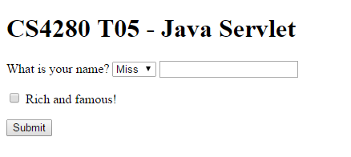

- Enter a name, e.g., Mr Joe Doe, and select the ‘Rich and famous’ checkbox. Then click the [Submit] button. The Java servlet svlt.NewServlet is executed and the output is displayed in your web browser.
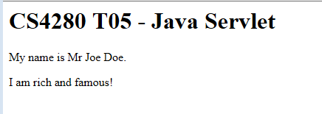

- Stop Apache Tomcat.

~/tomcat/stoptc.sh

- Delete the compiled bytecode:

H:\tomcat\cs4280\svlt\WEB-INF\classes\svlt\NewServlet.class

II. Debugging Apache Tomcat with NetBeans IDE

Being able to debug a server-side Java program in a debugger can make life much easier. With NetBeans IDE and its remote debugging feature, you can debug a server-side Java program running in Apache Tomcat. The following demonstrate the steps you need to start debugging a server-side Java program with NetBeans IDE on your local Windows machine (aka development/testing platform, while cs4280-01.cs.cityu.edu.hk will be your production platform).

CS Lab has put a copy of Apache Tomcat binary in G:\CS4280\apache-tomcat-6.0.20\lib. It is required for debugging a Java web application in NetBeans IDE 8.0.

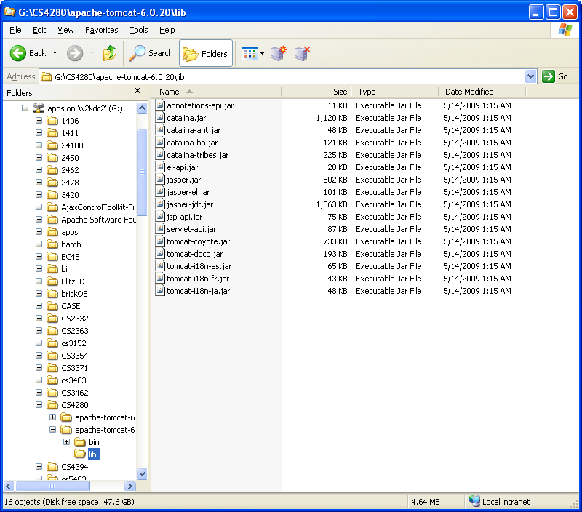

Step 1. Prepare the local Apache Tomcat server.

- Create a H:\NetBeansProjects\svlt directory in Windows Explorer.

- Open NetBeans from the CS Lab Applications Menu.

- Add Apache Tomcat to NetBeans IDE’s Servers definition.
- Go to the Services window by selecting Services in Window menu.

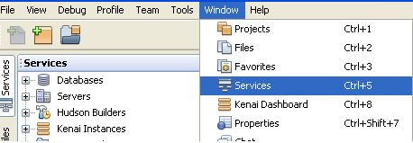

- Right click Servers tree to add a server. A Servers window appears. (A loading screen may appear to activate Java Web and EE component).

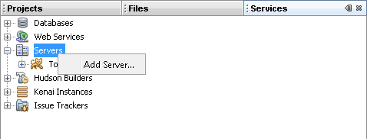
- Click the [Add Server…] button. An Add Server Instance window appears.
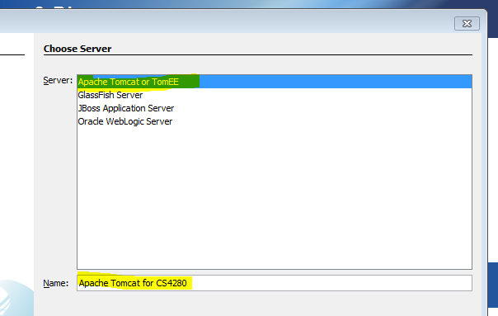

Select the following and then click the [Next] button.

Server: | Apache Tomcat or TomEE
Name: | Apache Tomcat for CS4280

- In the Installation and Login Details step, enter:

Server location: | G:\CS4280\apache-tomcat-6.0.20
Use Private Configuration Folder  (Catalina Base): | ✓
Catalina Base: | H:\tomcat
Username: | tomcat
Password: | manager
Create user if it does not exist | ✓

- Click the [Finish] button to add an Apache Tomcat to NetBeans IDE. A new entry appears in the Servers window. NetBeans IDE automatically reads the configurations in H:\tomcat\conf\server.xml file.

Step 2. Create a new NetBeans project.

- From NetBeans IDE menu, select File ➔ New Project …. A New Project window appears.

- Choose Web Application with Existing Sources from Java Web category, and click [Next >].

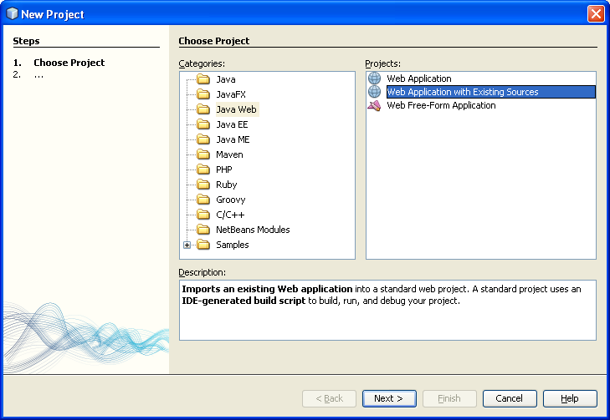

- In the Name and Location step, enter:

Location: | H:\NetBeansProjects\svlt
Project Name: | svlt
Project Folder: | H:\NetBeansProjects\svlt
Use Dedicated Folder for Storing Libraries | Leave Unchecked

- Click the [Next >] button to go to step 3, and select:

Server: | Apache Tomcat for CS4280
Java EE Version: | Java EE 5
Context Path: | /svlt

- Click the [Next >] button to go to step 4. Enter:

Web Pages Folder: | H:\tomcat\cs4280\svlt
WEB-INF Content: | H:\tomcat\cs4280\svlt\WEB-INF
Libraries Folder: | Leave empty
Source Package Folders | H:\tomcat\cs4280\src
Test Package Folders | Leave empty

- Click the [Finish] button to complete the New Web Project with Existing Sources wizard. A svlt project is added to the NetBeans IDE Projects tab on the top left corner.

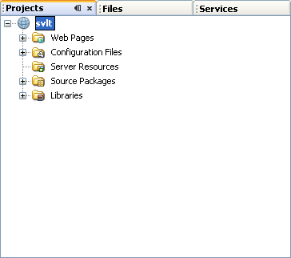

III. HTTP Request Header

- Modify the NewServlet.java in NetBeans 8.0 to show which HTTP method and user agent are using. You can obtain the information from the header of the HTTP request.
private void processRequest(HttpServletRequest request, HttpServletResponse response) throws IOException, ServletException {
.......
out.println("<body>");
out.println("<h1>CS4280 T05 - Java Servlet</h1>");
out.println("<h3>I used ... method with ... </h3>");
.......
}

[Hints]
- JavaEE 5 API: HttpServletRequest
- Lecture note: Servlet Slide #46
- Refer to request.getMethod() and request.getHeader(“User-Agent”).

- Run the project.

- ‘Clean and Build’ this project from ‘Run’ in the menu bar.

- If the build is successful, run the project by ‘Run-> Run Project’.

- NetBeans IDE automatically loads http://localhost:<Your Apache Tomcat Port>/svlt/ in your web browser.

d. Type ‘Jane Doe’ in the name field and submit. The sample output should look like:

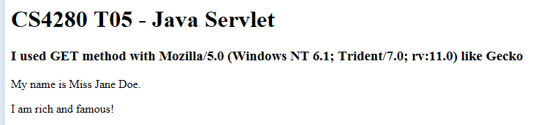
The user-agent may be different depends on the computer you are using.

IV. HTTP Request Method – GET / POST

The HTTP GET method appends the HTML form name/value pairs to the URL. If the HTML form contains a password or sensitive information, they are visible in the address bar of the web browser.

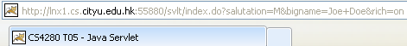

A web browser also has a limit on the length of the URL – 2,048 characters in Microsoft Internet Explorer. The URL can be truncated if the HTML form has too many parameters.

The HTTP POST method is more secure. The HTML form name/value pairs are placed inside the body of the HTTP request which has no size limitations. We will modify H:\tomcat\cs4280\svlt\index.html to use HTTP POST method and see the results.

- Open index.html in NetBeans IDE:

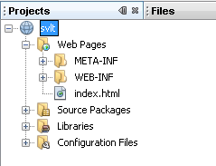

- Change:
<form action="index.do" method="GET">
to
<form action="index.do" method="POST">

- Save the change.

- Run the project.

- ‘Clean and Build’ this project from ‘Run’ in the menu bar.

If the build is successful, run the project by ‘Run-> Run Main Project’.

- NetBeans IDE automatically loads http://localhost:<Your Apache Tomcat Port>/svlt/ in your web browser.

- Enter ‘Mr Joe Doe’ and select the ‘Rich and famous’ checkbox. Then click the [Submit] button. The web browser should display:

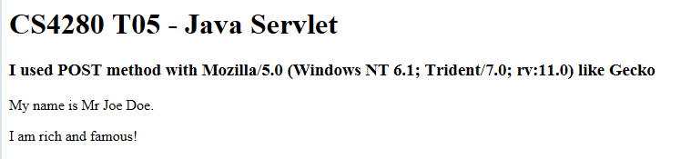

The address bar of the web browser should be cleaner – without all the HTML form name/value pairs.

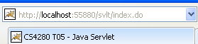

V. HTTP Status Code

- Modify the NewServlet.java in NetBeans 8.0 to check if the user input the name. If the name is missing, the servlet should return a 404 (Not Found) error page with message “Name is missing”.

[Hints]
- JavaEE 5 API: HttpServletResponse
- Lecture note: Servlet Slide #61 - 63

- Run the project.

- ‘Clean and Build’ this project from ‘Run’ in the menu bar.

- If the build is successful, run the project by ‘Run-> Run Main Project’.

- NetBeans IDE automatically loads http://localhost:<Your Apache Tomcat Port>/svlt/ in your web browser.

d. Do not type anything in the name field and click [Submit]. You will find the error page likes:

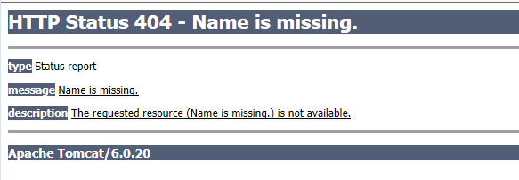

VI. Deploy to the Apache Tomcat on cs4280-01.cs.cityu.edu.hk

- Right click the project and click ‘Clean and Build’. You should find the distributable at H:\NetBeansProjects\svlt\dist\svlt.war

- Copy the H:\NetBeansProjects\svlt\dist\svlt.war to H:\tomcat\webapps\.

- You should be able to view the content at http://cs4280-01.cs.cityu.edu.hk:<Your assigned port number>/svlt

[Note]:
- Make sure you have started the Tomcat server on cs4280-01.cs.cityu.edu.hk

VII. Submission

- Copy svlt.war to H:\www\cs4280\tut5\svlt.war

- Copy NewServlet.java to H:\www\cs4280\tut5\NewServlet.java

- Create a simple HTML page H:\www\cs4280\tut5\svlt.html

<html>
<body>
<a href="http://cs4280-01.cs.cityu.edu.hk:<Your assigned port number>/svlt">CS4280 T05 Java Servlet</a><br/>
Name: <Your Name><br/>
Student ID: <Your Student ID></br>
</body>
</html>

- Stop Apache Tomcat if you finish demonstrating your work to tutor.
~/tomcat/stoptc.sh

IX. References
- Budi Kurniawan. (2002). Java Servlet Technology Primer. Retrieved November 17, 2008 from http://www.informit.com/articles/article.aspx?p=26920&seqNum=1
- Ian McFarland and Peter Harrison. (2002). Mastering Tomcat Development. Wiley.
- Adam Myatt. (2007). Pro NetBeans IDE 5.5 Enterprise Edition. Apress.

Maximum URL length is 2,083 characters in Internet Explorer. Retrieved November 19, 2008 from http://support.microsoft.com/kb/208427

