On completion of this hands-on, you should be able to:
- Use different mechanisms to share information across Java servlets – URL-Rewriting, hidden form fields and cookies.

Please place your work on the following URLs:

- http://personal.cs.cityu.edu.hk/~<student ID>/cs4280/tutor5/Registration.war
- http://personal.cs.cityu.edu.hk/~<student ID>/cs4280/tutor5/RegURLServlet.java
- http://personal.cs.cityu.edu.hk/~<student ID>/cs4280/tutor5/RegCookieServlet.java
- http://personal.cs.cityu.edu.hk/~<student ID>/cs4280/tutor5/registration.html

I. Registration Site – Scenario

City Company is currently developing a membership system. The manager from the company invites you to develop a registration site in order to collect some information from the customers. Session should be used to maintain state information across different pages of the site. The UI layouts of the site are as follows:

Page 1. Input Page 1

Name, Email and Password are compulsory fields. The system cannot proceed to page 2 if either one is missing.
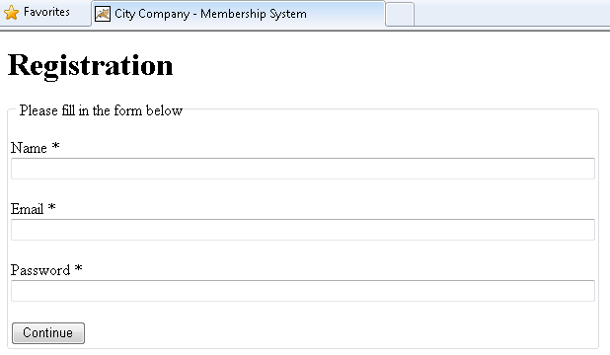
Error messages should be prompted if the content is missing.
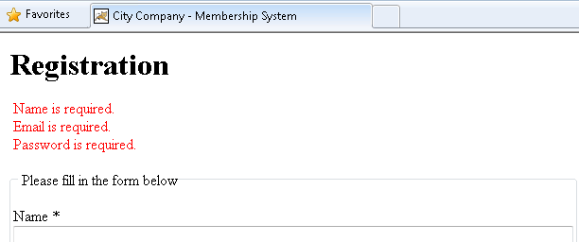

Page 2. Input Page 2

Education Level, Year of Birth and Self Description are optional. Education Level can be one of the following: Secondary School, College, Undergraduate, Postgraduate, and Other.

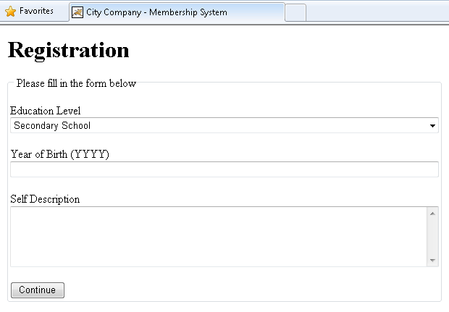

Page 3. Summary Page

This page shows all inputs from Page 1 and 2. E.g.
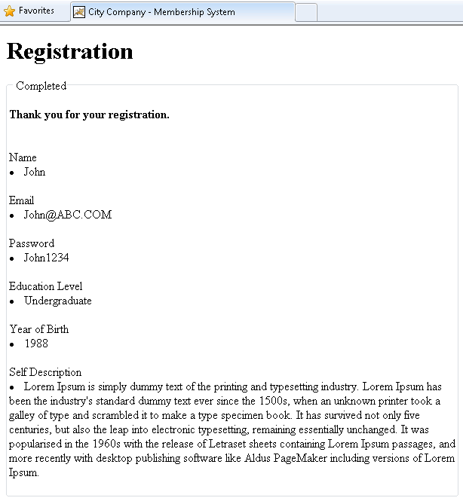

II. Session Tracking – URL-Rewriting & Hidden Form Fields

The manager requests you to build the site using URL-rewriting and hidden form fields. He believes it is simple as only knowledge of reading and writing parameters are required.

Step 1. Create new project.

- Open ‘NetBeans 8.0’ from CS Lab Applications Menu.

- Create a new Java Web Application project with following properties:
Project Name | Registration
Project Location | H:\NetBeansProjects
Project Folder | H:\NetBeansProjects\Registration
Use Dedicated Folder for Storing Libraries | Leave Unchecked
Set as Main Project | ✓
Server | Apache Tomcat 8.0.3.0
Java EE Version | Java EE 5
Context Path | /Registration

- Create a new Servlet:
Class Name | RegURLServlet
Location | Source Packages
Package | cs4280
Servlet Name | RegURLServlet
URL Pattern(s) | /Reg1

- Open Web Pages/WEB-INF/web.xml from the project explorer. Change the Welcome Files to Reg1 in Pages tab.

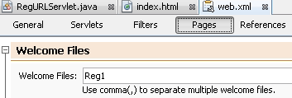

Step 2. Build and test the servlet.

- The code for building the UI RegURLServlet.java is prepared for you. You can download from Canvas.
- Complete the source code:

- Add error checking for Page 1’s fields (i.e. Name, Email and Password) in the Servlet.

- Add hidden form fields to store the Page 1’s inputs in Page 2’s form. So that Page 2 can pass all inputs (Page 1 + 2) together to Page 3.

[Hint]:
- Lecture Note Session Slide #14

- Complete the summary page for showing all inputs. You can obtain all user inputs from the request object.

- Right click the project and click [Debug]. You should see the following:

- Try to type something to fill the form in Page 1 and click [Continue]. In Page 2, right click the page and click [View Source]. You will find the password you have typed is shown:

III. Session Tracking – Cookie

The manager thinks that the data appearing in the HTML source is not secure. So he asks you to rebuild the site again using Cookie.

- Create a new Servlet:
Class Name | RegCookieServlet
Location | Source Packages
Package | cs4280
Servlet Name | RegCookieServlet
URL Pattern(s) | /Reg2

- Set Reg2 to be Welcome File in web.xml.

- Edit RegCookieServlet, a template is prepared for you at Canvas.

[Hint]:
- Because cookies are sent using HTTP headers, they should be added to the response before you send any content.

- Modify the codes to save user inputs using cookies. Retrieve the value from cookies in Page 3 to display in summary.

[Hint]:
- Java EE 5 Cookie API
- Lecture Slide Session Slide #10

- Right click the project and click [Debug].

IV. Deployment

- Right click the project and click [Clean and Build].

- If the build is successful, copy H:\NetBeansProjects\Registration\dist\Registration.war to H:\tomcat\webapps\.

- You should be able to view the site via
http://cs4280-01.cs.cityu.edu.hk:<Your assigned port number>/Registration/Reg1
http://cs4280-01.cs.cityu.edu.hk:<Your assigned port number>/Registration/Reg2

[Note]:
- Make sure you have started the Apache Tomcat.

V. Submission

- Copy the Registration.war to H:\www\cs4280\tutor5\Registration.war

- Copy the RegURLServlet.java to H:\www\cs4280\tutor5\RegURLServlet.java

- Copy the RegCookieServlet.java to H:\www\cs4280\tutor5\RegCookieServlet.java

- Use a text editor to create a simple HTML and save it as H:\www\cs4280\tutor5\registration.html

<html>
<body>
<a href="http://cs4280-01.cs.cityu.edu.hk:<Your assigned port number>/Registration/Reg1">CS4280 T05 Session – URL Rewriting and Hidden Form Field</a><br/>
<a href="http://cs4280-01.cs.cityu.edu.hk:<Your assigned port number>/Registration/Reg2">CS4280 T05 Session – Cookies</a><br/>
Name: <Your Name><br/>
Student ID: <Your Student ID><br/>
</body>
</html>

- Stop Apache Tomcat if you finish demonstrating your work to tutor.
~/tomcat/stoptc.sh

