A

SEMINAR REPORT
ON

Artificial General Intelligence
(AGI)

Submitted By
Tushar Ramdas Mhaske

S.Y. M.C.A

Guided By
P.P.Patil

Academic Year: 2024-2025

Department of MCA
K. K. Wagh Institute of Engineering Education & Research
Hirabai Haridas Vidyanagari, Amrutdham, Panchavati,
Nashik – 422 003
Autonomous Institute Since 2022
Affiliated to Savitribai Phule Pune University

K. K. WAGH INSTITUTE OF ENGINEERING EDUCATION AND RESEARCH, NASHIK

CERTIFICATE

This is to certify that
Tushar Ramdas Mhaske has successfully delivered a seminar on
Artificial General Intelligence

Towards the Partial Fulfilment of Master’s Degree In Computer Application
of Savitribai Phule Pune University

During Academic Year 2024 – 2025 Autonomous Institute since 2022

P.P.Patil  Seminar Guide | Dr. V. C. Bagal  I/c Head, Dept. of MCA | Dr. K. N. Nandurkar  Director KKWIEER, Nashik

t I. Table of Content

Sr. No | Topic | Page No.
 | Abstract | 6
1 | Introduction | 7
2 | Chater 2: Literature Survey  2.1 Introduction  2.2 Historical Background  2.3 Definitions and Core Concepts  2.4 Research Approaches in AGI  2.5 Evaluation Metrics and Benchmarks  2.6 Challenges in AGI Development  2.7 Key Research Institutions and Projects  2.8 Future Directions | 8
3 | Chapter 3 Details of Analytical and/or experimental work  Introduction  Characterizing AGI and General Intelligence  Approaches to Artificial General Intelligence  Structures Underlying Human-Like General Intelligence  Approaches to Artificial General Intelligence | 10
4 | Chapter 4: Discussions and Conclusions  4.1 Understanding the Scope of AGI  4.2 Current State and Methodological Approaches  4.3 Key Challenges and Ethical Implications  4.4 Conclusions and Future Prospects  4.5 Real-World Applications of AGI | 45
5 | Conclusion | 48
6 | Acknowledgement | 49
7 | REFERENCES | 50

II. List of Figures

Fig no. | Caption | Page No.
1 | High-Level Structure of a Human-Like Mind | 38
2 | Architecture of Working Memory and Reactive Processing, closely modeled on the LIDA architecture | 39
3 | Architecture of Motivated Action | 40
4 | Architecture of Long-Term Memory and Deliberative and Metacognitive Thinking | 41
5 | Architecture for Multimodal Perception | 42
6 | Architecture for Action and Reinforcement | 43
7 | Architecture for Language Processing | 44

Abstract

Artificial General Intelligence (AGI), the hypothetical ability of an AI to understand, learn, and apply knowledge across a wide range of cognitive tasks at a human level or beyond, represents a pivotal frontier in artificial intelligence research. This abstract explores the multifaceted landscape of AGI, encompassing its theoretical foundations, current progress, and the significant challenges that remain. We delve into the diverse approaches being investigated, from scaling deep learning models and developing novel neuro-symbolic architectures to drawing inspiration from human cognition and the principles of general intelligence. Furthermore, we address the profound ethical, societal, and philosophical implications that the potential realization of AGI presents, including considerations of safety, control, and the future of work. This overview aims to provide a concise yet comprehensive understanding of the ambitions, complexities, and transformative potential inherent in the quest for truly general artificial intelligence.

Chapter 1: Introduction

Artificial General Intelligence (AGI), often referred to as strong AI or full AI, represents the hypothetical ability of an intelligent agent to understand or learn any intellectual task that a human being can. This concept goes far beyond narrow AI systems that are designed for specific tasks (such as language translation or image recognition). AGI implies a machine with the flexibility and capability to perform a broad range of cognitive tasks with human-like versatility.
As research in artificial intelligence (AI) has progressed, the focus has increasingly shifted towards creating systems that can perform generalized reasoning and decision-making, learning from diverse environments and adapting to novel situations without task-specific programming. While AGI remains a long-term goal of the AI community, significant interest and debate persist regarding its feasibility, implications, and the technological pathways toward achieving it.
The pursuit of AGI raises profound scientific, ethical, and societal questions. What architecture or learning paradigms are most likely to yield AGI? What risks might accompany machines that can outperform humans in every cognitive task? And what safeguards or control mechanisms are necessary to ensure that AGI remains beneficial to humanity?
This report presents a comprehensive overview of the concept of AGI, its theoretical foundations, current state of the art, and potential future directions. It aims to synthesize existing literature, identify research challenges, and explore the transformative impact that AGI could have on society.

1.1 Background and Motivation
The idea of creating intelligent machines dates back centuries, but it was formally introduced during the mid-20th century with the advent of digital computing. Early AI pioneers, including Alan Turing, John McCarthy, and Marvin Minsky, envisioned machines that could mimic human reasoning and problem-solving. However, over the decades, AI research diverged into various subfields such as machine learning, natural language processing, robotics, and computer vision—each tackling specific problems with specialized algorithms.
Despite the remarkable progress in these subfields, the development of truly general-purpose AI has remained elusive. Current AI systems excel in narrow domains but fail to transfer their knowledge to unfamiliar contexts. The motivation for AGI stems from the limitations of narrow AI and the desire to build systems with broader cognitive capabilities, adaptability, and common sense reasoning.
The rise of deep learning and neural network architectures in the past decade has reignited interest in AGI, with some researchers proposing that scaling up existing models and training them on massive datasets could lead to emergent general intelligence. Others argue that fundamentally new approaches are required to replicate therichness and flexibility of human cognition

Chapter 2: Literature Survey

2.1 Introduction
Artificial General Intelligence (AGI), also known as strong AI, refers to the capability of an intelligent system to understand, learn, and apply knowledge across a wide range of tasks, in a manner similar to human intelligence. Unlike narrow AI systems, which are designed for specific tasks such as image recognition or language translation, AGI aims for general-purpose cognitive abilities. The concept of AGI has been a central theme in artificial intelligence research for decades and has gained renewed interest with the advancement of computational power and learning algorithms. This chapter provides a comprehensive review of the existing literature, encompassing historical foundations, current methodologies, evaluation benchmarks, and prevailing challenges in AGI research.

2.2 Historical Background
The conceptual roots of AGI can be traced back to the mid-20th century, particularly with Alan Turing’s seminal 1950 paper, “Computing Machinery and Intelligence”, where he introduced the Turing Test as a behavioral measure of machine intelligence. Early pioneers such as John McCarthy, Marvin Minsky, and Herbert Simon envisaged machines that could perform general reasoning tasks. However, due to limitations in hardware and algorithmic design, the field initially pivoted toward narrow, task-specific AI systems.
Throughout the 1980s and 1990s, symbolic AI dominated the research landscape, relying on logic-based rule systems and explicit knowledge representation. While effective in well-defined domains, these systems lacked robustness and adaptability in real-world environments. As a result, attention shifted toward neural networks and data-driven learning paradigms, which have since become foundational to many modern approaches to AGI.

2.3 Definitions and Core Concepts
The literature defines AGI based on its generality, adaptability, and autonomy. A system exhibiting AGI is expected to:
- Perform a variety of cognitive tasks across different domains without task-specific programming.
- Transfer knowledge from one task or environment to another (transfer learning).
- Exhibit high-level reasoning, decision-making, and learning abilities.
- Function effectively in dynamic and unstructured environments.
Ben Goertzel describes AGI as a system with sufficient cognitive generality and flexibility to apply knowledge across diverse situations. AGI is often contrasted with narrow AI by its emphasis on flexibility, learning efficiency, and contextual understanding.

2.4 Research Approaches in AGI
Numerous research paradigms have been explored in the literature to advance the development of AGI. Prominent approaches include:

2.4.1 Cognitive Architectures
Frameworks such as Soar, ACT-R, OpenCog, and Sigma aim to replicate the structural and functional properties of human cognition. These architectures integrate memory, attention, learning, reasoning, and perception into unified systems. They provide modularity and flexibility, allowing researchers to experiment with different components of cognition in isolation and integration.

2.4.2 Neuroscience-Inspired Models
Neuroscience has significantly influenced AGI research. Projects like DeepMind's AlphaGo, MuZero, and related reinforcement learning models are inspired by brain mechanisms like reward learning and hierarchical processing. These models attempt to emulate human-like learning through trial-and-error interactions with complex environments.

2.4.3 Hybrid (Neural-Symbolic) Systems
Hybrid systems combine symbolic reasoning with neural learning. The Neural-Symbolic Integration framework seeks to achieve general intelligence by leveraging the high-dimensional representation learning capabilities of neural networks along with the interpretability and logic of symbolic systems.

2.4.4 Memory-Augmented Neural Networks
AGI systems require mechanisms for long-term knowledge retention and flexible reasoning. Models such as the Neural Turing Machine and Differentiable Neural Computer incorporate external memory components that enhance the learning capacity and enable sequential task execution.

2.4.5 Meta-Learning and Few-Shot Learning
To achieve AGI, systems must generalize from minimal data—akin to how humans learn quickly from few examples. Algorithms like Model-Agnostic Meta-Learning (MAML) and few-shot learning techniques using transformer architectures are explored extensively for this purpose.

2.5 Evaluation Metrics and Benchmarks
Evaluating AGI is significantly more challenging than evaluating narrow AI. The literature proposes several evaluation frameworks:
- Turing Test: Measures indistinguishability from human behavior.
- ARC (Abstraction and Reasoning Corpus): Tests for cognitive flexibility and abstract reasoning.
- General AI Challenge: Promotes systems that accumulate and transfer knowledge over time.
- Multi-Agent Environments: Platforms like OpenAI Gym and Unity ML-Agents provide dynamic testbeds for learning in complex environments.
These benchmarks aim to test not just accuracy, but generalization, adaptability, and reasoning abilities across domains.

2.6 Challenges in AGI Development
Despite advances, several key challenges remain prominent in AGI research:
- Scalability: AGI systems must operate efficiently across complex domains without unsustainable computational growth.
- Interpretability: Understanding how AGI systems reach decisions is vital for trust and safety.
- Continual Learning: AGI systems must avoid catastrophic forgetting and support lifelong learning.
- Common Sense Reasoning: Current systems lack intuitive world knowledge that humans take for granted.
- Value Alignment and Ethics: Ensuring that AGI systems align with human values and behave safely in unforeseen circumstances is a critical concern.
Research on cooperative inverse reinforcement learning, corrigibility, and safe exploration is ongoing to address these issues.

2.7 Key Research Institutions and Projects
Several academic and corporate entities are leading AGI-focused research initiatives:
- OpenAI: Initially focused on AGI, now known for large-scale models like GPT-4 and its alignment efforts.
- DeepMind: Pioneers reinforcement learning-based AGI architectures with systems like AlphaGo and MuZero.
- GoodAI: Focuses on cognitive architectures and long-term AGI safety.
- IBM, Microsoft Research, and Meta AI: Invest in foundational research that supports the development of scalable AGI systems.
Collaborative efforts, open-source platforms, and AI alignment research are contributing to the global discourse on AGI development.

2.8 Future Directions
Future AGI research is expected to evolve along multiple axes:
- Hierarchical Reinforcement Learning: Enables modularity and abstraction in decision-making.
- World Modeling and Simulation: Supports internal prediction and planning (e.g., using world models).
- Neuro-symbolic Systems: Continue integrating perception-driven learning with logical reasoning.
- Bio-inspired AI: Advances such as spiking neural networks and neuromorphic computing promise more biologically plausible systems.
Long-term prospects may include autonomous cognitive agents capable of open-ended learning, ethical reasoning, and socially beneficial behavior.

Chapter 3 Details of Analytical and/or experimental work

1.1 Introduction

How can we best conceptualize and approach the original problem regarding which the AI field was founded: the creation of thinking machines with general intelligence comparable to, or greater than, that of human beings? The standard approach of the AI discipline (Russell and Norvig, 2010), as it has evolved in the 6 decades since the field’s founding, views artificial intelligence largely in terms of the pursuit of discrete capabilities or specific practical tasks. But while this approach has yielded many interesting technologies and theoretical results, it has proved relatively unsuccessful in terms of the original central goals of the field.

What is General Intelligence?
But what is this “general intelligence” of what we speak? A little later, I will review some of the key lines of thinking regarding the precise definition of the GI concept. Qualitatively speaking, though, there is broad agreement in the AGI community on some key features of general intelligence:
- General intelligence involves the ability to achieve a variety of goals, and carry out a variety of tasks, in a variety of different contexts and environments.
- A generally intelligent system should be able to handle problems and situations quite different from those anticipated by its creators.
- Kurzweil originally contrasted narrow AI with “strong AI”, but the latter term already has a different established meaning in the AI and cognitive science literature (Searle, 1980), making this an awkward usage.
- The brief history of the term “Artificial General Intelligence” is as follows. In 2002, Cassio Penna chin and I were editing a book on approaches to powerful AI, with broad capabilities at the human level and beyond, and we were struggling for a title. I emailed a number of colleagues asking for suggestions. My former colleague Shane Legg came up with “Artificial General Intelligence,” which Cassio and I liked, and adopted for the title of our edited book (Goertzel and Pennachin, 2007). The term began to spread further when it was used in the context of the AGI conference series. A few years later, someone brought to my attention that a researcher named Mark Gubrud had used the term in a 1997 article on the future of technology and associated risks (Gubrud, 1997). If you know of earlier published uses, please let me know.
- http://agi-conf.org
- http://bicasociety.org
- http://www.cogsys.org/
- http://www.aaai.org/Press/Reports/Symposia/Fall/fs-04-01.php,

  - A generally intelligent system should be good at generalizing the knowledge it’s gained, so as to transfer this knowledge from one problem or context to others.
  - Arbitrarily general intelligence is not possible given realistic resource constraints.
  - Real-world systems may display varying degrees of limited generality, but are inevitably going to be a lot more efficient at learning some sorts of things than others; and for any given real-world system, there will be some learning tasks on which it is unacceptably slow. So real-world general intelligences are inevitably somewhat biased toward certain sorts of goals and environments.
  - Humans display a higher level of general intelligence than existing AI programs do, and apparently also a higher level than other animals. ⁸.
  - It seems quite unlikely that humans happen to manifest a maximal level of general intelli- gence, even relative to the goals and environment for which they have been evolutionarily adapted.
There is also a common intuition in the AGI community that various real-world general intelligences will tend to share certain common properties; though there is less agreement on what these properties are!

The Core AGI Hypothesis
Another point broadly shared in the AGI community is confidence in what I would venture to call the “core AGI hypothesis,” i.e. that
Core AGI hypothesis: the creation and study of synthetic intelligences with sufficiently broad (e.g. human-level) scope and strong generalization capability, is at bottom qualitatively different from the creation and study of synthetic intelligences with significantly narrower scope and weaker generalization capability.
This “core AGI hypothesis” is explicitly articulated in English for the first time here in this review paper (it was presented previously in Japanese in Goertzel (2014)). I highlight it because it is something with which nearly all researchers in the AGI community agree, regardless of their different conceptualizations of the AGI concept and their different architectural, theoretical, technical and engineering approaches. ⁹
If this core hypothesis is correct, then distinguishing AGI as a separate pursuit and system class and property from the “narrow AI” that has come to constitute the main stream of the AI field, is a sensible and productive thing to do.
Note, the core AGI hypothesis doesn’t imply there is zero commonality between narrower- scope AI work and AGI work. For instance, if a researcher is engineering a self-driving car via
a combination of specialized AI techniques, they might use methods from the field of transfer learning (Taylor, Kuhlmann, and Stone, 2008) to help each component of the car’s control system (e.g. the object recognition system, the steering control system, etc.) better able to deal with various diverse situations it might encounter. This sort of transfer learning research, having to do with generalization, might have some overlap with the work one would need to do to make a generalized “AGI driver “that could, on its own, adapt its operations flexibly from one vehicle or one environment to another. But the core AGI hypothesis proposes that, in order to make the latter sort of AGI driver, additional architectural and dynamical principles would be required, beyond those needed to aid in the human-mediated, machine learning aided creation of a variety of narrowly specialized AI driving systems.

The Scope of the AGI Field
Within the scope of the core AGI hypothesis, a number of different approaches to defining and characterizing AGI are under current study, encompassing psychological, mathematical, pragmatic and cognitive architecture perspectives. This paper surveys the contemporary AGI field in a fairly inclusive way. It also discusses the question of how much evidence exists for the core AGI hypothesis – and how the task of gathering more evidence about this hypothesis should best be pursued. The goal here is not to present any grand new conclusions, but rather to summarize and systematize some of the key aspects AGI as manifested in current science and engineering efforts.
It is argued here that most contemporary approaches to designing AGI systems fall into four top- level categories: symbolic, emergentist, hybrid and universalist. Leading examples of each category are provided, and the generally perceived pros and cons of each category are summarized.
Not all contemporary AGI approaches seek to create human-like general intelligence specif- ically. But it is argued here, that, for any approach which does, there is a certain set of key cognitive processes and interactions that it must come to grips with, including familiar constructs such as working and long-term memory, deliberative and reactive processing, perception, action and reinforcement learning, metacognition and so forth.
A robust theory of general intelligence, human-like or otherwise, remains elusive. Multiple approaches to defining general intelligence have been proposed, and in some cases, these coincide with different approaches to designing AGI systems (so that various systems aim for general intelligence according to different definitions). The perspective presented here is that a mature theory of AGI would allow one to theoretically determine, based on a given environment and goal set and collection of resource constraints, the optimal AGI architecture for achieving the goals in the environments given the constraints. Lacking such a theory at present, researchers must conceive architectures via diverse theoretical paradigms and then evaluate them via practical metrics.

Characterizing AGI and General Intelligence
One interesting feature of the AGI community, alluded to above, is that it does not currently agree on any single definition of the AGI concept – though there is broad agreement on the general intuitive nature of AGI, along the lines I’ve summarized above; and broad agreement that some form of the core AGI hypothesis is true. There is a mature theory of general intelligence in the psychology field, and a literature in the AGI field on the formal mathematical definition of intelligence; both of these will be reviewed below; however, none of the psychological nor mathematical conceptions of general intelligence are accepted as foundational in their details, by more than a small plurality of the AGI community. Rather, the formulation of a detailed and rigorous theory of “what AGI is”, is a small but significant part of the AGI community’s ongoing research. The bulk of the emerging AGI community’s efforts is devoted to devising and implementing designs for AGI systems, and developing theories regarding the best way to do so; but the fleshing out of the concept of “AGI” is being accomplished alongside and in synergy with these other tasks.
It must be noted, however, that the term “AI” also has many different meanings within the AI research community, with no clear agreement on the definition. George Lugar’s popular AI textbook famously defined it as “that which AI practitioners do.” The border between AI and advanced algorithmics is often considered unclear. A common joke is that, as soon as a certain functionality has been effectively achieved by computers, it’s no longer considered AI. The situation with the ambiguity of “AGI” is certainly no worse than that with the ambiguity of the term “AI” itself.
In terms of basic semantics, the term “AGI” has been variously used to describe

- a property of certain systems (“AGI” as the intersection of “artificial” (i.e. synthetic) and “generally intelligent”)
- a system that displays this property (an “AGI” meaning “an AGI system”)
- the field of endeavor pursuing the creation of AGI systems, and the study of the nature of AGI

AGI is related to many other terms and concepts. Joscha Bach (Bach, 2009) has ele- gantly characterized it in terms of the quest to create “synthetic intelligence.” One also finds communities of researchers working toward AGI-related goals under the labels “computational intelligence”, “natural intelligence”, “cognitive architecture”, “biologically inspired cognitive architecture” (BICA), and many others. Each of these labels was introduced with a certain underlying purpose, and has a specific collection of concepts and approaches associated with it; each corresponds to a certain perspective or family of perspectives. The specific purpose underlying the concept and term “AGI” is to focus attention on the general scope and generalization capability of certain intelligent systems, such as humans, theoretical system like AIXI (Hutter, 2005), and a subset of potential future synthetic intelligences. That is, roughly speaking, an AGI system is a synthetic intelligence that has a general scope and is good at generalization across various goals and contexts.
, a variety of characterizations of general intelligence, finding each of them to contribute different insights to the AGI quest. Legg and Hutter (Legg and Hutter, 2007a) wrote a paper summarizing and organizing over 70 different published definitions of “intelligence”, most oriented toward general intelligence, emanating from researchers in a variety of disciplines. In the rest of this section, I will overview the main approaches to defining or characterizing general intelligence taken in the AGI field.

AGI versus Human-Level AI
One key distinction to be kept in mind as we review the various approaches to characterizing AGI, is the distinction between AGI and the related concept of “human-level AI” (which is usually used to mean, in effect: human-level, reasonably human-like AGI).
AGI is a fairly abstract notion, which is not intrinsically tied to any particular characteristics of human beings. Some properties of human general intelligence may in fact be universal among all powerful AGIs, but given our current limited understanding of general intelligence, it’s not yet terribly clear what these may be.
The concept of “human-level AGI”, interpreted literally, is confusing and ill-defined. It’s difficult to place the intelligences of all possible systems in a simple hierarchy, according to which the “intelligence level” of an arbitrary intelligence can be compared to the “intelligence level” of a human. Some researchers, as will be discussed below, have proposed universal intelligence measures that could be used in this way; but currently the details and utility of such measures are both quite contentious. To keep things simpler, here I will interpret “human-level AI” as meaning “human-level and roughly human-like AGI,” a restriction that makes the concept much easier to handle. For AGI systems that are supposed to operate in similar sorts of environments to humans, according to cognitive processes vaguely similar to those used by humans, the concept of “human level” is relatively easy to understand.
The concept of “AGI” appears more theoretically fundamental than “human-level AGI”; however, its very breadth can also be problematic. “Human-level AGI” is more concrete and specific, which lets one take it in certain directions more easily than can be done with general AGI. In our discussions on evaluations and metrics below, for example, we will restrict attention to human-level AGI systems, because otherwise creating metrics to compare qualitatively different AGI systems becomes a much trickier problem.

The Pragmatic Approach to Characterizing General Intelligence
The pragmatic approach to conceptualizing general intelligence is typified by the AI Magazine article “Human Level Artificial Intelligence? Be Serious!”, written by Nils Nilsson, one of the early leaders of the AI field (Nilsson, 2005). Nilsson’s view is

... that achieving real Human Level artificial intelligence would necessarily imply that most of the tasks that humans perform for pay could be automated. Rather than work toward this goal of automation by building special-purpose systems, I argue for the development of general-purpose, educable systems that can learn and be taught to perform any of the thousands of jobs that humans can perform. Joining others who have made similar proposals, I advocate eginning

although extensive, built-in capabilities. These would have to include the ability to improve through learning along with many other abilities.

In this perspective, once an AI obsoletes humans in most of the practical things we do, it’s got general Human Level intelligence. The implicit assumption here is that humans are the generally intelligent system we care about, so that the best practical way to characterize general intelligence is via comparison with human capabilities.
The classic Turing Test for machine intelligence – simulating human conversation well enough to fool human judges (Turing, 1950) – is pragmatic in a similar sense to Nilsson. But the Turing test has a different focus, on emulating humans. Nilsson isn’t interested in whether an AI system can fool people into thinking it’s a human, but rather in whether an AI system can do the useful and important practical things that people can do.

Psychological Characterizations of General Intelligence
The psychological approach to characterizing general intelligence also focuses on human-like general intelligence; but rather than looking directly at practical capabilities, it tries to isolate deeper underlying capabilities that enable these practical capabilities. In practice it encompasses a broad variety of sub-approaches, rather than presenting a unified perspective.
Viewed historically, efforts to conceptualize, define, and measure intelligence in humans reflect a distinct trend from general to specific (it is interesting to note the similarity between historical trends in psychology and AI) (Gregory, 2004). Thus, early work in defining and measuring intelligence was heavily influenced by Spearman, who in 1904 proposed the psychological factor g (the “g factor”, for general intelligence) (Spearman, 1904). Spearman argued that g was biologically determined, and represented the overall intellectual skill level of an individual. A related advance was made in 1905 by Binet and Simon, who developed a novel approach for measuring general intelligence in French schoolchildren (Binet and Simon, 1916). A unique feature of the Binet-Simon scale was that it provided comprehensive age norms, so that each child could be systematically compared with others across both age and intellectual skill level. In 1916, Terman introduced the notion of an intelligence quotient or IQ, which is computed by dividing the test-taker’s mental age (i.e., their age-equivalent performance level) by their physical or chronological age (Terman, 1915).
In subsequent years, psychologists began to question the concept of intelligence as a single, undifferentiated capacity. There were two primary concerns. First, while performance within an individual across knowledge domains is somewhat correlated, it is not unusual for skill levels in one domain to be considerably higher or lower than in another (i.e., intra-individual variability). Second, two individuals with comparable overall performance levels might differ significantly across specific knowledge domains (i.e., inter-individual variability). These issues helped to motivate a number of alternative theories, definitions, and measurement approaches, which share the idea that intelligence is multifaceted and variable both within and across individuals. Of these approaches, a particularly well-known example is Gardner’s theory of multiple intelligences, which proposes eight distinct forms or types of intelligence: (1) linguistic, (2) logical-mathematical, (3) musical, (4) bodily-
kinesthetic, (5) spatial, (6) interpersonal, (7) intrapersonal, and (8) naturalist (Gardner, 1999). Gardner’s theory suggests that each individual’s intellectual skill is represented by an intelligence profile, that is, a unique mosaic or combination of skill levels across the eight forms of intelligence.

    - Competencies Characterizing Human-Level General Intelligence
Another approach to understanding general intelligence based on the psychology literature, is to look at the various competencies that cognitive scientists generally understand humans to display. The following list of competencies was assembled at the 2009 AGI Roadmap Workshop (Adams et al., 2012) via a group of 12 experts, including AGI researchers and psychologists, based on a review of the AI and psychology literatures. The list is presented as a list of broad areas of capability, each one then subdivided into specific sub-areas:
      - Perception
        - Vision: image and scene analysis and understanding
        - Hearing: identifying the sounds associated with common objects; understanding which sounds come from which sources in a noisy environment
        - Touch: identifying common objects and carrying out common actions using touch alone
        - Crossmodal: Integrating information from various senses
        - Proprioception: Sensing and understanding what its body is doing
      - Actuation
        - Physical skills: manipulating familiar and unfamiliar objects
        - Tool use, including the flexible use of ordinary objects as tools
        - Navigation, including in complex and dynamic environments
      - Memory
        - Implicit: Memory the content of which cannot be introspected
        - Working: Short-term memory of the content of current/recent experience (awareness)
        - Episodic: Memory of a first-person experience (actual or imagined) attributed to a particular instance of the agent as the subject who had the experience
        - Semantic: Memory regarding facts or beliefs
        - Procedural: Memory of sequential/parallel combinations of (physical or mental) actions, often habituated (implicit)

      - Learning
        - Imitation: Spontaneously adopt new behaviors that the agent sees others carrying out
        - Reinforcement: Learn new behaviors from positive and/or negative reinforcement signals, delivered by teachers and/or the environment
        - Interactive verbal instruction
        - Learning from written media
        - Learning via experimentation

      - Reasoning

        - Deduction, from uncertain premises observed in the world
        - Induction, from uncertain premises observed in the world
        - Abduction, from uncertain premises observed in the world
        - Causal reasoning, from uncertain premises observed in the world
        - Physical reasoning, based on observed “fuzzy rules” of naive physics
        - Associational reasoning, based on observed spatiotemporal associations

      - Planning

        - Tactical
        - Strategic
        - Physical
        - Social

      - Attention

        - Visual Attention within the agent’s observations of its environment
        - Social Attention
        - Behavioral Attention

      - Motivation

        - Subgoal creation, based on the agent’s preprogrammed goals and its reasoning and planning
        - Affect-based motivation
        - Control of emotions

      - Emotion

        - Expressing Emotion
        - Perceiving / Interpreting Emotion

      - Modeling Self and Other

        - Self-Awareness
        - Theory of Mind
        - Self-Control
        - Other-Awareness
        - Empathy

      - Social Interaction

        - Appropriate Social Behavior
        - Communication about and oriented toward social relationships
        - Inference about social relationships
        - Group interactions (e.g. play) in loosely-organized activities

      - Communication

        - Gestural communication to achieve goals and express emotions
        - Verbal communication using natural language in its life-context
        - Pictorial Communication regarding objects and scenes with
        - Language acquisition
        - Cross-modal communication

      - Quantitative

        - Counting sets of objects in its environment
        - Simple, grounded arithmetic with small numbers
        - Comparison of observed entities regarding quantitative properties
        - Measurement using simple, appropriate tools

      - Building/Creation
        - Physical: creative constructive play with objects
        - Conceptual invention: concept formation
        - Verbal invention
        - Social construction (e.g. assembling new social groups, modifying existing ones)

Different researchers have different views about which of the above competency areas is most critical, and as you peruse the list, you may feel that it over or under emphasizes certain aspects of intelligence. But it seems clear that any software system that could flexibly and robustly display competency in all of the above areas, would be broadly considered a strong contender for possessing human-level general intelligence.

A Cognitive-Architecture Perspective on General Intelligence
Complementing the above perspectives, Laird et al (Laird et al., 2009) have composed a list of “requirements for human-level intelligence” from the standpoint of designers of cognitive architectures. Their own work has mostly involved the SOAR cognitive architecture, which has been pursued from the AGI perspective, but also from the perspective of accurately simulating human cognition:

- R0. FIXED STRUCTURE FOR ALL TASKS (i.e., explicit loading of knowledge files or software modification should not be done when the AGI system is presented with a new task)
- R1. REALIZE A SYMBOL SYSTEM (i.e., the system should be able to create symbolism and utilize symbolism internally, regardless of whether this symbolism is represented explicitly or implicitly within the system’s knowledge representation)
- R2. REPRESENT AND EFFECTIVELY USE MODALITY-SPECIFIC KNOWLEDGE
- R3. REPRESENT AND EFFECTIVELY USE LARGE BODIES OF DIVERSE KNOWL- EDGE
- R4. REPRESENT AND EFFECTIVELY USE KNOWLEDGE WITH DIFFERENT LEV- ELS OF GENERALITY
- R5. REPRESENT AND EFFECTIVELY USE DIVERSE LEVELS OF KNOWLEDGE
- R6. REPRESENT AND EFFECTIVELY USE BELIEFS INDEPENDENT OF CURRENT PERCEPTION
- R7. REPRESENT AND EFFECTIVELY USE RICH, HIERARCHICAL CONTROL KNOWL- EDGE
- R8. REPRESENT AND EFFECTIVELY USE META-COGNITIVE KNOWLEDGE
- R9. SUPPORT A SPECTRUM OF BOUNDED AND UNBOUNDED DELIBERATION
(where “bounded” refers to computational space and time resource utilization)
- R10. SUPPORT DIVERSE, COMPREHENSIVE LEARNING
- R11. SUPPORT INCREMENTAL, ONLINE LEARNING

As Laird et al (Laird et al., 2009) note, there are no current AI systems that plainly fulfill all these requirements (although the precise definitions of these requirements may be open to a fairly broad spectrum of interpretations).
It is worth remembering, in this context, Stan Franklin’s careful articulation of the difference between a software “agent” and a mere “program” (Franklin and Graesser, 1997):

An autonomous agent is a system situated within and a part of an environment that senses that environment and acts on it, over time, in pursuit of its own agenda and so as to effect what it senses in the future.

Laird and Wray’s requirements do not specify that the general intelligence must be an autonomous agent rather than a program. So, their requirements span both “agent AI” and “tool AI”. However, if we piece together Franklin’s definition with Laird and Wray’s requirements, we get a reasonable stab at a characterization of a “generally intelligent agent”, from the perspective of the cognitive architecture designer.

A Mathematical Approach to Characterizing General Intelligence
In contrast to approaches focused on human-like general intelligence, some researchers have sought to understand general intelligence in general. The underlying intuition here is that
- Truly, absolutely general intelligence would only be achievable given infinite computational ability. For any computable system, there will be some contexts and goals for which it’s not very intelligent
- However, some finite computational systems will be more generally intelligent than others, and it’s possible to quantify this extent
This approach is typified by the recent work of Legg and Hutter (Legg and Hutter, 2007b), who give a formal definition of general intelligence based on the Solomon off-Levin prior. Put very roughly, they define intelligence as the average reward-achieving capability of a system, calculated by averaging over all possible reward-summable environments, where each environment is weighted in such a way that more compactly describable programs have larger weights.
According to this sort of measure, humans are nowhere near the maximally generally intelligent system. However, humans are more generally intelligent than, say, rocks or worms. ¹⁰
While the original form of Legg and Hutter’s definition of intelligence is impractical to compute, a more tractable approximation has recently been developed (Legg and Veness, 2013). Also, Achler (Achler, 2012b) has proposed an interesting, pragmatic AGI intelligence measurement approach explicitly inspired by these formal approaches, in the sense that it explicitly balances the effectiveness of a system at solving problems with the compactness of its solutions. This is similar to a common strategy in evolutionary program learning, where one uses a fitness function comprising an accuracy term and an “Occam’s Razor” compactness term.

The Adaptationist Approach to Characterizing General Intelligence
Another perspective views general intelligence as closely tied to the environment in which it exists. Pei Wang has argued carefully for a conception of general intelligence as adaptation to the environment using insufficient resources (Wang, 2006). A system may be said to have greater general intelligence, if it can adapt effectively to a more general class of environments, within reaepilistic resource constraints.
In a 2010 paper, I sought to modify Legg and Hutter’s mathematical approach in an attempt to account for the factors Wang’s definition highlights (Goertzel, 2010);
- The pragmatic general intelligence is defined relative to a given probability distribution over environments and goals, as the average goal-achieving capability of a system, calculated by
- A possible practical issue with this approach is that the quantitative general-intelligence values it yields are dependent on the choice of reference Universal Turing Machine underlying the measurement of program length. A system is judged as intelligent largely based on extent that it solves simple problems effectively, but the definition of “simple”, in practice, depends on the assumed UTM – what is simple to one UTM may be complex to another. In the limit of infinitely large problems, this issue goes away due to the ability of any UTM to simulate any other one, but human intelligence is not currently mainly concerned with the limit of infinitely large problems. This means that in order to turn these ideas into a practical intelligence measure, one would have to make a commitment to a particular UTM; and current science and philosophy don’t give strong guidance regarding which one to choose. How large a difficulty this constitutes in practice remains to be seen. Researchers working on this sort of approach, tend not to consider this a real problem.
  - generality of a system’s intelligence is defined in a related way, as (roughly speaking) the entropy of the class of environments over which the system displays high pragmatic general intelligence
  - The efficient pragmatic general intelligence is defined relative to a given probability distribution over environments and goals, as the average effort-normalized goal-achieving capability of a system, calculated by weighted-averaging over all possible environments and goals, using the given distribution to determine the weights. The effort-normalized goal- achieving capability of a system is defined by taking its goal-achieving capability (relative to a particular goal and environment), and dividing it by the computational effort the system must expend to achieve that capability

Lurking in this vicinity are some genuine differences of perspective with the AGI community, regarding the proper way to conceive general intelligence. Some theorists (e.g. Legg and Hutter) argue that intelligence is purely a matter of capability, and that the intelligence of a system is purely a matter of its behaviors, and is independent of how much effort it expends in achieving its behaviors. On the other hand, some theorists (e.g. Wang) believe that the essence of general intelligence lies in the complex systems of compromises needed to achieve a reasonable degree of generality of adaptation using limited computational resources. In the latter, adaptationist view, the sorts of approaches to goal-achievement that are possible in the theoretical case of infinite or massive computational resources, have little to do with real-world general intelligence. But in the former view, real-world general intelligence can usefully be viewed as a modification of infinite-resources, infinitely-general intelligence to the case of finite resources.

The Embodiment Focused Approach to Characterizing General Intelligence
A close relative of the adaptationist approach, but with a very different focus that leads to some significant conceptual differences as well, is what we may call the embodiment approach to characterizing general intelligence. In brief this perspective holds that intelligence is something that physical bodies do in physical environments. It holds that intelligence is best understood via focusing on the modulation of the body-environment interaction that an embodied system carries out as it goes about in the world. Rodney Brooks is one of the better-known advocates of this perspective (Brooks, 2002).
Pfeifer and Bonard summarize the view of intelligence underlying this perspective adroitly as follows: “In spite of all the difficulties of coming up with a concise definition, and regardless of the enormous complexities involved in the concept of intelligence, it seems that whatever we intuitively view as intelligent is always vested with two particular characteristics: compliance and diversity. In short, intelligent agents always comply with the physical and social rules of their environment, and exploit those rules to produce diverse behavior.” (Pfeifer and Bongard, 2007). For example, they note: “All animals, humans and robots have to comply with the fact that there is gravity and friction, and that locomotion requires energy... [A]dapting to these constraints and exploiting them in particular ways open up the possibility of walking, running, drinking from a cup, putting dishes on a table, playing soccer, or riding a bicycle.”

Pfeifer and Bonard go so far as to assert that intelligence, in the perspective they analyze it, doesn’t apply to conventional AI software programs. “We ascribe intelligence only to ... real physical systems whose behavior can be observed as they interact with the environment. Software agents, and computer programs in general, are disembodied, and many of the conclusions drawn
... do not apply to them.” Of course, this sort of view is quite contentious, and e.g. Pei Wang has argued against it in a paper titled “Does a Laptop Have a Body?” (Wang, 2009) – the point being that any software program with any kind of user interface is interacting with the physical world via some kind of body, so the distinctions involved are not as sharp as embodiment-oriented researchers sometimes imply.

Approaches to Artificial General Intelligence
As appropriate for an early-stage research field, there is a wide variety of different approaches to AGI in play. Fairly comprehensive reviews have been provided by Wlodek Duch’s review paper from the AGI-08 conference (Duch, Oentaryo, and Pasquier, 2008); and Alexei Samsonovich’s BICA review paper (Samsonovich, 2010), which compares a number of (sometimes quite loosely) biologically inspired cognitive architectures in terms of a feature checklist, and was created collaboratively with the creators of the architectures. Hugo de Garis and I also wrote two review papers, one focused on biologically-inspired cognitive architectures (Goertzel et al., 2010a) and the other on computational neuroscience systems with AGI ambitions (De Garis et al., 2010). Here I will not try to review the whole field in detail; I will be content with describing the main categories of approaches, and briefly citing a few illustrative examples of each one. Duch’s survey (Duch, Oentaryo, and Pasquier, 2008), divides existing approaches into three paradigms – symbolic, emergentist and hybrid. Whether this trichotomy has any fundamental significance is somewhat contentious, but it is convenient given the scope of approaches currently and historically pursued, so I will use it to help structure the present brief review of AGI approaches. But I will deviate from Duch in a couple ways: I add one additional category (“universalist”), and I split the emergentist category into multiple subcategories.

Symbolic AGI Approaches
A venerable tradition in AI focuses on the physical symbol system hypothesis (Nilsson, 2007), which states that minds exist mainly to manipulate symbols that represent aspects of the world or themselves. A physical symbol system has the ability to input, output, store and alter symbolic entities, and to execute appropriate actions in order to reach its goals. Generally, symbolic cognitive architectures focus on “working memory” that draws on long-term memory as needed, and utilize a centralized control over perception, cognition and action. Although in principle such architectures could be arbitrarily capable (since symbolic systems have universal representational and computational power, in theory), in practice symbolic architectures tend to be weak in learning, creativity, procedure learning, and episodic and associative memory. Decades of work in this tradition have not compellingly resolved these issues, which has led many researchers to explore other options.
Perhaps the most impressive successes of symbolic methods on learning problems have occurred in the areas of Genetic Programming (GP) (Koza, 1992), Inductive Logic Programming (Muggleton, 1991), and probabilistic learning methods such as Markov Logic Networks (MLN) (Richardson and Domingos, 2006). These techniques are interesting from a variety of theoretical and practical standpoints. For instance, it is notable that, GP and MLN have been usefully applied to high-level symbolic relationships, and also to quantitative data resulting directly from empirical observations, depending on how one configures them and how one prepares their inputs. Another important observation one may make about these methods is that, in each case, the ability to do data-driven learning using an underlying symbolic representation, comes along with a lack of transparency in how and why the learning algorithms come up with the symbolic constructs that they do. Nontrivially large GP program trees are generally quite opaque to the human reader, though in principle using a comprehensible symbolic formalism. The propositions making up a Markov Logic Network are easy to understand, but the reasons that MLN weight learning ranks one propositional rule higher than another over a given set of evidence, are obscure and not easily determinable from the results MLN produces. In some ways these algorithms blur the border between symbolic and subsymbolic, because they use underlying symbolic representation languages according to algorithms that produce large, often humanly inscrutable combinations of data elements in a manner conceptually similar to many subsymbolic learning algorithms.
Indeed, the complex, somewhat “emergentist” nature of “symbolic” algorithms like GP and MLN provides a worthwhile reminder that the “symbolic vs. subsymbolic” dichotomy, while heuristically valuable for describing the AI and AGI approaches existent at the current time, is not necessarily a clear, crisp, fundamentally grounded distinction. It is utilized here more for its sociological descriptive value, as for its core value as a scientific, mathematical or philosophical distinction.
A few illustrative symbolic cognitive architectures are:

- ACT-R (Anderson and Lebiere, 2003) is fundamentally a symbolic system, but Duch classifies it as a hybrid system because it incorporates connectionist-style activation spreading in a significant role; and there is an experimental thoroughly connectionist implementation to complement the primary mainly-symbolic implementation. Its combination of SOAR-style “production rules” with large-scale connectionist dynamics allows it to simulate a variety of human psychological phenomena

- Cyc (Lenat and Guha, 1989) is an AGI architecture based on predicate logic as a knowledge representation, and using logical reasoning techniques to answer questions and derive new knowledge from old. It has been connected to a natural language engine, and designs have been created for the connection of Cyc with Albus’s 4D-RCS (Albus, 2001). Cyc’s most unique aspect is the large database of commonsense knowledge that Cycorp has accumulated (millions of pieces of knowledge, entered by specially trained humans in predicate logic format); part of the philosophy underlying Cyc is that once a sufficient quantity of knowledge is accumulated in the knowledge base, the problem of creating human- level general intelligence will become much less difficult due to the ability to leverage this knowledge.
- EPIC (Rosbe, Chong, and Kieras, 2001), a cognitive architecture aimed at capturing human perceptual, cognitive and motor activities through several interconnected processors working in parallel. The system is controlled by production rules for cognitive processor and a set of perceptual (visual, auditory, tactile) and motor processors operating on symbolically coded features rather than raw sensory data. It has been connected to SOAR for problem solving, planning and learning.
- ICARUS (Langley, 2005), an integrated cognitive architecture for physical agents, with knowledge. specified in the form of reactive skills, each denoting goal-relevant reactions to a class of problems. The architecture includes a number of modules: a perceptual system, a planning system, an execution system, and several memory systems.
- SNePS (Semantic Network Processing System) (Shapiro et al., 2007) is a logic, frame and network-based knowledge representation, reasoning, and acting system that has undergone over three decades of development, and has been used for some interesting prototype experiments in language processing and virtual agent control.
- SOAR (Laird, 2012), a classic example of expert rule-based cognitive architecture. designed to model general intelligence. It has recently been extended to handle sensorimotor functions and reinforcement learning.
A caricature of some common attitudes for and against the symbolic approach to AGI would be:

- For: Symbolic thought is what most strongly distinguishes humans from other animals; it’s the crux of human general intelligence. Symbolic thought is precisely what lets us generalize most broadly. It’s possible to realize the symbolic core of human general intelligence independently of the specific neural processes that realize this core in the brain, and independently of the sensory and motor systems that serve as (very sophisticated) input and output conduits for human symbol-processing.
- Against: While these symbolic AI architectures contain many valuable ideas and have yielded some interesting results, they seem to be incapable of giving rise to the emergent structures and dynamics required to yield humanlike general intelligence using feasible com- putational resources. Symbol manipulation emerged evolutionarily from simpler processes of perception and motivated action; and symbol manipulation in the human brain emerges from these same sorts of processes. Divorcing symbol manipulation from the underlying substrate

perception and motivated action don’t make sense, and will never yield generally intelligent agents, at best only useful problem-solving tools.

Emergentist AGI Approaches
Another species of AGI design expects abstract symbolic processing – along with every other aspect of intelligence – to emerge from lower-level “subsymbolic” dynamics, which sometimes (but not always) are designed to simulate neural networks or other aspects of human brain function. Today’s emergentist architectures are sometimes very strong at recognizing patterns in high-dimensional data, reinforcement learning and associative memory; but no one has yet compellingly shown how to achieve high-level functions such as abstract reasoning or complex language processing using a purely subsymbolic, emergentist approach. There are research results doing inference and language processing using subsymbolic architectures, some of which are reviewed in (Hammer and Hitzler, 2007); but these mainly involve relatively simplistic problem cases. The most broadly effective reasoning and language processing systems available are those utilizing various forms of symbolic representations, though often also involving forms of probabilistic, data-driven learning, as in examples like Markov Logic Networks (Richardson and Domingos, 2006) and statistical language processing (Jurafsky and James, 2000).
A few illustrative subsymbolic, emergentist cognitive architectures are:
- DeSTIN (Arel, Rose, and Karnowski, 2009; Arel, Rose, and Coop, 2009) is a hierarchical temporal pattern recognition architecture, with some similarities to HTM (Hawkins and Blakeslee, 2007) but featuring more complex learning mechanisms. It has been integrated into the CogPrime (Goertzel et al., 2011) architecture to serve as a perceptual subsystem; but is primarily being developed to serve as the center of its own AGI design, assisted via action and reinforcement hierarchies.
- Hierarchical Temporal Memory (HTM) (Hawkins and Blakeslee, 2007) is a hierarchical temporal pattern recognition architecture, presented as both an AI / AGI approach and a model of the cortex. So far it has been used exclusively for vision processing, but a conceptual framework has been outlined for extension to action and perception/action coordination.
- SAL (Jilk and Lebiere, 2008), based on the earlier and related IBCA (Integrated Biologically- based Cognitive Architecture) is a large-scale emergent architecture that seeks to model distributed information processing in the brain, especially the posterior and frontal cortex and the hippocampus. So far, the architectures in this lineage have been used to simulate various human psychological and psycholinguistic behaviors, but haven’t been shown to give rise to higher-level behaviors like reasoning or subgoaling.
- NOMAD (Neurally Organized Mobile Adaptive Device) automata and its successors (Krich- mar and Edelman, 2006) are based on Edelman’s “Neural Darwinism” model of the brain, and feature large numbers of simulated neurons evolving by natural selection into configurations that carry out sensorimotor and categorization tasks. This work builds conceptually on prior work by Edelman and colleagues on the “Darwin” series of brain-inspired perception systems (Reeke Jr, Sporns, and Edelman, 1990).
- Ben Kuipers and his colleagues (Modayil and Kuipers, 2007; Mugan and Kuipers, 2008, 2009) have pursued an extremely innovative research program which combines qualitative
reasoning and reinforcement learning to enable an intelligent agent to learn how to act, perceive and model the world. Kuipers’ notion of “bootstrap learning” involves allowing the robot to learn almost everything about its world, including for instance the structure of 3D space and other things that humans and other animals obtain via their genetic endowments.
- Tsvi Achler (Achler, 2012b) has demonstrated neural networks whose weights adapt accord- ing to a different methodology than the usual, combining feedback and feedforward dynamics in a particular way, with the result that the weights in the network have a clear symbolic meaning. This provides a novel approach to bridging the symbolic-subsymbolic gap.

There has also been a great deal of work relevant to these sorts of architectures, done without explicit reference to cognitive architectures, under labels such as “deep learning” – e.g. Andrew Ng’s well-known work applying deep learning to practical vision processing problems (Socher et al., 2012; Le, 2013), and the work of Tomasso Poggio and his team which achieves deep learning via simulations of visual cortex (Anselmi et al., 2013). And there is a set of emergentist architectures focused specifically on developmental robotics, which we will review below in a separate subsection, as all of these share certain common characteristics.
A caricature of some common attitudes for and against the emergentist approach to AGI would
be:

- For: The brain consists of a large set of simple elements, complexly self-organizing into dynamical structures in response to the body’s experience. So, the natural way to approach AGI is to follow a similar approach: a large set of simple elements capable of appropriately adaptive self-organization. When a cognitive faculty is achieved via emergence from subsymbolic dynamics, then it automatically has some flexibility and adaptiveness to it (quite different from the “brittleness” seen in many symbolic AI systems). The human brain is actually very similar to the brains of other mammals, which are mostly involved in processing high-dimensional sensory data and coordinating complex actions; this sort of processing, which constitutes the foundation of general intelligence, is most naturally achieved via subsymbolic means.
      - Markram’s IBM “Blue Brain Project”, which used a “Blue Gene” supercomputer to simulate (at ion channel level of detail) the neural signaling of a cortical column of the rat brain. The long-term goal of the project, now continuing in the EU with a large sum of government funding under the label “Human Brain Project”, is to “be able to simulate the full cortex of the human brain” (Markram, 2006).
      - Modha’s IBM “Cognitive Computation Project”, aimed at “reverse engineering the structure, function, dynamics and behavior of the human brain, and then delivering it in a small compact form factor consuming very low power that rivals the power consumption of the human brain.” The best publicized achievement of Modha’s team has been a simulation (at a certain level of accuracy) of a neural network the size of the “cortex of a cat”, with 10⁹ neurons, and 10¹³ synapses (Frye, Ananthanarayanan, and Modha, 2007).
      - Boahen’s “Neurogrid Project” (at Stanford), involving the creation of custom integrated circuits that emulate the way neurons compute. So far, his “neuromorphic engineering” research group has built a silicon retina, intended to be developed into something capable of giving the blind some degree of sight; and a self-organizing chip, that emulates the way a developing brain wires itself up (Silver et al., 2007).
      - Horwitz’s “Large-Scale Brain Modeling” (at the US NIH) initiative, involving simulation of the dynamic assemblage of neural subnetworks performing cognitive tasks, especially those associated with audition and language, and with an emphasis on the alteration of these networks during brain disorders. Horwitz’s simulation work is guided closely by data gathered from brain imaging using fMRI, PET, and MEG (Horwitz, Friston, and Taylor, 2000).
      - Izhikevich’s and Edelman’s “Large Scale Model of Thalamocortical Systems”, a simulation on a scale similar to that of the full human brain itself. By simulating the spiking and plasticity features of the neural cortex, they managed to reproduce certain special features of the brain, such as initial states sensitivity, brain wave propagation, etc. Their model was used to simulate a million spiking neurons consisting of multiple compartments, joined by a half billion synapses, with responses calibrated to reproduce known types of responses recorded in vitro in rats. In this simulation, they observed a variety of interesting phenomena, including: spontaneous activity, the emergence of waves and rhythms, and functional connectivity on different scales. (Ishikari and Edelman, 2008). Izhikevich’s

These are all fantastic projects; however, they embody a broad scope of interpretations of the notion of “simulation” itself. Different researchers are approaching the task of large-scale brain simulation with very different objectives in mind, e.g.
- Creating models that can actually be connected to parts of the human brain or body, and can serve the same role as the brain systems they simulate. (e.g. Boahen’s artificial cochlea and retina (Silver et al., 2007)).
- Creating a precise functional simulation of a brain subsystem, i.e. one that simulates the subsystem’s internal dynamics and its mapping of inputs to outputs with adequate fidelity to explain exactly what the brain subsystem does to control the organism. (something that so far has been done compelling only on a small scale for very specialized brain systems; Horwitz’s work is pushing in this direction on a somewhat larger scale than typical).
- Creating models that quantitatively simulate the generic behavior and internal dynamics of a certain subsystem of the brain, but without precisely functionally simulating that subsystem. (e.g. Izhikevich and Edelman’s large-scale simulation, and Markram’s “statistically accurate” simulated cortical column).
- Creating models that qualitatively simulate brain subsystems or whole brains at a high level, without simulating the particular details of dynamics or I/O, but with a goal of exploring some of the overall properties of the system. (e.g. Just’s 4CAPS work).
- Creating models that demonstrate the capacity of hardware to simulate large neural models based on particular classes of equations, but without any claims about the match of the models in question to empirical neuroscience data. (e.g. Modha’s “cat” simulation).
All of the above are validly called “large scale brain simulations”, yet they constitute very different forms of research. Simulations in the first and fifth category are adequate to serve as components of AGI systems. Simulations in the other categories are useful for guiding neuroscience or hardware development, but are less directly useful for AGI.
Now, any one of these simulations, if advanced a little further in the right direction, could become more robustly functional and hence more clearly “AGI” rather than just computational neuroscience. But at the present time, our understanding of neuroscience isn’t quite advanced enough to guide the creation of computational neuroscience systems that actually display interesting intelligent behaviors, while still displaying high neural fidelity in their internal structures and dynamics. The bottleneck here isn’t really the computational simulation side, but more the neuroscience side – we just haven’t gathered the neuroscience data needed to spawn the creation of the neuroscience knowledge and understanding we’d need to drive this sort of AGI approach effectively yet.
Summing up, a caricature of some common attitudes for and against computational neuroscience as an approach to AGI would be:
  - For: The brain is the only example we have of a system with a high level of general intelligence. So, emulating the brain is obviously the most straightforward path to achieving AGI. Neuroscience is advancing rapidly, and so is computer hardware; so, putting the two together, there’s a fairly direct path toward AGI by implementing cutting-edge neuroscience

models on massively powerful hardware. Once we understand how brain-based AGIs work, we will likely then gain the knowledge to build even better systems.
  - Against: Neuroscience is advancing rapidly but is still at a primitive stage; our knowledge about the brain is extremely incomplete, and we lack understanding of basic issues like how the brain learns or represents abstract knowledge. The brain’s cognitive mechanisms are well- tuned to run efficiently on neural wetware, but current computer hardware has very different properties; given a certain fixed amount of digital computing hardware, one can create vastly more intelligent systems via crafting AGI algorithms appropriate to the hardware than via trying to force algorithms optimized for neural wetware onto a very different substrate.

    - Artificial Life as a Route to AGI
Another potential emergentist approach to AGI is to simulate a different type of biology: not the brain, but the evolving ecosystem that gave rise to the brain in the first place. That is: to seek AGI via artificial life ¹². Although Alife itself is a flourishing field, the artificial organisms created so far have been quite simplistic, more like simplified bugs or microscopic organisms than like creatures typically thought of as displaying a high level of general intelligence. Further, given the state of the art, each Alife simulation tends to reach an upper limit of complexity relatively soon; no one has yet managed to emulate the open-ended nature of biological ecosystems. Bruce Damer’s Evogrid (Damer et al., 2010) attempts to break through this logjam directly, via a massive distributed-computing powered use of chemistry simulations, in which evolutionary algorithms are used in an effort to evolve the best possible chemical soups; but this is still early-stage, though initial results are promising.
The main limitation of this approach is computational resource related: An ecosystem obviously requires a lot more computing resources than an individual brain or body. At present it’s unclear whether we have sufficient computational resources to realize individual human-level minds at feasible cost; simulating a whole ecosystem may be out of reach until a few more Moore’s Law doublings have occurred. Although, this isn’t a definitive objection, because it may be possible to craft artificial life-forms making exquisitely efficient use of digital computer architecture, or even of quantum computers or other radical new computing fabrics. At any rate, the Alife approach is not a major force in the AGI community at present, but it may surge as readily available computational power increases.

    - Developmental Robotics
Finally, one subset of emergentist cognitive architectures that I consider particularly important is the developmental robotics architectures, focused on controlling robots without significant “hard- wiring” of knowledge or capabilities, allowing robots to learn (and learn how to learn etc.) via their engagement with the world. A significant focus is often placed here on “intrinsic motivation,” wherein the robot explores the world guided by internal goals like novelty or curiosity, forming a model of the world as it goes along, based on the modeling requirements implied by its goals. Many of the foundations of this research area were laid by Juergen Schmidhuber’s work in the 1990s (Schmid Huber, 1991b, a, 1995, 2003), but now with more powerful computers and robots the area is leading to more impressive practical demonstrations.
- See the site of the Society for Artificial Life http://alife.org

I mention here a handful of the illustrative initiatives in this area:
  - Juyang Weng’s Dav (Han et al., 2002) and SAIL (Weng et al., 2000) projects involve mobile robots that explore their environments autonomously, and learn to carry out simple tasks by building up their own world-representations through both unsupervised and teacher-driven processing of high-dimensional sensorimotor data. The underlying philosophy is based on human child development (Weng and Hwang, 2006), the knowledge representations involved are neural network based, and a number of novel learning algorithms are involved, especially in the area of vision processing.
  - FLOWERS (Barane`s and Oudeyer, 2009), an initiative at the French research institute INRIA, led by Pierre-Yves Oudeyer, is also based on a principle of trying to reconstruct the processes of development of the human child’s mind, spontaneously driven by intrinsic motivations. Kaplan (Kaplan, 2008) has taken this project in a practical direction via the creation of a “robot playroom.” Experiential language learning has also been a focus of the project (Oudeyer and Kaplan, 2006), driven by innovations in speech understanding.
  - IM-CLEVER ¹³, a new European project coordinated by Gianluca Baldassarre and conducted by a large team of researchers at different institutions, which is focused on creating software enabling an iCub (Metta et al., 2008) humanoid robot to explore the environment and learn to carry out human childlike behaviors based on its own intrinsic motivations.
A caricature of some common attitudes for and against the developmental robotics approach to AGI would be:
  - For: Young human children learn, mostly, by unsupervised exploration of their environment – using body and mind together to adapt to the world, with progressively increasing sophistication. This is the only way that we know of, for a mind to move from ignorance and incapability to knowledge and capability.
  - Against: Robots, at this stage in the development of technology, are extremely crude compared to the human body, and thus don’t provide an adequate infrastructure for mind/body learning of the sort a young human child does. Due to the early stage of robotics technology, robotics projects inevitably become preoccupied with robotics particulars, and never seem to get to the stage of addressing complex cognitive issues. Furthermore, it’s unclear whether detailed sensorimotor grounding is actually necessary in order to create an AGI doing human- level reasoning and learning.

Hybrid AGI Architectures
In response to the complementary strengths and weaknesses of the symbolic and emergentist approaches, in recent years a number of researchers have turned to integrative, hybrid architectures, which combine subsystems operating according to the two different paradigms. The combination may be done in many different ways, e.g. connection of a large symbolic subsystem with a large subsymbolic system, or the creation of a population of small agents each of which is both symbolic and subsymbolic in nature.
- http://im-clever.noze.it/project/project-description

Nils Nilsson expressed the motivation for hybrid AGI systems very clearly in his article at the AI-50 conference (which celebrated the 50’th anniversary of the AI field) (Nilsson, 2007). While affirming the value of the “Physical Symbol System Hypothesis” (PSSH) that underlies classical symbolic AI, he argues that

the PSSH explicitly assumes that, whenever necessary, symbols will be grounded in objects in the environment through the perceptual and effector capabilities of a physical symbol system.

Thus, he continues,

I grant the need for non-symbolic processes in some intelligent systems, but I think they supplement rather than replace symbol systems. I know of no examples of reasoning, understanding language, or generating complex plans that are best understood as being performed by systems using exclusively non-symbolic processes....
AI systems that achieve human-level intelligence will involve a combination of symbolic and non-symbolic processing.

Hybrid architectures are often designed to leverage (hypothesized or empirically observed) “whole is greater than the sum of the parts” phenomena arising when multiple components are appropriately connected. This is philosophically related to the emergence phenomena at the conceptual heart of many subsymbolic architectures. In (Goertzel et al., 2011) the concept of “cognitive synergy” is formulated to capture this idea; it is conjectured that human-level AGI intrinsically depends on the synergetic interaction of multiple components (for instance, as in the CogPrime design (Goertzel et al., 2011), multiple memory systems each supplied with its own learning process).
A few illustrative hybrid cognitive architectures are:

- CLARION (Sun and Zhang, 2004) is a hybrid architecture that combines a symbolic component for reasoning on “explicit knowledge” with a connectionist component for managing “implicit knowledge.” Learning of implicit knowledge may be done via neural net, reinforcement learning, or other methods. The integration of symbolic and subsymbolic methods is powerful, but a great deal is still missing such as episodic knowledge and learning and creativity. Learning in the symbolic and subsymbolic portions is carried out separately rather than dynamically coupled.
- CogPrime (Goertzel et al., 2011), an AGI approach developed by myself and my colleagues, and being implemented within the OpenCog open-source AI software platform. CogPrime integrates multiple learning algorithms associated with different memory types, using a weighted labeled hypergraph knowledge representation and making heavy use of probabilistic semantics. The various algorithms are designed to display “cognitive synergy” and work together to achieve system goals. It is currently being used to control video game characters, and a project to use it to control humanoid robots is in the planning stage.
- DUAL (Nestor and Kokinov, 2004) is arguably the most impressive system to come out of Marvin Minsky’s “Society of Mind” paradigm. It features a population of agents, each of which combines symbolic and connectionist representation, utilizing population-wide

self-organization to collectively carry out tasks such as perception, analogy and associative memory.
- LIDA (Franklin et al., 2012) is a comprehensive cognitive architecture heavily based on Bernard Baars’ “Global Workspace Theory” (Baars and Franklin, 2009). It articulates a “cognitive cycle” integrating various forms of memory and intelligent processing in a single processing loop. The architecture ties in well with both neuroscience and cognitive psychology, but it deals most thoroughly with “lower level” aspects of intelligence; the handling of more advanced aspects like language and reasoning in LIDA has not yet been worked out in detail.
- MicroPsi (Bach, 2009) is an integrative architecture based on Dietrich Dorner’s Psi model of motivation, emotion and intelligence. It has been tested on some practical control applications, and also on simulating artificial agents in a simple virtual world. MicroPsi’s basis in neuroscience and psychology are extensive and carefully-drawn. Similar to LIDA, MicroPsi currently focuses on the “lower level” aspects of intelligence, not yet directly handling advanced processes like language and abstract reasoning.
- PolyScheme (Cassimatis, 2007) integrates multiple methods of representation, reasoning and inference schemes for general problem solving. Each Polyscheme “specialist” models a different aspect of the world using specific representation and inference techniques, interacting with other specialists and learning from them. Polyscheme has been used to model infant reasoning including object identity, events, causality, spatial relations.
- Shruti (Shastri and Ajjanagadde, 1993) is a biologically-inspired model of human reflexive inference, which uses a connectionist architecture to represent relations, types, entities and causal rules using focal-clusters.
- James Albus’s 4D/RCS robotics architecture shares a great deal with some of the emergentist architectures discussed above, e.g. it has the same hierarchical pattern recognition structure as DeSTIN and HTM, and the same three cross-connected hierarchies as DeSTIN, and shares with the developmental robotics architectures a focus on real-time adaptation to the structure of the world. However, 4D/RCS is not foundationally learning-based but relies on hard-wired architecture and algorithms, intended to mimic the qualitative structure of relevant parts of the brain (and intended to be augmented by learning, which differentiates it from emergentist approaches).

The nature of integration between components varies among the hybrid architectures. Some of them are in essence, multiple, disparate algorithms carrying out separate functions, encapsulated in black boxes and communicating results with each other. For instance, PolyScheme, ACT-R and CLARION all display this “modularity” property to a significant extent. On the other hand, architectures such as CogPrime, DUAL, Shruti, LIDA and MicroPsi feature richer integration – which makes their dynamics more challenging to understand and tune.
A caricature of some common attitudes for and against the hybrid approach to AGI would be:

- For: The brain is a complex system with multiple different parts, architected according to different principles but all working closely together; so, in that sense, the brain is a

Different aspects of intelligence work best with different representational and learning mechanisms. If one designs the different parts of a hybrid system properly, one can get the different parts to work together synergetically, each contributing its strengths to help over come the others’ weaknesses. Biological systems tend to be messy, complex and integrative; searching for a single “algorithm of general intelligence” is an inappropriate attempt to project the aesthetics of physics or theoretical computer science into a qualitative different domain.
- Against: Gluing together a bunch of inadequate systems isn’t going to make an adequate system. The brain uses a unified infrastructure (a neural network) for good reason; when you try to tie together qualitatively different components, you get a brittle system that can’t adapt that well, because the different components can’t work together with full flexibility. Hybrid systems are inelegant, and violate the “Occam’s Razor” heuristic.

The Universalist Approach to AGI
A school of AGI research that doesn’t fit neatly into any of the three categories reviewed above (symbolic, emergentist, hybrid) is what I call the “universalist approach”. In this approach, one starts with AGI algorithms that would yield incredibly powerful general intelligence if supplied with massively, unrealistically much computing power; and then one tries to “scale them down,” via adapting them to work using feasible computational resources. Historically, the roots of this approach may be traced to Solomonoff’s pioneering work on the theory of induction (Solomon off, 1964a, b).
The paradigm case of a universalist AGI approach is Marcus Hutter’s AIXI system, which is based on the following simple concepts:

- An AGI system is going to be controlled by some program
- Instead of trying to figure out the right program via human wizardry, we can just write a “meta-algorithm” to search program space, and automatically find the right program for making the AGI smart, and then use that program to operate the AGI
- We can then repeat this meta-algorithm over and over, as the AGI gains more data about the world, so it will always have the operating program that’s best according to all its available data

Marcus Hutter (Hutter, 2005) has proved that the AIXI system, which works basically as described in the above list, would be maximally generally intelligent, if the latter is defined appropriately in terms of maximizing computable reward functions in computable environments. The catch is that AIXI requires infinite processing power. But there’s another version, AIXI^{tl}, that requires only an infeasibly massive finite amount of computing power.
Juergen Schmidhuber’s Goedel Machine (Schmidhuber, 2006) operates differently in detail, but the concept is similar. At each step of the way, it takes the action that it can prove, according to its axiom system and its perceptual data, will be the best way to achieve its goals. Like AIXI, this is uncomputable in the most direct formulation, and computable but probably intractable in its most straightforward simplified formulations.
These theoretical approaches suggest a research program of “scaling down from infinity”, and finding practical, scalable ways of achieving AGI using similar ideas. Some promising results have been obtained, using simplified program space search to solve various specialized problems (Veness et al., 2011). But whether this approach can be used for human-level AGI, with feasible resource usage, remains uncertain. It’s a gutsy strategy, setting aside particularities of the human mind and brain, and focusing on what’s viewed as the mathematical essence of general intelligence.
A caricature of some common attitudes for and against the program search approach to AGI would be:

- For: The case of AGI with massive computational resources is an idealized case of AGI, similar to assumptions like the frictionless plane in physics, or the large population size in evolutionary biology. Now that we’ve solved the AGI problem in this simplified special case, we can use the understanding we’ve gained to address more realistic cases. This way of proceeding is mathematically and intellectually rigorous, unlike the more ad hoc approaches typically taken in the field. And we’ve already shown we can scale down our theoretical approaches to handle various specialized problems.
- Against: The theoretical achievement of advanced general intelligence using infinitely or unrealistically much computational resources, is a mathematical game which is only minimally relevant to achieving AGI using realistic amounts of resources. In the real world, the simple “trick” of exhaustively searching program space until you find the best program for your purposes, won’t get you very far. Trying to “scale down” from this simple method to something realistic isn’t going to work well, because real-world general intelligence is based on various complex, overlapping architectural mechanisms that just aren’t relevant to the massive-computational-resources situation.

Structures Underlying Human-Like General Intelligence
AGI is a very broad pursuit, not tied to the creation of systems emulating human-type general intelligence. However, if one temporarily restricts attention to AGI systems intended to vaguely emulate human functionality, then one can make significantly more intellectual progress in certain interesting directions. For example, by piecing together insights from the various architectures mentioned above, one can arrive at a rough idea regarding what are the main aspects that need to be addressed in creating a “human-level AGI” system. ¹
I will present here my rough understanding of the key aspects of human-level AGI in a series of seven figures, each adapted from a figure used to describe (all or part of) one of the AGI approaches listed above. The collective of these seven figures I will call the “integrative diagram.” When the term “architecture” is used in the context of these figures, it refers to an abstract cognitive architecture that may be realized in hardware, software, wetware or perhaps some other way. This “integrative diagram” is not intended as a grand theoretical conclusion, but rather as a didactic overview of the key elements involved in human-level general intelligence, expressed in a way that is not extremely closely tied to any one AGI architecture or theory, but represents a fair approximation of the AGI field’s overall understanding (inasmuch as such a diverse field can be said to have a coherent “overall understanding”).
- The material in this section is adapted from a portion of the article (Goertzel, Ikle´, and Wigmore, 2012)

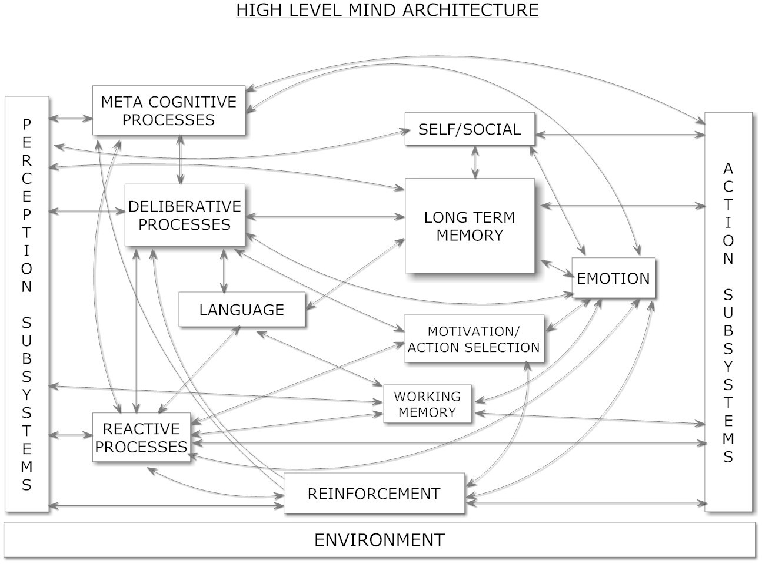
Figure 1: High-Level Structure of a Human-Like Mind

First, figure 1 gives a high-level breakdown of a human-like mind into components, based on Aaron Sloman’s high-level cognitive-architectural sketch (Sloman, 2001). This diagram represents, roughly speaking, “modern common sense” about the architecture of a human-like mind. The separation between structures and processes, embodied in having separate boxes for Working Memory vs. Reactive Processes, and for Long Term Memory vs. Deliberative Processes, could be viewed as somewhat artificial, since in the human brain and most AGI architectures, memory and processing are closely integrated. However, the tradition in cognitive psychology is to separate out Working Memory and Long-Term Memory from the cognitive processes acting thereupon, so I have adhered to that convention. The other changes from Sloman’s diagram are the explicit inclusion of language, representing the hypothesis that language processing is handled in a somewhat special way in the human brain; and the inclusion of a reinforcement component parallel to the perception and action hierarchies, as inspired by intelligent control systems theory (e.g. Albus as mentioned above) and deep learning theory. Of course, Sloman’s high level diagram in its original form is intended as inclusive of language and reinforcement, but I felt it made sense to give them more emphasis.
Figure 2, modeling working memory and reactive processing, is essentially the LIDA diagram as given in prior papers by Stan Franklin, Bernard Baars and colleagues (Baars and

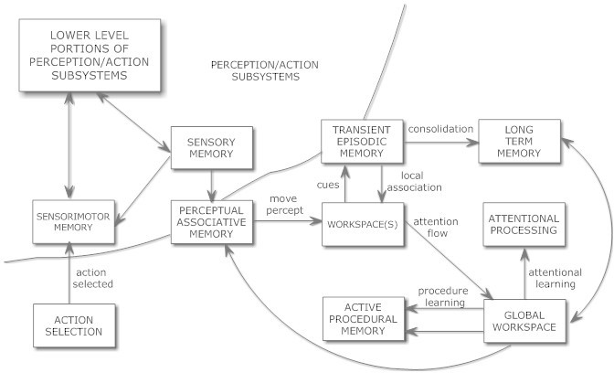

Figure 2: Architecture of Working Memory and Reactive Processing, closely modeled on the LIDA architecture

Franklin et al., 2012). ¹⁵ The boxes in the upper left corner of the LIDA diagram pertain to sensory and motor processing, which LIDA does not handle in detail, and which are modeled more carefully by deep learning theory. The bottom left corner box refers to action selection, which in the integrative diagram is modeled in more detail by Psi. The top right corner box refers to Long-Term Memory, which the integrative diagram models in more detail as a synergetic multi-memory system (Figure 4).
Figure 3, modeling motivation and action selection, is a lightly modified version of the Psi diagram from Joscha Bach’s book Principles of Synthetic Intelligence (Bach, 2009). The main difference from Psi is that in the integrative diagram the Psi motivated action framework is embedded in a larger, more complex cognitive model. Psi comes with its own theory of working and long-term memory, which is related to but different from the one given in the integrative diagram – it views the multiple memory types distinguished in the integrative diagram as emergent from a common memory substrate. Psi comes with its own theory of perception and action, which seems broadly consistent with the deep learning approach incorporated in the integrative diagram. Psi’s handling of working memory lacks the detailed, explicit workflow of LIDA, though it seems broadly conceptually consistent with LIDA.

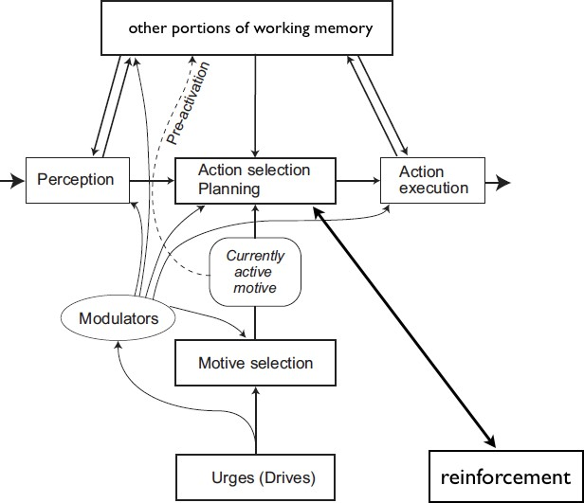

Figure 3: Architecture of Motivated Action

In Figure 3, the box labeled “Other parts of working memory” is labeled “Protocol and situation memory” in the original Psi diagram. The Perception, Action Execution and Action Selection boxes have fairly similar semantics to the similarly labeled boxes in the LIDA-like Figure 2, so that these diagrams may be viewed as overlapping. The LIDA model doesn’t explain action selection and planning in as much detail as Psi, so the Psi-like Figure 3 could be viewed as an elaboration of the action-selection portion of the LIDA-like Figure 2. In Psi, reinforcement is considered as part of the learning process involved in action selection and planning; in Figure 3 an explicit “reinforcement box” has been added to the original Psi diagram, to emphasize this.
Figure 4, modeling long-term memory and deliberative processing, is derived from my own prior work studying the “cognitive synergy” between different cognitive processes associated with different types of memory, and seeking to embody this synergy into the OpenCog system. The division into types of memory is fairly standard in the cognitive science field. Declarative, procedural, episodic and sensorimotor memory are routinely

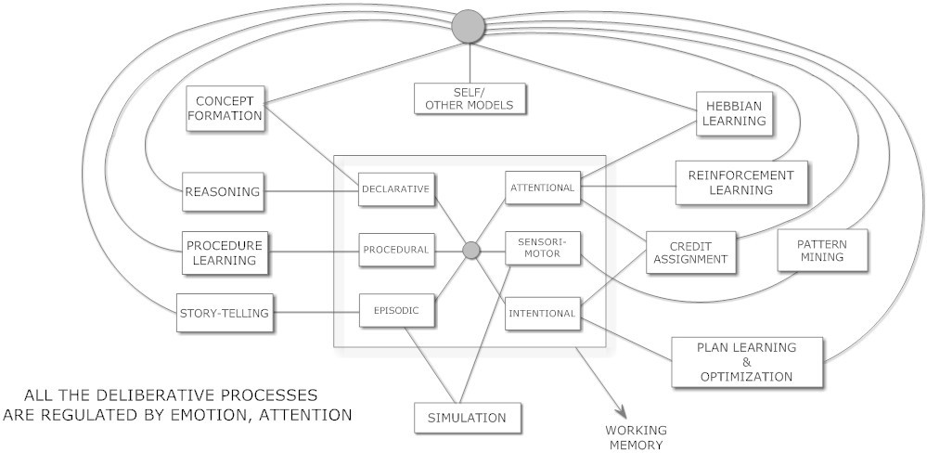

Figure 4: Architecture of Long-Term Memory and Deliberative and Metacognitive Thinking

attentional memory and intentional (goal) memory as well, and view these as the interface between long-term memory and the mind’s global control systems. One focus of our AGI design work has been on designing learning algorithms, corresponding to these various types of memory, that interact with each other in a synergetic way (Goertzel, 2009), helping each other to overcome their intrinsic combinatorial explosions. There is significant evidence that these various types of long- term memory are differently implemented in the brain, but the degree of structure and dynamical commonality underlying these different implementations remains unclear (Gazzaniga, Ivry, and Mangun, 2009).
Each of these long-term memory types has its analogue in working memory as well. In some cognitive models, the working memory and long-term memory versions of a memory type and corresponding cognitive processes, are basically the same thing. OpenCog is mostly like this –it implements working memory as a subset of long-term memory consisting of items with particularly high importance values. The distinctive nature of working memory is enforced via using slightly different dynamical equations to update the importance values of items with importance above a certain threshold. On the other hand, many cognitive models treat working and long-term memory as more distinct than this, and there is evidence for significant functional and anatomical distinctness in the brain in some cases. So, for the purpose of the integrative diagram, it seemed best to leave working and long-term memory subcomponents as parallel but distinguished.
Figure 4 may be interpreted to encompass both workaday deliberative thinking and metacog- nition (“thinking about thinking”), under the hypothesis that in human beings and human-like minds, metacognitive thinking is carried out using basically the same processes as plain ordinary deliberative thinking, perhaps with various tweaks optimizing them for thinking about thinking. If it turns out that humans have, say, a special kind of reasoning faculty exclusively for metacognition, then the diagram would need to be modified. Modeling of self and others is understood to occur via a combination of metacognition and deliberative thinking, as well as via implicit adaptation based on reactive processing.

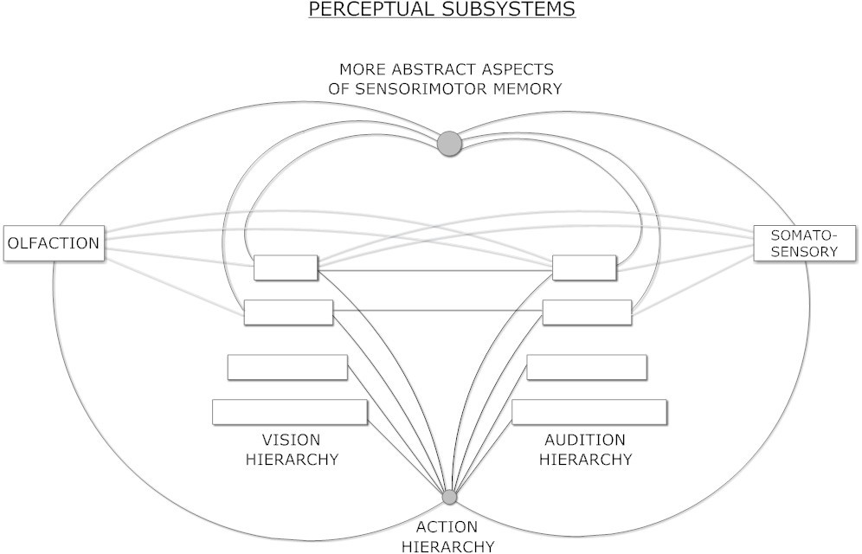

Figure 5: Architecture for Multimodal Perception

Figure 5 models’ perception, according to the concept of deep learning (Bengio, 2009; Anselmi et al., 2013). Vision and audition are modeled as deep learning hierarchies, with bottom-up and top-down dynamics. The lower layers in each hierarchy refer to more localized patterns recognized in, and abstracted from, sensory data. Output from these hierarchies to the rest of the mind is not just through the top layers, but via some sort of sampling from various layers, with a bias toward the top layers. The different hierarchies cross-connect, and are hence to an extent dynamically coupled together. It is also recognized that there are some sensory modalities that aren’t strongly hierarchical, e.g touch and smell (the latter being better modeled as something like an asymmetric Hopfield net, prone to frequent chaotic dynamics (Li et al., 2005)) – these may also cross-connect with each other and with the more hierarchical perceptual subnetworks. Of course, the suggested architecture could include any number of sensory modalities; the diagram is restricted to four just for simplicity.
The self-organized patterns in the upper layers of perceptual hierarchies may become quite complex and may develop advanced cognitive capabilities like episodic memory, reasoning, language learning, etc. A pure deep learning approach to intelligence argues that all the aspects of intelligence emerge from this kind of dynamics (among perceptual, action and reinforcement hierarchies). My own view is that the heterogeneity of human brain architecture argues against this perspective, and that deep learning systems are probably better as models of perception and action than of general cognition. However, the integrative diagram is not committed to my perspective on this – a deep-learning theorist could accept the integrative diagram,
other portions besides the perceptual, action and reinforcement hierarchies should be viewed as descriptions of phenomena that emerge in these hierarchies due to their interaction.
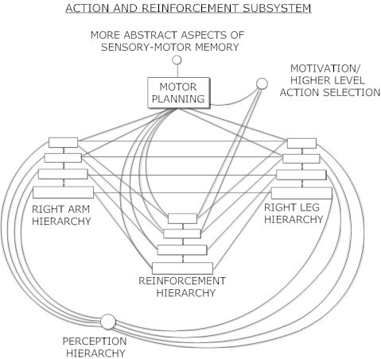

Figure 6: Architecture for Action and Reinforcement

Figure 6 shows an action subsystem and a reinforcement subsystem, parallel to the perception subsystem. Two action hierarchies, one for an arm and one for a leg, are shown for concreteness, but of course the architecture is intended to be extended more broadly. In the hierarchy corresponding to an arm, for example, the lowest level would contain control patterns corresponding to individual joints, the next level up to groupings of joints (like fingers), the next level up to larger parts of the arm (hand, elbow). The different hierarchies corresponding to different body parts cross-link, enabling coordination among body parts; and they also connect at multiple levels to perception hierarchies, enabling sensorimotor coordination. Finally, there is a module for motor planning, which links tightly with all the motor hierarchies, and also overlaps with the more cognitive, inferential planning
activities of the mind, in a manner that is modeled different ways by different theorists. Albus (Albus, 2001) has elaborated this kind of hierarchy quite elaborately.
The reinforcement hierarchy in Figure 6 provides reinforcement to actions at various levels on the hierarchy, and includes dynamics for propagating information about reinforcement up and down the hierarchy.
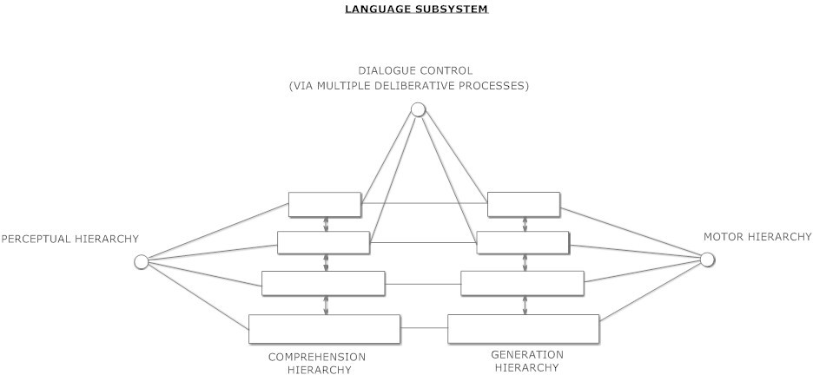

Figure 7: Architecture for Language Processing

Figure 7 deals with language, treating it as a special case of coupled perception and action. The traditional architecture of a computational language comprehension system is a pipeline (Jurafsky and James, 2000; Goertzel et al., 2010b), which is equivalent to a hierarchy with the lowest-level linguistic features (e.g. sounds, words) at the bottom, and the highest-level features (semantic abstractions) at the top, and syntactic features in the middle. Feedback connections enable semantic and cognitive modulation of lower-level linguistic processing. Similarly, language generation is commonly modeled hierarchically, with the top levels being the ideas needing verbalization, and the bottom level corresponding to the actual sentence produced. In generation the primary flow is top-down, with bottom-up flow providing modulation of abstract concepts by linguistic surface forms.
This completes the posited, rough integrative architecture diagram for human-like general intelligence, split among 7 different pictures, formed by judiciously merging together architecture diagrams produced via a number of cognitive theorists with different, overlapping foci and research paradigms. One may wonder: Is anything critical left out of the diagram? A quick perusal of the table of contents of cognitive psychology textbooks suggests that if anything major is left out, it’s also unknown to current cognitive psychology. However, one could certainly make an argument for explicit inclusion of certain other aspects of intelligence, that in the integrative diagram are left as implicit emergent phenomena. For instance, creativity is obviously very important to intelligence, but there is no “creativity” box in any of these diagrams – because in our view, and the view of the cognitive theorists whose work we’ve directly drawn on here, creativity is best viewed as a process emergent from other processes that are explicitly included in the diagrams
A high-level “cognitive architecture diagram” like this is certainly not a design for an AGI. Rather, it is more like a pointer in the direction of a requirements specification. These are, to a rough approximation, the aspects that must be taken into account, by anyone who wants to create a human-level AGI; and this is how these aspects appear to interact in the human mind. Different AGI approaches may account for these aspects and their interactions in different ways – e.g. via explicitly encoding them, or creating a system from which they can emerge, etc.

Chapter 4: Discussions and Conclusions

4.1 Understanding the Scope of AGI
Artificial General Intelligence (AGI) represents a paradigm shift in the field of artificial intelligence, moving beyond narrow task-specific capabilities toward general cognitive abilities that match or exceed human intelligence. The distinction between Artificial Narrow Intelligence (ANI) and AGI is foundational, with ANI excelling in domain-specific tasks like image recognition or language translation, while AGI aspires to perform any intellectual task that a human can do. The paper lays out that achieving AGI would require significant advances not only in computational power but also in theoretical understanding of cognition, learning, and consciousness.
As noted in the review, the theoretical underpinnings of AGI span neuroscience, cognitive psychology, and philosophy of mind. AGI systems must demonstrate adaptability, self-learning, contextual understanding, and reasoning across a wide spectrum of tasks. Importantly, AGI is not just about creating smarter algorithms, but also about embedding systems with an understanding of the world, intentionality, and possibly even moral reasoning.

4.2 Current State and Methodological Approaches
Despite ongoing research and optimism, the current state of AGI is largely conceptual and exploratory. Most existing AI systems are still classified as narrow AI. The research explores several frameworks and approaches towards AGI:

- Symbolic AI and Cognitive Architectures like SOAR and ACT-R model human-like reasoning and decision-making but often lack adaptability.
- Connectionist approaches, including deep learning and neural networks, offer scalability and performance but struggle with generalization, transfer learning, and explainability.
- Hybrid systems attempt to merge the strengths of both symbolic and sub-symbolic paradigms to simulate human-like reasoning and learning mechanisms.
- Neuromorphic computing is an emerging field aiming to emulate the neural structure and processing of the human brain, providing potential for energy-efficient and cognitively inspired AGI systems.
The document also highlights ongoing projects and research labs working on AGI, such as OpenAI, DeepMind, and others focusing on reinforcement learning, meta-learning, and world models.

4.3 Key Challenges and Ethical Implications
The journey toward AGI is not just a technical Endeavor but also one fraught with ethical and societal implications. Key technical challenges include:
- Common Sense Reasoning: AI systems still struggle to apply knowledge flexibly across domains.
- Transfer and Lifelong Learning: AGI systems must learn continuously from diverse experiences without catastrophic forgetting.
- Interpretability: Understanding how AGI systems reach conclusions is crucial for trust and transparency.
- Robustness and Safety: Ensuring that AGI behaves reliably in unpredictable environments is paramount.

Ethically, AGI development raises questions about autonomy, employment displacement, surveillance, and existential risk. Ensuring alignment with human values and embedding ethical frameworks within AGI systems is essential. Governance models, regulatory mechanisms, and inclusive design principles must be established proactively to mitigate potential misuse or unintended consequences.

4.4 Conclusions and Future Prospects
The development of AGI remains one of the most ambitious goals in science and engineering. While significant strides have been made in AI capabilities, AGI still lies in the realm of future prospects rather than immediate reality. The paper concludes that AGI research is inherently interdisciplinary, requiring collaboration across computer science, neuroscience, philosophy, ethics, and more.
Progress will likely come from continued innovation in machine learning algorithms, deeper insights into human cognition, and novel hardware architectures. Additionally, societal readiness — both in terms of infrastructure and policy — will shape how AGI is integrated into daily life.
To advance responsibly, the AI community must embrace transparency, inclusiveness, and foresight. Encouraging open research, diverse participation, and international cooperation will be key to ensuring Agi’s benefits are maximized while its risks are minimized.

4.5 Real-World Applications of AGI
While AGI is still under development, its prospective applications span nearly every industry and societal domain. The analytical findings indicate that AGI, once realized, could serve as a foundational platform for intelligent automation, decision-making, and innovation at a global scale.
Healthcare and Medical Research
- Autonomous diagnostics: AGI can analyse complex medical data (genomics, imaging, history) to make accurate diagnoses, even in rare or ambiguous cases.
- Drug discovery and personalized medicine: AGI systems could model biological systems and simulate drug interactions, significantly accelerating research and reducing trial costs.
- Caregiving and mental health support: With emotional intelligence and adaptive learning, AGI could support elderly care, neurodivergent individuals, or mental health therapies.
Education and Personalized Learning
- Adaptive tutoring systems: AGI would deliver personalized educational experiences, adjusting pace and teaching style in real time to each learner's needs.
- Curriculum design: AGI could analyse global learning trends and optimize syllabi for different populations, languages, and cognitive styles.
Scientific Discovery
- Theory formulation: AGI can generate hypotheses, design experiments, and interpret results across physics, chemistry, and biology, potentially leading to paradigm-shifting discoveries.
- Simulation and modelling: Complex systems—climate change, economic models, or astrophysics—could be better understood and predicted through AGI-driven simulations.
Autonomous Robotics and Smart Infrastructure
- General-purpose robots: From household helpers to rescue robots, AGI would allow machines to understand context and adapt without task-specific programming.
- Urban planning and traffic optimization: AGI could analyse real-time urban data to enhance resource distribution, reduce congestion, and plan future infrastructure.
Business and Strategic Decision-Making
- Enterprise management: AGI could manage logistics, finance, risk assessment, and strategic planning more efficiently than human analysts.
- Legal and policy advising: With vast knowledge and contextual reasoning, AGI can assist in interpreting laws, drafting policies, and simulating socioeconomic impacts.
Security and Defence
- Cybersecurity: AGI could proactively detect and respond to threats, adapting strategies in real time against sophisticated adversaries.
- Defence simulations and strategy: AGI could help develop non-violent strategic models, crisis forecasting, and ethical military planning.

Conclusion

Artificial General Intelligence (AGI) stands as one of the most ambitious and transformative pursuits in the field of computer science and artificial intelligence. It represents the frontier where machines evolve from specialized, task-specific agents to truly autonomous systems capable of performing any intellectual task a human can—adapting across diverse domains with flexibility, reasoning, and self-improvement. As we bring this technical seminar to a close, it’s essential to reflect on the multi-dimensional journey of AGI, from theoretical underpinnings and developmental milestones to the ethical, social, and technological challenges that lie ahead.

AGI is fundamentally different from the narrow AI systems dominating the present landscape. While narrow AI has achieved superhuman capabilities in domains such as image recognition, language modeling, and strategic games, it remains constrained by its lack of generalization beyond the specific datasets and problems it was trained on. AGI, in contrast, aspires to encompass the generality, adaptability, and contextual intelligence that characterize human cognition. It would not merely execute instructions or learn from fixed environments but engage in lifelong learning, abstraction, self-reflection, and problem-solving across a continuously evolving spectrum of inputs.

The path toward AGI is not merely an engineering challenge; it is deeply interdisciplinary, drawing upon insights from neuroscience, cognitive science, philosophy, computer science, linguistics, and ethics. Building AGI requires understanding how humans learn, reason, and adapt—not just from large datasets, but from sparse data, social interaction, and embodied experience. Techniques such as meta-learning, reinforcement learning, symbolic reasoning, transfer learning, and hybrid architectures combining connectionist (neural networks) and symbolic paradigms are converging to approximate aspects of human-like intelligence. Emerging paradigms such as neurosymbolic systems and causal inference are promising steps toward systems that are not only data-efficient but also interpretable and robust.
From a technical standpoint, the evolution of large-scale models like GPT, AlphaZero, and PaLM has demonstrated significant strides in multi-domain proficiency. These architectures suggest that scaling computation, data, and model size may lead to emergent capabilities previously thought unattainable. However, sheer scale alone does not equate to general intelligence. True AGI must demonstrate autonomy, common-sense reasoning, moral judgment, and the ability to generate and test hypotheses in the absence of exhaustive training. These requirements present fundamental challenges in areas such as representation learning, knowledge grounding, unsupervised learning, and computational efficiency.
.

Acknowledgement

I would like to take this opportunity to express my deepest gratitude to Prof. P. P. Patil for his continuous support, encouragement, and expert guidance throughout the preparation of this technical seminar on “Artificial General Intelligence (AGI)”. His vast knowledge, insightful suggestions, and unwavering mentorship played a crucial role in helping me understand and explore the intricate concepts and emerging challenges associated with AGI.
From the initial stages of topic selection to the finalization of the content, Prof. Patil provided valuable direction and critical feedback that significantly enhanced the quality and clarity of this seminar. His ability to simplify complex technical concepts and encourage critical thinking greatly contributed to my ability to dive deeper into the subject and present it in a comprehensive and structured manner.
Under his mentorship, I gained a broader perspective on the future scope and real-world implications of AGI, not just as a technological pursuit, but as a transformative force in the evolution of intelligent systems. His dedication to fostering an academic environment that emphasizes innovation, research, and ethical considerations has been truly inspiring.
I also appreciate the academic resources and learning environment provided by the department, which facilitated my research and understanding of this advanced topic. This seminar is a testament to the collaborative efforts, guidance, and support I have received during this academic journey.
Once again, I extend my sincere thanks to Prof. P. P. Patil for being a constant source of motivation and for guiding me through every step of this work. I am truly privileged to have had the opportunity to work under his mentorship.

REFERENCES

- https://en.wikipedia.org/wiki/Artificial_general_intelligence
- https://chatgpt.com/c/67ef7ceb-45fc-8010-9ec6-8bdde5639498
- https://g.co/gemini/share/c53ce652c47a
- https://www.researchgate.net/publication/271390398_Artificial_General_Intelligence_Concept_State_of_the_Art_and_Future_Prospec

