IOT BASED BIKE ENGINE OIL MONITORING SYSTEM

**Tushar Khandvikar, Kuber Markad**

*Department of Instrumentation and Control, Vishwakarma Institute of Technology Pune, India*

**Abstract**: Effective lubrication maintenance for engines in order to increase an engine's overall efficiency, oil is essential for lowering wear and tear, controlling heat generation, and minimizing vibrations. By not performing routine oil changes, dirt and sludge can build up inside the engine, inadequately lubricating the moving components. In this project, we provide an Internet of Things (IoT)-based method to evaluate engine oil's state and give a thorough study of its quality. We want to monitor important metrics and offer precise assessments of the oil's condition by integrating a variety of sensors, including turbidity sensors and an ultrasonic sensor. Turbidity sensors are used to detect the number of pollutants and suspended particles present in the oil, indicating the level of contamination. A diminished oil's ability to lubricate effectively is indicated by higher turbidity levels. The ultrasonic sensor also checks the engine's oil level to make sure it stays within the recommended range. This sensor-based technology enables rapid notification of vehicle owners when the state of the engine oil deteriorates beyond permissible limits. This proactive technique permits prompt oil changes, avoiding potential engine damage and preserving peak performance. Our system's thorough analysis equips users to make knowledgeable decisions about engine maintenance, enhancing efficiency and prolonging the engine's life. With the use of IoT approaches for engine oil evaluation, we want to increase engine efficiency through this research. Our system offers real-time monitoring, analysis, and alarms by using sensor-based technology, which facilitates preventive maintenance actions. This strategy optimizes performance while simultaneously extending the engine's useful life and lowering the danger of engine damage.

**Keywords:** Turbidity sensor, Oil quality, Ultrasonic sensor, Oil level detector, IOT

# INTRODUCTION

This project report describes a cutting-edge Internet of Things (IoT)-based oil monitoring system created especially for monitoring the condition of motorcycle engine oil. The system includes an ultrasonic sensor for accurate oil level measurement as well as a turbidity sensor for assessing oil quality. The system uses the Serial Monitor and ThingSpeak platform to gather data and deliver real-time updates thanks to the power of IoT. Bike performance and lifespan depend on keeping the engine oil in ideal condition. Due to a number of variables, engine oil can degrade over time, potentially damaging the engine and reducing its efficiency. We have created a remedy for this problem that incorporates a turbidity sensor into the oil monitoring system. This sensor provides precise measurements of the engine oil's clarity and impurity levels, allowing for prompt interventions to maintain the appropriate oil quality requirements. To avoid problems brought on by insufficient lubrication or oil overflow, it is equally important to monitor the oil level in addition to the oil quality. We include an ultrasonic sensor in our system to detect levels accurately. Real-time updates on the oil level in the engine are provided by this sensor, which measures the distance between the sensor and the oil surface. With this non-contact measuring method, accuracy, dependability, and the chance of oil contamination during monitoring are all guaranteed. The system's IoT capabilities, which enable smooth integration and data sharing across various devices, sensors, and platforms, are its primary functional component. The Serial Monitor receives data from the turbidity and ultrasonic sensors for local monitoring and analysis. We make use of the ThingSpeak platform, a complete IoT analytics and visualization tool, to further improve the system's capabilities. The oil monitoring data may be stored, examined, and shown in real time thanks to ThingSpeak. Users may establish alarm levels, produce comprehensive reports for additional research, and access historical and current data. Bike owners and mechanics may remotely check oil levels and condition using ThingSpeak, enabling preventative maintenance and improving engine efficiency. Finally, our IoT-based oil monitoring system created exclusively for motorcycle engines gives a complete solution for assessing oil quality and monitoring levels. We assist data-driven decision-making by combining a turbidity sensor for assessing oil quality, an ultrasonic sensor for detecting level, and using IoT capabilities. This study shows how the Internet of Things (IoT) may improve bike engine performance and maintenance, resulting in more dependable and effective operations. This report consists of five sections section 1 Literature survey, section 2 Tools and Technologies, section 3 Working, section 4 Result and Discussion, section 5 Conclusion.

# LITERATURE SURVEY

The main goal of a comparison research of various oil quality sensors was to evaluate the state of engine oil using IoT techniques and offer a thorough analysis. To assess the quality of the oil, the study used conductivity, pH, and turbidity sensors. As indicators of the oil state, variously colored LEDs were used to display the data [1]. Another research concentrated on employing an engine-mounted turbidity sensor to automatically assess the oil quality. The research created a method for performance and quality assessment of the oil using an Arduino controller. To avoid carelessness in oil changing, the instrument displayed the state of the oil as a percentage [2]. Research used a variety of sensors, including the TCS200 RGB color sensor and an ultrasonic sensor for level detection, to monitor the quality of the oil. A Wi-Fi module was used to transport the acquired data to the cloud after being shown on an LCD [3]. Another research article established a real-time Engine Oil Monitoring (EOM) system based on the Internet of Things. A Light Dependent Resistor (LDR) sensor for measuring oil quality, an LM35-Temperature sensor for measuring temperature, and an Ultrasonic Sensor for measuring oil level were all used in the system [4]. In research to build an IoT-based equipment for oil contaminants and level monitoring, a novel strategy utilizing personalized white LED spectrophotometry was used. The device offered precise oil impurity detection and monitoring [5]. A study article revealed the creation of an IoT-based engine oil sludge monitoring gadget. To measure the RGB concentration in oil, the gadget employed a colorimetric detecting technique and a thin film silver coated mirror arrangement. It provided the user with constant updates on the sludge concentration level [6]. In a study paper, a different strategy for assessing oil quality was suggested. Measurements of viscosity, conductivity, and transmittance were used in the procedure to describe the oil's quality [7]. The association between oil characteristics and the technical state of internal combustion engines was examined in research. In order to evaluate the age of motor oils and the remaining life of the engine and its parts, electrophysical methods were employed to evaluate the quality of motor oils [8].

These studies emphasize the value of adopting IoT-based methods to monitor engine oil status. These studies attempt to improve engine performance, reduce negligence in oil maintenance, and offer useful information for the best decision-making by utilizing a variety of sensors and techniques.

# TOOLS AND TECHNOLIGIES

The IoT-based bike engine oil monitoring system uses a variety of tools and technologies, including the ones listed below.

1. **Turbidity Sensor:** A sensor used to assess the purity and impurity levels of motorcycle engine oil, providing details on any pollutants, suspended particles, or sediments that may be present.

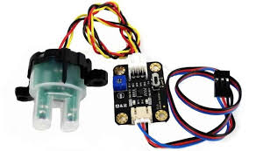

**Fig 1. Turbidity Sensor**

1. **Ultrasonic Sensor:** An ultrasonic sensor is a device that sends out ultrasonic waves in the direction of an oil surface and measures the distance to the surface using the time it takes the waves to return. This makes it possible to measure the oil level accurately.

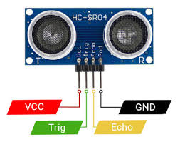

**Fig 2. Ultrasonic Sensor**

1. **NodeMCU ESP8266:** A microcontroller board based on the ESP8266 Wi-Fi module is called NodeMCU ESP8266. It serves as the system's central processing unit, collecting and analyzing data from the sensors and enabling IoT communication.

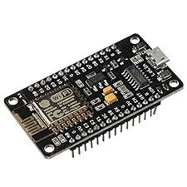

**Fig 3. NodeMCU ESP8266**

1. **Arduino IDE:** The NodeMCU ESP8266 microcontroller is programmed using the software tool known as the Arduino Integrated Development Environment (IDE). To write, compile, and upload code to the microcontroller, it offers a simple and user-friendly interface.
2. **Ethernet or Wi-Fi:** The system uses Ethernet or Wi-Fi connection to link the NodeMCU ESP8266 microcontroller to the internet. IoT capabilities and data transfer to web platforms are made possible by this.
3. **Serial Monitor:** For local monitoring and analysis of the oil monitoring data, the Arduino IDE provides a tool or interface called the serial monitor. It provides real-time displays of the sensor data, enabling testing and troubleshooting throughout the development process.
4. **ThingSpeak:** MathWorks offers an IoT analytics platform. The oil monitoring data are stored, visualized, and analyzed using ThingSpeak. It provides dashboards that may be customized, historical monitoring, and alert levels and settings.
5. **Web Interface/Mobile Application:** Users have the choice of using a web interface or a mobile application to access the ThingSpeak platform. Users may monitor real-time data on oil quality and level, examine historical patterns, and set up threshold alarms using these interfaces.

The oil monitoring system may be designed to read sensor data, process it, and transfer the important information to the selected platforms by utilizing the Arduino IDE. By offering an integrated environment for authoring and uploading code to the NodeMCU ESP8266 microcontroller, the Arduino IDE streamlines the development process.

# WORKING

The NodeMCU ESP8266 microcontroller is used for data processing and IoT connectivity in the IoT-based bike engine oil monitoring system. Turbidity sensors are also used for level detection and oil quality evaluation. Let's see how this system functions:

The device includes a turbidity sensor to assess the bike engine oil's quality. The bike's engine oil reservoir is connected to this sensor. It assesses the oil's clarity and impurity levels, looking for any potential pollutants, suspended particles, or sediments. These readings are transformed into electrical impulses by the turbidity sensor, which may then be analyzed further.

The bike's engine oil reservoir has an ultrasonic sensor put within it concurrently. The sensor detects the waves that bounce back after being sent ultrasonically in the direction of the oil surface. The ultrasonic sensor determines how far away the oil surface is from itself by measuring the time it takes for the waves to return. This measurement of distance is also transformed into an electrical signal.

Data processing and IoT networking are handled by the NodeMCU ESP8266 microcontroller. The system's core processing unit is this microcontroller. The electrical signals from the turbidity and ultrasonic sensors are received by it, enabling additional processing and analysis.

With its integrated Wi-Fi capabilities, the NodeMCU ESP8266 creates a wireless internet connection. With the help of this link, IoT applications may be seamlessly integrated.

The microcontroller transmits the information about the processed oil's quality and level. The information is sent to the Serial Monitor, where it may be locally seen and analyzed for real-time monitoring.

The system also makes use of the ThingSpeak platform, which makes data storage and transfer easier. In order to safely communicate the oil monitoring data to a predefined channel within the platform, the NodeMCU ESP8266 connects to ThingSpeak. ThingSpeak offers a number of tools for data visualization, analysis, and historical tracking in addition to acting as a data store.

# 

**Fig 4. Block Diagram of System**

The ThingSpeak platform is easily accessible to users through a web interface or a mobile application. They may use the platform to view configurable dashboards that provide real-time data about the quality and level of the oil. Insightful reports may also be produced by analyzing previous data to spot trends. Additionally, the platform offers the ability to define thresholds and alerts, providing prompt communication when particular requirements are satisfied.

In conclusion, the oil monitoring system delivers real-time updates through the Serial Monitor and ThingSpeak platform by integrating the turbidity sensor for oil quality evaluation, the ultrasonic sensor for level detection, and the NodeMCU ESP8266 microcontroller with IoT capabilities. This enables remote oil condition monitoring, preventive maintenance, and performance enhancement of motorcycle engines.

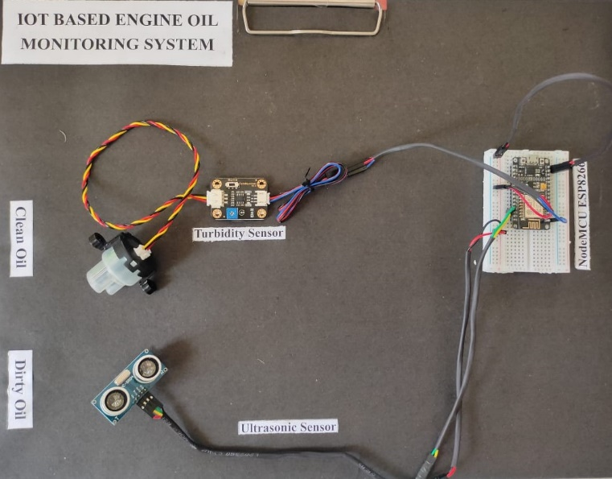

**Fig 5. Hardware Implementation of System**

# RESULTS AND DISCUSSION

The turbidity sensor, which is part of the IoT-based oil monitoring system, is effective at measuring the bike engine oil's clarity and impurity levels. It accurately identifies any pollutants, sediments, or suspended particles that are present in the oil, giving important information about its quality. The oil level in the reservoir is accurately determined by the ultrasonic sensor. It determines the distance to the oil surface by transmitting and receiving ultrasonic waves, which enables accurate oil level detection. The sensor data is processed by the NodeMCU ESP8266 microcontroller, which also enables IoT connectivity. Through the Serial Monitor, it offers real-time monitoring and analysis of the oil conditions, giving users fast information for quick decision-making. Data storage, visualization, and analysis are made possible thanks to the interaction with the ThingSpeak platform. Remote users may examine historical patterns, establish thresholds for preventive maintenance, and access the platform. The oil monitoring system provides precise oil quality evaluation, real-time monitoring, and remote access capabilities. Users are able to maximize engine performance, extend the lifespan of the bike, and make educated maintenance decisions.

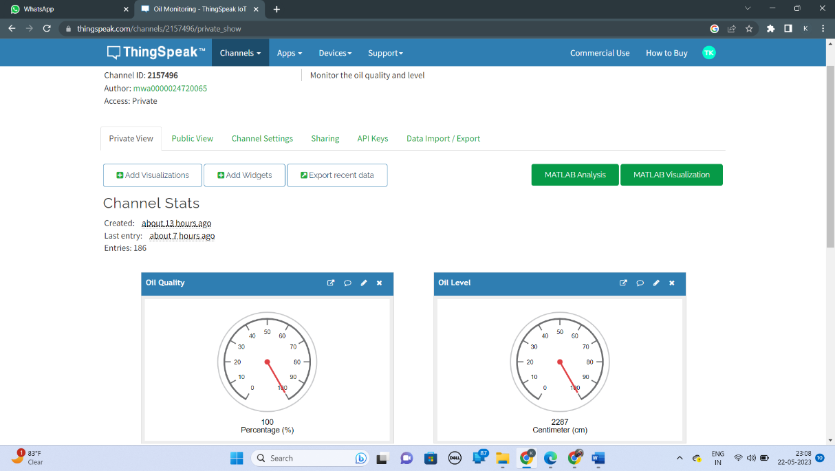

**Fig 6. ThingSpeak User Interface**

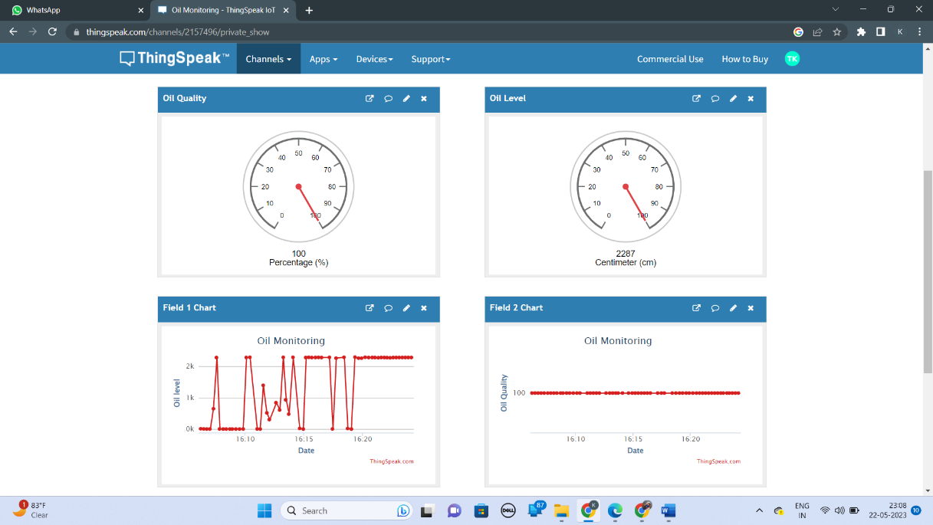

**Fig 7. ThingSpeak Graphical Representation**

# CONCLUSION

The NodeMCU ESP8266 microcontroller, used for data processing and IoT connectivity, along with a turbidity sensor for oil quality assessment, an ultrasonic sensor for level detection, and other components, provides an efficient solution for monitoring and maintaining bike engine oil conditions. Users are able to evaluate oil quality and take the necessary steps once the system precisely evaluates oil clarity and impurity levels. The excellent level detection allows accurate real-time monitoring of the oil level, enabling effective maintenance. The system supports remote monitoring and analysis thanks to IoT connectivity. Integration with the ThingSpeak platform enables data analysis, visualization, and storage, delivering insightful information and promoting preventative maintenance. Overall, the Internet of Things (IoT)-based oil monitoring system improves oil monitoring capabilities while maximizing bike engine efficiency and extending engine life.

# REFERENCE

[1] Mr.K.Madhana Mohan, S.Abinaya, P.Kaviya, S.M.Sandhya, P.Lavanya, "Engine Oil Condition Monitoring using IoT and Predictive Analysis," JOURNAL OF CRITICAL REVIEWS, 2020.

[2] Muhammad Kholid Shalahuddin, Endah Ratna Arumi, Setiya Nugroho, "Design of Motorcycle Oil Performance Detector," IEOM Society International, 2021.

[3] Gurushant Koulagi, Naveen Kumar S N, Gopalareddy, "ENGINE OIL MONITORING SYSTEM FOR AUTOMOBILES: A NOVEL APPROACH," GIS SCIENCE JOURNAL, 2020.

[4] Keshav Kumar Jha, B.S. Pabla, "A Real Time Engine Oil Monitoring System for Diagnosis of Lubricant using IoT Network," International Journal of Innovative Technology and Exploring Engineering (IJITEE), 2020.

[5] Sidharth Sharma, Supankar Das, Jitendra Virmani, Mamta Sharma, Satbir Singh, Amitava Das, "IoT Based Dipstick Type Engine Oil Level and Impurities Monitoring System: A Portable Online Spectrophotometer,"IEEE, 2019.

[6] Sidharth Sharma, Mamta Sharma, Supankar Das, Kiran Shankar Hazara, Harry Garg, Amitava Das, "IoT Based Engine Oil Sludge Monitoring System: A Portable Colorimetric Analyzer,"IEEE, 2019.

[7] Harish Shinde, Dr. Anand Bewoor, "Analyzing the relationship between the deterioration of engine oil in terms of change in viscosity, conductivity and transmittance,"IEEE, 2017.

[8] A.G. Vozmilov, R.Yu. Ilimbetov, D.S. Korobkov, N.L. Faizulloev, D.V. Astafev, L.N. Andreev, "Diagnostics of Engine oil of Internal Combustion Engine by Electrophysical Method of Control,"IEEE, 2018.