Create a Stream

<http://docs.aws.amazon.com/streams/latest/dev/learning-kinesis-module-one-create-stream.html>

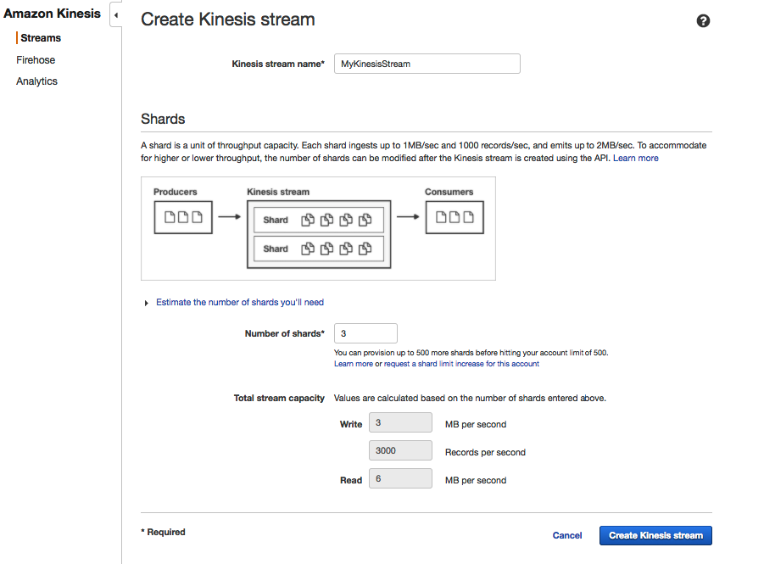

As you can see, there is a limit on number of writes and reads based on number of shards that you specify.

For every shard, you can write 1 MB/Sec that can have 1000 records. You can read double the size 2 MB/Sec.

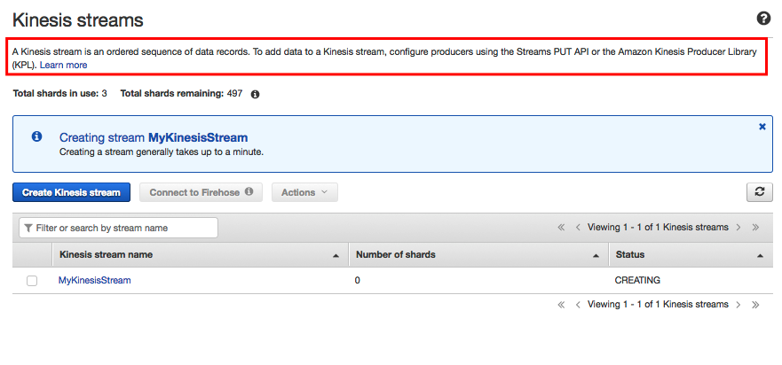

Stream is being created, you can use kinesis PutRecords API or KPL (Kinesis Producer Library) to write data to a Stream.

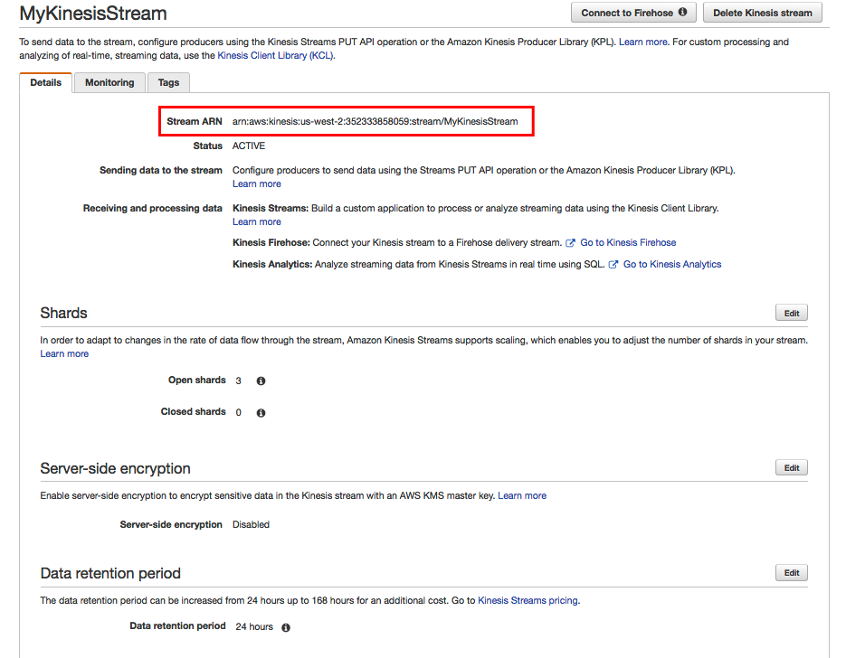

ARN- arn:aws:kinesis:<region>:<account id>:stream/<name of the stream>