*Synopsis On*

**“Arogya HealthCare”**

*Submitted by*

**Sahil Arora**

**Examination Roll No. 14003270031**

*Under Supervision of*

**Mrs. Uma Ojha**

**Faculty of Computer Sciences**

**ARSD, Delhi University**



**TABLE OF CONTENTS**

**1**. **Introduction**

1.1 Purpose

1.2 Scope

1.3 Definitions, Acronyms and Abbreviations

1.4 Overview

**2**. **General Description**

2.1 Product Perspective

2.1.1 Product Function

2.1.2 Hardware Requirements

2.1.3 Software Requirements

2.1.4 Communication Interfaces

2.2 User Characteristics

2.3 General Constraints

**3. System Architectural Design**

3.1 High Level Design Overview

3.1.1 Use Case Diagrams

3.1.2 Class Diagrams

3.1.3 Activity Diagrams

3.1.4 ER Diagram

3.1.5 Data Flow Diagrams

3.2 Specific Requirements

3.2.1 Non-Functional Requirements

3.3 Data Design

3.3.1 Database Description

**4. Work Plan**

4.1 Gantt Chart

4.2 Estimation

4.2.1 Problem Based Estimation

4.2.2 COCOMO Model Based Estimation

4.3 Risk Management

**5. Screen Layouts**

**6. Testing**

**6.1 Black-Box Testing**

**6.2 White-Box Testing**

**6.3 Cyclomatic Complexity**

**7. References**

**ACKNOWLEDGEMENT**

**I have taken efforts in this project. However, it would not have been possible without the kind support and help of my supervisor . I would like to extend my sincere thanks to my friends.**

**I am highly indebted to (Mrs. Uma Ojha) for their guidance and constant supervision as well as for providing necessary information regarding the project & also for their support in completing the project.**

**I would like to express my gratitude towards my parents & member of Atma Ram Sanatan Dharma College for their kind co-operation and encouragement which help me in completion of this project.**

**My thanks and appreciations also go to my colleague in developing the project and people who have willingly helped me out with their abilities.**

# Introduction

“Arogya Healthcare” is a web application that serves people with the facility of online medical hospitality. It is a medical clinic that works for the regular medical services as well as involved in “Help Needy” campaign that serves people who comes under below poverty line at just 10% of the regular charges as well as donates medicines to one who cannot afford to have those.

It saves time as it allows number of user to access information at the same time. It is automatically generated by the server.

Administrator has a privilege to modify and delete the services, user and its particular information.

User can view and search for the desired services like he/she can request for an appointment with the doctor available at the clinic or he/she can also go for the charitable campaign.

## Purpose

The main purpose behind the making of this project is to learn new technology & the main purpose to select this project is to help the needy ones by making a small initiative as well as to provide access to people regarding the hospitalities available at “We Care”.

## Scope

There are two basic users – **User and Admin.**

* The scope of this project is limited to the online services. The independent built module together forms software covering the medical procedures, selection of the hospitality required, booking of the appointment and display the confirmation.
* Allows the user to look over the website.
* The site allows the user to access the services that include different categories.
* Users can also submit their feedback.
* Maintain a centralized database which can be accessed only by the administrator.

## Definitions, Acronyms, and Abbreviations.

* Admin- Administrator
* NetBeans IDE 8.0.2
* PHP-Hypertext Preprocessor
* SQL- Structured Query Language
* Http-Hypertext MarkUp Language

## Overview

## 

The purpose of our project is to provide the facility of the medical services with just a click and also to let the user know about the medical services that a patient can avail at our medical Centre.

Modules specified are:

1. Login of Admin

2. Allow the user to visit the site.

3. To buy the services that covers:-

* Request for an appointment
* Career
* Organ Donation
* Donate your Medicine
* Blood Donation
* Clinical Specialties
* Contact Us
* News &Events
* About Us

4. Admin to add the relevant services.

* Updating the stored information of user.
* Retrieval of information.
* Delete user records.
* Add new services.
* Send the Confirmation to the user.
* Review Feedback.

# The Description

This section deals with the various phases of the project and also with the architecture of the project which is used to develop the system for the requirements requested. The section covers the various diagrams associated with the system. The section also deals with the basic hardware and software requirements needed for the system.

## 2.1 Product Perspective

### C:\Users\JUHI GARG\Downloads\online-quiz-system-project-ppt-5-638.jpg

* The web pages (HTML) are present to provide the user interface on user

Client side. Communication between user and server is provided through

**HTTP/HTTPS** protocols.

* The Client Software is to provide the user interface on system user client

side and for this TCP/IP protocols are used.

* On the server side, web server is for client and database server is for storing

the information.

### 2.1.1 Product Function

### 

### 2.1.2 Hardware Requirements

**Client Side-**

**Minimum :-** Processor **:** P-IV, 1.2GHz

RAM **:** 256MB

Hard Disk **:** 1 GB free space

**Recommended:-**

Processor  **:** Intel Core i3/i5, 2.53GHz and above

RAM  **:** 1GB

Hard Disk **:** 2 GB free space

**Server Side:-**

**Minimum:-** Processor **:** P-IV, 2.0 GHz

RAM **:** 524MB

Hard Disk  **:** 10 GB free space

**Recommended:-**

Processor  **:** Intel Core i3/i5/i7, 2.53GHz (above)

RAM **:** 1 GB and above

Hard Disk **:** 15 GB free space and above

### 2.1.3 Software Requirements

**Client Side-**

Minimum : Web Browser (IE version), Operating System (Window2000/XP)

Recommended: Web Browser (IE 8 version), Operating System (Windows 7/8),

NetBeans IDE 8.0.2

**Server Side-**

XAMPP, Windows Server 2000, Database (MySQL) .

### 2.1.4 Communications Interfaces:

The system should be accessed over internet. For Clients to access application server the network should be running TCP/IP protocol.

## 

## 2.2 User Characteristics

The end user of the software can be divided into two categories:

**Administrator:** Access to master forms for the purpose of data entry.

**User:** Access to the corresponding amenities and buy services only.

## 2.3 Constraints

* **Higher Order Language Functions:** The PHP will be used for developing the web-pages with the help of NETBeans IDE 8.0.2 and for the database information MySQL will be used.
* **Criticality of the Application:** The server application will be available 24*7.
* **Safety and Security Considerations:** The password and a valid username are the security issue.

# System Architectural Design

**3.1 High-level Design Overview**

## Pictorial representation of the system architecture is presented.

SQL Server

Web Server

(IIS with ASP.NET run time)

INTERNET

User

1-TIER

3-TIER

2-TIER

**3.1.1 Use Case Diagrams:**

**Use Case For Appointment:**

|  |  |
| --- | --- |
| Use Case No. | 1 |
| Use Case Name | Appointment |
| Actors | Admin, User |
| Description | This module helps Admin and User to make and confirms appointment respectively. |
| Pre-Conditions | The users must be known of the medical conditions. |
| Input | Details that are expected to be filled by the user. |
| Events | 1. Users enter their details. 2. Users enter his/her medical condition. 3. Users click submit button. 4. System connects to database. 5. Message displayed. |
| Output | Confirmation will be displayed. |

**Use Case For Career:**

|  |  |
| --- | --- |
| Use Case No. | 2 |
| Use Case Name | Career |
| Actors | Admin, User |
| Description | This module helps Admin and User to make career. |
| Pre-Conditions | The users must have his/her resume in softcopy. |
| Input | Click career button. |
| Events | 1. The website users click to career button. 2. User is expected to fill the appeared form. 3. User clicks the submit button. 4. Confirmation of data submission will be displayed. 5. The website will be directed to homepage. |
| Output | Homepage will be displayed. |

**Use Case For Save Life:**

|  |  |
| --- | --- |
| Use Case No. | 3 |
| Use Case Name | Save Life |
| Actors | Admin, User |
| Description | This module helps Admin and User to save life. |
| Pre-Conditions | The users must be known of his/her medical conditions. |
| Input | Click savelife button. |
| Events | 1. The website users click to savelife button. 2. User is expected to fill the appeared form. 3. User clicks the submit button. 4. Confirmation of data submission will be displayed. 5. The website will be directed to homepage. |
| Output | Homepage will be displayed. |

**Use Case For Donate Medicine:**

|  |  |
| --- | --- |
| Use Case No. | 4 |
| Use Case Name | Donate Medicine |
| Actors | Admin, User |
| Description | This module helps Admin and User to Donate Medicine. |
| Pre-Conditions | The users must have medicines which are unexpired. |
| Input | Click donate button. |
| Events | 1. The website users click to donatemedicine button. 2. User is expected to fill the appeared form. 3. User clicks the submit button. 4. Confirmation of data submission will be displayed. 5. The website will be directed to homepage. |
| Output | Homepage will be displayed. |

**3.1.2 Class Diagram:**



**3.1.3 Activity Diagram:**

**Activity Diagram for User:**



**Activity Diagram For Admin:**



**ER Diagram For Book an appointment Module:**

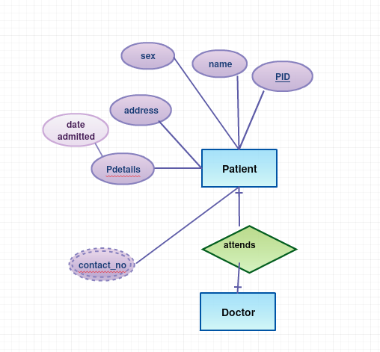

**3.1.3 Data Flow Diagram:**

**Level 0:**

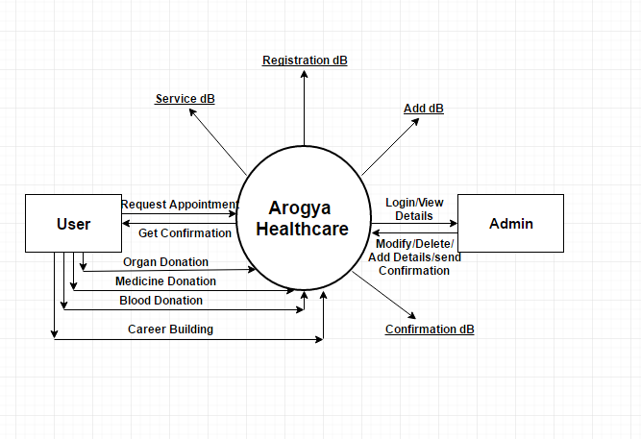

**Level 1:**

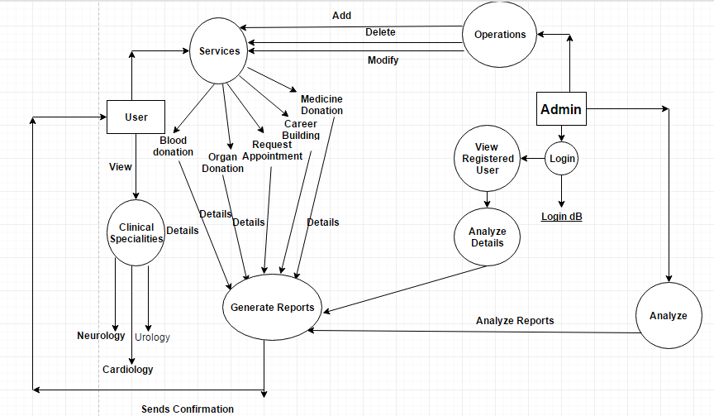

**Data Dictionary:**

LOGIN = user_name + password +forget_password +change_password + admin_type

USER_SERVICES=donate_medicine+ bood_donation+ organ_donation+ request_appointment

+Career_building

AVAIL_SERVICES =registration+ donate_medicine+ bood_donation+ organ_donation+ request_appointment +Career_building+ remarks+ submit_details.

CONFIRMATION_MODULE= admin_panel+final_verification+confirmation_sent.

DONATE_MEDICINE=registration_no+ donator_name+ phone_no+email_id+ address_details+

Pincode_verification+sent_by_user.

ORGAN_DONATION=registration_no+ donator_name+ phone_no+email_id+ address_details+

Evidence_details+details_verification+receives_confirmation.

BLOOD_DONATION=registration_no+donator_name+phone_no+email_id+blood_group_details+address_details+details_verification+receives_confirmation.

CARRIER_BUILDING=registration_no+ doctor_name+ phone_no+email_id+cv_details+

details_verification+receives_confirmation.

REQUEST_APPOINTMENT=registration_no+patient_name+phone_no+email_id+address_details+mediacl_condition_details+details_verification+receives_confirmation.

**3.2 SPECIFIC REQUIREMENTS:**

**Functional Requirements:**

**Home Page**

It is a master page that includes links to home, services, about us, FAQs, contact us, make an appointment, career, save life etc.

**Career Page:**

It is a page which enables the users to get into our team of doctor. For that user is expected to enter the required details like name, email id and an attachment of resume so that the admin can revert back to the respective contact details regarding the interview schedule if the candidate resume is according to the requirement of the clinic.

**Make an appointment Page:**

It gives a registration form for the user in which he/she is expected to enter the required details and on submission of the form, he/she is registered with the site for the appointment. Once the admin confirms the appointment of doctor with the patient , the patient will be notified via sms or email.

**Save Life Page:**

This section provides user a registration page in which user is expected to fill the details

required to save the someones life by donating his/her organ or blood.

* **Services Page**

This section of the website includes the information regarding the clinical specialties provided by our clinic like cardiology, nephrology etc.

* **About Us Page**

This section includes the vision, board members, mission and many other relevant and important information regarding our clinic.

* **Donate Your Medicine Page**

This page allows user to register themselves for donating the unused and non- required medicine to the needy ones.

* **FAQ Page:**

This page contains the commonly asked queries of users regarding our website and answers to them.

* **Contact Us Page:**

It lists all the key contacts and addresses of office.

**3.2.1 Non-Functional Requirements (software system attributes):**

* **Security:**

The login-id &password is only provided to Administrator so that no unauthorized user can update Database.

* **Reliability:**

System will be thoroughly tested at time of delivery so that error will not occur.

* **Maintainability:**

The System will be maintained by administrator only.

* **Robustness:**

System will continue to function accurately in any condition.

* **Understandable by user:**

The System should not be complex so that user can easily understand it.

**3.3 Data Design**

**3.3.1 Database description**

* In this we include, maintain & format Databases and its tables.
* The tables corresponding to each of the entity, holding the information about them are designed.
* The tables have the fields, their description, and their data type as well as integrity constraints.

**User Appointment Table**

|  |  |  |  |
| --- | --- | --- | --- |
| **FIELD NAME** | **DATA TYPE** | **CONSTRAINT** | **KEY** |
| **ID** | **VARCHAR(10)** | **NOT NULL** | **PRIMARY KEY** |
| **Patientname** | **VARCHAR(80)** | **NOT NULL** |  |
| **specialityrequired** | **VARCHAR(50)** | **NOT NULL** |  |
| **doctorname** | **VARCHAR(10)** | **NOT NULL** |  |
| **date** | **Date(30)** | **NOT NULL** |  |
| **contact** | **INT(10)** | **NOT NULL** |  |
| **email** | **VARCHAR(15)** | **NOT NULL** |  |
| **address** | **VARCHAR(15)** | **NOT NULL** |  |
| **comment** | **INT(6)** | **NOT NULL** |  |

**User Career Table**

|  |  |  |  |
| --- | --- | --- | --- |
| **FIELD NAME** | **DATA TYPE** | **CONSTRAINT** | **KEY** |
| **ID** | **VARCHAR(10)** | **NOT NULL** | **PRIMARY KEY** |
| **name** | **VARCHAR(80)** | **NOT NULL** |  |
| **email** | **VARCHAR(60)** | **NOT NULL** |  |
| **cv** | **VARCHAR(2000)** | **NOT NULL** |  |

**User Medidonor Table**

|  |  |  |  |
| --- | --- | --- | --- |
| **FIELD NAME** | **DATA TYPE** | **CONSTRAINT** | **KEY** |
| **ID** | **VARCHAR(10)** | **NOT NULL** | **PRIMARY KEY** |
| **name** | **VARCHAR(80)** | **NOT NULL** |  |
| **email** | **VARCHAR(50)** | **NOT NULL** |  |
| **contact** | **INT(10)** | **NOT NULL** |  |
| **address** | **VARCHAR(100)** | **NOT NULL** |  |
| **pincode** | **INT(6)** | **NOT NULL** |  |
| **comment** | **VARCHAR(600)** | **NOT NULL** |  |

1. **Work Plan** 
   1. **Gantt Chart**

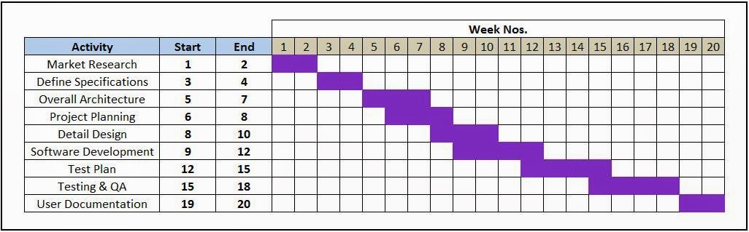

**4.2 ESTIMATION**

**4.2.1 Problem Based Estimation**

**Function Point Metrics**

**Our DFD contains the following things:**

**External inputs = 5**

**External outputs = 1**

**Internal Logical Files = 6**

**External Inquiries = 1**

**External Interfaces = 2**

**Thus the Function Point Metrics is as follows:**

**Information Weighting Factor**

**Domain Value Count Simple Average Complex**

**External Inputs = 5 X 3 4 6 = 15**

**External Outputs = 1 X 4 5 7 = 4**

**Internal Logical Files = 6 X 3 4 6 = 18**

**External Inquiries = 1 X 7 10 15 = 7**

**External Interfaces = 2 X 5 7 10 = 10**

**Count Total 54**

**For a moderately complex product ∑Fi = 46**

**FP = Count total*(0.65 + ( 0.01 * ∑Fi))**

**FP = 54 * (0.65 + ( 0.01 * 46))**

**FP = 54 * (1.11)**

**Thus the Function Point (UFP) = 60**

**4.2.2 Empirical model based estimation (COCOMO II model)**

**No. of screens in the project: 13**

**No. of reports: 5**

**No. of 3GL components: 0**

**Developer’s experience/capability: Very Low**

**Complexity of screens: 8 simple, 2 average, 3 complex**

**Complexity of reports: 5 simple**

**% reuse: 70**

**Taking the values from the given tables:**





Thus, Object Points= [8X1 + 2X2 + 3X3 + 5X2 + 0X10] =31

NOP= (object points) X [(100-%reuse)/100] =31 X 0.30=9.3

PROD=4

Thus, **Estimated effort**=NOP/PROD=9.3/4**=2.325 person-months**

**4.3 RISK MANAGEMENT (Risk Table)**

|  |  |  |  |
| --- | --- | --- | --- |
| **Risks** | **Category** | **Probability** | **Impact** |
| Size estimate may be significantly low.  Larger number of users than planned.  Less reuse than planned.  End-users resist system  Delivery deadline will be tightened.  Customer will change requirements.  Technology will not meet  expectations.  Lack of training on tools. | **PS**  **PS**  **PS**  **BU**    **BU**    **PS**  **TE**  **DE** | **60%**  **30%**  **70%**  **40%**  **50%**  **80%**  **30%**  **80%** | **2**  **3**  **2**  **3**  **2**  **2**  **1**  **3** |

Impact values:

1. Catastrophic 3. Marginal

2. critical 4. Negligible

**5. Screen Layouts**

**Home:**



**Career:**

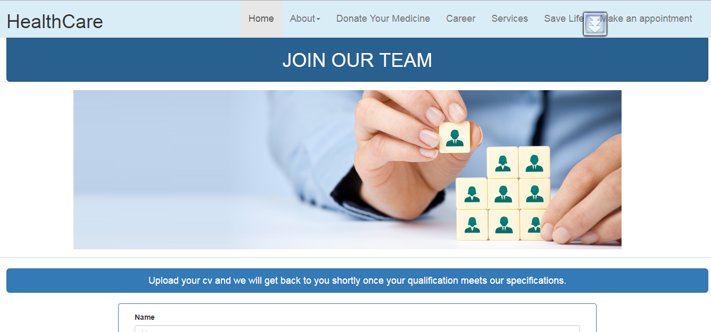

**About Us Module:**

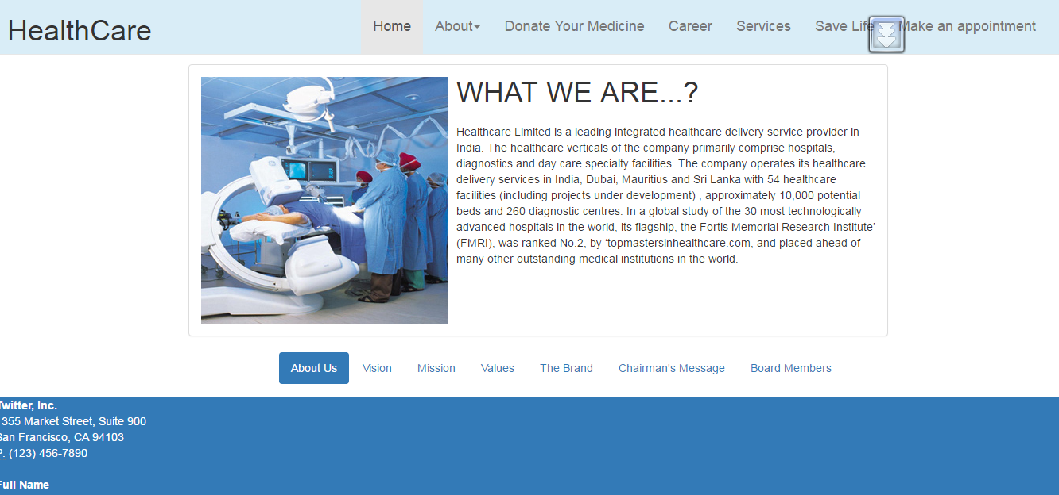

**6. TESTING**

**Testing Objective:-**

* Testing is the process of executing a process with the intent of finding an error.
* A good test is one that has a high probability of finding an as yet undiscovered error.
* A successful test is one that uncovers an as yet undiscovered error.
* The objective is to design test that systematically uncover different classes of error and do so with minimum amount of time and effort.
* Demonstrate that software functions appear to be
* Working according to specification.
* Data collected during testing provides a good indication of software reliability and some indication of software quality.
* Testing cannot show the absence of defects, it can only show that software defects are present.

.

**Black-Box Testing:** After devising the specific functions that the client had required and integrating the system, black box system methods were used. This was done with the prime objective of checking whether each function works properly and is error free also.

Dummy values were entered and database was checked separately to ensure that if was receiving data properly.

**White-Box Testing:** It was done to closely examine the procedural detail. This was done to check the performance of each individual module. Knowing how every module works, test was conducted to see if all the components of a single module work without error or not.

**Pseudo Code For Book an appointment Module:**

Procedure File

1. Output Home Page’
2. Input Choice
3. If Choice equals ‘Request Appointmnet
4. Fill the appeared form details
5. Input Data to Appointment_db
6. Output Confirmation of submission of data into Appointment_db
7. Else if choice equals ‘Carrier’
8. Fill the appeared form details
9. Input Data to Carrier_db
10. Output Confirmation of submission of data.

**Cyclomatic complexity:**

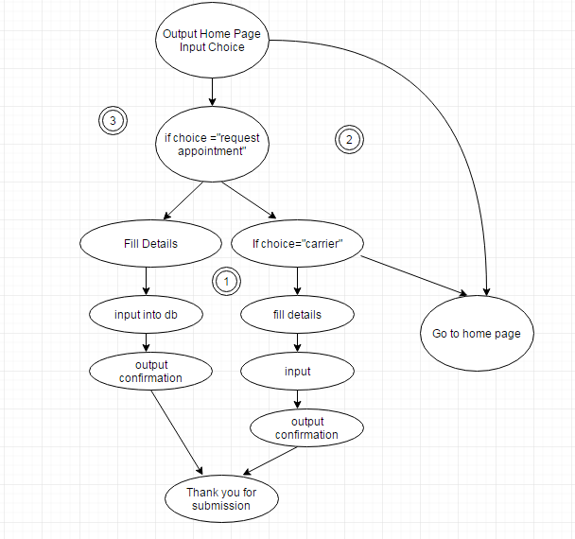

**Cyclomatic complexity=3**

**V(G) = E-V+2**

**= 12-11+2**

**= 3**

**Predicate Node = 2**

**V(G) = 3**

**7. References**

* www.w3schools.com
* [www.nchsoftware.com](http://www.nchsoftware.com)
* www.getbootstrap.com