**International Debt Analusis**

A. KPI’s

**1. Number of Distinct Countries:**

SELECT

COUNT(DISTINCT country_name) AS Total_Countries

FROM

ids;

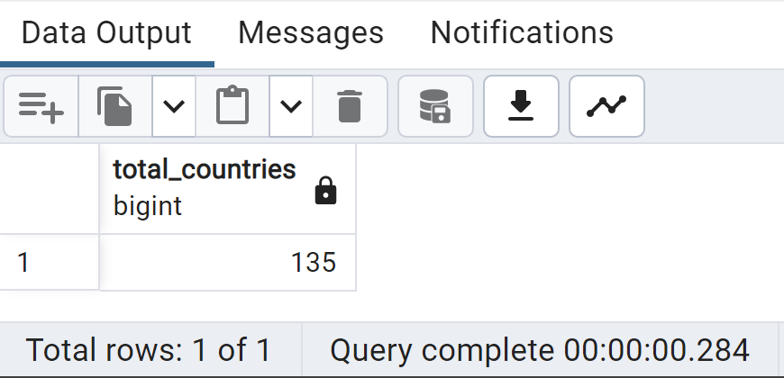

**2. Number of Distinct Debt indicators:**

SELECT

COUNT(DISTINCT series_name) AS total_indicators

FROM

Ids;

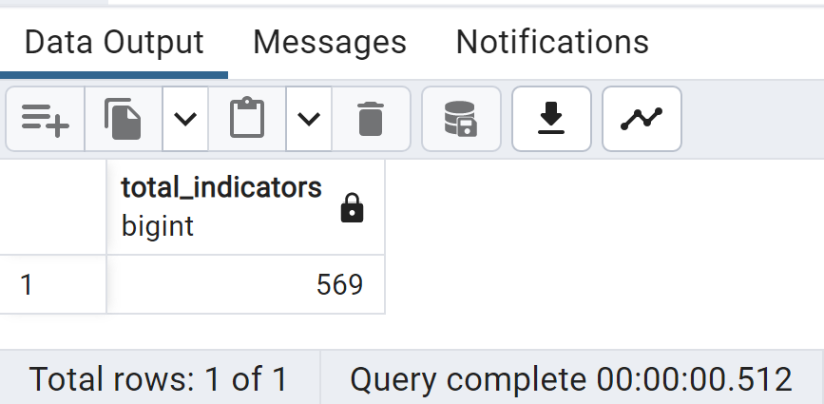

**3.** **Total amount of Debt owed by countries for 2022**

SELECT

country_name, SUM(_2022) AS Total_Debt_2022

FROM

ids

GROUP BY 1

ORDER BY 1;

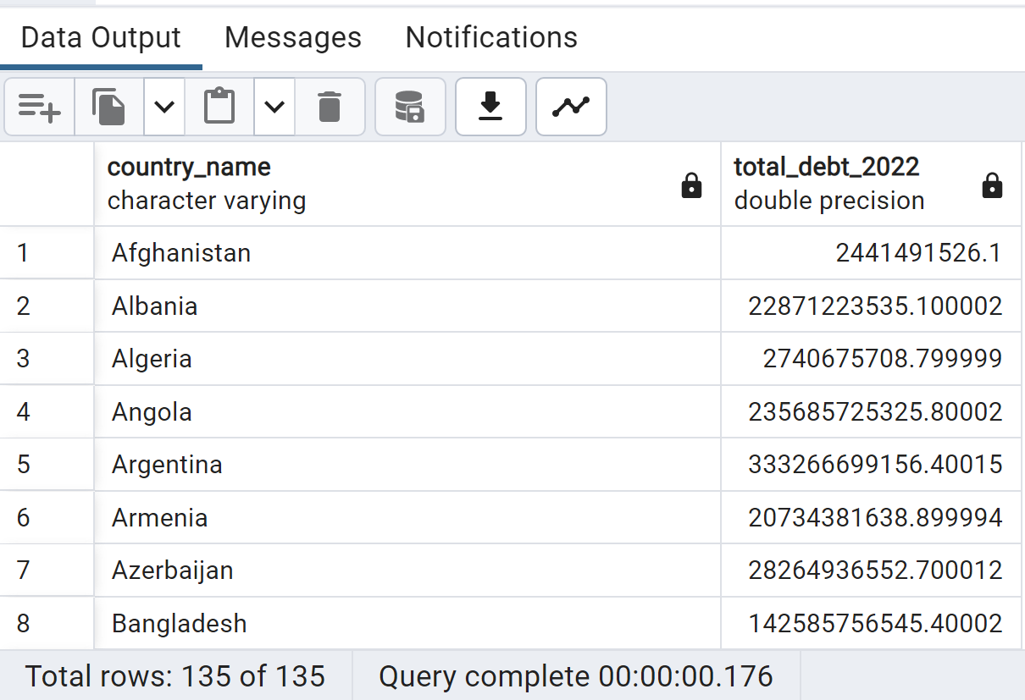

**4.** **Country with highest Total Debt in 2022**

SELECT

country_name, SUM(_2022) AS Total_Debt_2022

FROM

ids

GROUP BY 1

ORDER BY 2 DESC

LIMIT 8;

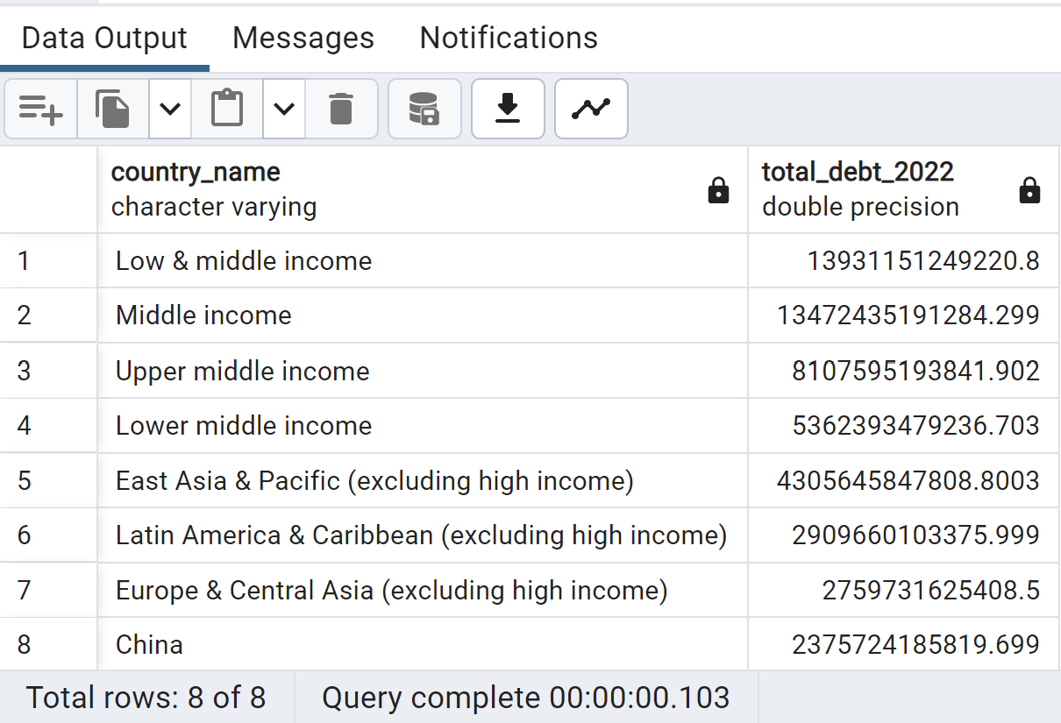

**5.Average Pizzas Per Order**

SELECT

ROUND(

ROUND(SUM(quantity),2) / ROUND(COUNT(DISTINCT order_id),2)

,2) AS Average_pizza_per_order

FROM

pizza_sales;

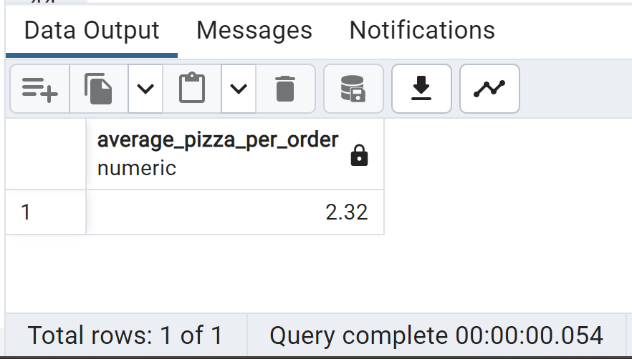

B. Daily Trend for Total Orders

SELECT

TO_CHAR(order_date, 'Day') AS order_day,

COUNT(DISTINCT order_id) AS Total_Orders

FROM

pizza_sales

GROUP BY

order_day

ORDER BY

Total_Orders DESC

;

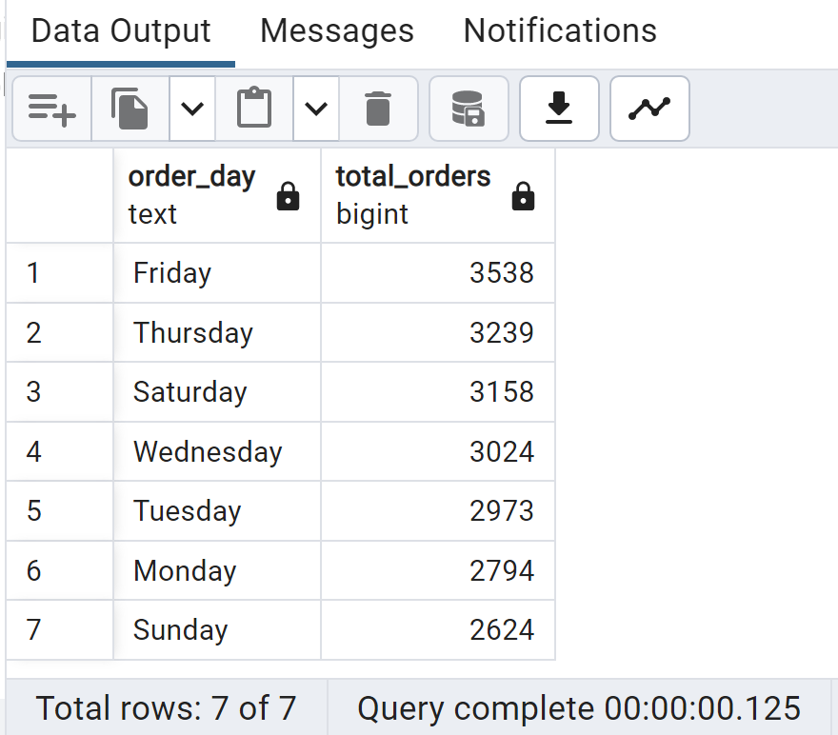

C. Monthly Trend for Total Orders

SELECT

TO_CHAR(order_date, 'Month') AS Month_Name,

COUNT(DISTINCT order_id) AS Total_Orders

FROM

pizza_sales

GROUP BY

Month_Name

ORDER BY

Total_Orders DESC

;

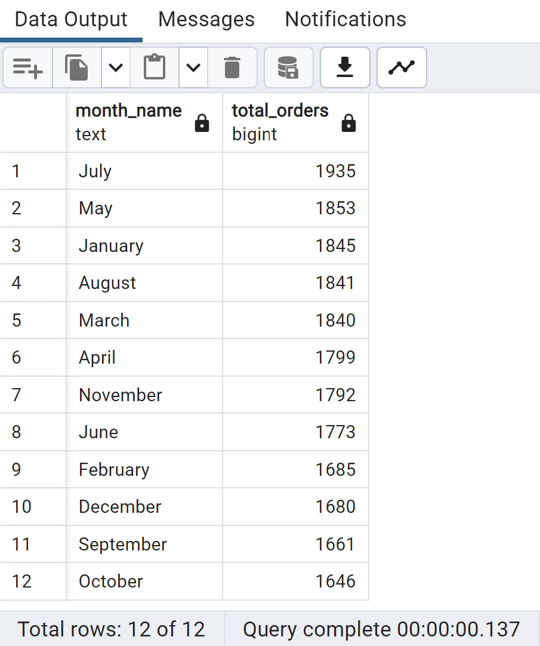

D. % of Sales by Pizza Category

SELECT

pizza_category,

ROUND(SUM(total_price) *100 / (SELECT SUM(total_price)

FROM pizza_sales

),2)

AS percent_of_Sales

FROM

pizza_sales

GROUP BY

pizza_category

;

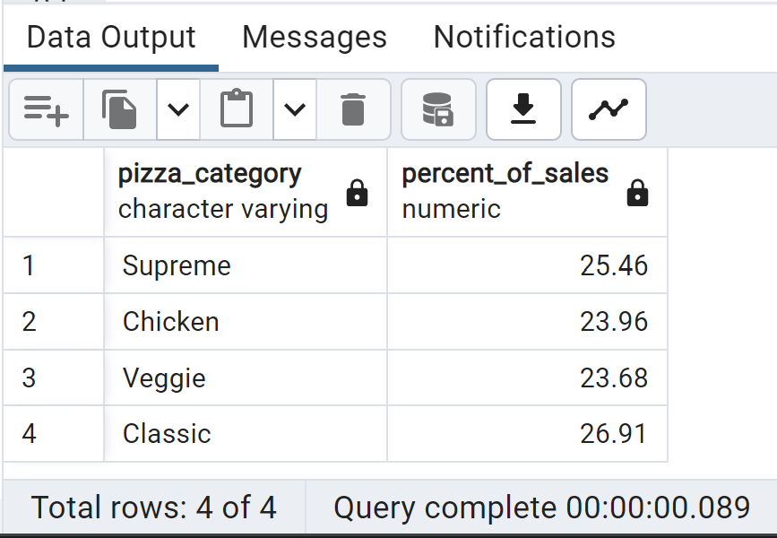

E. % of Sales by Pizza Size

SELECT

pizza_size,

ROUND(SUM(total_price)*100 / (SELECT SUM(total_price)

FROM pizza_sales

),2)

AS percent_of_sales

FROM

pizza_sales

GROUP BY

pizza_size

ORDER BY

percent_of_sales DESC;

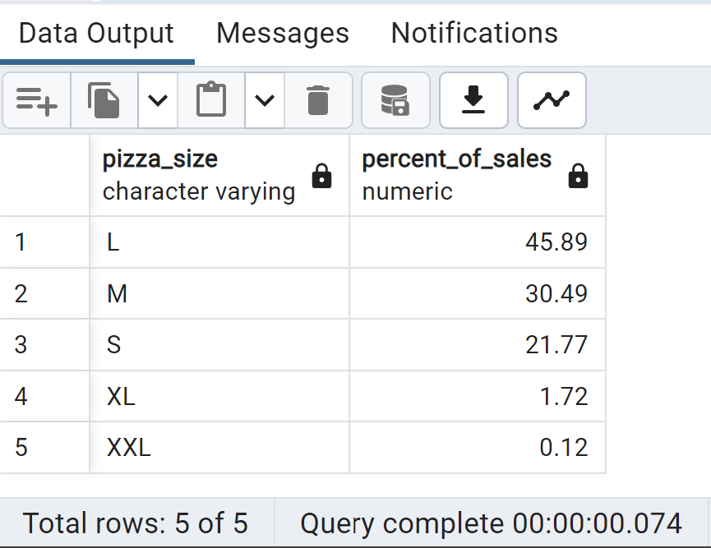

F. Top 5 Best Sellers by Revenue, Total Quantity & Total Orders

Top 5 Best Sellers by Revenue

SELECT

pizza_name, SUM(total_price) AS Total_Revenue

FROM

pizza_sales

GROUP BY

pizza_name

ORDER BY

Total_Revenue DESC

LIMIT

5

;

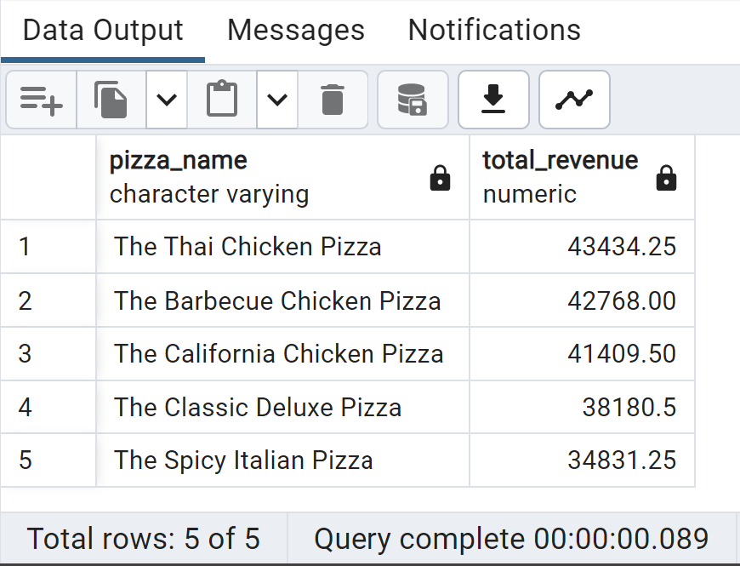

Bottom 5 Sellers by Revenue

SELECT

pizza_name, SUM(total_price) AS Total_Revenue

FROM

pizza_sales

GROUP BY

pizza_name

ORDER BY

Total_Revenue

LIMIT

5

;

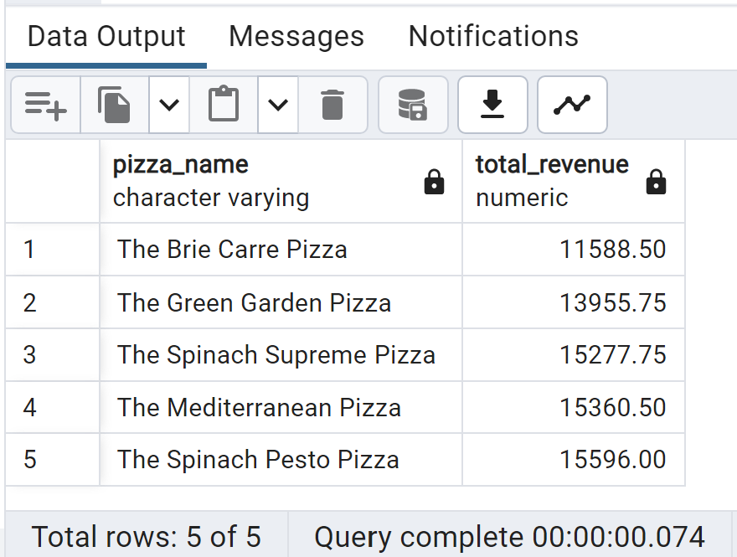

Top 5 Best Sellers by Quantity

SELECT

pizza_name, SUM(quantity) AS Total_Quantity

FROM

pizza_sales

GROUP BY

pizza_name

ORDER BY

Total_Quantity DESC

LIMIT

5

;

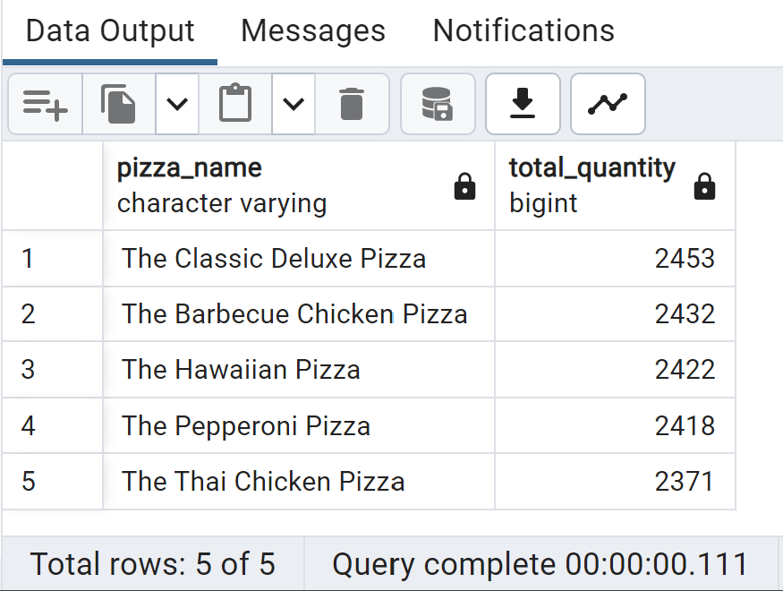

Bottom 5 Sellers by Revenue

SELECT

pizza_name, SUM(quantity) AS Total_Quantity

FROM

pizza_sales

GROUP BY

pizza_name

ORDER BY

Total_Quantity

LIMIT

5

;

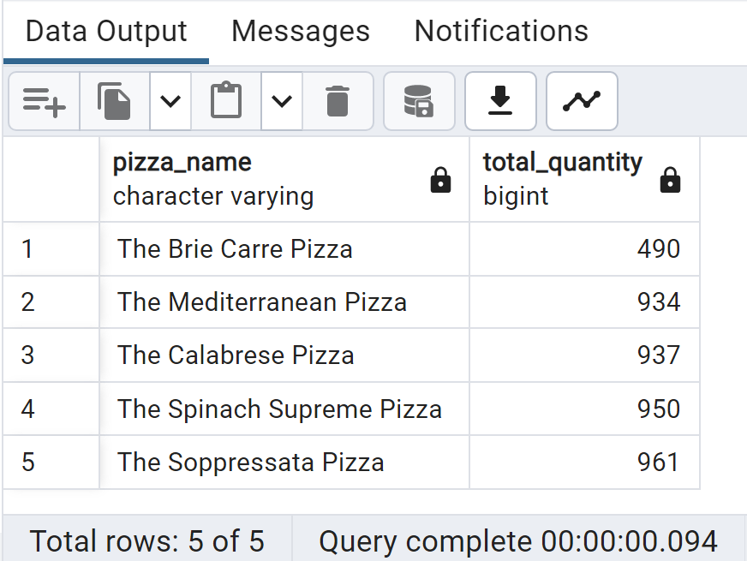

Top 5 Best Sellers by Total Orders

SELECT

pizza_name, COUNT(DISTINCT order_id) AS Total_Orders

FROM

pizza_sales

GROUP BY

pizza_name

ORDER BY

Total_Orders DESC

LIMIT

5

;

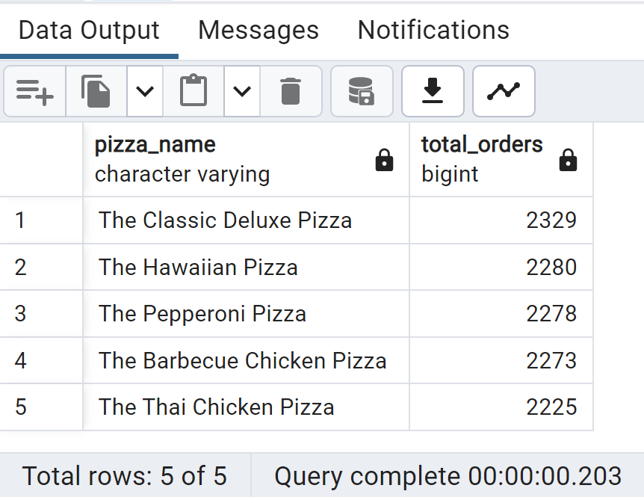

Bottom 5 Sellers by Total Orders

SELECT

pizza_name, COUNT(DISTINCT order_id) AS Total_Orders

FROM

pizza_sales

GROUP BY

pizza_name

ORDER BY

Total_Orders

LIMIT

5

;

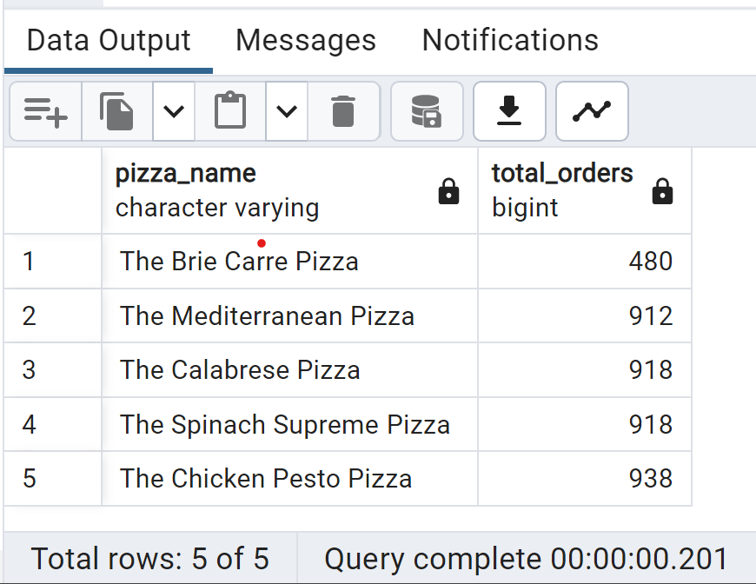

G. Number of Customers each day & Busiest hours

SELECT

order_date,

COUNT(DISTINCT order_id) AS num_customers

FROM

pizza_sales

GROUP BY

order_date

ORDER BY

order_date;

SELECT

EXTRACT(HOUR FROM order_time) AS order_hour,

COUNT(DISTINCT order_id) AS num_orders

FROM

pizza_sales

GROUP BY

order_hour

ORDER BY

num_orders DESC;

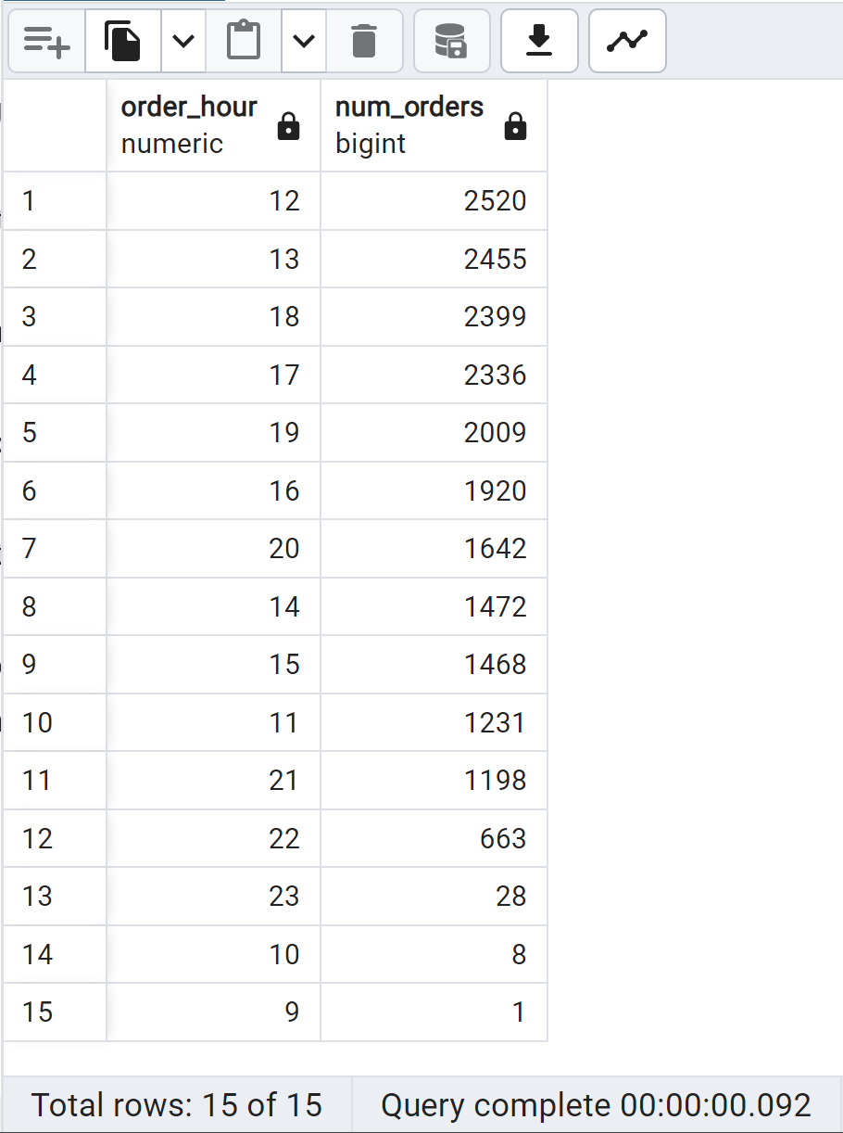

H. Seasonality Trends

SELECT

EXTRACT(MONTH FROM order_date) AS month,

COUNT(DISTINCT order_id) AS total_orders

FROM

pizza_sales

GROUP BY

month

ORDER BY

month;

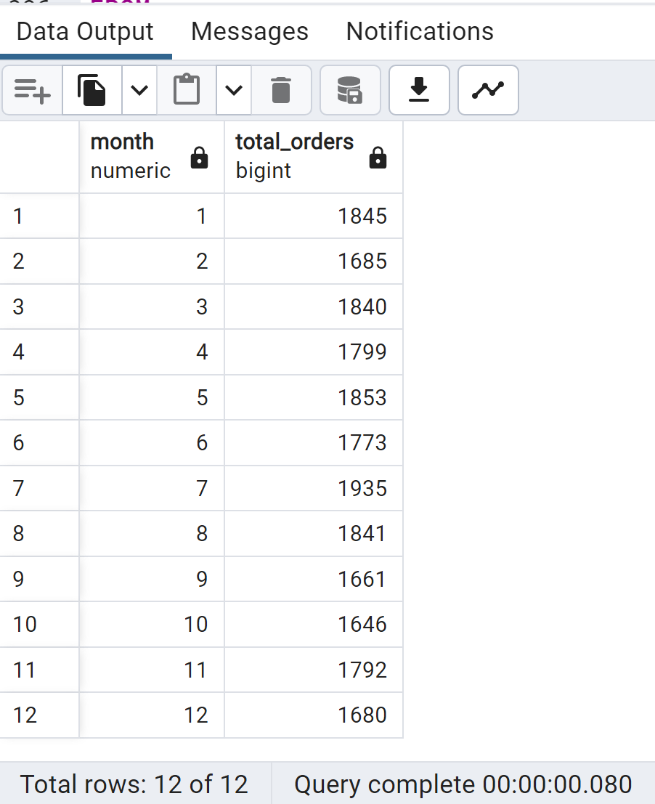

I.Average Orders per Day

WITH daily_orders AS (

SELECT

order_date,

COUNT(DISTINCT order_id) AS daily_order_count

FROM

pizza_sales

GROUP BY

order_date

)

SELECT

AVG(daily_order_count) AS avg_orders_per_day

FROM

daily_orders;

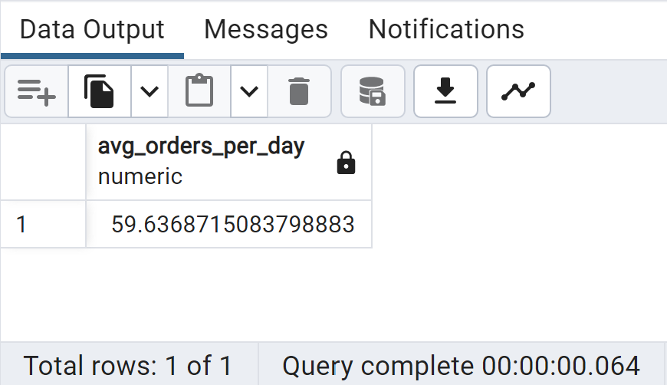

J.Average Pizza Per Day sold

WITH avg_pizza as(

SELECT order_date,

COUNT(quantity) as daily_pizza

FROM pizza_sales

GROUP BY order_date

)

SELECT

AVG(daily_pizza) AS AVG_PIZZA_PER_DAY

FROM avg_pizza

;

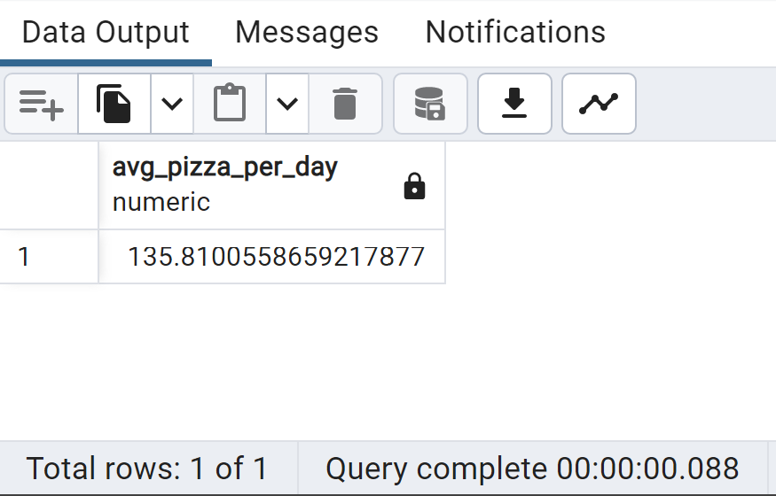

**Most occupied Days & Month**

**Days**-Orders are highest on Friday & Saturday evenings

**Month**-Orders are highest on January & July

**Sales Performance**

**Category**-Classical contributes maximum to Sales & Total Orders

**Size**-Large pizza contributes maximum to Sales

**Best Sellers**

**Revenue**-Thai Chicken Pizza contribute maximum to Revenue

**Quantity**-Classical Deluxe Pizza contributes maximum to Total Quantities

**Total Orders**-Classic Deluxe Pizza contributes maximum to Total Orders

**Lowest Sellers**

**Revenue**-Brie Carre Pizza contribute minimum to Revenue

**Quantity**-Brie Carre Pizza contribute minimum to Total Quantities

**Total Orders**-Brie Carre Pizza contribute minimum to Total Orders

**Most occupied Time**

**Lunch**-12 P.M. - 1:30 P.M., **Dinner**-6 P.M. - 8 P.M.

**Data Source: Maven Analytics**

**GitHub Repo:** <https://github.com/tushar2704/Pizza-Sales-Analysis>

**Author: ©** **2023** [**Tushar Aggarwal**](https://www.linkedin.com/in/tusharaggarwalinseec/)