**Case Study 1: Job Data Analysis**

**job_data with the following columns:**

* **job_id:**Unique identifier of jobs
* **actor_id:**Unique identifier of actor
* **event:**The type of event (decision/skip/transfer).
* **language:**The Language of the content
* **time_spent:**Time spent to review the job in seconds.
* **org:**The Organization of the actor
* **ds:**The date in the format yyyy/mm/dd (stored as text).

**Tasks:**

1. **Jobs Reviewed Over Time:**

(Calculating the number of jobs reviewed per hour for each day in November 2020)

SELECT

DATE_TRUNC('hour', ds) AS review_hour,

DATE_TRUNC('day', ds) AS review_date,

COUNT(*) AS num_jobs_reviewed

FROM

job_data

WHERE

DATE_TRUNC('month', ds) = '2020-11-01'::DATE

GROUP BY

DATE_TRUNC('hour', ds),

DATE_TRUNC('day', ds)

ORDER BY

review_date,

review_hour;

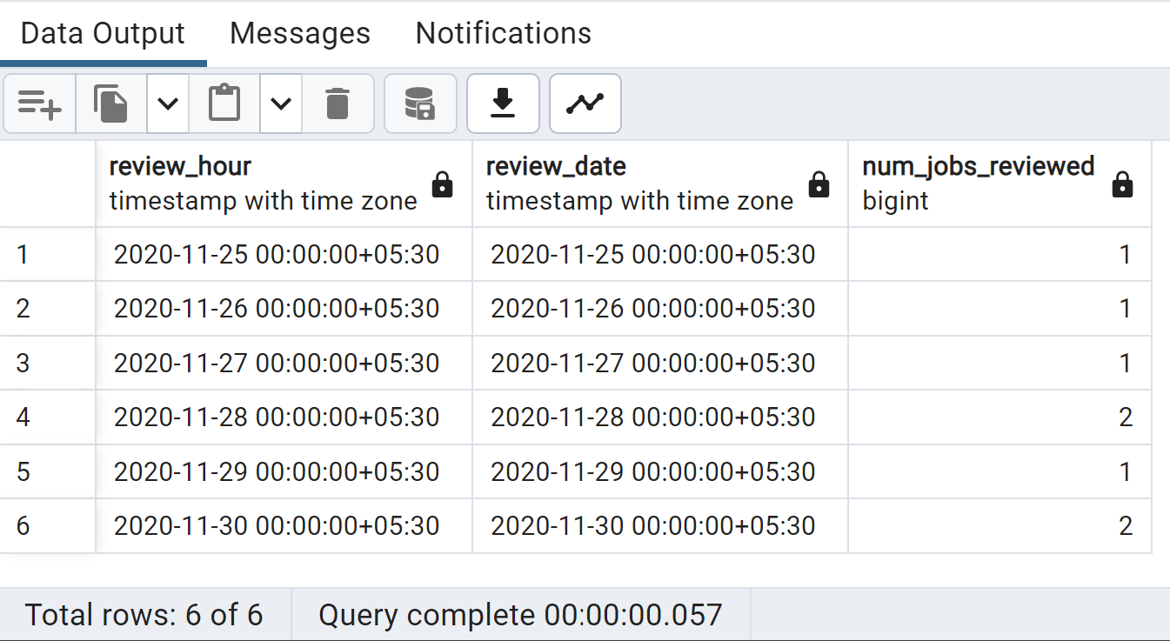

**B.Throughput Analysis:**

Calculating the 7-day rolling average of throughput (number of events per second)

WITH DAILY_METRIC AS (

SELECT

ds,

COUNT(job_id) AS job_review

FROM

job_data

GROUP BY

ds

)

SELECT

ds,

job_review,

AVG(job_review) OVER (ORDER BY ds ROWS BETWEEN 6 PRECEDING AND CURRENT ROW) AS throughput

FROM

DAILY_METRIC

ORDER BY

throughput DESC;

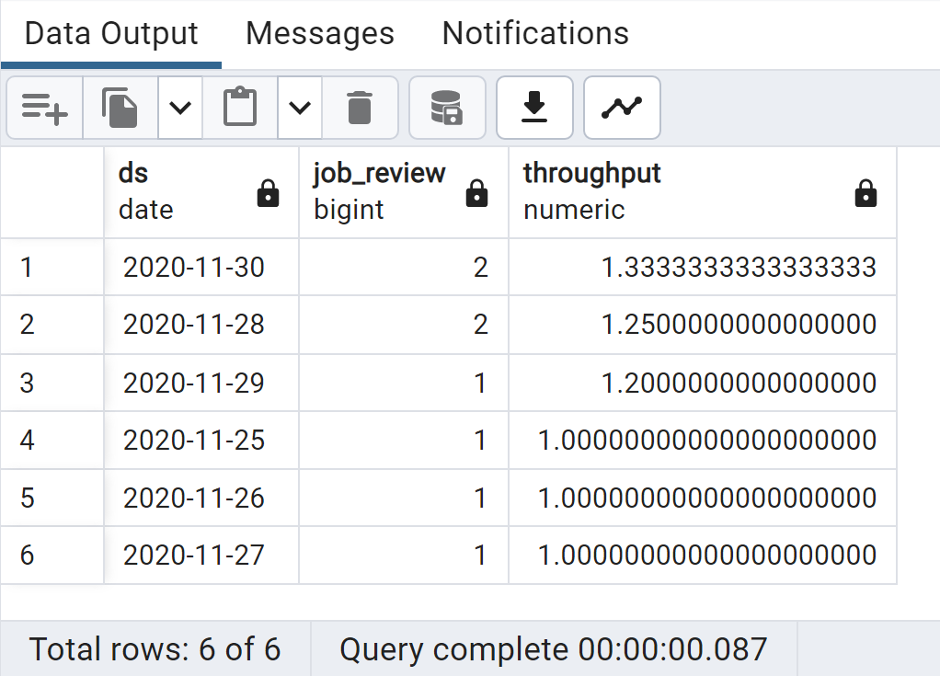

**C.Language Share Analysis:**

 Calculating the percentage share of each language in the last 30 days.

SELECT

language,

COUNT(language) AS language_count,

(COUNT(language) / (SELECT COUNT(*) FROM job_data)) * 100 AS percentage_share

FROM job_data

GROUP BY language

ORDER BY language DESC;

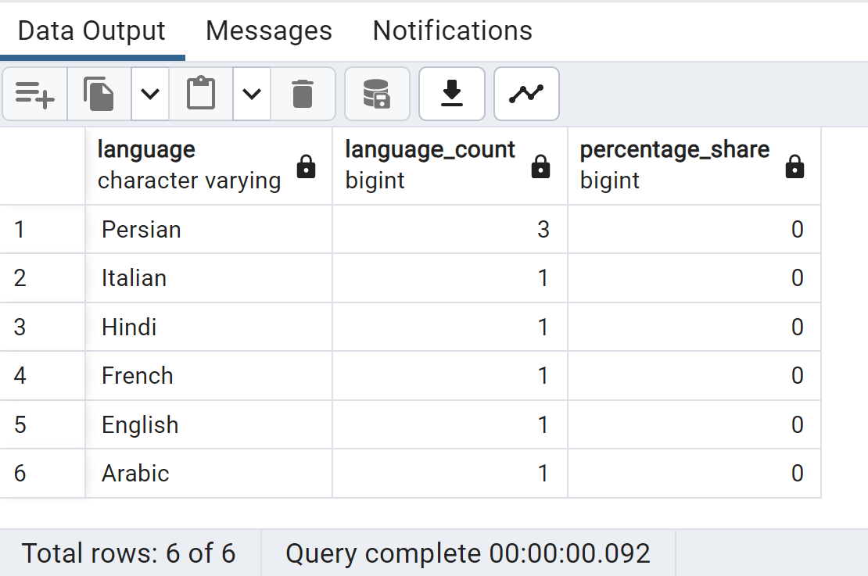

**D.Duplicate Rows Detection:**

 Identifying duplicate rows in the data.

SELECT *

FROM (

SELECT *,

ROW_NUMBER() OVER (PARTITION BY JOB_ID) AS DUPLICATE_ROWS

FROM JOB_DATA

) AS A_R

WHERE DUPLICATE_ROWS > 1;

