**Case Study 2: Investigating Metric Spike**

* **users**: Contains one row per user, with descriptive information about that user’s account.
* **events**: Contains one row per event, where an event is an action that a user has taken (e.g., login, messaging, search).
* **email_events**: Contains events specific to the sending of emails.

**A.Weekly User Engagement:**

Measuring the activeness of users on a weekly basis.

SELECT

DATE_TRUNC('week', created_at) AS week_start_date,

COUNT(DISTINCT user_id) AS active_users_count

FROM

users

GROUP BY

week_start_date

ORDER BY

week_start_date;

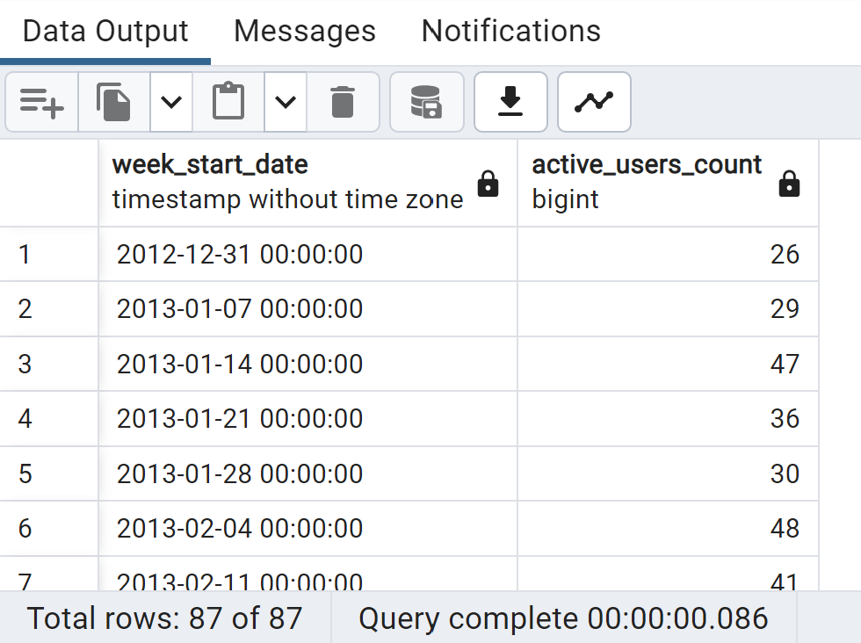

**B.User Growth Analysis:**

Analyzing the growth of users over time for a product.

SELECT

DATE_TRUNC('month', created_at) AS month_start_date,

COUNT(DISTINCT user_id) AS total_users

FROM

users

GROUP BY

month_start_date

ORDER BY

month_start_date;

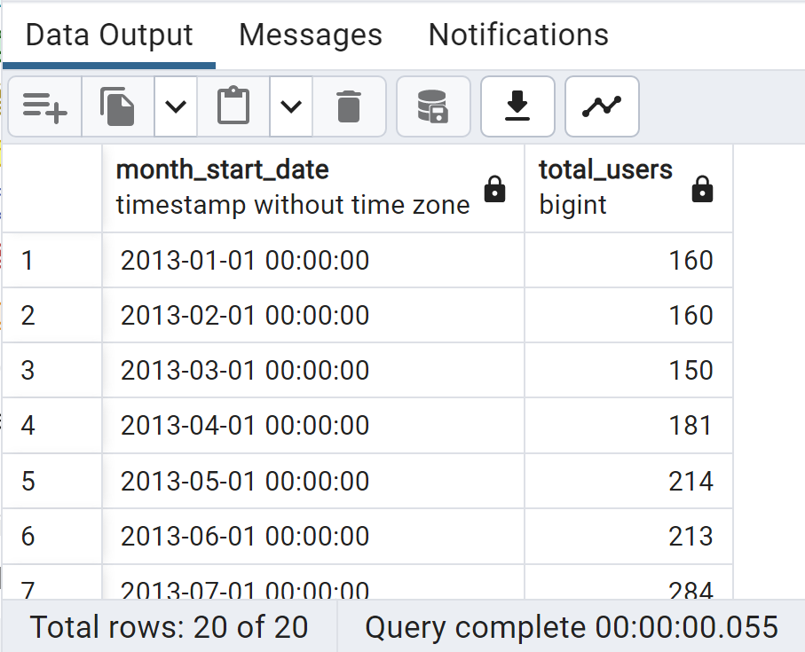

**C.Weekly Retention Analysis:**

**Analyzing the retention of users on a weekly basis after signing up for a product.**

WITH user_signups AS (

SELECT

user_id,

DATE_TRUNC('week', created_at) AS signup_week

FROM

users

),

user_activity AS (

SELECT

user_id,

DATE_TRUNC('week', occurred_at) AS activity_week

FROM

events

)

SELECT

us.signup_week AS cohort_week,

ua.activity_week AS retention_week,

COUNT(DISTINCT ua.user_id) AS retained_users

FROM

user_signups us

LEFT JOIN

user_activity ua ON us.user_id = ua.user_id AND ua.activity_week >= us.signup_week

GROUP BY

us.signup_week, ua.activity_week

ORDER BY

us.signup_week, ua.activity_week;

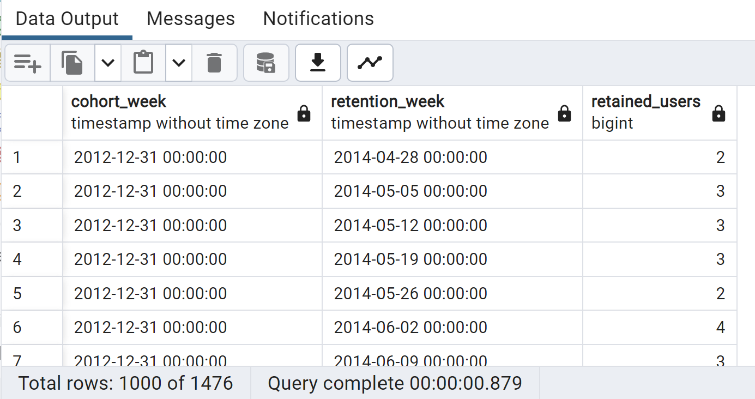

**D.Weekly Engagement Per Device:**

**Measuring the activeness of users on a weekly basis per device.**

SELECT

DATE_TRUNC('week', e.occurred_at) AS week_start_date,

e.device,

COUNT(DISTINCT e.user_id) AS active_users_count

FROM

events e

GROUP BY

week_start_date, e.device

ORDER BY

week_start_date, e.device;

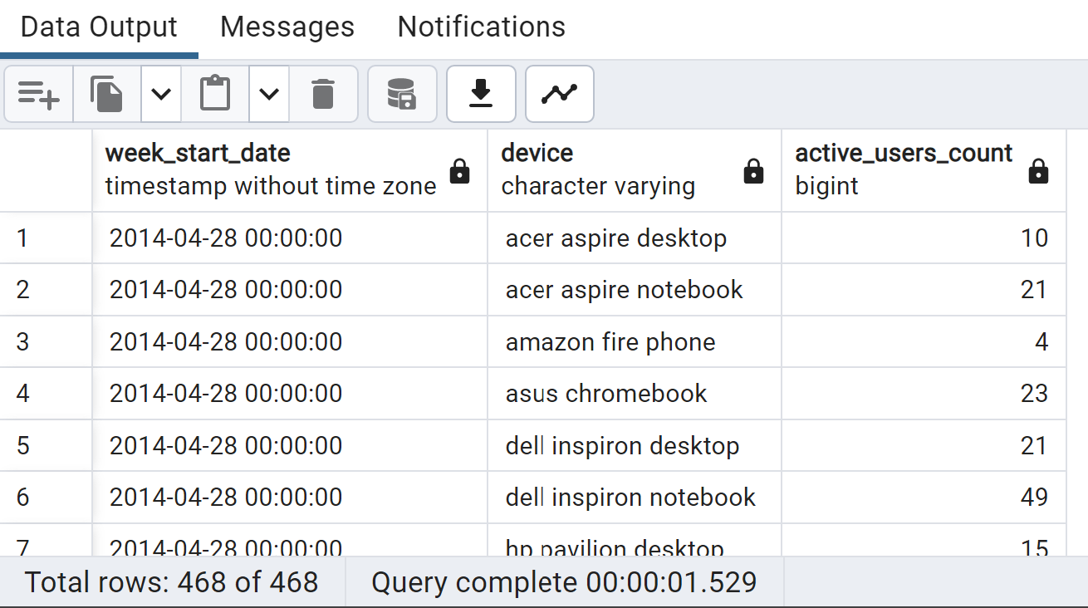

**E.Email Engagement Analysis:**

**Analyzing how users are engaging with the email service.**

SELECT

action,

COUNT(DISTINCT user_id) AS unique_users_count,

COUNT(*) AS total_actions_count

FROM

email_events

GROUP BY

action

ORDER BY

action;

