**PIZZA-SALES-ANALYSIS SQL REPORT**

A. KPI’s

**1. Total Revenue:**

SELECT

SUM(total_price) AS total_revenue

FROM

pizza_sales;

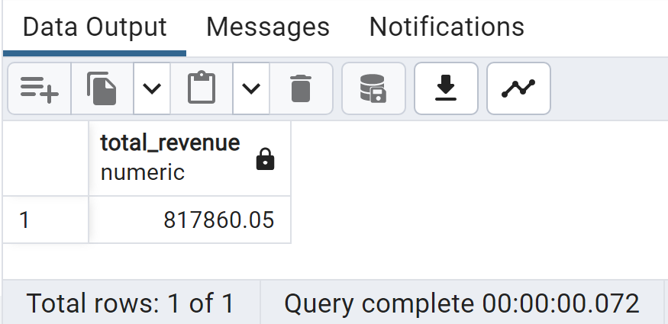

**2. Average Order Value:**

SELECT

SUM(total_price) / COUNT (DISTINCT order_id) AS AVG_Order_Value

FROM

pizza_sales;

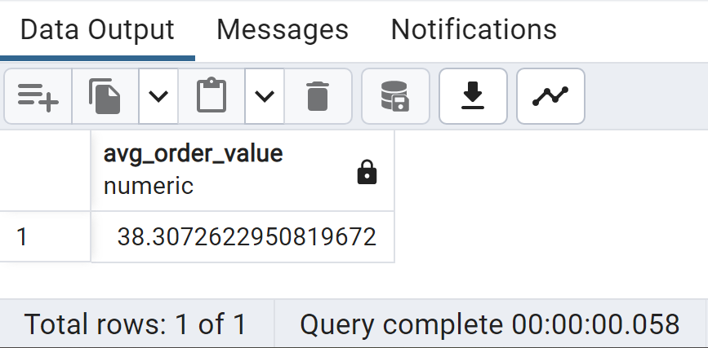

**3.Total Pizza Sold**

SELECT

SUM(quantity) AS Total_Pizza_Sold

FROM

pizza_sales;

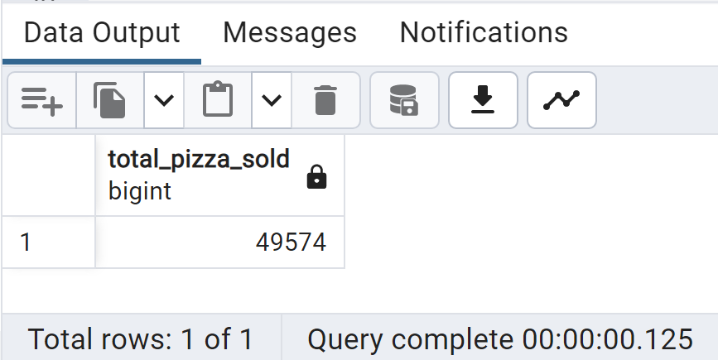

**4.Total Orders**

SELECT

COUNT(DISTINCT order_id) AS Total_Orders

FROM

pizza_sales;

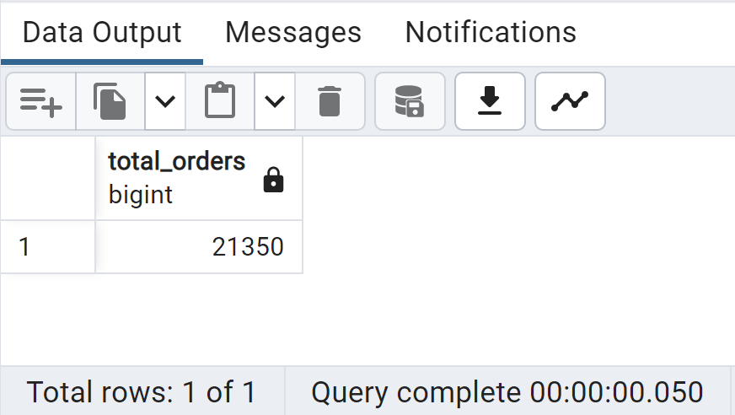

**5.Average Pizzas Per Order**

SELECT

ROUND(

ROUND(SUM(quantity),2) / ROUND(COUNT(DISTINCT order_id),2)

,2) AS Average_pizza_per_order

FROM

pizza_sales;

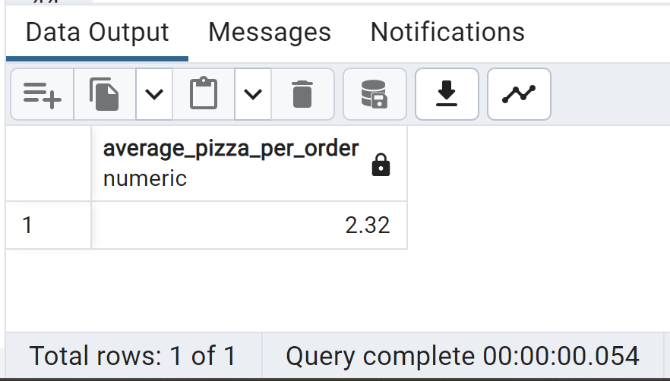

B. Daily Trend for Total Orders

SELECT

TO_CHAR(order_date, 'Day') AS order_day,

COUNT(DISTINCT order_id) AS Total_Orders

FROM

pizza_sales

GROUP BY

order_day

ORDER BY

Total_Orders DESC

;

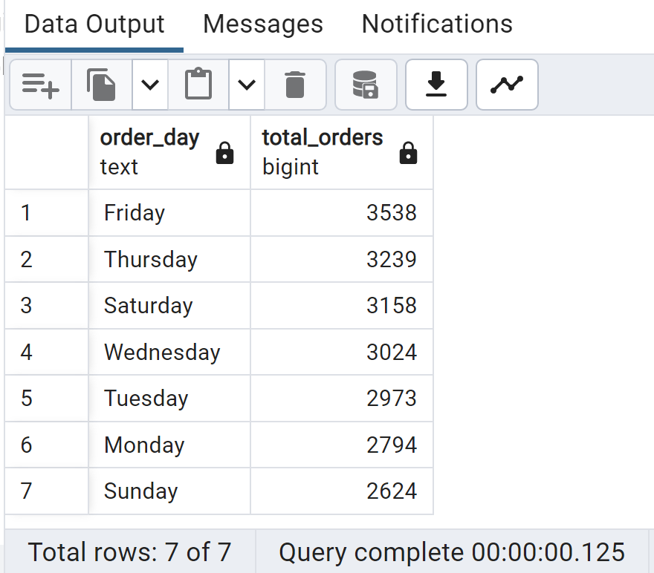

C. Monthly Trend for Total Orders

SELECT

TO_CHAR(order_date, 'Month') AS Month_Name,

COUNT(DISTINCT order_id) AS Total_Orders

FROM

pizza_sales

GROUP BY

Month_Name

ORDER BY

Total_Orders DESC

;

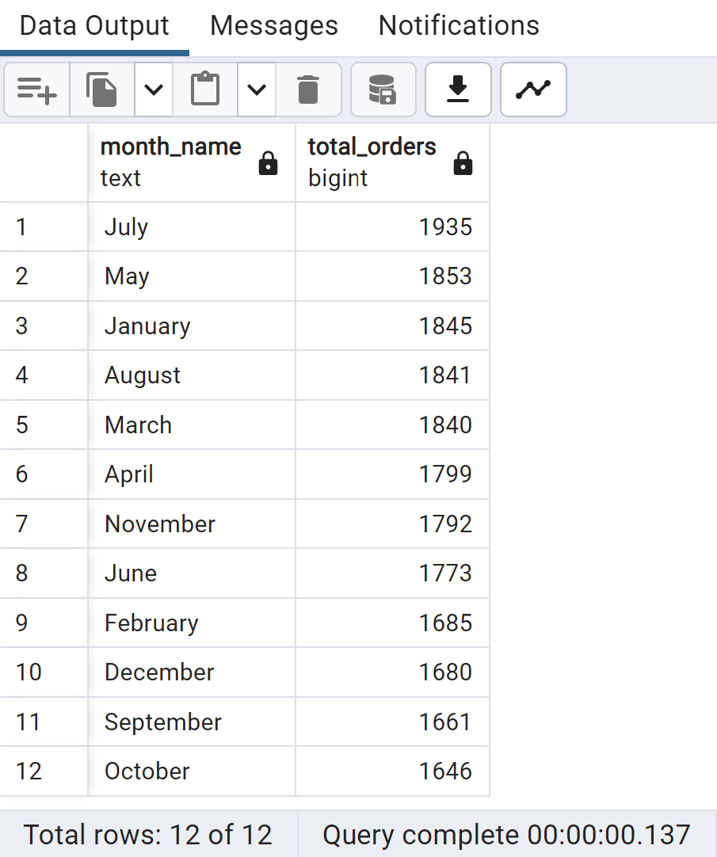

D. % of Sales by Pizza Category

SELECT

pizza_category,

ROUND(SUM(total_price) *100 / (SELECT SUM(total_price)

FROM pizza_sales

),2)

AS percent_of_Sales

FROM

pizza_sales

GROUP BY

pizza_category

;

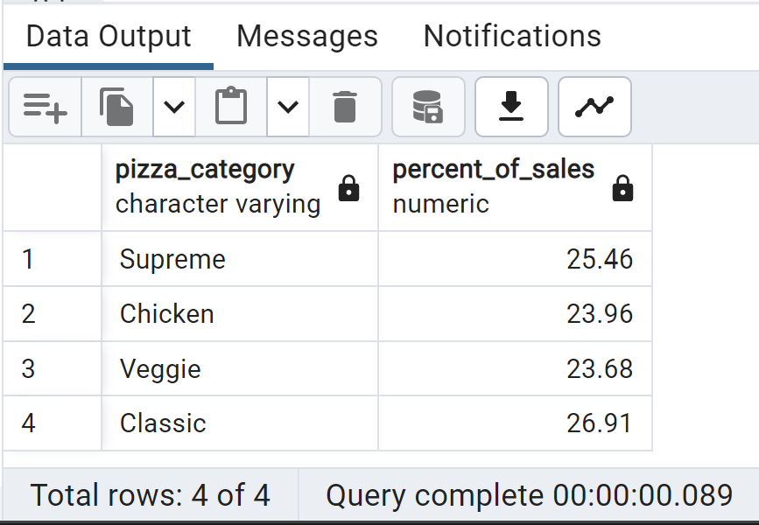

E. % of Sales by Pizza Size

SELECT

pizza_size,

ROUND(SUM(total_price)*100 / (SELECT SUM(total_price)

FROM pizza_sales

),2)

AS percent_of_sales

FROM

pizza_sales

GROUP BY

pizza_size

ORDER BY

percent_of_sales DESC;

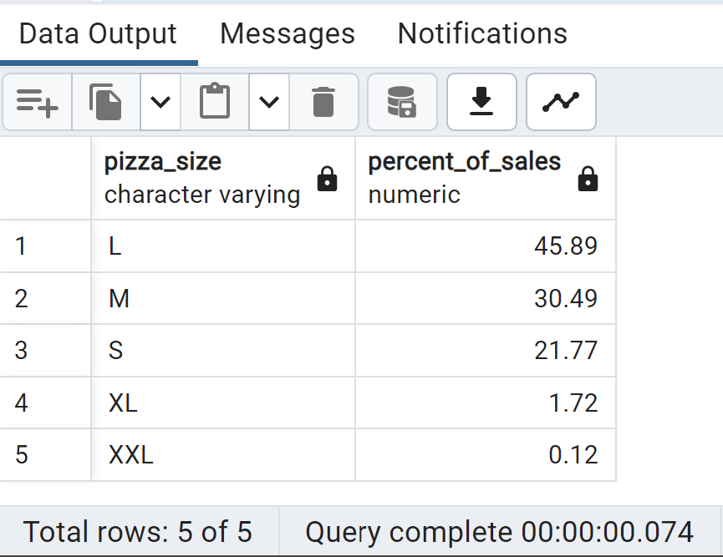

F. Top 5 Best Sellers by Revenue, Total Quantity & Total Orders

Top 5 Best Sellers by Revenue

SELECT

pizza_name, SUM(total_price) AS Total_Revenue

FROM

pizza_sales

GROUP BY

pizza_name

ORDER BY

Total_Revenue DESC

LIMIT

5

;

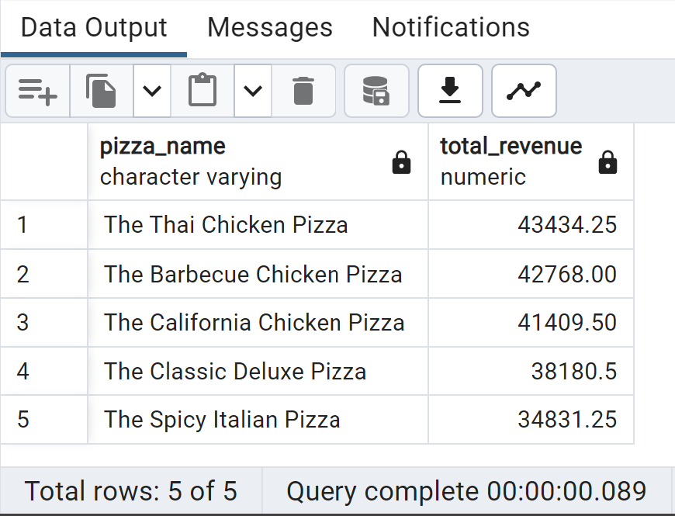

Bottom 5 Sellers by Revenue

SELECT

pizza_name, SUM(total_price) AS Total_Revenue

FROM

pizza_sales

GROUP BY

pizza_name

ORDER BY

Total_Revenue

LIMIT

5

;

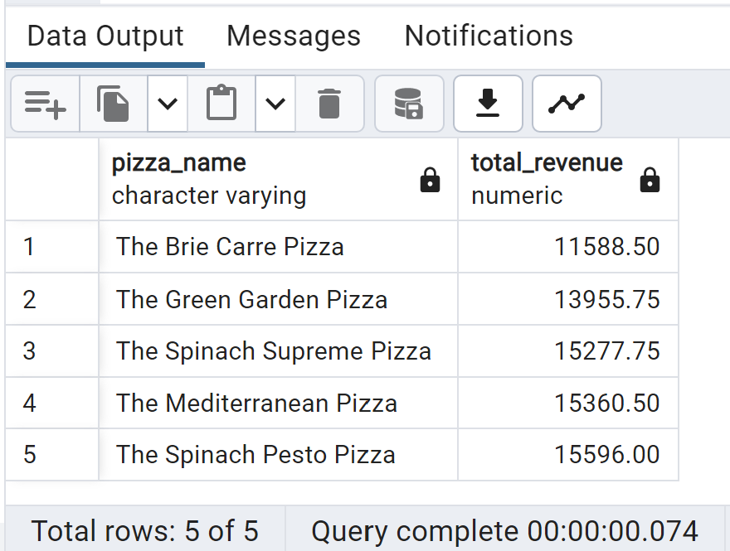

Top 5 Best Sellers by Quantity

SELECT

pizza_name, SUM(quantity) AS Total_Quantity

FROM

pizza_sales

GROUP BY

pizza_name

ORDER BY

Total_Quantity DESC

LIMIT

5

;

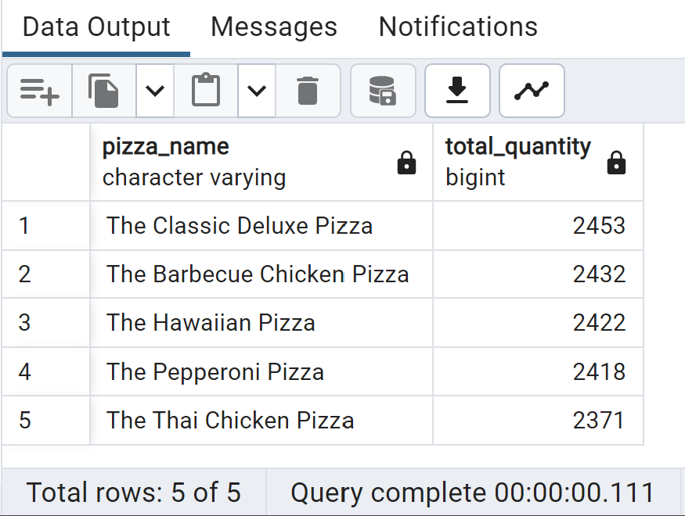

Bottom 5 Sellers by Revenue

SELECT

pizza_name, SUM(quantity) AS Total_Quantity

FROM

pizza_sales

GROUP BY

pizza_name

ORDER BY

Total_Quantity

LIMIT

5

;

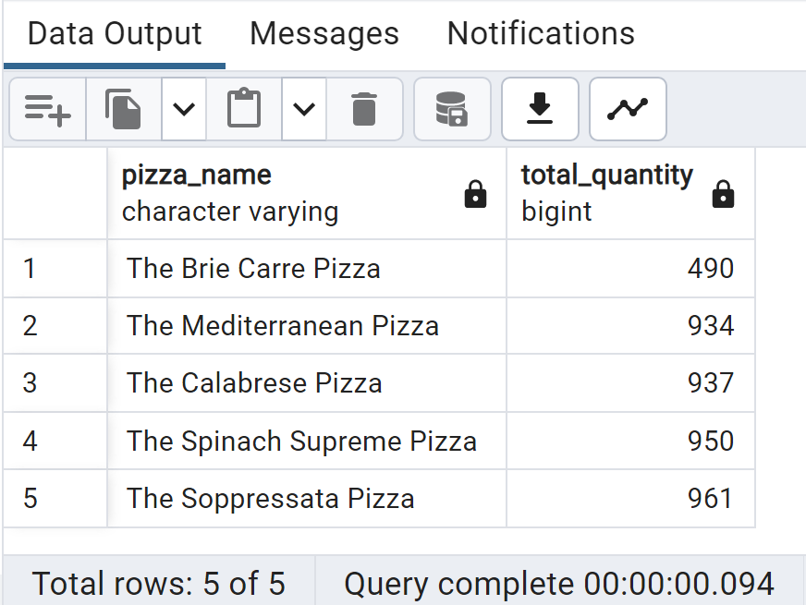

Top 5 Best Sellers by Total Orders

SELECT

pizza_name, COUNT(DISTINCT order_id) AS Total_Orders

FROM

pizza_sales

GROUP BY

pizza_name

ORDER BY

Total_Orders DESC

LIMIT

5

;

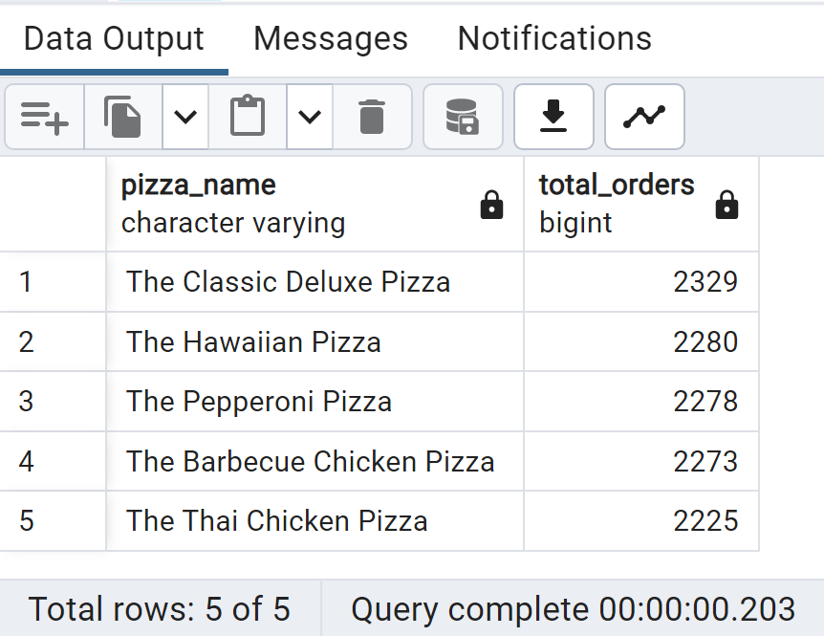

Bottom 5 Sellers by Total Orders

SELECT

pizza_name, COUNT(DISTINCT order_id) AS Total_Orders

FROM

pizza_sales

GROUP BY

pizza_name

ORDER BY

Total_Orders

LIMIT

5

;

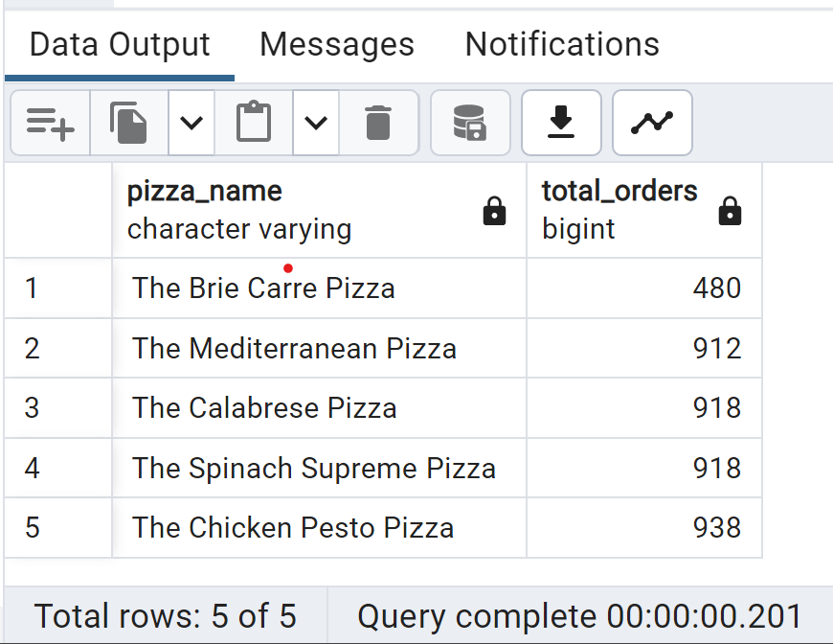

G. Number of Customers each day & Busiest hours

SELECT

order_date,

COUNT(DISTINCT order_id) AS num_customers

FROM

pizza_sales

GROUP BY

order_date

ORDER BY

order_date;

SELECT

EXTRACT(HOUR FROM order_time) AS order_hour,

COUNT(DISTINCT order_id) AS num_orders

FROM

pizza_sales

GROUP BY

order_hour

ORDER BY

num_orders DESC;

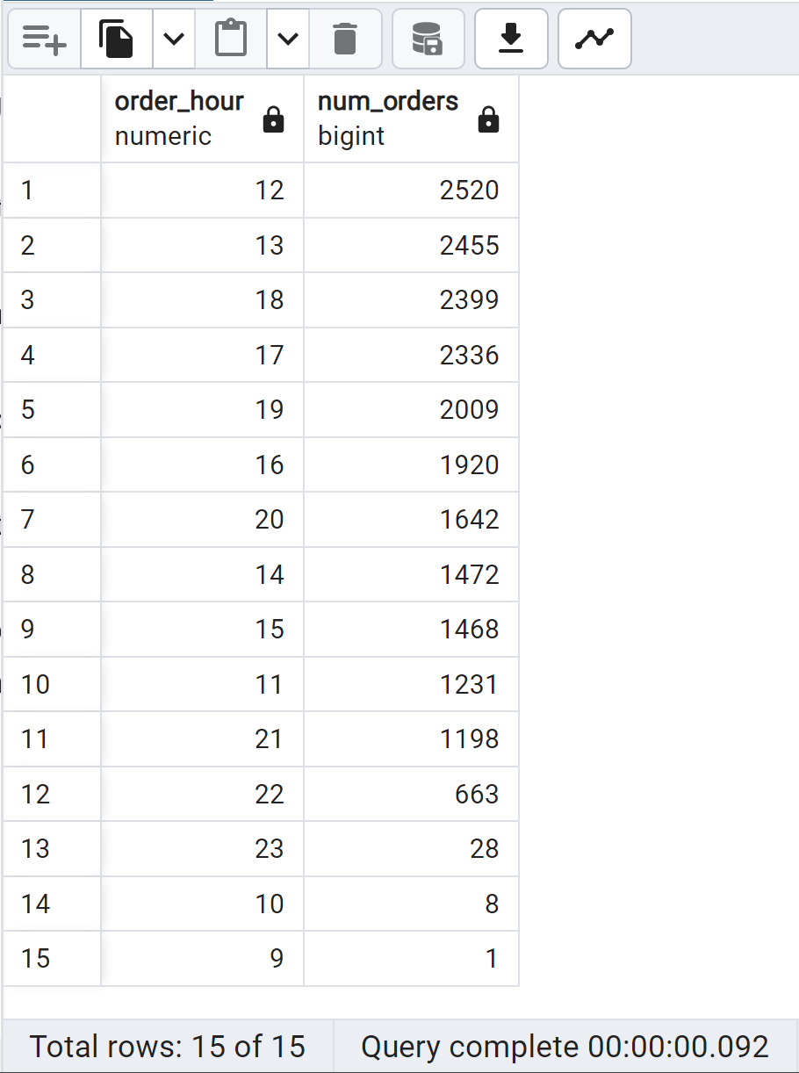

H. Seasonality Trends

SELECT

EXTRACT(MONTH FROM order_date) AS month,

COUNT(DISTINCT order_id) AS total_orders

FROM

pizza_sales

GROUP BY

month

ORDER BY

month;

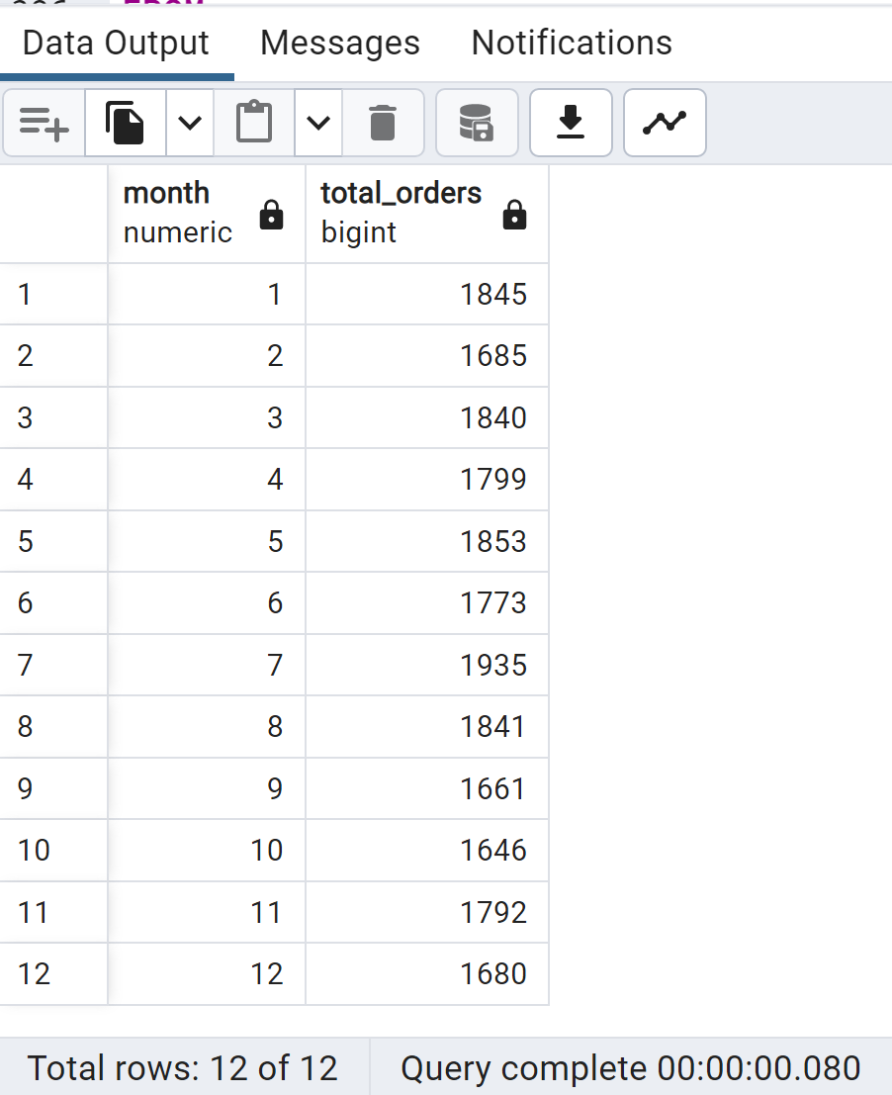

I.Average Orders per Day

WITH daily_orders AS (

SELECT

order_date,

COUNT(DISTINCT order_id) AS daily_order_count

FROM

pizza_sales

GROUP BY

order_date

)

SELECT

AVG(daily_order_count) AS avg_orders_per_day

FROM

daily_orders;

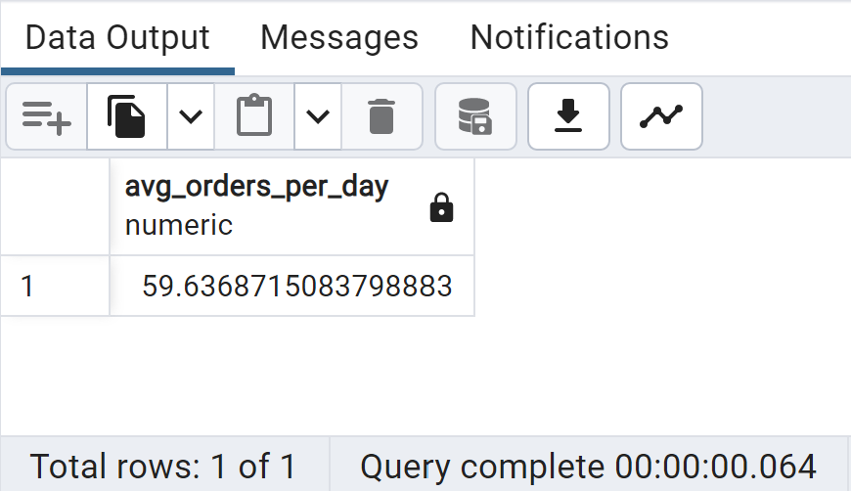

J.