**Sales for Retail and Food Services in U.S.A.**

**1)Top-performing industries in terms of sales for a year 2021, and how do their sales compare month-over-month?**

WITH monthly_sales AS (

SELECT

year,

month,

industry,

SUM(sales) AS total_sales

FROM

retail_sales

WHERE

year = 2021

GROUP BY

year,

month,

industry

),

top_industries AS (

SELECT

year,

month,

industry,

total_sales,

RANK() OVER (PARTITION BY year, month ORDER BY total_sales DESC) AS industry_rank

FROM

monthly_sales

)

SELECT

year,

month,

industry,

total_sales

FROM

top_industries

WHERE

industry_rank = 1

ORDER BY

year,

month;

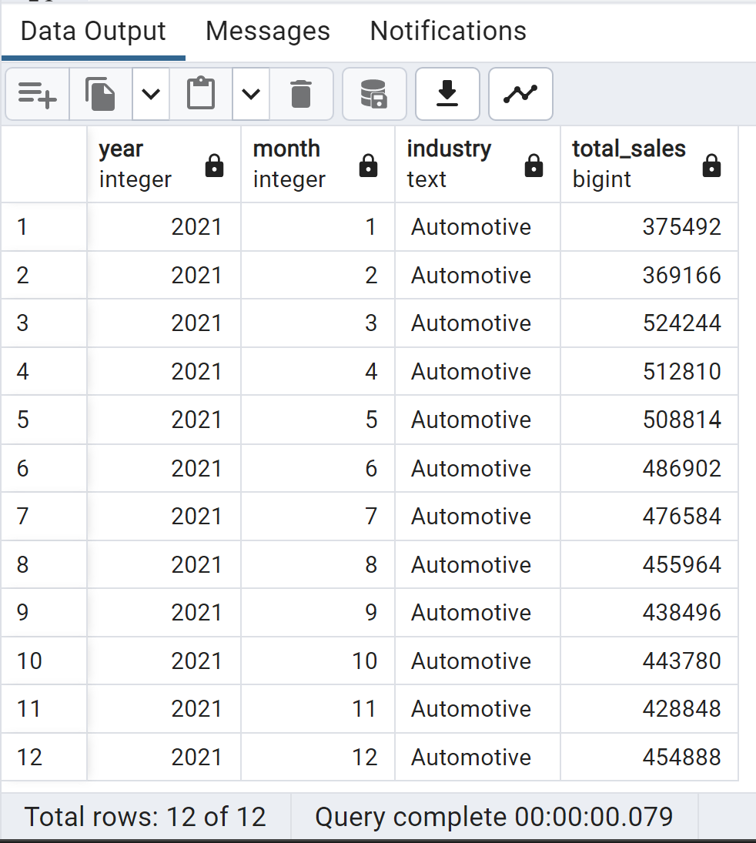

2)Top-performing industries in terms of sales for a year 2022, and how do their sales compare month-over-month?

WITH monthly_sales AS (

SELECT

year,

month,

industry,

SUM(sales) AS total_sales

FROM

retail_sales

WHERE

year = 2022

GROUP BY

year,

month,

industry

),

top_industries AS (

SELECT

year,

month,

industry,

total_sales,

RANK() OVER (PARTITION BY year, month ORDER BY total_sales DESC) AS industry_rank

FROM

monthly_sales

)

SELECT

year,

month,

industry,

total_sales

FROM

top_industries

WHERE

industry_rank = 1

ORDER BY

year,

month;

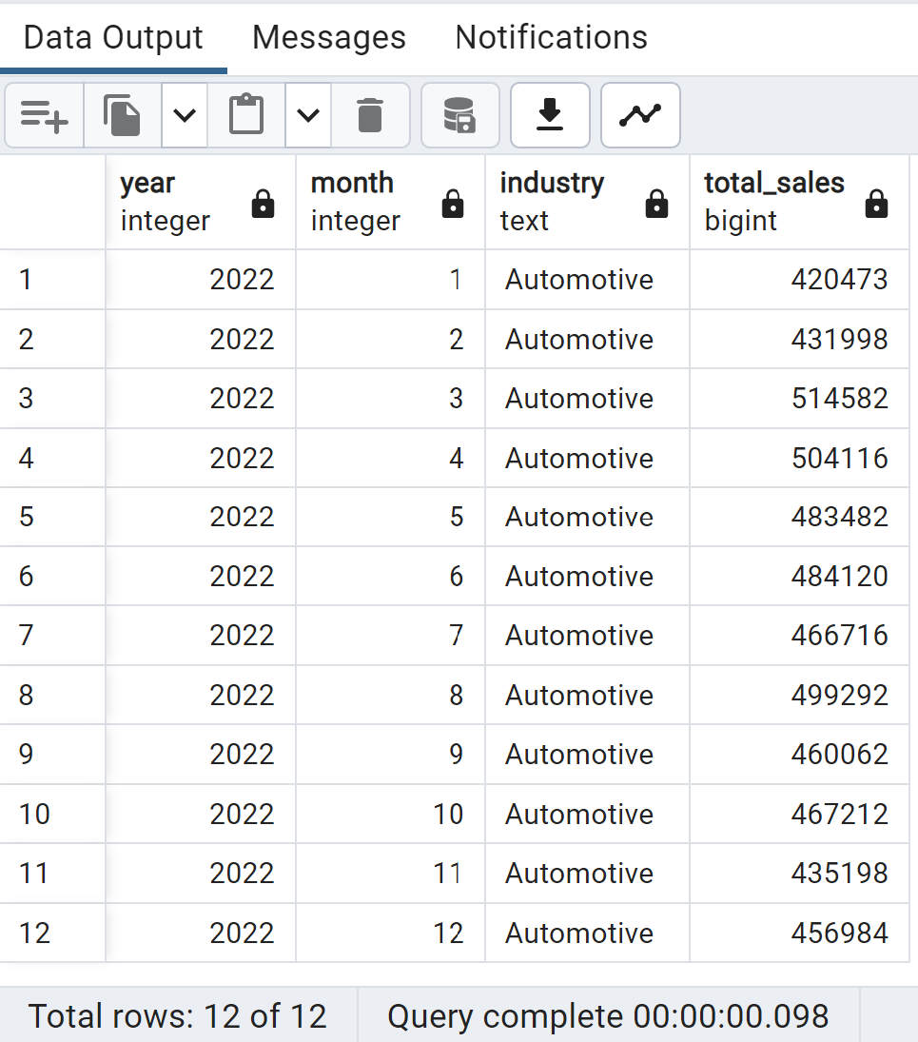

3)Top-performing industries in terms of sales for a year 2020, and how do their sales compare month-over-month?

WITH monthly_sales AS (

SELECT

year,

month,

industry,

SUM(sales) AS total_sales

FROM

retail_sales

WHERE

year = 2020

GROUP BY

year,

month,

industry

),

top_industries AS (

SELECT

year,

month,

industry,

total_sales,

RANK() OVER (PARTITION BY year, month ORDER BY total_sales DESC) AS industry_rank

FROM

monthly_sales

)

SELECT

year,

month,

industry,

total_sales

FROM

top_industries

WHERE

industry_rank = 1

ORDER BY

year,

month;

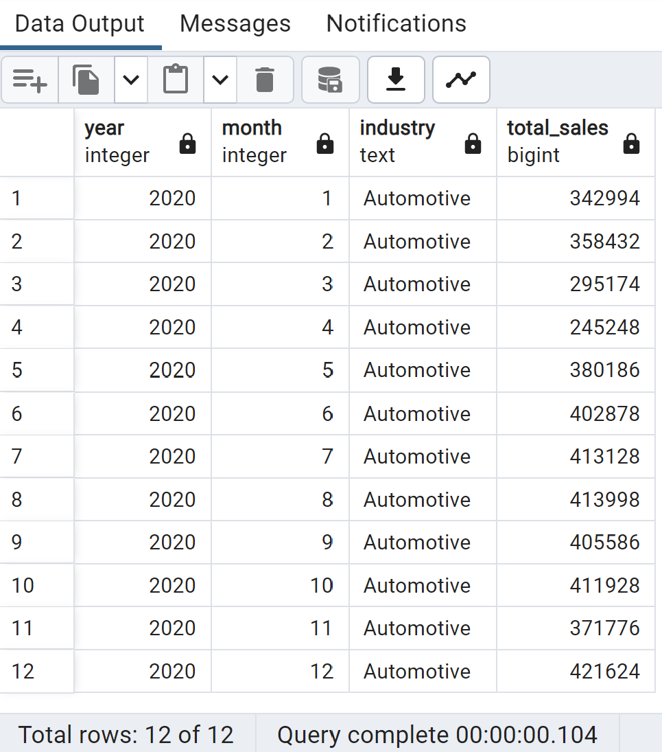

4)Top-performing industries in terms of sales for a year 2019, and how do their sales compare month-over-month?

WITH monthly_sales AS (

SELECT

year,

month,

industry,

SUM(sales) AS total_sales

FROM

retail_sales

WHERE

year = 2019

GROUP BY

year,

month,

industry

),

top_industries AS (

SELECT

year,

month,

industry,

total_sales,

RANK() OVER (PARTITION BY year, month ORDER BY total_sales DESC) AS industry_rank

FROM

monthly_sales

)

SELECT

year,

month,

industry,

total_sales

FROM

top_industries

WHERE

industry_rank = 1

ORDER BY

year,

month;

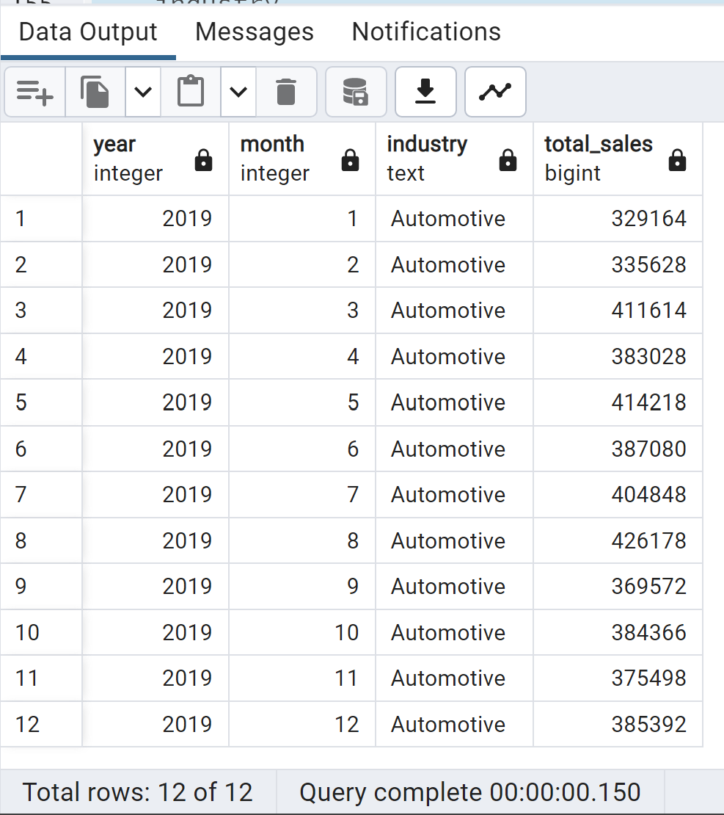

Business Question

2: Which specific kind of businesses contribute the most to total sales, and how does their performance vary across industries?

SELECT

kind_of_business,

industry,

SUM(sales) AS total_sales

FROM

retail_sales

GROUP BY

kind_of_business,

industry

ORDER BY

total_sales DESC;

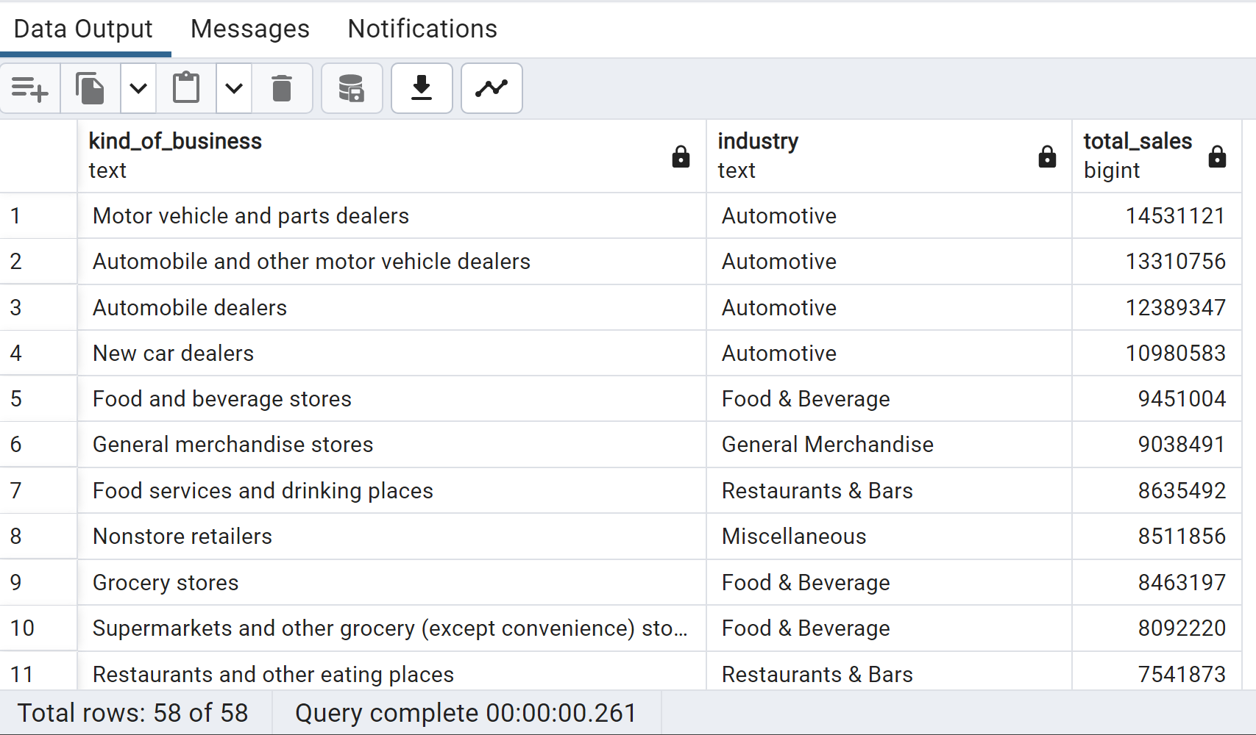

3: Is there any seasonality in sales for specific industries, and how do they perform month-over-month?

SELECT

industry,

year,

month,

SUM(sales) AS total_sales

FROM

retail_sales

GROUP BY

year,

industry,

month

ORDER BY

year,

industry,

month;

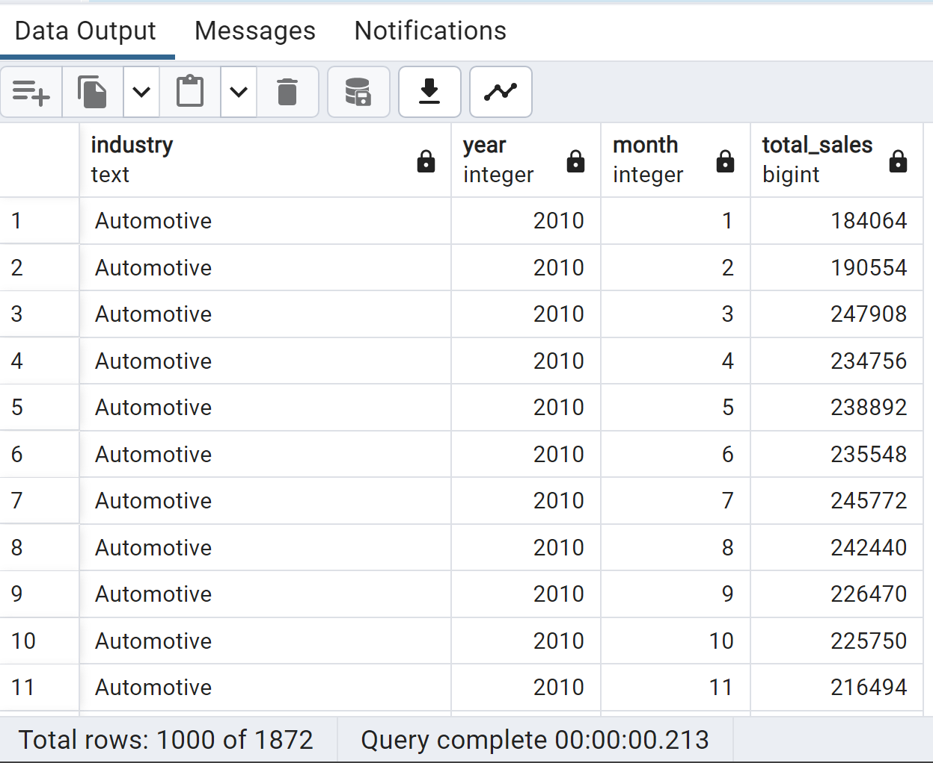

4: How does the sales distribution vary among industries based on their North American Industry Classification System (NAICS) codes?

SELECT

naics_code,

industry,

SUM(sales) AS total_sales

FROM

retail_sales

GROUP BY

naics_code,

industry

ORDER BY

naics_code,

total_sales DESC;

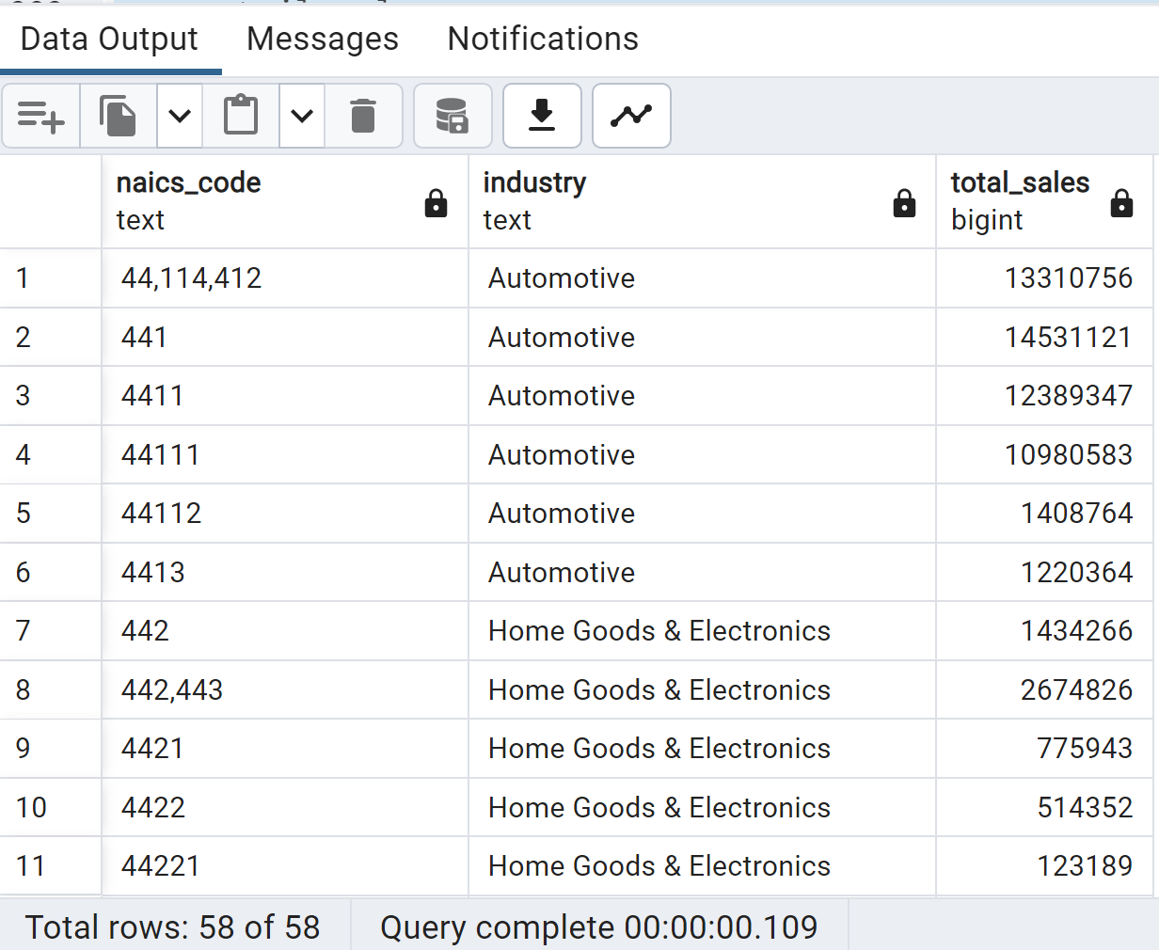

5: Are there any outliers or significant changes in sales for specific industries during particular months or years?

SELECT

industry,

year,

month,

sales

FROM

retail_sales

WHERE

(industry, year, month) IN (

SELECT

industry,

year,

month

FROM (

SELECT

industry,

year,

month,

sales,

LAG(sales) OVER (PARTITION BY industry ORDER BY year, month) AS prev_sales,

LEAD(sales) OVER (PARTITION BY industry ORDER BY year, month) AS next_sales

FROM

retail_sales

) AS sales_analysis

WHERE

sales > 1.5 * COALESCE(prev_sales, 0) OR sales > 1.5 * COALESCE(next_sales, 0)

)

ORDER BY

industry,

year,

month;

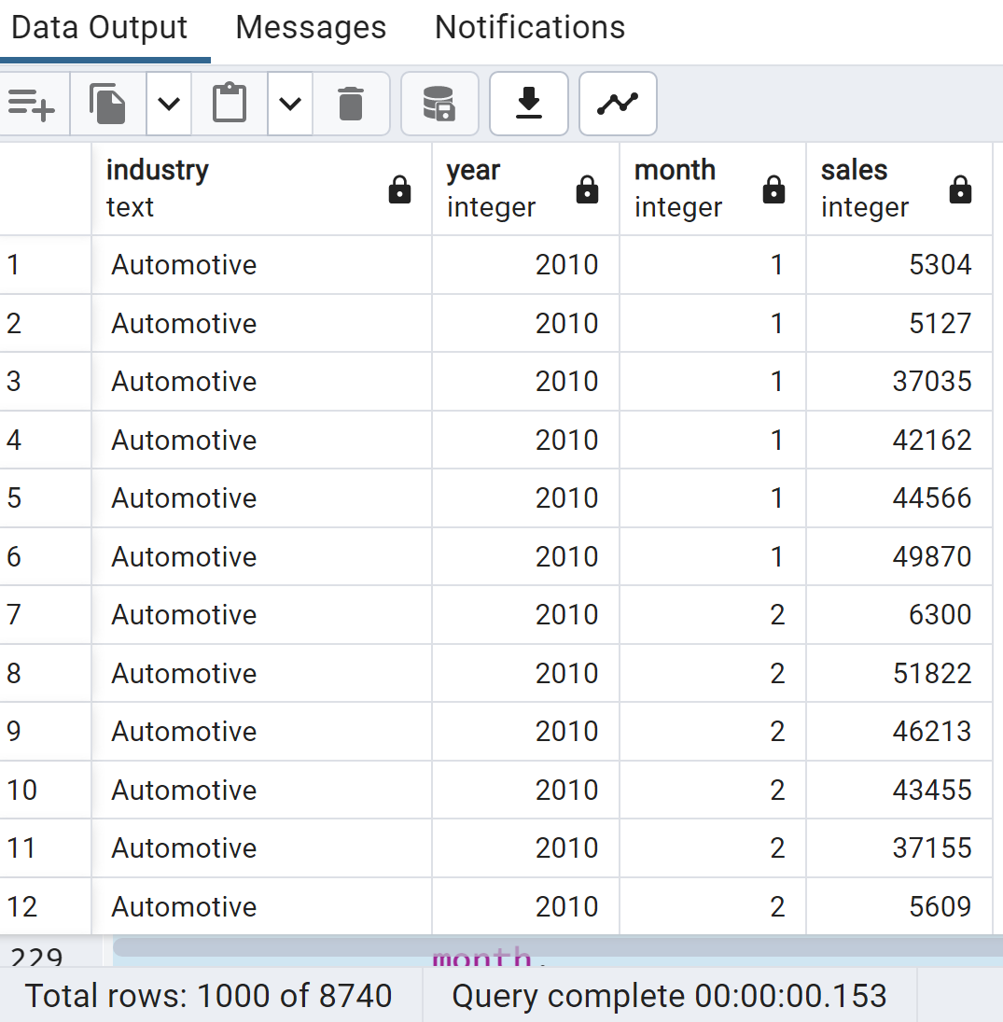

Which businesses all-time average sale was above 10 billion dollars?

SELECT

kind_of_business,

AVG(sales) AS average_sale

FROM

retail_sales

GROUP BY

kind_of_business

HAVING

AVG(sales) > 10000; -- 10 billion dollars in cents (1 dollar = 100 cents)

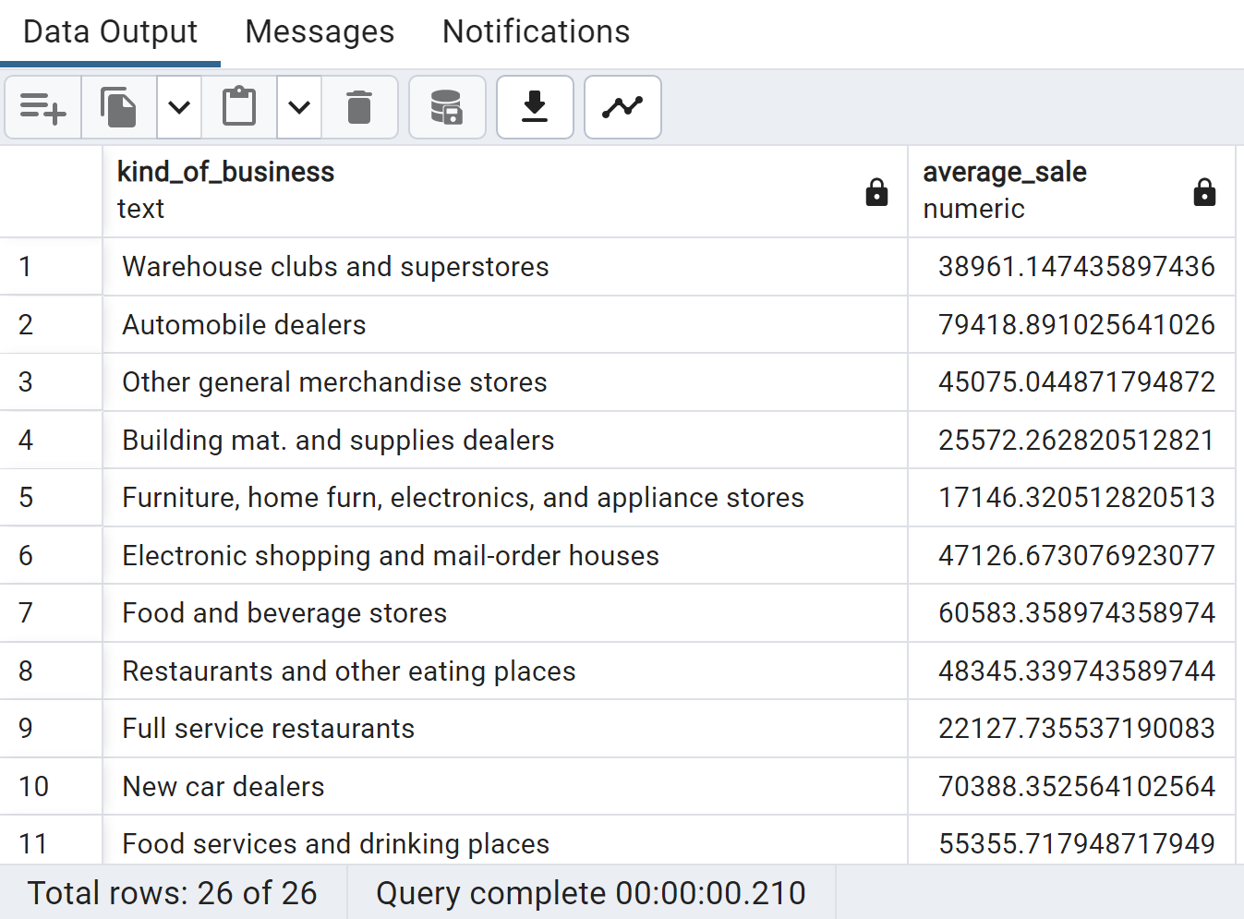

Which kind of businesses within the automotive industry had the highest sales revenue for 2022?

SELECT

kind_of_business,

SUM(sales) AS total_sales

FROM

retail_sales

WHERE

industry = 'Automotive' AND year = 2022

GROUP BY

kind_of_business

ORDER BY

total_sales DESC

;

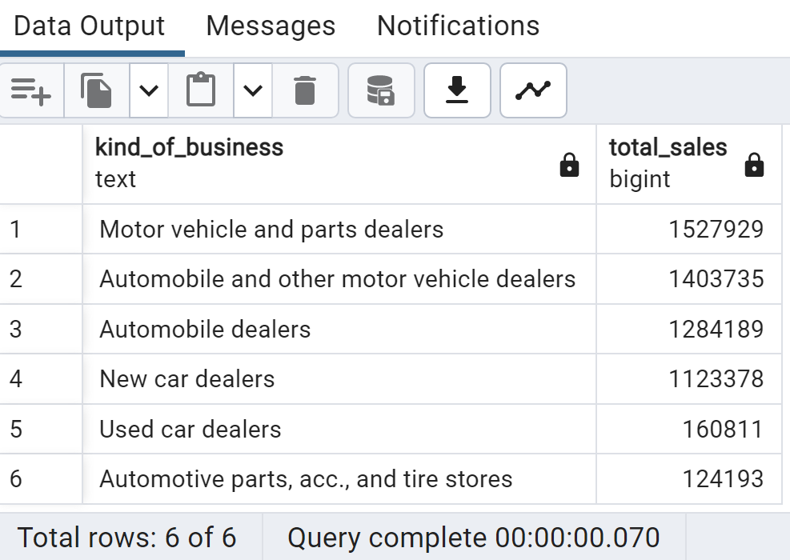

What is the contribution percentage of each business in the automotive industry this year?

WITH automotive_sales AS (

SELECT

kind_of_business,

SUM(sales) AS total_sales

FROM

retail_sales

WHERE

industry = 'Automotive' AND

year = 2022

GROUP BY

kind_of_business

),

total_sales_automotive AS (

SELECT

SUM(sales) AS total_sales_automotive

FROM

retail_sales

WHERE

industry = 'Automotive' AND

year = 2022

)

SELECT

kind_of_business,

ROUND((total_sales / total_sales_automotive.total_sales_automotive) * 100, 2) AS contribution_percentage

FROM

automotive_sales

CROSS JOIN

total_sales_automotive;

*What are the year-over-year growth rates for each industry per year?*

with total_sales as(select year, industry, sum(sales) as sales_sum

from retail_sales

GROUP BY 1,2)

SELECT curr.industry, prev.year as previous_year, curr.year as current_year,

    (curr.sales_sum - prev.sales_sum) / prev.sales_sum * 100 as YoY

from total_sales as curr

join total_sales as prev

   on curr.year=prev.year+1 AND curr.industry=prev.industry

ORDER BY industry, curr.year DESC;

*What are the yearly total sales for womenâ€™s clothing stores and menâ€™s clothing stores?*

SELECT year,

sum(CASE WHEN kind_of_business = "Women's clothing stores" THEN sales ELSE 0 END) as women_sales,

sum(CASE WHEN kind_of_business = "Men's clothing stores" THEN sales ELSE 0 END) as men_sales

FROM retail_sales

GROUP BY 1;

*What is the yearly ratio of total sales for women's clothing stores to total sales for men's clothing stores?*

SELECT year, women_sales/men_sales as Women_to_Men_rario

from (SELECT year,

sum(CASE WHEN kind_of_business = "Women's clothing stores" THEN sales ELSE 0 END) as women_sales,

sum(CASE WHEN kind_of_business = "Men's clothing stores" THEN sales ELSE 0 END) as men_sales

FROM retail_sales

GROUP BY 1;

*What is the year-to-date total sale of each month for 2019, 2020, 2021, and 2022 for the womenâ€™s clothing stores?*

select rs.month, rs.year, rs.sales,

((SELECT SUM(sales)

        FROM retail_sales rs2

        WHERE rs2.year = rs.year AND rs2.month <= rs.month AND rs2.kind_of_business = 'Women\'s clothing stores') AS ytd_sales

)

from retail_sales as rs

WHERE rs.kind_of_business = 'Women\'s clothing stores' AND rs.year IN (2019, 2020, 2021, 2022);

*What is the month-over-month growth rate of womenâ€™s clothing businesses in 2022?*

select month, sales as current_sales, *-- now we want the sales from 1 previous period*

lag(sales, 1) over (order by month) as prev_sales

from retail_sales

where kind_of_business ='Women\'s clothing stores' and year =2022;

*-- growth rate*

select month, sales as current_sales,

lag(sales, 1) over (order by month) as prev_sales,

(sales - lag(sales, 1) over (order by month))/lag(sales, 1) over (order by month) *100 as growth_rate

from retail_sales

where kind_of_business ='Women\'s clothing stores' and year =2022;

**Most occupied Days & Month**

**Days**-Orders are highest on Friday & Saturday evenings

**Month**-Orders are highest on January & July

**Sales Performance**

**Category**-Classical contributes maximum to Sales & Total Orders

**Size**-Large pizza contributes maximum to Sales

**Best Sellers**

**Revenue**-Thai Chicken Pizza contribute maximum to Revenue

**Quantity**-Classical Deluxe Pizza contributes maximum to Total Quantities

**Total Orders**-Classic Deluxe Pizza contributes maximum to Total Orders

**Lowest Sellers**

**Revenue**-Brie Carre Pizza contribute minimum to Revenue

**Quantity**-Brie Carre Pizza contribute minimum to Total Quantities

**Total Orders**-Brie Carre Pizza contribute minimum to Total Orders

**Most occupied Time**

**Lunch**-12 P.M. - 1:30 P.M., **Dinner**-6 P.M. - 8 P.M.

**Data Source: Maven Analytics**

**GitHub Repo:** <https://github.com/tushar2704/Pizza-Sales-Analysis>

**Author: ©** **2023** [**Tushar Aggarwal**](https://www.linkedin.com/in/tusharaggarwalinseec/)