CHAPTER 1

Project Overview and
Technical Foundations
Understanding what Aera is, why it exists, and how its parts work together

1.1 Introduction
Aera is a connected air-quality monitoring prototype: a small sensor node gathers measurements, a cloud service receives and processes them, and mobile and web applications make the information available to users. The project brings embedded hardware, cloud software, data storage, and two client applications into one working system.
Aera is not a single app, but a chain of cooperating parts. Each part has a distinct role: the firmware interacts with sensors and the network, the backend validates and coordinates data, the database retains records, and the clients turn that data into screens a person can use. Understanding these boundaries makes the implementation chapters easier to follow.

1.2 Project Rationale
Aera explores a practical question: how can readings from a compact, low-cost sensor station be carried through a complete software system and presented in a useful way? A device that only displays a local value cannot, by itself, provide remote access, shared user and device management, live updates, or a history of previous readings. Aera was conceived as a way to connect those pieces, from sensing and communication to storage and presentation.
The project also brings embedded development, backend engineering, databases, mobile software, and web development into one integrated product. It makes the dependencies between these areas visible: a measurement must be meaningful before software can interpret it, the device and service must agree on how data is exchanged, and the resulting information must be presented clearly to be useful.

1.3 Aim and Objectives
The aim of Aera is to design and build a connected prototype that collects selected environmental measurements with an ESP32 sensor node, transfers readings to a cloud service, and presents the processed information through mobile and web applications.
To achieve this aim, the project brings together the following objectives:
• Measure temperature and relative humidity with a DHT22 sensor and derive an estimated carbon-monoxide (CO) value from an MQ-9 sensor.
• Provision the ESP32 for a nearby 2.4 GHz Wi-Fi network and identify it when it communicates with Aera Cloud.
• Transmit telemetry to the backend, validate incoming readings, calculate the configured air-quality index and category, and retain readings for later review.

• Provide authenticated account and device management, current readings, historical data, and live updates through the mobile and web clients.
• Support optional integrations—including AI-assisted general guidance, email, caching, and public ingress—when configured by the deployment.
• Explain the system’s design and implementation, platform-specific development and execution, troubleshooting, installation, observed output, and known limitations.

1.4 Scope and Intended Use
The scope of this project covers four connected areas: an ESP32 sensor node, the Aera Cloud API and its data services, a mobile application, and a browser-based web dashboard. Together, they support device provisioning, telemetry ingestion, account and device functions, current and historical readings, and live updates. Optional AI and email features rely on separately configured external services; Redis is an optional cache, and public ingress is deployment-dependent.
The present hardware is intended for educational and informational monitoring. Its measurements are constrained by the sensors and their calibration: the MQ-9 reading is an estimate, and the device has no particulate-matter sensor. The backend’s calculated index therefore reflects only the inputs supplied to it and should not be presented as a complete measurement of ambient air pollution.
IMPORTANT — MEASUREMENT LIMITS
Aera is a prototype for informational use, not a certified gas detector, life-safety alarm, medical device, or calibrated air-quality instrument. The MQ-9 value is an estimate, and PM2.5/PM10 are not measured by this hardware. Do not use the displayed index as the sole basis for health, evacuation, or emergency decisions.

1.5 How the System Works
A reading follows a defined path from the physical sensors to the user-facing clients and, where applicable, back to the device:
• Sensing — The ESP32 samples temperature and relative humidity from the DHT22 and reads the MQ-9 analog signal used to estimate CO. Firmware associates the measurements with the station identity and prepares the telemetry fields; the sensor estimate remains subject to calibration limits.
• Transmission — Once provisioned for Wi-Fi, the station submits its telemetry to Aera Cloud over HTTPS using the configured device credential. The request carries the values and device identity needed by the backend to validate and route the reading.
• Validation and processing — The backend verifies the device request and validates the telemetry shape and ranges before normalizing the values. It derives the project-configured index and category from available inputs, evaluates alert conditions, and prepares a response for the device and connected clients.
• Persistence — PostgreSQL is the durable store for account, device, and historical-reading records. When configured, Redis holds expiring latest-state and heartbeat data to support quick access; it complements rather than replaces the relational history.
• Distribution and response — Mobile and web clients use the backend APIs for account, device, latest-reading, and history operations, and WebSockets for live updates. The HTTP acknowledgement returns to the ESP32, which can use the service response to determine transmission status and operate its buzzer when instructed.
ESP32 sensors → HTTPS telemetry → Aera Cloud API → PostgreSQL → Mobile app / Web dashboard
Figure 1.1. Simplified telemetry and presentation path; Redis and external integrations are optional.

1.6 The Four Main Components

1.6.1 Mobile application
The mobile client is built with Expo and React Native and provides one shared application for Android and iOS. Its account, dashboard, device-selection, history, and settings flows let users move from sign-in to monitoring without treating the phone as a separate data system. The dashboard presents the selected source, current index and pollutant readings, while the history screen requests stored records from Aera Cloud; the Ambient Grid is a separate external-data source, not a physical station. Authentication and device state are managed in the app, while monitoring requests and live WebSocket updates use the same backend contract as the browser client. AI-assisted chat is available when its backend integration is configured. Shared JavaScript avoids duplicating most interface and service logic, but navigation, local session storage, network addressing, native permissions, signing, and platform builds still require Android/iOS-specific handling. For framework details, consult Expo and React Native documentation. [1]–[4]

1.6.2 Web dashboard
The web client is a React application developed with Vite and delivered in production as static files served by Nginx. It brings account access, device claiming and selection, current sensor status, pollutant detail, recommendations, and reading history together in a browser dashboard. Shared hooks coordinate the selected source and current view state; service modules make HTTP requests and establish the device-specific WebSocket connection. Users can switch between a claimed ESP32 and the Ambient Grid, whose location-based external readings remain distinct from station telemetry. The browser stores the session token, while history remains on the backend and live values are held in client state. For framework details, see React and Vite documentation. [5], [6]

1.6.3 Cloud backend and data services
Aera Cloud is an asynchronous Python service built with FastAPI and served by Uvicorn. It is the system’s shared service boundary: device routes accept authenticated telemetry, while versioned user APIs handle registration, sign-in, profiles, device ownership, monitoring, and optional assistant features. Request schemas and dependencies validate inputs and identity; service modules coordinate processing, AQI calculation, alerts, live events, and persistence instead of placing all behavior in route handlers. SQLAlchemy connects the application to PostgreSQL, and Alembic tracks schema changes. Redis can hold short-lived latest state and heartbeat information, while Groq-powered assistance, SMTP email, and public ingress are optional integrations. PostgreSQL must be configured separately because Docker Compose does not start it. For framework and data-layer background, see FastAPI, SQLAlchemy and PostgreSQL documentation. [7]–[15]

1.6.4 ESP32 sensor node
The sensor node is an ESP32 programmed in C++ with Arduino IDE and Espressif’s ESP32 board support. It reads temperature and relative humidity from the DHT22 and samples the MQ-9 analog output to produce an estimated CO value. The firmware provisions Wi-Fi, identifies the station, sends periodic telemetry, reports status, and can operate a buzzer in response to the backend acknowledgement. Its sensor readings and device identity form the input contract for the cloud path; wiring, calibration, credentials, and board-specific build steps are detailed in the device chapter. For platform details, see the official Arduino ESP32 documentation. [16]–[19]

1.7 Languages, Frameworks, and Development Tools
Aera uses a different toolchain at each layer because a browser, a mobile operating system, a cloud service, and a microcontroller have different runtimes and build requirements. The table summarizes each tool’s role; the later development chapters explain how the tools are installed, configured, and used together.
Area | Technology / tool | Purpose in Aera
Firmware | ESP32, C++, Arduino IDE, Espressif ESP32 support | Build and upload the sensor firmware; access the ESP32 pins, Wi-Fi, and device peripherals.
Mobile | JavaScript, React Native, Expo, Node.js, npm | Develop and run the shared Android/iOS client and manage its JavaScript dependencies.
Android toolchain | Android Studio, Android SDK, Gradle | Provide the Android emulator/device platform and native build tools used by the Android project.
iOS toolchain | Xcode, iOS Simulator, CocoaPods | Build, sign, and run the iOS project on macOS; CocoaPods installs native iOS dependencies.
Web | JavaScript, React, Vite, npm, Tailwind CSS, Nginx | Develop the browser dashboard, create the production bundle, and serve static web files.
Backend | Python, FastAPI, Uvicorn, Pydantic | Implement and serve API endpoints, validate data, and manage application configuration.
Data and migrations | PostgreSQL, SQLAlchemy, asyncpg, Alembic | Persist application data through an asynchronous ORM and evolve the database schema.
Testing and quality | pytest, pytest-asyncio, Oxlint | Run backend tests and check the web client for common code-quality issues.
Local deployment | Docker Engine, Docker Compose | Build and run the API and web services as containers for local or hosted deployment. See the Docker Compose documentation.
Optional services | Redis, Groq API, SMTP, Cloudflare Tunnel | Provide caching, AI inference, email delivery, or public ingress when configured.

1.8 How the Parts Communicate
Aera uses two complementary communication patterns. HTTPS carries individual requests and responses; WebSockets keep a connection open for updates that should arrive while a client is viewing the dashboard. [3], [4]
The responsibilities can be summarized as follows:
• HTTP API requests handle discrete tasks such as signing in, claiming a device, or requesting a reading history.
• WebSocket connections deliver live monitoring updates without requiring the clients to repeatedly request the same latest value.
• PostgreSQL stores durable account, device, and historical reading data; Redis, when enabled, is used to accelerate recent state rather than replace the database.
• The mobile and web clients communicate with the backend, not directly with PostgreSQL. This keeps data access and application rules in one service shared by both clients.

1.9 Capabilities, Boundaries, and Responsible Interpretation
Taken as a whole, Aera demonstrates an end-to-end monitoring workflow. Its main capabilities include:
• provisioning a sensor node and associating it with the cloud service;
• collecting, validating, processing, and storing telemetry;
• accessing accounts, devices, current readings, and historical records through mobile and web clients;
• receiving live updates and, when configured, optional AI-assisted general guidance.
These capabilities do not remove the limits of the present hardware or software. The MQ-9 estimate is not equivalent to a calibrated CO instrument; the firmware currently sends zero for PM2.5 and PM10 because it has no particulate sensor; and the configured index is not a certified exposure assessment. AI-generated text, when available, is general information—not professional, medical, or emergency advice.
A transport-security limitation is important when considering deployment beyond a trusted test network.
IMPORTANT — HTTPS CERTIFICATE VERIFICATION
The current ESP32 firmware disables server-certificate verification. HTTPS encrypts the connection, but without certificate validation the device cannot authenticate the server and may be vulnerable to an intermediary impersonating it. Validate or pin the server certificate before using this transport on an untrusted network.

1.10 Reading the Rest of This Book
This chapter has introduced the project’s purpose, boundaries, data path, and technology choices. The next chapters will move from this shared foundation into the design and implementation of the mobile client, web dashboard, cloud backend, and ESP32 firmware. Platform-specific development and execution—including the distinct Android and iOS workflows—will be addressed where each applies, followed by debugging, installation or deployment, and observed output. Sources will appear alongside the topics they support; page numbers for the contents section can be finalized after the complete manuscript is assembled.
CHAPTER 2

How Aera Works: From Sensor to Screen
Following a reading through the device, cloud service, and user applications

2.1 Overview of the Operating Flow
Aera provides two different ways to view air-quality information. In Physical Station mode, an ESP32 measures its connected sensors and sends a telemetry record to the cloud; the cloud processes it and makes the result available to the mobile and web clients. In Ambient Grid mode, the clients request location-based weather and air-quality information from external services instead. These paths may appear in the same application, but Ambient Grid data is not measured by the ESP32 or sent through the device telemetry pipeline.

How the Main Path Moves
The physical-station route is not simply a one-way transfer from sensor to screen. Its main responsibilities are:
• Device to cloud — After startup and network connection, the ESP32 periodically reads its sensors, prepares a record with its device identity, and sends it to the authenticated telemetry endpoint. This is the upstream measurement path.
• Cloud processing — The backend checks the device credentials and required fields, then normalizes the values, calculates the project’s index and category, and evaluates the configured alert rules. The accepted record is now enriched with the results used by the clients and device response.
• Cloud to state — The service updates the short-lived Redis heartbeat and latest-reading cache when configured, and separately attempts to save a durable history record in PostgreSQL. These are distinct outcomes, not a single guaranteed write.
• Cloud to clients — When a user opens a physical station, the app or website requests the latest reading and history over HTTP, then subscribes to WebSocket updates. New readings can then be pushed to the open view without waiting for another history request.
• Cloud back to device — The response to the ESP32’s telemetry request acknowledges the result and includes the current buzzer instruction. This closes the device’s request-response loop; it is separate from the client update and database paths.

The flowchart therefore shows several related routes: measurements travel up to the cloud, processed readings fan out to cache, history, and subscribed clients, and an acknowledgement travels back to the device. A successful live update or device acknowledgement does not by itself prove that historical storage succeeded. The Ambient Grid is a separate location-based route, shown apart from ESP32 telemetry. The next sections examine the physical-station stages one by one before returning to Ambient Grid in its own section.

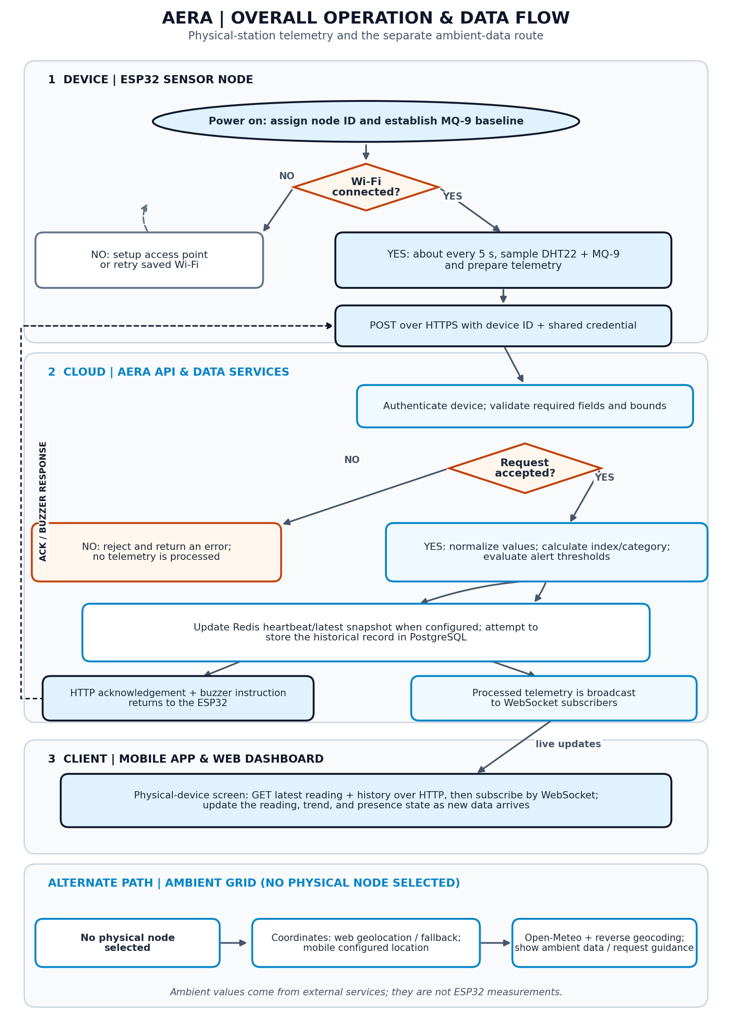
Figure 2.1. Overall operation and data flow. The physical and ambient routes use different data sources.

2.2 Power-Up, Identity, and Network Readiness
When the sensor node starts, the firmware initializes its peripherals, establishes a device identifier, and checks whether a Wi-Fi profile has already been saved. This happens before periodic telemetry can be sent.
• Identity — The firmware extracts a short identifier from the ESP32 eFuse MAC address and formats it as an AERA node ID. The same ID appears in the setup access-point name and identifies the node to the cloud service.
• Sensor baseline — On boot, the MQ-9 analog input is sampled repeatedly to estimate a clean-air baseline resistance (R₀). If the voltage is outside the expected range, the firmware uses a nominal fallback value instead.
• Saved network — Wi-Fi credentials are read from the ESP32 non-volatile preferences store. If a saved network is available, the node attempts to join it and enters its online state after connection.
• Provisioning fallback — If no saved profile exists or the connection attempt fails, the node opens its temporary setup access point and serves a local configuration page. Once credentials are saved, the board restarts and tries the selected network.
The status LED reflects broad device states such as booting, connecting, portal mode, and online operation. If Wi-Fi later drops, the main loop periodically attempts to reconnect using the saved profile. The detailed user steps, network prerequisites, and Arduino IDE configuration are deferred to the later environment and execution chapters.

2.3 Sampling and Preparing a Telemetry Record
While the node is running, the firmware starts a telemetry cycle approximately every five seconds. It reads temperature and humidity from the DHT22 and obtains an analog reading from the MQ-9. The two sensor paths require different interpretation: the DHT22 provides temperature and relative humidity, while the MQ-9 output is a resistance-related electrical signal from which the firmware estimates a gas concentration.
For the MQ-9 estimate, the firmware averages 16 analog samples, converts the average to a voltage, estimates the sensor resistance (Rₛ), and compares that resistance with the boot-time baseline R₀. It then applies the firmware’s configured curve:
Estimated CO (PPM) = 95 × (Rₛ / R₀)⁻¹·⁴⁵
At very low input voltage, the firmware reports 0 PPM; when the input approaches the ADC rail, it caps the estimate at 1000 PPM. This equation and those guard values describe the current firmware’s estimate;
READING THE DHT22 FAILURE VALUE
When the firmware cannot read either DHT22 value, it currently places 0.0 in both temperature and humidity fields and continues the telemetry cycle. A downstream screen may therefore display a zero rather than a visibly marked sensor fault; the firmware also prints a diagnostic message to Serial Monitor.

The outgoing JSON record contains the device ID, temperature, humidity, estimated CO, and particulate fields. In the current hardware build, PM2.5 and PM10 are transmitted as 0.0 because no particulate sensor is attached. The field name used for PM2.5 in the hardware request is accepted by the backend’s schema and normalized during processing.

2.4 Sending the Reading and Identifying the Device
When Wi-Fi is connected, the firmware sends the telemetry record as an HTTPS POST request to the device-ingestion endpoint, /api/device/telemetry/ingest. It supplies the node ID in an X-Device-ID header and includes the shared device credential in an Authorization header. The backend checks that credential and uses the verified header ID to determine which device the request belongs to; the ID in the JSON body is not the authority for this HTTP route.
FastAPI parses the incoming request against a Pydantic schema. Required values and declared field bounds are checked before the handler receives a typed payload. The request handler then passes the normalized device ID and telemetry values to the shared processing service. Background on request bodies and field constraints is available in the FastAPI request-body documentation and Pydantic field documentation. [8], [20]
The application also has an additional sensor-range checking helper. In the HTTP telemetry path, an out-of-range result from that helper is logged as a warning but does not itself stop processing; values that cannot be parsed as numbers are rejected by the processing service. This distinction matters when interpreting the word “validation”: schema validation rejects invalid required fields, while this extra check currently reports a warning rather than acting as a complete rejection gate.
The ESP32 uses HTTPS for transport, but its current client configuration does not verify the server certificate. The encrypted connection therefore does not confirm the server’s identity; see the HTTPS certificate-verification note in Chapter 1 before considering use on an untrusted network.

2.5 Cloud Processing, AQI, and Alert Decisions
After the request is accepted, the processing service standardizes the incoming keys and converts sensor values to numeric form. Missing optional pollutant values default to zero. It then calculates an index and category using the breakpoints configured in Aera’s backend. For each active pollutant, the code calculates a sub-index by linearly interpolating between the selected concentration and index breakpoints:
I = [(Iₕᵢ − Iₗₒ) / (Cₕᵢ − Cₗₒ)] × (C − Cₗₒ) + Iₗₒ
C is the measured concentration; Cₗₒ and Cₕᵢ are the concentration bounds, and Iₗₒ and Iₕᵢ are their corresponding index bounds.
A value of zero is treated as an inactive pollutant by the current calculation. Since the ESP32 sends zero for both particulate fields, this hardware configuration’s calculated index is currently driven by the CO estimate rather than measured PM2.5 or PM10. The index and category are application outputs based on the inputs and breakpoints implemented in the project; they should not be interpreted as a complete or certified environmental measurement.
The service also evaluates whether an alert should be requested. Its current rule sets the buzzer flag when the calculated index is greater than 190 or the CO estimate is at least 10 PPM. It places that flag, the index, category, normalized values, device ID, and a UTC timestamp in an enriched telemetry record. The firmware receives the acknowledgement and activates its buzzer on a positive server instruction or when the local CO estimate reaches its configured 12 PPM threshold, provided it receives a successful acknowledgement with status “ok”.
TWO ALERT CHECKS, TWO THRESHOLDS
The backend currently requests a buzzer at CO ≥ 10 PPM or AQI > 190. The firmware also has a local CO check at 12 PPM. These are implementation thresholds in a prototype, not calibrated exposure limits or a certified alarm specification.

2.6 Live State, Historical Storage, and Device Pairing
Once the backend has assembled the enriched reading, it updates Redis if Redis is configured. A heartbeat key expires after 15 seconds, and the latest telemetry snapshot expires after 60 seconds. These short-lived values support presence checks, fast access to the newest reading, and immediate hydration of a newly connected dashboard. Redis is an optional cache; it is not the permanent reading history.
The service also attempts to append a reading to PostgreSQL. If the device has not yet been registered, the telemetry flow can create a device record with no owner; unclaimed devices can then be found by the account workflow. A signed-in user can claim an available device, at which point the account becomes its owner. Database migrations and the precise account/device APIs will be covered in their own development sections.
There is an important distinction between cache/live success and durable storage: Redis and database writes are handled separately. A database write failure is logged, but the processing function can still return the enriched reading to the route. As a result, receiving a live packet or an HTTP success response is not by itself proof that the historical database insert succeeded.
The latest-reading endpoint checks device visibility, tries Redis first, and falls back to the most recent PostgreSQL record when no cached snapshot is available. The history endpoint reads stored records and returns them in chronological order. For persistence and query background, see the SQLAlchemy ORM documentation and PostgreSQL documentation.

2.7 Delivering Updates to the Mobile and Web Clients
A client opening a physical device view first requests a recent reading, a limited history series, and recommendation data through HTTP endpoints. It then opens a WebSocket subscription for that device. If a recent snapshot is cached, the backend can send it as soon as the socket is registered; subsequent processed readings are broadcast to all subscribers for that device.
The WebSocket keeps a two-way network connection open, allowing the server to push new readings without the client polling for every update. The mobile and browser dashboards parse each message, update the visible reading, and extend the in-memory trend data. If a socket closes, the clients attempt to reconnect after a short delay. The official WebSocket API documentation explains this browser networking model.
• Initial view — The client loads the latest snapshot, history, and available recommendation data for the selected node.
• Live view — Each WebSocket telemetry message replaces the current reading and is added to the chart’s recent in-memory series.
• Presence view — The client treats recent telemetry as evidence that the hardware is active and marks it inactive when updates stop beyond its freshness window.
• Recovery — A closed live connection triggers a retry; stored history remains available through the HTTP history endpoint when the database is reachable.
The client connection status, the hardware heartbeat, and successful persistence describe different things. On initial load, the clients treat a reading less than 20 seconds old as fresh; each live packet resets a 12-second watchdog, and the account device-status check polls the Redis heartbeat every 10 seconds. A socket may be connected while the device is silent; a cached heartbeat indicates recent contact but not that the database write succeeded; and historical availability depends on stored records. Keeping these states distinct helps explain apparently different “online” indicators across the user interface.

2.8 The Ambient Grid Path
Aera can also show an ambient view when no physical device is selected. This is a separate data path, not a simulated ESP32 reading. The web client attempts to use browser geolocation and falls back to a configured coordinate when location is unavailable; the mobile client currently starts from a configured coordinate. The clients request weather and air-quality data from Open-Meteo and use reverse geocoding to obtain a readable place name. [21], [22]
Ambient values and hourly history are assembled in the client, then the current ambient measurements are sent to the backend recommendation endpoint when the screen requests guidance. The displayed ambient figures therefore come from external data services, whereas a hardware view is based on telemetry received from the selected ESP32. Open-Meteo documents its weather API and air-quality API.
KNOW WHICH SOURCE IS ON SCREEN
“Hardware Station” refers to data received from an Aera ESP32. “Ambient Grid” refers to weather and air-quality values fetched from external services for a location. They have different sources, update paths, and limitations; an ambient result is not evidence that an Aera sensor node measured those values.

2.9 Boundary of This Chapter
This chapter has established the operating logic and end-to-end data flow. The next chapter will prepare the development environment: Git and repository workflow, required installations, configuration and environment files, and the distinct Android, iOS, web, backend, and ESP32 toolchains. Detailed code walkthroughs will follow that foundation.
CHAPTER 3

Tools, Components and Installation Guide
Preparing the software and platform toolchains used to build Aera
This chapter identifies what must be installed on a development computer, what is installed inside each project workspace, and which supporting services are required or optional. It follows the actual Aera repository rather than treating every framework as a system-wide application. The focus is preparation and installation; source-code walkthroughs, first launches, builds, and firmware uploads are left for their dedicated chapters.

3.1 Aera’s Workspaces and Their Toolchains
Aera is maintained as four related workspaces. Each has its own dependency manifest, and not every contributor needs every platform tool: a web-only change does not require Xcode or an ESP32 board, while a firmware build does not require mobile simulator toolchains.
Workspace / layer | Tools and components | What they are used for
Shared workstation | Git, terminal, VS Code (recommended) | Check out the repository, edit files, and run setup commands.
Web dashboard | Node.js, npm, React, Vite, Tailwind CSS, shadcn CLI | Build the browser dashboard. UI and build dependencies are declared in aera-web/package.json.
Mobile client | Node.js, npm, Expo, React Native; Android or iOS native tools | Share the JavaScript client across Android and iOS, with platform SDKs for native builds.
Cloud backend | Python 3.13+, pip, venv, FastAPI, Uvicorn, SQLAlchemy, Alembic | Run the API, process telemetry, and connect to the configured database.
Sensor firmware | Arduino IDE, Espressif ESP32 board support, Adafruit DHT library | Compile and upload the ESP32 sketch for the attached sensors and hardware.
Supporting services | PostgreSQL; optional Redis; optional Docker Compose | PostgreSQL stores durable history; Redis is an optional cache; Compose starts selected app services.

Version snapshot: The current manifests declare React 19, Vite 8, Tailwind CSS 3.4, shadcn CLI 4.x, Expo SDK 57, and React Native 0.86. Exact installed package versions are resolved by each workspace’s committed package-lock.json; check those files before following third-party tutorials that assume a different major version.

3.1.1 Software Tools: Purpose, Download and Learning
Aera’s toolchain combines a few shared foundations with the frameworks used by the web, mobile, cloud, and firmware workspaces. The important tools below are explained in the context of this project; smaller libraries are managed by each workspace and are not listed as separate workstation installations.

Shared foundations
Git — tracks source history and lets contributors synchronize the project. Install it from the official Git downloads; the Pro Git book introduces the everyday workflow. [23]
Node.js and npm — provide the runtime and package manager for both JavaScript workspaces. Aera’s React, Expo, and other client packages are installed locally from their lockfiles, not globally. See the Node.js download page and its getting-started guide. [24], [25]
Python — runs the Aera Cloud backend; Python’s virtual-environment tool keeps backend packages isolated. The official Python tutorial is a useful language reference. [7]

Web dashboard
React — builds the browser interface from reusable components. Aera’s web client uses React with React DOM; start with React Learn. [5]
Vite — serves the dashboard during local development and produces its static web build. Consult the Vite guide for the development-server and build workflow. [6]
Tailwind CSS and shadcn — Tailwind provides the web project’s utility styling, while shadcn is used to add reusable UI patterns. The repository is configured for Tailwind CSS 3; use the matching Tailwind v3 Vite guide rather than applying setup instructions for another major version. [26], [27]

Mobile application
React Native — renders the shared mobile interface as native Android and iOS applications. React Native’s environment guide describes the platform toolchain needed for local native builds. [2]
Expo — supplies the mobile SDK and development workflow around React Native. The project uses Expo for its app configuration and platform commands; follow the Expo environment setup and Expo tutorial for supported development options. [1]

Cloud backend and data
FastAPI and Uvicorn — FastAPI defines Aera’s HTTP and WebSocket API; Uvicorn runs the Python application. The backend manifest sets Python 3.13 as its container baseline. Learn the API framework through the FastAPI tutorial. [8], [9]
PostgreSQL — stores durable account, device, and telemetry history. The server can use optional Redis for short-lived heartbeat and latest-reading data; Redis is a cache, not a replacement for the database. See the PostgreSQL documentation for database concepts. [11], [13]

Firmware and platform build tools
Arduino IDE — the desktop environment used to open, compile, and upload Aera’s ESP32 firmware. It also provides board/port selection and a Serial Monitor for startup messages and sensor diagnostics. In this repository, the small .ino file supplies the includes Arduino’s sketch scanner expects, while the firmware implementation is in the neighboring main.cpp file. Aera uses Arduino IDE and Espressif’s Arduino-ESP32 core; it is not a PlatformIO project. Install the Arduino IDE and follow its IDE 2 getting-started guide. [16], [17]
ESP32 board support and the DHT library — the Espressif board package lets Arduino IDE compile and upload for the selected ESP32; the Adafruit DHT library provides the DHT22 reading interface. Follow the Arduino-ESP32 installation guide and the Adafruit DHT sensor guide. [17], [18]
Android Studio and Xcode — Android Studio supplies the Android SDK and emulator; Xcode supplies the iOS SDK and Simulator and is required for native iOS builds on macOS. Follow the Android Studio setup guide or Apple’s Xcode documentation for the platform you build. [28], [29]
The exact dependency versions are controlled by the project manifests and lockfiles, not by the tutorial links. Use the official installation guidance as reference, but install the versions declared by this repository.
INSTALL TOOLS ONCE; INSTALL LIBRARIES PER PROJECT
Git, Python, Node.js, Xcode, Android Studio, and Arduino IDE are workstation tools. React, React Native, Expo, Tailwind CSS, shadcn, and backend libraries are project dependencies installed from workspace manifests. Do not install these JavaScript frameworks globally: use each workspace lockfile to install its recorded compatible versions.

3.1.2 Physical Components
The following is the physical-parts inventory for the current ESP32 build. Conditional items are needed only if they are not already built into the selected board or sensor module.
Physical component | Use case (description)
ESP32 development board | Runs the firmware, reads attached inputs, controls indicators, and connects the station to Wi-Fi.
DHT22 sensor | Measures temperature and relative humidity for the station’s telemetry.
MQ-9 gas sensor / module | Produces the analog gas response used by the firmware to estimate CO; it is not a calibrated CO instrument.
Power LED | Shows that the board’s power/run indicator is active.
Status LED | Provides a visual indication of firmware states such as startup, connection, and provisioning.
Active buzzer | Provides the station’s local audible alert when activated by firmware.
MQ module load resistor / breakout | Provides the sensor interface and load-resistance path assumed by the firmware’s MQ-9 calculation.
DHT pull-up resistor (if required) | Supports reliable digital communication when a bare DHT22 does not already include a pull-up on its module.
Analog divider / level protection (if required) | Keeps the MQ module’s analog signal within the ESP32 input-voltage range.
Stable MQ heater supply | Powers the MQ-9 heater at the supply level required by the selected module.
USB data cable | Connects the development board to the computer for programming and serial communication.
Breadboard and jumper wires | Provide temporary connections between the board, sensors, indicators, and power rails.
For wiring, pin assignments, and sensor-interface details, consult the Aera firmware hardware guide, the Espressif ADC documentation, and the Adafruit DHT sensor guide. [17]–[19]
HARDWARE SAFETY AND MEASUREMENT LIMITS
Do not power the MQ-9 heater from an ESP32 GPIO. Share a common ground and ensure the analog signal never exceeds the ESP32’s 3.3 V input limit. The MQ-9 output is an estimate requiring sensor-specific warm-up and calibration; it is not a certified gas alarm. The current build has no particulate sensor, so PM2.5 and PM10 are not physically measured.

3.2 Obtain the Repository and Prepare the Workstation
Before installing Aera’s project dependencies, create a local working copy of the source. The public GitHub repository is: https://github.com/tushar6076/Aera. The visible address is clickable, so it can be opened directly from the digital book. [30]
Install Git from the official Git downloads page. Open a terminal in the parent folder where you want the project directory to be created. Cloning copies the repository and its tracked files into a new local folder named Aera; it does not install Node, Python, platform SDKs, or application dependencies.
• For a read-only local copy, clone the public repository using HTTPS:
git clone https://github.com/tushar6076/Aera.git
cd Aera
git status

• If you plan to contribute changes, create a fork in GitHub first and clone your fork instead; this keeps your work separate from the original repository. GitHub explains cloning a repository and forking a repository. [30]
• After cloning, the root folder contains four main workspaces: aera-aqi (ESP32 firmware), aera-cloud (Python API), aera-web (browser client), and aera-app (Android/iOS client). Keep the workspace folders together; their build files and local instructions rely on this repository structure.

Shared workstation prerequisites
Choose a Node.js version that satisfies both client workspaces. The web project’s Vite 8 requires Node.js 20.19+ or 22.12+, while the installed Expo/React Native environment also requires a recent Node release. Node.js 22.12 or newer is a suitable common baseline; npm is included with Node.js. See the official Node.js download page and Expo environment guide. [1], [24]
• Install Python 3.13 or newer for the cloud backend; this matches the Python version in the backend container. Python’s built-in venv module isolates Aera packages from system Python. See Python downloads and the venv documentation. [7]
• Git and a terminal are needed to obtain the code and run commands. VS Code is optional; use any editor you prefer. Android Studio, Xcode, Docker, and Arduino IDE are needed only for their corresponding platform.
Open a fresh terminal after installing the shared runtimes and check that the executable commands are available. On Windows, Python may be registered as py or py -3.13 rather than python3.
git --version
node --version
npm --version
python3 --version

3.3 Prepare the Web Dashboard
The browser client uses React and Vite; Tailwind CSS and the shadcn-based UI dependencies are part of the web workspace. Install these from the committed package-lock.json, not globally or from the repository root.

Install the locked web dependencies
1. In the terminal, move into the web workspace:
cd aera-web

2. While inside aera-web, copy the example Vite settings to a local environment file:
cp .env.example .env

The template configures the local browser app to contact an API at localhost:8085 and its WebSocket endpoint. The HTTP API uses an http:// address, while live updates use ws:// locally. For an HTTPS deployment, use https:// and wss:// respectively.
3. Install the exact versions resolved in the checked-in package-lock.json:
npm ci

• Run npm ci from inside aera-web. It recreates node_modules from package-lock.json without changing the manifest. If dependencies are intentionally changed later, update the manifest and lockfile through npm rather than installing a global copy.
• Do not install React, Vite, Tailwind, or shadcn globally. Their project-specific versions and configuration belong to this workspace.
• When the dashboard is viewed from another computer or a physical phone, localhost refers to that client—not the development computer. Set VITE_API_URL and VITE_WS_URL to an address reachable from the client, and ensure backend CORS settings allow the web origin.
• For containerized builds, the root Compose file passes VITE_API_URL and VITE_WS_URL as build arguments. These values are embedded into the static browser bundle at build time, so changing them requires rebuilding the web image.

3.4 Prepare the Python Backend
Aera Cloud is a FastAPI application served by Uvicorn. Its Python dependencies—including Pydantic, SQLAlchemy, Alembic, database drivers, and test libraries—are listed in aera-cloud/requirements.txt. Install them into a virtual environment so they do not interfere with other Python projects.

Create the isolated environment
1. From the repository root, enter aera-cloud and create the environment:
cd aera-cloud
python3 -m venv .venv

2. Activate it. The activation command depends on the shell:
# macOS / Linux
source .venv/bin/activate
# Windows PowerShell
.\.venv\Scripts\Activate.ps1

If already inside aera-cloud in PowerShell, use .\.venv\Scripts\Activate.ps1. Once activated, the prompt usually shows (.venv); use python -m pip so packages install into the selected environment.
3. Upgrade the package installer and install the project requirements:
python -m pip install --upgrade pip
python -m pip install -r requirements.txt

• On Windows, create the environment with py -3.13 -m venv .venv if python3 is not on PATH. The remaining commands are the same after activation.
• The virtual environment is local setup state. Do not commit .venv; recreate it from requirements.txt if removed or inconsistent.

Create private backend configuration
The backend reads configuration from aera-cloud/.env. Start from the example template, then provide values suitable for your own development database and integrations. Do not copy live credentials from a shared machine or publish private values in screenshots or the book.
cp .env.example .env

Configuration values that need deliberate setup include:
• DATABASE_URL — connection string for a PostgreSQL database that already exists and is reachable by the backend. The container stack does not create PostgreSQL.
• SECRET_KEY — a unique signing secret for account tokens. Generate a strong private value; do not reuse a sample or commit it.
• DEVICE_PRESHARED_KEY — private credential shared with the firmware when authenticating a device. Configure the matching private value on the device side when testing real hardware.
• REDIS_URL — optional connection to the short-lived cache. Groq and SMTP settings are needed only when testing those integrations.
This chapter covers dependency installation and local settings. Database migrations and starting Uvicorn belong to the later execution/setup walkthrough.

3.5 Prepare the Mobile Application
The mobile app uses Expo and React Native, but native Android or iOS builds also need the corresponding platform toolchain. A physical device can be used for development, but it must be able to reach the configured API address over the network.

Install the JavaScript workspace dependencies
cd aera-app
npm ci

• Keep the app’s package.json and package-lock.json together; npm ci uses the committed lockfile to install compatible Expo, React Native, and navigation dependencies.
• The app currently defaults to the hosted Aera API. To use a local backend, change API_BASE_URL and WS_BASE_URL in aera-app/src/services/api.js. A phone’s localhost is the phone itself; use the development computer’s network address instead.

Android native requirements
• Install Android Studio from the official Android Studio download page. Use SDK Manager to install an Android SDK platform, Android SDK Platform-Tools (including adb), and an emulator image if using a virtual device. [28]
• Install the JDK version supported by the project’s Expo/React Native Gradle plugins. Let Android Studio manage SDK locations, and confirm ANDROID_HOME or the SDK path is available to terminal tools when needed.
• Alternatively, connect a physical Android device with USB debugging enabled and authorize the computer when prompted. The device must have network access to the selected backend.
For SDK and emulator setup details, see the Expo environment setup guide. [1]

iOS native requirements
• Native iOS builds require macOS. Install Xcode from the Mac App Store or Apple’s Xcode page, then install its command-line tools and an iOS Simulator runtime.
• Install CocoaPods using the CocoaPods installation guide. The repository already has an iOS Podfile and workspace; from aera-app/ios, run pod install when pods are absent or native dependencies have changed.
cd aera-app/ios
pod install

• A connected iPhone requires Apple signing configuration; an iOS Simulator does not require signing into a physical device. Local native iOS builds cannot be performed on Windows or Linux.
NATIVE PROJECTS AND ANDROID WRAPPER CAVEAT
Aera already contains Android and iOS native project folders. Do not run npx expo prebuild --clean as a routine install step: it deletes and regenerates these folders, so native-only edits can be lost. The current Android Gradle wrapper also points to a machine-local Gradle archive path. A fresh clone may need a portable wrapper distribution URL before Gradle can download the expected version; this is a repository configuration issue, not a missing Android SDK.

3.6 Prepare the ESP32 Firmware Toolchain
Aera firmware is C++ built and uploaded from Arduino IDE with Espressif’s Arduino-ESP32 board package. There is no PlatformIO configuration in this repository. Arduino IDE supplies the compiler, board/port selection, Verify and Upload controls, and Serial Monitor used to inspect startup messages and the generated node ID.
1. Install Arduino IDE from the official Arduino IDE download page, then open it once so Boards Manager and Library Manager are available. [16]
2. In Boards Manager, install Espressif’s esp32 board package using the official Arduino-ESP32 installation guide. This package provides the ESP32 compiler, core libraries, and board definitions; it is separate from the sketch libraries installed next.
• The Aera screenshots and recorded build use ESP32 Dev Module. Select that target only when it matches the physical module; otherwise select the exact variant printed on the board. After connecting it, select its detected serial port (the captured macOS port is only an example and may differ).
3. In Library Manager, install Adafruit DHT sensor library. Install Adafruit Unified Sensor if the IDE or compiler reports it as a missing dependency.
4. Keep the firmware files together. Open aera-aqi/aera-aqi.ino from the cloned repository and leave main.cpp beside it. Arduino IDE opens the .ino sketch; it contains the include list used by Arduino’s sketch scanner, while main.cpp contains the sensor, provisioning, telemetry, and buzzer implementation.
• Before powering hardware, check the pinout and wiring against the Aera firmware guide: DHT22 data GPIO 4, MQ-9 analog GPIO 34, power LED GPIO 13, status LED GPIO 2, and active buzzer GPIO 15. Confirm labels on the actual ESP32 board before wiring.
• Power the MQ-9 heater from a suitable stable supply, never an ESP32 GPIO; use a common ground and keep GPIO 34 at or below 3.3 V. A bare DHT22 may need a data pull-up. Check the firmware guide’s power/ground diagram before connecting the sensor.
• Use a data-capable USB cable for programming and Serial Monitor output. If the board browns out during upload, disconnect the MQ-9 heater supply while flashing and reconnect it after startup. Serial Monitor is configured at 115200 baud in the firmware.
This section prepares the workstation and hardware prerequisites; compile/upload, board-menu configuration, first boot, and Wi-Fi provisioning are performed in Chapter 5. Firmware endpoint and shared-key values are compile-time source settings, not .env entries; see Section 3.7.4 for the configuration-file map.

3.7 Prepare Databases, Optional Services, and Environment Files

3.7.1 PostgreSQL: required for durable backend history
• Aera stores durable accounts, devices, and telemetry history in PostgreSQL. Install or obtain a development database separately; neither Docker Compose nor the backend creates the database server for you.
• Create or obtain an empty development database and set DATABASE_URL in aera-cloud/.env (see the environment-file guide below). For local backend runs, localhost is the development computer; from a Docker container, use a hostname reachable from the container, such as host.docker.internal on Docker Desktop.
• Docker Compose starts the API and web containers but does not include PostgreSQL. Before running migrations or tests, use a dedicated disposable database; never point a cleanup-capable test fixture at production or a database containing real user data.

3.7.2 Redis and integrations: optional
• Redis is optional. Configure REDIS_URL only when Redis is available and cache-backed behavior is needed; the basic API can be tested without adding Redis.
• Groq API access and SMTP/email credentials are optional integrations. Add their credentials only when testing those features; do not confuse optional service settings with the minimum database, signing, and device-authentication configuration.

3.7.3 Docker Compose: optional combined service setup
• Docker Compose is an optional way to run the API and production web container together. Install Docker Desktop or Docker Engine with the Compose v2 plugin. The optional cloudflared service also requires a valid Cloudflare Tunnel token before it can connect.
• The Compose services require the root .env for variable interpolation and aera-cloud/.env for backend settings. A real Cloudflare Tunnel token is required to start cloudflared/the full tunnel-enabled stack; the template token is only a placeholder. The API and web can be started without launching cloudflared, but the placeholder must not be mistaken for a working tunnel credential.
• For a public Docker web build, set VITE_API_URL to the public HTTPS API URL and VITE_WS_URL to its WSS URL in the root .env. Compose passes them as build arguments and Vite embeds them in the static bundle; rebuild aera-web after changing either value. For local Vite development, use aera-web/.env instead.

3.7.4 Create local environment files
Environment values are split across three files because local backend, direct Vite development, and Docker Compose have different consumers. Copy only files needed for the workflow, then replace its required placeholders before starting. Subsections 3.7.1–3.7.3 explain database and optional-service dependencies; this subsection maps each .env file and its values.
# macOS / Linux — from the repository root
cp .env.example .env
cp aera-cloud/.env.example aera-cloud/.env
cp aera-web/.env.example aera-web/.env

# Windows PowerShell — from the repository root
if (-not (Test-Path .env)) { Copy-Item .env.example .env }
if (-not (Test-Path aera-cloud/.env)) { Copy-Item aera-cloud/.env.example aera-cloud/.env }
if (-not (Test-Path aera-web/.env)) { Copy-Item aera-web/.env.example aera-web/.env }

• Root .env (Docker Compose): replace CLOUDFLARE_TUNNEL_TOKEN with the real token from the Cloudflare Zero Trust tunnel before starting cloudflared; the example token is a placeholder and cannot authenticate. Set VITE_API_URL and VITE_WS_URL to endpoints the browser should use. Use HTTPS/WSS for public deployment. Compose passes these values to the web build, so rebuild the image after changing them.
• aera-cloud/.env (backend): set DATABASE_URL to PostgreSQL reachable from the backend, generate a private SECRET_KEY, set DEVICE_PRESHARED_KEY, and set BACKEND_CORS_ORIGINS to the intended browser origins. The firmware shared key must match. REDIS_URL, Groq, SMTP/email, and public URL settings are optional.
• aera-web/.env (direct Vite development): set VITE_API_URL and VITE_WS_URL to backend addresses reachable from the browser. This file applies to Vite development; Docker builds use the equivalent root .env values. Mobile API URLs are currently in app source; firmware endpoint/key values are compile-time source settings and Wi-Fi credentials are entered through the ESP32 provisioning portal, not .env files.
PROTECT LOCAL CONFIGURATION
Environment templates contain placeholders, not credentials. Replace sensitive values with strong private values, keep local .env files out of Git, and do not copy real keys or connection strings into screenshots, public documentation, or commits. The firmware device credential must match the backend configuration for the device to authenticate.

3.8 Installation Readiness Checklist
Not every contributor needs every platform tool. Before starting Chapter 5, confirm the shared requirements and the checklist for each workflow you intend to run. A prerequisite is ready only when local configuration has real, reachable values for that workflow—not untouched template placeholders. Use Section 3.7.4 to identify the right file and Section 3.7.1 for PostgreSQL requirements.

Shared and repository access
• The Aera repository has been cloned from the visible GitHub URL; keep repository folders together and run commands from the directory specified in each walkthrough.
• Git and a terminal are available. Install Node.js/npm versions supported by the client project before web or mobile dependency commands.
• Python 3.13 or newer is available for backend work; use a project virtual environment rather than system Python for backend packages.
• Create only the local environment files needed for the chosen task. Replace required placeholders, verify URLs and database hosts are reachable from the process/container that will use them, and keep secrets private and untracked (Section 3.7.4).

Web and mobile
• For direct browser development, install aera-web dependencies from its package-lock.json and set aera-web/.env URLs that the browser can reach; for Docker builds, configure the root .env instead.
• For mobile work, install aera-app dependencies from its package-lock.json and confirm the configured API host is reachable from the selected emulator/device; mobile URLs are currently maintained in source rather than .env.
• For Android native work, Android Studio, Android SDK/platform tools, a compatible JDK/Gradle chain, and an emulator or USB device are available.
• For iOS native work, a Mac has Xcode, an iOS Simulator runtime, and CocoaPods; native iOS builds are unavailable on Windows/Linux.
• Before any clean Expo prebuild, preserve native-only changes and confirm the Android wrapper’s machine-local distribution path; a clean prebuild replaces generated native folders.

Backend and firmware
• For backend work, install cloud requirements in aera-cloud/.venv and configure aera-cloud/.env with a reachable development PostgreSQL database, private SECRET_KEY, device key, and intended CORS origins. Use a separate disposable database for tests.
• Configure Redis, Groq, or SMTP only when testing those optional features. For Docker, replace the root CLOUDFLARE_TUNNEL_TOKEN placeholder with a real token only when starting cloudflared; API/web-only services do not need to launch the tunnel.
• For firmware work, install Arduino IDE, Espressif’s ESP32 board package, and the Adafruit DHT library; confirm the selected board matches the physical module before Verify or Upload.
• Before hardware testing, have the ESP32, DHT22, MQ-9, indicators, safe power supply, USB data cable, and verified wiring available. Keep sensor voltage limits and MQ-9 heater requirements in view.
Use this checklist as a go/no-go gate: if a required environment value is still a placeholder, a database or endpoint is unreachable, or platform hardware/tooling is missing, finish that prerequisite before running the corresponding Chapter 5 commands. Optional integrations and platforms can be skipped when outside the selected workflow.
CHAPTER 4

Coding and Environment: Key Implementations
Selected code walkthroughs for ESP32, backend, web and mobile
Aera contains four code areas, each built for a different environment: ESP32 firmware, a Python API, a React web dashboard and an Expo/React Native mobile client. This chapter follows that order, tracing sensor data from the device, through the backend, to the two user-facing applications. It focuses on selected files, imports and functions rather than reproducing entire source files.
The operating flow and tool installation were covered earlier. Here, “environment” means the role of each workspace and the way its code handles state, requests and hardware—not a second installation guide. Code samples are exact excerpts from the project where shown; an ellipsis (...) marks intervening code intentionally left out.

4.1 Reading the Code as One Project
Aera is organized as four neighboring workspaces. The ESP32 firmware reads sensors and sends telemetry; the backend provides the shared API and processing rules; web and mobile clients present readings and user features. The clients share API conventions, but are separate applications with different interface and storage patterns.
• ESP32 firmware — Arduino entry files, pin definitions, sensor acquisition, Wi-Fi provisioning and HTTPS telemetry.
• Cloud backend — FastAPI routes, request schemas, device services, persistence models and AQI utilities.
• Web dashboard — React pages and reusable components, with hooks coordinating login, device selection, readings and live updates.
• Mobile application — React Native screens and navigation, with native-friendly storage and the same cloud service boundary.
The excerpts below are intentionally narrow. They show code that explains a responsibility or a link between layers; surrounding styles, repeated UI markup and routine helper functions are omitted.

4.2 ESP32 Firmware: Files, Pins and Key Routines
The firmware is the boundary between the physical station and the cloud API. Its source is split between an Arduino IDE sketch entry point and a C++ implementation. The selected excerpts follow the firmware’s declared pin assignments and main runtime responsibilities; they are not a substitute for checking the actual hardware revision.

4.2.1 Firmware file structure
The two files must remain side by side in the firmware workspace.
aera-aqi/
├── aera-aqi.ino # Arduino sketch entry point and library includes
└── main.cpp # Initialization, portal, sensors and telemetry logic

The .ino file gives Arduino’s sketch scanner the required library includes. Most implementation is in main.cpp: it configures peripherals, provisions Wi-Fi, samples sensors, sends telemetry and reacts to the cloud response. The build/upload procedure itself belongs to the execution chapter.

4.2.2 ESP32 signal and pin diagram
The image below shows straight, right-angle signal paths based on the GPIO constants in main.cpp. Component drawings are illustrative and not to scale. Only firmware signal/control mappings are drawn; power, ground, current-limiting resistors and exact module terminals are omitted until the physical assembly is confirmed.
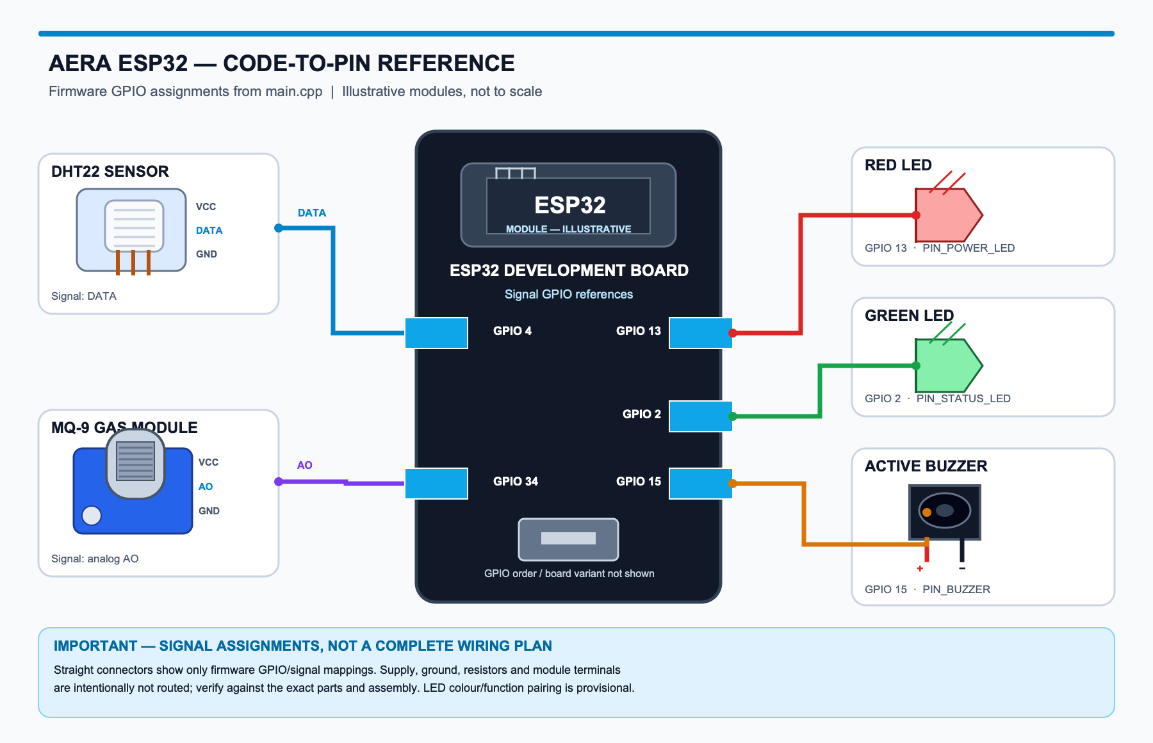
Figure 4.1. ESP32 firmware GPIO/signal map; the separate power and common-ground schematic follows.
VERIFY THE ASSEMBLY BEFORE ADDING POWER AND GROUND WIRES
The image maps firmware signal assignments, not verified physical wire routes. The ESP32 board revision, module terminal labels, LED colour/function pairing, resistor values and supply rails must be checked against the actual build. The MQ-9 heater requires a suitable stable supply, and GPIO 34 must never receive more than 3.3 V.

The firmware uses named constants rather than scattering raw GPIO numbers through sensor and indicator routines. These source assignments are the signal references represented in the illustration; they do not identify power, ground or resistor connections:
Source: aera-aqi/main.cpp
#define PIN_DHT 4
#define PIN_MQ9_ANALOG 34
#define PIN_POWER_LED 13
#define PIN_STATUS_LED 2
#define PIN_BUZZER 15

4.2.3 Power distribution and common ground
The previous image follows the firmware signal assignments. This schematic adds the breadboard supply wiring you described: four 1.2 V NiCd AA cells in series (4.8 V nominal) feed the MQ-9 VCC and ESP32 VIN in parallel. A 1000 µF electrolytic capacitor is connected across battery positive and common ground. The DHT22 takes VCC from the ESP32 3.3 V pin; its ground goes to a second ESP32 GND pin, which is electrically part of the same common ground. The lines are consolidated as rails for readability; they do not show the physical breadboard placement.
Before energizing, verify that the board VIN accepts the battery pack’s full charged range and measure MQ-9 AO at GPIO 34 (maximum 3.3 V). Add a suitable series resistor to each GPIO-driven LED as planned, check whether the buzzer needs a driver, and confirm the electrolytic capacitor’s polarity and voltage rating.
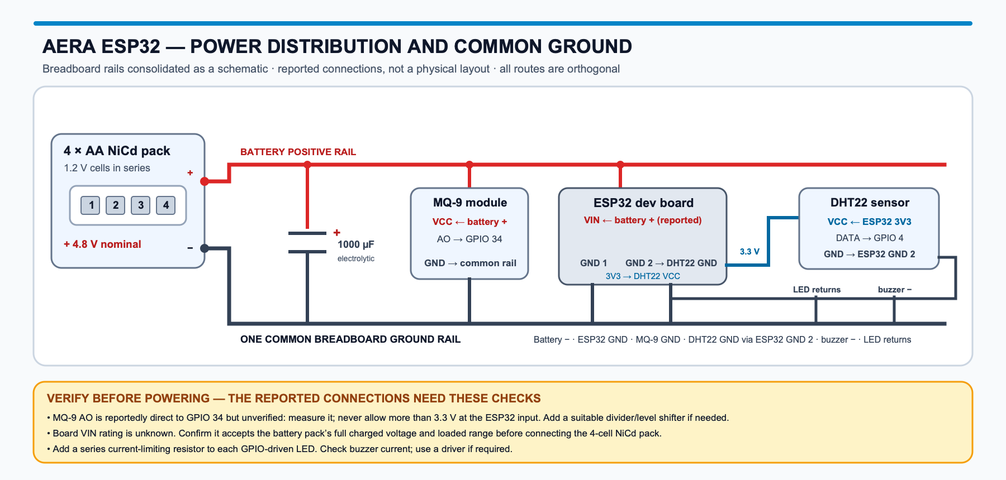
Figure 4.2. Reported power rails and shared returns; battery and capacitor symbols are editable in the companion SVG.

4.2.4 Imports and hardware declarations
The imports at the top of main.cpp select the capabilities used by the firmware: Arduino core and Wi-Fi connectivity, TLS/HTTP communication with the API, the DHT sensor driver, and the local web/DNS/preferences services used for Wi-Fi setup and saved credentials.
#include <Arduino.h>
#include <WiFi.h>
#include <WiFiClientSecure.h>
#include <HTTPClient.h>
#include <DHT.h>
#include <WebServer.h>
#include <DNSServer.h>
#include <Preferences.h>
Source: aera-aqi/main.cpp
static DHT dhtSensor(PIN_DHT, DHT22);
static WebServer server(80);
static DNSServer dnsServer;
static Preferences prefs;
The DHT object binds the sensor driver to the pin constant and DHT22 type. The WebServer and DNSServer support the local provisioning portal, while Preferences provides non-volatile storage for saved network settings. The network and API objects have separate jobs; none of these declarations represents a physical wire diagram.

4.2.5 Identity and sensor preparation
initHardwareIdentity() derives a short station identifier from the ESP32’s eFuse MAC value and uses it to form both the node ID and the temporary setup access-point name. This gives the device a repeatable identity without manually assigning a different text ID to every board:
Source: aera-aqi/main.cpp; serial diagnostics are omitted.
uint64_t mac = ESP.getEfuseMac();
char idBuffer[20];
char apBuffer[20];
uint32_t shortId = (uint32_t)(mac >> 24) & 0xFFFFFF;
snprintf(idBuffer, sizeof(idBuffer), "AERA-%06X", shortId);
snprintf(apBuffer, sizeof(apBuffer), "Aera-%06X", shortId);
aeraDeviceId = String(idBuffer);
aeraAPName = String(apBuffer);

The setup routine configures output pins and ADC resolution, starts the DHT sensor, creates the device identity and calibrates the MQ-9 baseline. It then loads saved network credentials; if the node cannot connect, it starts the local provisioning portal.
Source: aera-aqi/main.cpp; intervening pin setup and saved-Wi-Fi checks are omitted.
void setup() {
Serial.begin(SERIAL_BAUD_RATE);
...
analogReadResolution(MQ9_ADC_RESOLUTION);
...
dhtSensor.begin();
initHardwareIdentity();
calibrateCleanAirR0();
...
startCaptivePortal();
}

readMQ9Ppm() averages ADC samples, converts the reading to an input voltage, calculates sensor resistance relative to the stored clean-air baseline, and applies the firmware curve approximation to estimate PPM. It is an implementation-specific estimate, not a calibrated safety measurement:
Source: aera-aqi/main.cpp; bounds checks and ADC averaging loop are omitted.
float rawAdc = (float)rawSum / 16.0f;
float voltage = (rawAdc / 4095.0f) * 3.3f;
...
float rs = MQ9_RL_VALUE_KOHM * (3.3f - voltage) / voltage;
float ratio = rs / mq9_R0;
if (ratio <= 0.01f) ratio = 0.01f;
float ppm = 95.0f * pow(ratio, -1.45f);
...
return ppm;

4.2.6 Sampling, transmission and device response
loop() keeps the station responsive between samples. It updates status indicators, serves the captive portal when provisioning is active, retries Wi-Fi after a disconnection, and dispatches a reading when the telemetry interval has elapsed. The core sampling sequence is:
Source: aera-aqi/main.cpp; DHT failure handling and serial logging are omitted.
if (now - lastTransmit >= TELEMETRY_INTERVAL_MS) {
lastTransmit = now;
float temperature = dhtSensor.readTemperature();
float humidity = dhtSensor.readHumidity();
...
float co_ppm = readMQ9Ppm();
...
if (WiFi.status() == WL_CONNECTED) {
bool dispatched = postTelemetry(temperature, humidity, co_ppm);
if (dispatched) {
pulseStatusLed();
}
}
}

postTelemetry() formats selected values into JSON, sends an HTTPS POST to the device-ingest endpoint, reads the acknowledgement and controls the local buzzer when the server requests an alert or the firmware’s own CO threshold is reached. The payload currently sends PM2.5 and PM10 as zero because this hardware configuration has no particulate sensor.
Source: aera-aqi/main.cpp; request headers and response parsing are omitted.
char jsonBody[280];
...
int httpCode = https.POST((uint8_t*)jsonBody, strlen(jsonBody));
bool success = (httpCode >= 200 && httpCode < 300);
...
if (serverBuzzerAlert || co >= HARD_SAFETY_CO_LIMIT) {
digitalWrite(PIN_BUZZER, HIGH);
}

The device therefore combines two alert inputs: an advisory directive returned by the cloud and a local firmware threshold. A successful HTTP response also drives the online state indicator, while each successful dispatch produces a brief status-LED pulse. These are implementation behaviors, not a certified alarm specification.
CREDENTIALS ARE NOT PRINTED IN THIS CHAPTER
The firmware source includes a compile-time device credential used for device authentication. Its value is intentionally excluded from the printed excerpts. Do not publish or reuse live credentials; rotate any credential that has been committed to a public repository and move deployment secrets out of source code. The HTTPS connection also requires proper server-certificate verification before being trusted on an untrusted network.

4.3 Backend: Application, APIs and Persistence
The cloud workspace is organized around clear boundaries between request handling, business services, data models, and external resources. Device ingestion and user-facing API routes enter through separate modules; Pydantic schemas define payload contracts, dependencies resolve authentication and database access, and services coordinate work that should not be embedded in endpoint declarations. Models describe persistent entities, while utilities contain shared calculations such as the configured index. This structure lets the walkthrough follow one reading from the authenticated route through validation, processing, storage, and delivery to subscribed clients.
A simplified view of the backend workspace:
aera-cloud/app/
├── api/device/ # Device authentication and telemetry ingestion
├── api/v1/ # Client-facing account and monitoring routes
├── schemas/ # Validated request and response models
├── services/device/ # Telemetry processing and live device manager
├── db/models/ # PostgreSQL entities
└── utils/aqi.py # Pollutant sub-index and aggregate NAQI

The ESP32 POST route receives a typed telemetry payload and requires the device-authentication dependency. It uses the verified device identity, passes the record to the telemetry service, broadcasts an enriched reading to connected clients and returns the acknowledgement used by the firmware:
Source: aera-cloud/app/api/device/telemetry.py; intervening error handling is omitted.
@device_router.post("/telemetry/ingest", response_model=IngestAckResponse, status_code=status.HTTP_200_OK)
async def ingest_http_telemetry(
payload: TelemetryIngestPayload,
device: Device = Depends(verify_device_http_auth),
):
target_id = device.id
data_dict = payload.model_dump()
data_dict["device_id"] = target_id
enriched = await process_telemetry(target_id, data_dict)
...
await device_manager.broadcast_telemetry(target_id, enriched)
return IngestAckResponse(
status="ok",
buzzer=enriched.get("buzzer_alert", False),
aqi=enriched.get("aqi"),
)

process_telemetry() standardizes incoming values, asks the AQI utility to calculate pollutant sub-indices, builds an enriched payload, updates Redis when available and attempts to persist a Reading in PostgreSQL. Redis holds expiring latest-state/heartbeat data; it is not the historical database. In the current service, a database persistence exception is logged and the enriched payload is still returned, so an HTTP “ok” acknowledgement should not be read as proof that every history write succeeded.
The AQI utility calculates an index for each available positive pollutant and selects the highest sub-index as the overall value/category. If no pollutant contributes an index, it returns the project’s zero/Good baseline:
Source: aera-cloud/app/utils/aqi.py; surrounding function signature is omitted.
sub_indices = []
if pm2_5 > 0.0:
sub_indices.append(_calc_sub_index(pm2_5, PM25_BREAKPOINTS))
if pm10 > 0.0:
sub_indices.append(_calc_sub_index(pm10, PM10_BREAKPOINTS))
if co > 0.0:
sub_indices.append(_calc_sub_index(co, CO_BREAKPOINTS))
if not sub_indices:
return 0, "Good"
return max(sub_indices, key=lambda item: item[0])

This selection rule matters: the overall index is the highest calculated pollutant sub-index, not an average across pollutants. The breakpoints and interpretation are project logic, and do not turn this prototype into a certified monitoring or alarm instrument.

4.3.1 Application entry point and imports
The backend starts in main.py, which loads the application factory and settings before handing execution to Uvicorn. The factory creates the FastAPI application, separating startup configuration from route and service logic; the runner supplies the host, port, and development reload behavior.
from app import create_app
from app.core.config import settings
app = create_app()
if __name__ == "__main__":
import uvicorn
uvicorn.run("main:app", host=settings.HOST, port=settings.PORT, reload=settings.DEBUG)
Source: aera-cloud/main.py
The factory in app/__init__.py applies shared middleware and lifecycle behavior, including CORS configuration and asynchronous database-engine disposal at shutdown. It mounts the combined API router below /api; versioned account and monitoring endpoints are grouped below /api/v1, while the device-ingestion route is mounted directly below /api. This keeps the device contract distinct from user-facing operations without changing the common service boundary.
app.add_middleware(
CORSMiddleware,
allow_origins=settings.BACKEND_CORS_ORIGINS,
allow_credentials=True,
allow_methods=["*"],
allow_headers=["*"],
)
app.include_router(api_router, prefix="/api")
Source: aera-cloud/app/__init__.py; surrounding application metadata and lifecycle code are omitted.

4.3.2 Environment settings and database sessions
Pydantic Settings reads backend configuration from aera-cloud/.env or environment variables, allowing deployment-specific secrets, database URLs, origins, and optional integrations to remain outside source code. The in-memory SQLite URL shown below is only a convenient code default; configure DATABASE_URL for PostgreSQL when records must survive process restarts. Redis is independent and optional: it can hold expiring latest telemetry and device heartbeats, whereas PostgreSQL is the durable source for accounts, devices, and historical readings.
class Settings(BaseSettings):
...
DATABASE_URL: str = "sqlite+aiosqlite:///:memory:"
DIRECT_URL: str | None = None
REDIS_URL: str | None = None
...
model_config = SettingsConfigDict(
env_file=".env",
env_file_encoding="utf-8",
case_sensitive=True,
extra="ignore",
)
Source: aera-cloud/app/core/config.py; unrelated settings are omitted.
database.py creates an asynchronous SQLAlchemy engine and session factory. A route that declares get_db receives a request-scoped session; the dependency commits successful work, rolls back and re-raises on failure, and closes the session in all cases. This gives route and service code a consistent transaction boundary and avoids leaving database resources open after a request.
async def get_db() -> AsyncGenerator[AsyncSession, None]:
async with AsyncSessionLocal() as session:
try:
yield session
await session.commit()
except Exception:
await session.rollback()
raise
finally:
await session.close()
Source: aera-cloud/app/core/database.py; engine and session-factory declarations are omitted.

4.3.3 Telemetry contract and processing service
The telemetry path begins with a typed Pydantic contract that checks the incoming field shape and numeric ranges. The ingest route also requires device authentication and uses the verified device record as the identity boundary rather than trusting a caller-supplied ID alone. It delegates to the device service, which normalizes and validates sensor values, calculates the project-configured NAQI, prepares the enriched response, attempts to persist the reading, refreshes Redis state when configured, and makes the processed event available to connected clients. The HTTP acknowledgement returns to the firmware; WebSocket delivery is a separate path for monitoring clients.
The service boundary makes these dependencies visible: database access, optional Redis state, Reading and Device models, sensor validation, and AQI calculation are composed in the device service. Keeping this work outside the route makes the API handler responsible for request orchestration while the service owns the telemetry-processing sequence.
from sqlalchemy.ext.asyncio import AsyncSession
from sqlalchemy import select
from app.core import logger, AsyncSessionLocal, get_redis_client
from app.db.models.reading import Reading
from app.db.models.device import Device
from app.utils.aqi import compute_naqi
from app.utils.validators import validate_sensor_payload
async def process_telemetry(
device_id: str,
data: dict,
session: AsyncSession | None = None,
) -> dict | None:
...
Source: aera-cloud/app/services/device/telemetry.py; implementation details are covered by the route and AQI excerpts above.

4.3.4 Account authentication and access tokens
Registration stores a bcrypt password hash rather than the supplied password. Login verifies the password and returns a signed bearer token containing the user ID and expiry. Protected endpoints use get_current_user to decode the token, load the account and reject missing, expired or inactive users. Password recovery uses a separate signed reset token with a 15-minute lifetime. The clients store the returned access token and attach it to authenticated API calls.
pwd_context = CryptContext(schemes=["bcrypt"], deprecated="auto")
def get_password_hash(password: str) -> str:
return pwd_context.hash(password)
...
to_encode = {"exp": expire, "sub": str(subject), "type": "access"}
return jwt.encode(to_encode, settings.SECRET_KEY, algorithm=settings.ALGORITHM)
Source: aera-cloud/app/core/security.py; unrelated password-reset token code is omitted.
payload = jwt.decode(token, settings.SECRET_KEY, algorithms=[settings.ALGORITHM])
user_id_raw = payload.get("sub")
...
user_id = int(user_id_raw)
...
user = await db.get(User, user_id)
if not user or not user.is_active:
raise CredentialsException(detail="Inactive or non-existent user account.")
Source: aera-cloud/app/api/v1/deps.py; token error handling is omitted.

4.3.5 Pairing a device to an account
The ESP32 reports a MAC-derived device ID with telemetry; a signed-in user can claim that ID through the user-device API. The claim route creates or assigns the device to the current account and rejects a claim if another account already owns it. Later device and private-reading requests check the authenticated owner. Releasing a device clears the account association rather than erasing the sensor’s historical record.
device = await db.get(Device, payload.device_id)
...
if device.owner_id and device.owner_id != current_user.id:
raise HTTPException(
status_code=status.HTTP_409_CONFLICT,
detail="Device is already claimed by another user.",
)
...
device.owner_id = current_user.id
await db.commit()
Source: aera-cloud/app/api/v1/user/device.py; creation, notification email and cache invalidation are omitted.

4.3.6 Historical readings and live WebSocket updates
Monitoring provides three distinct views of device data. The latest snapshot is read from Redis when available and falls back to PostgreSQL; historical charts query durable Reading records; and WebSockets push newly processed telemetry to connected viewers. A new subscriber can receive the latest cached snapshot before later broadcasts arrive. Device visibility and account ownership are checked for user-facing access, while hardware WebSocket connections use a separate device-authentication dependency. These paths explain why a live update, a current snapshot, and a historical query are related but not interchangeable.
async def register_subscriber(self, device_id: str, ws: WebSocket) -> None:
await ws.accept()
...
redis = get_redis_client()
if redis:
cached = await redis.get(f"device:{device_id}:latest")
if cached:
await ws.send_text(cached)
async def broadcast_telemetry(self, device_id: str, payload: dict) -> None:
listeners = self.subscribers.get(device_id, set())
...
await ws.send_json(payload)
Source: aera-cloud/app/services/device/manager.py; disconnect and delivery-error handling are omitted.

4.3.7 AI chat, recommendations and guardrails
The AI chat route requires a signed-in account and checks whether a requested private device belongs to that user before passing the question, device ID or ambient context to the chat service. The service validates environmental values before prompt construction and sanitizes the model reply with a non-clinical disclaimer where appropriate. Recommendations can return structured fallback guidance when no model API key is configured; they are environmental precautions, not medical diagnosis or treatment.
if payload.device_id:
dev = await db.get(Device, payload.device_id)
...
if dev.visibility == DeviceVisibility.PRIVATE and dev.owner_id != current_user.id:
raise HTTPException(
status_code=status.HTTP_403_FORBIDDEN,
detail="Unauthorized access to target device telemetry.",
)
return await handle_user_chat(
user_id=str(current_user.id),
message=payload.message,
session_id=payload.session_id,
device_id=payload.device_id,
ambient_context=payload.ambient_context,
db=db,
)
Source: aera-cloud/app/api/v1/ai.py; authorization error details are abbreviated.
if not settings.GROQ_API_KEY:
tone = "emerald" if resolved_aqi <= 50 else "sky" if resolved_aqi <= 100 else "rose"
return StructuredRecommendation(
source=source,
aqi=resolved_aqi,
category=resolved_cat,
tone=tone,
summary=f"Air quality currently sits at index {resolved_aqi} ({resolved_cat}).",
precautions=[
"Maintain standard indoor air filtration.",
"Ventilate living spaces during low-particulate hours.",
"Stay hydrated and monitor breathing ease outdoors.",
],
vulnerable_groups_warning="Individuals with respiratory sensitivities should moderate high-intensity outdoor activities.",
)
Source: aera-cloud/app/services/ai/recommendation.py and app/services/ai/chat.py; prompt and response fields are omitted.

4.4 Web Dashboard: Imports, APIs and Live State
The web client is a browser-based React application organized so routes and screens describe the interface while hooks and service modules own reusable state and network behavior. The authenticated dashboard composes device selection, current AQI and pollutant cards, recommendations, history, and assistant access. React state reflects the selected source and live session; it is not the durable store for readings. The following sections trace how routing, authentication, reusable components, REST requests, WebSockets, and optional ambient data cooperate to produce that screen.
A simplified view of the web workspace:
aera-web/src/
├── App.jsx # Routes and authenticated route boundary
├── pages/ # Dashboard and account screens
├── components/ # Layout, cards, charts and dialogs
├── hooks/ # Authentication, devices and AQI state
└── services/ # HTTP and WebSocket client operations

The route boundary waits for authentication state before deciding whether to show the requested page. While authentication is loading, it avoids prematurely redirecting the browser; once resolved, it allows the dashboard for an authenticated user or returns the visitor to login.
Source: aera-web/src/App.jsx
function ProtectedRoute({ children }) {
const { user, loading } = useAuth();
if (loading) return null;
return user ? children : <Navigate to="/login" replace />;
}

The Dashboard page composes selected-device controls, the AQI card, pollutant details, recommendations, and the history chart from reusable components. Its useAQI hook supplies reading state, while useDevice supplies the account’s device list and selected station. When the user selects a physical station, the hook obtains the initial latest snapshot and history and then opens that station’s WebSocket stream; the screen renders the resulting state rather than implementing the transport itself:
Source: aera-web/src/hooks/useAQI.jsx; omitted lines reset the live watchdog.
ws.onmessage = (event) => {
if (!isEffectActive) return;
try {
const telemetry = JSON.parse(event.data);
setCurrentReading(telemetry);
setHistory((prev) => [...prev.slice(-49), telemetry]);
setIsHardwareActive(true);
...
} catch (e) {
console.error("Malformed telemetry packet:", e);
}
};

The isEffectActive guard prevents callbacks from an obsolete socket from updating a screen after the selected device changes or the component is cleaned up. A watchdog marks a station inactive when live packets stop arriving, and the close handler attempts reconnection. These controls protect the view from stale asynchronous events; they do not replace the backend as the source of stored history or device ownership.
Aera also has an Ambient Grid path when no hardware device is selected. It obtains external location-based data through the monitoring service rather than treating those values as ESP32 telemetry; the data-source distinction was explained in Chapter 2.

4.4.1 Imports, page composition and hooks
The browser entry point in src/main.jsx mounts the route tree and its shared providers. App.jsx resolves the account boundary and protected pages; Dashboard.jsx composes the screen from layout elements and focused dashboard components. Imports show the intended direction of dependency: the page chooses and arranges components, hooks provide state and actions, and service modules perform backend communication. This keeps visual cards reusable and avoids duplicating request logic across individual widgets.
import React, { useState } from "react";
import { useDevice } from "@/hooks/useDevice";
import { useAQI } from "@/hooks/useAQI";
import AppLayout from "@/components/layout/AppLayout";
import AQICard from "@/components/dashboard/AQICard";
import AQIChart from "@/components/dashboard/AQIChart";
import DeviceSelector from "@/components/dashboard/DeviceSelector";
Source: aera-web/src/pages/Dashboard.jsx; representative imports only.
The hooks divide dashboard state by responsibility. useAuth tracks the signed-in user and browser session; useDevice loads claimed devices and synchronizes selection and pairing actions; useAQI resolves the active data source and manages its latest, historical, and live-reading state. The screen combines these results and passes values and callbacks to cards, selectors, and dialogs, so a user action updates shared state without each visual component issuing its own API calls.

4.4.2 API client, configuration and authentication
services/api.js creates the shared Axios client. Vite exposes browser-specific configuration through VITE_API_URL and VITE_WS_URL; when no WebSocket URL is supplied, the code maps HTTPS to WSS and HTTP to WS. The client prefixes HTTP requests with /api so individual services can use the backend’s versioned paths.
export const API_BASE_URL =
import.meta.env.VITE_API_URL || "https://aera-cloud.hacksmiths.dev";
export const WS_BASE_URL =
import.meta.env.VITE_WS_URL ||
(API_BASE_URL.startsWith("https")
? API_BASE_URL.replace("https://", "wss://")
: API_BASE_URL.replace("http://", "ws://"));
const api = axios.create({
baseURL: `${API_BASE_URL}/api`,
headers: { "Content-Type": "application/json" },
});
Source: aera-web/src/services/api.js; request/response interceptors are omitted.
The shared request interceptor attaches the bearer token from browser localStorage. If an API response reports an unauthorized session, the response interceptor removes the token and returns the user to the login flow. Centralizing these steps means auth and monitoring service methods use the same client behavior.

4.4.3 Service endpoints and live state
services/monitoring.js groups reading operations behind named methods. The dashboard does not construct its own URLs: getLatest and getHistory call the REST resources, while getLiveStreamUrl returns the device-specific WebSocket address. Other services similarly wrap authentication, claimed-device management, recommendations and assistant requests.
async getLatest(deviceId) {
const res = await api.get(`/v1/monitoring/latest/${deviceId}`);
return res.data;
},
async getHistory(deviceId, limit = 50) {
const res = await api.get(
`/v1/monitoring/history/${deviceId}?limit=${limit}`
);
return res.data;
},
getLiveStreamUrl(deviceId) {
return `${WS_BASE_URL}/api/v1/monitoring/ws/live/${deviceId}`;
}
Source: aera-web/src/services/monitoring.js; selected methods only.
For a selected hardware station, useAQI first requests the latest snapshot and a history window through the monitoring service, then subscribes to the device-specific WebSocket. Incoming events refresh the displayed reading and rolling chart state. Changing the station closes the previous socket and clears its timers before the next source is loaded. Browser localStorage contains the session token, not the telemetry archive: durable history is fetched from the backend, while the most recent live values are held in React state. The Ambient Grid uses a separate external-data request path.

4.4.4 Device discovery, claiming and source selection
The device service retrieves the signed-in user’s claimed stations and exposes claim and release operations. useDevice keeps the device list and active selection available to the dashboard, selector, and pairing modal, so those controls stay consistent after a claim or source change. Choosing an ESP32 directs useAQI to that station’s cloud readings; choosing the Ambient Grid requests location-based ambient data instead. The two sources may share presentation components, but they are not represented as the same sensor stream.
async claimDevice(deviceId, name = "Aera Node") {
const res = await api.post("/v1/user/claim-device", {
device_id: deviceId,
name,
});
return res.data;
},
async releaseDevice(deviceId) {
await api.delete(`/v1/user/devices/${deviceId}`);
}
Source: aera-web/src/services/device.js; listing and live-state methods are omitted.

4.4.5 AI assistant and per-tab chat history
The web chat hook creates or restores a session ID in sessionStorage, loads saved turns from the backend, and sends each question with the selected device ID. This lets the backend attach authorized hardware context when a station is selected. Chat message history is stored server-side; sessionStorage holds only the tab’s session identifier.
const [sessionId] = useState(() => {
const saved = sessionStorage.getItem("aera_chat_session");
if (saved) return saved;
const generated = `session-${Date.now()}-${Math.random().toString(36).substring(2, 9)}`;
sessionStorage.setItem("aera_chat_session", generated);
return generated;
});
const response = await aiService.sendMessage({
message: text.trim(), sessionId, deviceId: activeDeviceId,
});
Source: aera-web/src/hooks/useChat.jsx; asynchronous state and error handling are omitted.

4.4.6 Custom web favicon
The browser tab icon is selected in aera-web/index.html, not imported by a React component. The HTML link points to /aera.svg; Vite serves the matching file from aera-web/public/aera.svg at the site root. This keeps the custom artwork as a standalone SVG, so its shapes scale cleanly at favicon sizes. If the artwork or file path changes, update the link and confirm the public asset is included in the production build.
<head>
<meta charset="UTF-8" />
<link rel="icon" type="image/svg+xml" href="/aera.svg" />
<meta name="viewport" content="width=device-width, initial-scale=1.0" />
<title>Aera</title>
</head>
Source: aera-web/index.html; surrounding document markup is omitted. The icon file is aera-web/public/aera.svg.

4.5 Mobile App: Imports, APIs and Local State
The mobile client is a native-rendered React Native application built with Expo, not a browser page wrapped for a phone. It shares Aera’s backend contracts and many monitoring concepts with the web dashboard, but uses native screens, touch-oriented controls, platform navigation, and device-specific networking and storage. Screens live in screens/, reusable controls in components/, and API operations in services/; hooks coordinate authentication, device selection, readings, and assistant sessions. This separation allows the app to share domain behavior with the web client without pretending that its runtime or build process is identical.
A simplified view of the mobile workspace:
aera-app/src/
├── navigation/AppNavigator.js # Auth-dependent screen stack
├── screens/ # Dashboard, history and account screens
├── components/ # Native cards, navigation and dialogs
├── hooks/ # Auth, device and reading state
└── services/ # API, auth, devices and monitoring

The navigation stack is selected from authentication state. Visitors receive the account screens for sign-in, registration, or recovery; after authentication, the navigator exposes the monitoring, history, settings, and assistant screens. This gate keeps unauthenticated and account-owned workflows separate, while data loading and AQI calculations remain in hooks and backend services rather than in navigation declarations.
Source: aera-app/src/navigation/AppNavigator.js; remaining account screens are omitted.
{user ? (
<>
<Stack.Screen name="Dashboard" component={DashboardScreen} />
<Stack.Screen name="History" component={HistoryScreen} />
<Stack.Screen name="Settings" component={SettingsScreen} />
<Stack.Screen name="AiChat" component={AiChatScreen} />
</>
) : (
<>
<Stack.Screen name="Login" component={LoginScreen} />
<Stack.Screen name="Register" component={RegisterLayout} />
...
</>
)}

After login, the mobile authentication provider stores the returned access token in AsyncStorage, designed for persistent key/value data in a native app. The web client instead uses browser storage. This is platform-specific; both clients attach the session token when making authenticated API requests.
Source: aera-app/src/hooks/useAuth.jsx
const login = async (credentials) => {
const data = await authService.login(credentials);
await AsyncStorage.setItem("aera_token", data.access_token);
return await refreshProfile();
};
...
const logout = async () => {
await AsyncStorage.removeItem("aera_token");
setUser(null);
};

The mobile DashboardScreen assembles a native layout from dashboard cards, source selection, and a device-pairing modal. It reads the selected device and current measurements from shared hooks, then supplies values and actions to the visual components. Opening the assistant passes the chosen device and current reading as navigation context; the destination screen can therefore present a relevant conversation without owning the dashboard’s telemetry connection. The same backend monitoring service serves the native UI even though its layout differs from the browser.

4.5.1 Native entry point, providers and screen imports
App.jsx is the React Native entry point. It initializes the Expo application and wraps the navigation tree in authentication and device providers, making those shared values available to nested screens. AppNavigator selects the account or signed-in screen stack; it remains a routing boundary rather than the place where readings are fetched, history is stored, or air quality is calculated.
import React, { useState, useEffect, useRef, useCallback } from "react";
import { View, StyleSheet, Animated, Easing, InteractionManager } from "react-native";
import { SafeAreaProvider } from "react-native-safe-area-context";
import { AuthProvider, useAuth } from "./src/hooks/useAuth";
import { DeviceProvider } from "./src/hooks/useDevice";
import AppNavigator from "./src/navigation/AppNavigator";
Source: aera-app/App.jsx; startup and splash-screen imports are omitted.
DashboardScreen combines native layout and touch controls with the same device and AQI hooks used by the web client. React Native components render cards and controls for a phone-sized screen, while hooks and service modules own source selection, requests, and live state. This keeps the visual layer focused on presentation and lets common monitoring behavior remain consistent across platforms.
import { View, StyleSheet, TouchableOpacity } from "react-native";
import { useDevice } from "../hooks/useDevice";
import { useAQI } from "../hooks/useAQI";
import ScreenLayout from "../components/layout/ScreenLayout";
import AQICard from "../components/dashboard/AQICard";
import DeviceSelector from "../components/dashboard/DeviceSelector";
import ClaimDeviceModal from "../components/dashboard/ClaimDeviceModal";
Source: aera-app/src/screens/DashboardScreen.jsx; representative imports only.

4.5.2 API client and service methods
The mobile client also uses Axios and the /api server prefix, but its current base URLs are declared directly in src/services/api.js rather than read from Vite variables. For local testing, the configured address must be reachable from the simulator or physical phone; localhost on the mobile device does not refer to the developer’s computer.
export const API_BASE_URL = "https://aera-cloud.hacksmiths.dev";
export const WS_BASE_URL = "wss://aera-cloud.hacksmiths.dev";
const api = axios.create({
baseURL: `${API_BASE_URL}/api`,
headers: { "Content-Type": "application/json" },
timeout: 10000,
});
Source: aera-app/src/services/api.js; interceptors are omitted.
Mobile monitoring methods call the same latest-reading, history, ambient-data, and live-stream resources used by the browser. Authentication, user profile, and device pairing are also wrapped in service modules. The shared backend contract keeps account and telemetry behavior aligned, while native navigation, AsyncStorage, and simulator/device network addresses remain mobile-specific.
async getLatest(deviceId) {
const res = await api.get(`/v1/monitoring/latest/${deviceId}`);
return res.data;
},
async getHistory(deviceId, limit = 50) {
const res = await api.get(`/v1/monitoring/history/${deviceId}?limit=${limit}`);
return res.data;
},
getLiveStreamUrl(deviceId) {
return `${WS_BASE_URL}/api/v1/monitoring/ws/live/${deviceId}`;
}
Source: aera-app/src/services/monitoring.js; selected methods only.

4.5.3 AsyncStorage and reading history
The mobile project does not define a local SQLite database or offline telemetry-history store. AsyncStorage persists small key/value items such as the access token and AI chat-session identifier. Reading history is requested from the backend; current screen state is refreshed from REST responses and live WebSocket events. AsyncStorage should therefore not be mistaken for the source of historical sensor records.
The Axios request interceptor reads the stored access token and adds it to authenticated requests. The authentication hook writes the returned token after sign-in and removes it on sign-out; these are session values, not cached sensor measurements.

4.5.4 Device pairing and native history
The mobile service layer exposes the same account-owned device workflow as the browser: load claimed or unclaimed nodes, claim a node ID, and release it when pairing changes.
async claimDevice(deviceId, name = "Aera Node") {
const res = await api.post("/v1/user/claim-device", {
device_id: deviceId,
name,
});
return res.data;
},
async releaseDevice(deviceId) {
await api.delete(`/v1/user/devices/${deviceId}`);
}
Source: aera-app/src/services/device.js; list and live-state methods are omitted.
Unlike the web dashboard’s history panel, the mobile client has a dedicated HistoryScreen in its authenticated navigation stack. For a selected ESP32 it requests up to 40 stored readings through monitoringService; when no hardware station is selected it requests the Ambient Grid’s 24-hour timeline. Both are backend responses, not local database queries. The source selector and useAQI hook keep these histories associated with their respective origins, and the screen can render loading, empty, and error states independently of the dashboard.

4.5.5 Assistant session and ambient context
The mobile chat hook stores a small session ID in AsyncStorage and restores the conversation from the backend. When a user selects a hardware device, requests include that device ID so the service can apply its authorization and contextual-data rules. Without a selected device, the client can send the current Ambient Grid reading as explicit context. The locally stored identifier reconnects the UI to a conversation; it does not store the message archive or create an offline telemetry history.
const ambientContext = !activeDeviceId && currentReading ? {
location_name: "Mobile Device Region",
aqi: currentReading.aqi,
category: currentReading.category,
temperature: currentReading.temperature,
humidity: currentReading.humidity,
pm25: currentReading.pm2_5,
pm10: currentReading.pm10,
co: currentReading.co,
} : null;
const response = await aiService.sendMessage({
message: trimmed, sessionId, deviceId: activeDeviceId, ambientContext,
});
Source: aera-app/src/hooks/useChat.jsx; message state and error handling are omitted.

4.5.6 App icon and splash artwork
Expo reads the application icon from app.json. Splash-screen artwork and its background are configured through the expo-splash-screen config plugin, rather than the unsupported top-level splash field. The Android adaptive-icon foreground uses a separate monochrome asset on the configured pale background. These asset paths are relative to aera-app/app.json. Platform-specific icon and splash files are copied or transformed into generated native projects during prebuild/build; changing source artwork does not necessarily update already-generated native assets until those projects are regenerated.
{
"expo": {
"icon": "./assets/icons/favicon.png",
"android": {
"adaptiveIcon": {
"foregroundImage": "./assets/icons/android-icon-monochrome.png",
"backgroundColor": "#f8fafc"
}
},
"plugins": [
[
"expo-splash-screen",
{
"backgroundColor": "#f8fafc",
"image": "./assets/icons/favicon.png",
"imageWidth": 100
}
]
]
}
}
Source: aera-app/app.json; unrelated app identity and native settings are omitted.
The assets are deliberately different in scale and use: the 48 × 48 PNG supplies the general Expo icon, while the Android adaptive-icon foreground is a 432 × 432 monochrome mark. The splash image and background are supplied by the Expo config plugin. When producing release builds, inspect the icon and splash on both platforms because iOS and Android apply different safe areas, masks and display scaling.

4.6 How the Four Implementations Connect
The four implementations connect through two related paths: telemetry travels from the ESP32 to Aera Cloud, while monitoring data travels from the cloud to authenticated web and mobile clients. The components do not call into one another directly; they coordinate through device identity, request and response schemas, shared API resources, and the live-event contract. Following one reading through these boundaries shows how the separate firmware, service, persistence, and presentation layers form a single workflow.
• Device-to-cloud contract — The firmware samples its inputs, attaches the station identity, and submits telemetry using the device credential. The typed ingest route validates the request and resolves the authenticated device before processing begins; this is the boundary where hardware identity must agree with the backend record.
• Cloud processing and storage — The device service normalizes the values, calculates the project-configured index and category, evaluates alert conditions, and prepares the enriched reading. PostgreSQL is intended to retain durable history; Redis may provide expiring latest-state and heartbeat data. Because the current service logs a persistence failure and can still return the enriched payload, an HTTP acknowledgement alone does not prove that a history row was committed.
• Distribution to clients — The backend exposes snapshots and historical records through HTTP resources and sends new readings to subscribed clients over WebSockets. The web and mobile clients use the same account and monitoring contract, but each keeps platform-specific navigation and session state. Ownership checks determine which private device data an authenticated user may request.
• Client presentation and source selection — Each client combines service responses with its own screen state. A user may select an account-owned ESP32 or the separate Ambient Grid source; shared cards do not make external ambient data equivalent to device telemetry. History comes from the service rather than from live chart state.
• Feedback to the device — The HTTP response returns to the ESP32. Firmware uses the acknowledgement to distinguish successful submission from failure and can act on a buzzer instruction. WebSocket broadcasts serve the clients independently, so device feedback does not depend on a browser or mobile app being open.
Taken together, these contracts define the system’s integration points: the device payload and identity, backend processing and persistence behavior, and the API/event shapes consumed by both clients. The code excerpts are representative rather than exhaustive; platform-specific UI and storage differ, but the shared service boundary keeps the same monitored device and reading semantics across implementations. The later execution and troubleshooting chapters verify these components in sequence, where each failure can be isolated at the boundary that produced it.
CHAPTER 5

Testing, Deployment and
Packaging
  - Verifying each part of Aera, then preparing its clients and services to run
This chapter follows the same path as the system: verify the ESP32 firmware, test and start the backend, test and preview the web client, then test and package the mobile client for iOS and Android. The Cloudflare Tunnel is introduced only after the local services are verified. Docker Compose is described separately as an optional deployment route.
A successful unit test or build confirms only the behavior exercised by that check. It does not calibrate the MQ-9, prove the physical wiring, confirm reliable readings in a particular room, or make Aera a certified safety instrument. Keep physical and public-network checks separate from software tests.

5.1 Verification sequence and safe test data
Use the following sequence so that errors can be isolated at the layer that introduced them:

5.1.1 Project folders and command locations
Begin each workflow at the cloned repository root (the folder containing docker-compose.yml and the four component directories). Change into the named component directory before running its commands. Arduino IDE opens the .ino file by path; Docker Compose commands are run from the root. The folder map below shows the exact locations used in this chapter.

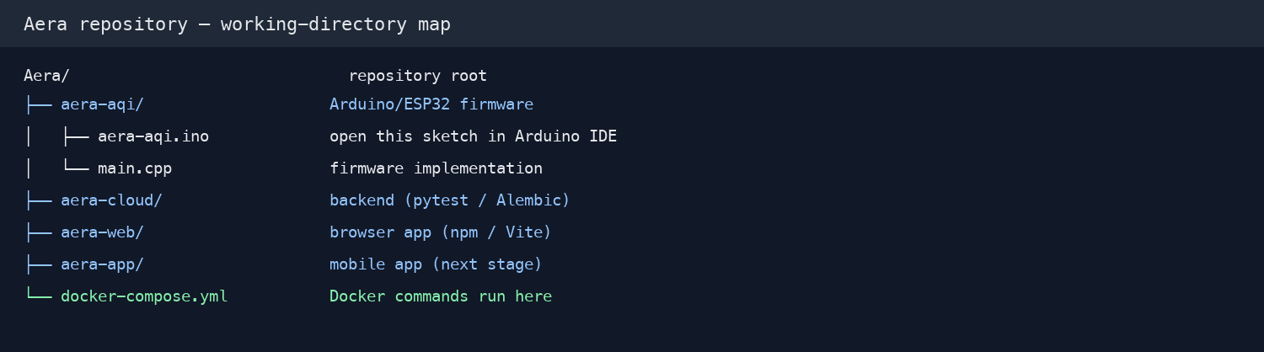
Figure 5.1. Aera repository folders and the working directory for each tool.
Treat firmware, backend, and web as sequential checkpoints: complete each stage before moving on so a failure can be traced to the layer that introduced it. After web, the optional Docker Compose lesson demonstrates a containerized backend/web route; it is not a prerequisite for the mobile build. Continue to the app only after the earlier stages and the Docker overview are complete.
Stage 1 — ESP32: compile and upload the firmware, then confirm startup and telemetry on the physical node. Stage 2 — Backend: apply schema migrations, pass the automated tests on a disposable database, and confirm the API health endpoint. Stage 3 — Web: pass its tests, build the static client, and confirm the built page is served by Preview.
• Compile and, when the ESP32 is connected, upload the firmware; inspect startup messages through Serial Monitor.
• Apply the backend database migrations, run pytest against a disposable database, and then start the API locally.
• Run the web unit tests, produce the static build, and serve that build with Vite Preview; then review the optional Docker Compose route.
• Run the mobile unit tests, regenerate the native projects when needed, then build and launch iOS before Android.
• After web verification, review the optional Docker Compose tools lesson; then continue to mobile. For the manual route, configure the Cloudflare Tunnel last.
TEST-DATABASE WARNING
The backend test fixture connects to DATABASE_URL and removes records matching its test ID/email patterns. Point it only at a newly created disposable database; never run pytest against production or a database containing personal data. The examples below use placeholders rather than real credentials.

5.2 ESP32 firmware: compile, upload and inspect
From the repository root, open aera-aqi/aera-aqi.ino in Arduino IDE. The .ino file and main.cpp must remain together in the aera-aqi folder: Arduino IDE opens the .ino sketch, while main.cpp contains the firmware implementation. Use the Espressif ESP32 Dev Module target and the serial port belonging to the connected board. Verify checks/compiles; Upload compiles and then flashes; Debug is a separate debugging tool and is not required for this workflow.

5.2.1 Prepare and verify the sketch
Before compiling, confirm these exact source files are in the same folder. The .ino file supplies the Arduino scanner’s library includes; the substantive sensor, Wi-Fi, provisioning, telemetry, and buzzer logic lives in main.cpp. Open the .ino in Arduino IDE, not main.cpp. Do not copy the device shared key into the book, screenshots, or public source.
The seven include lines in aera-aqi.ino identify the libraries needed to compile the sketch. The implementation is in main.cpp; its setup() and loop() functions are the firmware entry points. Keep both source files beside one another when opening or compiling the sketch.
aera-aqi.ino — the scanner/include stub:
#include <WiFi.h>
#include <WiFiClientSecure.h>
#include <HTTPClient.h>
#include <DHT.h>
#include <WebServer.h>
#include <DNSServer.h>
#include <Preferences.h>
main.cpp — selected beginning of setup(), where hardware startup begins:
void setup() {
Serial.begin(SERIAL_BAUD_RATE);
pinMode(PIN_POWER_LED, OUTPUT);
pinMode(PIN_STATUS_LED, OUTPUT);
pinMode(PIN_BUZZER, OUTPUT);
pinMode(PIN_MQ9_ANALOG, INPUT);
analogReadResolution(MQ9_ADC_RESOLUTION);
The original Aera Arduino IDE screenshot is reproduced in Figure 5.2. The toolbar controls are explained alongside the image; use the selected ESP32 Dev Module target and the recorded settings in Figure 5.3.
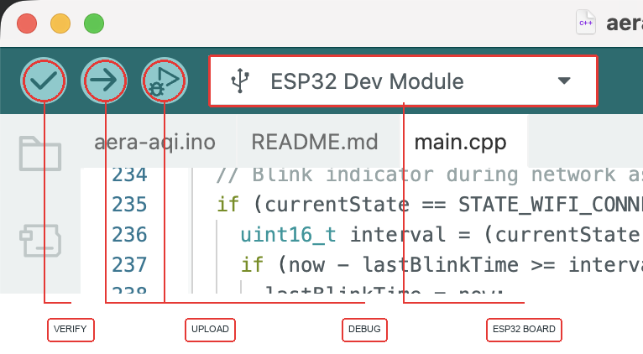 | Verify — Checks/compiles the sketch; it does not flash the board.  Upload — Compiles and transfers the firmware to the selected ESP32.  Debug — Opens debugging functions; it is not required for this workflow.  Board selector — The capture shows ESP32 Dev Module as the active target.  Sketch files — Open aera-aqi.ino and keep it beside main.cpp in aera-aqi.
Figure 5.2. Aera Arduino IDE screenshot with static red callouts identifying Verify, Upload, Debug, and ESP32 board selection.
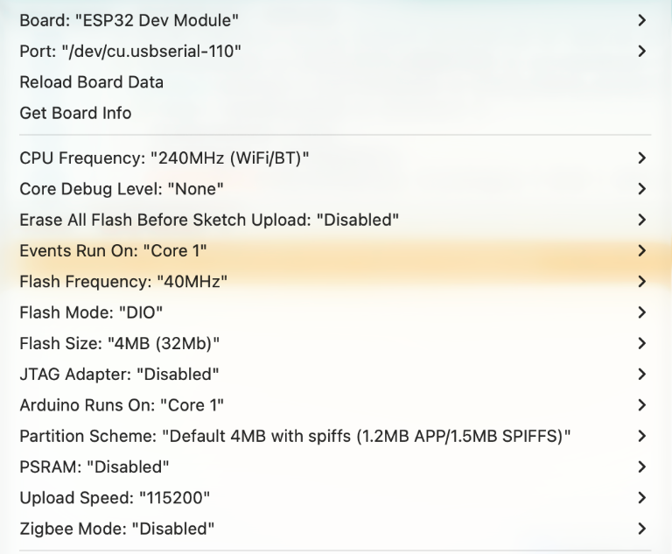 | Recorded setup — These are the values selected for this project, not assumptions based on IDE defaults.  Target — ESP32 Dev Module. Port: /dev/cu.usbserial-110 (this capture; the port name is machine-specific).  CPU — 240MHz (WiFi/BT). Events Run On and Arduino Runs On: Core 1.  Flash — 40MHz; DIO; 4MB (32Mb). Partition Scheme: Default 4MB with spiffs (1.2MB APP/1.5MB SPIFFS).  Upload — 115200.  Disabled options — Core Debug Level: None; Erase All Flash Before Sketch Upload: Disabled; JTAG Adapter: Disabled; PSRAM: Disabled; Zigbee Mode: Disabled.  Note — “Default” is part of the selected partition-scheme label shown in the menu.
Figure 5.3. Focused crop of the Aera Arduino IDE Tools menu showing the project-used ESP32 configuration.
If you prefer the command line, open Terminal at the repository root, then enter the firmware directory and compile. This is the exact command used for the successful Aera compile below:
cd aera-aqi
arduino-cli compile --fqbn esp32:esp32:esp32 .
The firmware compiled successfully in this environment. The compiler reported 1,076,092 bytes of program storage (82% of the available 1,310,720 bytes) and 49,520 bytes of global memory (15% of 327,680 bytes). These numbers are for the selected esp32:esp32:esp32 board target and installed libraries; another board or library version can change them.

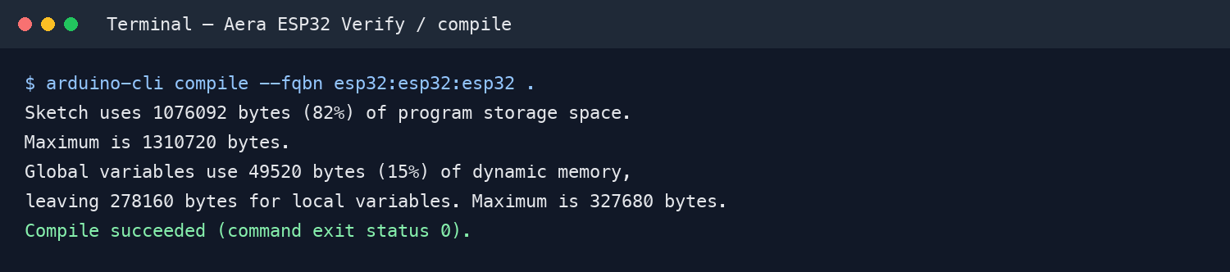
Figure 5.4. Aera firmware Verify/compile result from aera-aqi; the command returned exit status 0. This confirms compilation, not hardware upload.

5.2.2 Upload and inspect device startup
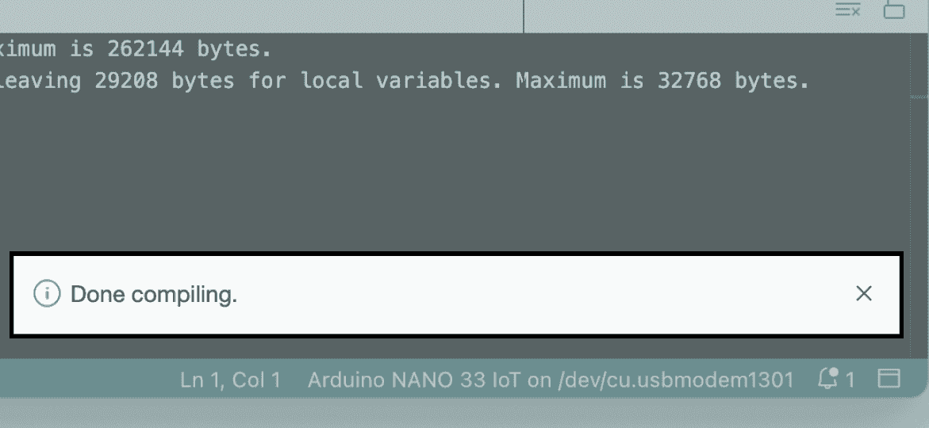
With the ESP32 connected by a data-capable USB cable, select its serial port and press Upload (the right-arrow button marked in Figure 5.2). Watch the Output/console panel until the transfer finishes; do not unplug the board during flashing. The Debug control is separate from Upload. If flashing fails or the board resets, check the cable, selected port, power supply, and MQ-9 heater load before retrying.
The upload screenshot below illustrates the Arduino IDE “Done uploading” notification. Its status bar identifies an Arduino Nano 33 IoT as not connected, so it is an example of the success message only—not evidence that the Aera ESP32 was flashed.

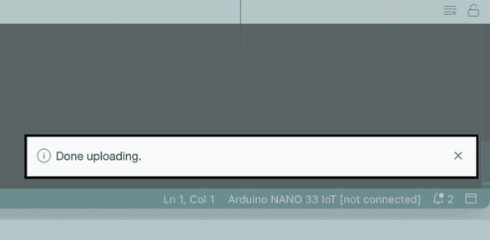
Figure 5.5. Arduino IDE “Done compiling” example on an Arduino Nano 33 IoT; illustrative IDE success message, not the Aera ESP32 build. The Aera compile evidence is Figure 5.4.
After upload, open Serial Monitor at 115200 baud. Read the startup output, note the generated device identifier, and observe whether the node connects to Wi-Fi or starts its temporary Aera setup access point. A first-time setup uses the node’s Aera-… network and the local provisioning page at 192.168.4.1; provision a 2.4 GHz network that the node can reach.
Figure 5.6. Arduino IDE “Done uploading” example on an Arduino Nano 33 IoT marked “[not connected]”; this illustrates the IDE notification and does not verify an Aera ESP32 upload.

5.2.3 Confirm telemetry before moving on
With the backend available on the same reachable network, confirm that the node sends readings at its configured interval and receives a valid HTTP response. Compare the device identifier and temperature/humidity fields with the backend’s latest-reading endpoint before proceeding to the backend walkthrough. The MQ-9 value is a sensor estimate; a plausible-looking number is not proof of calibration, and GPIO 34 must never be driven above 3.3 V.
For this documented run, Arduino CLI compiled the sketch and reported the resource usage shown above. The supplied IDE captures confirm the selected ESP32 target, port, and board settings, but do not show a completed hardware upload, Wi-Fi provisioning, live telemetry, sensor readings, or buzzer response. Confirm those behaviors on the physical node separately.
The supplied Aera IDE captures document the active ESP32 target, selected port, and Tools-menu configuration. They are setup evidence, not proof of a completed upload or Serial Monitor run; verify those results on the physical node before reporting them.

5.3 Backend: migrations, tests and local health check
The backend is the bridge between device telemetry and the web/mobile clients: it authenticates devices, processes readings, stores records, and exposes readiness and data endpoints. Before running it locally, prepare aera-cloud/.env as described in Section 3.7.4; use the isolated-database, migration, test, and health-check steps below.
BEFORE RUNNING BACKEND COMMANDS
Create and review aera-cloud/.env as described in Section 3.7.4; make sure PostgreSQL is reachable (Section 3.7.1) and replace required secret/key placeholders. For pytest, point DATABASE_URL to a newly created disposable database as required by the warning below. Never run tests against production or a database containing personal data.

5.3.1 Isolate the test database
The current test fixture does not create an isolated database automatically. It reads DATABASE_URL and removes matching test-pattern records after tests, so first create a new, empty PostgreSQL database specifically for the suite. Do not point DATABASE_URL at the normal development database, and never run this fixture against production data. Replace the placeholders with a local PostgreSQL role that can create and own this database; percent-encode special characters in the URL password. Set DATABASE_URL only in this terminal session and do not commit it. The example drops aera_test only after the test run because that exact database was created for this purpose.
After creating the disposable database and activating the backend virtual environment, run these commands from aera-cloud. Replace the URL placeholders locally; percent-encode special characters in the password. Never paste a live database URL into a shared document or screenshot.
cd aera-cloud
export DATABASE_URL='postgresql+asyncpg://<user>:<encoded-password>@localhost:5432/aera_test_db'
alembic upgrade head
pytest -q

# After the run, remove only this disposable database.
dropdb aera_test
The complete focused backend suite passed: 13 tests against a temporary local PostgreSQL database after the schema migration. The run covered authentication, telemetry/monitoring, and account/device behavior; the temporary database was removed afterward.

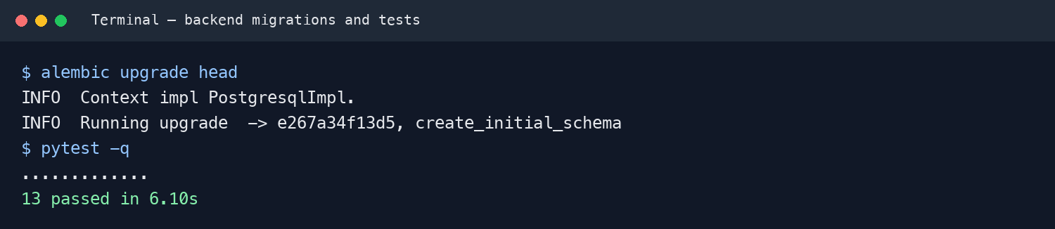
Figure 5.7. Selected terminal output for the database migration and 13-test pytest run against a disposable database.
Coverage includes four authentication cases (registration/login, duplicate email, invalid password, and password reset), four monitoring/telemetry cases (NAQI and CO logic, request validation, persistence/buzzer processing, and latest-reading fallback), and five user/device cases (profile access, claiming/listing, ownership conflicts, and release). These tests check API and service behavior; they do not replace a real ESP32-to-cloud integration test.

5.3.2 Start the API and check readiness
Once migration and tests pass, keep that terminal available and start the API from a second terminal. The health request checks that the service has started and is answering HTTP requests before you test the device or client.
cd aera-cloud
uvicorn main:app --reload --host 0.0.0.0 --port 8085
# In another terminal:
curl -i http://127.0.0.1:8085/health
The local API startup check returned HTTP 200 and a healthy status. The interactive API reference is available at http://localhost:8085/docs. For an ESP32 or phone on the same Wi-Fi, use the development computer’s reachable LAN address rather than 127.0.0.1; keep database and device credentials private.

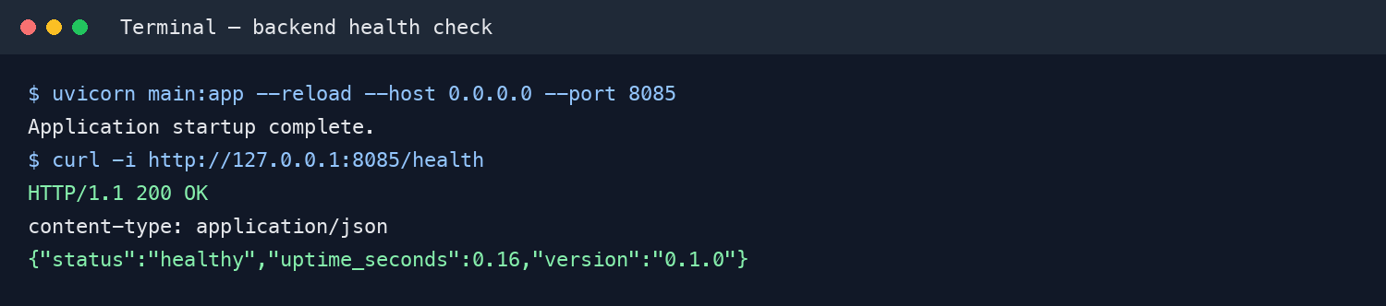
Figure 5.8. Selected terminal output showing the local backend health endpoint returning HTTP 200.

5.3.3 Confirm the ingestion path
With the API running, the device sends authenticated readings to /api/device/telemetry/ingest. The backend validates each payload, processes and stores it, then makes the latest reading available to clients. Match the device ID in the server log and latest-reading endpoint to confirm the same request reached persistence. A healthy /health response confirms readiness only; it does not prove device authentication or successful telemetry storage.
Before moving on, keep the evidence levels distinct: the local health check confirms API readiness, while the telemetry route and latest-reading record confirm the separate ingestion path. The health check used a disposable database, which was removed after testing.

5.4 Web dashboard: test, build and preview
The browser dashboard is a static production bundle, but its live readings and account flows depend on a reachable Aera API. Configure aera-web/.env for direct Vite development as described in Section 3.7.4; for Docker builds use the root .env instead (Section 5.5). The steps below check tests, bundle, preview, and API connectivity separately.
BEFORE RUNNING WEB COMMANDS
Create and review aera-web/.env as described in Section 3.7.4. Set VITE_API_URL and VITE_WS_URL to endpoints the browser can reach; do not leave template values unless they are correct for this machine. If using Docker instead of Vite directly, configure the root .env as described in Section 3.7.4.

5.4.1 Install dependencies and confirm API settings
Run these commands from aera-web. Section 3.7.4 explains which API/WebSocket URLs belong in aera-web/.env and how they differ from the root Compose .env. Preserve existing private settings; Vite embeds the chosen URLs in the build, so edits afterward require a new bundle.
cd aera-web
npm ci
cp -n .env.example .env
npm test
npm run build
npm run preview
Run the tests before producing the bundle. The current suite checks AQI category boundaries and loading-state messages across two test files (13 assertions total); it does not yet exercise sign-in, device pairing, charts, WebSocket recovery, or complete user journeys.
cd aera-web
npm test
npm run lint
npm run build
npm run preview
The Vitest suite passed all 13 tests and the production bundle built successfully. Lint completed without errors but still reports existing warnings; treat those as cleanup items, not test failures. The preview is a local check of generated files—not a deployment or API integration test.
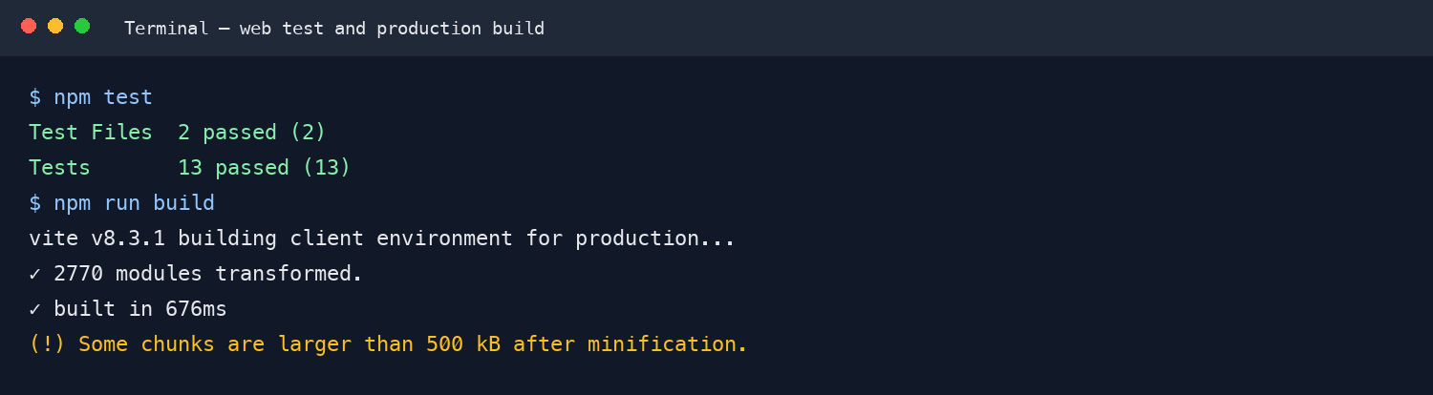
Figure 5.9. Selected web terminal output: all 13 tests passed and the production build completed; Vite reported a large-chunk warning.

5.4.2 Build and serve the production files
npm run build writes the production site to dist/, and npm run preview serves those exact files on the configured local port. Open the printed URL and confirm the page and static assets load; the captured run returned HTTP 200 for the built page.
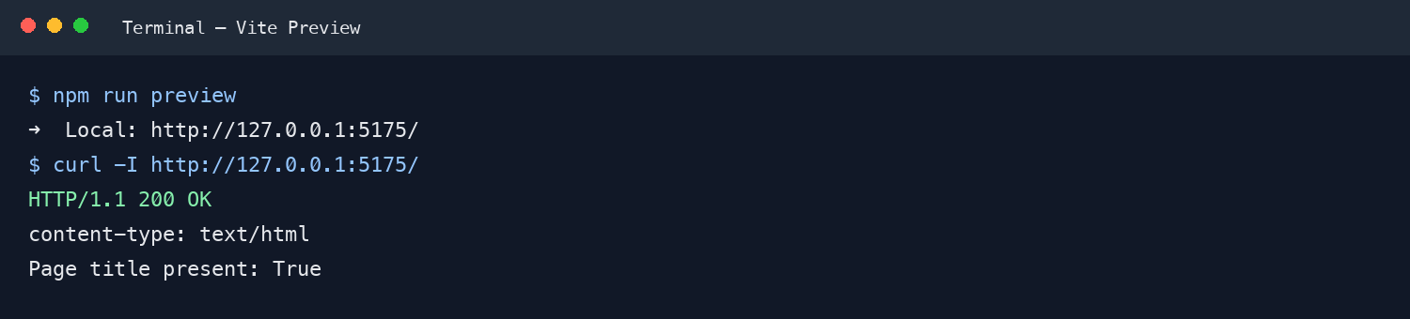
Figure 5.10. Selected Vite Preview terminal output and HTTP 200 response for the locally built page; this does not verify API connectivity.
Static page delivery and API connectivity are separate results: during this preview, the browser reached the sign-in page, but its request to the configured hosted API was rejected by that API’s CORS policy for the local preview origin. Until the intended origin is allowed—or the bundle points to a reachable test API—authenticated data and live updates remain unverified. On a physical device, use a network-reachable host instead of localhost.

5.4.3 Review results before continuing
Web checkpoint: 13/13 unit tests passed, the production bundle built, and Vite Preview served the page with HTTP 200. Existing lint warnings remain, and the CORS rejection means the local static preview does not prove sign-in, telemetry, or live updates work end to end. Resolve the API origin/URL before treating the dashboard as fully connected.
In the preview terminal, use the URL it prints (5175 in this project’s configuration). When previewing against a local API, make sure the configured HTTP and WebSocket addresses match the API host that the browser can reach.

5.5 Optional toolchain: Docker Compose
This is a separate, optional tools lesson after the ESP32, backend, and web checkpoints and before mobile. Prepare the root Compose .env and aera-cloud/.env using Section 3.7.4 before running these commands. Compose packages the API and browser dashboard as containers; it does not replace unit tests, build ESP32 firmware or mobile apps, or provide PostgreSQL. cloudflared is optional and requires a real Cloudflare token.

5.5.1 What Docker Compose runs
docker-compose.yml defines three services: aera-cloud (FastAPI on port 8085), aera-web (a production Vite build served by Nginx on port 5175), and cloudflared (the Cloudflare Tunnel connector). All three services share the aera-network bridge, so a tunnel ingress rule can route to the API by its Compose service name. The host-published ports are available on the development computer. PostgreSQL is external and must be reachable from the backend container. Redis, AI, and email integrations are optional. [15], [31], [32]
BEFORE RUNNING DOCKER COMPOSE
Create and review root .env and aera-cloud/.env using Section 3.7.4. Set browser API/WebSocket URLs and a database host reachable from containers. Before starting cloudflared/the full tunnel-enabled stack, replace CLOUDFLARE_TUNNEL_TOKEN with a real Cloudflare token; the template placeholder is not a working credential. API/web-only commands can omit the tunnel service.

5.5.2 Install and configure from the repository root
Install Docker Desktop for macOS or Windows (or Docker Engine plus the Compose v2 plugin on Linux), start the engine, and check that docker compose version returns a version. Every command here runs from the repository root. Section 3.7.4 has the environment-file checklist and secret-handling guidance; the commands below create missing root/backend files without overwriting existing private settings.
cp -n .env.example .env
cp -n aera-cloud/.env.example aera-cloud/.env
docker compose config --quiet
docker compose config --services
Configure root .env and aera-cloud/.env as described in Section 3.7.4. Compose passes root VITE_API_URL and VITE_WS_URL into the web image build, while aera-cloud/.env supplies backend settings. Use a database host reachable from the container and a disposable development database. Before starting cloudflared, replace the root CLOUDFLARE_TUNNEL_TOKEN placeholder with a real tunnel token; the tunnel is not needed when starting only aera-cloud and aera-web. Keep both files private and out of source control.

5.5.3 Build and start the local services
First build the API and web images without starting the public tunnel. Then start only those two services. After confirming the backend points to the intended disposable database, apply migrations in the backend container:
docker compose build aera-cloud aera-web
docker compose up --build -d aera-cloud aera-web
docker compose exec aera-cloud alembic upgrade head
docker compose ps
Open http://localhost:5175 for the dashboard, http://localhost:8085/health for API readiness, and http://localhost:8085/docs for the API documentation. Check logs with docker compose logs --tail=50 aera-cloud aera-web. To stop this local stack, run docker compose down from the same repository root; this stops containers but does not delete the external PostgreSQL database.

5.5.4 Read the output and know what was verified
Compose configuration validation passed and listed aera-cloud, aera-web, and cloudflared. After the local Colima Docker engine was available, the backend and web images both built successfully; the build used Docker’s classic builder because the Buildx plugin was unavailable. This verifies image builds, not a running API/database stack.
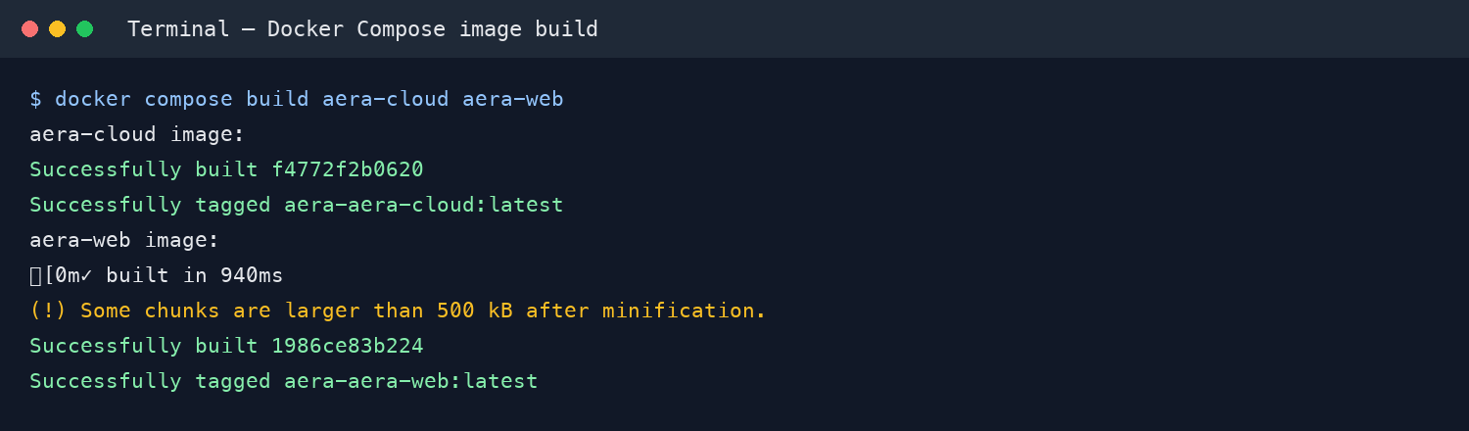
Figure 5.11. Selected output from the successful Docker Compose build of both the backend and web images. Vite emitted its existing large-chunk warning.
To isolate the web image check, I ran the built static site in a temporary container published only on 127.0.0.1. This did not start the backend, connect a database, or expose the dashboard publicly;
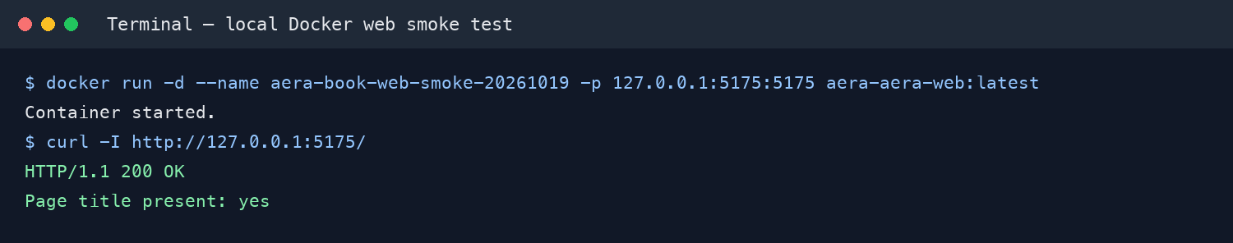
Figure 5.12. Actual loopback-only test of the built web image: HTTP 200 and page title present; the temporary container was removed.
The backend image was built but not started, so this Docker check did not validate database connectivity, migrations, API health inside Compose, or Cloudflare ingress. The Compose stack and tunnel were not launched; verify those only after Docker is ready and the intended disposable database and private tunnel settings are configured.

5.6 Mobile app: configuration, tests and native projects
The Aera mobile client is an Expo/React Native app with shared JavaScript screens and separate generated native projects for iOS and Android. Start with the shared API configuration and Expo checks, regenerate native folders only when needed, then follow the platform-specific build steps. The mobile API endpoints are source constants rather than .env values, so the simulator or device must be able to reach the configured backend.

5.6.1 Confirm API configuration and validate the Expo project
From aera-app, install the lockfile dependencies and run the unit tests and Expo configuration checks before building either native app. This verifies the shared JavaScript layer and package compatibility; it does not prove that a signed-in mobile flow can reach the backend.
BEFORE RUNNING MOBILE TESTS OR LAUNCHING THE APP
There is no mobile .env file in this project. Confirm API_BASE_URL and WS_BASE_URL in aera-app/src/services/api.js point to the intended backend and are reachable from the simulator/device; a device’s localhost is not the development computer. See Section 3.7.4 for how mobile configuration differs from the web and Docker environment files.
cd aera-app
npm ci
npm test
npx expo-doctor
npx expo install --check
The mobile Jest suite passed 13 tests. Expo Doctor passed all 21 checks, and `npx expo install --check` reported dependencies up to date. These checks confirm the JavaScript suite and SDK/package compatibility; validate sign-in, API access, device selection, and live telemetry separately on a simulator or device.
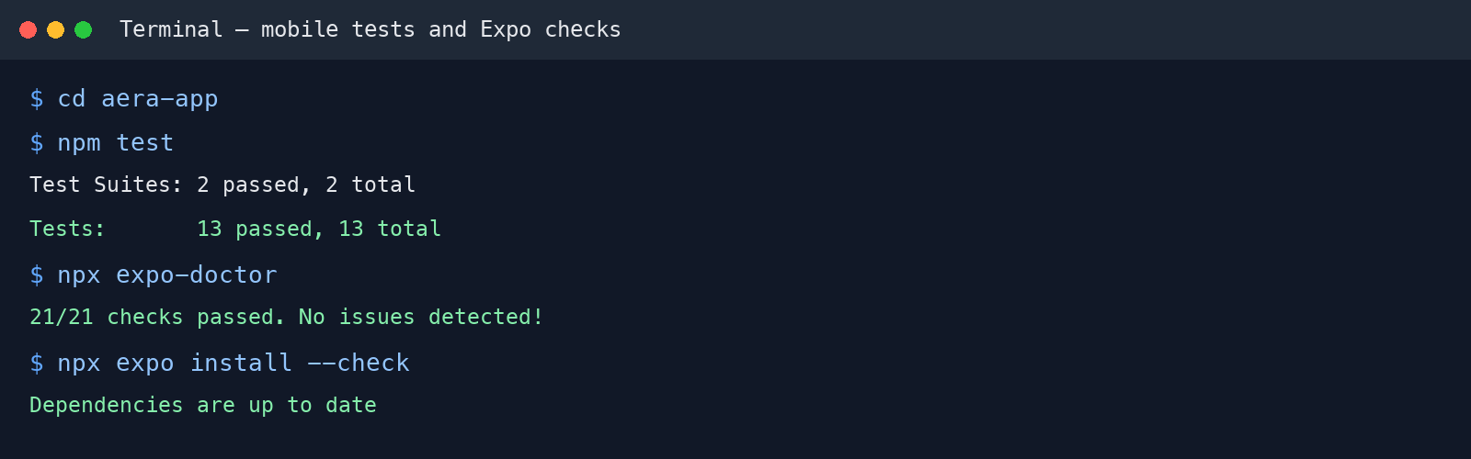
Figure 5.13. Mobile terminal checks: 13 Jest tests passed, Expo Doctor passed all 21 checks, and Expo dependencies were up to date.
Dependency advisory: The first npm audit reported 65 advisories, including a critical finding for the transitive shell-quote 1.10.0 package (GHSA-pqg4-j6r4-53mv). The package is required through react-devtools-core; a minimal npm override pins shell-quote to patched version 1.11.0. A subsequent npm audit reported 64 advisories (19 moderate, 45 high, zero critical), and the shared CVE assessment reported no known CVEs for shell-quote 1.11.0. The remaining advisories still require review before public production release; no blanket npm audit fix was applied.

5.6.2 Regenerate the native iOS and Android projects
Run a clean prebuild only when native project files need to be regenerated from app.json and the Expo config plugins. It deletes and recreates both native project directories, so preserve native-only edits first. The saved before/after comparison below records what changed in this regeneration; the platform build instructions follow as Sections 5.6.4 and 5.6.6.
CLEAN PREBUILD REPLACES NATIVE PROJECTS
expo prebuild --clean deletes and recreates both ios/ and android/. Back up native-only files or encode required changes in app.json/config plugins before continuing. Do not copy old build caches into regenerated projects.
cd aera-app
npx expo prebuild --clean
The prebuild completed after the Expo configuration warning was resolved by adding expo-system-ui; the dependency check and Expo Doctor then passed again. A comparison with the saved pre-clean projects found that several generated integration/configuration files changed, while the principal app identity and configuration files listed below remained unchanged.
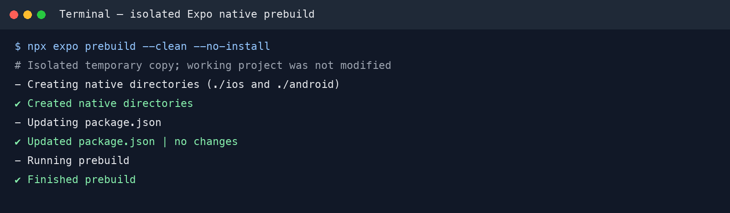
Figure 5.14. Expo clean prebuild reproduced in an isolated copy: both native directories were generated successfully without changing the project folders.

5.6.3 Review the generated native-project changes
iOS comparison — ios/Aera/Info.plist is byte-for-byte unchanged: the bundle identifier, version/build number, URL scheme, status-bar style, and orientation settings did not change. The Podfile and Podfile.properties.json are also unchanged. The generated Xcode project and shared scheme changed to integrate the current CocoaPods/Expo modules; Podfile.lock adds ExpoSystemUI 57.0.4 and updates ExpoSplashScreen from 57.0.9 to 57.0.10. The shared scheme’s Launch action now selects Debug rather than Release. These are generated project/dependency changes, not edits to Info.plist. The changed project.pbxproj references the CocoaPods library and generated ExpoModulesProvider.swift.
Android comparison — android/app/build.gradle and app/src/main/AndroidManifest.xml are byte-for-byte unchanged; the app identity and version settings remain the same. The regenerated strings.xml adds the Expo system-UI style value “light”. The Gradle wrapper now uses the standard HTTPS Gradle distribution URL instead of a machine-specific local file URL. Machine-specific local.properties and gradle/gradle-daemon-jvm.properties from the saved prior project are absent from the regenerated tree; Android setup and build details are covered later in Section 5.6.6. To change the app identity or appearance, edit the source settings in aera-app/app.json and regenerate; do not edit generated Info.plist, AndroidManifest.xml, strings.xml, or project files directly. The configuration excerpt below identifies the source fields; the generated setting is shown separately.
For app-specific native identity and appearance, edit the source values in aera-app/app.json. Replace the identifier, display name, version, or style only when those values should change for this app; then rerun the prebuild steps in Section 5.6.2 to regenerate the native files. Do not manually edit generated copies.
{
"expo": {
"name": "Aera",
"version": "1.0.0",
"userInterfaceStyle": "light",
"ios": {
"bundleIdentifier": "dev.hacksmiths.aera",
"infoPlist": {
"UIStatusBarStyle": "UIStatusBarStyleDarkContent"
}
},
"android": {
"package": "dev.hacksmiths.aera"
}
}
}
The added Android resource is generated from userInterfaceStyle; it is shown here to explain the observed diff, not as a file to edit manually:
<string name="expo_system_ui_user_interface_style" translatable="false">light</string>
The project-tree and comparison screenshots below summarize which native files are generated from app.json and what changed during this regeneration.
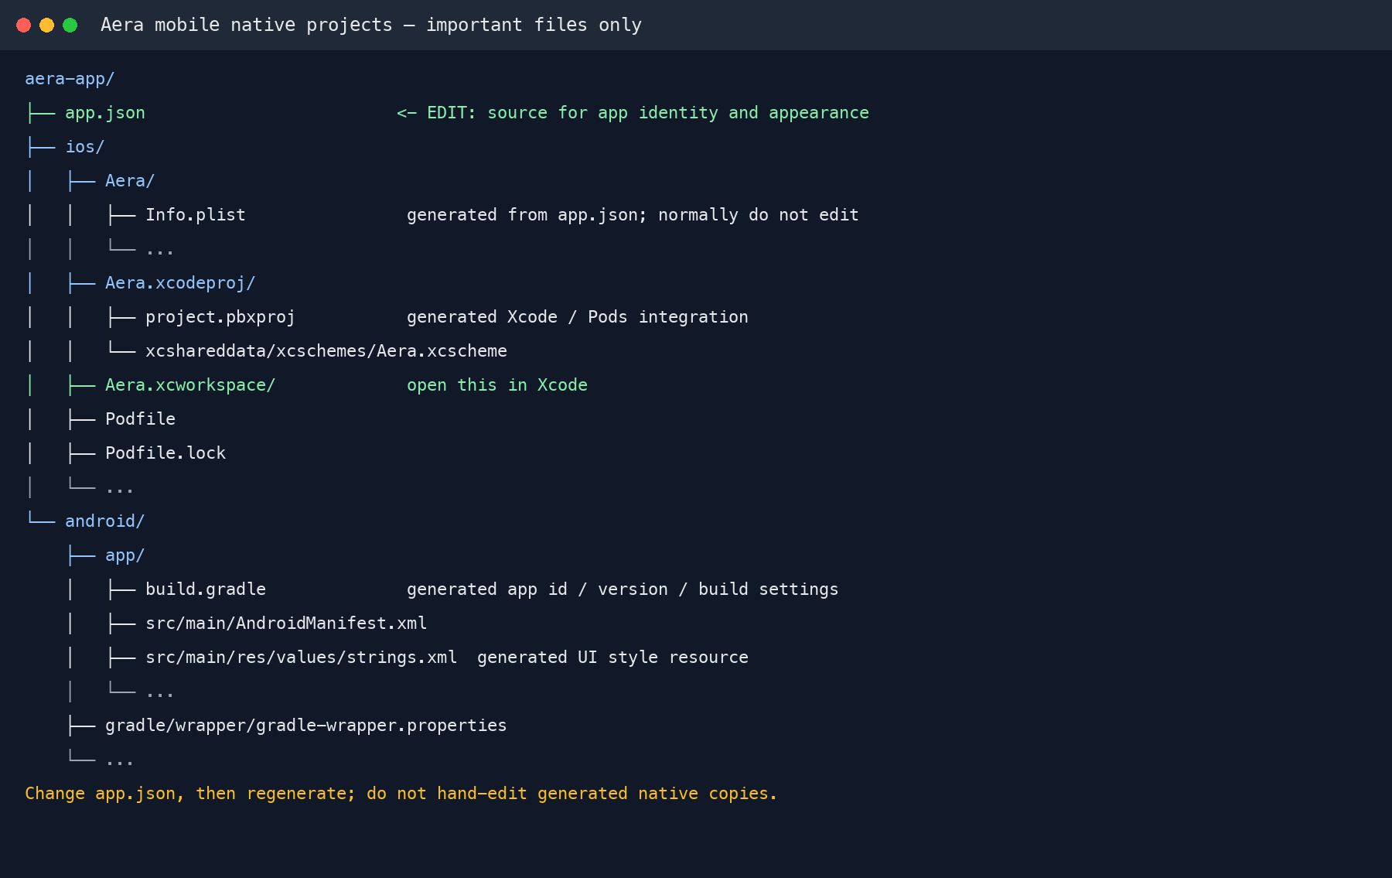
Figure 5.15. The mobile native-project tree identifies app.json as the source configuration and shows the key generated iOS and Android files.
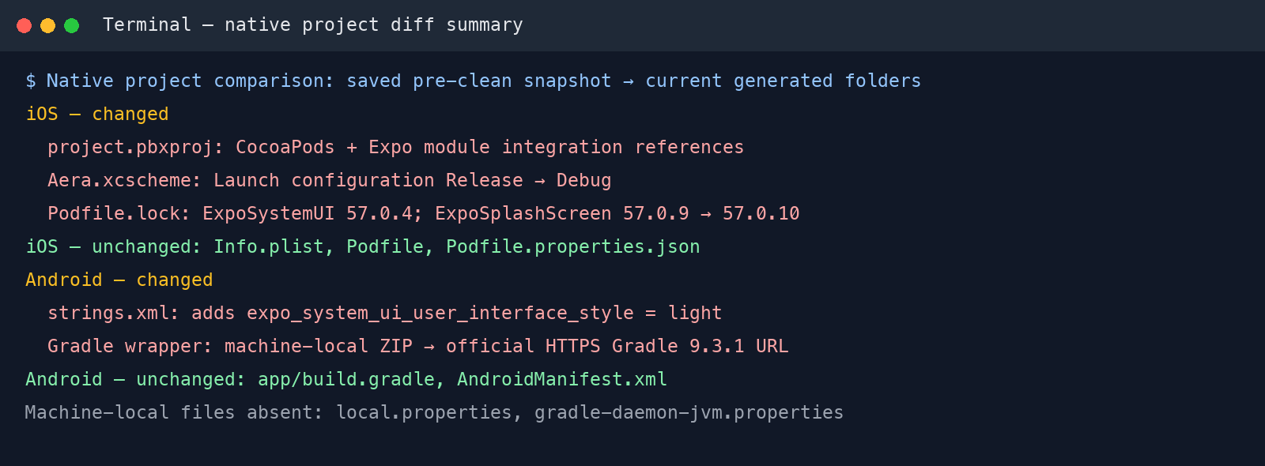
Figure 5.16. Terminal summary comparing saved pre-clean native-project files with the regenerated folders; changed and unchanged settings are summarized in the surrounding text.

5.6.4 iOS: configure signing, select a destination, and build
Before building for iOS, open Aera.xcworkspace (not Aera.xcodeproj). Confirm the target identity, configure automatic signing with a development team you control, set the Run action to Release for this workflow, and select the intended simulator or connected iPhone.
After prebuild completes, open the workspace from the repository root:
cd aera-app/ios/
open Aera.xcworkspace
In the Aera target, confirm the General settings show the intended app identity and iOS deployment settings (Figure 5.17).

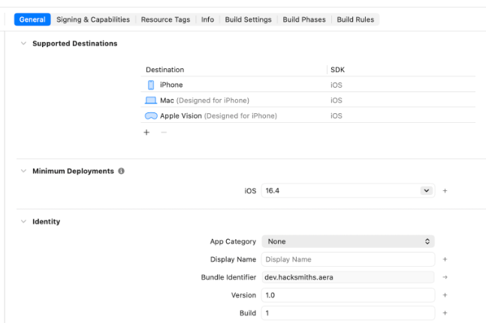
Figure 5.17. Xcode target General settings showing the iOS destination and app identity.
In Signing & Capabilities, enable Automatically manage signing and choose your own development team; do not add capabilities the app does not need (Figure 5.18). Account and certificate details are redacted.
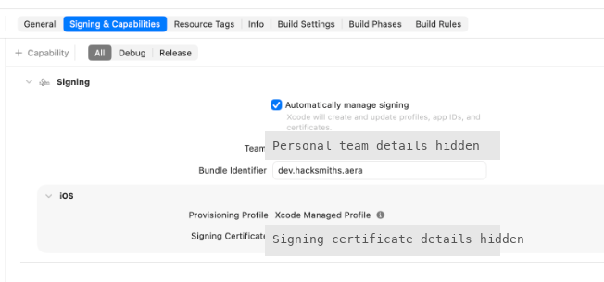
Figure 5.18. Xcode automatic signing configuration; personal team and certificate details are redacted.

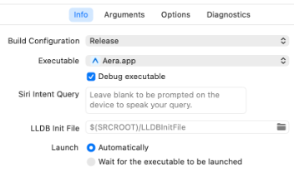 | 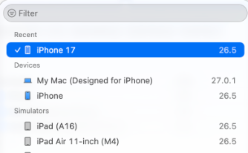 | 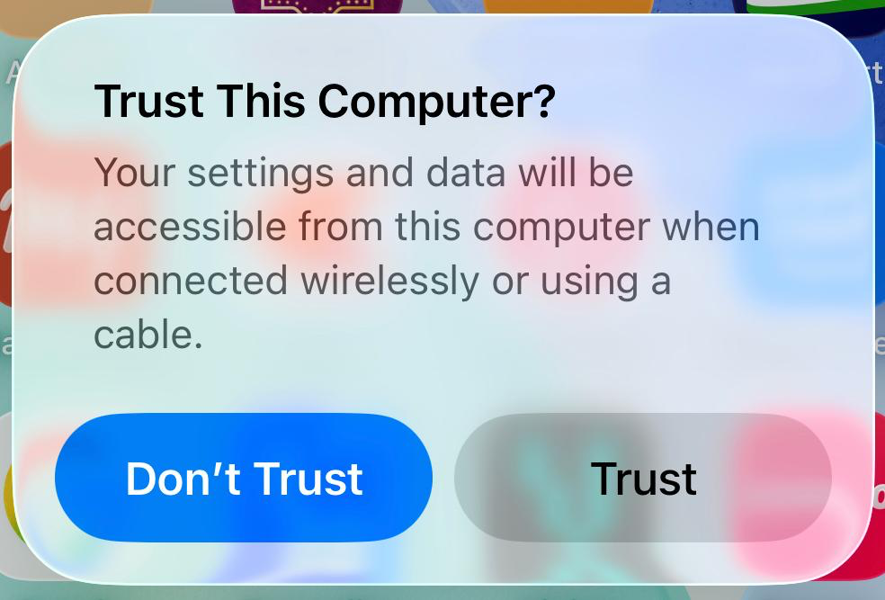
Figure 5.19. Xcode Run scheme configured with the Release build configuration. | Figure 5.20. Xcode destination menu with the physical iPhone selected. | Figure 5.21. iPhone prompt to trust the connected Mac after device selection.
Set the Run action to Release in Product > Scheme > Edit Scheme. This changes the Run action only; it does not change the Debug settings used by Test or the Release configuration used by Archive (Figure 5.19).
Select the connected physical iPhone in Xcode’s destination menu (Figure 5.20). Keep it unlocked and accept “Trust This Computer” on the iPhone when prompted (Figure 5.21). Enter the passcode only on the iPhone.
Choose Product > Build (⌘B), then Product > Run (⌘R) to install and launch Aera. Build and Run are separate checks. A simulator run does not create a signed device archive; use Product > Archive with the appropriate signing setup for distribution.

5.6.5 iOS: install and trust the app on a physical iPhone
With the physical iPhone selected and paired (Figures 5.20–5.21), choose Product > Build (⌘B), then Product > Run (⌘R). Keep the iPhone unlocked while Xcode installs and launches Aera.

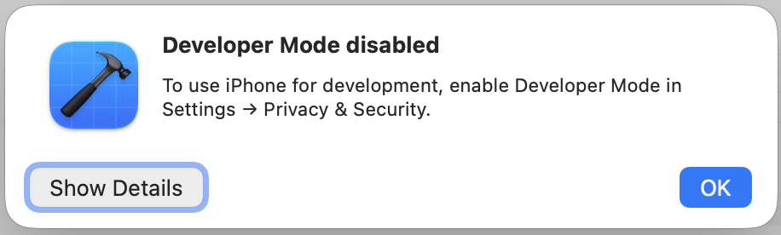
Figure 5.22. Xcode reports that Developer Mode must be enabled on the iPhone.
If Xcode reports that Developer Mode is disabled (Figure 5.22), open Settings > Privacy & Security > Developer Mode (Figure 5.23), enable the switch (Figure 5.24), and confirm the restart (Figure 5.25). After the iPhone restarts, unlock it and retry the build and run.

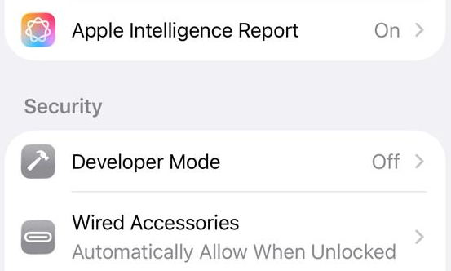 | 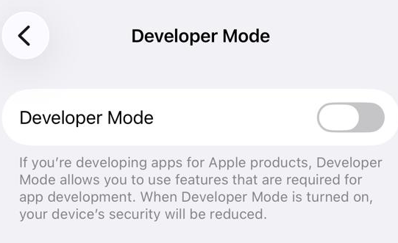 | 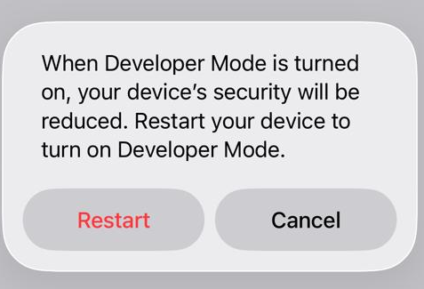
Figure 5.23. iPhone Privacy & Security settings showing Developer Mode off. | Figure 5.24. Developer Mode switch before activation. | Figure 5.25. iOS restart prompt after Developer Mode is enabled.

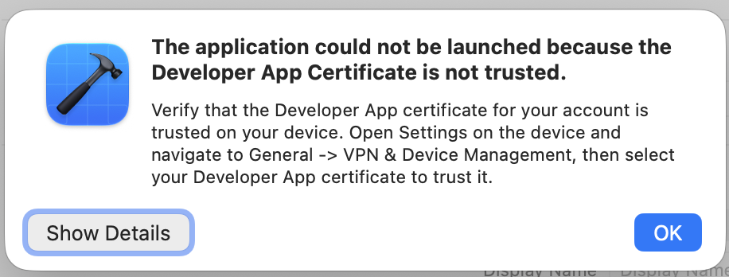
Figure 5.26. Xcode reports that the Developer App certificate is not trusted.
If Xcode reports an untrusted Developer App certificate (Figure 5.26) or iOS blocks the first launch (Figure 5.27), this is a signing-trust issue, not proof of a build failure. Open Settings > General > VPN & Device Management and select the Developer App profile (Figure 5.28).

Verify that the profile belongs to a team you recognize, then tap Trust Developer (Figure 5.29). Confirm the iOS prompt (Figure 5.30). Never trust an unfamiliar profile. Figure 5.31 shows the profile after it is trusted.
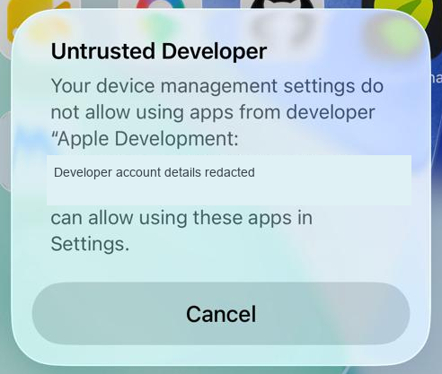  Figure 5.27. iOS blocks the first launch because the developer is not trusted; account details are redacted. | 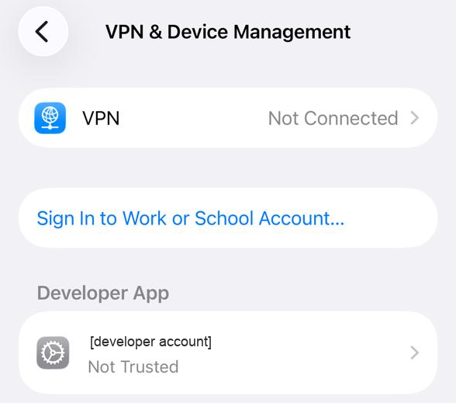  Figure 5.28. VPN & Device Management lists the developer profile as not trusted; account details are redacted. | 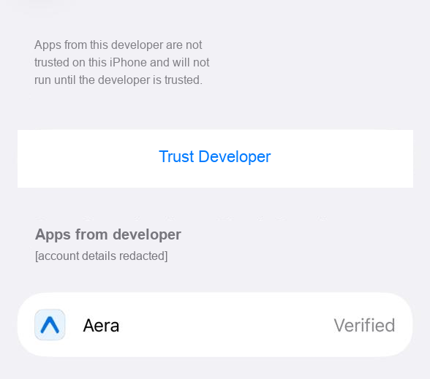  Figure 5.29. Developer profile page with the Trust Developer action and Aera listed; account details are redacted.

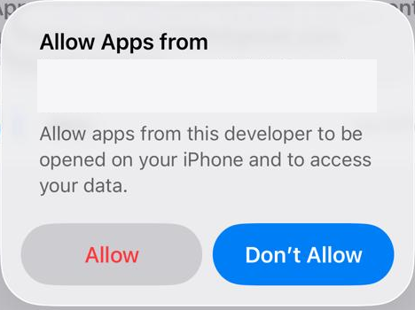  Figure 5.30. iOS confirmation to allow apps from the selected developer; account details are redacted. | 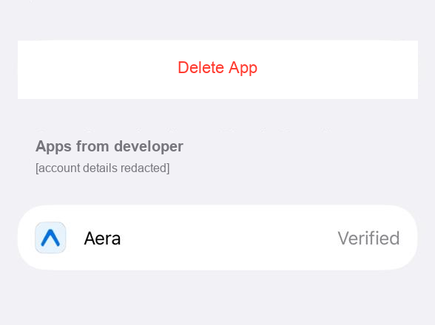  Figure 5.31. Developer profile shows trusted status and Aera is Verified; account details are redacted. | 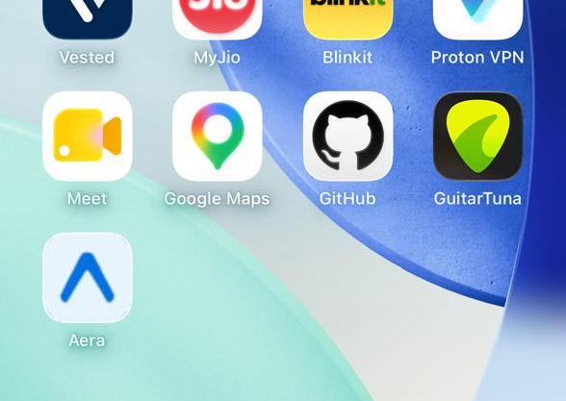  Figure 5.32. Aera icon is visible on the iPhone Home Screen; its presence confirms installation, not developer trust or successful launch.
The Aera icon can appear on the Home Screen even while the developer profile is untrusted; tapping it will not open the app until the profile is trusted. Figure 5.32 confirms that Aera is installed, but does not prove that it can launch. After the profile shows Trusted (Figure 5.31), return to the Home Screen and open Aera.
The final Xcode capture (Figure 5.33) shows “Build Succeeded” and “Debug session ended with code 9.” This confirms compilation only, not a successful app launch.
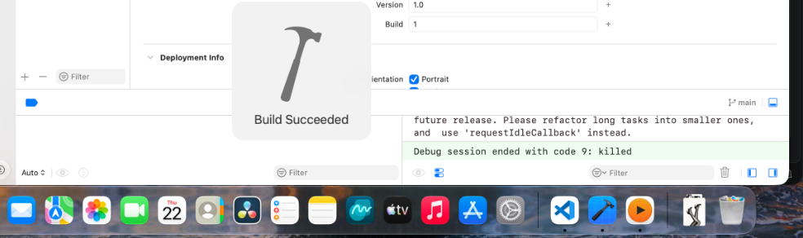
Figure 5.33. Xcode shows “Build Succeeded,” then “Debug session ended with code 9”; this confirms compilation, not a successful launch.

5.6.6 Android: assemble a release APK
This section follows the Android release APK from Gradle packaging through signing, publication, and phone installation. Building the APK and verifying its installation are separate checks. The walkthrough covers downloading the published APK and completing Android’s installation prompts.
BEFORE BUILDING FOR ANDROID
Android builds require the Android SDK/platform tools and a compatible Java/Gradle toolchain. Choose an emulator or connected device for launch checks, and confirm the mobile API host is reachable from that device. Release APKs use the private Aera signing key configured through user-level Gradle properties; keep the key and credentials outside the project and backed up securely.
After the iOS check, build Android from the regenerated project. The wrapper uses the project’s Gradle version and avoids relying on a separately installed Gradle command:
Create the Android signing keystore once, before the first user release. This key is the app’s permanent update identity: every future APK update must use the same keystore. Never regenerate or replace it for an app users already installed.
mkdir -p "$HOME/.config/aera/android-release"
chmod 700 "$HOME/.config/aera/android-release"
keytool -genkeypair -v \
-keystore "$HOME/.config/aera/android-release/aera-release.jks" \
-storetype JKS -alias aera-release \
-keyalg RSA -keysize 2048 -validity 10000
At keytool’s prompts, enter a strong unique keystore password, identify the publisher, and protect the private-key password. Do not put passwords on the command line or in screenshots. For Aera, the keystore is kept outside the repository at ~/.config/aera/android-release/aera-release.jks. Set AERA_UPLOAD_STORE_FILE to that absolute path, AERA_UPLOAD_STORE_PASSWORD and AERA_UPLOAD_KEY_PASSWORD to the private passwords, and AERA_UPLOAD_KEY_ALIAS to aera-release in ~/.gradle/gradle.properties. Restrict that file to its owner and keep a secure backup. The real passwords and private key are not included in this report or source control.
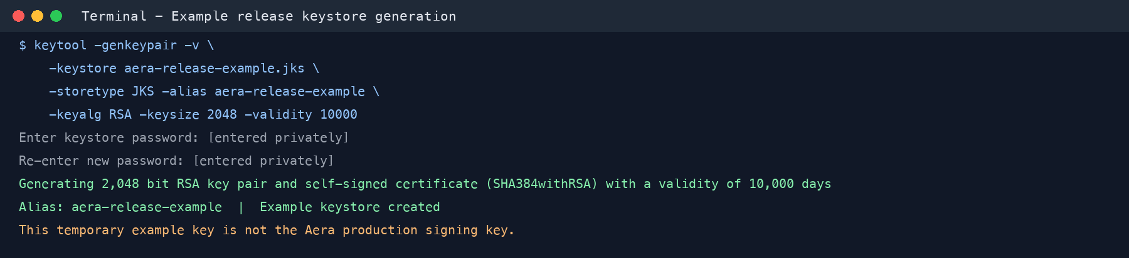
Figure 5.34. Example keytool generation output from a temporary demonstration keystore. Use the Aera production keystore for updates; never sign releases with this sample key.
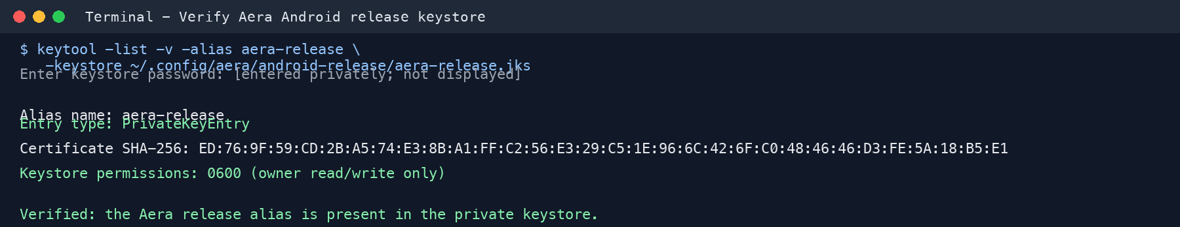
Figure 5.35. Keytool confirms the generated Aera release keystore contains the private aera-release signing alias; the password is not shown.
cd aera-app/android
./gradlew assembleRelease \
-Dorg.gradle.internal.http.connectionTimeout=120000 \
-Dorg.gradle.internal.http.socketTimeout=120000
The Release build completed successfully and created the 81 MB APK at android/app/build/outputs/apk/release/app-release.apk. The APK is now signed with the private Aera release key configured through user-level Gradle properties. Keep the keystore and credentials outside the project and backed up securely; never commit either. All future app updates must use this same key. The earlier debug-signed APK is not suitable for distribution.
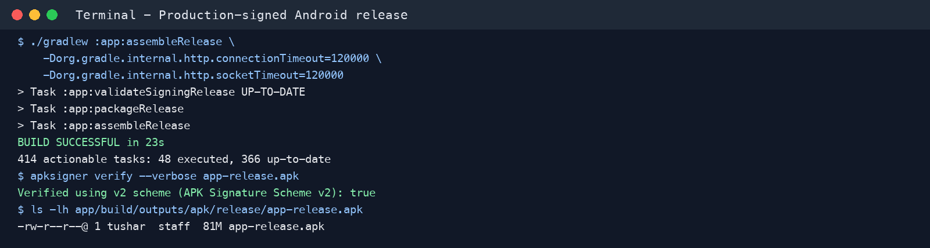
Figure 5.36. Gradle confirms the production-signed Android APK built successfully and passed APK signature verification.

5.6.7 Android: install the app from GitHub Releases
To prepare a release, create a GitHub Release for the next version (for example, v1.0.1 after v1.0.0), target main, and add notes covering the app version, installation, signing continuity, and backend requirements. Attach the production-signed app-release.apk, then verify its filename, size, and SHA-256 digest against the local APK. Review the asset and notes before publishing.
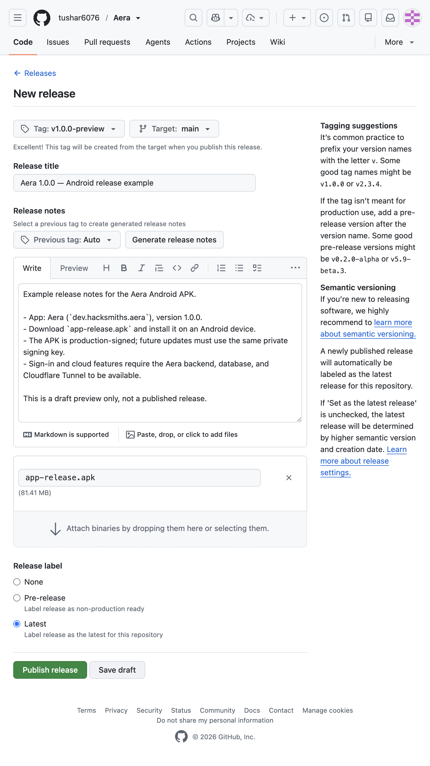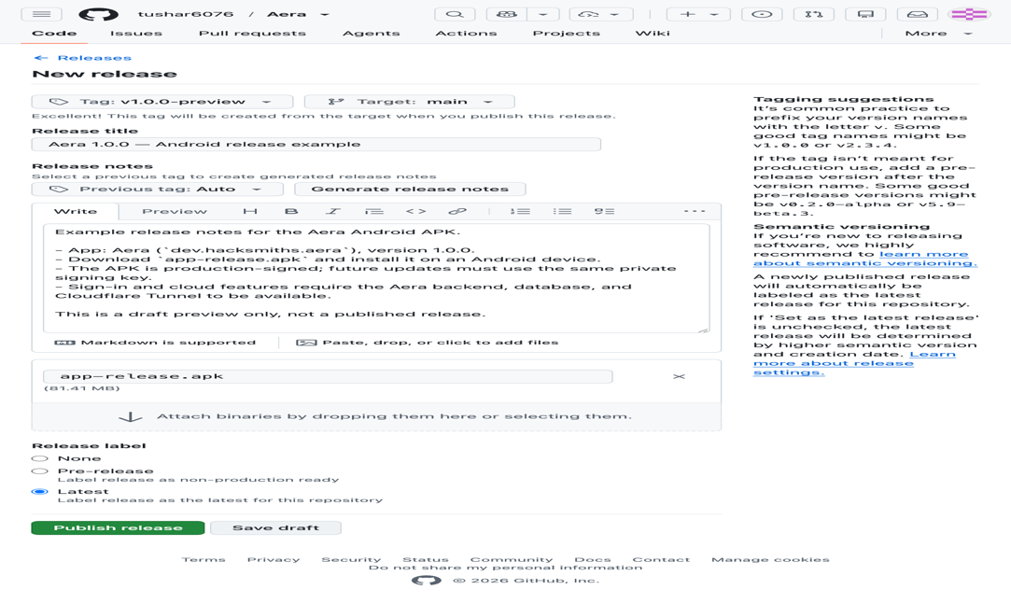 | 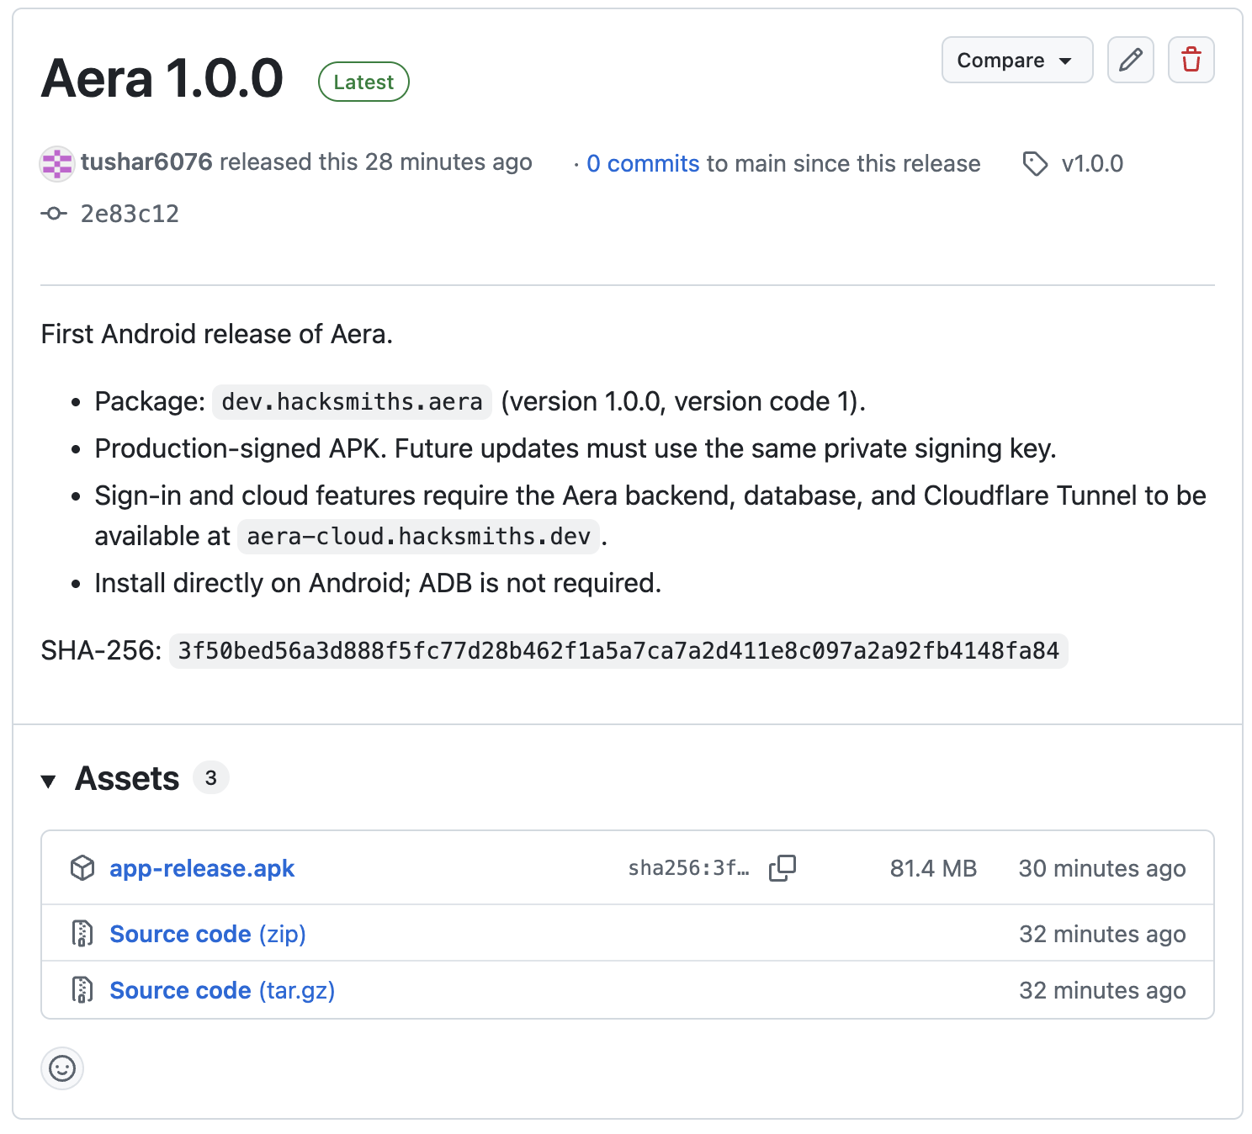
Figure 5.37. Example GitHub Release draft with title, notes, and APK asset. The actual v1.0.0 tag already has a published release, so this preview used a temporary v1.0.0-preview tag. The draft was deleted after capture; publish only after review. | Figure 5.38. Published Aera 1.0.0 GitHub Release showing the production-signed APK asset and SHA-256 digest.
On the Android phone, open the official Aera release in Chrome. Check the address bar and confirm that the repository and release are the expected ones (Figure 5.39).
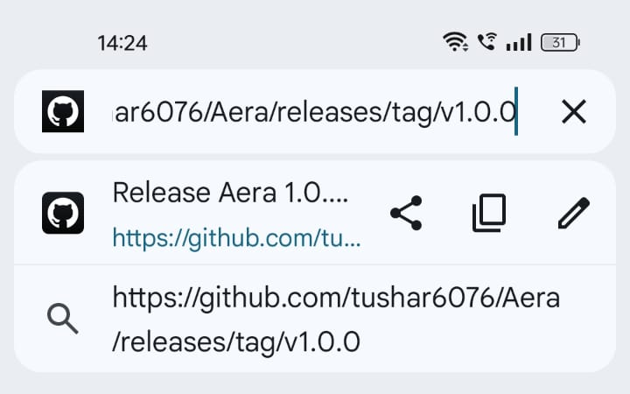  Figure 5.39. Chrome address bar showing the official Aera v1.0.0 GitHub release URL. | 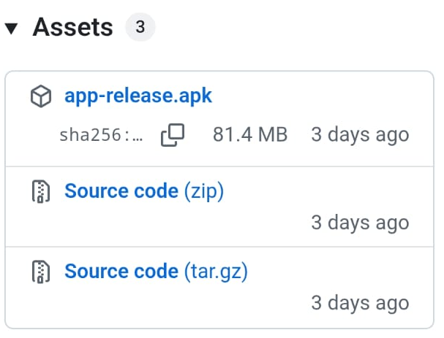  Figure 5.40. GitHub release assets showing app-release.apk and its published SHA-256 checksum. | 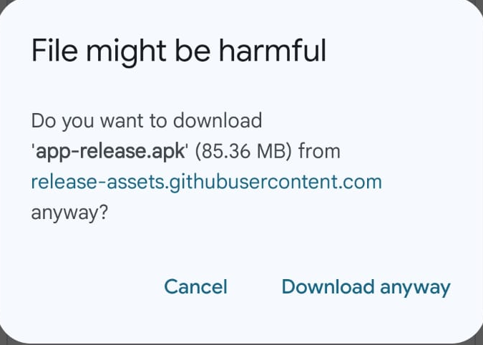  Figure 5.41. Chrome’s warning before downloading app-release.apk.

On the release page, confirm the Aera version and locate app-release.apk. Before downloading, compare the release’s published SHA-256 checksum with the locally built APK (Figure 5.40).
Chrome may warn that the APK could be harmful (Figure 5.41). Continue only after confirming that it came from the official Aera release and its SHA-256 checksum matches the published value.
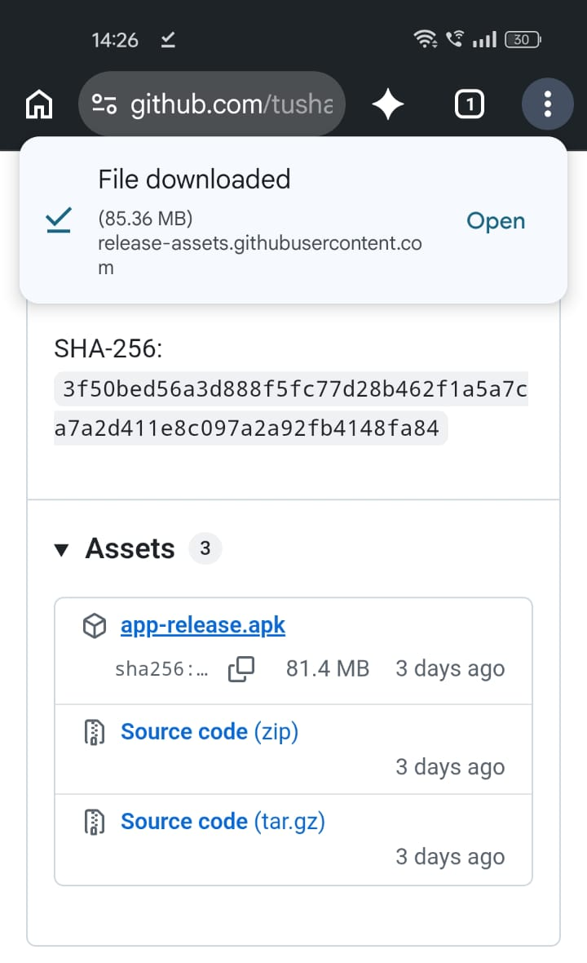
Figure 5.42. Chrome Downloads showing app-release.apk after the download completes.
After the download completes (Figure 5.42), open app-release.apk. If Android displays the Open with chooser, select Package installer (Figure 5.43).
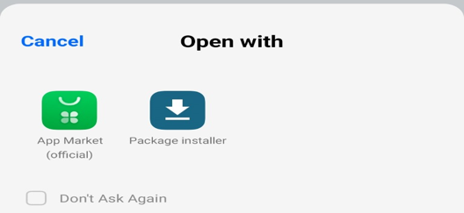  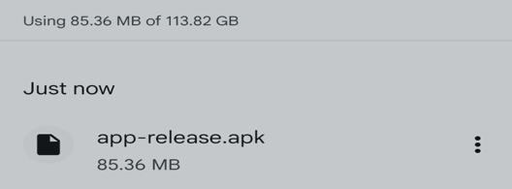  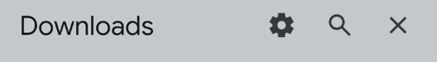  Figure 5.43. Android’s Open with chooser, with Package installer available for the APK. | 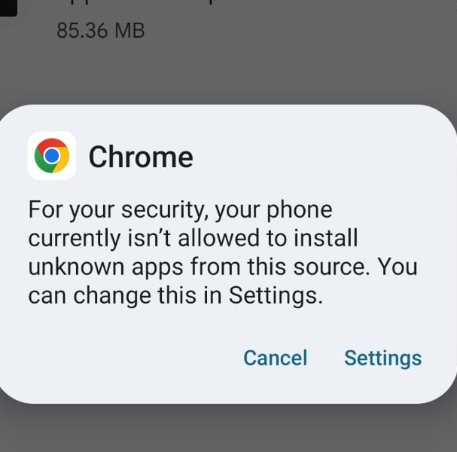  Figure 5.44. Android prompts the user to allow Chrome to install apps from this source. | 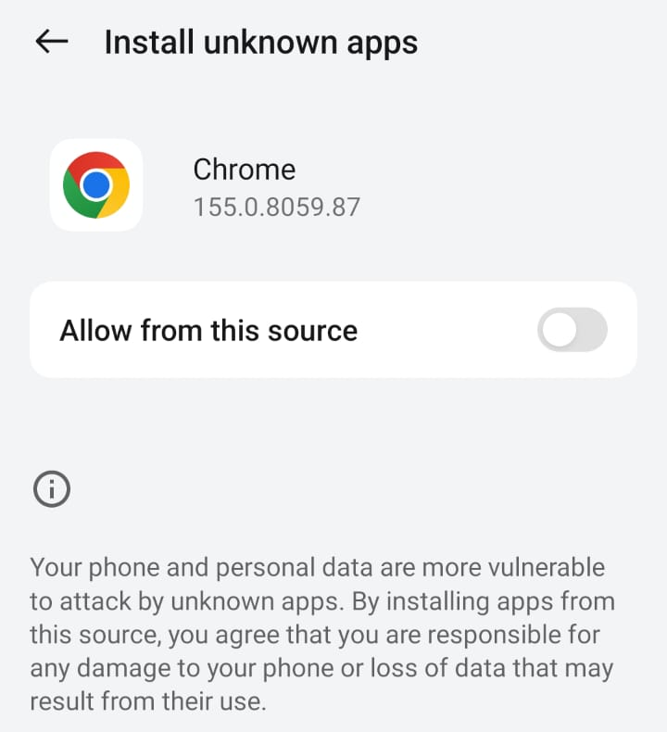  Figure 5.45. Chrome’s Install unknown apps setting with permission disabled.
If Android blocks Chrome from installing the APK, choose Settings when prompted (Figure 5.44) and enable “Allow from this source” for Chrome (Figure 5.45). Return to the installer when finished.
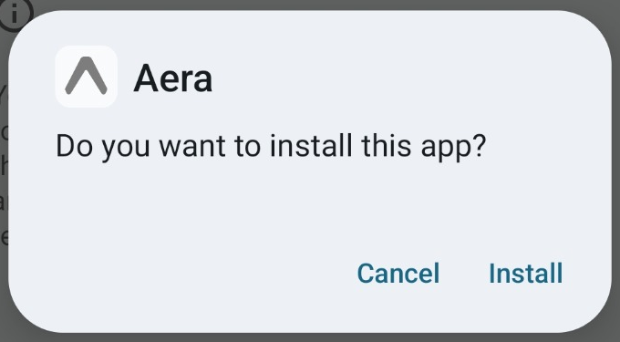  Figure 5.47. Chrome’s Install unknown apps setting with permission enabled. | 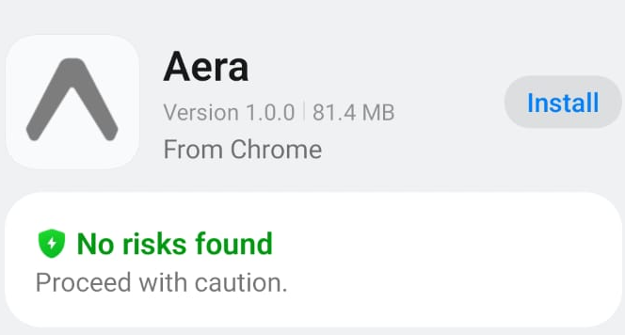  Figure 5.48. Google Play Protect recommends scanning the APK; this screenshot does not show the scan result. | 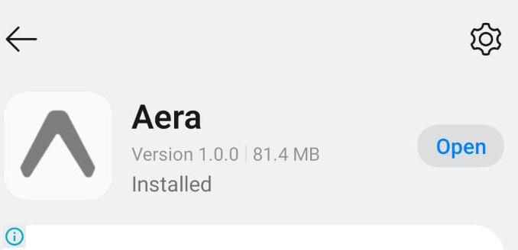  Figure 5.49. Android confirms that Aera is installed and offers the Open action.
After enabling Chrome as an install source (Figure 5.47), return to the installer. Google Play Protect may recommend scanning an unfamiliar APK. If a scan completes without detecting a harmful app, some devices may then offer Install app in the same dialog; the flow varies by device and Play Protect version. Figure 5.48 shows the scan recommendation, not a completed scan. On the phone shown, the expected scan flow is not completing, and the screenshots do not establish why. Keep Play Protect enabled and install only when the APK has been verified.
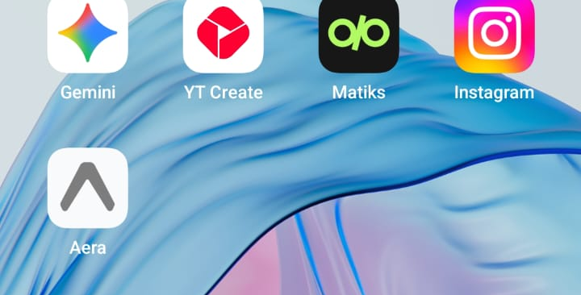
Figure 5.46. Aera icon visible on the Android Home Screen after installation.
After installation, Android confirms that Aera is installed and offers Open (Figure 5.49). You can also launch it from the Home Screen (Figure 5.46). Installation alone does not confirm sign-in or cloud connectivity; those features require the Aera API, database, and Cloudflare Tunnel to be available at aera-cloud.hacksmiths.dev. The tunnel provides network access but does not run the API or database. Turn off Chrome’s install-from-this-source permission when finished.
CHAPTER 6

System Outputs and User Interfaces
  - From the ESP32 sensor node to Aera web and mobile interfaces
This chapter follows Aera from the physical ESP32 sensor node to its serial telemetry, web dashboard, and mobile application. The hardware and interface images document the system as captured; readings, connection status, and recommendations may change over time. Sensor values are indicative and should not be treated as calibrated measurements, medical advice, or official air-quality alerts.

6.1 ESP32 Sensor Node: Hardware and Serial Output

6.1.1 Physical Assembly and Sensor Connections
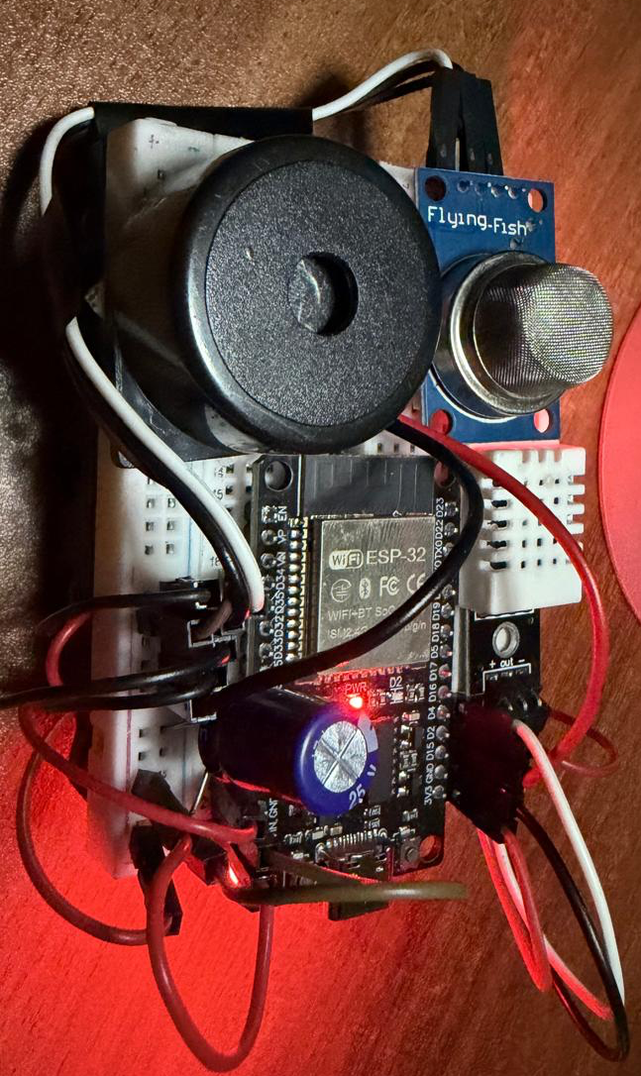Figure 6.1. Aera ESP32 sensor node assembled on a breadboard with the controller, sensor modules, and buzzer. | Hardware assembly.The photograph shows the Aera node assembled on a breadboard around an ESP32 development board, with connected sensor modules and a buzzer. Jumper wires link the components.  Role in the system.The ESP32 reads its attached sensors and prepares telemetry for Aera. The illuminated indicator shows power at capture; the photograph alone does not verify sensor accuracy, firmware operation, or network connectivity. The Serial Monitor capture below documents the communication output.
FROM HARDWARE TO SERIAL OUTPUT
The hardware photograph shows the assembled node; the Serial Monitor view that follows documents one runtime session. Its startup messages show Wi-Fi association and an assigned local IP, telemetry lines show sampled sensor values, and HTTP 200 responses show successful request handling at capture time.

6.1.2 Serial Communication and Telemetry Output
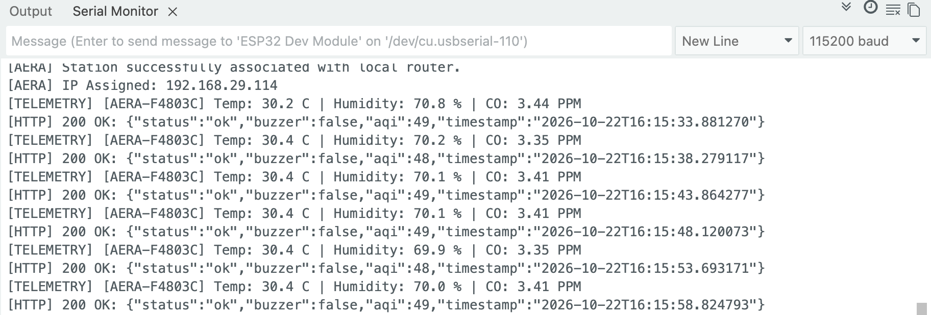
Figure 6.2. ESP32 Serial Monitor showing network association, telemetry samples, and successful HTTP responses.
Arduino IDE 2.3.10 is configured for the ESP32 Dev Module, and the Serial Monitor is set to 115200 baud.
The startup messages record Wi-Fi association and the local IP address assigned to the node, showing that this captured run reached network connection.
Each “[TELEMETRY]” line displays temperature, humidity, and estimated CO values. These are sample readings from the captured run, not evidence of sensor calibration.
“[HTTP] 200 OK” indicates that the telemetry request received a successful response. The accompanying JSON includes status, buzzer state, AQI, and timestamp. Repeated entries show continued sampling and communication during this capture; they do not establish continuous availability or AQI accuracy.

6.2 Aera Web Dashboard: Ambient Grid and Live Readings
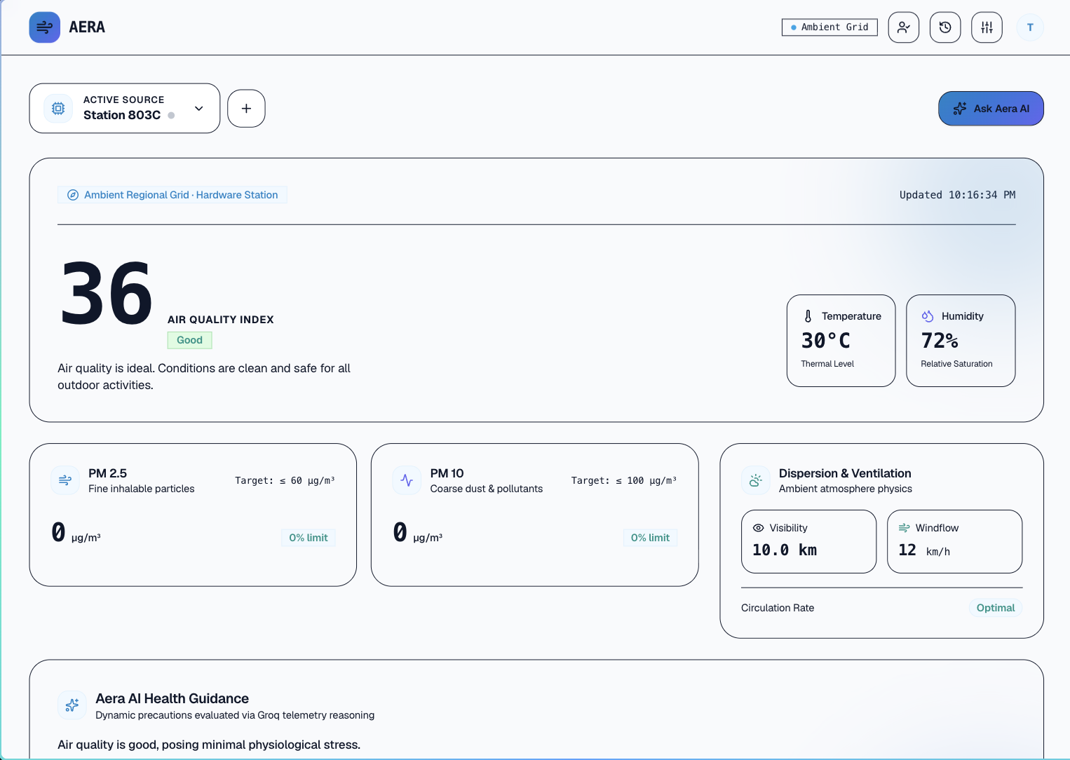
Figure 6.3. Aera web dashboard showing the Ambient Grid summary, particulate readings, health guidance, and trend chart.
The dashboard header identifies the selected “Ambient Grid” source and provides navigation to device management, telemetry history, and system settings.
“Active Source” identifies the data context. The adjacent plus button opens hardware pairing, and “Ask Aera AI” opens the web assistant.
The main card shows AQI 176 (“Unhealthy”) for “Ambient Regional Grid · Durg,” alongside the update time, temperature, and humidity. This is a time-specific dashboard snapshot; live values may differ.
The PM2.5 and PM10 cards show particulate concentrations alongside their displayed reference values. “Dispersion & Airflow” summarizes visibility, wind velocity, and circulation. AI guidance presents generated precautions, while “Atmospheric Trend” plots a selected metric over time. These summaries can change as new data arrives.

6.3 Aera Mobile Application Interface and Operation

Mobile Application Walkthrough
The following screens show how to access Aera, manage an account, select a data source, review readings and trends, and manage hardware. Live measurements and generated guidance can change as new data arrives.

6.3.1 Launch
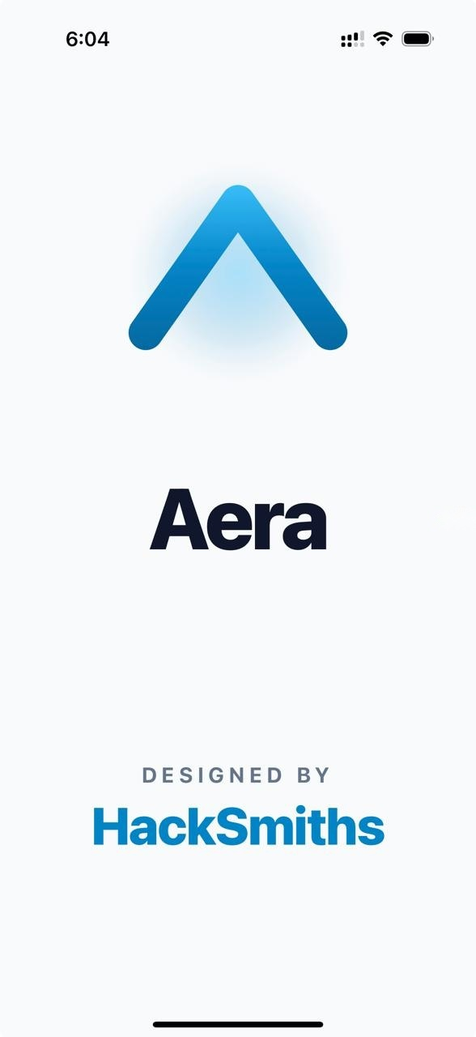  Figure 6.4. Aera launch screen with the brand mark and HackSmiths attribution. | The launch screen displays the Aera mark and HackSmiths attribution while the application starts. It has no controls; wait for loading to finish before continuing to sign-in or workspace setup.  This screen is a startup state rather than an interactive page. Allow the app to finish loading before attempting another action.  This is a brief startup screen, not a settings or sign-in page. No action is available here: wait for initialization to finish, then continue on the sign-in or workspace screen that appears.

6.3.2 Authentication

Sign in
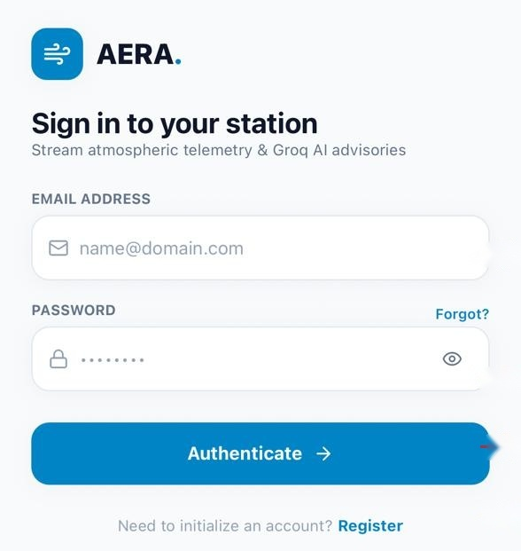  Figure 6.5. Sign-in screen with account fields and links to password recovery and registration. | Enter the account email in “Email Address.”  Enter the account password in “Password.” Use the eye icon to show or hide it while checking.  Select “Forgot?” to open the password-recovery screens.  Select “Authenticate” to submit the credentials. If form validation or sign-in fails, review the message shown in the app.  Select “Register” to begin creating a new workspace.

Workspace setup
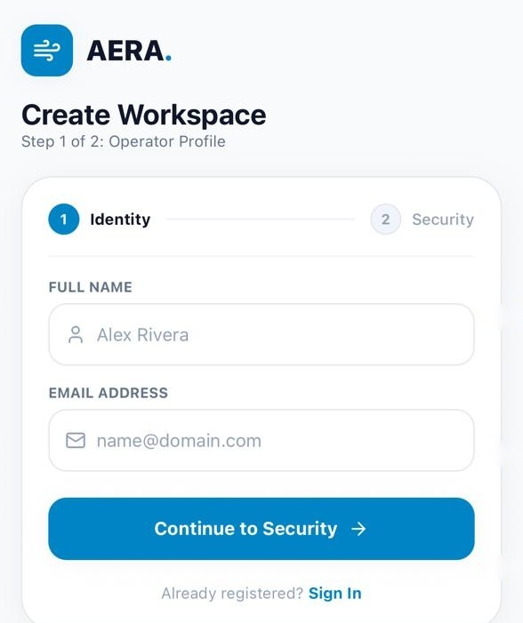  Figure 6.6. Create Workspace, Identity step, for entering the operator name and account email. | 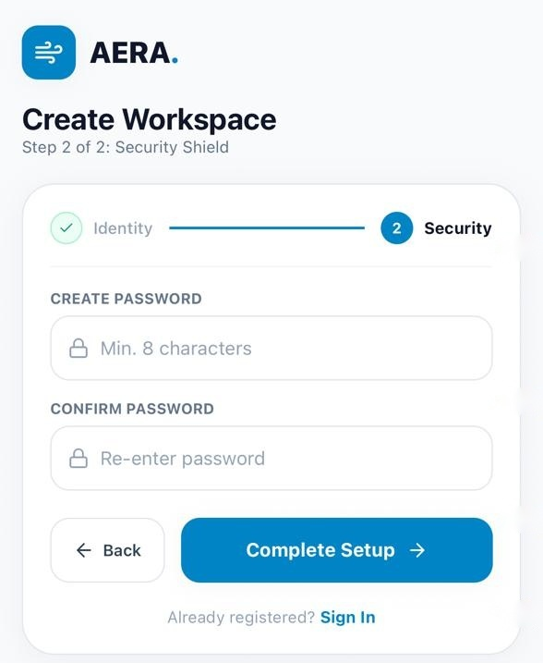  Figure 6.7. Create Workspace, Security step, for setting and confirming the account password. | The progress indicator marks Identity as the current first step of workspace setup.  “Full Name” is optional; enter it if you want the workspace profile to display a name.  An “Email Address” is required before setup can continue.  Select “Continue to Security” to submit the identity details and proceed to password setup. Select “Sign In” to return to the existing-account screen.

- Enter a required email address on Identity; the display name is optional. Select “Continue to Security” to proceed.
- Set and confirm a password on Security. Use “Back” to review details or “Sign In” to leave registration.

Password recovery
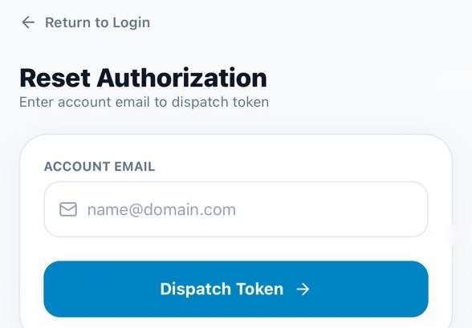  Figure 6.8. Reset Authorization screen for requesting a password-reset token. | Select “Return to Login” to leave recovery and return to sign-in.  Enter the account email whose password needs to be reset.  Select “Dispatch Token” to request a reset token, then follow the confirmation displayed by the app.
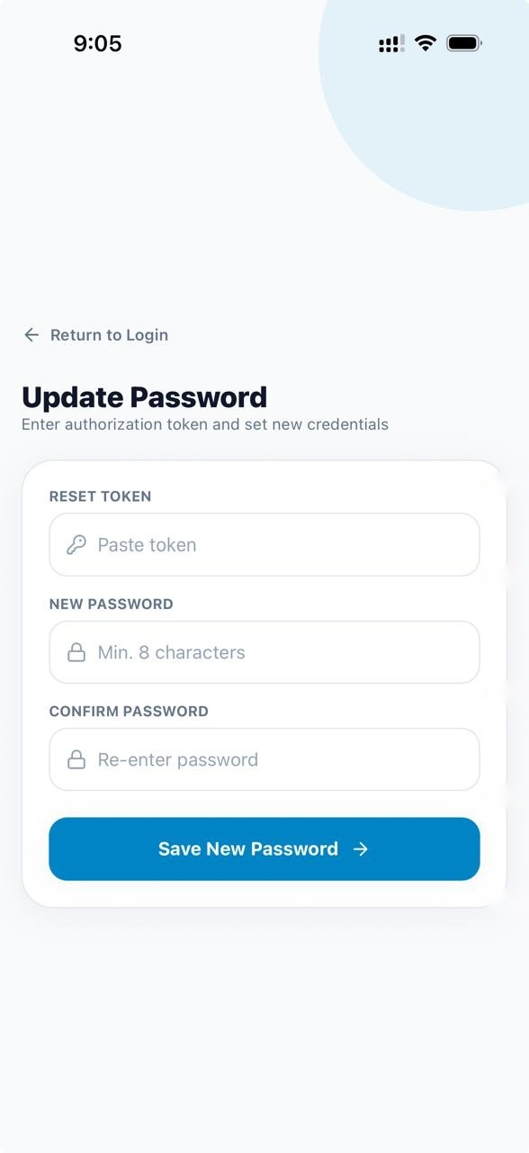  Figure 6.9. Update Password screen for entering a reset token and replacement password. | Select “Return to Login” to exit the password-reset form and return to sign-in.  Enter the reset token received for the account.  Enter the replacement in “New Password.” The eye icon toggles whether it is visible.  Re-enter the replacement in “Confirm New Password” and check that both entries match.  Select “Save New Password” to submit the token and replacement password. If the token is invalid or expired, the app reports that the reset could not be completed.

6.3.3 Ambient and Custom Hardware Sources
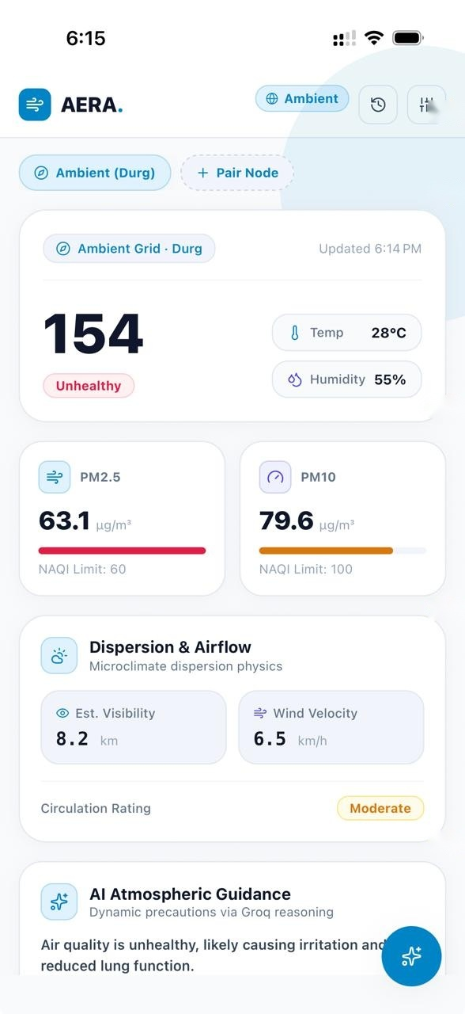  Figure 6.10. Ambient dashboard showing the regional source and its air-quality overview. | “Ambient Grid · Durg” is the selected regional source. The history and settings icons open their respective pages; “Pair Node” begins hardware pairing.  The dashboard summarizes AQI, temperature, humidity, particulate readings, and airflow information. Values are a snapshot and can change as new data arrives.  Ambient is the regional data source, rather than a direct reading from the paired ESP32 node. The dashboard groups AQI, temperature, humidity, particulate readings, and airflow information for the selected region. Choosing a custom hardware station presents the same categories of information using that station’s reported readings. Because the sources, locations, sensors, and update times differ, their values need not match and should be interpreted as separate snapshots.

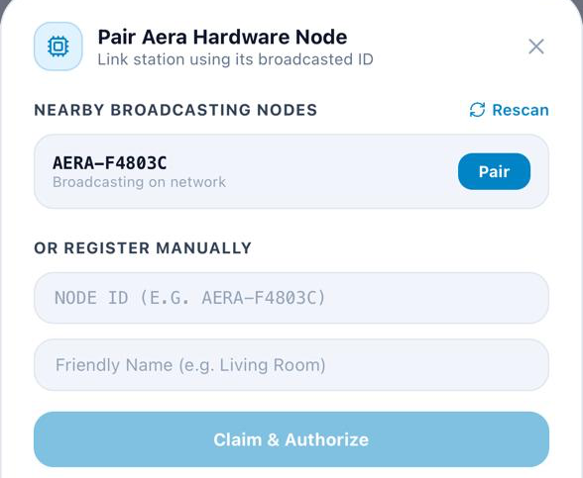  Figure 6.11. Pair Aera Hardware Node panel with a discovered broadcasting node and manual-registration fields. | The “Pair Aera Hardware Node” panel lists nearby nodes available to pair with the account.  Select “Rescan” to refresh discovery, then choose “Pair” beside a listed node.  If the node is not listed, enter its broadcast ID and an optional name under “OR REGISTER MANUALLY.”  Select “Claim & Authorize” to submit the manual details.

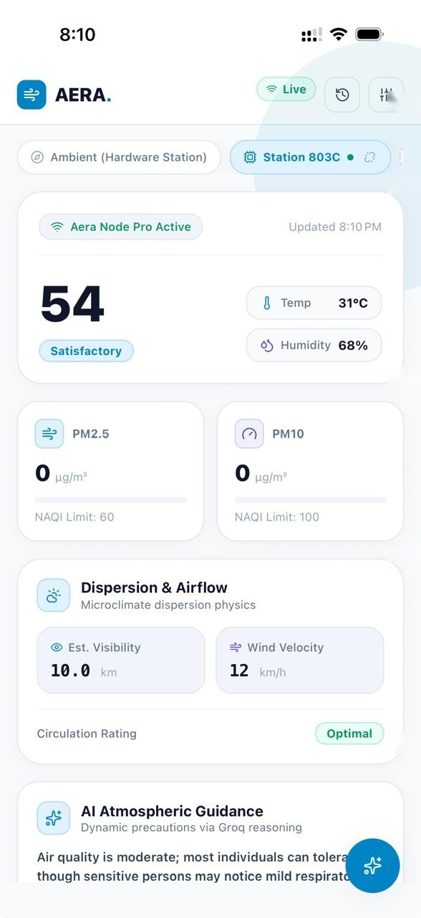  Figure 6.12. Ambient-style dashboard displaying readings from the custom Aera hardware station. | Selecting “Station 803C” switches the dashboard from the regional Ambient source to the paired custom node. The green “Live” badge and dot indicate that the node is reporting in this capture.  The custom hardware source presents the same kinds of outputs as Ambient—AQI, temperature, humidity, PM2.5, PM10, and airflow summaries—using readings reported by the station. Values are snapshots and do not establish sensor calibration.

6.3.4 Dashboard guidance and trends
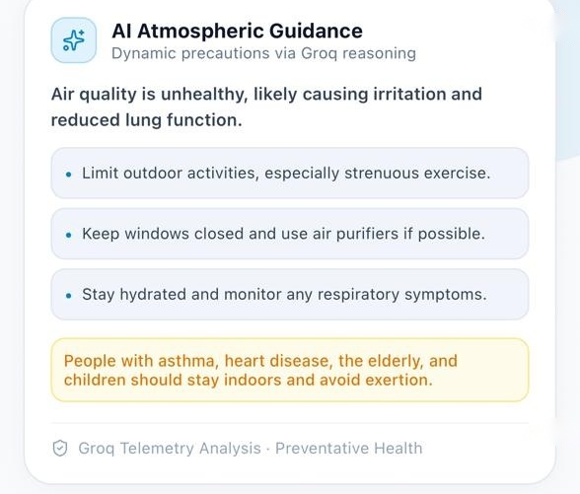  Figure 6.13. Atmospheric Trend with PM2.5 selected, beneath AI Atmospheric Guidance. | “AI Atmospheric Guidance” presents a generated summary and precautions for the selected air-quality context. Use it as general information, not as a medical diagnosis or official alert.  The trend tabs switch the chart between “AQI,” “CO (MQ-9),” “PM2.5,” and “PM10.” “PM2.5” is selected in this capture.  The bars and labels summarize the displayed recent values for the selected metric. Select another tab to view its series.  Select the floating sparkle button to open Aera Atmospheric AI with the selected source as context.

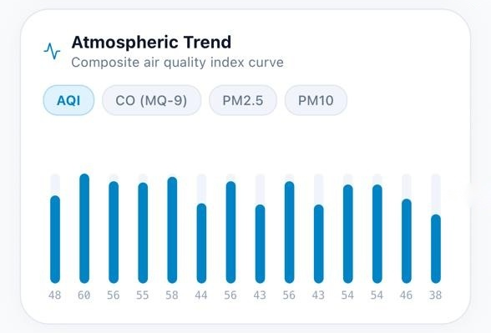  Figure 6.14. Atmospheric Trend with AQI selected, beneath AI Atmospheric Guidance. | “AI Atmospheric Guidance” presents a generated summary and precautions for the selected air-quality context. Recommendations are an example from this capture and can vary as data changes.  The trend tabs switch the chart between “AQI,” “CO (MQ-9),” “PM2.5,” and “PM10.” “AQI” is selected in this capture.  The bars and labels show the recent AQI series displayed in this capture; values and appearance can change over time.  Select the floating sparkle button to open Aera Atmospheric AI with the selected source as context.

6.3.5 Atmospheric AI assistant
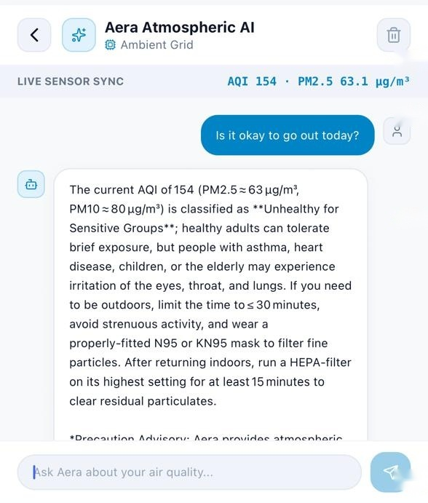  Figure 6.15. Aera Atmospheric AI conversation using the displayed live sensor context. | Use the back arrow to return to the dashboard. The trash icon clears the current conversation.  “LIVE SENSOR SYNC” displays the AQI and PM2.5 readings supplied as context for this exchange.  The message bubbles show a question about outdoor safety and an AI-generated response with precautions. Treat the response as general information, not medical advice or an official air-quality alert.  Enter a follow-up question in the composer and select the send arrow. An empty message cannot be sent.  The on-screen keyboard is the device’s text-entry surface. Dismiss it to review more of the conversation.

6.3.6 Telemetry history
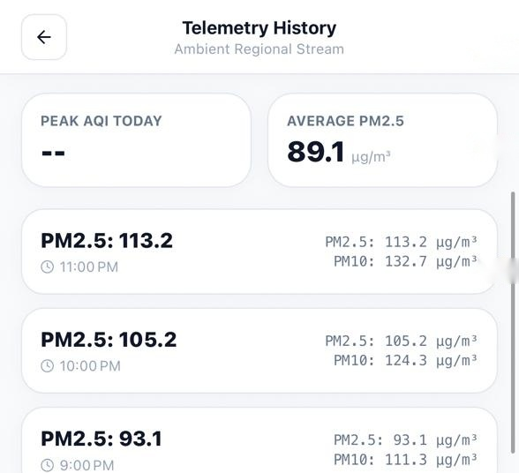  Figure 6.16. Telemetry History with summary metrics and timestamped particulate readings. | Use the back arrow to return to the dashboard. The heading and subtitle identify the history source, shown here as “Ambient Regional Stream.”  “Peak AQI Today” and “Average PM2.5” summarize records available to this screen. A “--” value indicates that no AQI summary is displayed.  Each timestamped card pairs the recorded time with the primary value and its PM2.5 and PM10 readings.  Scroll vertically to review older records, when available.  Pull down on the list to request refreshed history. If no records are available, the screen shows an empty result.

6.3.7 Operator settings
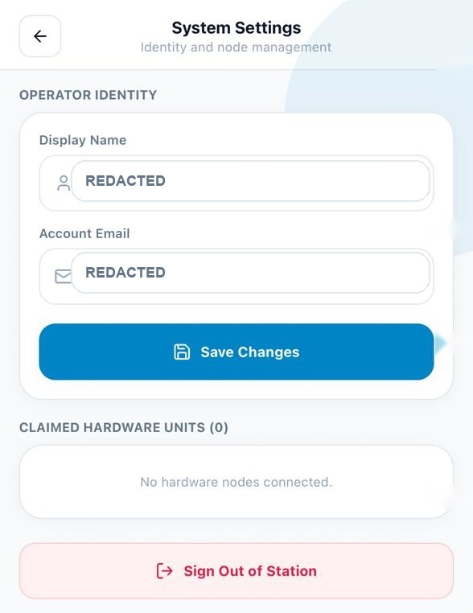  Figure 6.17. System Settings for operator identity, claimed hardware, and sign-out. | Use the back arrow to return to the dashboard. System Settings groups account and hardware-node options.  “Display Name” and “Account Email” are the profile fields shown here. Personal values are redacted in this report copy.  After editing profile details, select “Save Changes.” The app displays whether the update succeeded.  “Claimed Hardware Units (0)” is the empty state in this capture. Linked nodes are listed here when the account has claimed hardware.  Select “Sign Out of Station” to end the current authenticated session and return to sign-in.
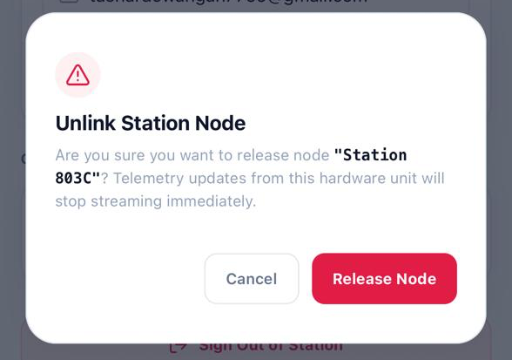  Figure 6.18. Confirmation dialog for unlinking Station 803C from System Settings. | The “Unlink Station Node” dialog names “Station 803C” as the selected hardware unit.  The warning states that releasing the node will stop its telemetry updates.  Select “Cancel” to close the dialog and keep the node linked.  Select “Release Node” to confirm unlinking; the station’s telemetry updates then stop.  The dimmed System Settings page remains in the background until you choose “Cancel” or “Release Node.”

