Introduction
AeroMind is a hybrid autonomous drone platform developed by HackSmiths. It is built for the following.
- Operational use in inspection, mapping, agriculture, surveillance, and emergency response
- Unified operator control, live telemetry, camera and map overlay, and AI-based identification
- Administered access with device binding, approval, and forced control
- Four layers: Flutter app, FastAPI backend, Raspberry Pi 4, and F7 / INAV
NOTE
The operator never commands the flight controller directly. This report covers the aim, the layered architecture, the operating flow, and the implementation of each layer.

Aim and Objectives
The aim of this project is to design and implement AeroMind, a hybrid autonomous drone system that combines real-time operator control, live telemetry, visual overlay, AI-based multi-model identification, and secure administered access within one layered platform.
The specific objectives of the project are as follows.
- Design a Flutter mobile application that provides dual-joystick flight command, live telemetry, and a camera or map overlay.
- Implement a FastAPI backend for authentication, device binding, session control, telemetry exchange, and AI service delivery.
- Deploy a Raspberry Pi 4 companion computer as the onboard bridge between backend services and the flight controller.
- Configure an INAV-based F7 flight controller to retain low-level attitude control and stable flight behavior.
- Support AI-based multi-model identification on visual data and return results to the operator during a session.
- Enforce secure operation through device binding, administrator approval, and forced control.
The work is limited to the items listed above.

Architecture
AeroMind is four layers on one path. Each layer talks only to its neighbor. The operator never sends motor or MSP commands to the flight controller.
Flutter Application | FastAPI Backend | Raspberry Pi 4 | F7 / INAV
Operator client | System authority | Onboard bridge | Real-time flight stack
Joysticks, overlays, SQLite | JWT, bind, one controller | MSP, sensors, 4G | Modes, PID, motors, ESCs
Commands out | WebSocket to the aircraft | MSP setpoints to INAV | Attitude and throttle
Camera / map / status in | Redis, WebRTC, AI results | Telemetry and video up | IMU, barometer, current
Figure 1. Layered architecture of AeroMind. Commands travel left to right. Telemetry, video, and identification results travel right to left.

Flutter Mobile Application
The Flutter application is the operator client.
- Captures dual-joystick and button input
- Displays live telemetry
- Presents camera or map as an overlay
- Stores login and settings in SQLite
- Sends every command to the FastAPI backend

FastAPI Backend
The FastAPI backend is the system authority.
- Route groups: Auth, Users, Admin, Connection, Commands, Telemetry, and AI
- JWT authentication with device binding
- Only one active controller at a time
- Latest telemetry stored in Redis
- Commands to the companion computer over WebSocket
- Live camera and audio signaling over WebRTC
- Multi-model, multi-level identification
- Administrator approval, access policy, and forced control
NOTE
External language models (OpenAI, Groq, Gemini, and Grok) only refine identification results inside the service. They are not the operator interface.

Raspberry Pi 4 Companion Computer
The Raspberry Pi 4 is the onboard bridge.
- Modules: Core, Sensors, Flight, Autonomy, Network, and Utils
- Core: configuration, state management, and logging
- Sensors: rain, LIDAR, ultrasonic, battery, environment, GPS, IMU, camera, and microphone
- Flight: MSP communications, flight-controller interface, and fail-safe
- Autonomy: decision engine, state machine, and safety rules
- Network: telemetry sender, command listener, and SIM7600 4G handler
- Utils: helpers and retry / failure logic

F7 Flight Controller
The F7 flight controller, running INAV, is the real-time flight stack.
- UART MSP to the Raspberry Pi and UART for the receiver
- Sensors: IMU (gyro and accelerometer), barometer, and current
- Flight modes: stabilize / angle, altitude hold, and multi-stage fail-safe
- Motors and ESCs: mapping, DShot protocol, and motor direction
- PID tuning with gyro and D-term filters
- MSP enable, baud rate, and feature flags
NOTE
Inner-loop stability stays on INAV. Policy, media, and identification stay in software that can be updated independently.

How the System Works
An operator action travels the same path every time. Nothing on the handset talks to the flight controller.
Command path
01 | 02 | 03 | 04 | 05
Operator | Flutter App | FastAPI | Raspberry Pi | F7 / INAV
Input | Command | Auth and policy | MSP bridge | Flight
Return path
01 | 02 | 03 | 04
F7 / INAV | Raspberry Pi | FastAPI | Flutter App
Sensors | Video and telem. | Redis · WebRTC · AI | Overlay
Figure 2. End-to-end operating flow of AeroMind.
The operating sequence is as follows.
- The operator signs in. An unapproved account is blocked.
- The operator pairs a bound aircraft and opens the controller.
- Stick and button inputs go to the FastAPI backend.
- The backend checks the JWT, the device binding, and that this session is the only active controller.
- The command is sent to the Raspberry Pi over WebSocket.
- The Pi forwards a validated setpoint to INAV over MSP.
- INAV moves the airframe and keeps attitude stable.
- Telemetry returns Pi → Redis → application.
- Live camera and audio use WebRTC. If the camera is off, the map overlay is shown.
- AI identification can be run on visual data. External language models only refine those results internally.
- An administrator can approve a session or seize control at any time.
NOTE
Only one controller may be active. An unapproved session cannot command the aircraft.

Features
AeroMind is a complete hybrid drone platform. Its overall capabilities are as follows.
- Hybrid operation: the same aircraft supports direct human control and onboard autonomy
- End-to-end remote flight over 4G, not a private radio-only link
- Live telemetry with camera or map overlay
- Photo and video capture from the operator client
- Multi-model, multi-level identification, with optional internal language-model refinement
- Secure access through JWT, device binding, approval, and a single active controller
- Administrator override and forced control
- Onboard fail-safe on the INAV flight stack
- Modular four-layer design so each layer can be replaced without rewriting the others
- Scalable users, devices, and aircraft through the backend
- Extensible AI: new models can be added without changing the flight controller
- Room to grow autonomy on the companion computer while INAV stays the real-time core
- Wide-area operation through SIM7600 4G backhaul
NOTE
Software features scale on the backend and companion computer. The flight controller stays dedicated to real-time stability.

Components & Tools
Each part has a fixed job on this aircraft. Photos sit beside the use of that part. Supporting hardware is listed with a collage.

Flight Hardware
- DYS FC722 Flight Controller

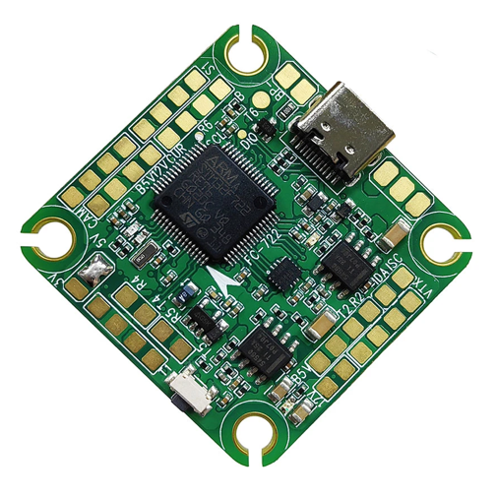
- A2212/13 1400KV Brushless Motors ×4

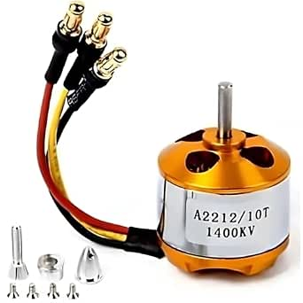

- SimonK 30A ESCs ×4

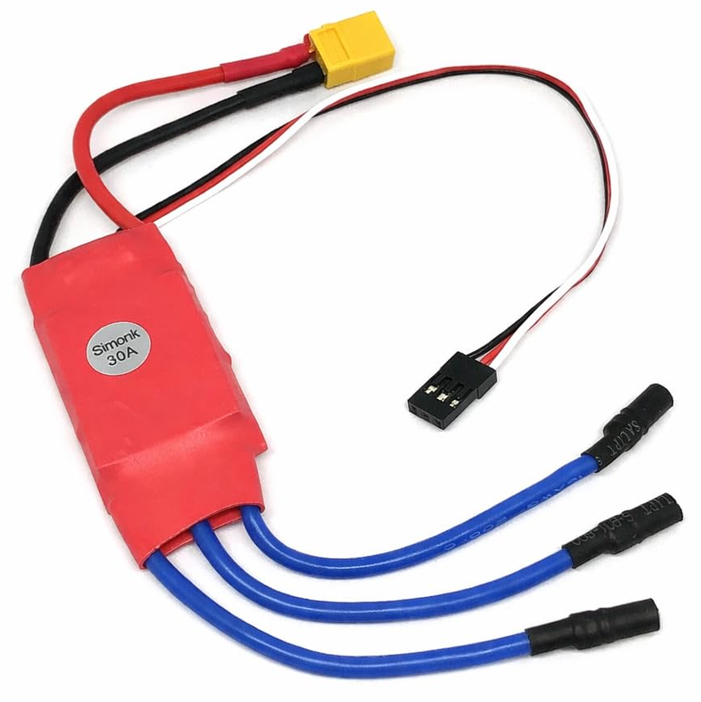

- RadioMaster RP1 ELRS Nano Receiver

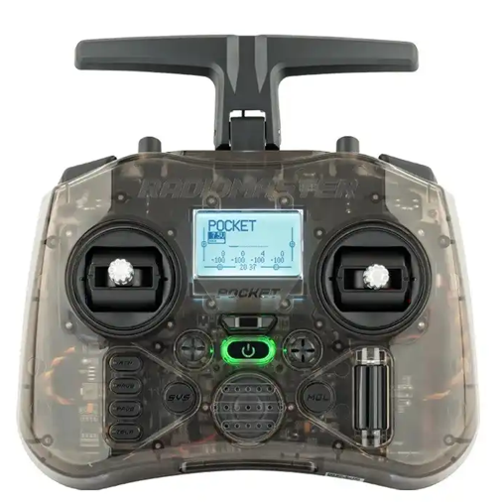

- ELRS 2.4 GHz Radio Transmitter

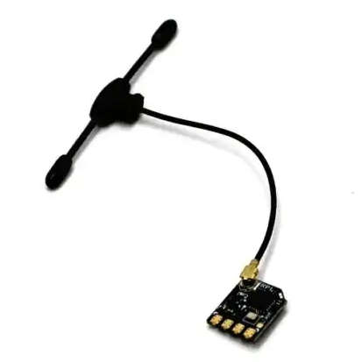

- Caddx Baby Ratel 2 FPV Camera

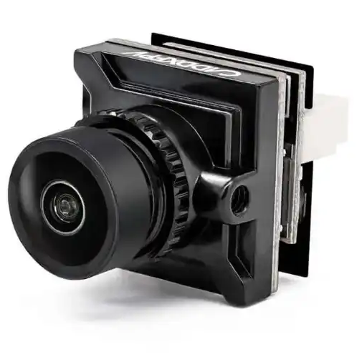

- HGLRC Zeus 800mW 5.8 GHz VTX

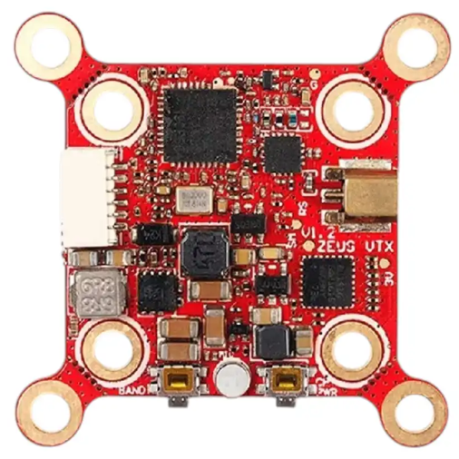

- Foxeer M10Q 5883 GPS + Compass

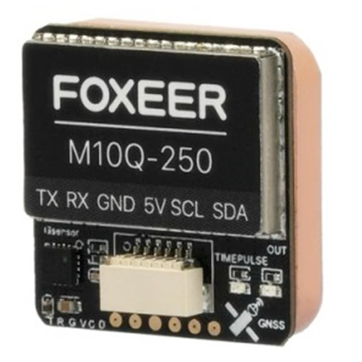

- Pro-Range 11.1V 5200mAh 40C 3S LiPo Battery

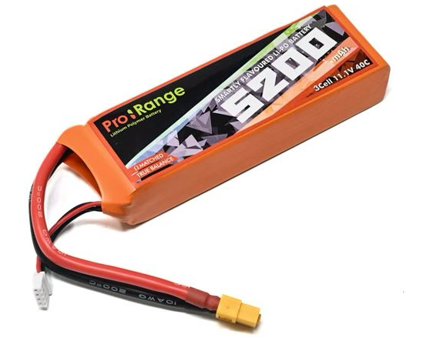

- Matek PDB-XT60

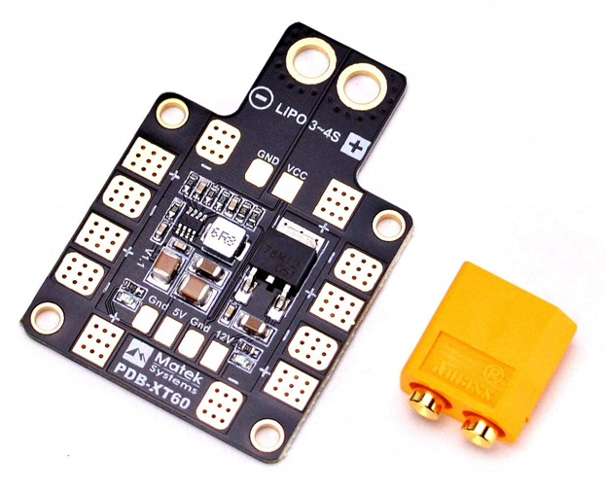

- HCS-150A Hall Current Sensor

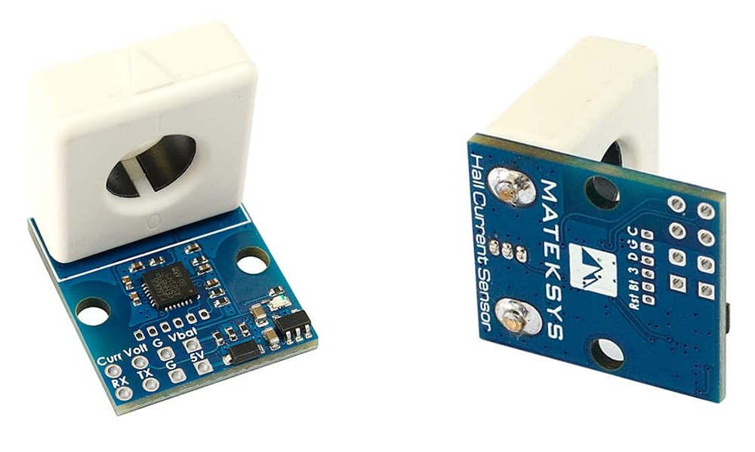

- INMP441 Digital MEMS Microphone

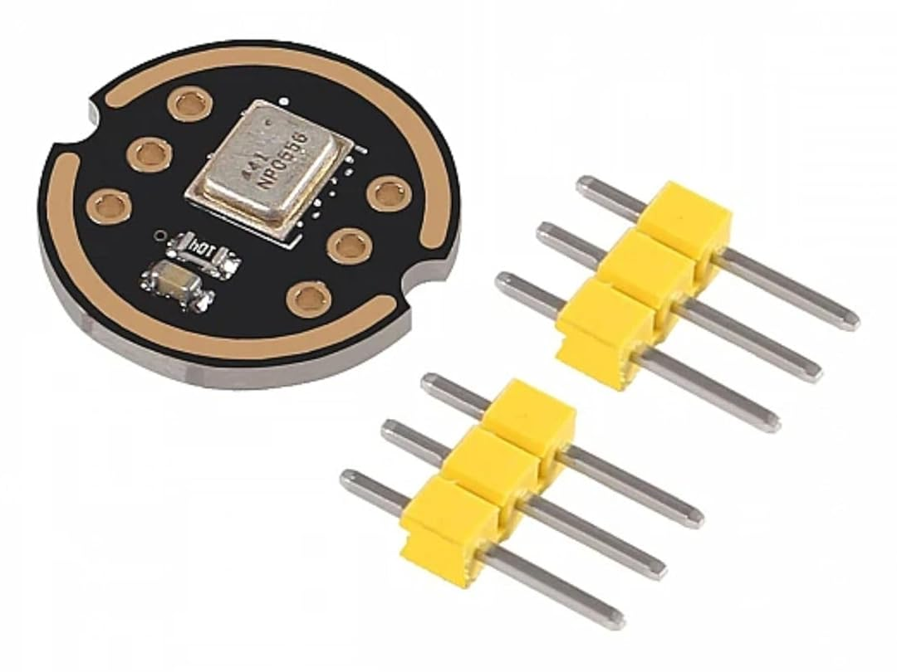

- MAX98357A I2S Class-D Amplifier

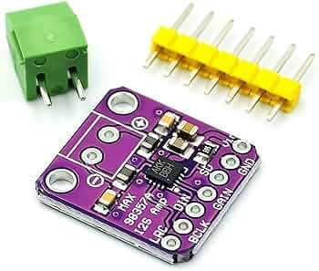

- INVENTO 0.5W 8Ω Speaker

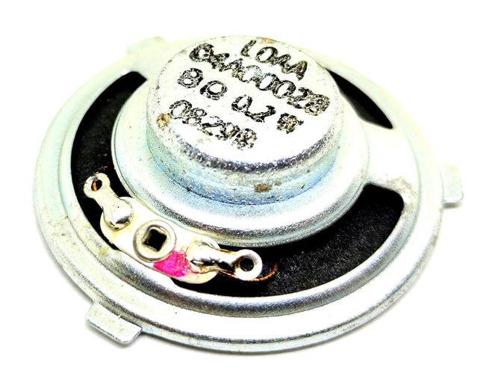

- DYP-A02YYUW Waterproof Ultrasonic Sensor

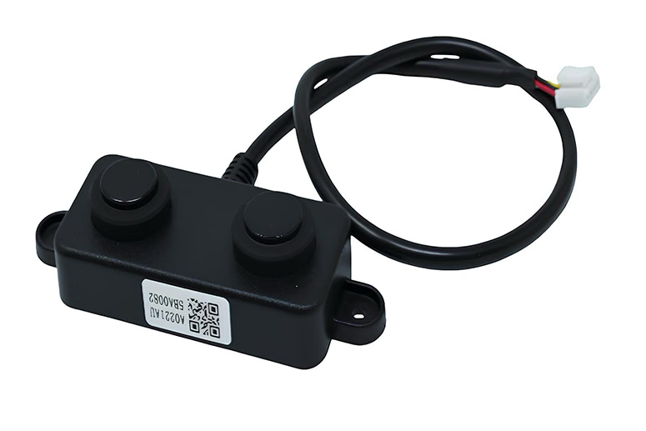

- Contact-Type Rain Sensor

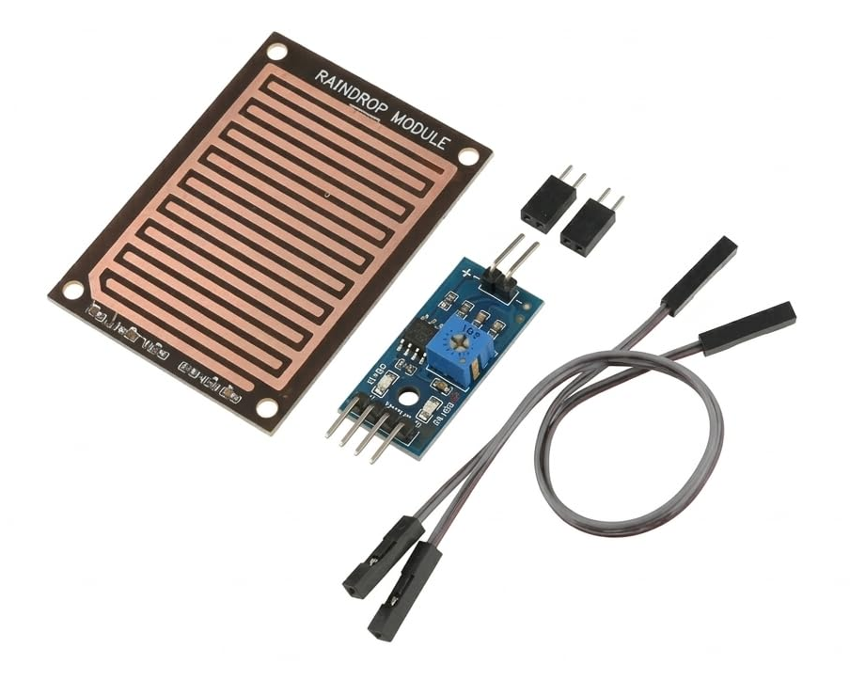
- Q450 V3 Quadcopter Frame

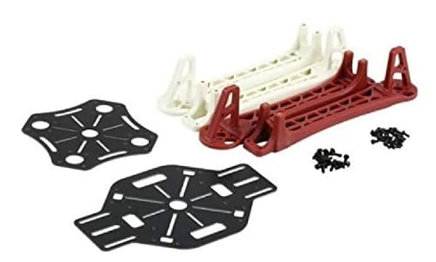

- 1045 (10×4.5") CW/CCW Propeller Set

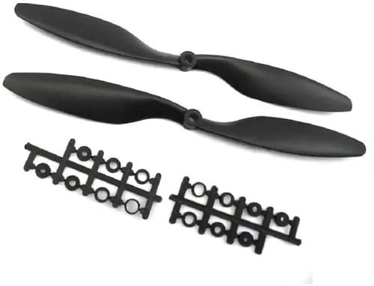

- RX5808 Dual Diversity 5.8 GHz Video Receiver

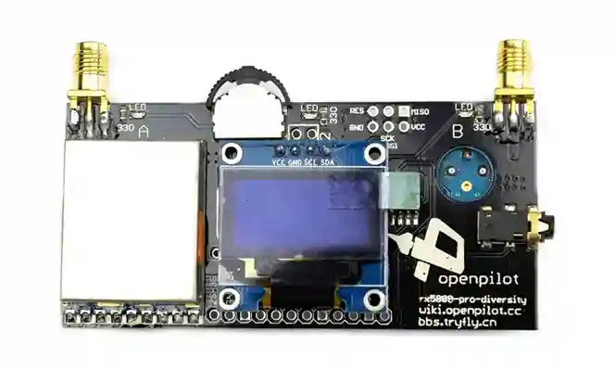
- USB HDMI Capture Card

