1.

SELECT l.location_id,   
       l.location_name,   
       s.sales_class_id,   
       s.sales_class_desc,   
       s.base_price,   
       d.time_year,   
       d.time_month,   
       **SUM**(f.quantity_ordered)                AS QOSum,   
       **SUM**(f.quantity_ordered * f.unit_price) AS JOSum   
FROM   w_location_d l,   
       w_sales_class_d s,   
       w_time_d d,   
       w_job_f f   
WHERE  l.location_id = f.location_id   
       AND s.sales_class_id = f.sales_class_id   
       AND d.time_id = f.contract_date   
GROUP  BY l.location_id,   
          l.location_name,   
          s.sales_class_id,   
          s.sales_class_desc,   
          s.base_price,   
          d.time_year,   
          d.time_month

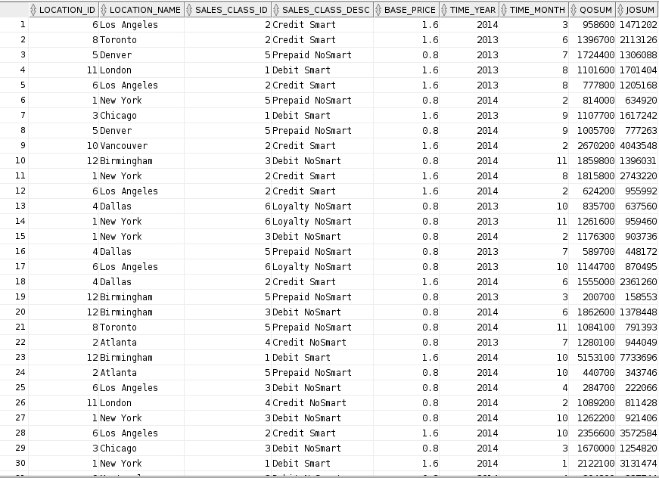

2.

CREATE VIEW invoice_summary   
AS   
  SELECT sj.job_id,   
         **SUM**(invoice_quantity) AS IQSum,   
         **SUM**(invoice_amount)   AS IASum   
  FROM   w_sub_job_f sj,   
         w_job_shipment_f js,   
         w_invoiceline_f i   
  WHERE  sj.sub_job_id = js.sub_job_id   
         AND js.invoice_id = i.invoice_id   
  GROUP  BY sj.job_id

;   
  
SELECT j.job_id,   
       j.location_id,   
       j.unit_price,   
       j.quantity_ordered,   
       l.location_name,   
       t.time_year,   
       t.time_month,   
       invoice_summary.iqsum,   
       invoice_summary.iasum   
FROM   w_job_f j,   
       w_location_d l,   
       w_time_d t,   
       invoice_summary   
WHERE  j.location_id = l.location_id   
       AND j.contract_date = t.time_id   
       AND j.job_id = invoice_summary.job_id

;

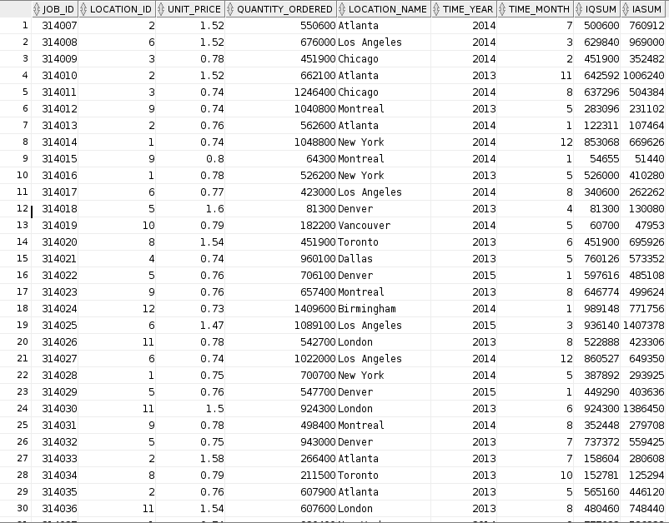

3.

CREATE VIEW machine_costs   
AS   
  SELECT sj.sub_job_id,   
         sj.machine_hours * m.rate_per_hour AS Machine_Costs   
  FROM   w_sub_job_f sj,   
         w_machine_type_d m   
  WHERE  sj.machine_type_id = m.machine_type_id

;   
  
SELECT j.job_id,   
       j.location_id,   
       l.location_name,   
       t.time_year,   
       t.time_month,   
       **SUM**(sj.cost_labor)                                      AS CLSum,   
       **SUM**(sj.cost_material)                                   AS CMSum,   
       **SUM**(mc.machine_costs)                                   AS MCSum,   
       **SUM**(sj.cost_overhead)                                   AS COSum,   
       **SUM**(sj.cost_labor) + **SUM**(sj.cost_material)   
       + **SUM**(mc.machine_costs)   
       + **SUM**(sj.cost_overhead)                                 AS TCSum,   
       **SUM**(sj.quantity_produced)                               AS QPSum,   
       ( **SUM**(sj.cost_labor) + **SUM**(sj.cost_material)   
         + **SUM**(mc.machine_costs)   
         + **SUM**(sj.cost_overhead) ) / **SUM**(sj.quantity_produced) AS Unit_Cost   
FROM   w_job_f j,   
       w_location_d l,   
       w_time_d t,   
       w_sub_job_f sj,   
       machine_costs mc   
WHERE  j.location_id = l.location_id   
       AND j.contract_date = t.time_id   
       AND j.job_id = sj.job_id   
       AND sj.sub_job_id = mc.sub_job_id   
GROUP  BY j.job_id,   
          j.location_id,   
          l.location_name,   
          t.time_year,   
          t.time_month

;

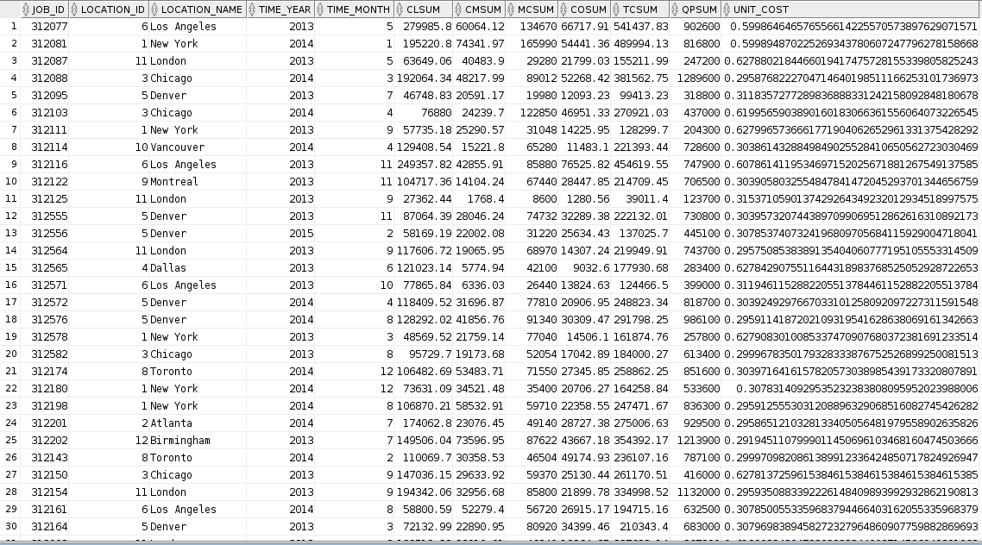

4.

SELECT l.location_id,   
       l.location_name,   
       sc.sales_class_id,   
       sc.sales_class_desc,   
       t.time_year,   
       t.time_month,   
       i.quantity_shipped - i.invoice_quantity   AS Return_Quantity,   
       ( i.invoice_amount / i.invoice_quantity ) * (   
       i.quantity_shipped - i.invoice_quantity ) AS ReturnsSum   
FROM   w_location_d l,   
       w_sales_class_d sc,   
       w_invoiceline_f i,   
       w_time_d t   
WHERE  l.location_id = i.location_id   
       AND sc.sales_class_id = i.location_id   
       AND i.invoice_sent_date = t.time_id

;

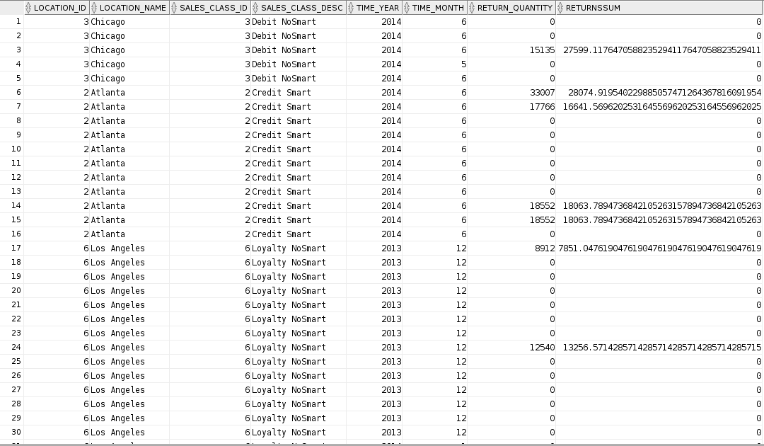

5.

CREATE VIEW shipment_delays   
AS   
  SELECT w_sub_job_f.job_id,   
         **Max**(actual_ship_date) AS Last_Shipment_Date,   
         **SUM** (actual_quantity) AS SumDelayShipQty   
  FROM   w_job_shipment_f,   
         w_sub_job_f,   
         w_job_f   
  WHERE  w_sub_job_f.sub_job_id = w_job_shipment_f.sub_job_id   
         AND w_job_f.job_id = w_sub_job_f.job_id   
         AND actual_ship_date > date_promised   
  GROUP  BY w_sub_job_f.job_id

;   
  
SELECT j.job_id,   
       j.date_promised,   
       j.date_ship_by,   
       j.quantity_ordered,   
       l.location_id,   
       l.location_name,   
       sc.sales_class_id,   
       sc.sales_class_desc,   
       x.sumdelayshipqty,   
       **Getbusdaysdiff**(x.last_shipment_date, j.date_promised) AS BusDiff   
FROM   w_job_f j,   
       w_location_d l,   
       w_sales_class_d sc,   
       shipment_delays x   
WHERE  j.location_id = l.location_id   
       AND sc.sales_class_id = j.sales_class_id   
       AND j.job_id = x.job_id

;

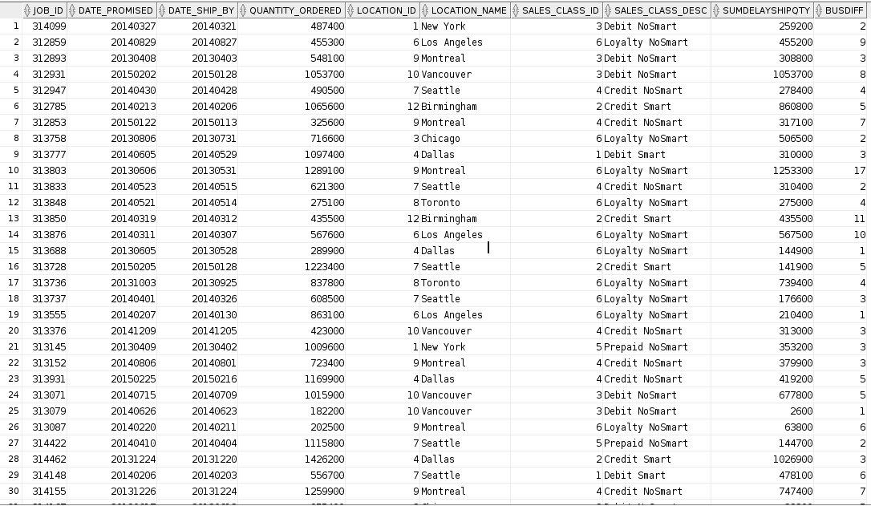

6.

CREATE VIEW firstship   
AS   
  SELECT w_sub_job_f.job_id,   
         **Min**(actual_ship_date) AS FirstShipDate   
  FROM   w_job_shipment_f,   
         w_sub_job_f   
  WHERE  w_sub_job_f.sub_job_id = w_job_shipment_f.sub_job_id   
  GROUP  BY w_sub_job_f.job_id

;   
  
SELECT j.job_id,   
       j.location_id,   
       l.location_name,   
       j.sales_class_id,   
       sc.sales_class_desc,   
       j.date_ship_by,   
       x.firstshipdate,   
       **Getbusdaysdiff**(j.contract_date, x.firstshipdate) AS BusDiff   
FROM   w_job_f j,   
       w_location_d l,   
       w_sales_class_d sc,   
       firstship x   
WHERE  j.location_id = l.location_id   
       AND j.sales_class_id = sc.sales_class_id   
       AND j.job_id = x.job_id

;

