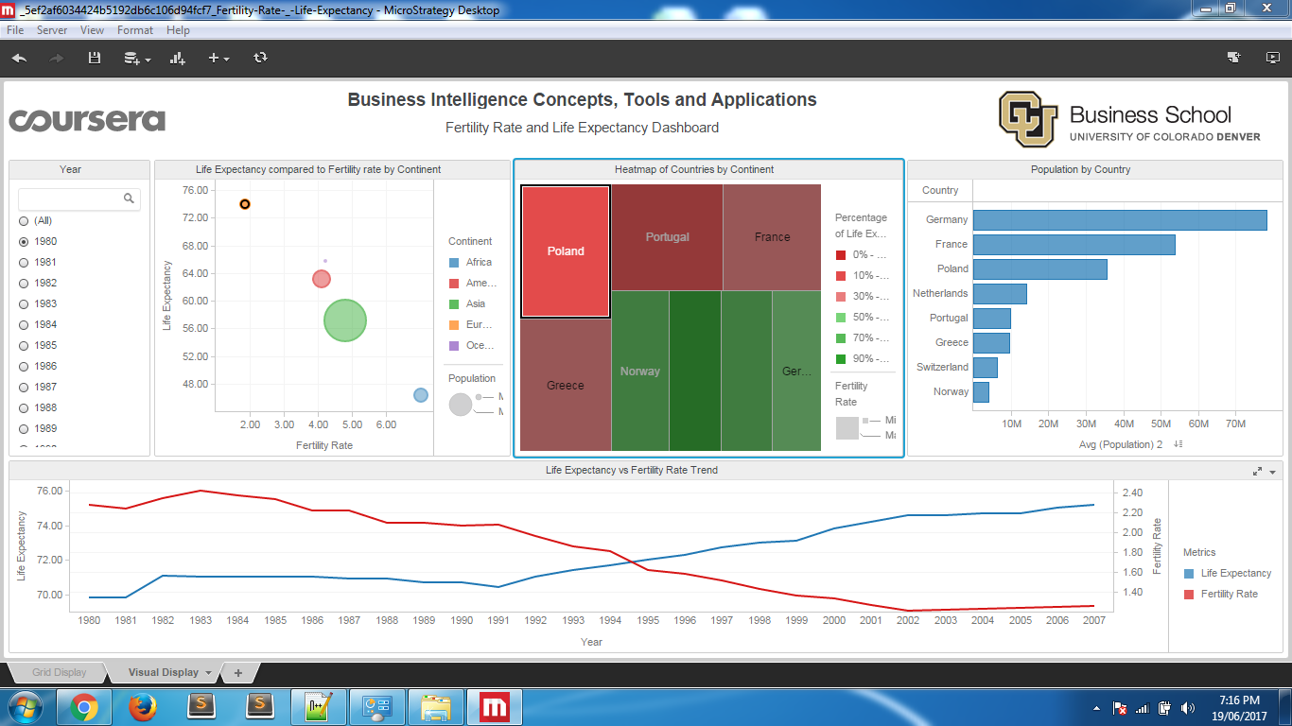

Poland has highest fertility rate for its continent in 1980, but gradually changed to the lowest fertility rate