Implementation

SNAPSHOTS OF MODULES:

This system contains following modules:

BNS app.py

Description:

In the above image a web interface is provided for registering a new domain or transferring the existing one along with the display of metadata of that peer node.

IMPLEMENTATION

project in four major phases

1. BNS software

2. Blockchain module

3. IPFS interface

4. Web interface

4.1 BNS software

This module will be completely written using Python. BNS will be installed in every system. It will be the end point for our system. BNS makes our system backward compatible with 28 DNS protocol. BNS will communicate with browser via port 53. For the end user DNS will encapsulate all the working of our system and it looks like a traditional DNS for the end users using it. BNS software is the main component of our system through which all other modules coordinate. Since it will be developed in Python which is compatible with all major platforms/OS like Windows, MacOS and Linux making it platform independent and easy to setup.

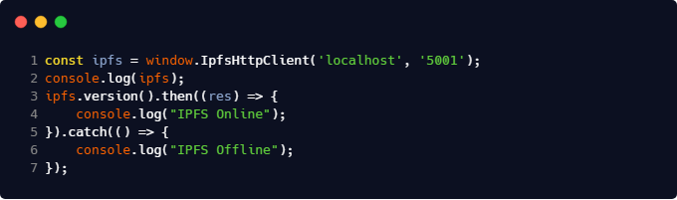

4.2 Blockchain module Blockchain module is responsible for providing security, robustness and decentralization to the system. Blockchain will maintain all the work related with ownership and electronic trust. All the blocks in blockchain will be stored in JSON that makes it easy to query upon large data size. Each peer in the network will have one copy of blockchain which will consists of all the blocks present in the chain. Blockchain module will distribute any new block for verification and validation over the entire peer network. Using the distributed consensus approach the block will be added to the chain. Blockchain module will serve to DNS module by providing a distributed ledger.

4.3 IPFS interface This module will be using IPFS APIs to distribute and retrieve the zone files over the network. It makes use of content addressing to locate the zone files in the nearest peer in the network. It will help reduce the latency of DNS request giving the response much faster which is one of the major concerns of DNS. IPFS module will serve to BNS module by providing it the required zone file. The zone file fetched by IPFS will be processed by BNS and the required web page location(IP address) and other details.

4.4 Web Interface Web interface will be hosted on all local machines who have BNS software installed. Web interface helps us to manage domain name credits, ownership rights. Using web interface users will buy or sell the domains. It also keeps account of domain credits for every individual user in the network of peers. Web interface will be developed in HTML5, CSS3 and web sockets. Web sockets plays major role in communication between web interface and BNS.

