Assignment – 1

1-Install Power BI Desktop and share the final screenshot of the report view page which appears when power desktop starts.

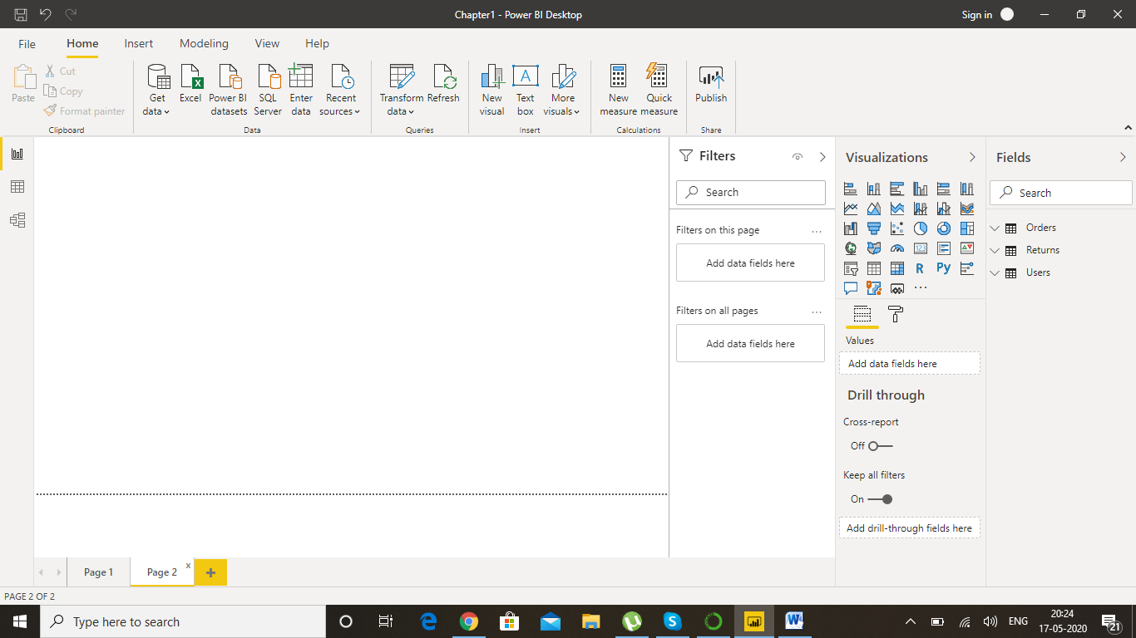

2-Prepare a document and with the following screenshot:

* Report View

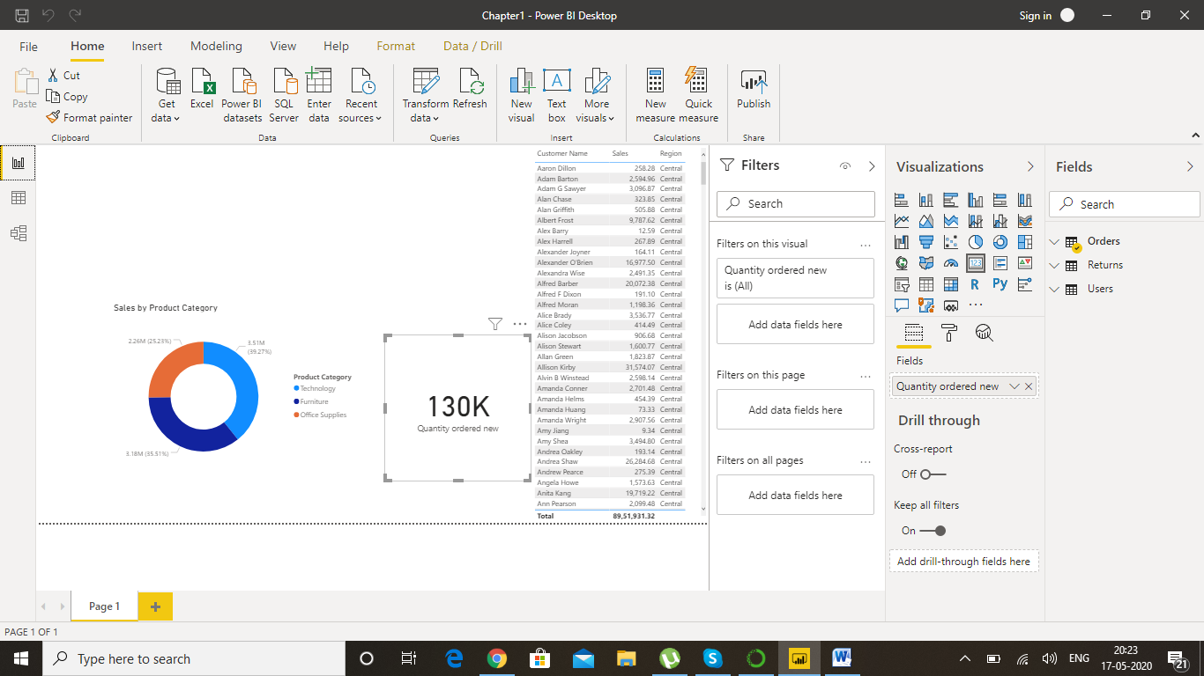

* Data View

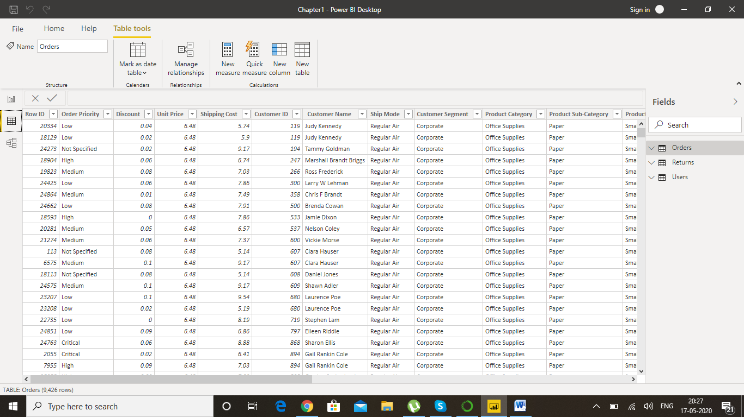

* Model View

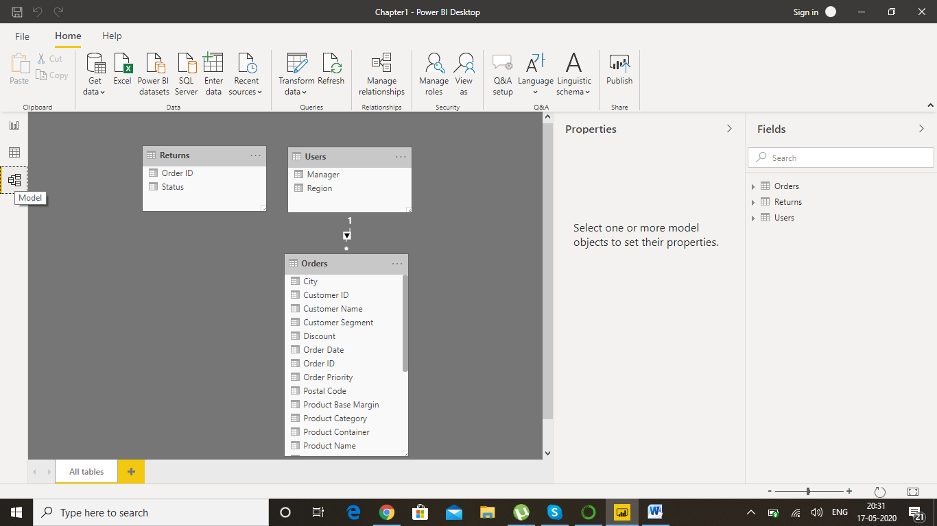

* Power Query Editor

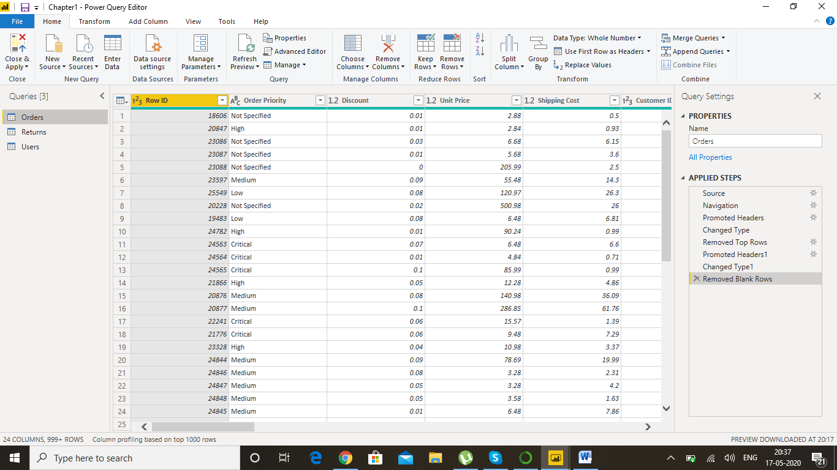

* Advance Editor

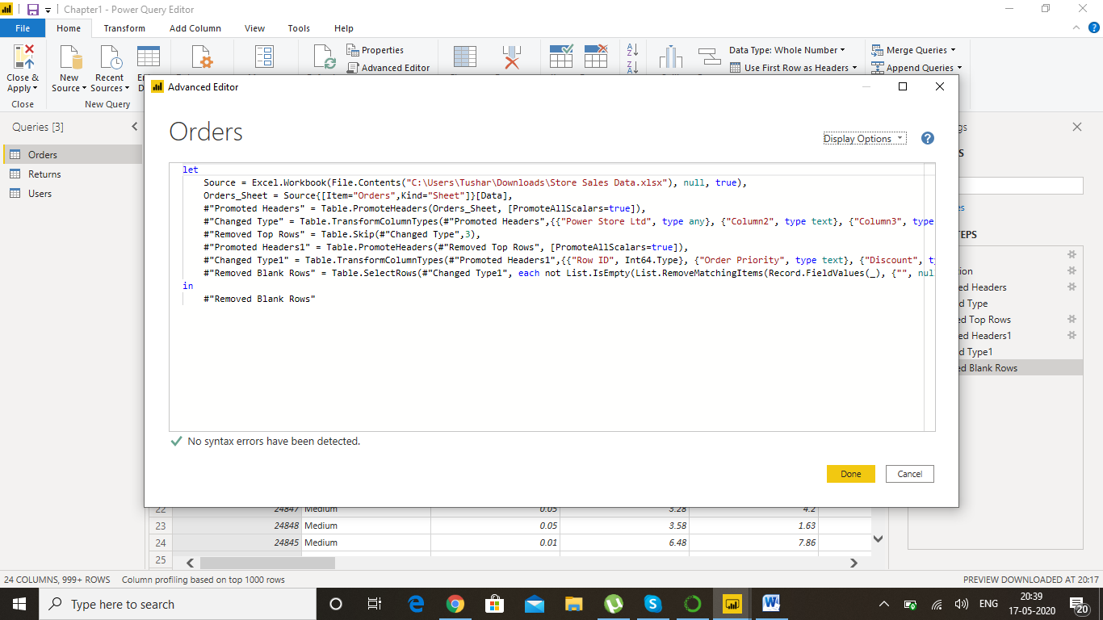

3- Prepare a document with details of the following along with their price

− Power BI Desktop

With **Power BI Desktop**, you can connect to multiple different sources of data, and combine them (often called modeling) into a data model. This data model lets you build visuals, and collections of visuals you can share as reports, with other people inside your organization.

Cost-Free

− Power BI Pro

**Power BI Pro** is an individual user license that lets users read and interact with reports and dashboards that others have published to the **Power BI** service. Users with this license type can share content and collaborate with other **Power BI Pro** users.

Cost-$9.99 per user per month

-Power BI Premium

**Power BI Premium** is a capacity-based offering that includes: Flexibility to publish reports broadly across an enterprise, without requiring recipients to be licensed individually per user. Greater scale and performance than shared capacity in the **Power BI** service.

Cost-Premium plan starts at $4,995 a month per dedicated cloud compute and storage resource