Project Report
On
GreenCart
A Microservices-Based Farmer-to-Buyer E-Commerce Platform


Submitted
In partial fulfilment
For the award of the
Post Graduate Certification Program in Advance Computing (PGCP-AC)
C-DAC, ACTS (Pune)
Guided By:
Milind Sonawane
Submitted By:
Tushar Chaudhari - 260240120208
Sushant Pawar - 260240120121
Ajinkya Shedge - 260240120168
Siddhesh Chandere - 260240120186

Centre for Development of Advanced Computing (C-DAC), ACTS
(Pune – 411008)

ABSTRACT
GreenCart is a web-based, microservices-oriented e-commerce platform that connects farmers directly with wholesale buyers, removing the dependency on middlemen that traditionally erodes farmer margins and slows the produce-to-market cycle. The system is architected as four independently deployable services — a Java/Spring Boot User Service for authentication and role management, a Java/Spring Boot Product Service for catalogue and stock management, a Java/Spring Boot Buyer Service for cart, ordering and payments, and a .NET 8 Admin Service for platform administration and oversight — fronted by a Spring Cloud Gateway and coordinated through a Netflix Eureka discovery server. A React single-page application, built with Redux Toolkit for state management and Axios for API communication, provides role-specific dashboards for three user types: Farmer (Seller), Buyer (Wholesaler/Customer) and Admin. Authentication and authorization across services are secured using stateless JWT tokens, and a normalized MySQL schema (greencartdb) persists users, products, categories, carts, orders and payments. The project demonstrates the practical application of polyglot microservices, service discovery, API gateway routing, and role-based access control to solve a real-world agricultural supply-chain problem, and highlights the trade-offs and integration challenges involved in combining a Java backend ecosystem with a .NET service within a single distributed system.

Table of Contents
S. No. | Title | Page No.
 | Front Page / Acknowledgement / Abstract | I – III
 | Table of Contents | IV
1 | Introduction | 01–02
1.1 | Introduction | 01
1.2 | Objective and Scope | 02
2 | Literature Review / Existing System Study | 03–04
3 | Methodology / System Design | 05–10
3.1 | System Architecture | 05
3.2 | Technology Stack | 06
3.3 | Database Design | 07
3.4 | Use Case Diagrams | 09
4 | Implementation | 11–13
4.1 | Modules Implemented | 11
4.2 | API Gateway and Service Discovery | 12
4.3 | Security Implementation | 13
5 | Results and Testing | 14–15
5.1 | Testing Approach | 14
5.2 | Results | 15
6 | Conclusion | 16
6.1 | Conclusion | 16
6.2 | Future Enhancement | 16
7 | References | 17

Chapter 1
Introduction

1.1 Introduction
Agricultural produce in India, and in many developing economies, moves from farmer to end buyer through multiple layers of intermediaries — local agents, mandis and traders — each of whom takes a commission and adds delay to the transaction. Farmers have little visibility into buyer demand or market price, and buyers have little visibility into what is actually available and where. GreenCart was conceived to address this gap by providing a direct, digital marketplace where a Farmer can list produce for sale and a Wholesaler/Buyer can browse, cart and order it directly, with an Admin overseeing the health of the platform.
The system is built as a set of independently deployable microservices rather than a single monolithic application. This was a deliberate architectural choice: it allows each business capability (user management, product catalogue, ordering, administration) to be developed, tested, scaled and deployed independently, and it allows the team to use the most appropriate technology for each service — Java and Spring Boot for the core transactional services, and .NET 8 for the administrative service — while still presenting a single, unified API surface to the React frontend through an API Gateway.
All inter-service communication is stateless and secured using JSON Web Tokens (JWT), and service instances register themselves with a Eureka discovery server so that the gateway and other services can locate them without hard-coded network addresses. A single MySQL database (greencartdb) backs the platform, with a normalized schema for users, roles, locations, products, categories, stock, carts, orders and payments.

1.2 Objective and Scope
The objectives of the project are:
- To design and implement a microservices-based e-commerce platform that connects farmers directly with wholesale buyers, eliminating middlemen.
- To provide separate, role-based experiences for three user types — Farmer, Buyer and Admin — through a single React frontend.
- To implement secure, stateless authentication and role-based access control across all services using JWT.
- To design a normalized relational database that supports catalogue management, cart and order processing, and payments.
- To demonstrate service discovery and centralized API routing using Eureka and Spring Cloud Gateway.
- To demonstrate interoperability between a Java/Spring Boot backend ecosystem and a .NET 8 administrative service within one distributed system.
The scope of the current implementation (Phase 1) covers farmer product listing and stock management, buyer browsing, cart and order placement with Cash-on-Delivery, and administrative oversight of accounts, products and orders. Online payment gateway integration, delivery-partner logistics tracking, and multi-language support are identified as future enhancements beyond the current scope.

Chapter 2
Literature Review / Existing System Study
Direct farmer-to-buyer digital marketplaces have been studied and built in various forms, ranging from government-backed produce exchanges to private agri-tech startups. Reviewing existing approaches helped shape the requirements and architecture of GreenCart.
Government e-marketplace platforms for agricultural commodities typically operate as centralized trading portals that connect farmers to registered traders through regulated mandis. These platforms improve price transparency and enable inter-state trade, but they are heavily oriented toward bulk auction-style trading between farmers and licensed traders rather than a simple cart-and-checkout experience, and they are typically built as monolithic government IT systems with limited API extensibility.
Private agri-tech marketplace applications generally focus on a simpler buyer-facing cart and order flow, similar to consumer e-commerce, and often layer in logistics and cold-chain management. Most publicly documented systems in this space are implemented as single monolithic web applications; few published case studies describe a microservices decomposition for a farmer-buyer marketplace at small-to-medium scale, which motivated the architectural exploration in this project.
From a software-architecture standpoint, the microservices pattern is well established for systems that need independent scalability and technology diversity across business domains — user management, catalogue, and order processing are natural service boundaries, each with different read/write and scaling characteristics. Service discovery (e.g., Netflix Eureka) and an API gateway (e.g., Spring Cloud Gateway) are the standard supporting patterns used to keep such a system manageable from a client's perspective, and both are adopted in GreenCart.
The study of existing systems and patterns identified the following gaps that GreenCart addresses:
- Lack of a lightweight, cart-based direct marketplace focused specifically on the farmer-to-wholesaler transaction, rather than bulk auction trading.
- Limited examples of combining a polyglot backend (Java + .NET) behind a single gateway for a marketplace-style application.
- Need for role-based dashboards (Farmer, Buyer, Admin) served from one frontend codebase rather than three separate applications.

Chapter 3
Methodology / System Design

3.1 System Architecture
GreenCart follows a microservices architecture in which distinct business capabilities are implemented as independently deployable services. The React frontend never talks to a backend service directly; every request is routed through a single API Gateway, which forwards it to the correct downstream service based on the request path. Services register themselves with a Eureka Discovery Server on startup, which keeps the gateway's routing table decoupled from fixed IP addresses.
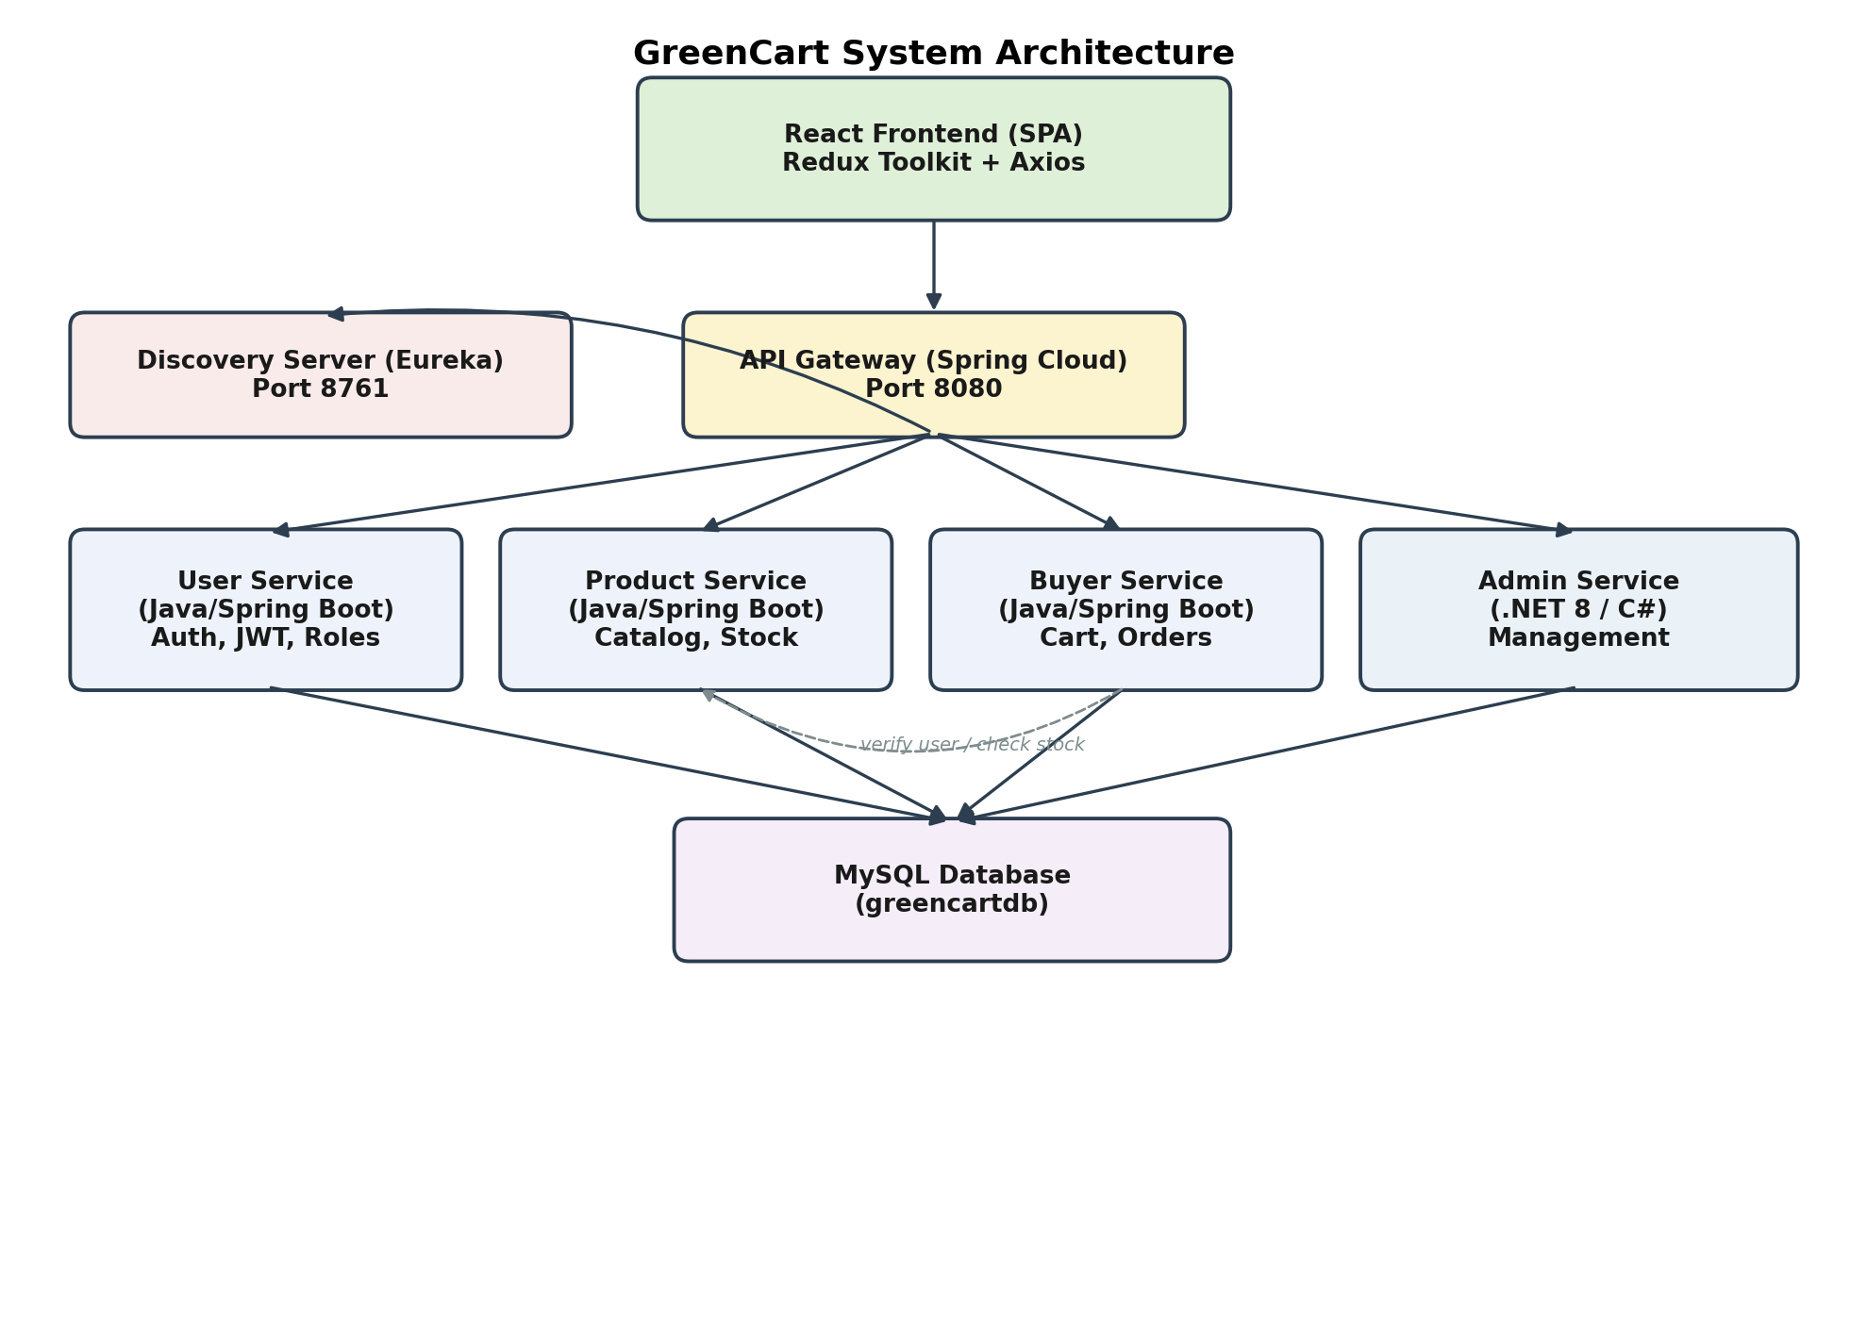
Fig. 1 GreenCart System Architecture
The Buyer Service communicates with the User Service to verify a logged-in user's identity and with the Product Service to check stock availability before confirming an order, illustrating the cross-service collaboration typical of a microservices system (shown as dashed lines in Fig. 1).

3.2 Technology Stack
Layer | Technology | Purpose
Frontend | React.js, Redux Toolkit, Axios, React Router | Single-page application, state management, API calls, client-side routing
Backend (Core Services) | Java 21, Spring Boot, Spring Cloud Gateway, Spring Data JPA / Hibernate | User, Product and Buyer services; REST APIs; ORM
Backend (Admin Service) | .NET 8 (C#), ASP.NET Core, Entity Framework Core | Administrative control, reporting, system orchestration
Service Discovery | Netflix Eureka (Spring Cloud Netflix) | Dynamic registration and lookup of service instances
Database | MySQL (greencartdb) | Centralized relational data store shared/split across services
Security | JSON Web Tokens (JWT) | Stateless authentication and role-based authorization
Build Tools | Maven (Java services), MSBuild/.NET CLI (Admin service), npm (frontend) | Dependency management and builds

3.3 Database Design
The system uses a single normalized MySQL database, greencartdb, shared and logically split across the services. Core tables include users, roles, security_questions, cities and areas (for user location), categories and sub_categories, products and products_stock, and orders, order_items and payments. Referential integrity is enforced through foreign keys — for example, every product belongs to a sub_category, every order is linked to a user through order_items, and every user is linked to a role that determines whether they see the Farmer, Buyer or Admin dashboard.
Table | Key Columns | Purpose
users | user_id (PK), username, password, role_id (FK), area_id (FK), status | Stores all Farmer, Buyer and Admin accounts with role and approval status
roles | role_id (PK), role_name | Defines Admin / Farmer(Seller) / Buyer(Wholesaler) roles
security_questions | question_id (PK), question | Supports the Forgot Password recovery flow
cities / areas | city_id / area_id (PK) | Location hierarchy used for user addresses
categories / sub_categories | category_id / sub_category_id (PK) | Product taxonomy
products / products_stock | pid (PK), pname, sub_category_id (FK) | Product catalogue and available quantity
orders / order_items | order_id (PK), user_id (FK), pid (FK) | Order header and line items
payments | payment_id (PK), order_id (FK), status | Payment method and status per order (Cash on Delivery in current scope)

3.4 Use Case Diagrams
Three primary actors interact with GreenCart: the Admin, the Seller/Farmer, and the Customer/Wholesaler (Buyer).
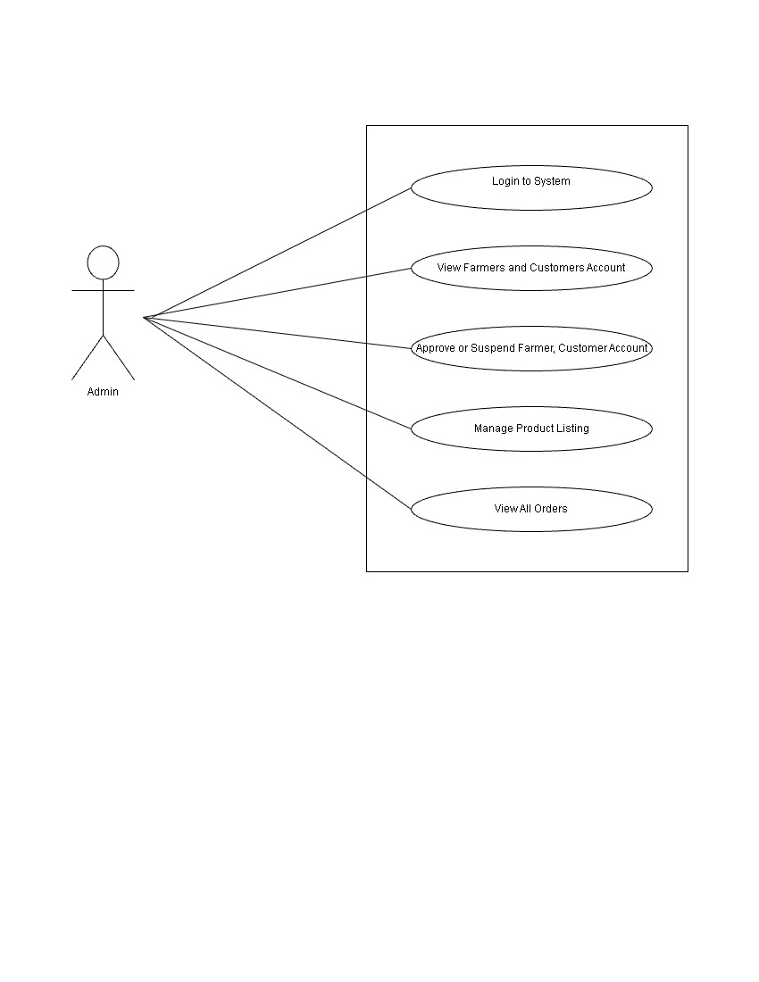
Fig. 2 Admin Use Case Diagram
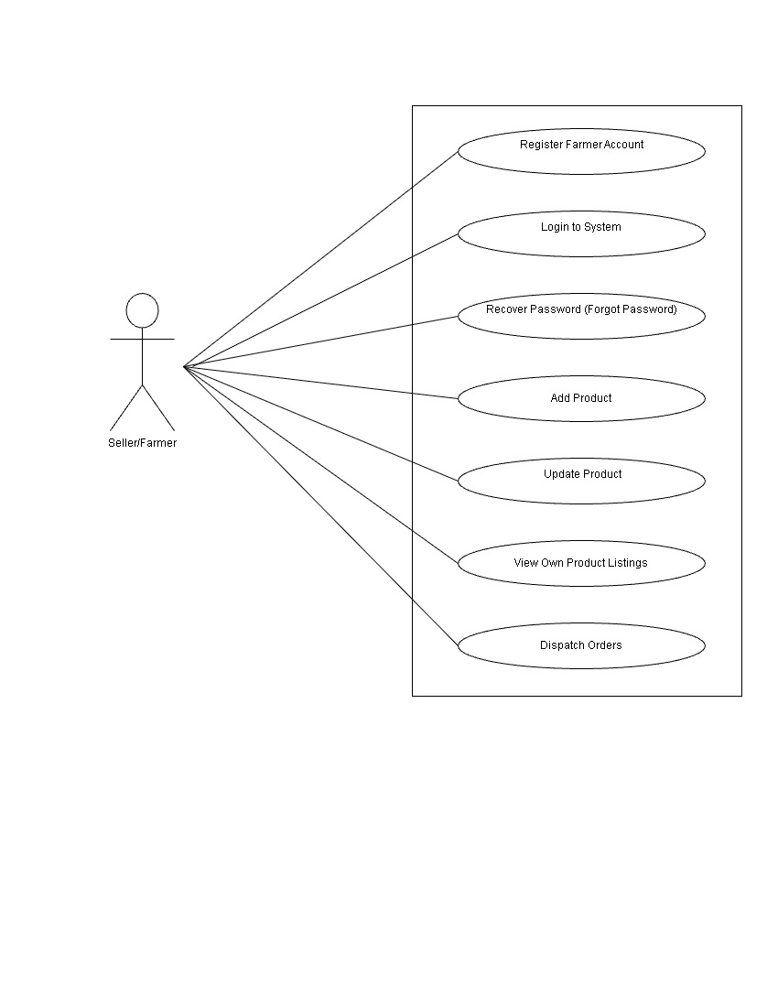
Fig. 3 Seller / Farmer Use Case Diagram
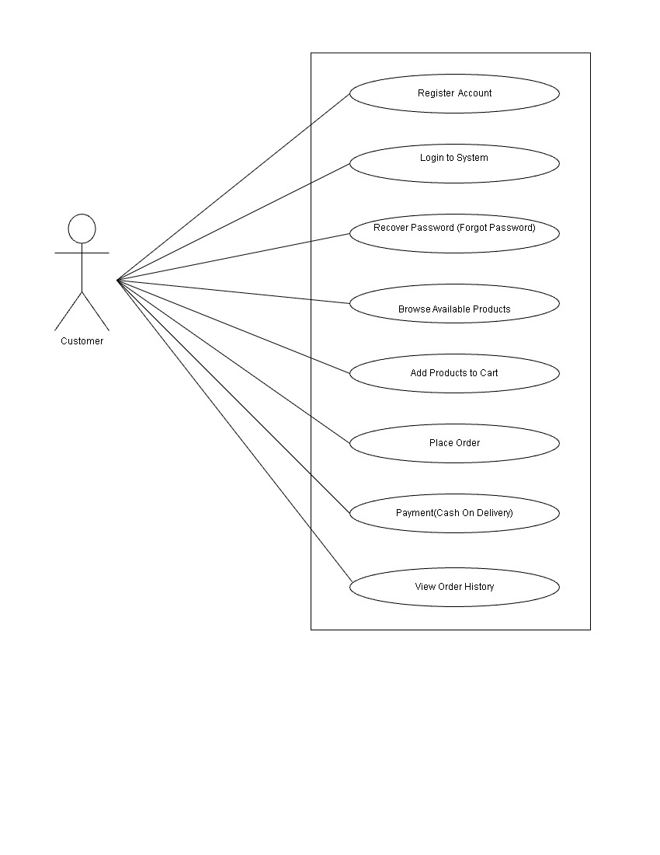
Fig. 4 Customer / Buyer Use Case Diagram

Chapter 4
Implementation

4.1 Modules Implemented
User Service (Java / Spring Boot) —
- Farmer and Buyer registration and login with JWT issuance.
- Forgot-password recovery using security questions.
- City/Area location lookup used during registration.
Product Service (Java / Spring Boot) —
- Category and sub-category management.
- Product CRUD operations (add, update, list, delete) for Farmers.
- Stock management, exposing an "available products" endpoint consumed by the Buyer Service.
Buyer Service (Java / Spring Boot) —
- Cart management (add, update, remove items).
- Order placement (Cash on Delivery) and order history.
- Farmer-side order view and dispatch endpoint.
- JWT authentication filter shared across secured endpoints.
Admin Service (.NET 8 / C#) —
- Account management: approve, suspend or deactivate Farmer and Buyer accounts.
- Monitoring of product listings and viewing of all orders/transactions.
- Entity Framework Core models mapped to the same greencartdb schema (Users, Products, Orders, Payments, etc.).
React Frontend —
- Role-specific pages: BuyerHome, Cart, Orders and OrderDetails for buyers; FarmerDashboard, AddProduct, FarmerProducts and FarmerOrders for farmers; AdminDashboard, ManageAccounts, ManageCategories, ProductsList and OrdersList for admins.
- Redux Toolkit slices (authSlice, cartSlice) for global state; Axios-based service modules (authService, adminService, farmerService) for API calls; a shared axios interceptor (axiosConfig.js) attaches the JWT to outgoing requests.

4.2 API Gateway and Service Discovery
All client traffic enters through the Spring Cloud Gateway on port 8080. Routes are configured to forward requests by path prefix to the correct downstream service: /user/**, /location/** and /security/** to the User Service; /api/orders/**, /api/cart/** and /api/farmer/orders/** to the Buyer Service; /api/products/**, /api/categories/** and /stocks/** to the Product Service; and /api/admin/** to the .NET Admin Service. Every service instance registers itself with the Eureka Discovery Server on port 8761, and the gateway's global CORS configuration allows requests from the React development server.

4.3 Security Implementation
Authentication is implemented using stateless JWT tokens. On successful login, the User Service issues a signed token containing the user's identity and role. Subsequent requests to protected endpoints in the Product and Buyer services pass this token in the Authorization header; a JwtAuthenticationFilter validates the token and populates the Spring Security context before the request reaches the controller. Role-based access ensures that, for example, only users with the Farmer role can call product-management endpoints and only users with the Admin role can approve or suspend accounts. Passwords are never stored or transmitted in plain text.

Chapter 5
Results and Testing

5.1 Testing Approach
Each Java microservice includes a Spring Boot test class (e.g., GreenCartUserServiceApplicationTests, GreencartProductServiceApplicationTests, ApiGatewayApplicationTests) used to verify that the Spring application context loads correctly for that service. The .NET Admin Service is structured to be tested using xUnit, consistent with standard ASP.NET Core practice. Manual functional testing was carried out for each module against its use cases: registration and login for all three roles, product add/update/delete for Farmers, cart and order placement for Buyers, and account/product/order oversight for Admins.
Module | Test Scenario | Expected Result | Status
User Service | Register with a duplicate username | Registration rejected with a validation error | Pass
User Service | Login with correct credentials | JWT token issued and role-based redirect occurs | Pass
Product Service | Farmer adds a new product with stock | Product appears in the Buyer's available-products list | Pass
Buyer Service | Add product to cart and place order | Order created and visible in Buyer's order history and Farmer's order list | Pass
Admin Service | Admin suspends a Farmer account | Suspended Farmer is denied login on next attempt | Pass
API Gateway | Request without a valid JWT to a secured route | Request rejected with an unauthorized response | Pass

5.2 Results
The implemented system successfully demonstrates an end-to-end flow across all three roles: a Farmer can register, log in, list and manage products; a Buyer can browse the catalogue, manage a cart, place a Cash-on-Delivery order and track order history; and an Admin can oversee accounts, product listings and orders across the platform. The API Gateway correctly routes requests to the appropriate Java or .NET service based on path, and service registration with Eureka allows services to be started and stopped independently without hard-coding network locations. JWT-based authorization was verified to correctly block unauthenticated and out-of-role requests to protected endpoints.

Chapter 6
Conclusion

6.1 Conclusion
- In this project, we designed and built GreenCart, a microservices-based platform that connects farmers directly with wholesale buyers, removing dependency on middlemen.
- We implemented four independently deployable services — User, Product, Buyer and Admin — using a polyglot stack of Spring Boot (Java) and ASP.NET Core (.NET 8), coordinated through a Spring Cloud API Gateway and a Eureka Discovery Server.
- We designed a normalized MySQL schema to support catalogue management, cart and order processing, and secured all services using stateless JWT-based authentication and role-based access control.
- The React frontend, built with Redux Toolkit and Axios, provides distinct, role-appropriate dashboards for Farmers, Buyers and Admins from a single codebase.
The system demonstrates that a microservices architecture, even with a mixed Java/.NET backend, can be integrated behind a single gateway to deliver a coherent, role-based marketplace experience.

6.2 Future Enhancement
- Integrate an online payment gateway in addition to the current Cash-on-Delivery option.
- Add a delivery-partner module with real-time order/delivery tracking.
- Introduce market-price visibility and analytics dashboards for Farmers.
- Add containerization (Docker) and orchestration (Kubernetes) for easier deployment and horizontal scaling of individual services.
- Extend the product catalogue with search, filtering and recommendation features.

Chapter 7
References
[1] Spring Boot Reference Documentation — https://docs.spring.io/spring-boot/
[2] Spring Cloud Gateway Reference Documentation — https://docs.spring.io/spring-cloud-gateway/
[3] Netflix Eureka / Spring Cloud Netflix Documentation — https://docs.spring.io/spring-cloud-netflix/
[4] ASP.NET Core Documentation, Microsoft — https://learn.microsoft.com/aspnet/core/
[5] Entity Framework Core Documentation, Microsoft — https://learn.microsoft.com/ef/core/
[6] React Documentation — https://react.dev/
[7] Redux Toolkit Documentation — https://redux-toolkit.js.org/
[8] MySQL 8.0 Reference Manual — https://dev.mysql.com/doc/
[9] JSON Web Token (JWT) — RFC 7519, IETF — https://datatracker.ietf.org/doc/html/rfc7519
[10] GreenCart Business Requirement Specification and Software Requirement Specification (project documents), GreenCart Group, 2025.

