Pocket-Buddy
React Native

L.J. SCHOOL OF COMPUTER APPLICATION



Pocket-Buddy

Developed By:

Tushar Chauhan

22004501210011

Bhoomi Chavada

22004501210012

L.J. SCHOOL OF COMPUTER APPLICATIONS

LJ Campus, LJ University Road, Off S.G. Road, Ahmedabad-382210



CERTIFICATE

Enrolment No: 22004501210011
This is to certify that Mr. Tushar Chauhan of Integrated Master of Computer Applications Semester 8 has satisfactorily completed his project titled Pocket-Buddy under the supervision of Prof. Anurag Jobanputra

Internal Guide Name Head of Department

Prof. Anurag Jobanputra Dr. Monica Gahalawat
Signature
Date of Submission:
Director
Prof. Alok Manke

L.J. SCHOOL OF COMPUTER APPLICATIONS
L.J. SCHOOL OF COMPUTER APPLICATIONS

LJ Campus, LJ University Road, Off S.G. Road, Ahmedabad-382210



CERTIFICATE

Enrolment No: 22004501210012
This is to certify that Ms. Bhoomi Chavada of Integrated Master of Computer Applications Semester 6 has satisfactorily completed his project titled Pocket-Buddy under the supervision of Prof. Anurag Jobanputra

Internal Guide Name Head of Department

Prof. Anurag Jobanputra Dr. Monica Gahalawat
Signature
Date of Submission:
Director
Prof. Alok Manke

L.J. SCHOOL OF COMPUTER APPLICATIONS
Table of Contents
1. Introduction 6
1.1. Existing System 6
1.2. Need for the New System 6
1.3. Objective of the New System 6
1.4. Problem Definition 6
1.5. Core Components 6
1.6. Project Profile 6
1.7. Assumptions and Constraints 7
1.8. Advantages and Limitations of the Proposed System 7
1.9. Proposed Time Line Chart 8
2. Requirement Determination & Analysis 10
2.1. Requirement Determination 10
2.2. Targeted Users 10
3. System Design 11
3.1. Use Case Diagram 11
3.2. Class Diagram 12
3.3. Interaction Diagram 13
3.4. Activity Diagram 16
3.5. Data Dictionary 20
4. Development 23
4.1. Coding Standards 23
4.2. Screenshots ..………………………………………………………………………………………………………….24
5. Agile Documentation 33
5.1. Agile Project Charter 33
5.2. Agile Project Charter 34
5.3. Agile Project Plan 35
5.4. Agile User Story ( Minimum 3 Tasks) 35
5.5. Agile Release Plan 36
5.6. Agile Sprint Backlog 36
5.7. Agile Test Plan 38
6. Proposed Enhancements 40
7. Conclusion 41
8. Bibliography 41

Introduction

This document explains the Pocket Buddy project, its features, and how it works. It covers the main parts of the system, including the frontend, backend, and how users interact with the platform.
Pocket Buddy is a platform that helps users find and redeem restaurant offers easily. It also helps restaurant owners manage and promote their deals. The app connects both sides, making it easier for users to save money and for restaurants to attract more customers.
Pocket Buddy is a mobile-based application that helps users discover and redeem the best restaurant offers in one place. It provides a seamless connection between customers and restaurant owners through an easy-to-use platform. The application enhances user experience by offering real-time deals, search features, and a smooth mobile interface.

Existing System
Currently, restaurant promotions and offers are scattered across multiple platforms, making it difficult for users to find the best deals. Restaurant owners struggle with reaching their target audience effectively.

Need for the New System
Pocket Buddy aims to provide a centralized platform where restaurant owners can manage offers, and users can easily discover and review them.

Objective of the New System
- Provide a seamless platform for restaurant owners to share promotions.
- Allow users to search, review, and moderate offers.
- Enhance user engagement through a transparent community-driven system.

Problem Definition
The lack of a unified system for restaurant offers creates inefficiency for both users and businesses. Users must browse multiple platforms to find deals, Restaurant owners also face challenges in reaching their target audience effectively.. Pocket Buddy solves this by providing a centralized mobile application for easy offer discovery and management.

Core Components
- Role-based access (Admin, Restaurant Owner, Regular User)
- Offer management system
- Search and filtering options
- User claim offers and moderation system

Project Profile
Project Name: Pocket Buddy
Technology Stack: Frontend: React Native
- Backend: Node.js with Express.js
- Database: MongoDB
- File Storage: Multer + Cloudinary
- Payment Integration: Razor pay
Monetization Strategy:
- Subscription Plans: Restaurant owners subscribe to promote offers.
- Exclusive Discounts: Users receive members-only restaurant discounts.
- In-App Promotions: (Future enhancement) Restaurants can pay for premium listing and visibility.
- Commission on Redemptions: (Future enhancement) Admins can earn per deal redeemed.
- Authentication: JWT-based token authentication with role management (User, Restaurant, Admin)

Assumptions and Constraints
- Users must have an internet connection.
- Moderation is necessary to maintain content quality.
- The system must be scalable to support growing users and offers.

Advantages and Limitations of the Proposed System

Advantages:
- All restaurant offers in one place.
- Easy to use for both users and restaurant owners.
- Mobile-friendly and responsive design.
- Secure login with role-based access.
- Built-in subscription and payment support.
Limitations:
- Needs regular moderation to keep content clean.
- It depends on users and restaurants being active.
- Works only with internet connection.
- Some features are planned but are not available yet.

Proposed TIMELINE Chart
This Gantt chart provides a visual representation of the development workflow for the Pocket Buddy project, starting from March 1, 2026, and ending on April 5, 2026. Each task is represented as a horizontal bar, indicating the duration and start date of that phase.
Structure & Purpose:
- Y-Axis (Tasks): Lists all 16 tasks in sequential order, from initial planning to deployment.
- X-Axis (Timeline): Spans date from early March to mid-April 2026.
- Bars (Tasks Duration): The length of each bar shows how many days that task takes.
- Color Coding: Each task is uniquely colored to distinguish different phases of the project.
Duration Summary:
- Most tasks span 7 days (1 week).
- Tasks 15 and 16 are shorter, taking 3 days and 2 days respectively for final polish and deployment.
- The flow is continuous—there are no gaps between tasks, maintaining consistent progress.

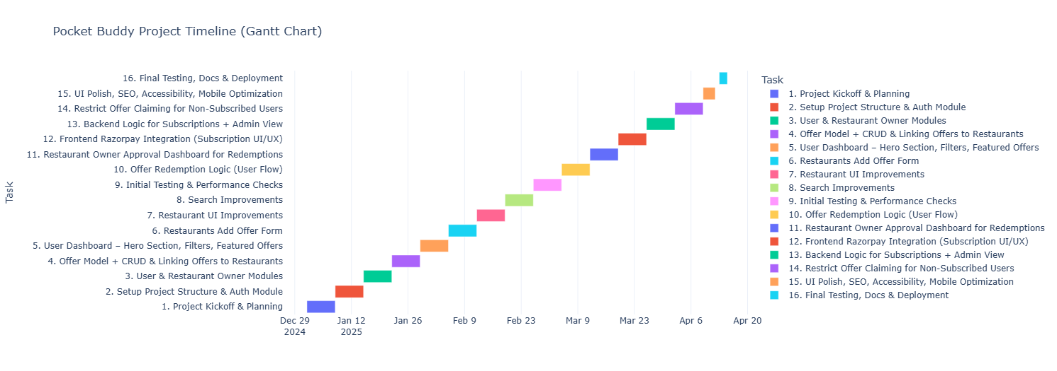

Requirement Determination & Analysis

Requirement Determination

The core requirements of the Pocket Buddy system include:
- User Authentication & Role Management:
Secure login system with roles like Admin, Restaurant Owner, and Customer.
- Offer Management:
Restaurants can create, update, and delete promotional offers.
- Search & Filter Features:
Users can easily discover offers using search and category filters.
- Offer Redemption System:
Users can request to redeem offers; restaurant owners can approve or decline.
- Subscription Handling:
Integration with payment gateway (Razorpay) for subscription plans.

Targeted Users

Pocket Buddy is designed to serve the following user groups:
- Restaurants, Cafes, and Hotels:
To promote and manage their offers.
- Regular Users (Customers):
To browse and redeem available offers.
- Admins:
To monitor the platform, manage users, and ensure content quality.

System Design

Use Case Diagram

The use case diagram illustrates the interactions between different user roles and the system. It defines how Admins, Restaurant Owners and Regular Users interact with Pocket Buddy.

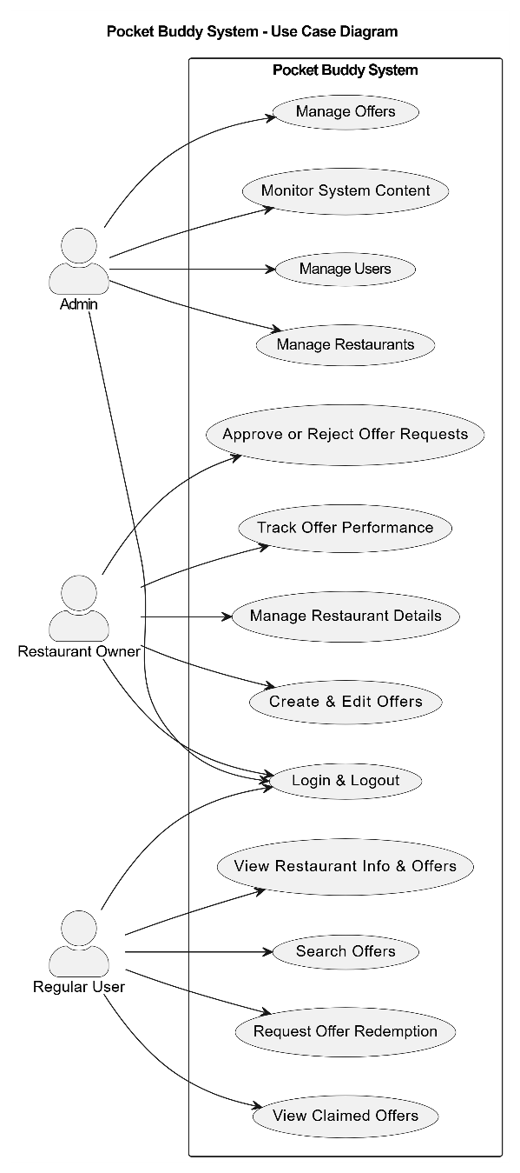

Class Diagram
The class diagram represents the data structure of the application, including key entities such as Users, Restaurants, Offers, Reviews, and Reports, along with their relationships.
- 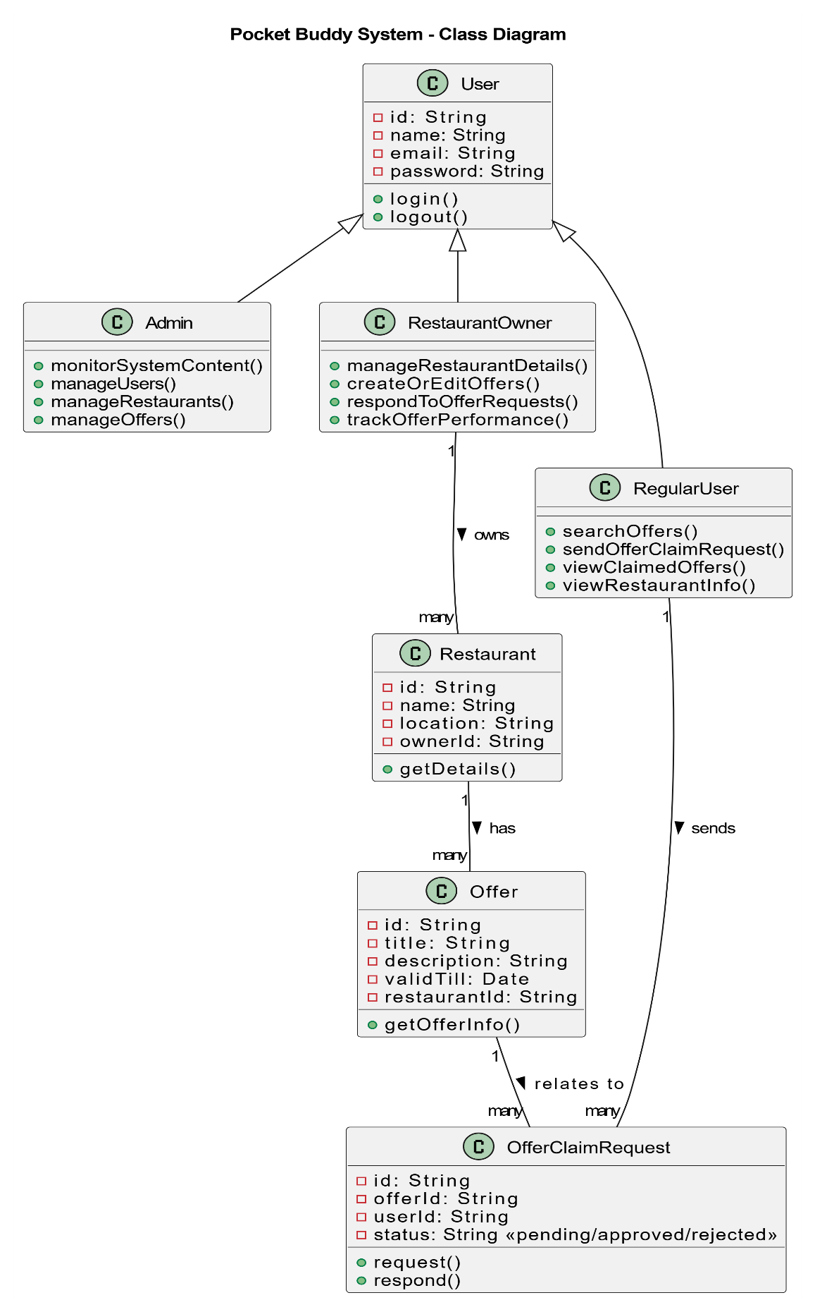

Interaction Diagram
The interaction diagram shows the sequence of actions between users and the system for key functionalities such as offer creation, login, searching.
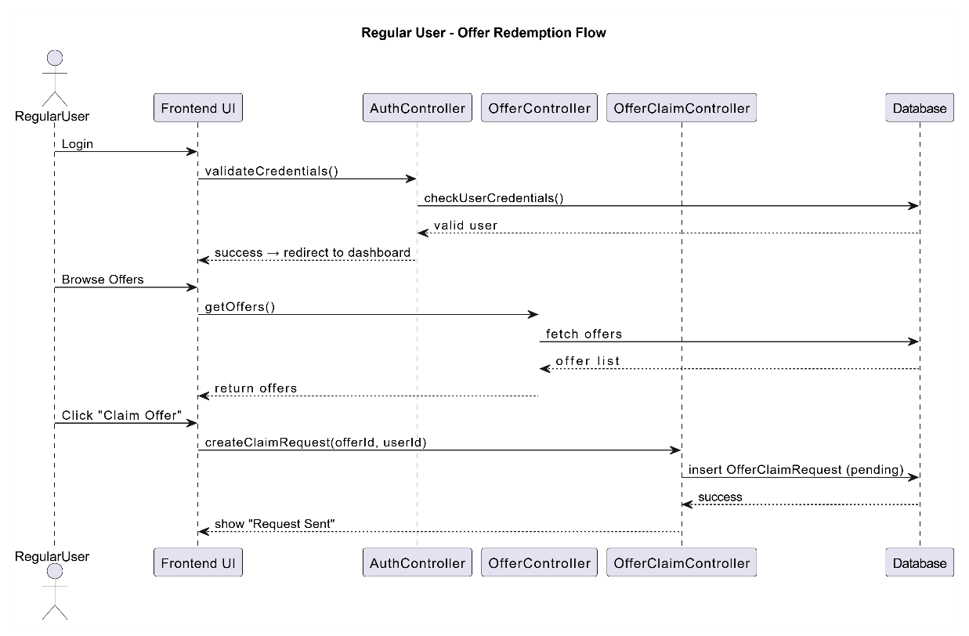
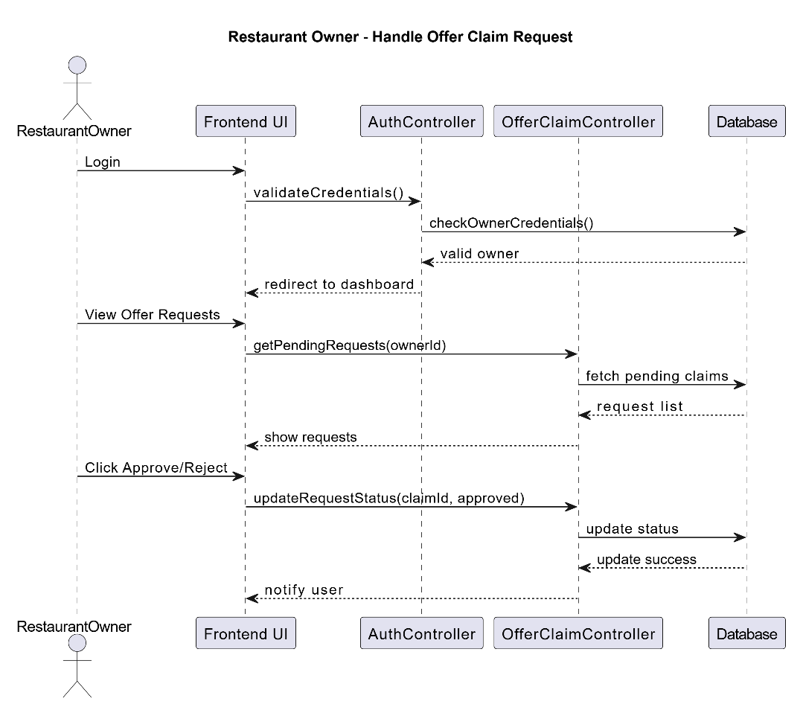
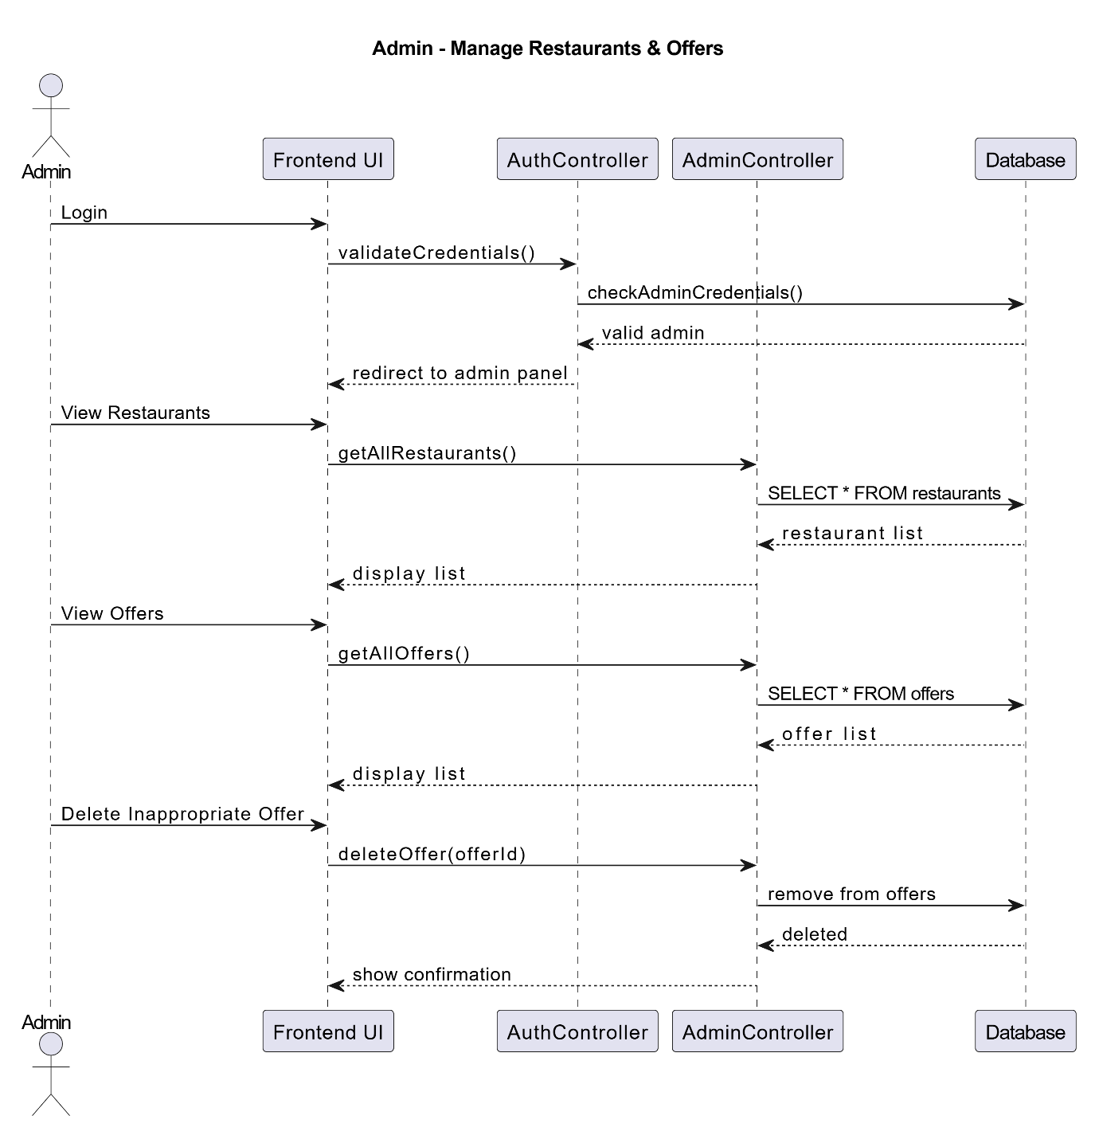
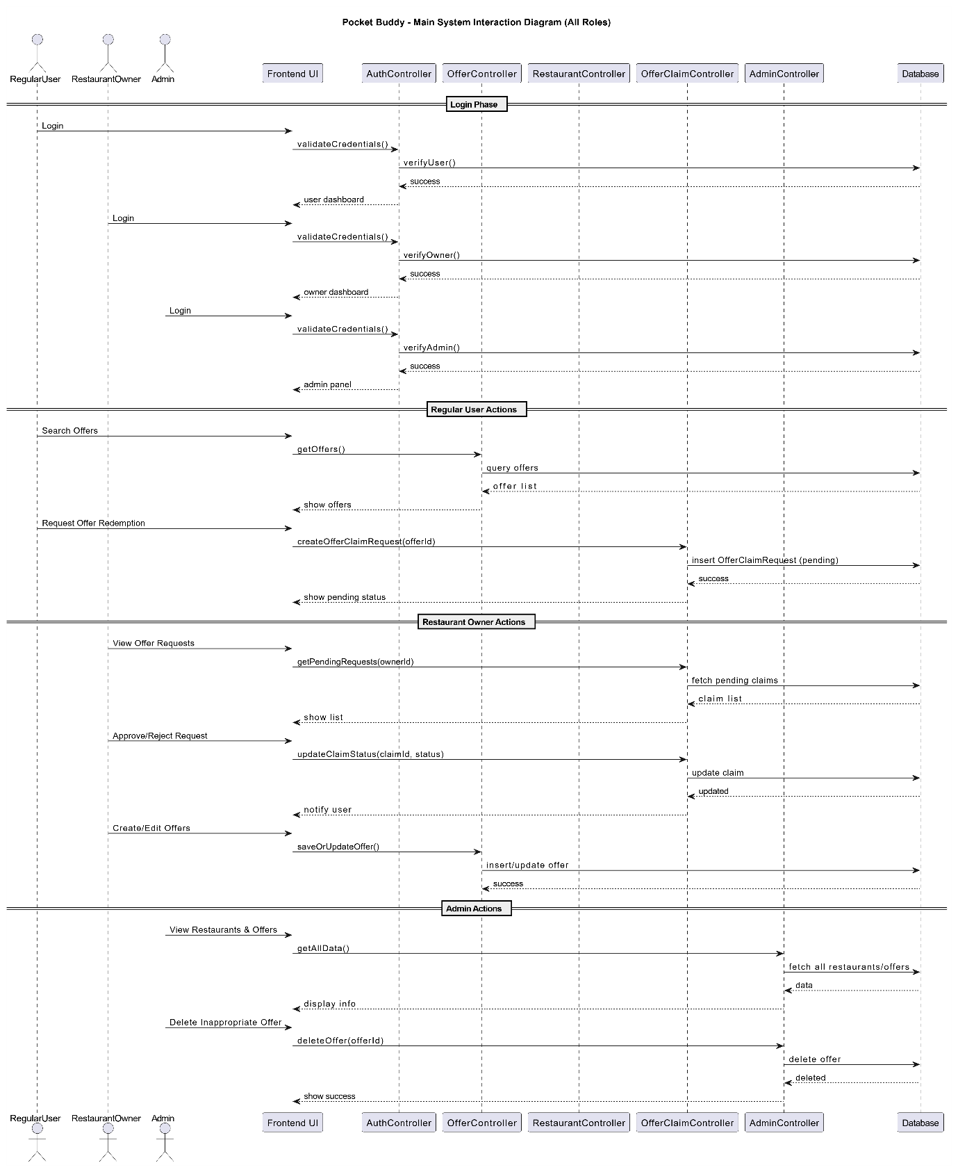

Activity Diagram
The activity diagram visualizes the workflow for major processes, including user registration, offer posting, review moderation, and admin actions.
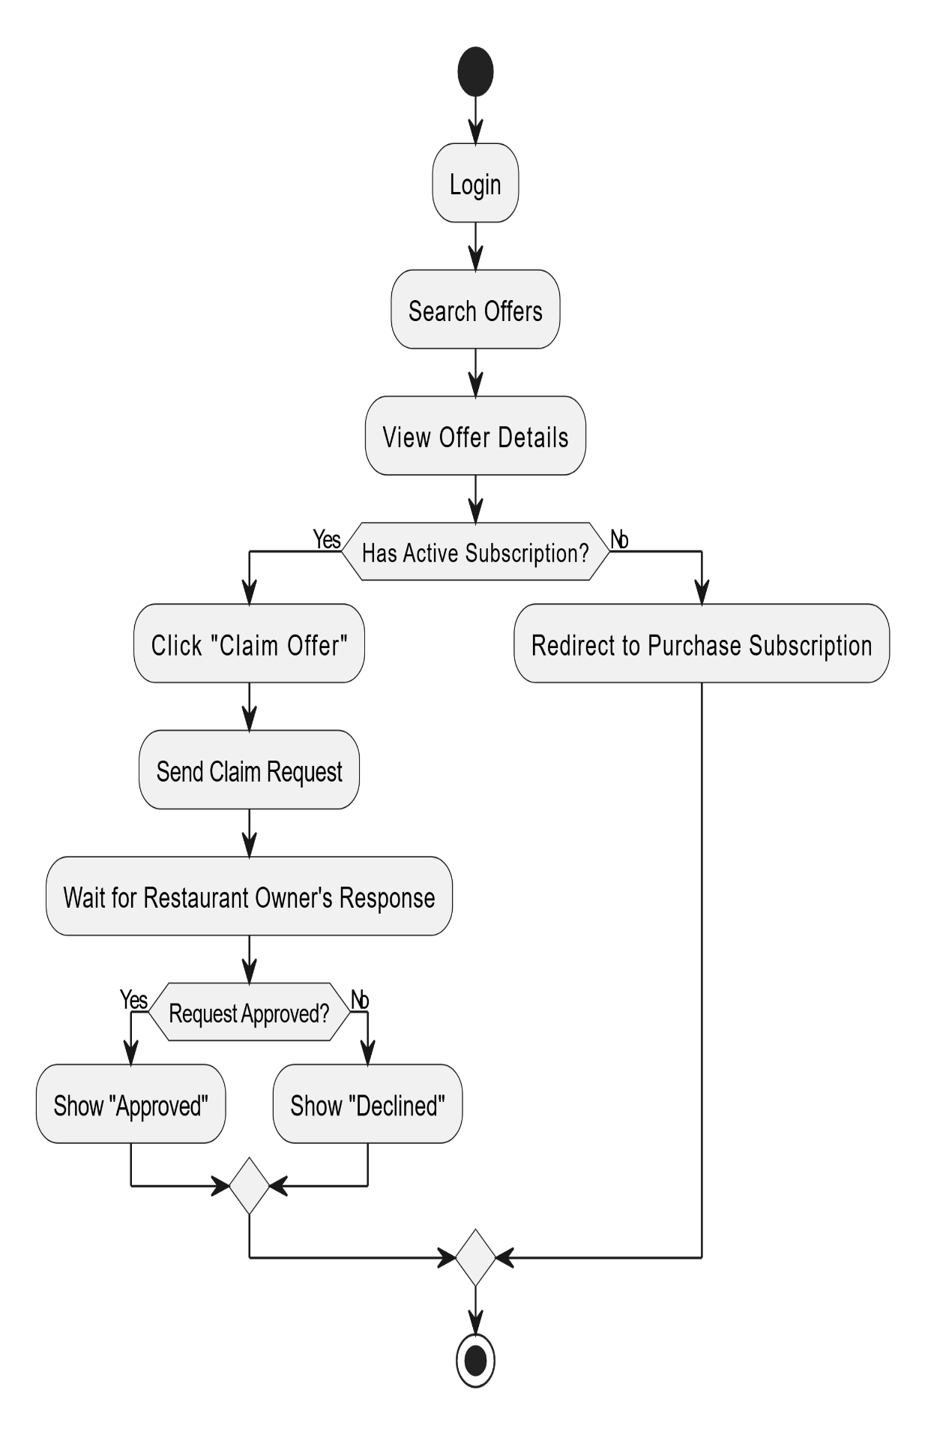

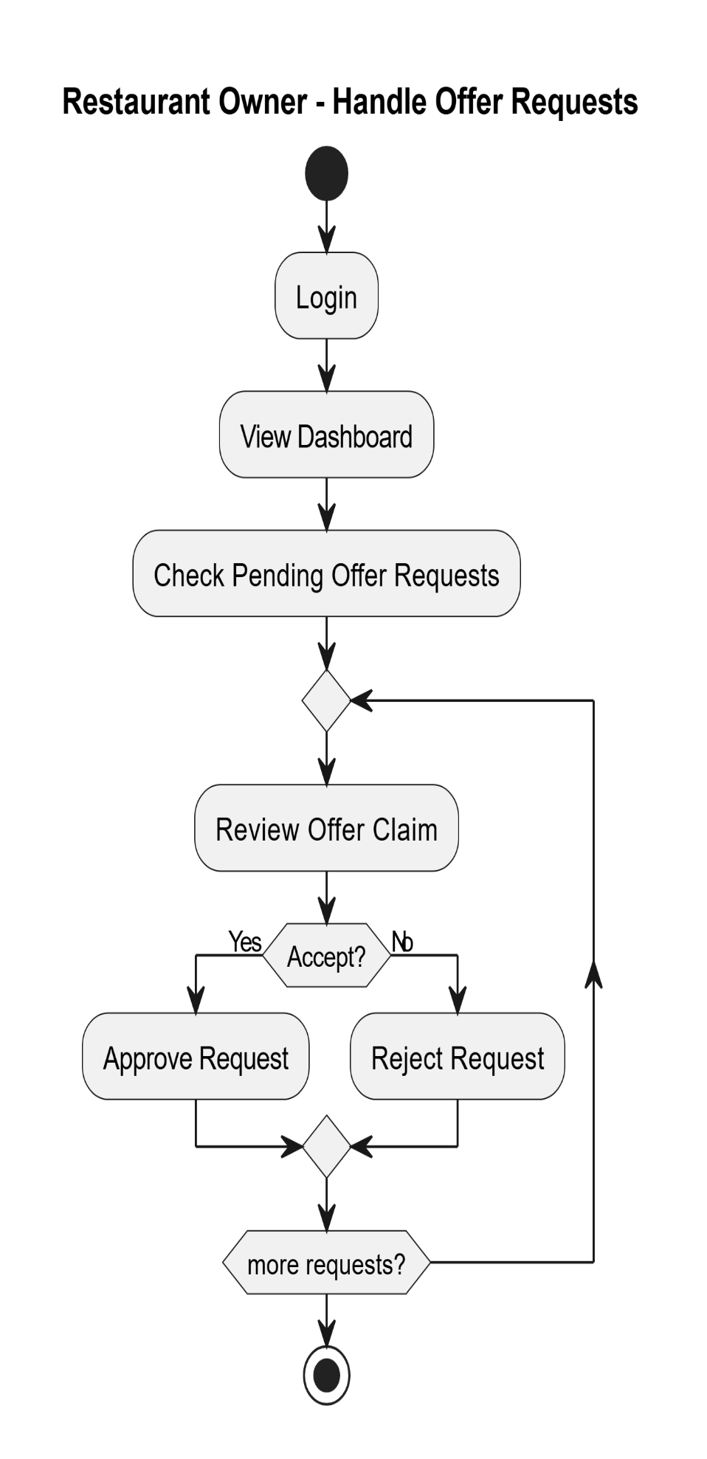

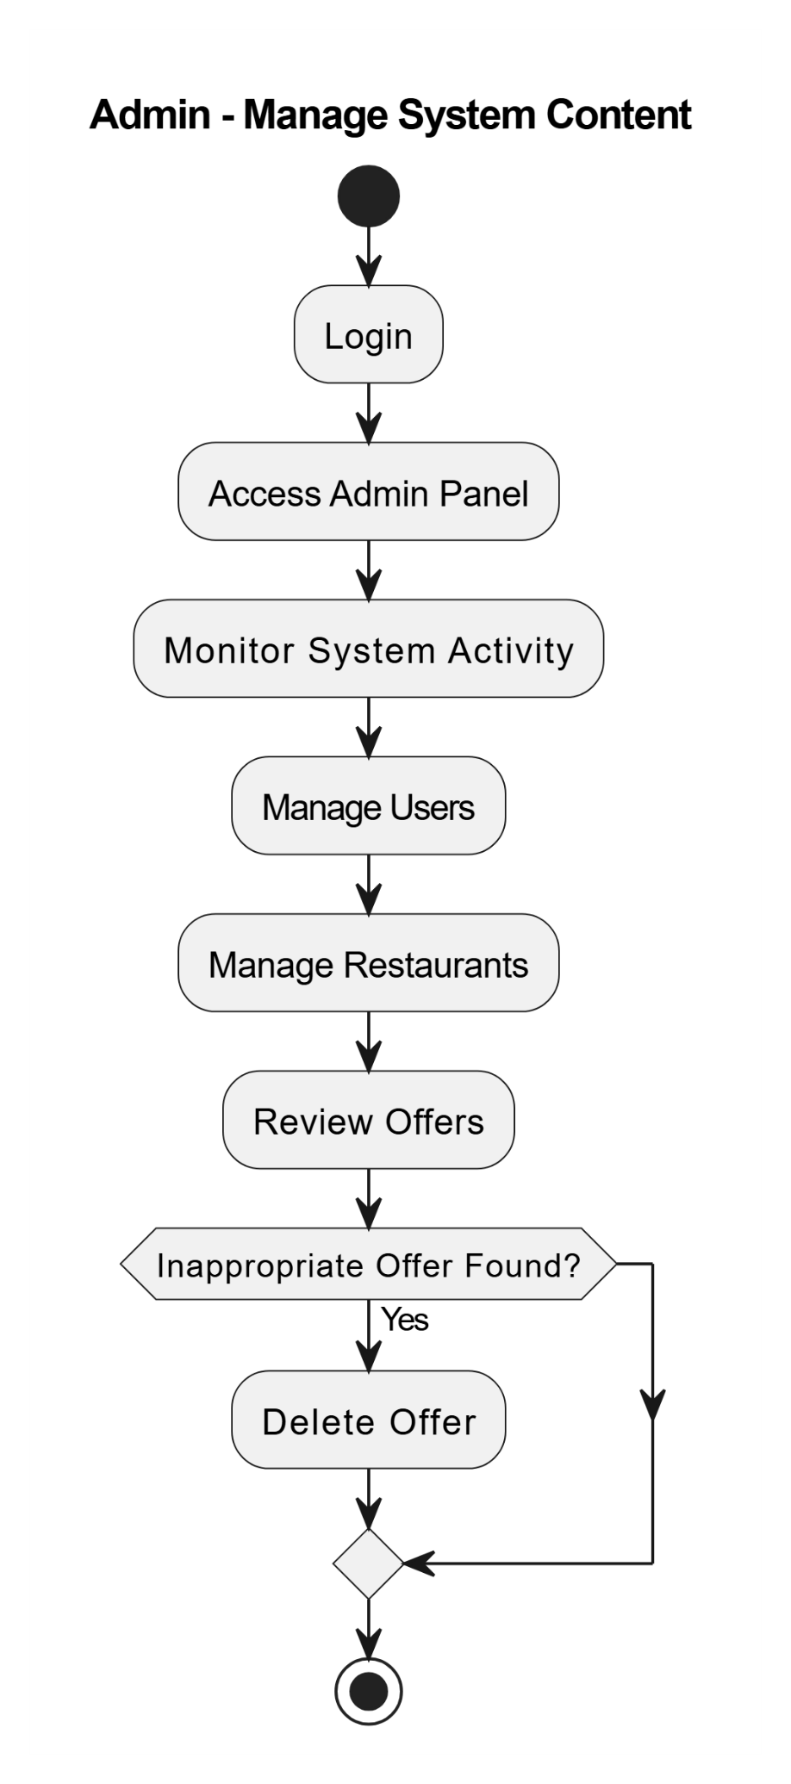
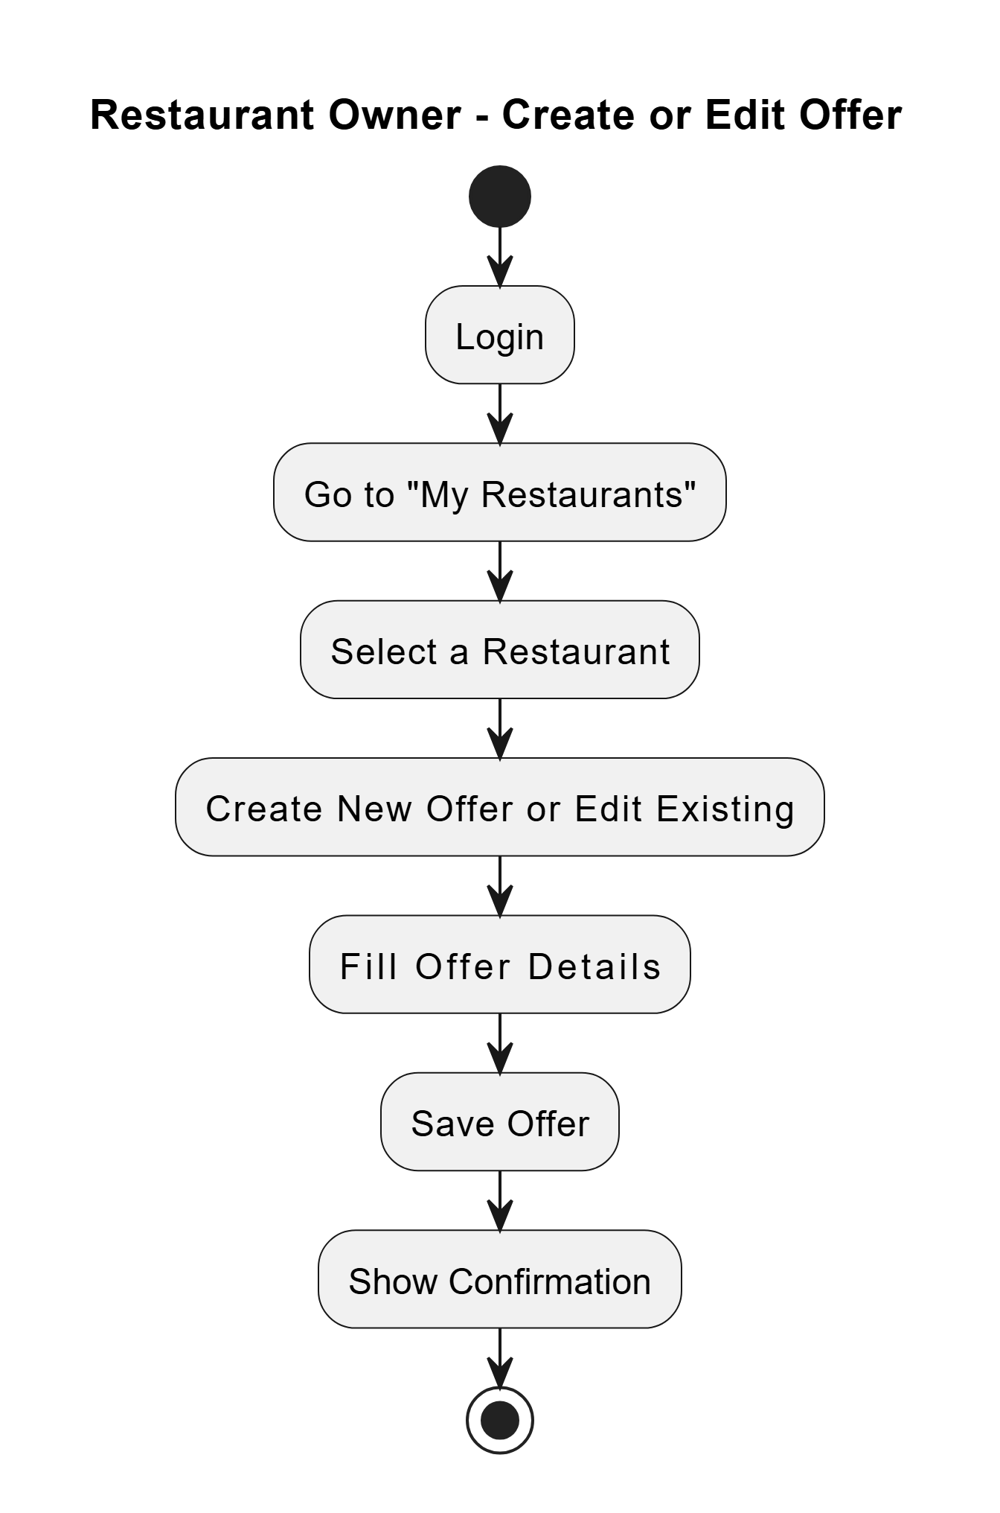

Data Dictionary

1. Table Name: Location
Table Description: Stores restaurant/location details including address, timings, and coordinates.

Table Name | Field Name | Data Type | Constraint | Description | Sample Data
Location | _id | ObjectID | Primary Key | Unique document ID | 507f1f77bcf86cd799439011
Location | title | String | Required | Name of the location | Café Delight
Location | category | String | Required | Category (e.g. Restaurant,café) | Restaurant
Location | description | String | Required | Detailed description | Cozy café with outdoor seating
Location | timings | String | Required | Operating hours | 9:00 AM - 10:00 PM
Location | active | Boolean | Default: true | Whether the location is active | TRUE
Location | contactNumber | String | Required | Contact number | 1234567890
Location | address | String | Required | Physical address | 123 Main St
Location | stateId | ObjectID | Foreign Key (State) | Reference to State | 507f1f77bcf86cd799439012
Location | cityId | ObjectID | Required | Foreign Key (City) | 507f1f77bcf86cd799439013
Location | areaId | ObjectID | Required | Foreign Key (Area) | 507f1f77bcf86cd799439014
Location | foodTypeId | ObjectID | Required | Foreign Key (FoodType) | 507f1f77bcf86cd799439015
Location | latitude | Number | Required | Geographic latitude | 40.7128
Location | longitude | Number | Required | Geographic longitude | -74.006
Location | imageURL | String | Required | URL of location image | https://example.com/image.jpg
Location | userId | ObjectID | Foreign Key (users) | User who added the location | 507f1f77bcf86cd799439016

2. Table Name: Offer
Table Description: Stores promotional offers for restaurants.
Table Name | Field Name | Data Type | Constraint | Description | Sample Data
Offer | _id | ObjectID | Primary Key | Unique offer ID | 507f1f77bcf86cd799439021
Offer | title | String |  | Offer title | Summer Discount
Offer | description | String |  | Offer details | 20% off on all items
Offer | offer_type | String |  | Type of offer (e.g. Discount, Combo) | Discount
Offer | discount_value | Number |  | Discount percentage/amount | 20
Offer | restaurant_ids | Array[ObjectID] | Foreign Key (Location) | Applicable restaurants | [507f1f77bcf86cd799439011]
Offer | valid_from | Date |  | Offer start date | 01-07-2023
Offer | valid_to | Date |  | Offer end date | 31-07-2023
Offer | requires_approval | Boolean |  | Needs admin approval | FALSE
Offer | min_order_value | Number |  | Minimum order to redeem | 100
Offer | max_redemptions | Number |  | Max times offer can be used | 50
Offer | imageURL | String | Required | Offer image URL | https://example.com/offer.jpg
Offer | status | String | Enum: Active/Inactive | Current status | Active
Offer | payment_required | Boolean | Default: false | Whether payment is needed | FALSE

3. Table: RedeemOffer
Description: Tracks user redemptions of offers.
Table Name | Field Name | Data Type | Constraint | Description | Sample Data
RedeemOffer | _id | ObjectID | Primary Key | Unique redemption ID | 507f1f77bcf86cd799439031
RedeemOffer | user_id | ObjectID | Required | Foreign Key (User) | User who redeemed
RedeemOffer | offer_id | ObjectID | Required | Foreign Key (Offer) | Redeemed offer ID
RedeemOffer | restaurant_id | ObjectID | Required | Foreign Key (Location) | Restaurant where redeemed
RedeemOffer | owner_id | ObjectID | Required | Foreign Key (User) | Restaurant owner
RedeemOffer | status | String | Enum: Pending/Approved/Rejected | Redemption status | Pending
RedeemOffer | redeemTime | Date |  | Time of redemption | 2023-07-15T14:30:00Z

4. Table: users
Description: Stores user account details.

Table Name | Field Name | Data Type | Constraint | Description | Sample Data
users | _id | ObjectID | Primary Key | Unique user ID | 507f1f77bcf86cd799439016
users | firstName | String | Required | User's first name | John
users | lastName | String | Required | User's last name | Doe
users | name | String |  | Auto-generated full name | John Doe
users | age | Number |  | User's age | 30
users | status | Boolean | Default: true | Account status | TRUE
users | roleId | ObjectID | Foreign Key (roles) | User's role | 507f1f77bcf86cd799439041
users | email | String | Unique + Required | User email | john@example.com
users | password | String | Required | Encrypted password | hashed_123

Development

The development of Pocket Buddy followed the MVC architecture to separate concerns and improve maintainability. Frontend (React Native) and backend (Node.js, Express, MongoDB) tasks were divided among team members based on expertise. React Native components and user flows were built independently from the API and database layer. Git was used for version control, with regular code reviews and sync meetings to ensure collaboration and smooth module integration. Each feature was tested individually before merging into the full system.

Coding Standards

✅ Naming Conventions
- Components & Models: PascalCase (e.g., UserCard.jsx, OfferModel.js)
- Variables & Functions: camelCase (e.g., handleClick, userData)
- Constants: SCREAMING_SNAKE_CASE (e.g., MAX_REDEEM_LIMIT)
- Database: camelCase (e.g., offerDetails, userSubscriptions)
✅ Code Structure
- 4-space indentation
- Braces on the same line
- One blank line between functions
✅ Comments
- Single-line comments for clarity
- Multi-line comments for complex logic
- Functions and components include brief documentation
✅ Tools
- Prettier and linting tools were used for consistent formatting.

4.2 SCREENSHOTS

User Home page
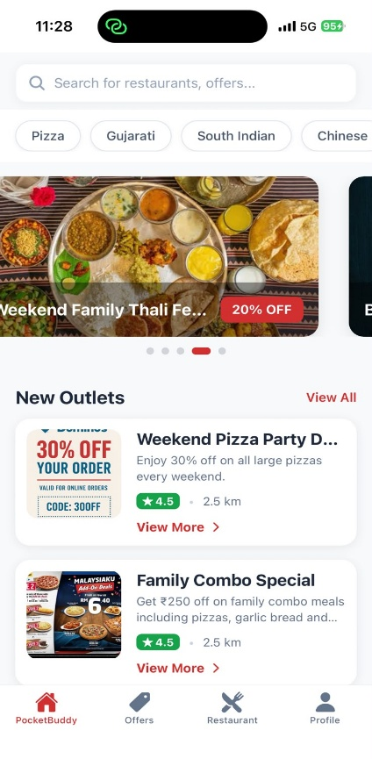
User Signup
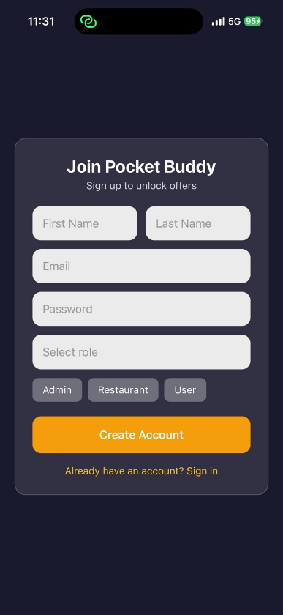
User Login
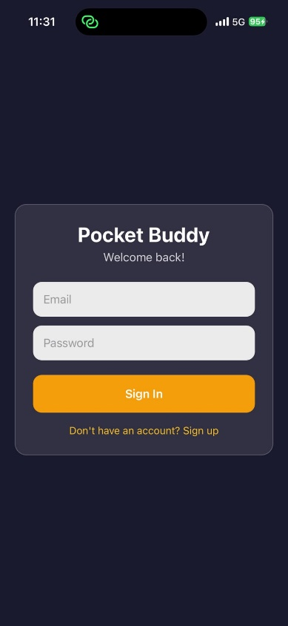

User Offers
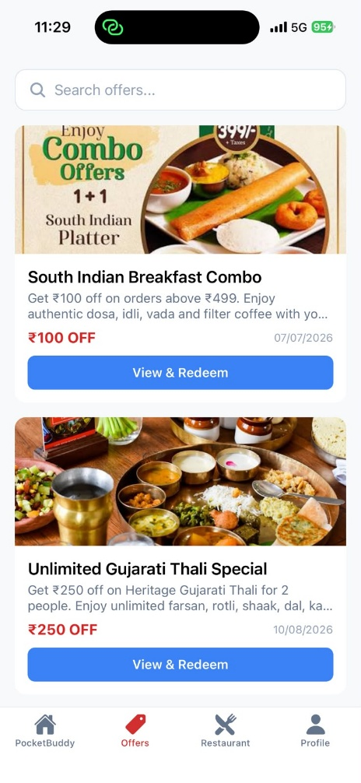
User Request
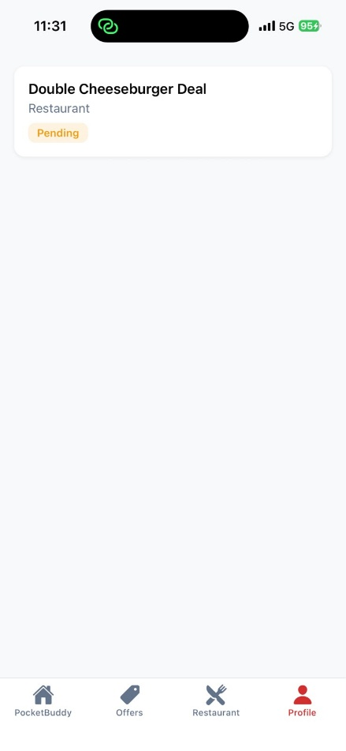
User Profile
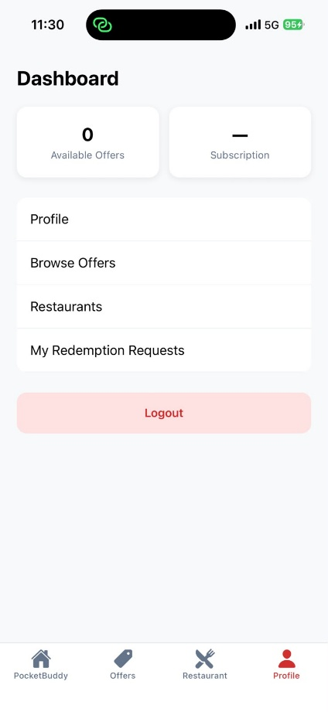
Restaurants Dashboard
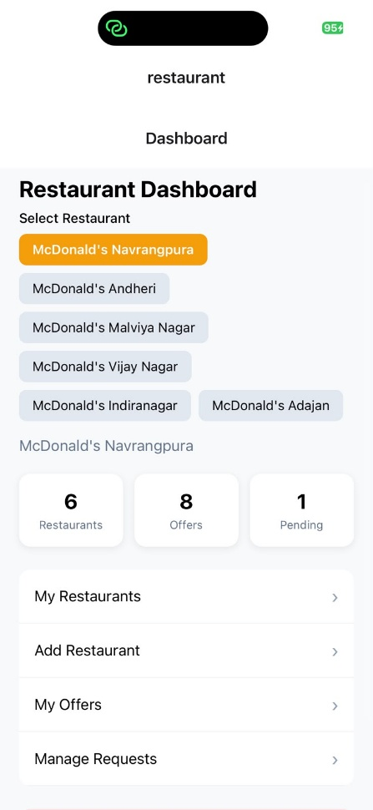

Restaurants Manage Offer Requests
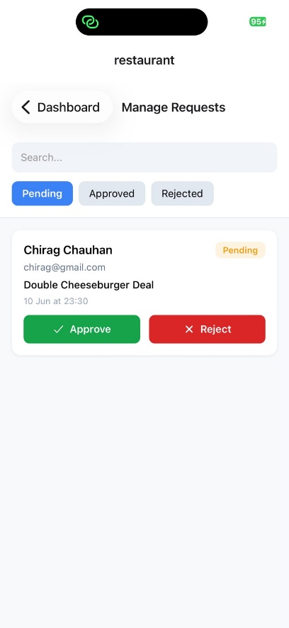
Add Restaurants
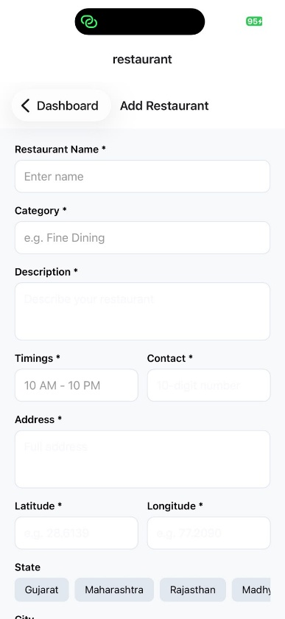
Restaurant My Restaurant
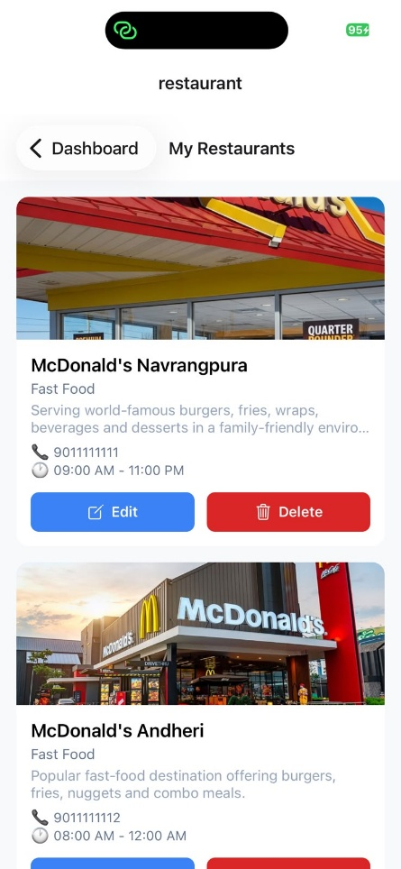
Restaurant My Offers
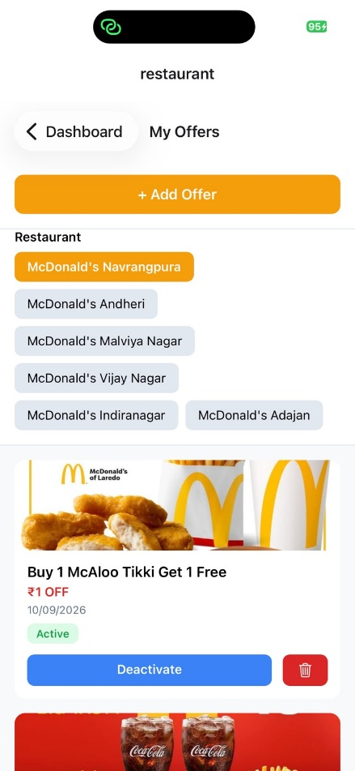
Restaurant Add Offer
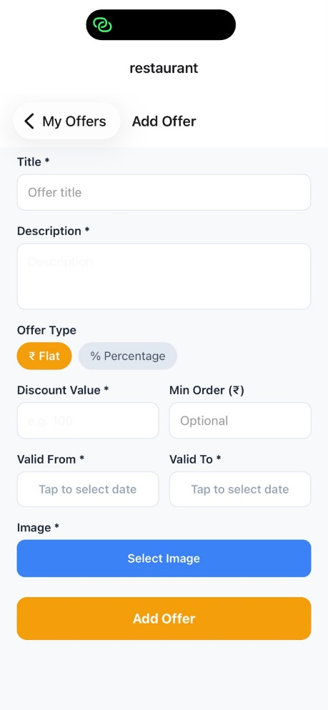
Admin Dashboard
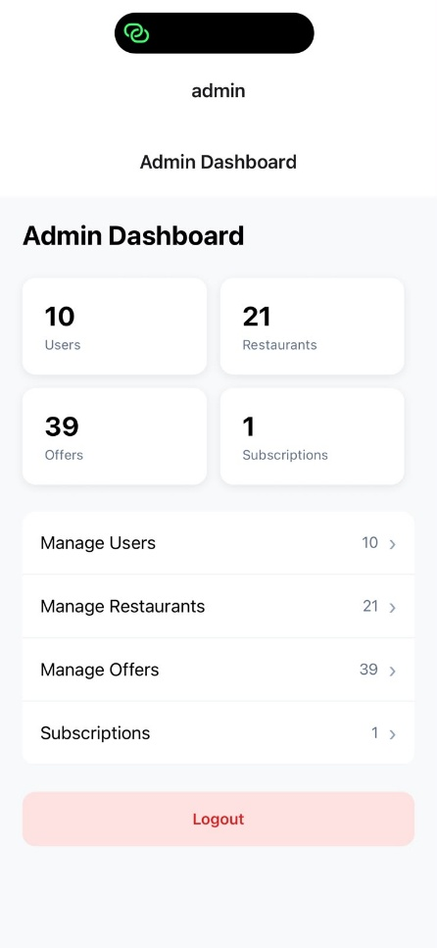
Admin Users
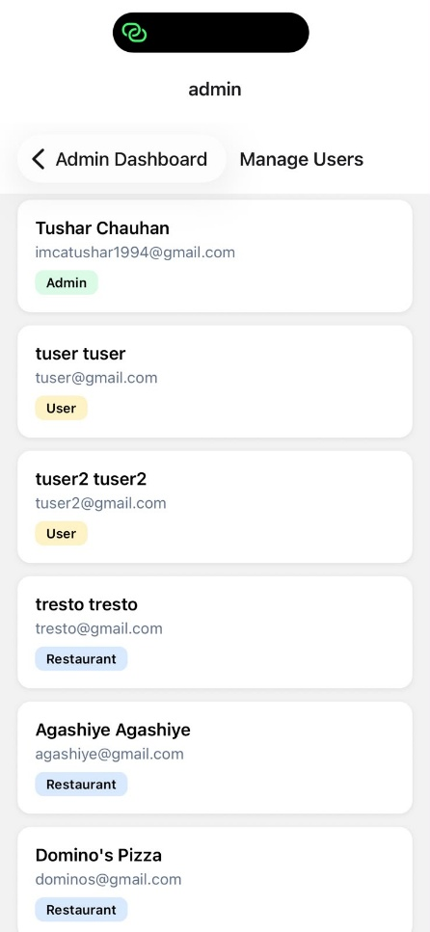
Admin Manage Restaurants
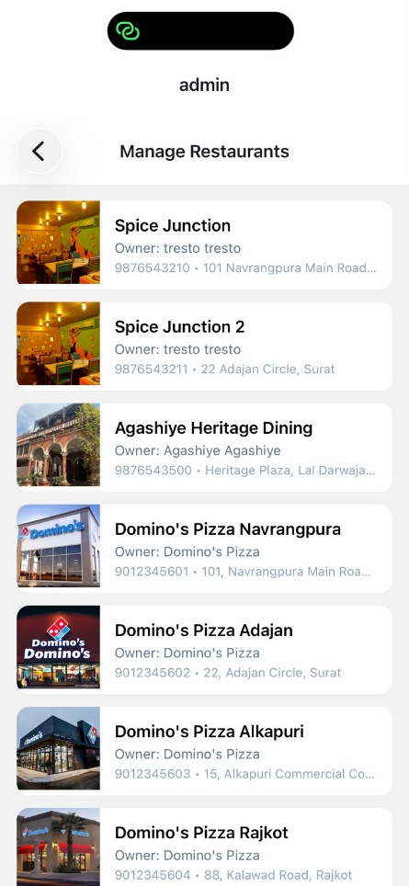
Admin Manage Offers
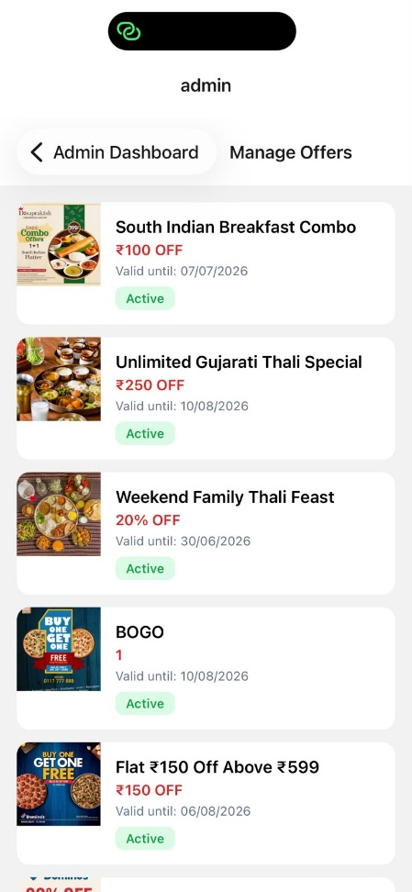
Admin Subscription Plan(Future enhancement)
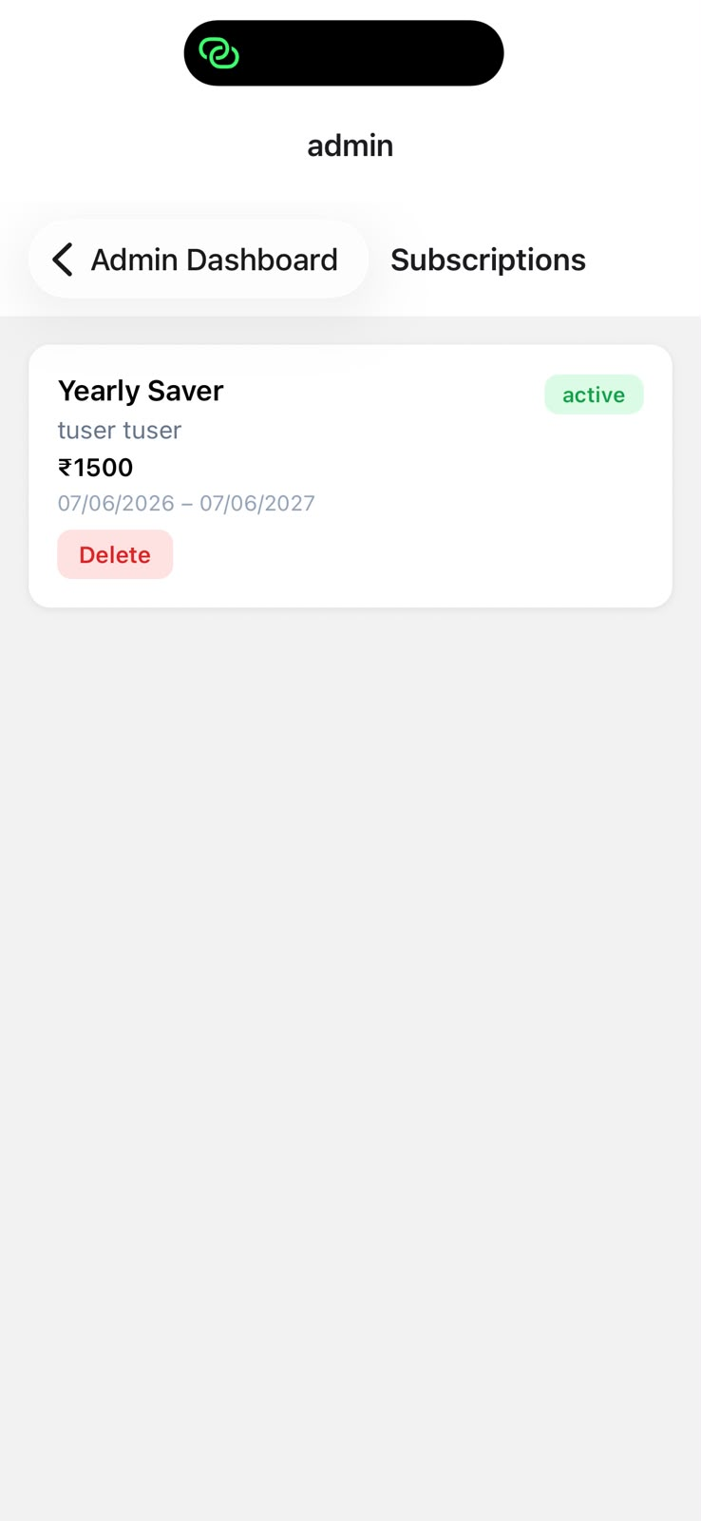

Agile Documentation

Agile Project Charter

General Project Information
Project Name | Pocket Buddy
Project Champion | Tushar Chauhan  Bhoomi Chavada
Project Sponsor | Tushar Chauhan  Bhoomi Chavada
Project Manager | Anurag Jobanputra
Stakeholders | Tushar Chauhan  Bhoomi Chavada
Expected Start Date | March 1, 2026
Expected Completion Date | April 5, 2026
Project Details
Mission | We continuously innovate to be the best offers and deals platform for our users, making dining out and saving money easier and more rewarding.
Vision | Pocket Buddy aims to revolutionize the way users access restaurant deals by creating an online platform that connects customers with restaurant owners. It functions like a digital marketplace, simplifying the way users discover and redeem food-related offers. Just like e-commerce made shopping easier, Pocket Buddy makes access to local and international dining offers more seamless and personalized.
Scope | The admin has full control over platform management, including handling user accounts, restaurant owners, and analyzing user behavior. Based on user activity and preferences, admins and restaurant owners can offer personalized discounts and services. The system is designed to be scalable, allowing future expansion into different types of offers and possibly partnering with platforms like Zomato, Swiggy, or new learning or subscription-based platforms. Pocket Buddy also provides restaurant owners a trusted platform to promote their business digitally.

Agile Road Map
Agile Roadmap – Pocket Buddy Project (March–Apr 2026)
The Pocket Buddy project follows an agile roadmap structured into five major sprints from March 2026 April 2026. Each sprint focuses on building key components of the platform in a phased and iterative manner:
- Sprint 1: Foundation & Authentication (March 1, 2026 – March 7, 2026)
  - Set up the project structure and development environment.
  - Implemented user authentication, authorization, and basic roles.
- Sprint 2: Core Models & User Modules (March 8, 2026 – March 14, 2026)
  - Developed essential MongoDB models and Express-based backend routes.
  - Built foundational user-related modules and logic.
- Sprint 3: Frontend UI (March 15, 2026 – March 20, 2026)
  - Created core frontend components using React Native.
  - Integrated backend APIs with dynamic user interfaces.
- Sprint 4: Redemption Flow & QA (March 21, 2026 – March 28, 2026)
  - Designed and implemented the offer redemption request and approval system.
  - Conducted thorough testing and bug fixing for major flows.
- Sprint 5: Subscriptions & Final Polish (March 29, 2026 – April 5, 2026)
  - Integrated subscription-based access with Razorpay for payments.
  - Finalized features, improved UI/UX, and completed project polish
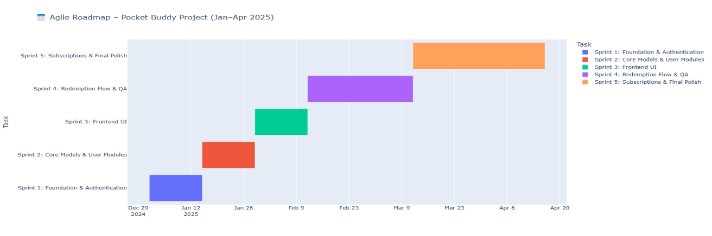

Agile Project Plan
Sprint | Task Name | Duration | Start | Finish | Status
Sprint#1 : Foundation Setup | Sprint Planning | 2d | 01-03-2026 | 02-03-2026 | Completed
Sprint#1 : Foundation Setup | Project Boilerplate Setup | 3d | 03-03-2026 | 05-03-2026 | Completed
Sprint#1 : Foundation Setup | Authentication System | 4d | 06-03-2026 | 09-03-2026 | Completed
Sprint#1 : Foundation Setup | Role-based Access Control | 2d | 10-03-2026 | 11-03-2026 | Completed
Sprint#2 : Core Modules | User & Restaurant Modules (CRUD) | 5d | 12-03-2026 | 16-03-2026 | Completed
Sprint#2 : Core Modules | Offer Model CRUD | 5d | 17-03-2026 | 21-03-2026 | Completed
Sprint#2 : Core Modules | Link Offers to Restaurants | 3d | 22-03-2026 | 24-03-2026 | Completed
Sprint#3 : UI & Dashboard | User Dashboard | 5d | 25-03-2026 | 29-03-2026 | Completed
Sprint#3 : UI & Dashboard | Offer Form for Restaurants | 3d | 30-01-2026 | 01-04-2026 | Completed
Sprint#3 : UI & Dashboard | Restaurant Dashboard UI Enhancements | 5d | 02-04-2026 | 04-04-2026 | Completed
Sprint#4 : Search & Redemption | Enhance Filters/Search | 5d | 05-04-2026 | 08-04-2026 | Completed
Sprint#4 : Search & Redemption | QA & Performance Testing | 5d | 09-04-2026 | 13-04-2026 | Completed
Sprint#4 : Search & Redemption | Offer Redemption Flow | 7d | 14-04-2026 | 16-04-2026 | Completed
Sprint#4 : Search & Redemption | Redemption Approval Dashboard | 7d | 17-04-2026 | 19-04-2026 | Completed
Sprint#5 : Subscription & Final Touches | Razorpay Integration | 5d | 20-04-2026 | 23-04-2026 | Completed
Sprint#5 : Subscription & Final Touches | Subscription Backend Logic | 1d | 24-04-2026 | 25-04-2026 | Completed
Sprint#5 : Subscription & Final Touches | Restrict Non-Subscribers | 2d | 26-04-2026 | 28-04-2026 | Completed
Sprint#5 : Subscription & Final Touches | Final UI/UX Polish & SEO | 1d | 29-04-2026 | 30-04-2026 | Completed
Sprint#5 : Subscription & Final Touches | Testing, Docs & Deployment | 1d | 30-04-2026 | 01-05-2026 | Completed

Agile User Story
User Story ID | As a (type of user) | I want to (perform some task) | So that I can (achieve some goal)
1 | Admin | Manage Login Module | Ensure that only validated users can access the platform
2 | Admin | Manage Users and Restaurant Owners | Monitor and control platform access
3 | Admin | View and Manage Subscriptions | Track who has active plans and manage billing status
4 | Restaurant Owner | Manage Offers (Insert, Update, Delete, View) | Control and update promotions for their restaurants
5 | Restaurant Owner | View and Approve/Decline Redemption Requests | Control how and when offers are redeemed
6 | Restaurant Owner | Track Offer Redemptions and Customer Interactions | Understand offer performance and improve engagement
7 | Customer | View and Filter Restaurant Offers | Easily find the best deals nearby
8 | Customer | Redeem Offers with Restaurant Approval | Ensure fair use and transparency of the offers
9 | Customer | Subscribe to a Plan and Unlock Premium Offers | Gain access to exclusive deals and benefits

Agile Release Plan
Task Name | Duration | Start | Finish | Status | Release Date
Sprint#2:Login (Admin) | 6d | 01-03-2026 | 01-03-2026 | Complete | 03-03-2026
UI Designing | 1d | 15-01-2026 | 03-03-2026 | Complete | 05-03-2026
Email and Password verification | 2d | 16-01-2026 | 06-03-2026 | Complete | 08-03-2026
View Credit Card Details | 1d | 18-01-2026 | 09-03-2026 | Complete | 13-03-2026
View Bank Details | 1d | 19-01-2026 | 14-03-2026 | Complete | 19-03-2026
View Account Holder Details | 1d | 20-01-2026 | 20-03-2026 | Complete | 24-03-2026

Agile Sprint Backlog
Task Name | Story | Sprint Ready | Priority | Status | Story Point
Sprint#1: Project Setup & Authentication | Yes | Yes | High | Completed | 10
- UI Designing (Login & Role UI) | Yes | Yes | High | Completed | 5
- Setup Project Structure (Frontend + Backend) | Yes | Yes | High | Completed | 5
- Implement Auth (JWT, Roles) | Yes | Yes | High | Completed | 8
Sprint#2: Core Modules & Offers | Yes | Yes | High | Completed | 10
- User & Restaurant Owner Module | Yes | Yes | High | Completed | 6
- Offer Model + CRUD | Yes | Yes | High | Completed | 6
- Link Offers to Restaurant | Yes | Yes | Medium | Completed | 4
Sprint#3: UI Improvements & Add Offer Form | Yes | Yes | High | Completed | 8
- User Dashboard UI (Hero, Filters) | Yes | Yes | Medium | Completed | 5
- Restaurant Add Offer Form | Yes | Yes | High | Completed | 5
- Restaurant UI Enhancement | Yes | Yes | Medium | Completed | 4
Sprint#4: Search, Redemption & QA | Yes | Yes | High | Completed | 10
- Search Filter Improvements | Yes | Yes | Medium | Completed | 4
- Redemption Flow (User Side) | Yes | Yes | High | Completed | 6
- Redemption Approval by Owner | Yes | Yes | High | Completed | 5
- Initial Testing & Debugging | Yes | Yes | Medium | Completed | 3
Sprint#5: Subscription, Polish & Deployment | Yes | Yes | High | Completed | 10
- Razorpay Integration (Frontend) | Yes | Yes | High | Completed | 4
- Backend Subscription + Admin View | Yes | Yes | High | Completed | 5
- Restrict Offer Claims | Yes | Yes | Medium | Completed | 3
- Final UI Polish + SEO | Yes | Yes | Medium | Completed | 3
- Final Testing, Docs, Deployment | Yes | Yes | High | Completed | 3

Agile Test Plan

Project Name: Pocket Buddy
Technology Stack: MERN (MongoDB, Express.js, React Native, Node.js)
Testing Device: HP Intel Core i3 (7th Gen) / Modern Browsers (Chrome, Firefox)
Test Case 1: User Authentication
Module: Login & Role Management
Priority: High
Tested By: Tushar Chauhan
Test Step | Action | Expected Result | Actual Result | Pass/Fail
1. Click "Login" as Admin | Enter valid admin credentials | Redirect to admin dashboard | Redirected to admin dashboard | ✅ Pass
2. Enter wrong password | Submit form | Show error: "Invalid credentials" | Error message displayed correctly | ✅ Pass
3. Login with empty email field | Leave email blank | Show error: "Email required" | Error message: "Email required" shown | ✅ Pass
4. Login as unregistered user | Use fake credentials | Show error: "User not found" | Error message: "User not found" displayed | ✅ Pass

Test Case 2: Offer Creation & Management
Module: Restaurant Owner Dashboard
Priority: High
Tested By: Tushar Chauhan & Bhoomi Chavada
Test Step | Action | Expected Result | Actual Result | Pass/Fail
1. Add new offer (valid data) | Fill all required fields | Offer appears in "Active Offers" | Offer successfully added and listed | ✅ Pass
2. Add offer with missing title | Leave title blank | Show error: "Title required" | Error message displayed correctly | ✅ Pass
3. Edit offer discount value | Update discount to 20% | Changes reflect in database | Discount updated and reflected in UI | ✅ Pass
4. Delete expired offer | Click "Delete" on expired offer | Offer removed from list | Offer deleted and no longer visible | ✅ Pass

Test Case 3: Offer Redemption Flow
Module: User Dashboard
Priority: Medium
Tested By: Tushar Chauhan, Bhoomi Chavada

Test Step | Action | Expected Result | Actual Result | Pass/Fail
1. User views redeemable offers | Open "Available Offers" tab | List loads without errors | Offers loaded successfully | ✅ Pass
2. Attempt redemption (no sub) | Click "Redeem" button | Show prompt: "Subscribe first" | Subscription prompt displayed | ✅ Pass
3. Subscribed user redeems offer | Complete redemption steps | Status changes to "Pending" | Offer marked as pending | ✅ Pass
4. Owner rejects redemption | Click "Reject" in dashboard | User notified of rejection | User received rejection notification | ✅ Pass

Proposed Enhancements

While the current system covers core features like offer management, user authentication, restaurant dashboards, and subscription payments, future enhancements can improve user experience, scalability, and system intelligence. Proposed improvements include:

- AI-Powered Personalized Recommendations
Implement machine learning algorithms to analyze user preferences and behavior to show the most relevant offers and restaurants.
- Subscription Analytics for Admins
Include dashboards for admins to analyze trends in subscriptions, user engagement, and revenue.
- In-app Notifications and Alerts
Notify users about new offers, expiring deals, and subscription reminders via real-time notifications.
- Multi-language Support
Add support for regional languages to increase accessibility and reach a broader user base.
- Advanced Search and Filter Options
Improve search by allowing users to filter based on offer type, cuisine, rating, distance, and more.
- Offer Sharing and Referral System
Allow users to share offers with friends and earn rewards, boosting engagement and organic growth.
- QR Code-Based Redemption
Integrate QR codes for faster in-store offer redemptions, reducing manual validation steps for restaurant staff.

Conclusion
The Pocket Buddy application provides a modern, scalable, and user-friendly platform for managing and accessing restaurant offers. By bridging the gap between customers and restaurants through an intuitive interface and robust backend system, it enhances promotional strategies for businesses and delivers value to users. The inclusion of subscription-based access adds monetization potential and prioritizes loyal users. Continuous improvement through Agile methodology ensures adaptability to user needs and technological growth.
The system successfully meets the current requirements while being extendable for future enhancements and integrations, ensuring long-term viability and user satisfaction.

Bibliography
- MongoDB Documentation – https://www.mongodb.com/docs
- Express.js Guide – https://expressjs.com
- React Native Documentation – https://reactnative.dev/
- Razorpay Integration Docs – https://razorpay.com/docs
- Sommerville, Ian. Software Engineering, 10th Edition – Pearson
- IEEE Std 830-1998 – IEEE Recommended Practice for Software Requirements Specifications
- OpenAI GPT-4 Assistance for Planning and Content Structuring
- UI/UX References – Dribbble, Figma Community Templates

