L.J. SCHOOL OF COMPUTER APPLICATION



Pocket-Buddy

Developed By:

Tushar Chauhan

22004501210011

Bhoomi Chavada

22004501210012

L.J. SCHOOL OF COMPUTER APPLICATIONS

LJ Campus, LJ University Road, Off S.G. Road, Ahmedabad-382210



CERTIFICATE

Enrolment No: 22004501210011
This is to certify that Mr. Tushar Chauhan of Integrated Master of Computer Applications Semester 8 has satisfactorily completed his project titled Pocket-Buddy under the supervision of Prof. Anurag Jobanputra

Internal Guide Name Head of Department

Prof. Parth Joshi Dr.Monica Gahalawat
Signature
Date of Submission:
Director
Prof. Alok Manke

L.J. SCHOOL OF COMPUTER APPLICATIONS
L.J. SCHOOL OF COMPUTER APPLICATIONS

LJ Campus, LJ University Road, Off S.G. Road, Ahmedabad-382210



CERTIFICATE

Enrolment No: 22004501210012
This is to certify that Ms. Bhoomi Chavada of Integrated Master of Computer Applications Semester 6 has satisfactorily completed his project titled Pocket-Buddy under the supervision of Prof. Anurag Jobanputra

Internal Guide Name Head of Department

Prof. Parth Joshi Dr. Monica Gahalawat
Signature
Date of Submission:
Director
Prof. Alok Manke

L.J. SCHOOL OF COMPUTER APPLICATIONS
1. Introduction 3
1.1. Existing System 3
1.2. Need for the New System 3
1.3. Objective of the New System 3
1.4. Problem Definition 3
1.5. Core Components 3
1.6. Project Profile 3
1.7. Assumptions and Constraints 4
1.8. Advantages and Limitations of the Proposed System 4
2. Requirement Determination & Analysis 6
2.1. Requirement Determination 6
2.2. Targeted Users 6
3. System Design 7
3.1. Use Case Diagram 7
3.2. Class Diagram 8
3.3. Interaction Diagram 9
3.4. Activity Diagram 11
3.5. Data Dictionary 15
4. Development 18
4.1. Coding Standards 18
4.2. Screenshots ..………………………………………………………………………………………………………….21
5. Agile Documentation 28
5.1. Agile Project Charter 28
5.2. Agile Project Charter 29
5.3. Agile Project Plan 30
5.4. Agile User Story ( Minimum 3 Tasks) 31
5.5. Agile Release Plan 31
5.6. Agile Sprint Backlog 33
5.7. Agile Test Plan 34
6. Proposed Enhancements 36
7. Conclusion 37
8. Bibliography 38

Introduction
This document explains the Pocket Buddy project, its features, and how it works. It covers the main parts of the system, including the frontend, backend, and how users interact with the platform.
Pocket Buddy is a platform that helps users find and redeem restaurant offers easily. It also helps restaurant owners manage and promote their deals. The app connects both sides, making it easier for users to save money and for restaurants to attract more customers.

Existing System
- Right now, restaurant deals and promotions are spread out across many different platforms. Some restaurants post offer on their social media pages, others put them on their websites, and some use food delivery apps like Swiggy or Zomato. A few might even send deals through emails or text messages.

- At the same time, restaurant owners struggle to reach the right customers. Without a centralized platform focused just on restaurant offers, it’s difficult for them to promote deals effectively and get noticed.

Need for the New System
Pocket Buddy aims to provide a centralized platform where restaurant owners can manage offers, and users can easily discover and redeem them.

Objective of the New System
- Provide a seamless platform for restaurant owners to share and manage their Offers.
- Allow users to easily search and discover the best offers in one place.

Problem Definition
There’s no single place where people can find all the restaurant deals, which makes things messy for both customers and restaurant owners. Pocket Buddy fixes this by offering a clear and easy-to-use platform that brings everything together.

Core Components
- Role-based access (Admin, Restaurant Owner, Regular User)
- Offer management system
- Search and filtering options
- User can claim offers

Project Profile
Project Title | Pocket Buddy
Duration | 3 months
Front End | ReactJS (with Vite)
Framework | ExpressJS
Backend | NodeJS
Database | MongoDB
Operating System | Windows 11
Users | Restaurants, Cafes, Hotels, Customer

Assumptions and Constraints
• Users must have an active internet connection to use the platform.
• Content moderation is essential to ensure quality and compliance.
• The system should be designed to scale efficiently with increasing numbers of users and offers.

Advantages and Limitations of the Proposed System
Advantages:
- All restaurant offers in one place.
- Easy to use for both users and restaurant owners.
- Mobile-friendly and responsive design.
- Secure login with role-based access.
- Built-in subscription and payment support.
Limitations:
- Needs regular moderation to keep content clean.
- It depends on users and restaurants being active.
- Works only with internet connection.
- Some features are planned but are not available yet

Requirement Determination & Analysis

Requirement Determination

The core requirements of the Pocket Buddy system include:
- User Authentication & Role Management:
Secure login system with roles like Admin, Restaurant Owner, and Customer.
- Offer Management:
Restaurants can create, update, and delete promotional offers.
- Search & Filter Features:
Users can easily discover offers using search and category filters.
- Offer Redemption System:
Users can request for redeem offers; restaurant owners can approve or decline.
- Subscription Handling:
Integration with payment gateway (Razorpay) for subscription plans.

Targeted Users

Pocket Buddy is designed to serve the following user groups:
- Restaurants, Cafes, and Hotels:
To promote and manage their offers.
- Regular Users (Customers):
To browse and redeem available offers.
- Admins:
To monitor the platform, manage users, and ensure content quality.

System Design

Use Case Diagram

The use case diagram illustrates the interactions between different user roles and the system. It defines how Admins, Restaurant Owners and Regular Users interact with Pocket Buddy.

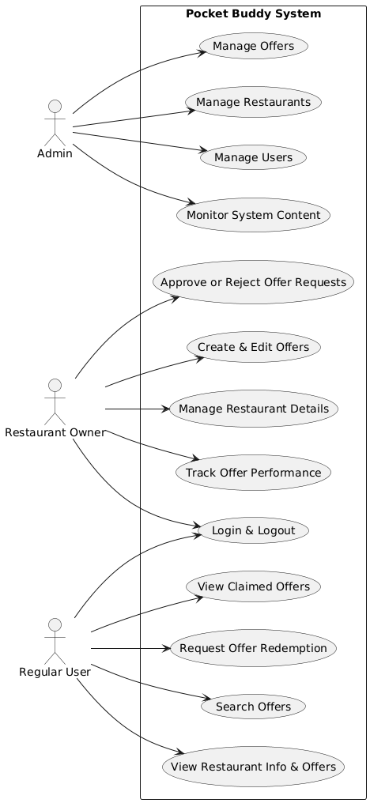

Class Diagram
NOTE: This class diagram and database schema are included to fulfill academic documentation requirements. However, the actual project is built using the MERN stack (MongoDB, Express.js, React, Node.js), which follows a schema-less, document-based structure in MongoDB. Therefore, these diagrams are conceptual representations and may not fully reflect the dynamic and flexible nature of the implemented system.
The class diagram represents the data structure of the application, including key entities such as Users, Restaurants, Offers, Reviews, and Subscription plan, along with their relationships.
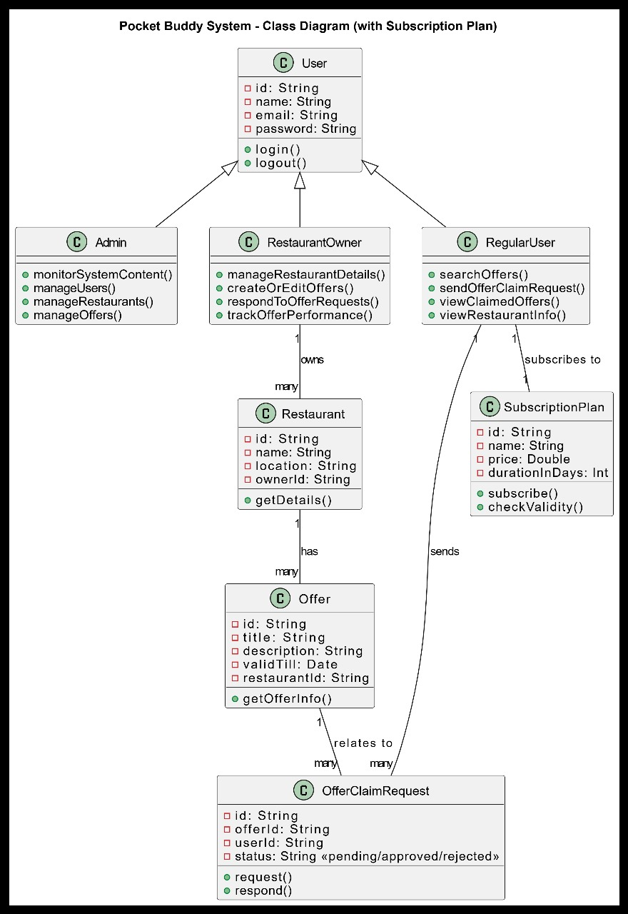

Interaction Diagram
The interaction diagram shows the sequence of actions between users and the system for key functionalities such as offer creation, login, searching.
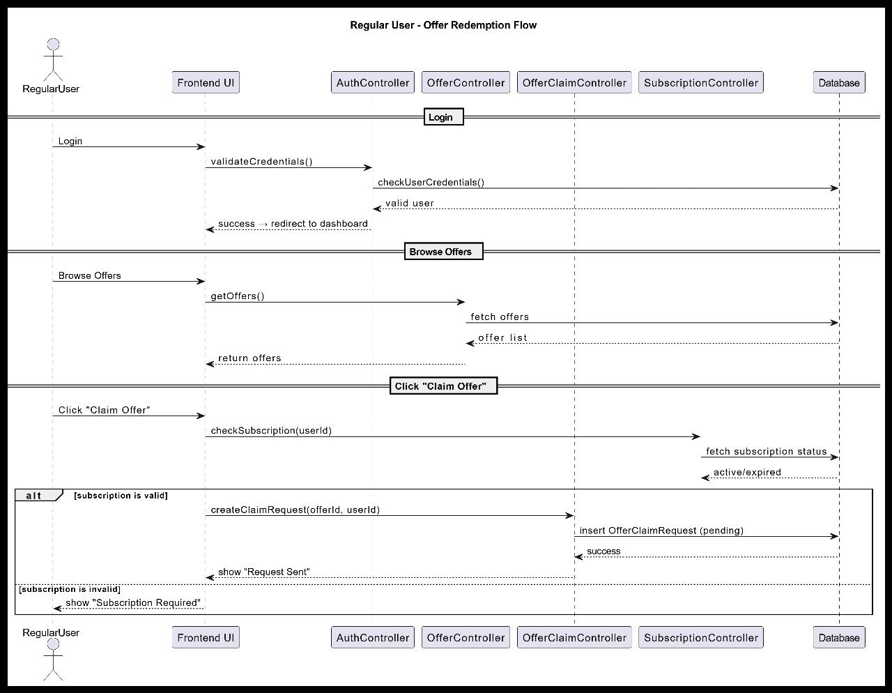
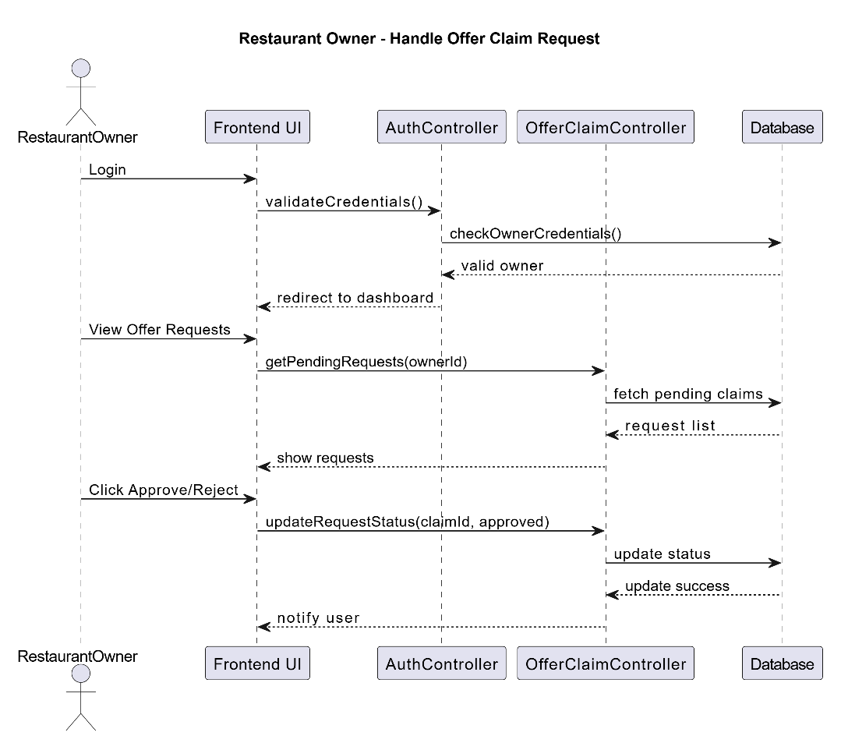
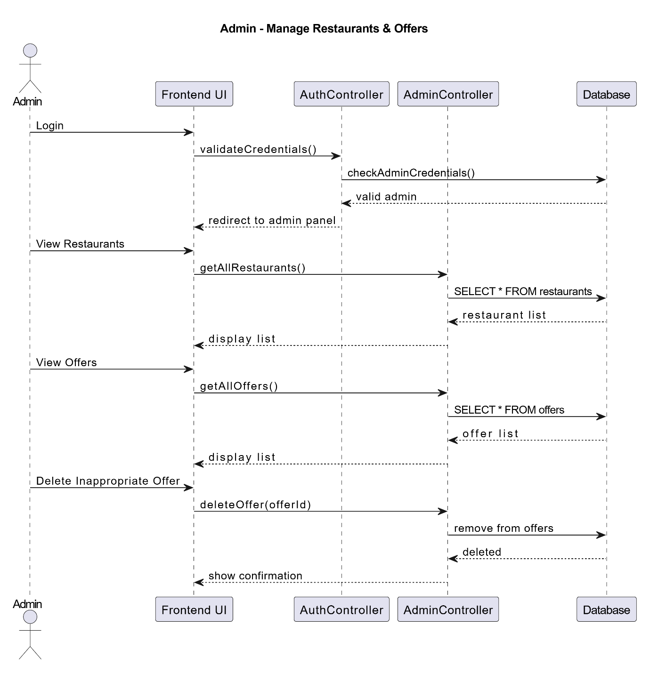

Activity Diagram
The activity diagram visualizes the workflow for major processes, including user registration, offer posting, review moderation, and admin actions.
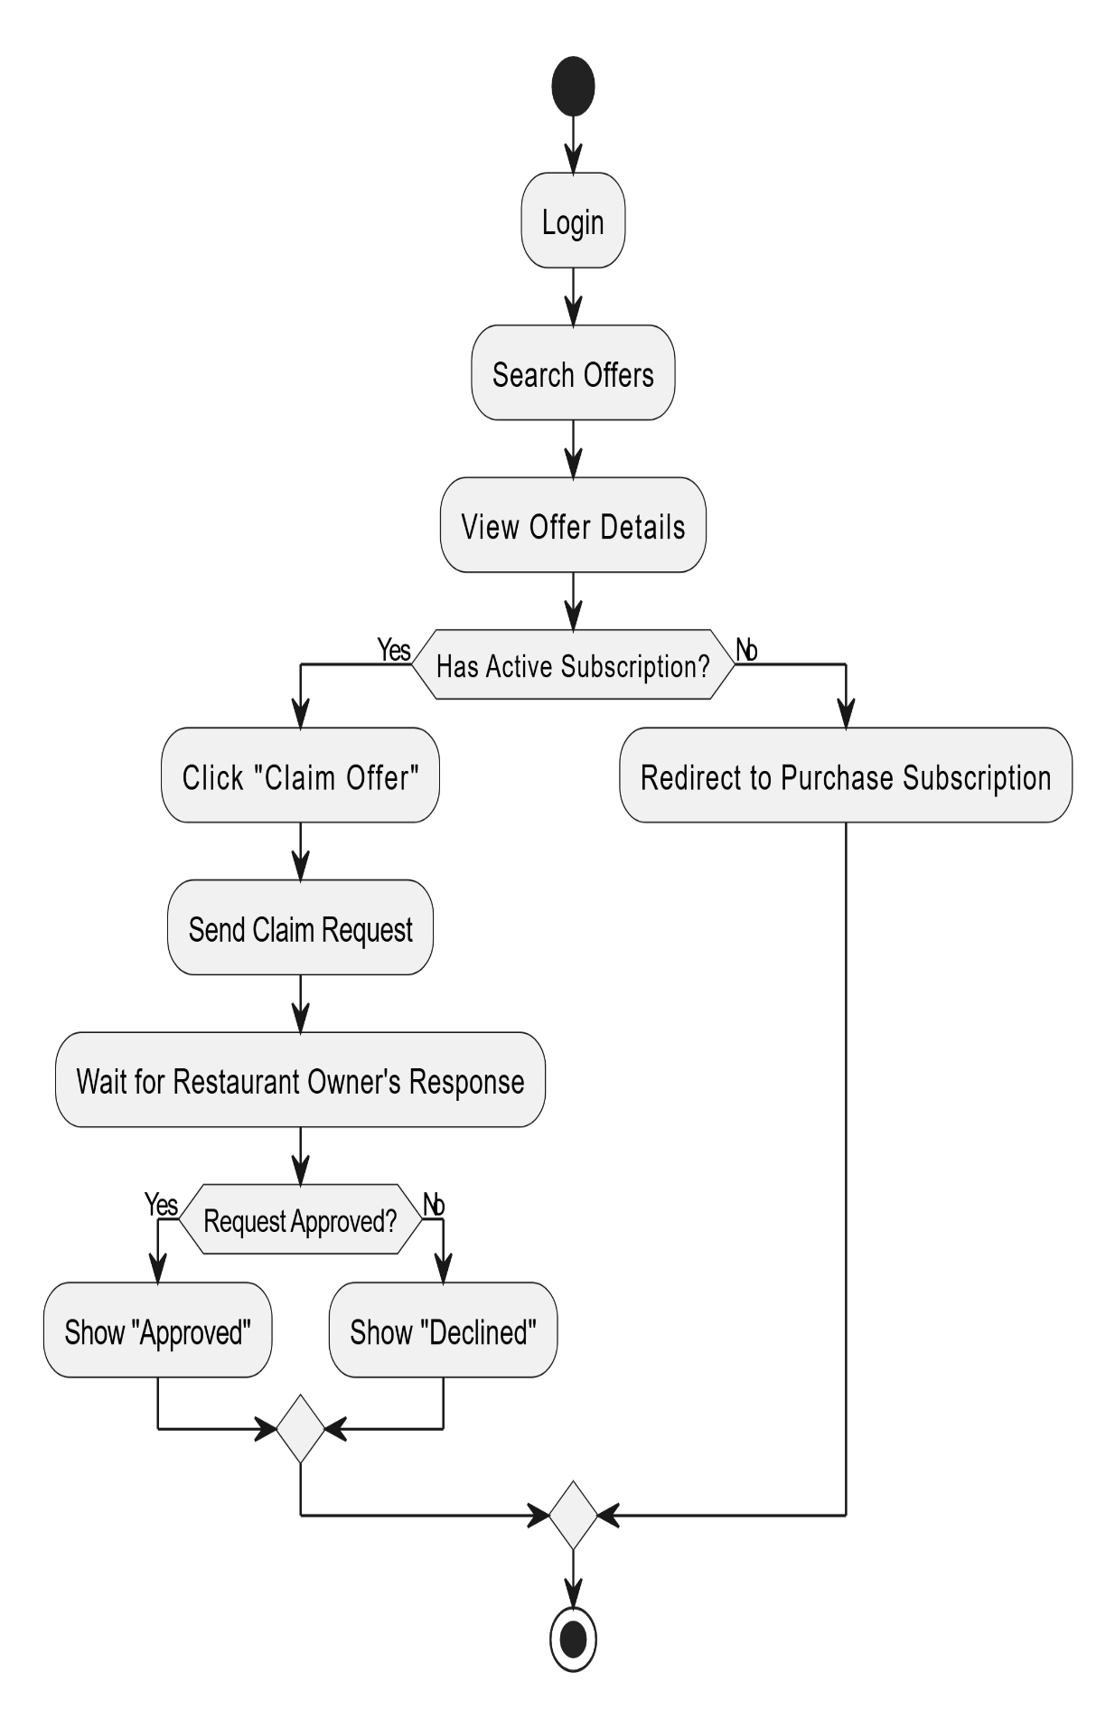

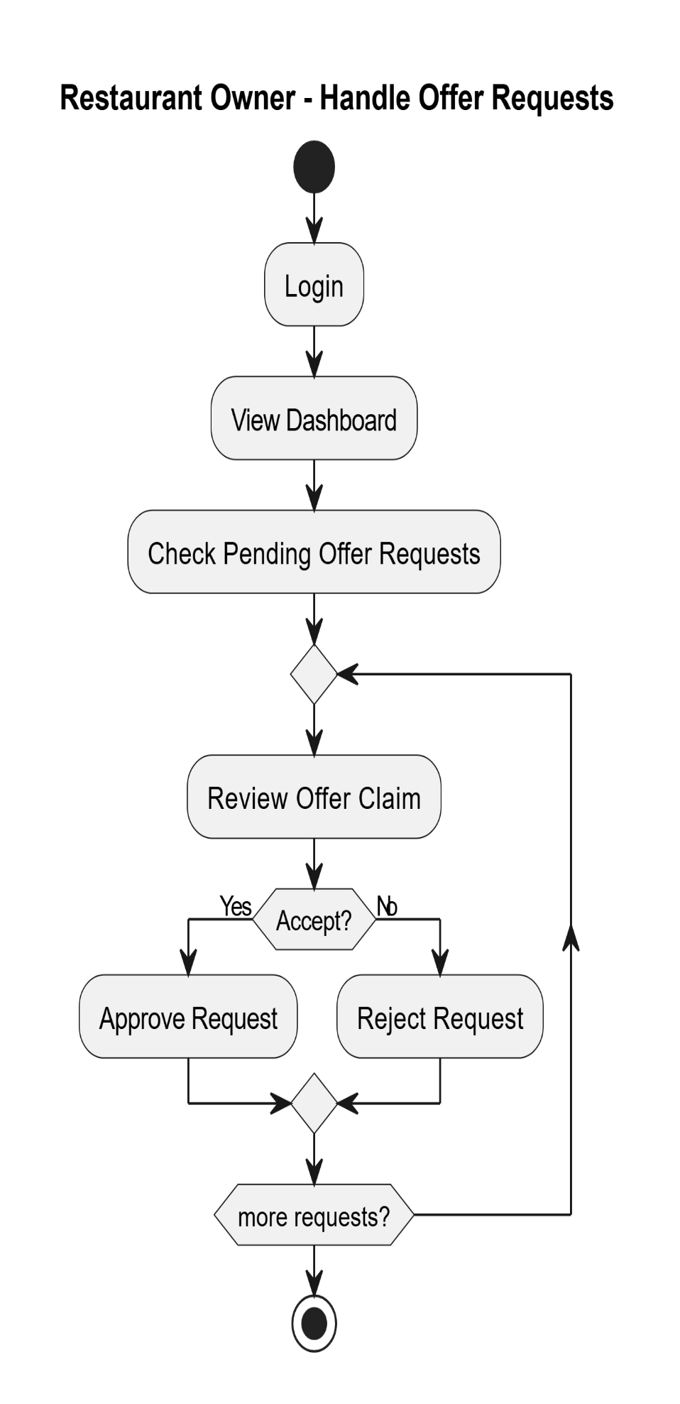

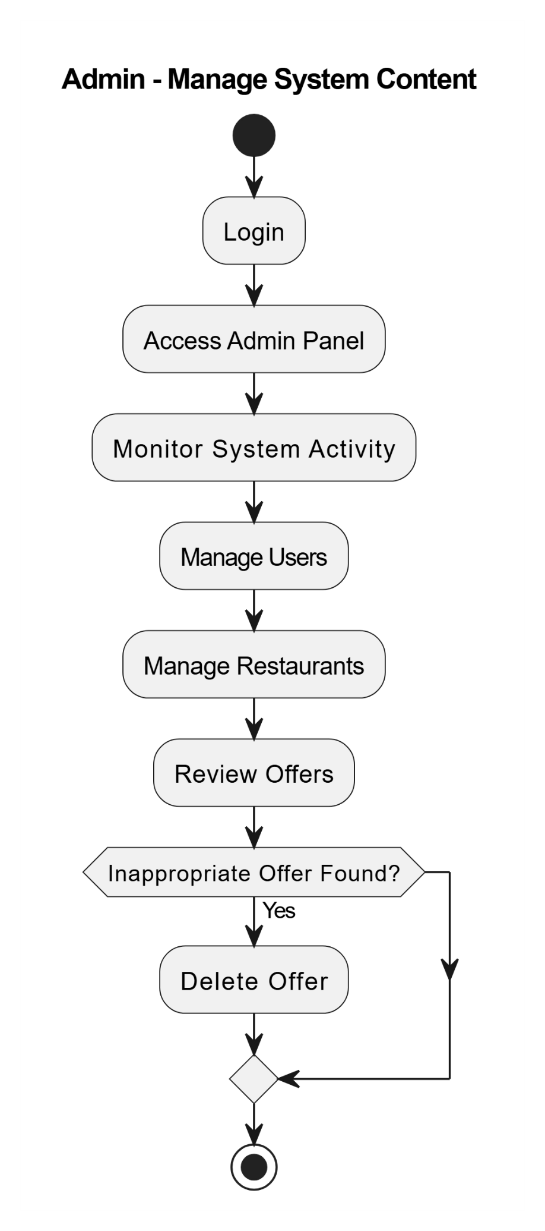
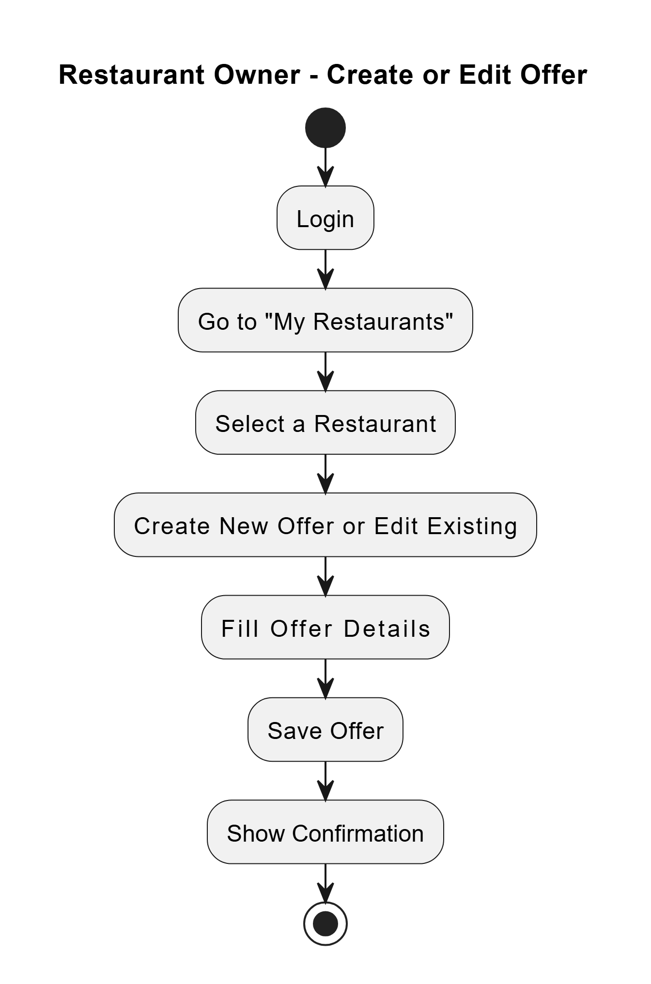

Data Dictionary

1. Table Name: Location
Table Description: Stores restaurant/location details including address, timings, and coordinates.

Table Name | Field Name | Data Type | Constraint | Description | Sample Data
Location | _id | ObjectID | Primary Key | Unique document ID | 507f1f77bcf86cd799439011
Location | title | String | Required | Name of the location | Café Delight
Location | category | String | Required | Category (e.g. Restaurant,café) | Restaurant
Location | description | String | Required | Detailed description | Cozy café with outdoor seating
Location | timings | String | Required | Operating hours | 9:00 AM - 10:00 PM
Location | active | Boolean | Default: true | Whether the location is active | TRUE
Location | contactNumber | String | Required | Contact number | 1234567890
Location | address | String | Required | Physical address | 123 Main St
Location | stateId | ObjectID | Foreign Key (State) | Reference to State | 507f1f77bcf86cd799439012
Location | cityId | ObjectID | Required | Foreign Key (City) | 507f1f77bcf86cd799439013
Location | areaId | ObjectID | Required | Foreign Key (Area) | 507f1f77bcf86cd799439014
Location | foodTypeId | ObjectID | Required | Foreign Key (FoodType) | 507f1f77bcf86cd799439015
Location | latitude | Number | Required | Geographic latitude | 40.7128
Location | longitude | Number | Required | Geographic longitude | -74.006
Location | imageURL | String | Required | URL of location image | https://example.com/image.jpg
Location | userId | ObjectID | Foreign Key (users) | User who added the location | 507f1f77bcf86cd799439016

2. Table Name: Offer
Table Description: Stores promotional offers for restaurants.
Table Name | Field Name | Data Type | Constraint | Description | Sample Data
Offer | _id | ObjectID | Primary Key | Unique offer ID | 507f1f77bcf86cd799439021
Offer | title | String |  | Offer title | Summer Discount
Offer | description | String |  | Offer details | 20% off on all items
Offer | offer_type | String |  | Type of offer (e.g. Discount, Combo) | Discount
Offer | discount_value | Number |  | Discount percentage/amount | 20
Offer | restaurant_ids | Array[ObjectID] | Foreign Key (Location) | Applicable restaurants | [507f1f77bcf86cd799439011]
Offer | valid_from | Date |  | Offer start date | 01-07-2023
Offer | valid_to | Date |  | Offer end date | 31-07-2023
Offer | requires_approval | Boolean |  | Needs admin approval | FALSE
Offer | min_order_value | Number |  | Minimum order to redeem | 100
Offer | max_redemptions | Number |  | Max times offer can be used | 50
Offer | imageURL | String | Required | Offer image URL | https://example.com/offer.jpg
Offer | status | String | Enum: Active/Inactive | Current status | Active
Offer | payment_required | Boolean | Default: false | Whether payment is needed | FALSE

3. Table: RedeemOffer
Description: Tracks user redemptions of offers.
Table Name | Field Name | Data Type | Constraint | Description | Sample Data
RedeemOffer | _id | ObjectID | Primary Key | Unique redemption ID | 507f1f77bcf86cd799439031
RedeemOffer | user_id | ObjectID | Required | Foreign Key (User) | User who redeemed
RedeemOffer | offer_id | ObjectID | Required | Foreign Key (Offer) | Redeemed offer ID
RedeemOffer | restaurant_id | ObjectID | Required | Foreign Key (Location) | Restaurant where redeemed
RedeemOffer | owner_id | ObjectID | Required | Foreign Key (User) | Restaurant owner
RedeemOffer | status | String | Enum: Pending/Approved/Rejected | Redemption status | Pending
RedeemOffer | redeemTime | Date |  | Time of redemption | 2023-07-15T14:30:00Z

4. Table: users
Description: Stores user account details.
Table Name | Field Name | Data Type | Constraint | Description | Sample Data
users | _id | ObjectID | Primary Key | Unique user ID | 507f1f77bcf86cd799439016
users | firstName | String | Required | User's first name | John
users | lastName | String | Required | User's last name | Doe
users | name | String |  | Auto-generated full name | John Doe
users | age | Number |  | User's age | 30
users | status | Boolean | Default: true | Account status | TRUE
users | roleId | ObjectID | Foreign Key (roles) | User's role | 507f1f77bcf86cd799439041
users | email | String | Unique + Required | User email | john@example.com
users | password | String | Required | Encrypted password | hashed_123

Development
Pocket Buddy was developed using the MVC architecture for better organization and easy maintenance. The frontend was built with React and Vite, while the backend used Node.js, Express, and MongoDB. Team members focused on their areas of expertise, working on the frontend and backend separately. Git was used for version control, and we had regular code reviews and meetings to ensure smooth collaboration. Each feature was tested individually before being added to the full system.

Coding Standards
✅ Naming Conventions
- Components & Models: PascalCase (e.g., UserCard.jsx, OfferModel.js)
- Variables & Functions: camelCase (e.g., handleClick, userData)
- Database: camelCase (e.g., offerDetails, userSubscriptions)
✅ Code Structure
- 4-space indentation
- Braces on the same line
- One blank line between functions
✅ Comments
- Single-line comments for clarity
- Multi-line comments for complex logic
- Functions and components include brief documentation
✅ Tools
- Prettier tools were used for consistent formatting.

4.2 SCREENSHOTS

User Dashboard
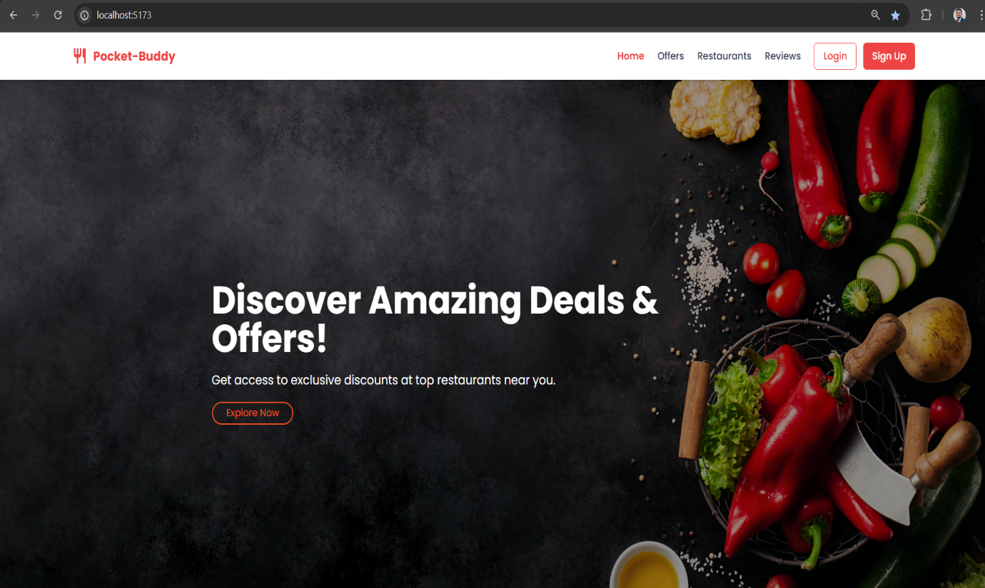

About Page
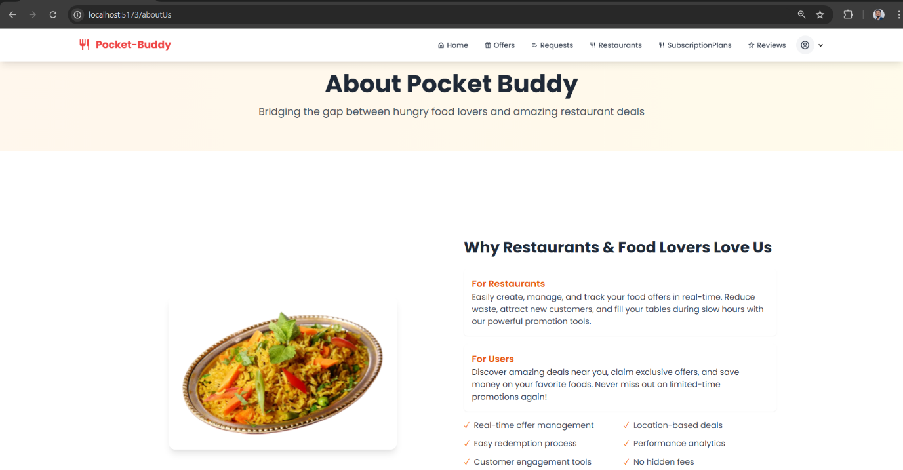

User Signup
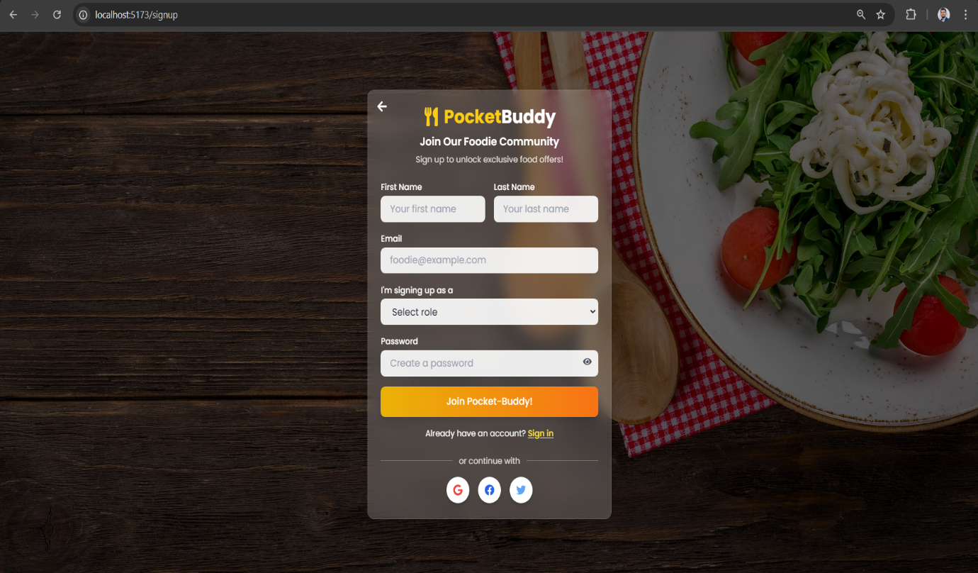

User Login
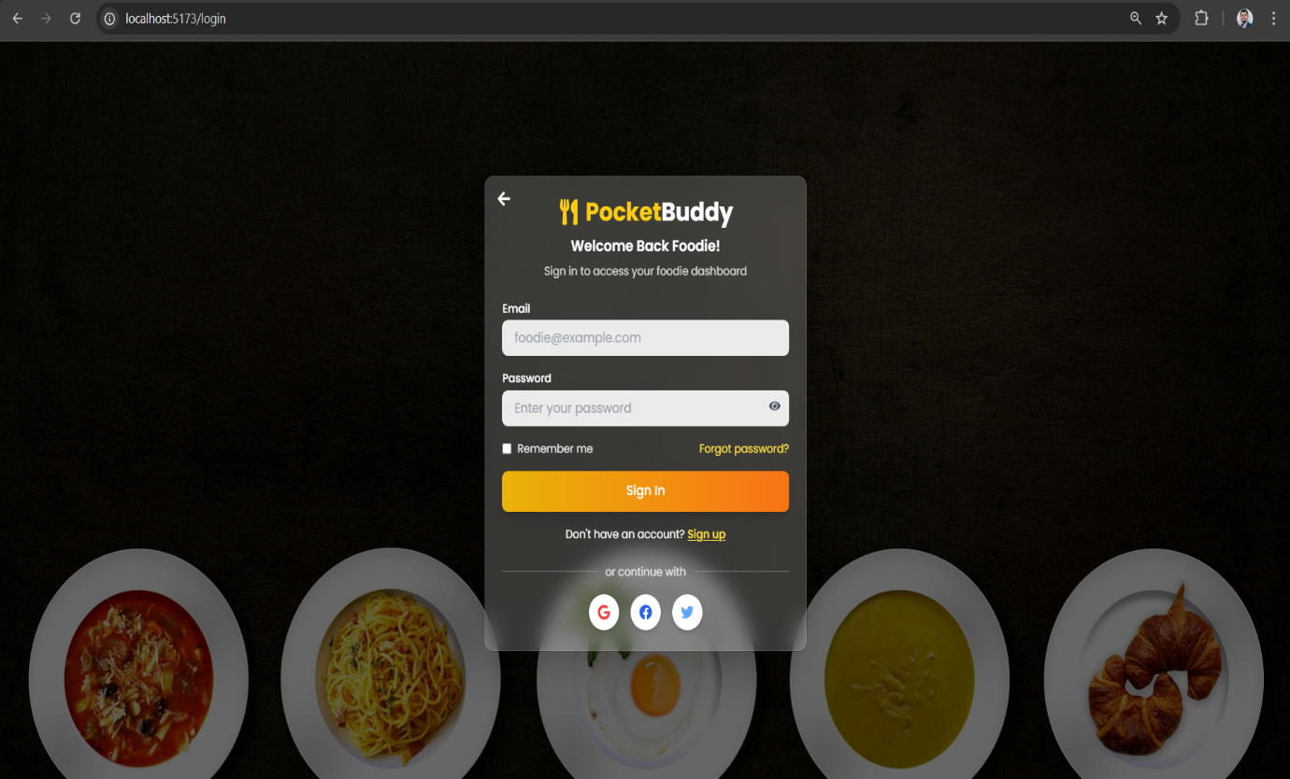

User Offers
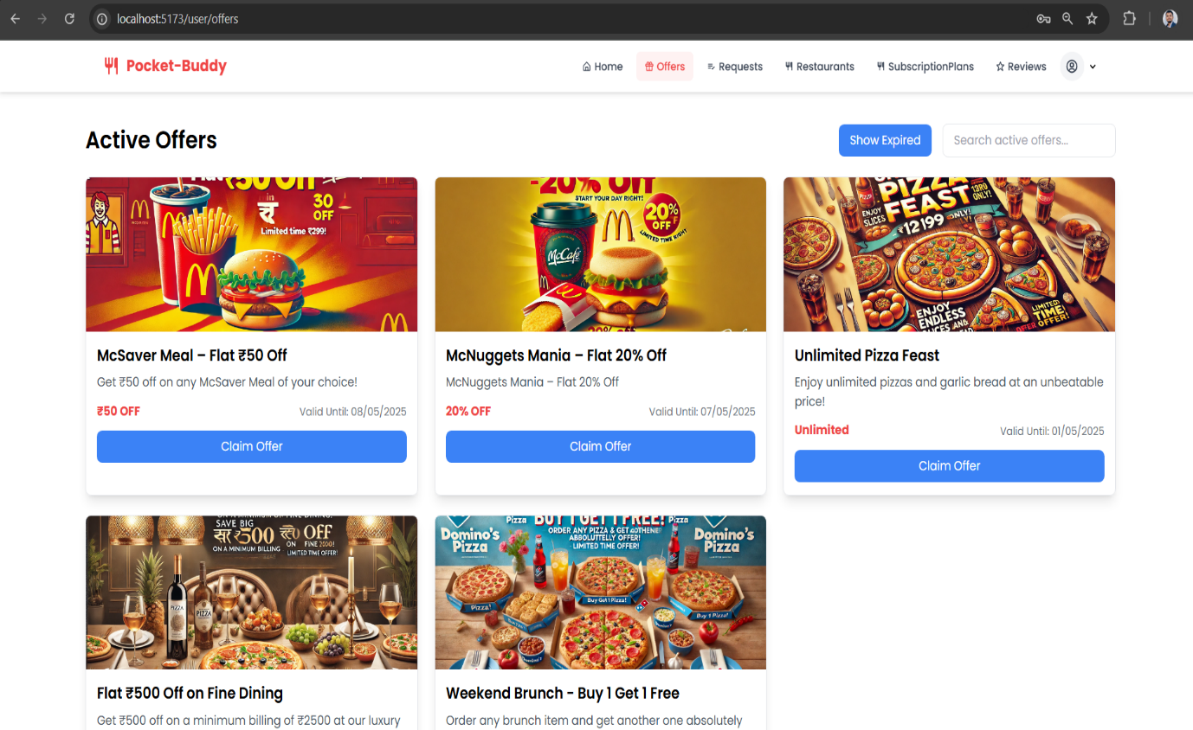

User Request
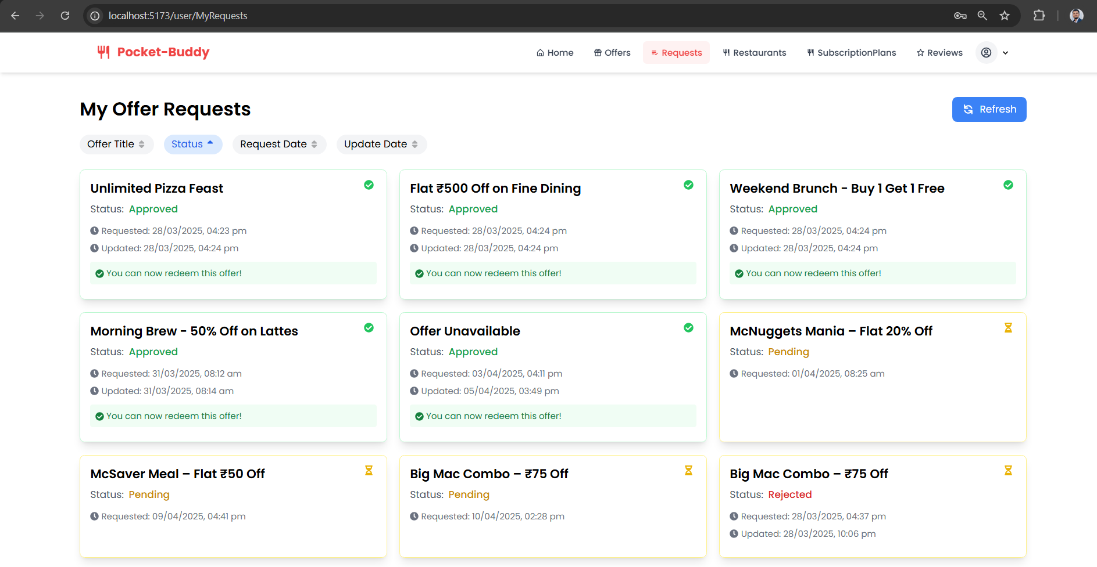

User Subscription plan
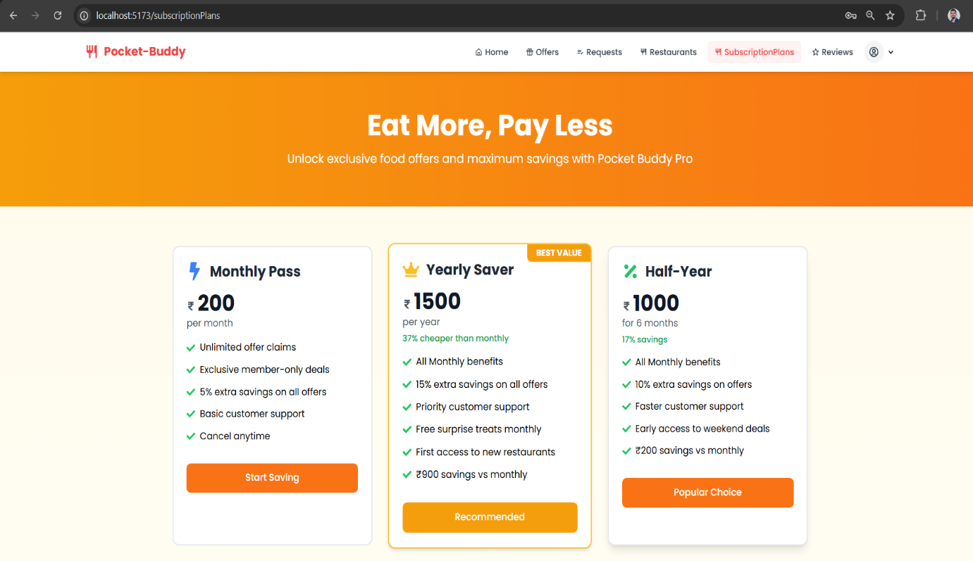
User Profile
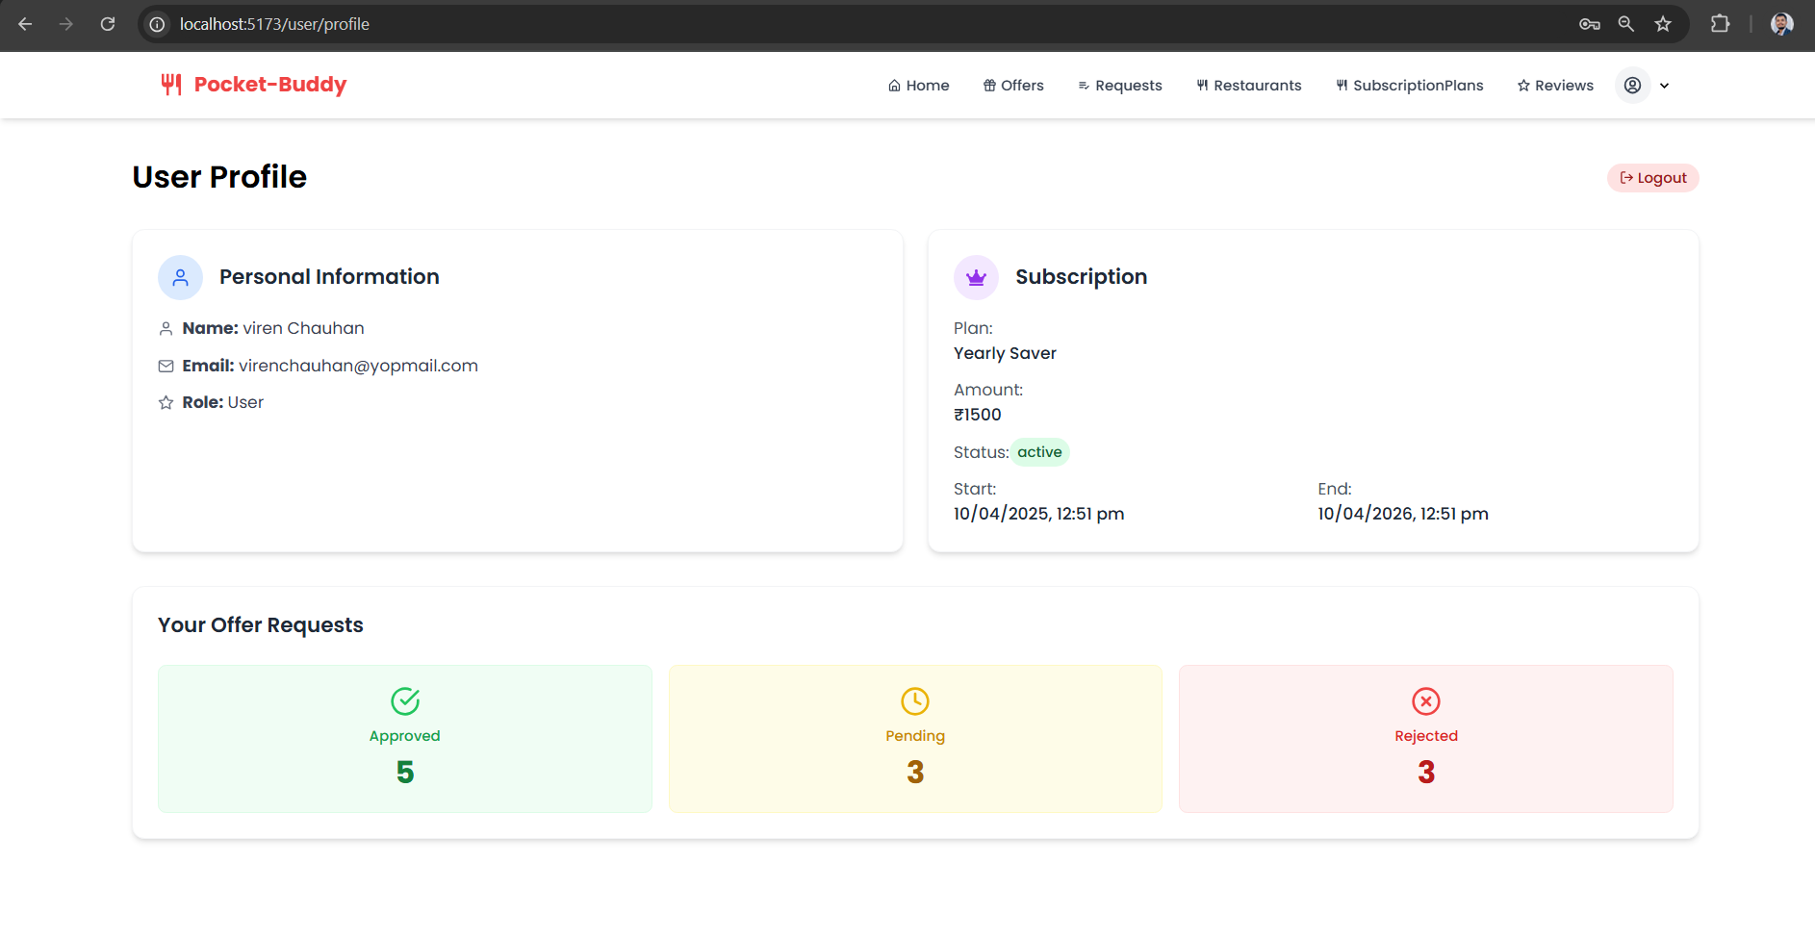

Restaurants Manage Offer Requests
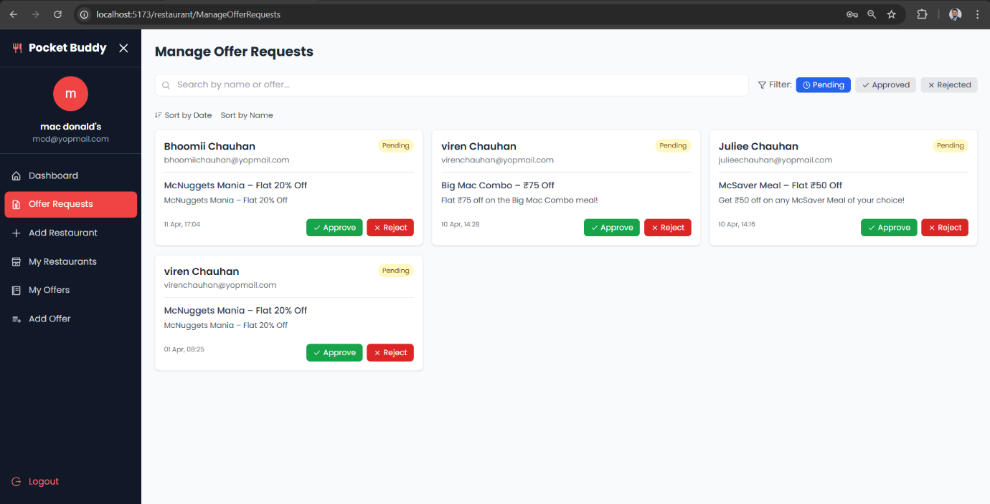

Add Restaurants
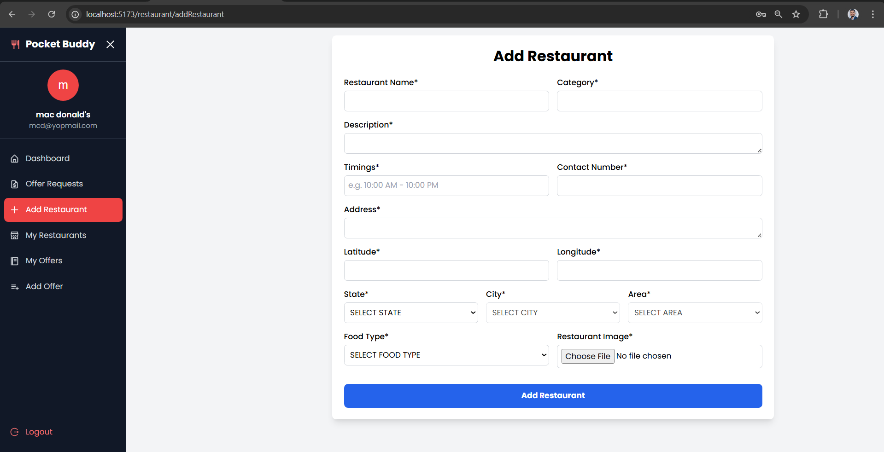

Restaurant My Restaurant
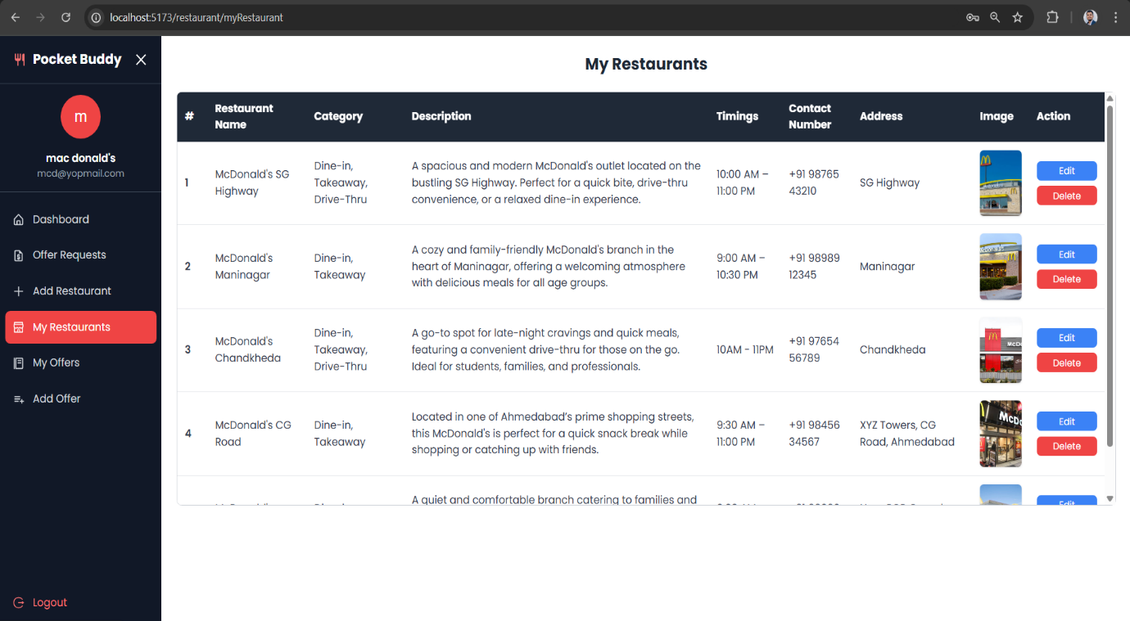

Restaurant My Offers
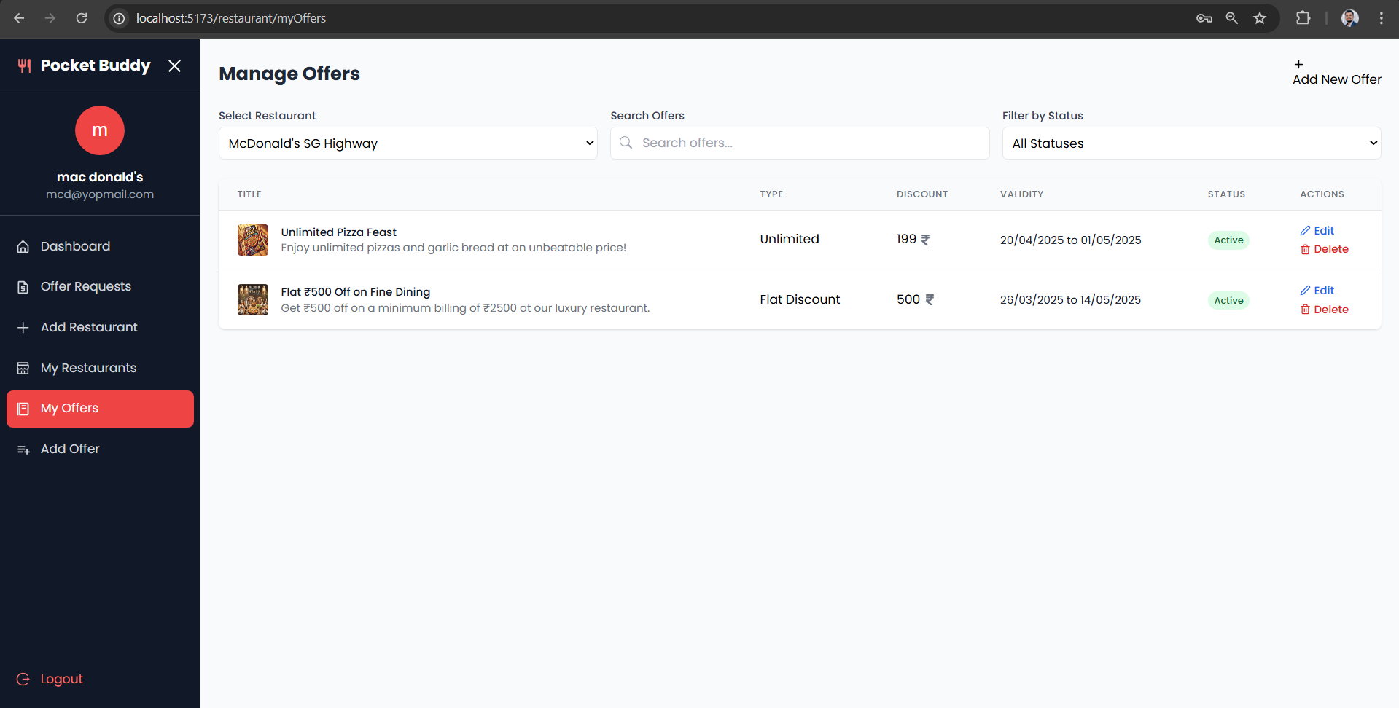

Restaurant Add Offer
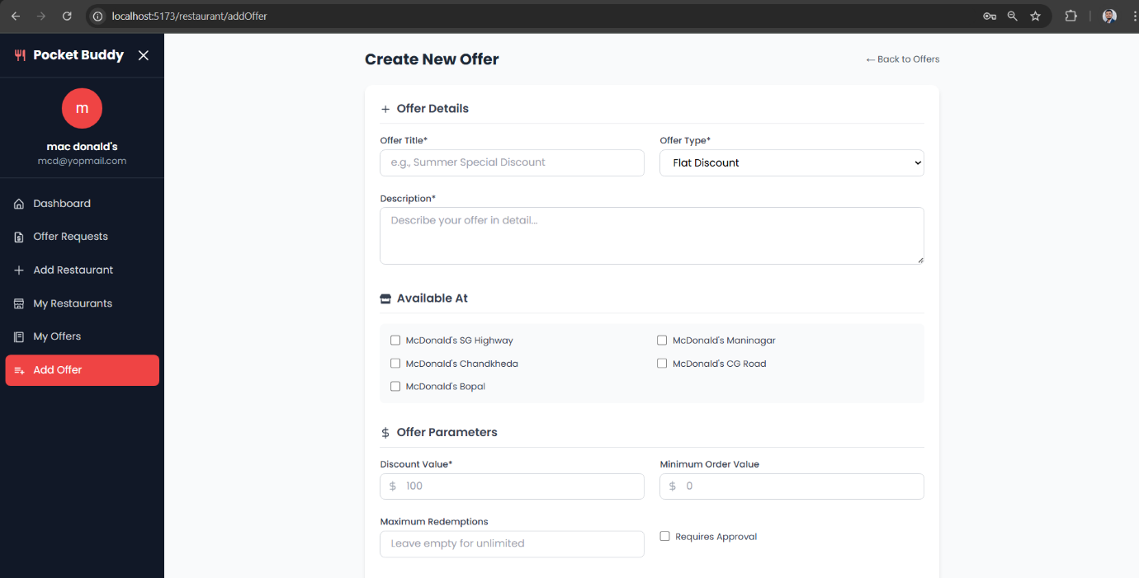

Admin Users
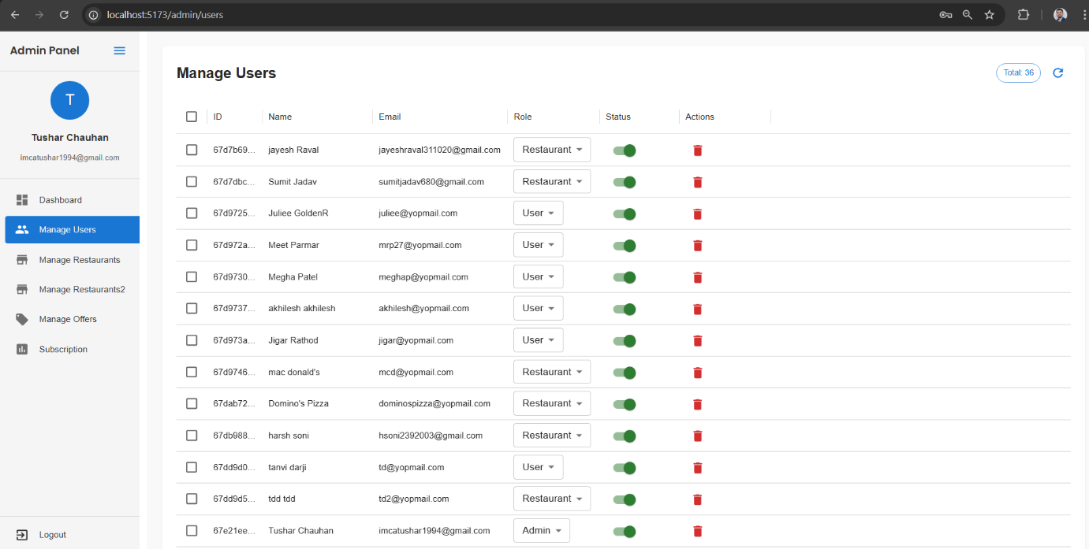

Admin Manage Restaurants
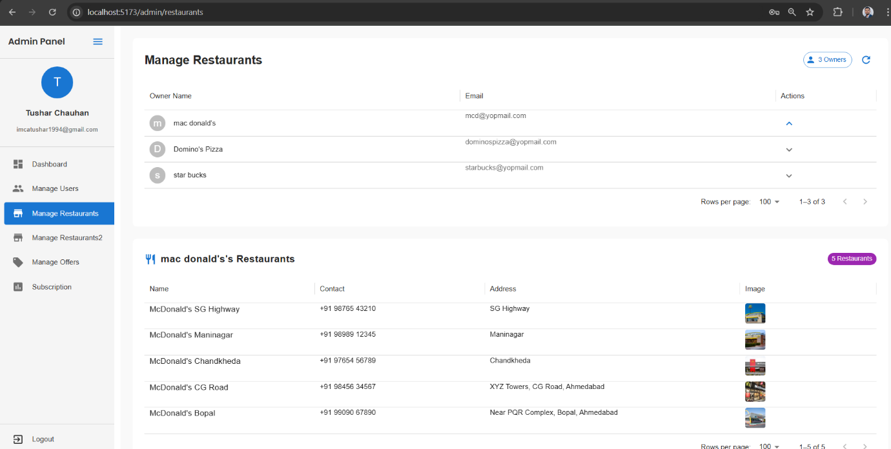

Admin Manage Offers
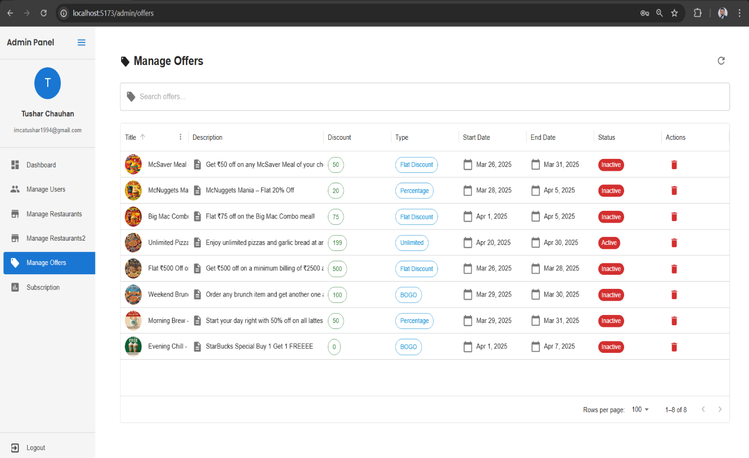

Admin Subscription Plan

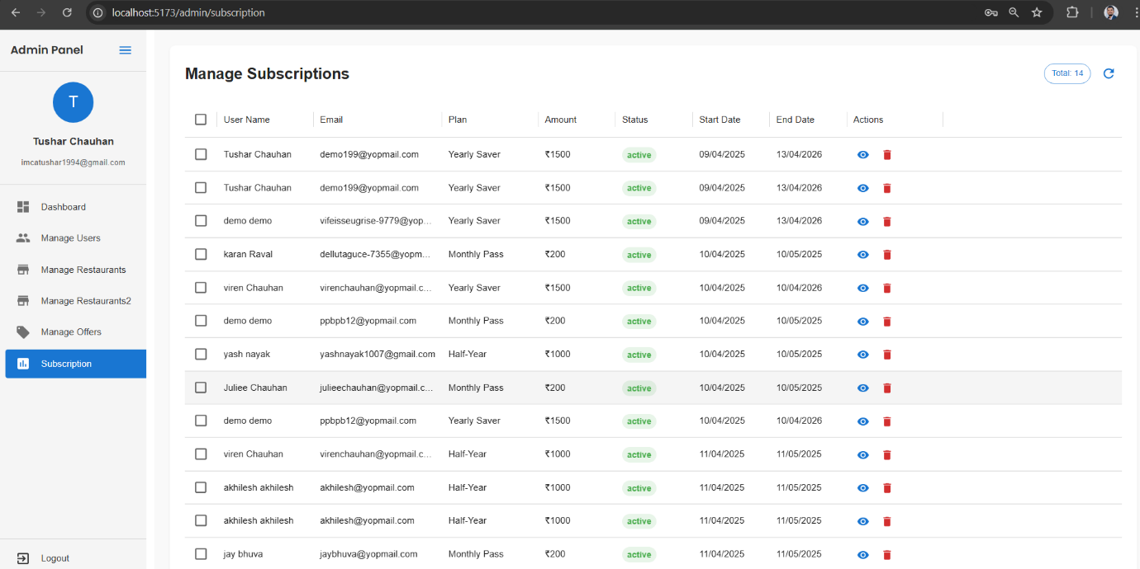

Agile Documentation

Agile Project Charter

General Project Information
Project Name | Pocket Buddy
Project Champion | Tushar Chauhan - Bhoomi Chavada
Project Sponsor | Tushar Chauhan - Bhoomi Chavada
Project Manager | Parth joshi
Stakeholders | Grownited Private Limited
Expected Start Date | January 1, 2026
Expected Completion Date | April 15, 2026
Project Details
Mission | We continuously innovate to be the best offers and deals platform for our users, making dining out and saving money easier and more rewarding.
Vision | Pocket Buddy is a digital platform that helps people find and use restaurant deals easily. It connects users with restaurant owners, making it simple to browse, claim, and enjoy food offers—just like how online shopping made buying things easier. Whether it's a local café or a big chain, Pocket Buddy brings tasty deals straight to your screen
Scope | The admin has complete control over the platform, managing user accounts, restaurant owners, and analyzing user activity. They can offer personalized discounts based on user preferences. The system can grow in the future, allowing new types of offers and partnerships with platforms like Zomato or Swiggy. Pocket Buddy also helps restaurant owners promote their businesses online in a trusted environment

Agile Road Map
Agile Roadmap – Pocket Buddy Project (Jan–Apr 2026)
The Pocket Buddy project follows an agile roadmap structured into five major sprints from late December 2025 to mid-April 2026. Each sprint focuses on building key components of the platform in a phased and iterative manner:
- Sprint 1: Foundation & Authentication (Dec 29, 2025 – Jan 11, 2026)
  - Set up the project structure and development environment.
  - Implemented user authentication, authorization, and basic roles.
- Sprint 2: Core Models & User Modules (Jan 12 – Jan 25, 2026)
  - Developed essential MongoDB models and Express-based backend routes.
  - Built foundational user-related modules and logic.
- Sprint 3: Frontend UI (Jan 26 – Feb 8, 2026)
  - Created core frontend components using React and Vite.
  - Integrated backend APIs with dynamic user interfaces.
- Sprint 4: Redemption Flow & QA (Feb 10 – Mar 12, 2026)
  - Designed and implemented the offer redemption request and approval system.
  - Conducted thorough testing and bug fixing for major flows.
- Sprint 5: Subscriptions & Final Polish (Mar 13 – Apr 15, 2026)
  - Integrated subscription-based access with Razorpay for payments.
  - Finalized features, improved UI/UX, and completed project polish.

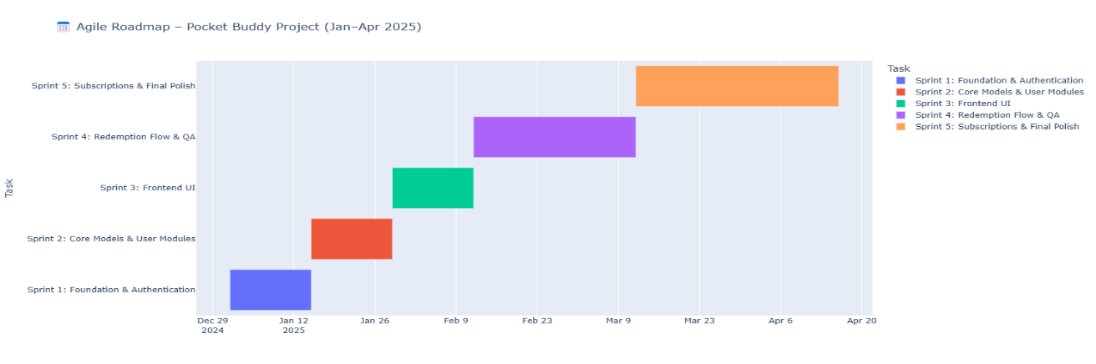

Agile Project Plan
Sprint | Task Name | Duration | Start | Finish | Status
Sprint #1 | Foundation Setup | 11d | 01-01-2026 | 11-01-2026 | Completed
Sprint#1 : Foundation Setup | Sprint Planning | 2d | 01-01-2026 | 02-01-2026 | Completed
Sprint#1 : Foundation Setup | Project Boilerplate Setup | 3d | 03-01-2026 | 05-01-2026 | Completed
Sprint#1 : Foundation Setup | Authentication System | 4d | 06-01-2026 | 09-01-2026 | Completed
Sprint#1 : Foundation Setup | Role-based Access Control | 2d | 10-01-2026 | 11-01-2026 | Completed
Sprint #2 | Core Modules | 13d | 15-01-2026 | 27-01-2026 | Completed
Sprint#2 : Core Modules | User & Restaurant Modules (CRUD) | 5d | 15-01-2026 | 19-01-2026 | Completed
Sprint#2 : Core Modules | Offer Model CRUD | 5d | 20-01-2026 | 24-01-2026 | Completed
Sprint#2 : Core Modules | Link Offers to Restaurants | 3d | 25-01-2026 | 27-01-2026 | Completed
Sprint #3 | UI & Dashboard | 13d | 29-01-2026 | 10-02-2026 | Completed
Sprint#3 : UI & Dashboard | User Dashboard | 5d | 29-01-2026 | 02-02-2026 | Completed
Sprint#3 : UI & Dashboard | Offer Form for Restaurants | 3d | 03-02-2026 | 05-02-2026 | Completed
Sprint#3 : UI & Dashboard | Restaurant Dashboard UI Enhancements | 5d | 06-02-2026 | 10-02-2026 | Completed
Sprint #4 | Search & Redemption | 24d | 12-02-2026 | 07-03-2026 | Completed
Sprint#4 : Search & Redemption | Enhance Filters/Search | 5d | 12-02-2026 | 16-02-2026 | Completed
Sprint#4 : Search & Redemption | QA & Performance Testing | 5d | 17-02-2026 | 21-02-2026 | Completed
Sprint#4 : Search & Redemption | Offer Redemption Flow | 7d | 22-02-2026 | 28-02-2026 | Completed
Sprint#4 : Search & Redemption | Redemption Approval Dashboard | 7d | 01-03-2026 | 07-03-2026 | Completed
Sprint #5 | Subscription & Final Touches | 25d | 12-03-2026 | 05-04-2026 | Completed
Sprint#5 : Subscription & Final Touches | Razorpay Integration | 5d | 12-03-2026 | 16-03-2026 | Completed
Sprint#5 : Subscription & Final Touches | Subscription Backend Logic | 5d | 17-03-2026 | 21-03-2026 | Completed
Sprint#5 : Subscription & Final Touches | Restrict non-subscribers | 5d | 22-03-2026 | 26-03-2026 | Completed
Sprint#5 : Subscription & Final Touches | Final UI/UX Polish & SEO | 5d | 27-03-2026 | 31-03-2026 | Completed
Sprint#5 : Subscription & Final Touches | Testing and Docs | 5d | 01-04-2026 | 05-04-2026 | Completed

Agile User Story
User Story ID | As a (type of user) | I want to (perform some task) | So that I can (achieve some goal)
1 | Admin | Manage Login Module | Ensure that only validated users can access the platform
2 | Admin | Manage Users and Restaurant Owners | Monitor and control platform access
3 | Admin | View and Manage Subscriptions | Track who has active plans and manage billing status
4 | Restaurant Owner | Manage Offers (Insert, Update, Delete, View) | Control and update promotions for their restaurants
5 | Restaurant Owner | View and Approve/Decline Redemption Requests | Control how and when offers are redeemed
6 | Restaurant Owner | Track Offer Redemptions and Customer Interactions | Understand offer performance and improve engagement
7 | Customer | View and Filter Restaurant Offers | Easily find the best deals nearby
8 | Customer | Redeem Offers with Restaurant Approval | Ensure fair use and transparency of the offers
9 | Customer | Subscribe to a Plan and Unlock Offers | Gain access to exclusive deals and benefits

Agile Release Plan
Sprint | Task Name | Duration | Start | Finish | Status
Sprint #1 | Foundation Setup | 11d | 01-01-2026 | 11-01-2026 | Completed
Sprint#1 : Foundation Setup | Sprint Planning | 2d | 01-01-2026 | 02-01-2026 | Completed
Sprint#1 : Foundation Setup | Project Boilerplate Setup | 3d | 03-01-2026 | 05-01-2026 | Completed
Sprint#1 : Foundation Setup | Authentication System | 4d | 06-01-2026 | 09-01-2026 | Completed
Sprint#1 : Foundation Setup | Role-based Access Control | 2d | 10-01-2026 | 11-01-2026 | Completed
Sprint #2 | Core Modules | 13d | 15-01-2026 | 27-01-2026 | Completed
Sprint#2 : Core Modules | User & Restaurant Modules (CRUD) | 5d | 15-01-2026 | 19-01-2026 | Completed
Sprint#2 : Core Modules | Offer Model CRUD | 5d | 20-01-2026 | 24-01-2026 | Completed
Sprint#2 : Core Modules | Link Offers to Restaurants | 3d | 25-01-2026 | 27-01-2026 | Completed
Sprint #3 | UI & Dashboard | 13d | 29-01-2026 | 10-02-2026 | Completed
Sprint#3 : UI & Dashboard | User Dashboard | 5d | 29-01-2026 | 02-02-2026 | Completed
Sprint#3 : UI & Dashboard | Offer Form for Restaurants | 3d | 03-02-2026 | 05-02-2026 | Completed
Sprint#3 : UI & Dashboard | Restaurant Dashboard UI Enhancements | 5d | 06-02-2026 | 10-02-2026 | Completed
Sprint #4 | Search & Redemption | 24d | 12-02-2026 | 07-03-2026 | Completed
Sprint#4 : Search & Redemption | Enhance Filters/Search | 5d | 12-02-2026 | 16-02-2026 | Completed
Sprint#4 : Search & Redemption | QA & Performance Testing | 5d | 17-02-2026 | 21-02-2026 | Completed
Sprint#4 : Search & Redemption | Offer Redemption Flow | 7d | 22-02-2026 | 28-02-2026 | Completed
Sprint#4 : Search & Redemption | Redemption Approval Dashboard | 7d | 01-03-2026 | 07-03-2026 | Completed
Sprint #5 | Subscription & Final Touches | 25d | 12-03-2026 | 05-04-2026 | Completed
Sprint#5 : Subscription & Final Touches | Razorpay Integration | 5d | 12-03-2026 | 16-03-2026 | Completed
Sprint#5 : Subscription & Final Touches | Subscription Backend Logic | 5d | 17-03-2026 | 21-03-2026 | Completed
Sprint#5 : Subscription & Final Touches | Restrict non-subscribers | 5d | 22-03-2026 | 26-03-2026 | Completed
Sprint#5 : Subscription & Final Touches | Final UI/UX Polish & SEO | 5d | 27-03-2026 | 31-03-2026 | Completed
Sprint#5 : Subscription & Final Touches | Testing and Docs | 5d | 01-04-2026 | 05-04-2026 | Completed

Agile Sprint Backlog
Task Name | Story | Sprint Ready | Priority | Status | Story Point
Sprint#1: Project Setup & Authentication | Yes | Yes | High | Completed | 10
→ UI Designing (Login & Role UI) | Yes | Yes | High | Completed | 5
→ Setup Project Structure (Frontend + Backend) | Yes | Yes | High | Completed | 5
→ Implement Auth (JWT, Roles) | Yes | Yes | High | Completed | 8
Sprint#2: Core Modules & Offers | Yes | Yes | High | Completed | 10
→ User & Restaurant Owner Module | Yes | Yes | High | Completed | 6
→ Offer Model + CRUD | Yes | Yes | High | Completed | 6
→ Link Offers to Restaurant | Yes | Yes | Medium | Completed | 4
Sprint#3: UI Improvements & Add Offer Form | Yes | Yes | High | Completed | 8
→ User Dashboard UI (Hero, Filters) | Yes | Yes | Medium | Completed | 5
→ Restaurant Add Offer Form | Yes | Yes | High | Completed | 5
→ Restaurant UI Enhancement | Yes | Yes | Medium | Completed | 4
Sprint#4: Search, Redemption & QA | Yes | Yes | High | Completed | 10
→ Search Filter Improvements | Yes | Yes | Medium | Completed | 4
→ Redemption Flow (User Side) | Yes | Yes | High | Completed | 6
→ Redemption Approval by Owner | Yes | Yes | High | Completed | 5
→ Initial Testing & Debugging | Yes | Yes | Medium | Completed | 3
Sprint#5: Subscription, Polish | Yes | Yes | High | Completed | 10
→ Razorpay Integration (Frontend) | Yes | Yes | High | Completed | 4
→ Backend Subscription + Admin View | Yes | Yes | High | Completed | 5
→ Restrict Offer Claims | Yes | Yes | Medium | Completed | 3
→ Final UI Polish + SEO | Yes | Yes | Medium | Completed | 3
→ Final Testing, Docs | Yes | Yes | High | Completed | 3

Agile Test Plan

Project Name: Pocket Buddy
Technology Stack: MERN (MongoDB, Express.js, React.js, Node.js)
Testing Device: HP Intel Core i3 (7th Gen) / Modern Browsers (Chrome, Microsoft edge)
Test Case 1: User Authentication
Module: Login & Role Management
Priority: High
Tested By: Tushar Chauhan - Bhoomi Chavada
Test Step | Action | Expected Result | Actual Result | Pass/Fail
1. Click "Login" as Admin | Enter valid admin credentials | Redirect to admin dashboard | Redirected to admin dashboard | ✅ Pass
2. Enter wrong password | Submit form | Show error: "Invalid credentials" | Error message displayed correctly | ✅ Pass
3. Login with empty email field | Leave email blank | Show error: "Email required" | Error message: "Email required" shown | ✅ Pass
4. Login as unregistered user | Use fake credentials | Show error: "User not found" | Error message: "User not found" displayed | ✅ Pass

Test Case 2: Offer Creation & Management
Module: Restaurant Owner Dashboard
Priority: High
Tested By: Tushar Chauhan - Bhoomi Chavada
Test Step | Action | Expected Result | Actual Result | Pass/Fail
1. Add new offer (valid data) | Fill all required fields | Offer appears in "Active Offers" | Offer successfully added and listed | ✅ Pass
2. Add offer with missing title | Leave title blank | Show error: "Title required" | Error message displayed correctly | ✅ Pass
3. Edit offer discount value | Update discount to 20% | Changes reflect in database | Discount updated and reflected in UI | ✅ Pass
4. Delete expired offer | Click "Delete" on expired offer | Offer removed from list | Offer deleted and no longer visible | ✅ Pass

Test Case 3: Offer Redemption Flow
Module: User Dashboard
Priority: Medium
Tested By: Tushar Chauhan - Bhoomi Chavada

Test Step | Action | Expected Result | Actual Result | Pass/Fail
1. User views redeemable offers | Open "Available Offers" tab | List loads without errors | Offers loaded successfully | ✅ Pass
2. Attempt redemption (no sub) | Click "Redeem" button | Show prompt: "Subscribe first" | Subscription prompt displayed | ✅ Pass
3. Subscribed user redeems offer | Complete redemption steps | Status changes to "Pending" | Offer marked as pending | ✅ Pass
4. Owner rejects redemption | Click "Reject" in dashboard | User notified of rejection | User received rejection notification | ✅ Pass

Proposed Enhancements

While the current system covers core features like offer management, user authentication, restaurant dashboards, and subscription payments, future enhancements can improve user experience, scalability, and system intelligence. Proposed improvements include:

- AI-Powered Personalized Recommendations
Implement machine learning algorithms to analyze user preferences and behavior to show the most relevant offers and restaurants.
- Subscription Analytics for Admins
Include dashboards for admins to analyze trends in subscriptions, user engagement, and revenue.
- In-app Notifications and Alerts
Notify users about new offers, expiring deals, and subscription reminders via real-time notifications.
- Multi-language Support
Add support for regional languages to increase accessibility and reach a broader user base.
- Advanced Search and Filter Options
Improve search by allowing users to filter based on offer type, cuisine, rating, distance, and more.
- Offer Sharing and Referral System
Allow users to share offers with friends and earn rewards, boosting engagement and organic growth.
- QR Code-Based Redemption
Integrate QR codes for faster in-store offer redemptions, reducing manual validation steps for restaurant staff.

Conclusion

- The Pocket Buddy app makes it easy for users to find and access restaurant deals. It connects customers with restaurants through a simple and easy-to-use interface, helping businesses promote their offers effectively. The subscription feature allows restaurants to earn money from loyal users by giving them exclusive access to deals.

- Using Agile development, the app can keep improving and adding new features based on what users want. It meets the current needs and can be easily updated in the future to add more features, ensuring it continues to work well for users over time.

Bibliography
- MongoDB Documentation – https://www.mongodb.com/docs
- Express.js Guide – https://expressjs.com
- React.js Documentation – https://reactjs.org
- Razorpay Integration Docs – https://razorpay.com/docs
- Sommerville, Ian. Software Engineering, 10th Edition – Pearson
- IEEE Std 830-1998 – IEEE Recommended Practice for Software Requirements Specifications
- OpenAI GPT-4 Assistance for Planning and Content Structuring
- UI/UX References –Figma Community Templates

