Assignment 11th Oct 2024

1. Install git and initialise git repository
2. Create 3 branch like 2024Q1, 2024Q2 and 2024Q3

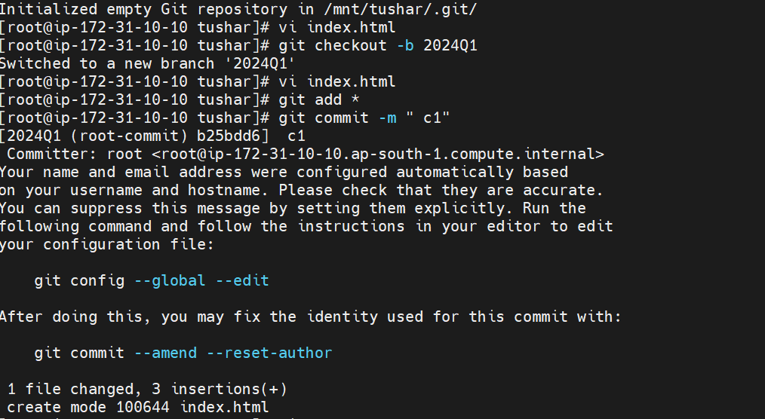

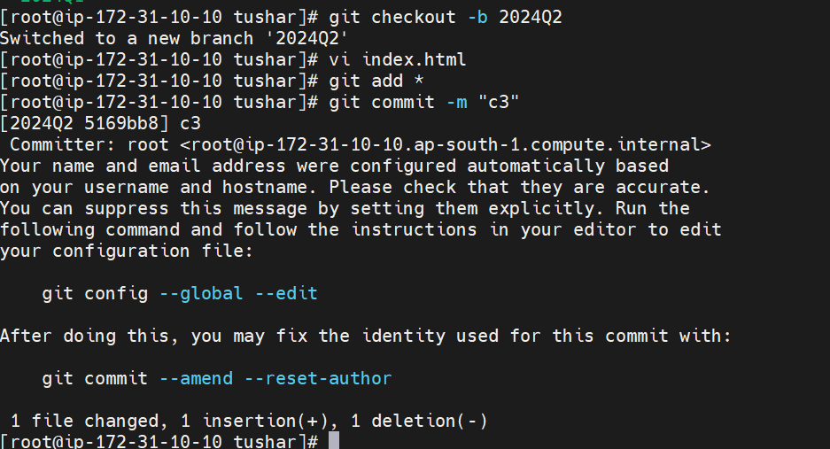

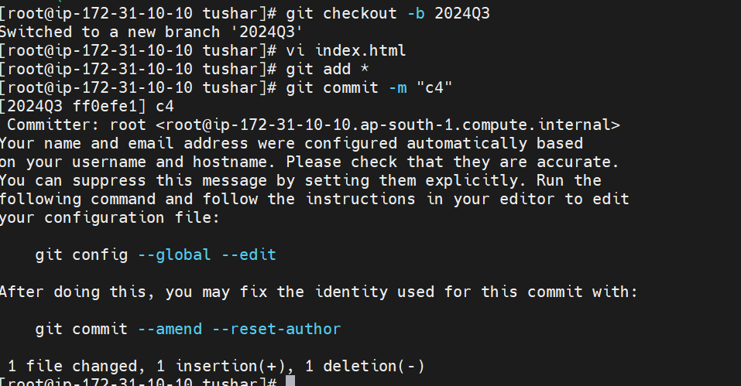

1. Create and Configure GitHub repository

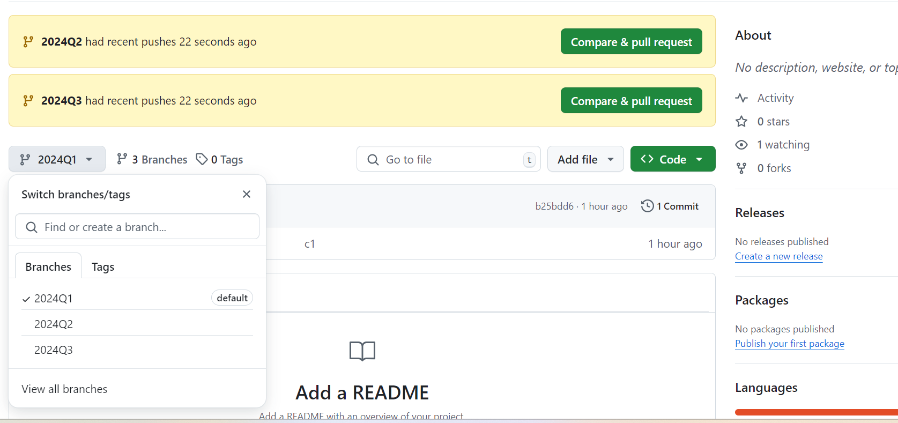

1. create job 1-🡪 git 🡪 past github url 🡪 build trigger🡪GitHub hook trigger for GITScm polling-🡪apply+save
2. Manage Jenkins--🡪system --🡪github server-🡪credentials-🡪secret text --🡪enter github code--🡪 apply save

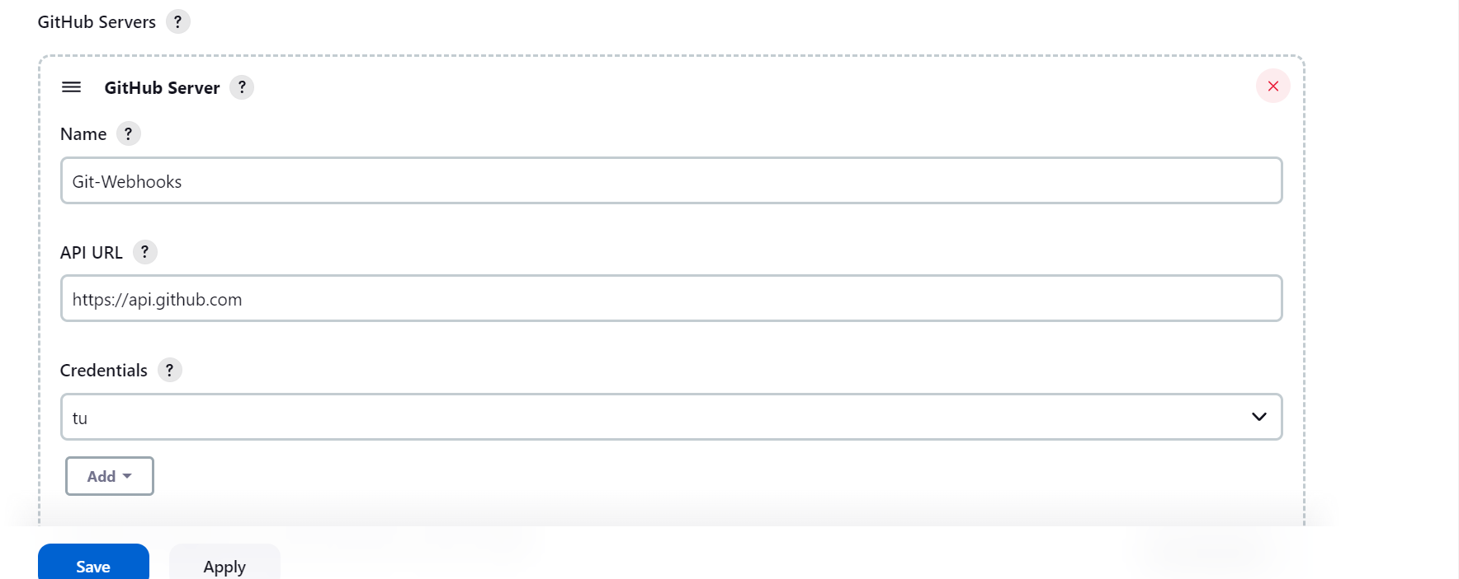

1. goto github repository where branches are created  
   settings🡪on left hand side select **webhooks** option🡪payload URL

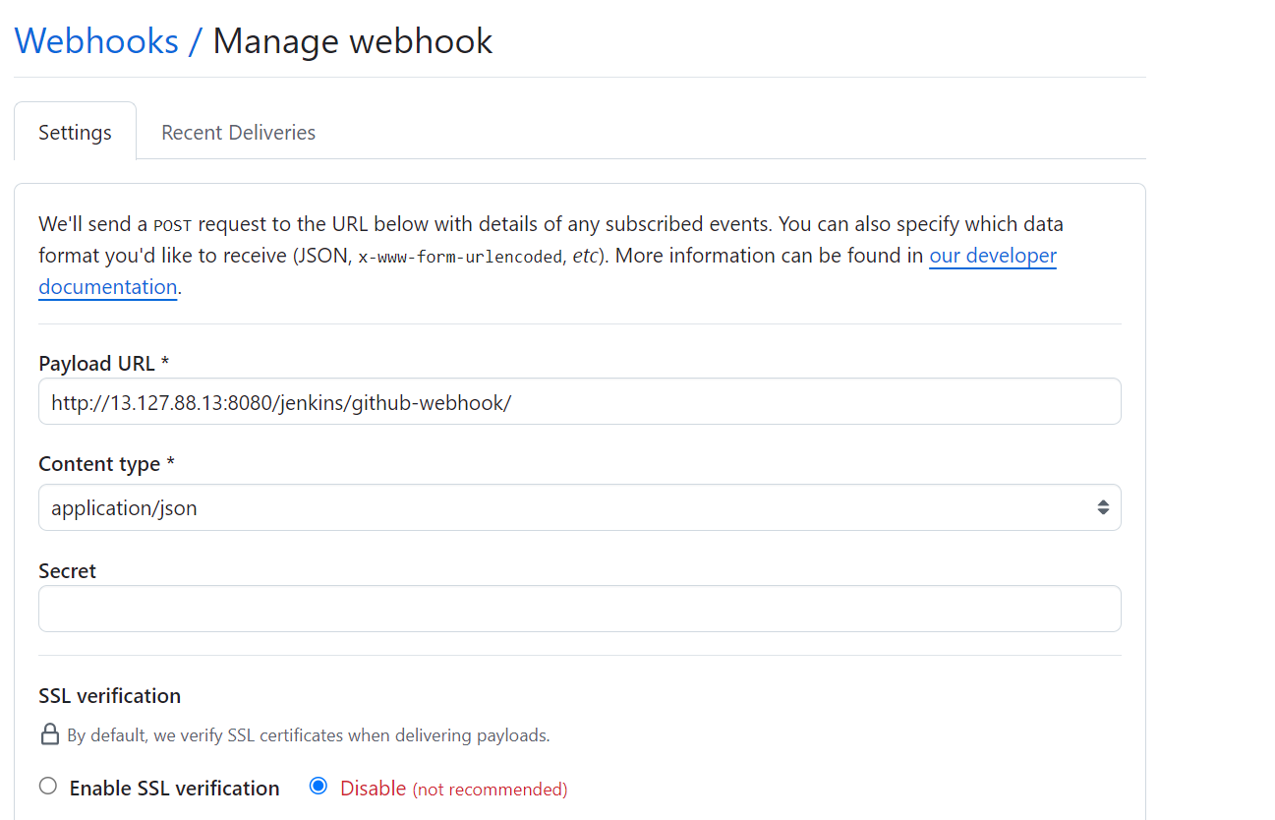

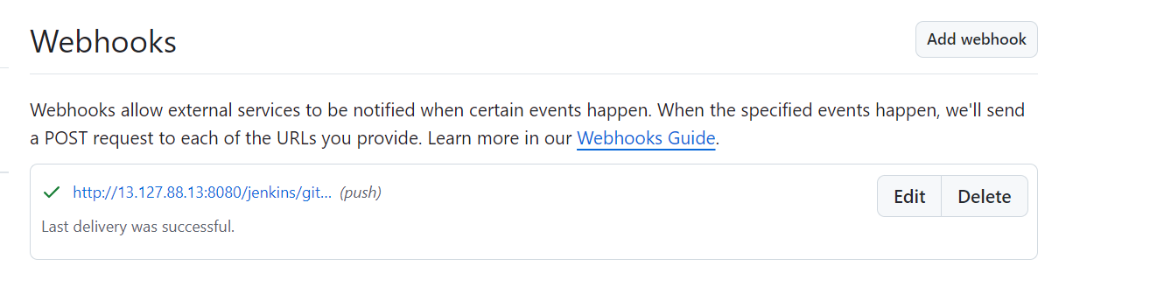

1. Then go to build 1 🡪 configure

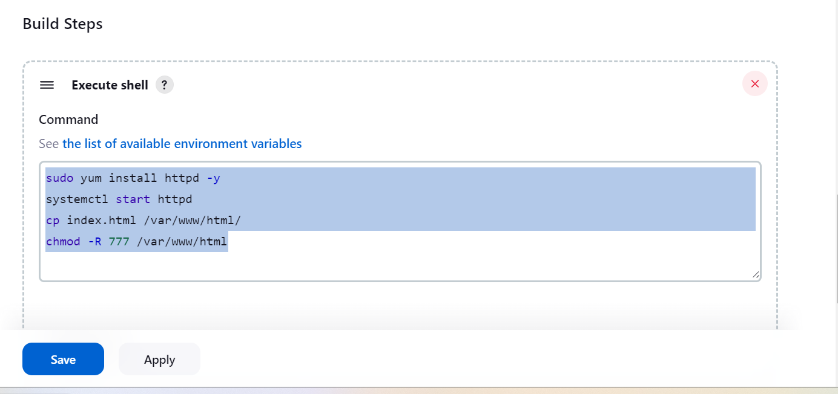

1. Start build

Started by user [Tushar Chavan](http://13.127.88.13:8080/jenkins/user/412tushar)

Running as SYSTEM

Building in workspace /root/.jenkins/workspace/Git-Webhooks for Q1

The recommended git tool is: NONE

using credential Tu

> git rev-parse --resolve-git-dir /root/.jenkins/workspace/Git-Webhooks for Q1/.git # timeout=10

Fetching changes from the remote Git repository

> git config remote.origin.url <https://github.com/tusharchavan412/Riya.git> # timeout=10

Fetching upstream changes from <https://github.com/tusharchavan412/Riya.git>

> git --version # timeout=10

> git --version # 'git version 2.40.1'

using GIT_ASKPASS to set credentials

> git fetch --tags --force --progress -- <https://github.com/tusharchavan412/Riya.git> +refs/heads/*:refs/remotes/origin/* # timeout=10

> git rev-parse refs/remotes/origin/2024Q1^{commit} # timeout=10

Checking out Revision b25bdd6df84ec60b5ba331fd93840211a2135719 (refs/remotes/origin/2024Q1)

> git config core.sparsecheckout # timeout=10

> git checkout -f b25bdd6df84ec60b5ba331fd93840211a2135719 # timeout=10

Commit message: " c1"

First time build. Skipping changelog.

[Git-Webhooks for Q1] $ /bin/sh -xe /mnt/server/apache-tomcat-9.0.96/temp/jenkins12201813185814112642.sh

+ sudo yum install httpd -y

Loaded plugins: extras_suggestions, langpacks, priorities, update-motd

Package httpd-2.4.62-1.amzn2.0.2.x86_64 already installed and latest version

Nothing to do

+ systemctl start httpd

+ cp index.html /var/www/html/

+ chmod -R 777 /var/www/html

Finished: SUCCESS

1. After hit IP address

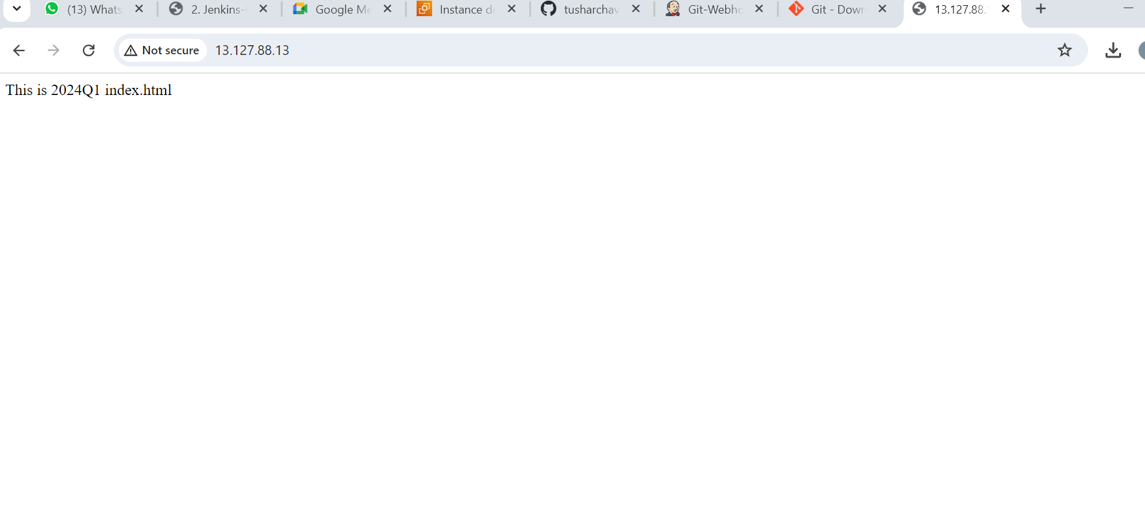

1. Create another job and follow same process

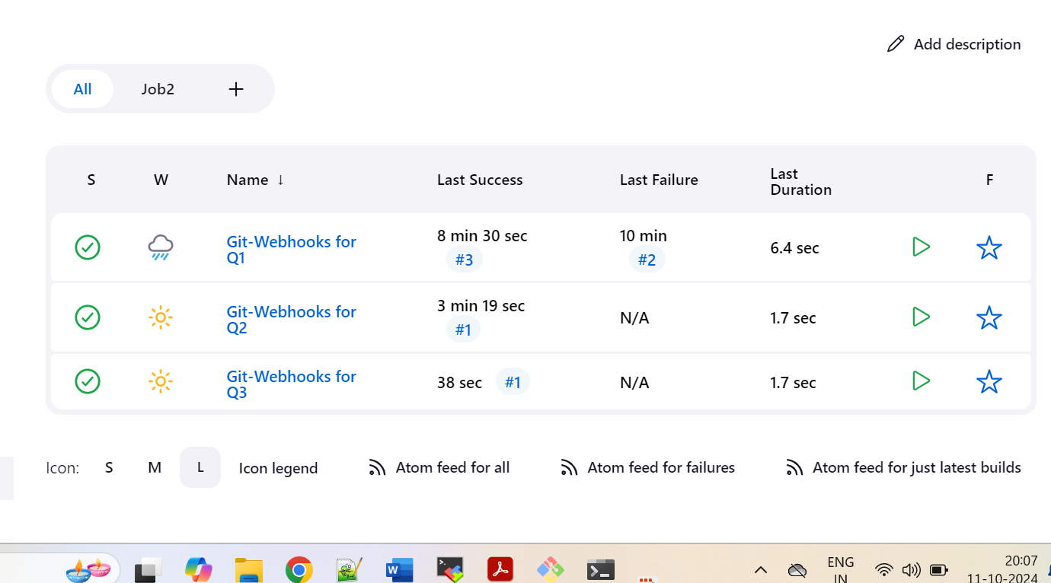

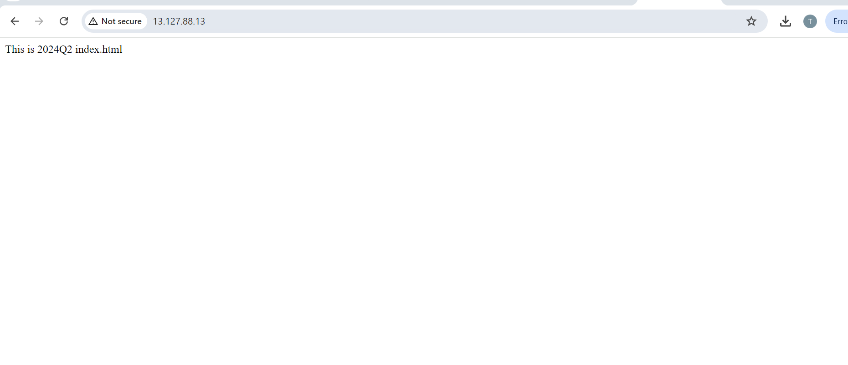

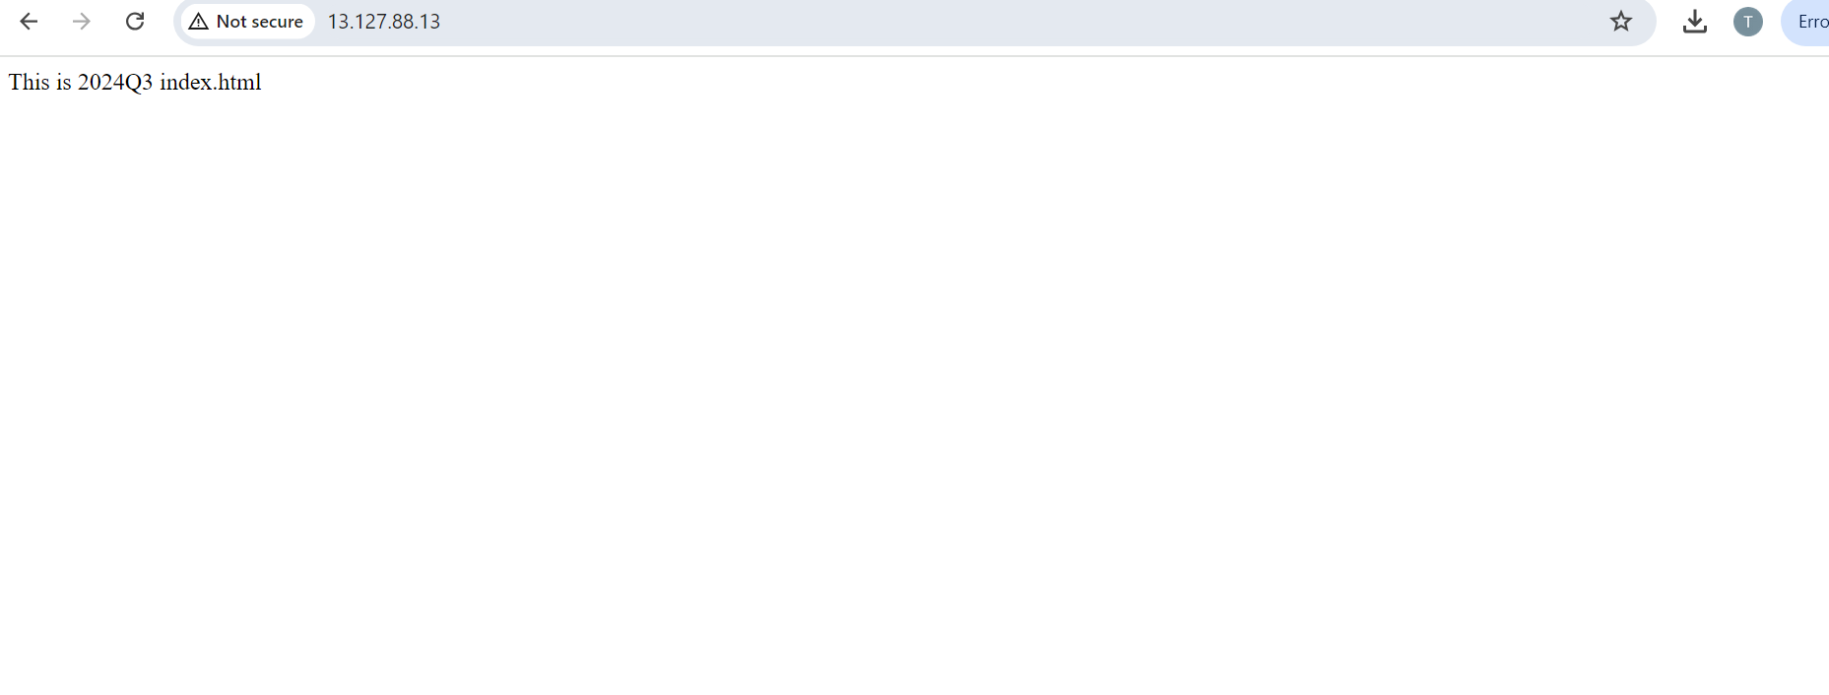

1. After some change on Github repos then refresh

