Name:Tushar Wankhede.  
1).Delete the Item from cart

2)Updating the quantity of item in the cart:  
  
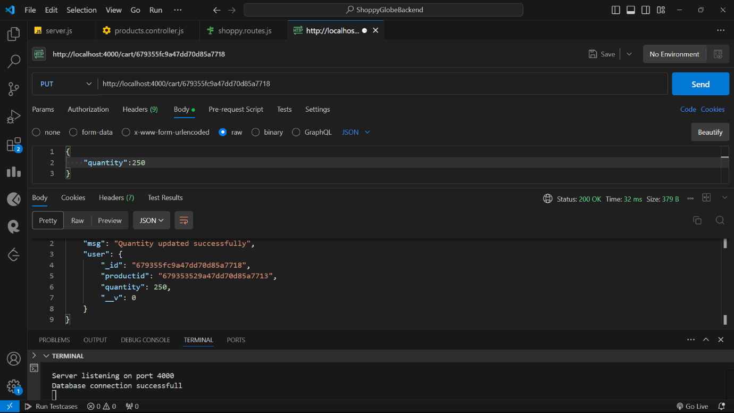

3)Adding the item in the cart  
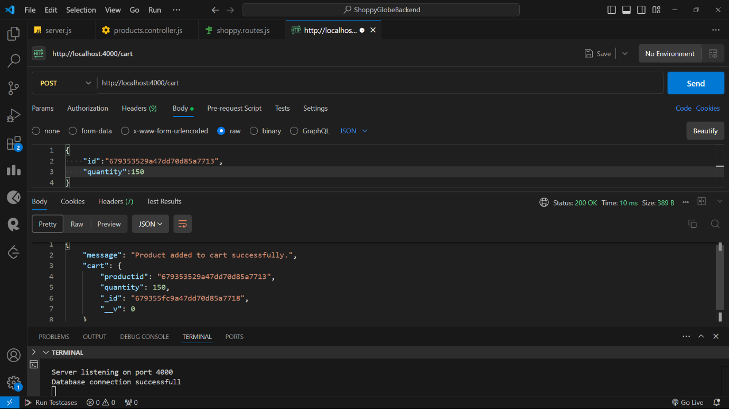  
  
  
4)Get the product based on the ID: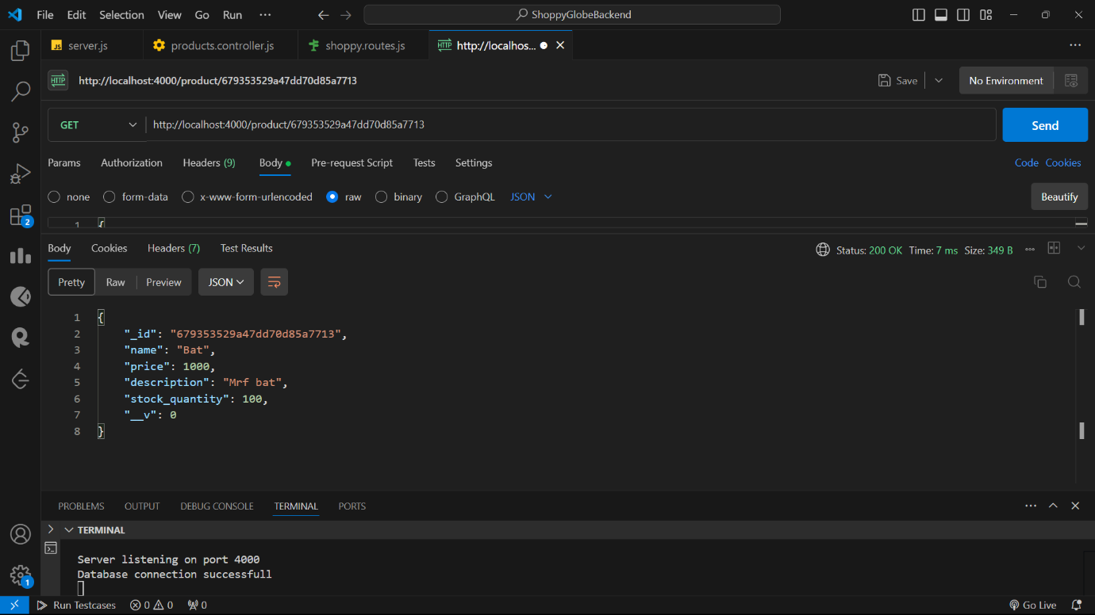

5)Get all the product:  
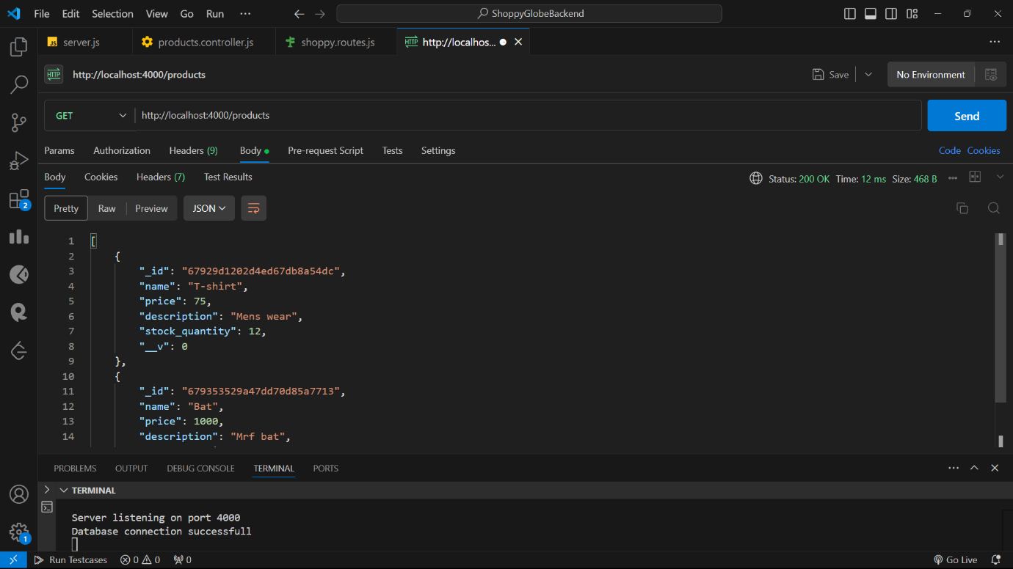  
  
6)Add the product in the products collections: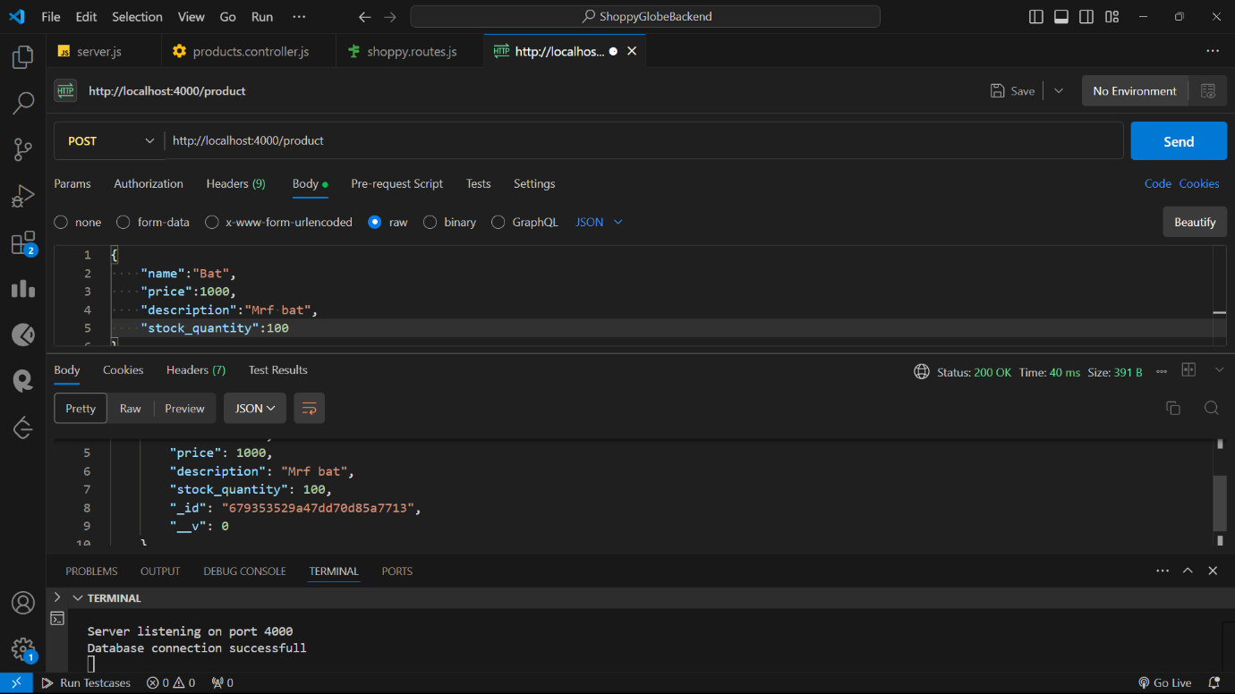

7)Register the user:

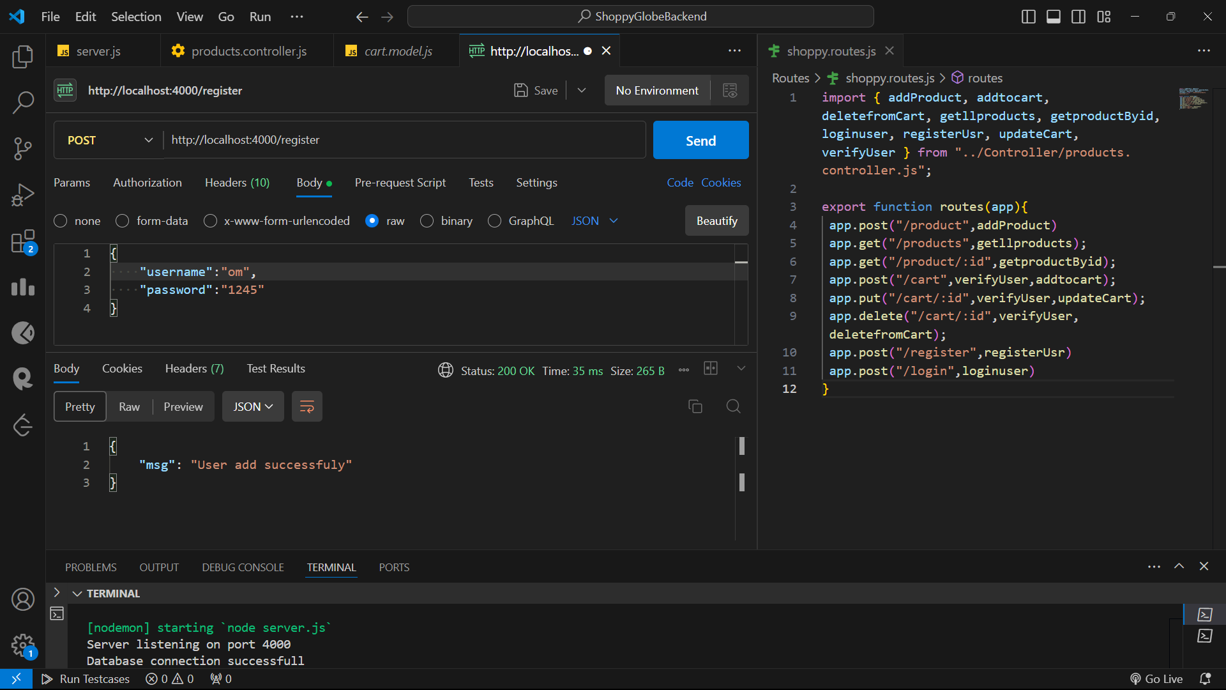

8)Login with user:

