0..Count at Main Java
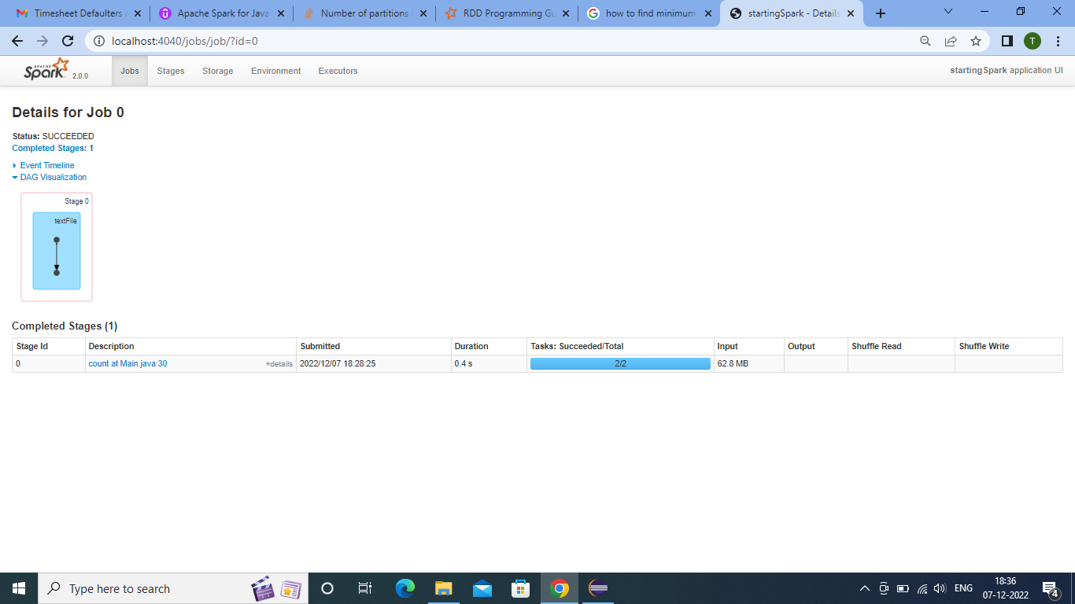
- The Data is read frim File.
- Two partitions are being created at this process
- It takes 0.4s duration.
- The process is completing in one stage.
- The size input is 62.8mb

1..For each at Main Java

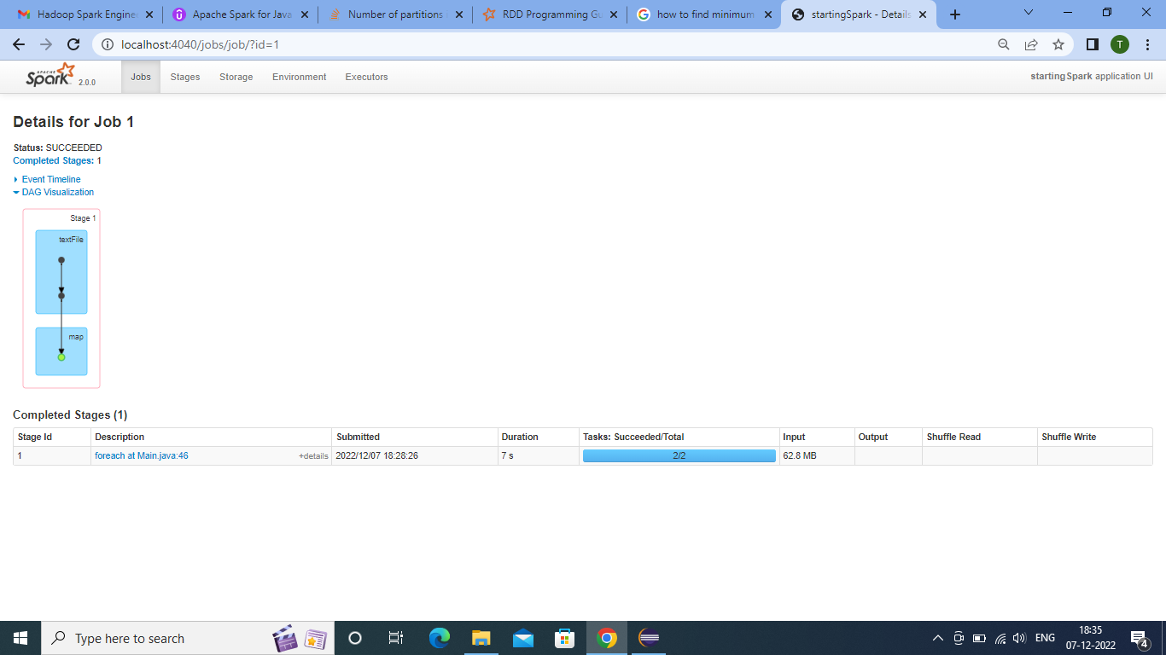
- That Data is already saved in Java RDD.
- One action is Called here for for each .
- Which is reading all the line sof file.
- The number of partitions is two.
- The duration of process is 0.2s.
- The input data is of 62.8 mb.
- And the cache is used at this stage.

2..Count at main number of records

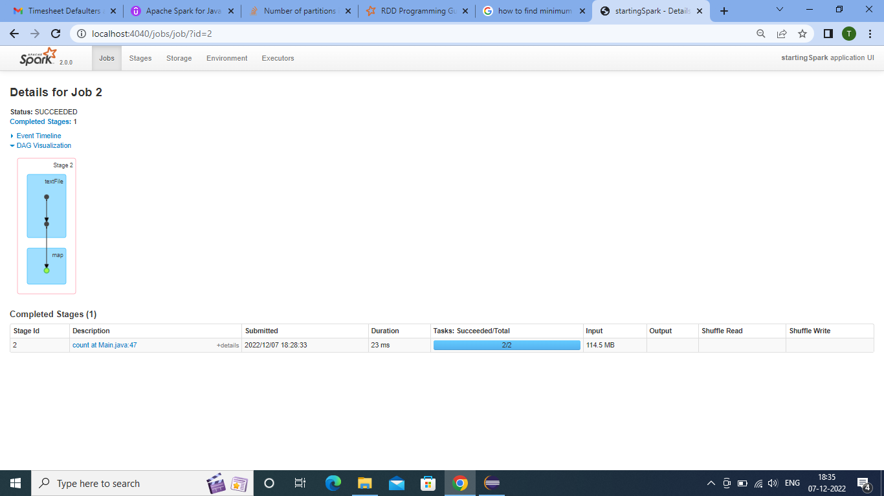
- Here we can see increased in input Data which is 114.5 mb
- But the duration is rduced to 23 ms because as we have used cashe.
- Here Count action is executed and giving the count of records.
- Direction of Dag is showing execution plan.

3..Count at Main Java without Numeric
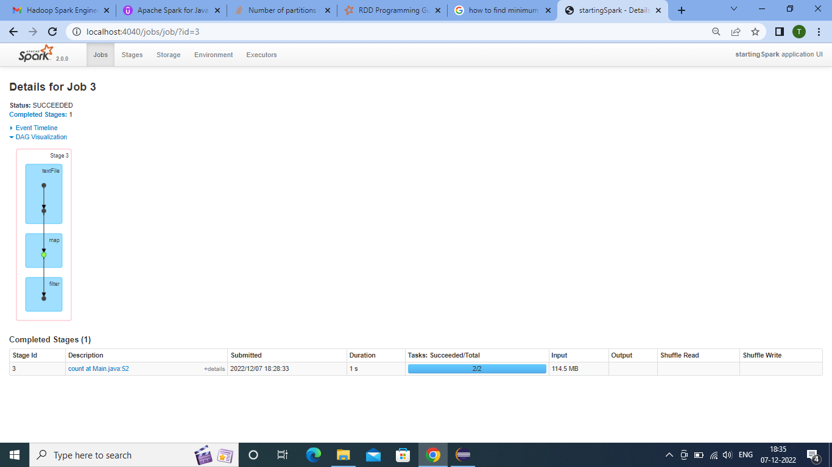
- Here is the Data is Filtered with which doesn't contains the numbers.
- And Giving the number of records without numeric.
- Number of partitions present is 2.
- It is executed in 1s.
- The Data size is
4.The count of words movie
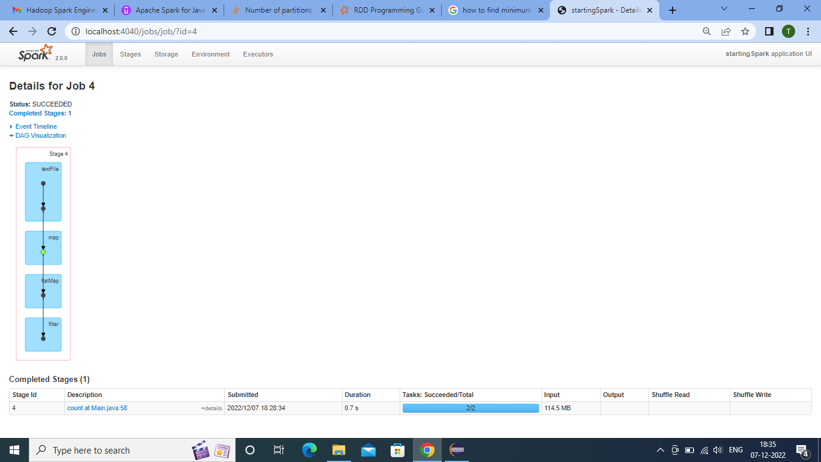
*Here the Data which ia mapped in Java RDD is with the help of Flatmap converted into words.
*Then by the use of filter find all the words matching movie
*And then count is printed
* It takes 0.7s.

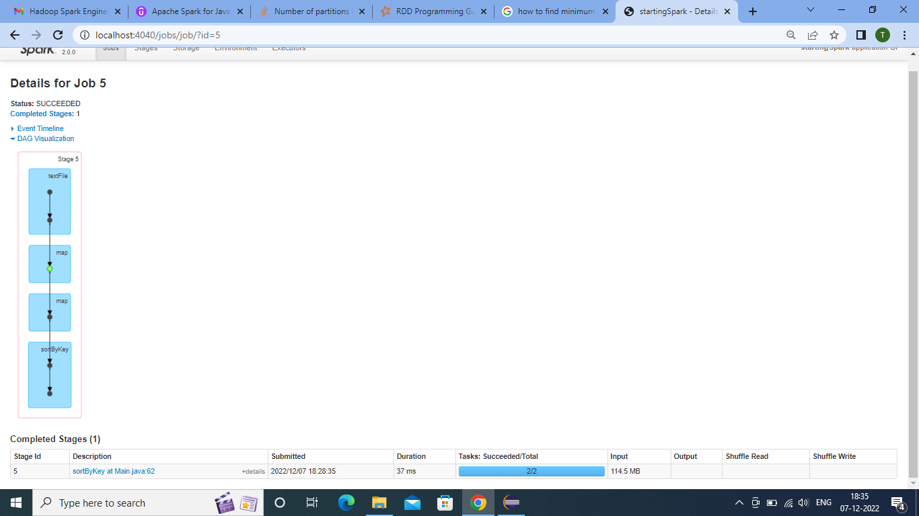
5.SortbyKey for Minimum length of of Line
*Here the Data which maped in Key value pair is sorted with keys.
- With the help of sort by finding the minimum length of records.
- A new Job is created at this stage.
- The duration of execution is
- The size of data is still same 114.5 mb .
6.First at main Java
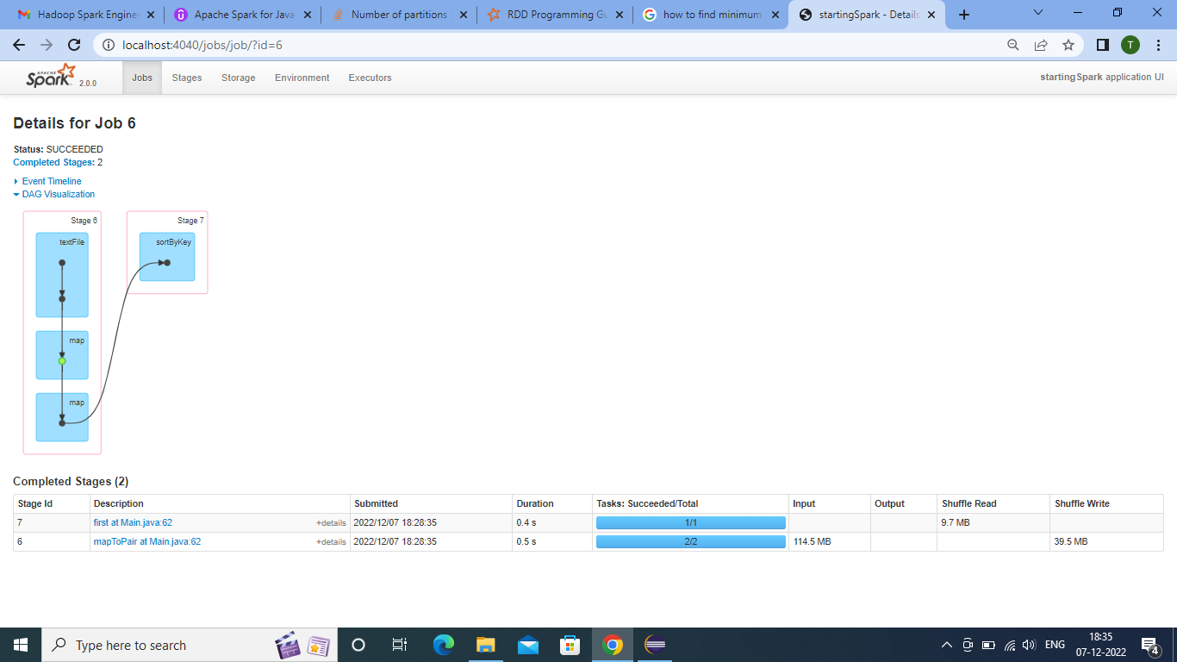

  - At this stage it is executing in two stages one sis for map and other is for first.
  - The data is shuffled
  - And then again the execution plan is ponting towards the sortbykey.
  - The total time is 0.9s – 1s.
7.Sort bykey at main
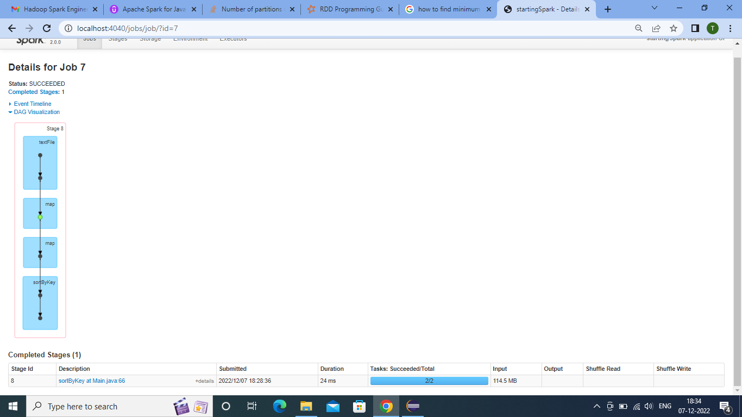
  - From here we can observe that the numbe rof partitions is still two.
  - And which is outputting the actual values of maximum and minimum values of length of records with the help of sortbykey.
  - The mappped data is used for the execution of these actions.
  - It takes 24ms.
  - It takes input of 114mb with two partitions.
8.Writting File, giving TAT on localhost , First at main
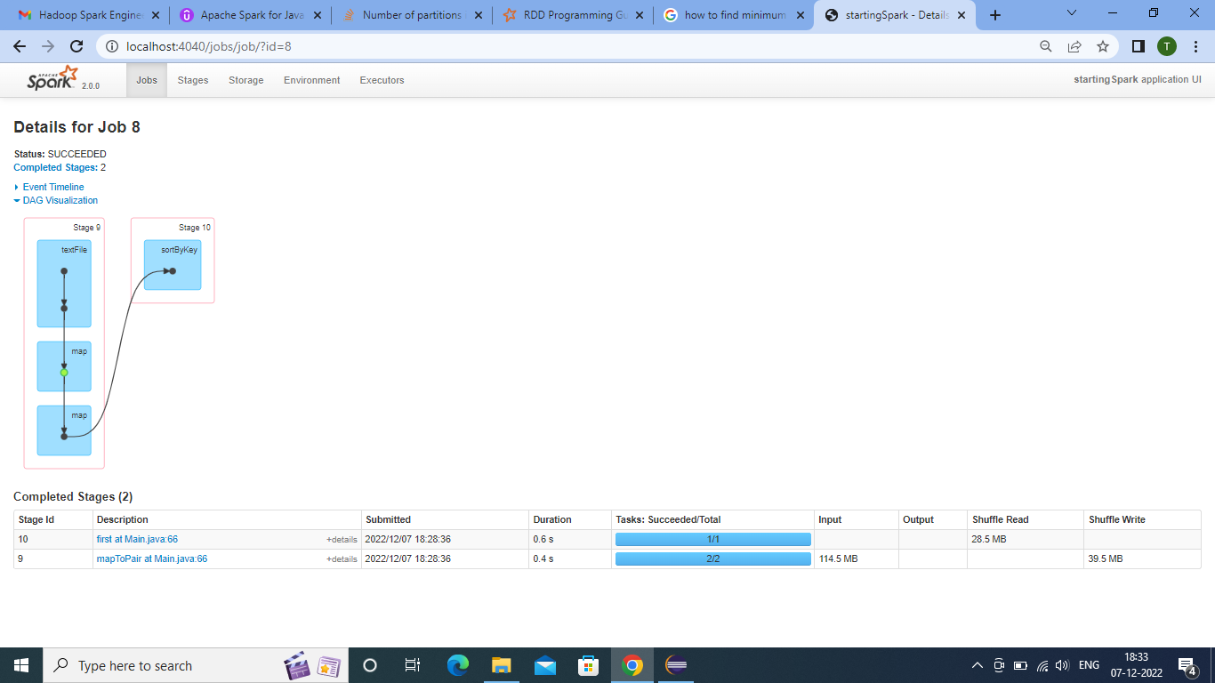
  - Here the file is written on the given path .
  - With the help of Localhost : 4040 The Dags are created for all the stages and actions.
  - This had done by running the scanner
  - At last the program is stopped manually.

