**Task : Create Invoice by using Quickbooks API**

Step 1: Go through this website and explore its features

Link: <https://developer.intuit.com/app/developer/qbo/docs/develop>

Step 2: Go to API explorer Section and search for Invoice API

Link: https://developer.intuit.com/app/developer/qbo/docs/api/accounting/all-entities/invoice

Step 3: Go to Create an Invoice section and read about it . E.g.- Request body and returns

Step 4: Now , Set up Oauth 2.0 following are its step:

For generation of Oauth keys (Client ID and Client Secret), Access token, Realm ID

1. Create an Intuit Account on - <https://accounts.intuit.com/>
2. Click on Dashboard to create an app.
3. When you create your app, select the QuickBooks Online Accounting scope.

1. A screenshot of a computer

   Description automatically generatedClick over the created app you will find Keys and Credentials option in Development settings.
2. Copy Client Id and Client Secret , Then click on Oauth 2.0 Playground

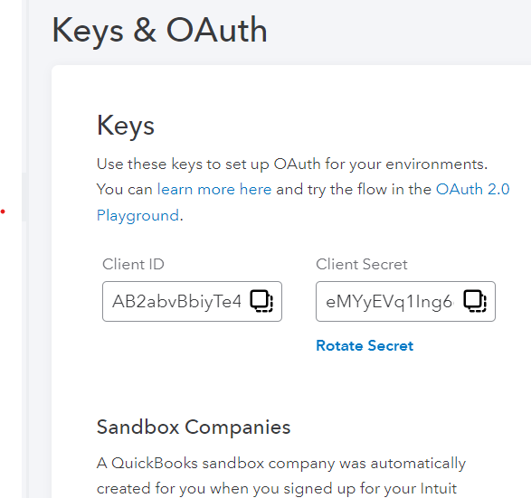

1. Get authorization Code, Select your company ,which generates Realm Id

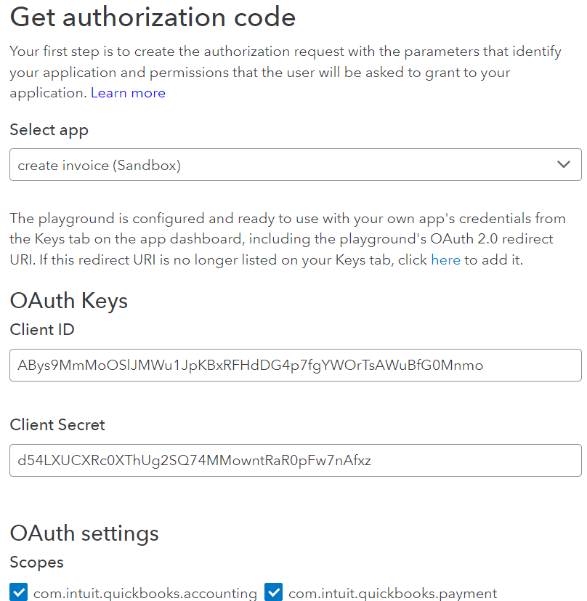

1. 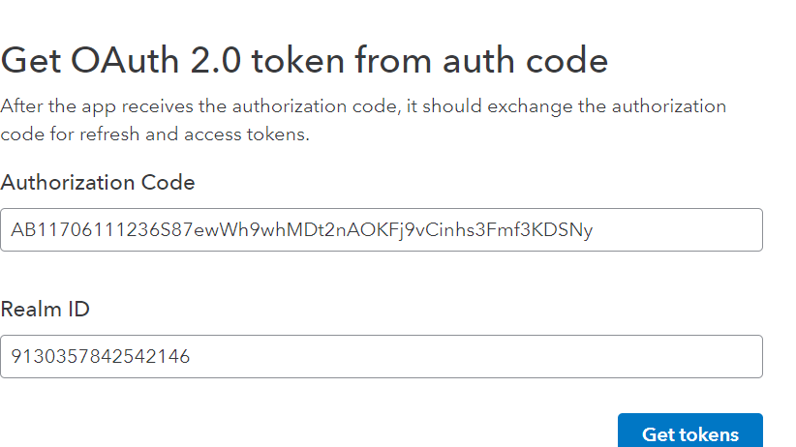Click on get token to generate Access Token which will produce the below output, copy the access token from there . This access token will expires in 60 minutes. You have to generate it again

Now you can use these credentials to create an API which will create invoice in quickbook.

It also provides request body to use while hitting your post api to request quickbook api to create invoice by using access token and use axios library for this.

Below json code use as body while hitting api :

{

"Line": [

{

"Amount": 160,

"DetailType": "SalesItemLineDetail",

"SalesItemLineDetail": {

"Qty": 1,

"ItemRef": {

"value": "19"

}

}

}

],

"CustomerRef": {

"value": "58"

}

}

