Create an Admin User with IAM (AWS)

Go to AWS Console search For IAM and open the Service

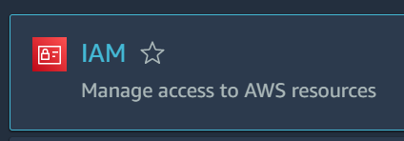

After that click on Users, select Add Users

Now give username for that User

In AWS Credential Type Select Password- AWS Management Console Access



Use Custom Password & Unselect checkbox for require password reset

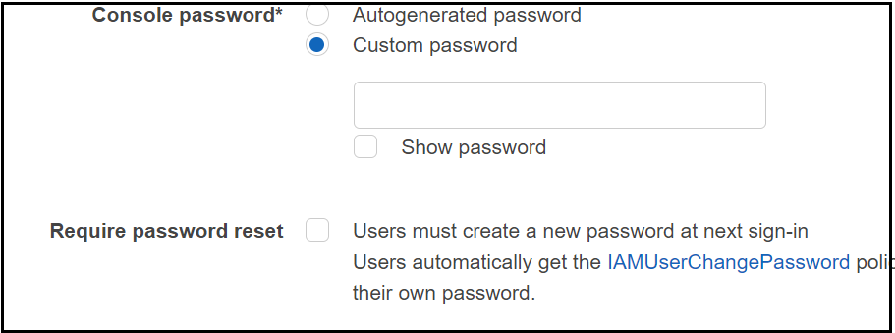

After that Click on Next

Now in Set Permissions select Attach Existing Policies Directly

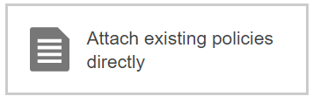

In Policies select Administrator Access



Click on Next Tags

We are using tags as key(role)=Value(tester), You can give anything as per your needs

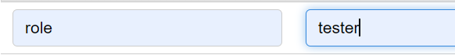

After that Click on Next & Click on Create User

Your IAM Admin User is Successfully Created

To access the user, go to IAM & then users click on your username

Go to security Credentials & Console-sign in link Given in the summary



Enter your Username & Password & click on Sign in.

Now you can use your IAM user with all Access except Billing Dashboard.

Note: - It is very necessary to not use your root user account for any services, the best practices always suggest to create a new user admin user by Admin.