Bluestock Mutual Fund Analytics Capstone Project
Executive Summary
The Indian mutual fund industry has witnessed significant growth in recent years, driven by increasing investor participation, rising SIP contributions, and growing awareness of market-linked investment products. This project was developed to analyze mutual fund industry trends, evaluate fund performance, study investor behavior, and create an interactive analytics dashboard for business insights.
The project involved data cleaning, database creation using SQLite, SQL-based analysis, exploratory data analysis (EDA), and dashboard development using Power BI. Multiple datasets related to mutual funds, fund houses, investor transactions, SIP inflows, and benchmark indices were analyzed to identify trends and performance patterns.
The final deliverable is a four-page Power BI dashboard that provides insights into industry growth, fund performance, investor analytics, and SIP market trends.

1. Introduction
Problem Statement
Mutual fund companies and investors generate large amounts of data related to assets under management, transactions, SIP contributions, portfolio holdings, and fund performance. However, raw data alone does not provide actionable insights.
The objective of this project is to transform raw mutual fund datasets into meaningful business intelligence that can support investment analysis and decision-making.
Project Objectives
- Analyze mutual fund industry growth.
- Evaluate fund performance and risk metrics.
- Study investor behavior and transaction patterns.
- Analyze SIP inflows and market trends.
- Build an interactive dashboard for stakeholders.

2. Data Sources
The project uses ten datasets representing different areas of the mutual fund ecosystem.
Dataset | Purpose
Fund Master | Scheme information and metadata
NAV History | Historical Net Asset Value data
AUM by Fund House | Assets under Management analysis
Monthly SIP Inflows | SIP growth trends
Category Inflows | Category-level investment patterns
Industry Folio Count | Investor participation analysis
Scheme Performance | Returns and risk metrics
Investor Transactions | Transaction analysis
Portfolio Holdings | Portfolio composition
Benchmark Indices | Market comparison

3. ETL Design
Extract
All datasets were imported into Python using Pandas.
Activities performed:
- Dataset loading
- Schema validation
- Initial profiling
Transform
Data quality checks were performed.
Transformation steps included:
- Missing value analysis
- Duplicate record removal
- Date format standardization
- Data type correction
- Consistency checks
Load
The cleaned datasets were:
- Exported to processed CSV files
- Loaded into SQLite database tables
- Used for SQL analysis and dashboard reporting

4. Database Design
SQLite was used as the analytical database.
Main tables created:
- fund_master
- nav_history
- aum_by_fund_house
- monthly_sip_inflows
- category_inflows
- industry_folio_count
- scheme_performance
- investor_transactions
- portfolio_holdings
- benchmark_indices
The database enabled structured querying and simplified analytical workflows.
Before performing analysis, data quality checks were conducted to ensure reliability and consistency across all datasets.

The following validations were performed:

• Missing Value Analysis
• Duplicate Record Detection
• Data Type Validation
• Date Standardization
• Outlier Detection
• Column Consistency Checks

5. SQL Analysis
Several SQL queries were developed to answer business questions.
Examples include:
Query 1
Top fund houses by Assets Under Management.
Query 2
Top-performing mutual fund schemes.
Query 3
Monthly SIP contribution trends.
Query 4
Category-wise inflow analysis.
Query 5
Investor transaction analysis by geography.
Query 6
Benchmark comparison analysis.
SQL outputs were used to validate trends observed in Power BI.
Data cleaning was a critical step because inconsistencies in financial datasets can lead to misleading insights.

The following transformations were applied:

1. Null Value Handling
2. Duplicate Removal
3. Date Conversion
4. Column Standardization
5. Validation of Numeric Fields
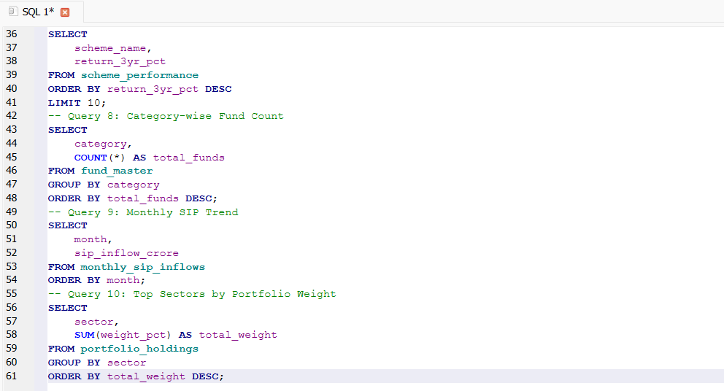

6. Exploratory Data Analysis (EDA)
Industry Growth Analysis
The industry AUM trend indicates continued growth in mutual fund adoption.
Key Observation:
- Industry assets increased steadily across the analysis period.
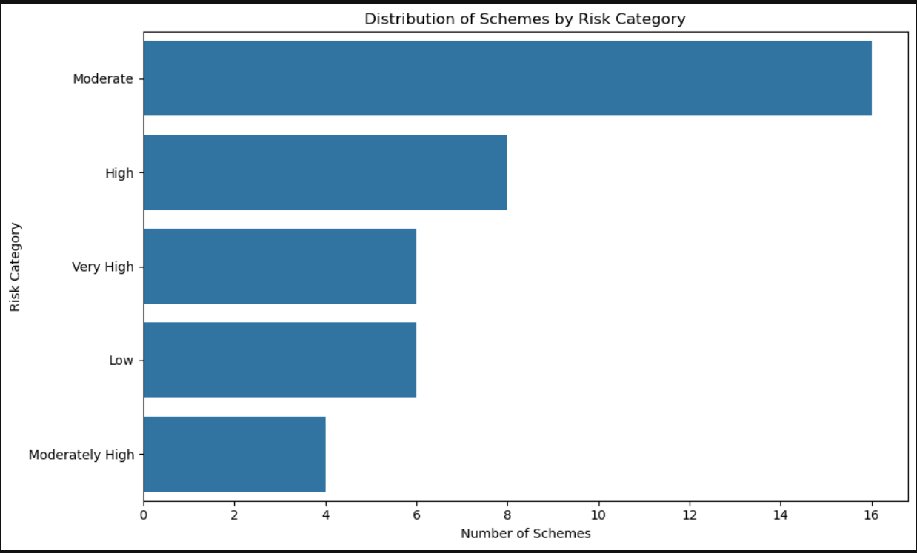
SIP Analysis
Monthly SIP contributions show increasing investor participation.
Key Observation:
- SIP inflows remained resilient despite market fluctuations.
- 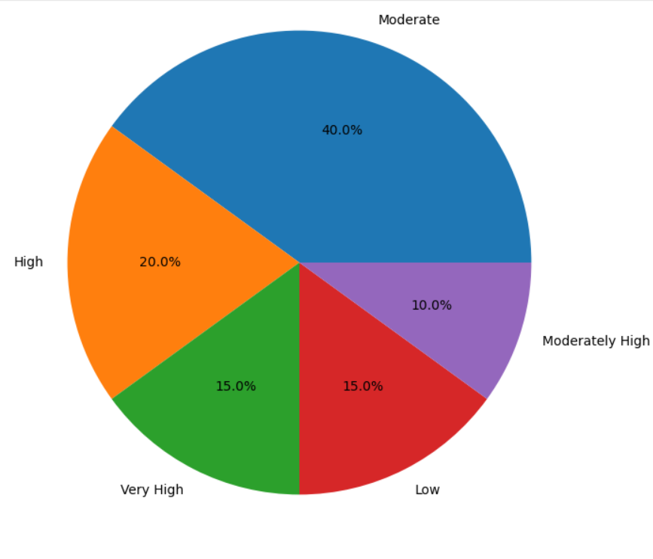
AMC Analysis
AUM distribution highlights concentration among major fund houses.
Key Observation:
- A limited number of AMCs account for a significant share of total assets.
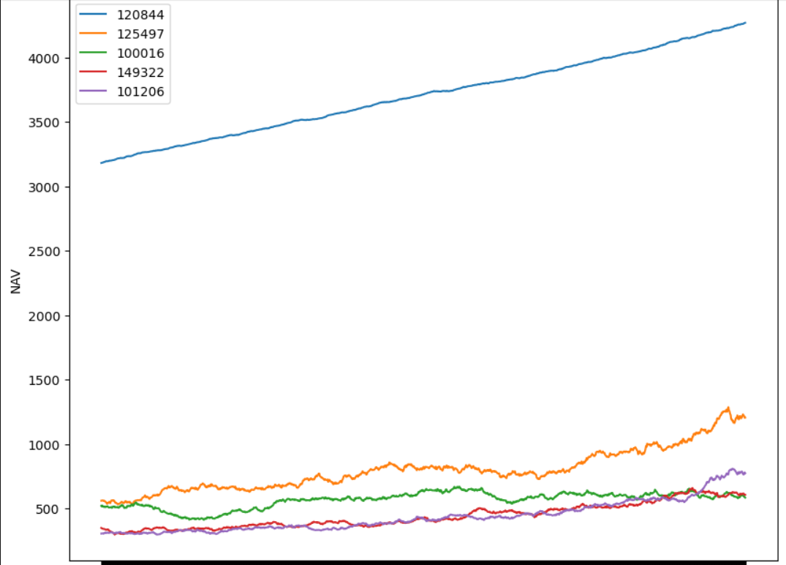
Risk Analysis
Risk categories were analyzed to understand fund volatility.
Key Observation:
- Higher-return funds generally exhibit higher risk levels.
- 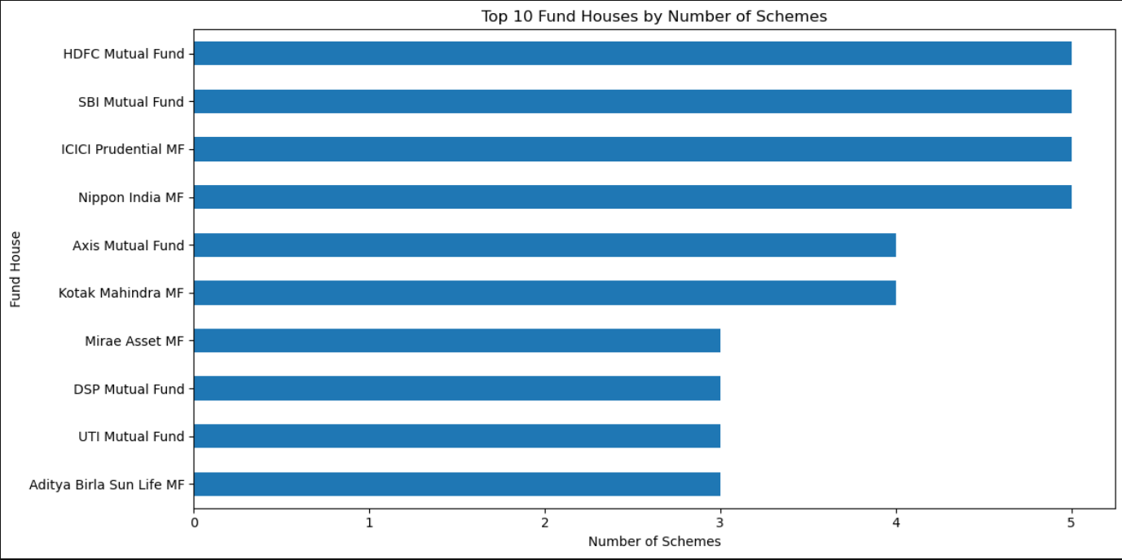

7. Performance Analysis
Fund performance was evaluated using return and risk metrics.
Metrics analyzed:
- Annualized Return
- Standard Deviation
- Sharpe Ratio
- NAV Growth
Key Findings:
- Some funds delivered strong risk-adjusted performance.
- Sharpe Ratio provided better insight than return alone.
- Risk-return tradeoffs varied significantly across categorie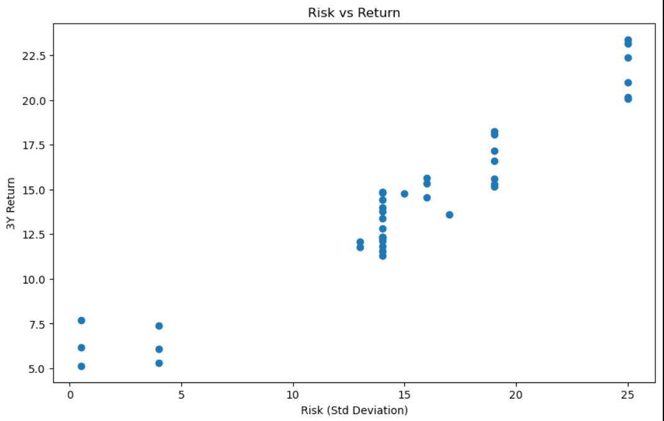

8. Power BI Dashboard
Detailed Dashboard Analysis
Dashboard Design Philosophy
The dashboard was designed to provide stakeholders with a comprehensive and interactive view of mutual fund industry performance.
The design focused on three principles:
- Simplicity
- Business Relevance
- Actionable Insights
The dashboard consists of four analytical pages.

Page 1: Industry Overview
The Industry Overview page provides a high-level summary of mutual fund industry performance.
KPIs Included
- Total AUM
- SIP Inflows
- Industry Folios
- Active Schemes
Business Value
This page enables executives and analysts to quickly assess overall industry growth and market participation.
Key Insights
- Industry assets continue to expand.
- SIP participation remains strong.
- Investor adoption has increased steadily.
- Mutual fund penetration continues to improve. 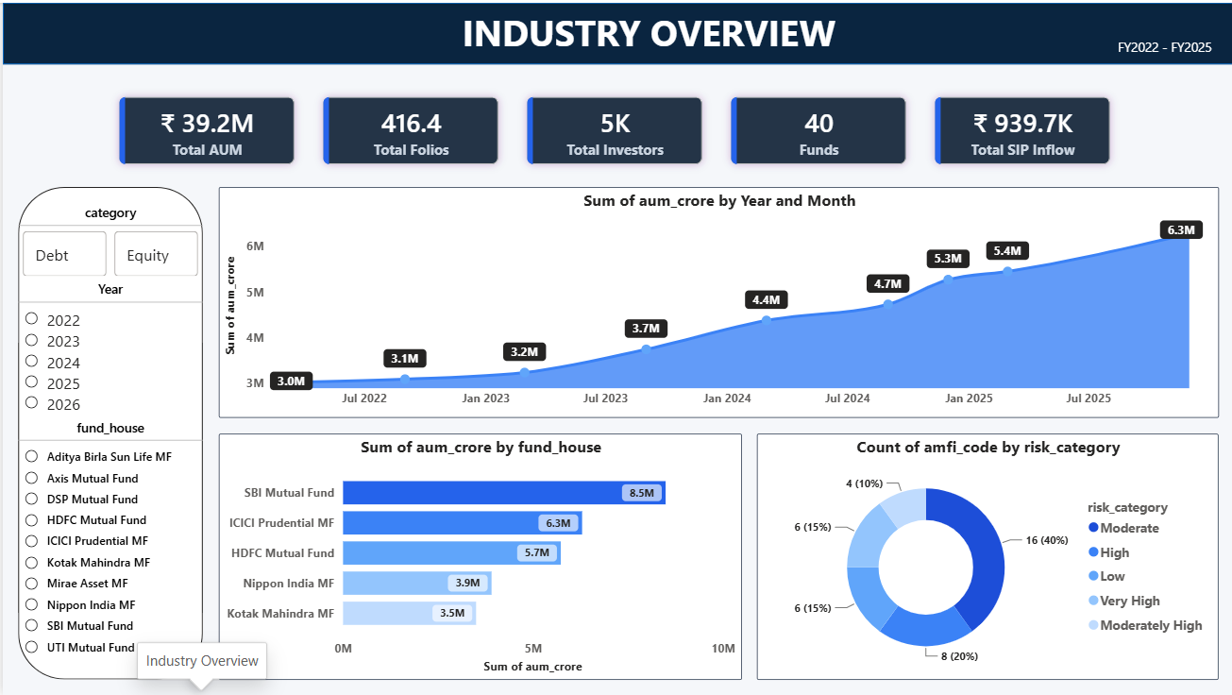

Page 2: Fund Performance
The Fund Performance page focuses on evaluating risk-adjusted investment performance.
Visualizations Included
- Risk vs Return Scatter Plot
- Fund Scorecard Table
- NAV Trend Analysis
- Benchmark Comparison
Business Value
Investors and analysts can identify high-performing schemes and compare risk-return characteristics across funds.
Key Insights
- Higher-return funds generally exhibit greater volatility.
- Certain schemes deliver superior risk-adjusted returns.
- Benchmark comparisons highlight fund management effectiveness. 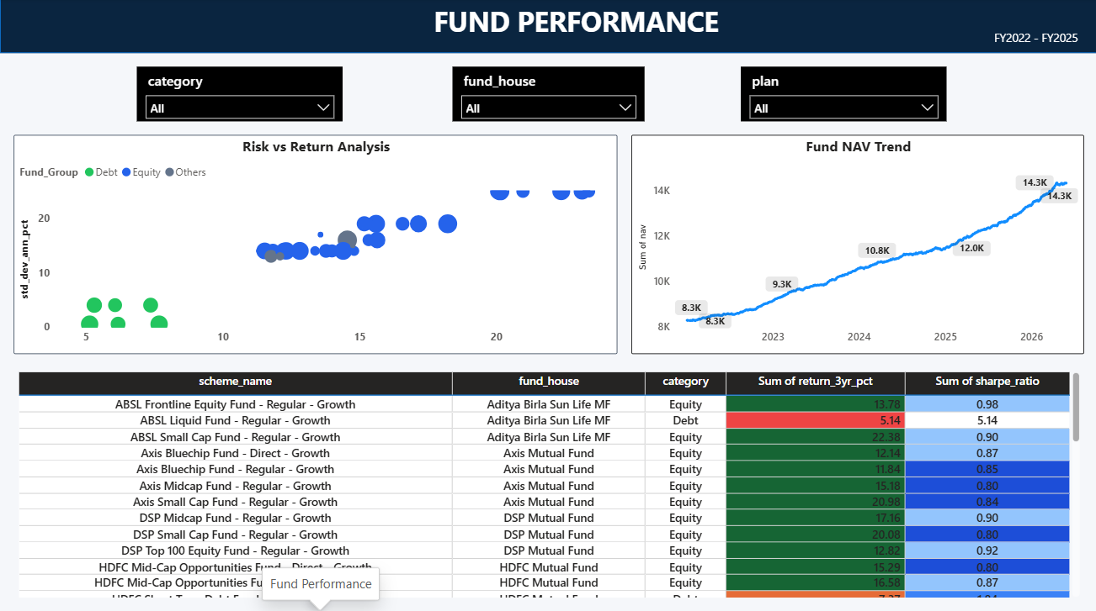

Page 3: Investor Analytics
The Investor Analytics page focuses on investor behavior and transaction patterns.
Visualizations Included
- State-wise Transaction Analysis
- SIP vs Lumpsum Distribution
- Age Group Analysis
- Monthly Transaction Trends
Business Value
This page helps stakeholders understand investor demographics and investment preferences.
Key Insights
- Investor participation varies significantly by geography.
- SIP investments account for a substantial portion of transactions.
- Younger age groups are increasingly active investors.
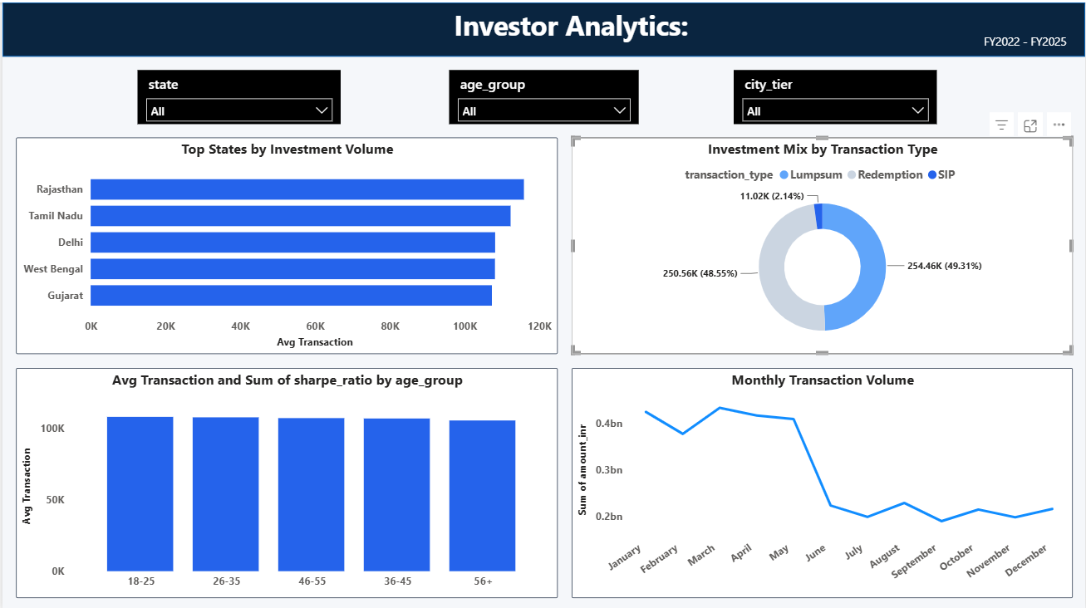

Page 4: SIP and Market Trends
The final dashboard page focuses on understanding the relationship between SIP participation and market performance.
Visualizations Included
- SIP Inflow vs Nifty Trend
- Category Inflow Heatmap
- Top Categories by Net Inflow
- SIP Growth KPIs
Business Value
This page helps identify relationships between investor behavior and market conditions.
Key Insights
- SIP participation remains resilient during market fluctuations.
- Certain categories consistently attract investor capital.
- Long-term investing behavior appears increasingly common. 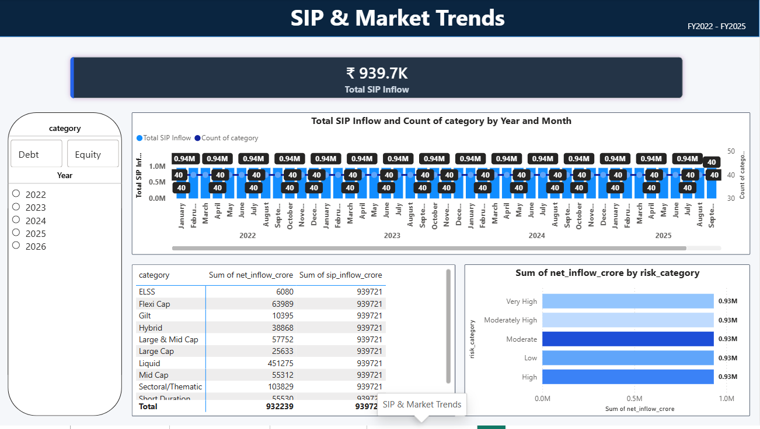

9. Key Findings
- Mutual fund industry assets have grown consistently.
- SIP participation continues to increase year over year.
- Large AMCs dominate total industry AUM.
- Higher returns are generally associated with higher volatility.
- Investors aged 26–35 contribute significantly to SIP investments.
- Certain fund categories attract a majority of net inflows.
- Market performance influences investor participation trends.

10. Limitations
- Dataset represents a limited sample of industry activity.
- Real-time NAV data was not integrated.
- Some analyses rely on historical information only.
- Advanced forecasting models were outside the project scope.

11. Recommendations
- Integrate live NAV APIs for real-time monitoring.
- Develop automated ETL pipelines.
- Build a recommendation engine for investors.
- Implement predictive analytics for SIP forecasting.
- Enhance dashboard refresh automation.
Project Challenges, Learnings and Business Impact
Challenges Faced
Several challenges were encountered during the project lifecycle.
Data Quality Issues
The datasets contained missing values, duplicate records, inconsistent formats, and varying date structures. Significant effort was required to standardize the data before analysis.
Data Integration Challenges
Multiple datasets had to be linked using common identifiers and dates. Ensuring consistency across datasets required extensive validation.
Dashboard Design Challenges
Designing a dashboard that was both visually appealing and analytically useful required multiple iterations. Visual clutter had to be minimized while retaining important information.
Performance Considerations
Large datasets and multiple visualizations required optimization to maintain dashboard responsiveness.

Key Learnings
The project provided hands-on experience across multiple areas of data analytics.
Data Engineering
- ETL pipeline design
- Data validation
- Data cleaning methodologies
Database Management
- SQLite implementation
- Schema design
- SQL query optimization
Data Analysis
- Exploratory Data Analysis
- Risk-return evaluation
- Trend analysis
Business Intelligence
- Dashboard development
- KPI design
- Interactive reporting

Business Impact
The completed solution can provide measurable value to multiple stakeholders.
Asset Management Companies
- Monitor industry growth
- Evaluate fund performance
- Identify market opportunities
Financial Analysts
- Compare risk-adjusted returns
- Monitor category performance
- Analyze investment trends
Investors
- Evaluate investment options
- Understand market dynamics
- Track SIP performance
Senior Management
- Access centralized reporting
- Improve strategic decision-making
- Monitor industry developments efficiently

Overall Project Outcome
The project successfully transformed fragmented mutual fund datasets into a centralized analytics platform. The final solution combines data engineering, database management, SQL analytics, and business intelligence to provide actionable insights for decision-makers.
The project demonstrates the practical application of modern data analytics techniques within the financial services industry and provides a strong foundation for future enhancements such as predictive analytics, recommendation systems, and real-time reporting.

12. Conclusion
This project demonstrates an end-to-end data analytics workflow using Python, SQLite, SQL, and Power BI.
The solution successfully transformed raw mutual fund datasets into actionable business insights through data cleaning, analytical modeling, SQL querying, and dashboard visualization. The resulting dashboard enables stakeholders to monitor industry growth, evaluate fund performance, understand investor behavior, and analyze SIP market trends effectively.

