**Project Title:** Team Number: - **114**

**D_LearnEnglish**

**Objective:**

This is android based app specially designed for aakash tablet.

This app is help full to learn English for the students of middle and high school.

**Working:**

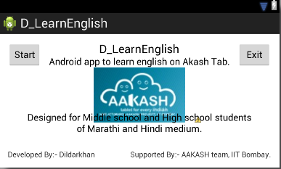 After start the application on aakash tablet click on start button of left corner.

It shows the level like this

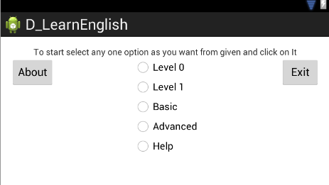

Select any on level by clicking on them and it will start tour of that.

Each level has multiple activities and to go from to other click on next button.

Level 0:

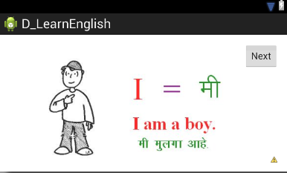

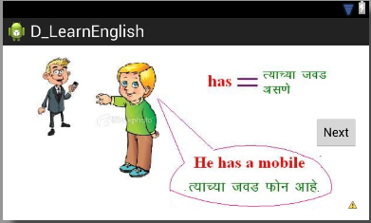Level 1:

Basic :

In basic level there is test like fill in the blanks.

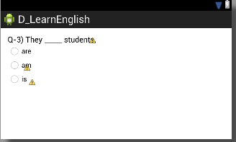

Advanced:

This will direct link to online reference of learn English that may be presentation or video’s

**Installation:**

It is simple to install on android device.

1. Double click on D_LearnEnglish.apk and click on package installer.
2. Then click on install button
3. After completion of installation click on done button.
4. The application is ready to use.

**Important links:**

Video on youtube describes how to use this application.

<http://www.youtube.com/watch?v=xFWTiaLG_vo&feature=youtu.be>

User Manual