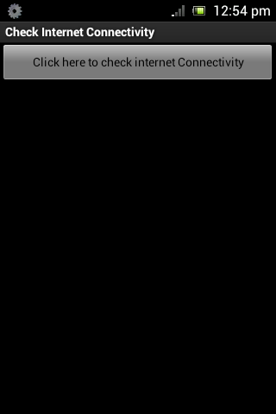

Figure1: Front end of Check Internet Connectivity App.

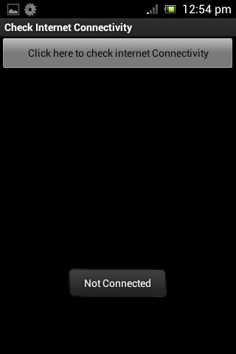

Figure2: It shows the device is not connected with internet by pressing the “click here to check internet connectivity” button.

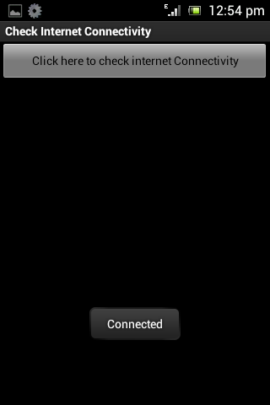

Figure3: It shows the device is connected with internet by pressing the “click here to check internet connectivity” button.