Software Requirement Specification (SRS)

**SECURITY MANAGEMENT(ARCANE)**

OBJECTIVE **/** VISION:

Due to busy life style we can’t remember all credential data like all Mail-ID, passwords, bank account numbers, Bank Details, LIC numbers, PAN numbers, Driving License numbers, Other Certificates’ details etc. So here arises the aim of our project to develop a Highly Confidential Security Android application to store all the confidential data in human unreadable formats in single credentials

EXISTING APPLICATION:

There are many android applications in the market that are used to lock or hide the important or confidential information on the device from others. But it is a basic functionality of the application which can just provide a security code or lock password. Also there is no guarantee provided for the data if the application is corrupted. Also the security is not achieved if any one successfully attempts to unlock the application. Once it is unlocked, then the unauthorized users can modify the data where the details are directly available.

# 

PROPOSED APPLICATION:

It is an Android application which can hold user sign in information, and the important details as provided by the user. This application mainly focuses on various kinds of enhanced services for the benefit and well being of users’ secrecy. It provides the data backup for the information which can be retained in anonymous failures resulting in losing the application from the device. It stores the information in a well build, unbreakable human unreadable structures. The application provides security at various levels. It is completely user friendly application as it reduces the burden on the user. This application provides various ease and feels for the users.

OPTIONAL FEATURES:

* Professional look and feel.
* Difficult to break the functionality of the application without authentication.
* User managing facility.
* Secure access of the confidential data.
* Flexible service based architecture.
* Highly desirable for future extension of the application.
* Best code format writers and readers

USERS:

The only users of this application are the Android phone users as Android has the key role in providing basement for the application since it is specially designed for the Android Mobiles as they are emerging into the market with great speed and attracting almost all categories of mobile phone users.

MODULES:

The total application is developed under several modules that can be listed as:

* User Module
* Storing Information
* Creating and Reading Code
* Managing the Information

MODULE DESCRIPTION:

**User Module:**

This module mainly focuses on the user registration based on which the user can sign in into the application and later can create new files to store the information and also can manage them. Thus the user can make changes to his data in the application.

**Storing Information:**

This module provides ease to the user where in the user can save his confidential information in an encrypted form which can further be grouped as per user interest along with some predefined groups provided within the application.

**Creating and Reading Code:**

This module plays the key role in this application as it converts the provided information into an encrypted, i.e. unreadable, format which is not at all understandable for a human eye. It also focuses on reading the data from the code that is generated earlier, whenever the user wants the details.

**Managing the Information:**

Since the human mind set is highly unstable, the application provides this module for managing the information according to the priorities of the user. The user can make changes to the details or delete the details, or also can keep on re-grouping the information according to his interest.

UML DIAGRAMS:

Use case:



Class Diagram:



Activity Diagram:

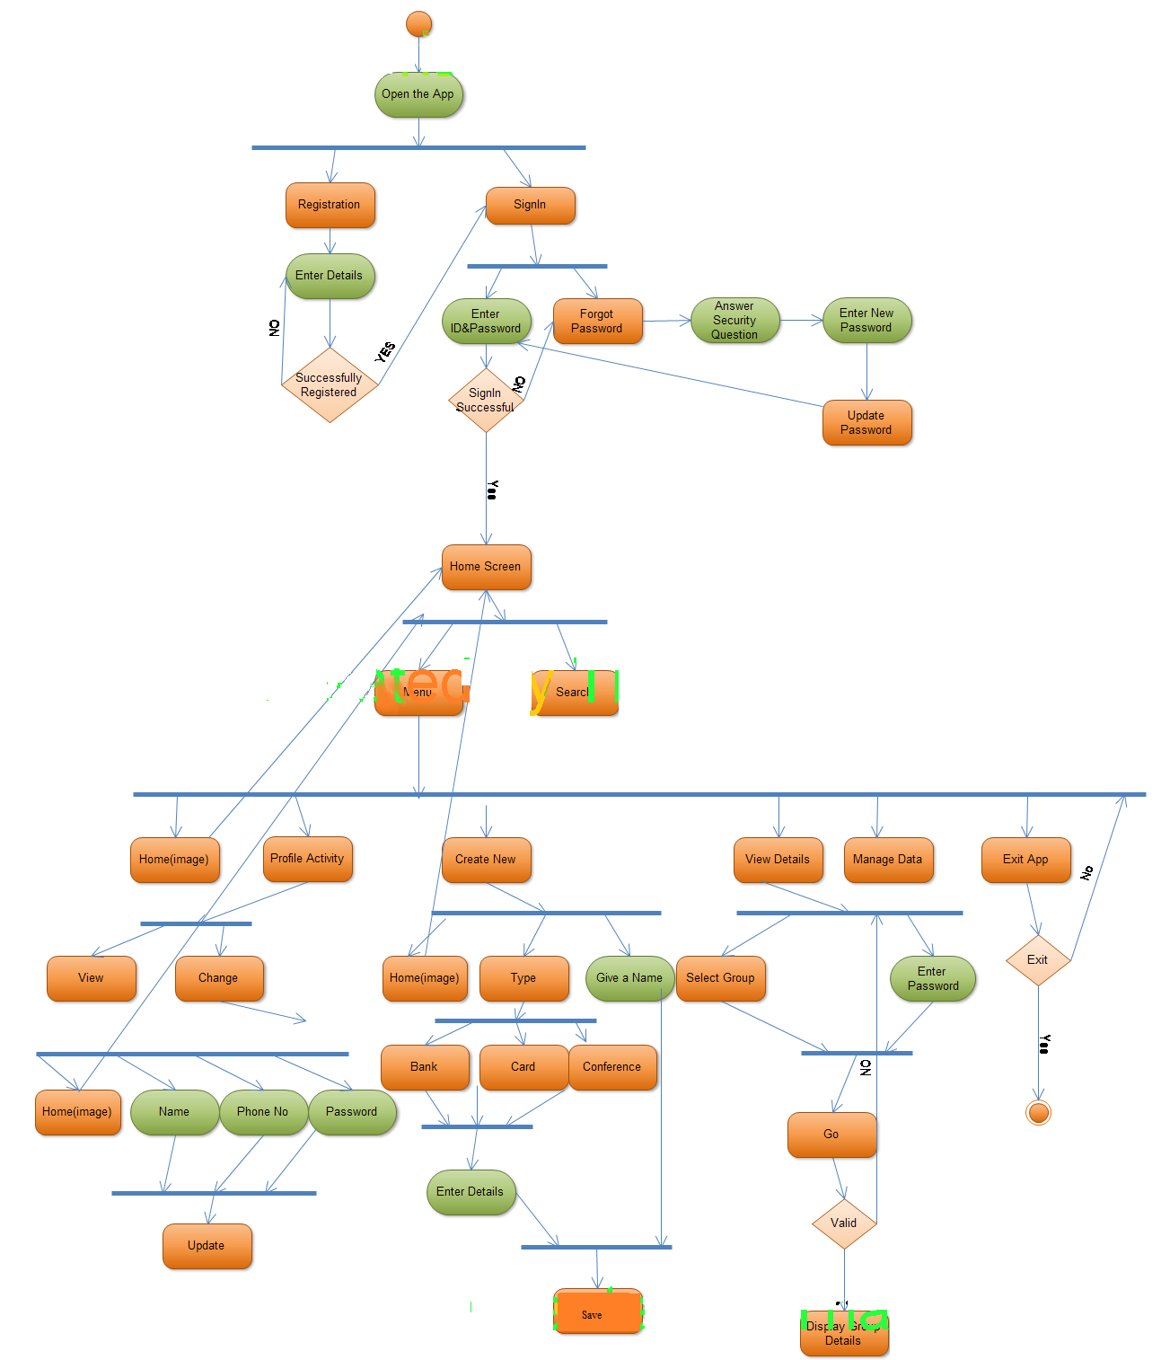

Sequence Diagram:

1)

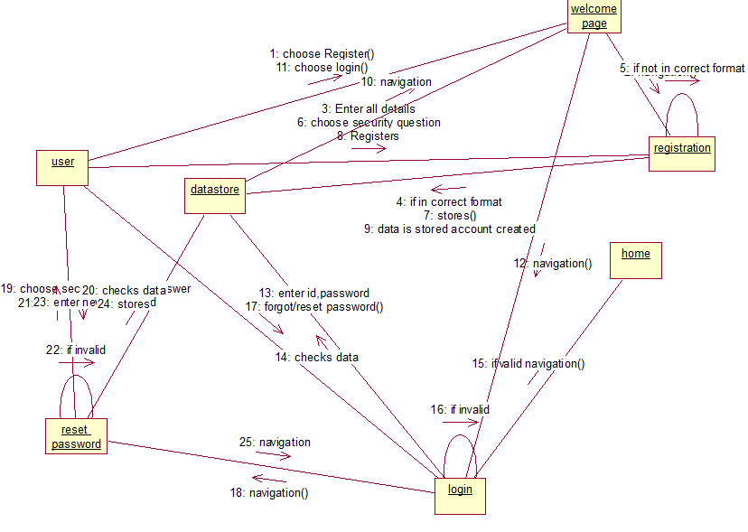

**2)**  
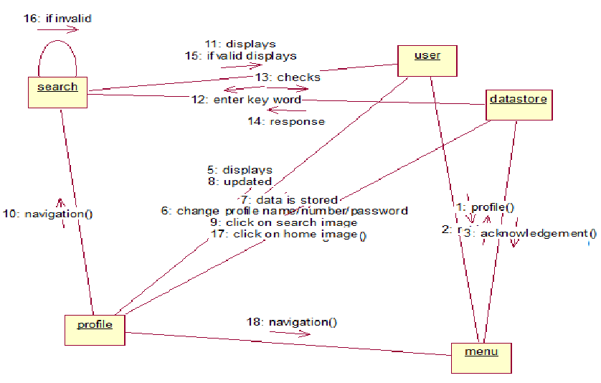

**3)**

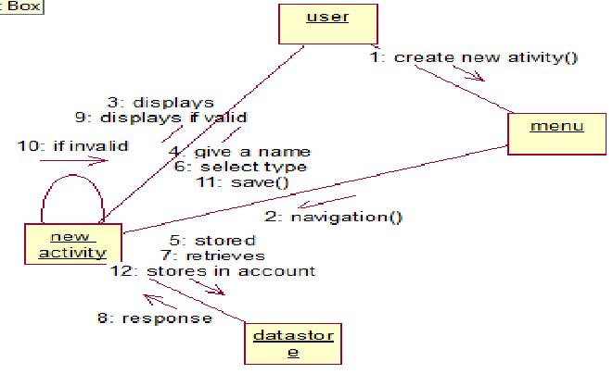

**4)**

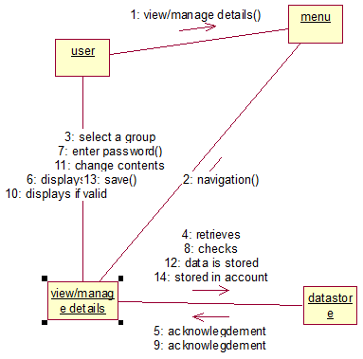

**5)**

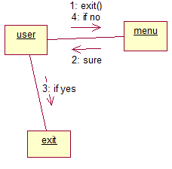

**6)**

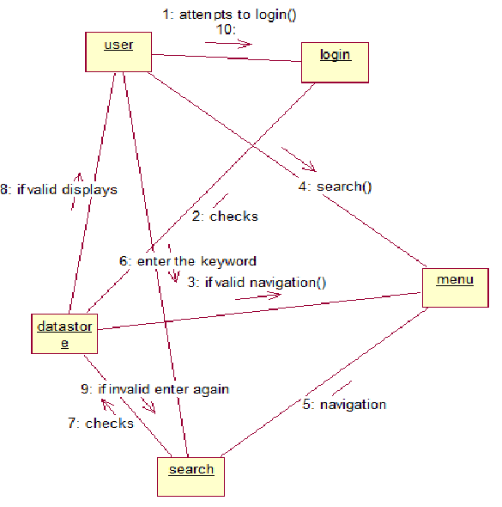

Interaction Diagram:

**1)**

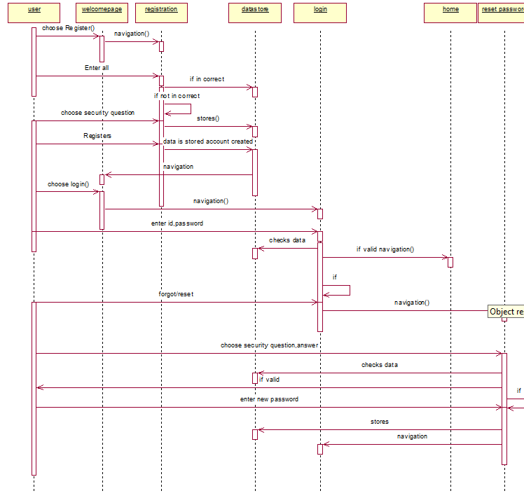

**2)**

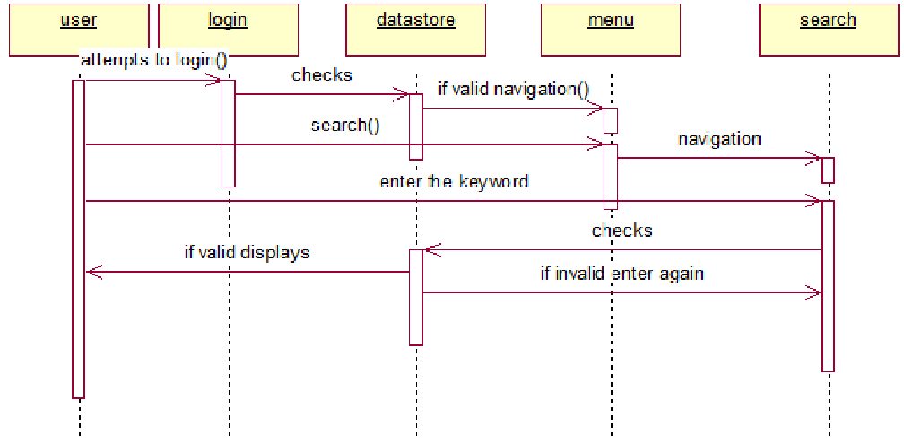

**3)**

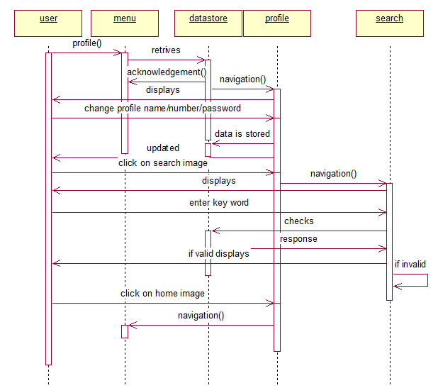

**4)**

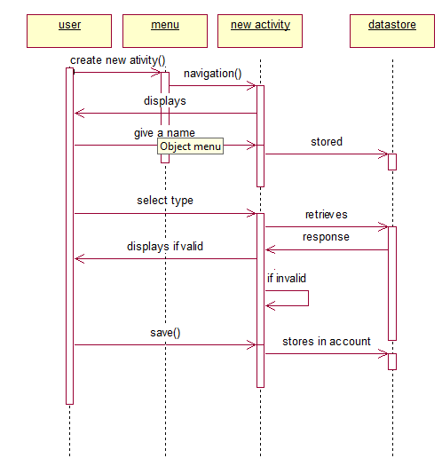

**5)**

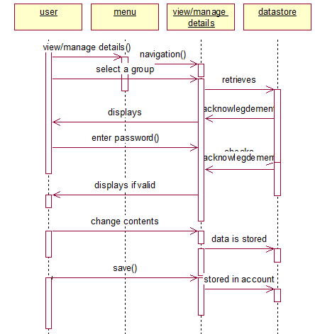

**6)**

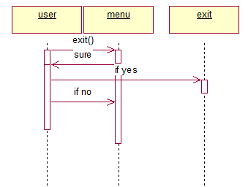

***APP DESIGN:***

1. **Welcome Activity:**

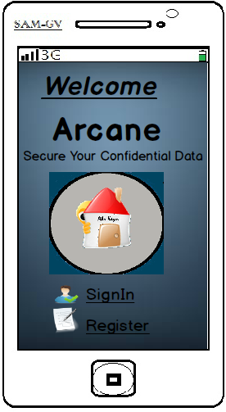

**CONDITIONS:**

Not Applicable

**FUNCTIONALITIES:**

* **Sign In: (Link)** A user must sign in order to use the application. Clicking this link will navigate to the Sign In activity.
* **Register: (Link)** Every person should first register in order to sign in and use the application. This link will navigate to the Registration page Activity

1. **Register Activity:**

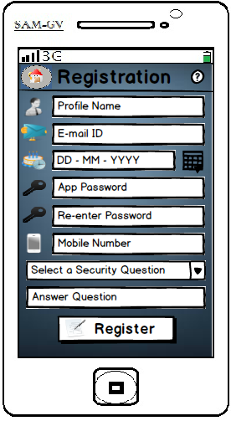

**CONDITIONS:**

The user should enter all the fields compulsory in order to get registered for using the application. The following conditions must be satisfied accordingly.

* Profile Name should not contain any special characters such as arithmetic operators, special symbols etc.
* Email ID should be a valid mail to which the user will receive the important details regarding the application.
* Date of Birth should match with the date provided in the mail which is being provided in the same form.
* Password should contain a minimum of 4 characters and a maximum of 30.
* Password should not contain any white spaces, and special operators.
* Both the passwords should match in order to get registered.
* Mobile Number entry is must, which can also be altered or modified later after entering into the application.
* A Security Question should be selected for which a unique answer should be given. This is used for security issues of the application in future.
* Profile Name and Mobile can be modified as per the user interest in future.

**FUNCTIONALITIES:**

* **Register: (Button)** The Register button will save all the data and register the user only after verifying the details. Clicking this Register button will again navigate the user to the Sign In activity page.
* **HELP: (Image Button)** The Help Image Button on the top right corner of the application screen will provide guidance for the user regarding the current page of the application.

1. **Sign In Activity:**

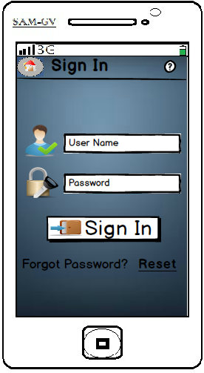

**CONDITIONS:**

* The User Name is nothing but the profile that the users wish to have. It also alters as the user changes the Profile Name after signing into the application.
* Password should be the same as that was first selected by the user. This can also be changed in future.

**FUNCTIONALITIES:**

* **Sign In: (Button)** The event of clicking the Sign In button will navigate the user from the present Sign In Activity to the new Home page Activity.

1. **Reset Password Activity:**

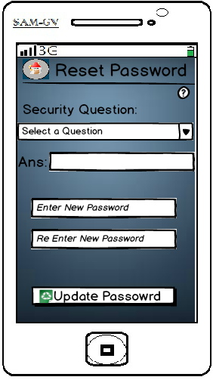

**CONDITIONS:**

* Both the security question selected and the answer provided should match with the values provided during the registration of the user.
* The new password and the re-entered password should also be the same in order to update the password.

**FUNCTIONALITIES:**

* **Update Password: (Button)** This event will update the user details in the database only after verifying the required conditions.

1. **Home Screen Activity:**

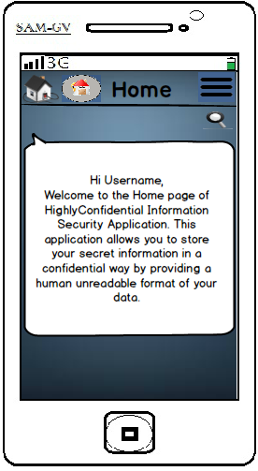

**CONDITIONS:**

Not Applicable

**FUNCTIONALITIES:**

* **Home: (Image Button)** This is a image button that will return the user from any activity in the application to the home screen activity (current screen).
* **Menu: (Image Button)** This image button provides the available activities that are possible in this application i.e. it provides the list of options.
* **Search: (Image Button)** This allows the user to search his contents of information that is stored in the application.

1. **Menu Activity:**

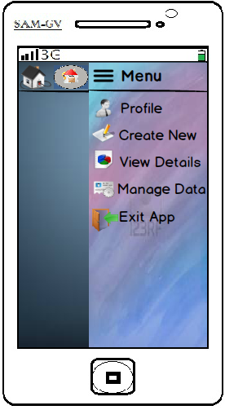

**CONDITIONS:**

Not Applicable.

**FUNCTIONALITIES:**

* **Profile: (Link)** This is a link that will navigate the user to the appropriate Profile Activity where in the user can view and update his details.
* **Create New: (Link)** This is a link that will navigate the user to the appropriate New Activity where in the user can create new information details that are to be stored.
* **View Details: (Link)** This is a link that will navigate the user to the appropriate View Activity where in the user can view his stored information.
* **Manage Data: (Link)** This is a link that will navigate the user to the appropriate Manage Activity where in the user can view and update his information.
* **Exit App: (Link)** This is a link that will navigate the user to the appropriate Exit Activity where in the user is asked for confirmation whether he is really interested to exit the app.

1. **Profile Activity:**

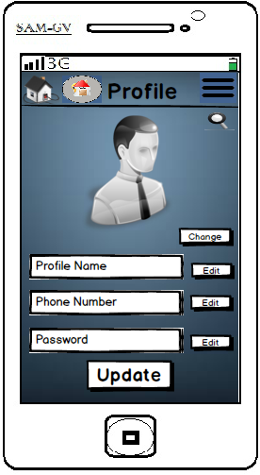

**CONDITIONS:**

Not Applicable.

**FUNCTIONALITIES:**

* **Change: (Button)** This button will allow the user to change his profile picture in the application.
* **Edit: (Button)** This button will allow the user to change his profile Name or Phone Number or the Password for the application.
* **Update: (Button)** This button will allow the user to update changes to his profile in the application.

1. **Create New Activity:**

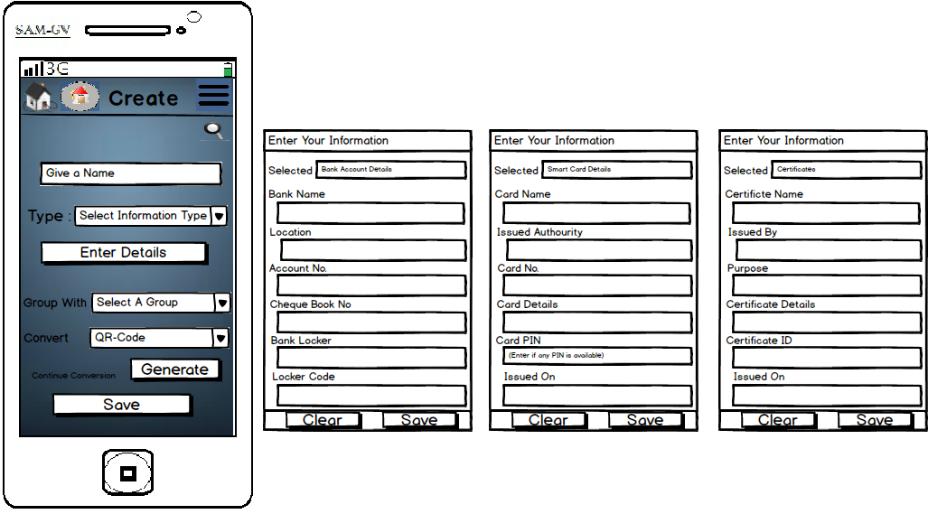

**CONDITIONS:**

* The Name should not contain any special symbols or operators.
* Information Type, Conversion types are to be selected from the existing list only.

**FUNCTIONALITIES:**

* **Enter Details: (Button)** Clicking on this button opens a new window where the user has to provide the specified details which are to be provided according to the type of details that the user has selected from the drop down list.
* The Group With drop down list also provides an option for adding a new group to the existing groups.
* **Generate: (Button)** This button will perform the action of converting the provided details into the selected type of format that was selected by the user in the drop down list of Convert To.
* **Save: (Button)** It will store the user details securely.

1. **View Details Activity:**

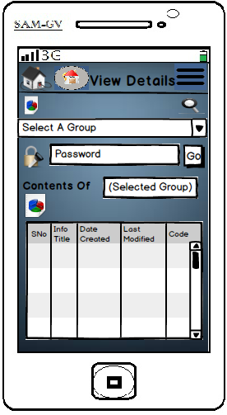

**CONDITIONS:**

* The group name should be selected from the available list.
* The contents will be displayed only after the password is verified to be correct.

**FUNCTIONALITIES:**

* **Go: (Button)**  This button will validate the password in order to display the contents.

1. **Manage Activity:**

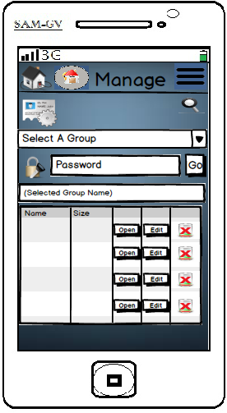

**CONDITIONS:**

* The group name should be selected from the available list.
* The contents will be displayed only after the password is verified to be correct.

**FUNCTIONALITIES:**

* **Go: (Button)** This button will validate the password in order to display the contents which can further be modified or read or deleted as per the users requirement.

1. **Exit App Activity:**

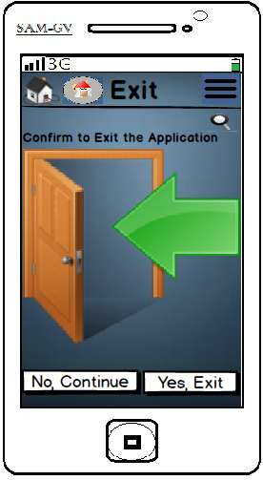

**CONDITIONS:**

Not Applicable.

**FUNCTIONALITIES:**

* **No, Continue: (Button)** This will allow the user to confirm not to exit if in case the exit option is selected unknowingly.
* **Yes, Exit: (Button)** This will allow the user to confirm to exit if in case the exit option is selected intentionally.