CHAPTER 1
INTRODUCTION

  - OBJECTIVE
The main objective of this project is to develop and deploy a scalable accurate, android application for donating blood by registering and search the blood donors and make easy communication through internet.

  - ABOUT THE PROJECT
The “Blood Donor’s Locator using SMS” is a smart device android application. The person will be register as blood donor with their personal details such as name, blood group, mobile number, email id and address. The registered donor information will be saved into the database. When the user needs to search for the particular blood group, they can search based city or state wise or locality or blood group. Then it will list the list of donors available under the searched criteria. When the user click the list it will shows the entire detail about donor. Then user can request for donor current location from the application through the SMS.When the user will request for donor current location, the request SMS will be sent automatically from the user mobile with the predefined request message. When the donor will receive the SMS from the user, that time GPS Tracker will automatically recognize the current location (ie., Latitude and Longitude) of the donor. And the Donor’s Current location will be sent as Google map link through SMS. The user will able to see the donor’s current location in Google Map. As well as the user can get the route navigation from the user’s location to donors location. And also the donor’s current street and area will be sent with that SMS. The “Blood donor’s location using SMS” will provide easy and efficient access to the get the location of the donors.

  - MODULES
The following modules are used in the proposed system
- Blood Donor Registration.
- Donor Search.
- Auto SMS Sender & SMS Hander
- GPS Tracker
- Google Map Integration.

  - MODULE DESCRIPTION
    - Blood Donor Registration
The blood donor registration module will get the personal information from a user and save it into a database which created in the mobile device. Then the user will become a registered blood donor. When the user will be register, they need to provide the following,
- Full Name
- Blood Group
- Date of Birth
- Last Donated
- Address
- District
- City
- State
- Availability

1.4.2 Donor Search
The user can able to search the donor by using the State, City, District and Blood group. Then the data will be retrieved from the SQLite database and listed in a list view. When the user clicks on the list view item, it will display the entire details about the donor. The user can able to sort the list dynamically. They can search with any of criteria or else they can search particularly using defined criteria.

1.4.3 Auto SMS Sender & SMS Handler
The user request for a blood group to the donor, the automatic SMS will be sent to the blood donor with predefined subject. The SMS will be sent by the background process. And the donor’s mobile it will be handle by the SMS Handler. The SMS handler will be activated when it receives the message from the user.
And it will invoke the GPS Tracker to get the current location of the donor and location will be send to user mobile automatically through the SMS.
1.4.4 GPS Tracker
The GPS Tracker will be customized and coded manually to get the current location of the user. It will use the mobile network or Wi-Fi network to get the latitude and longitude values. The GPS Tracker will communicate with the Google server and fetch the current location such the values are latitude, longitude, locality, street, city and postal code. Then the collected data will be passing to the SMS Handler Module.

1.4.5 Google Map Integration
The user will be get a SMS from the user and the SMS will contains the information about the donor’s location. When the user will click on the SMS link, it will open in the Google Map to show the location of donor. And also the user can able to get the direction path between their current locations to the donor location to pick up them. It will provide the various kind of route direction like walking direction, driving direction and etc.,

CHAPTER 2
SYSTEM ANALYSIS

2.1 EXISTING SYSTEM
In existing, the user was able to join as a blood donor using the registration. If the user required for any particular blood group, they can able to search through the application. When the user will click on the donor name from the donor list, it will display the entire detail about the donor which includes their contact number and email address. Then, the user need to request him/her for a particular blood group. The user needs to check the donate status of the donor manually and they were needs to contact them.

2.1.1 DRAWBACKS IN EXISTING SYSTEM
- It needs manual work to check the status of blood donor.
- Time consumption to get the donor details is high.
- There is no possibility to get the current location about the user.

2.2 PROPOSED SYSTEM
In proposed system, the GPS Tracker will used to get the current location of the blood donor. When the user acquire for a particular blood group, they can searching the available donors using the search criteria. It will list the, list of available donors. When selecting the particular user, the SMS will be sent form the user mobile to donors mobile automatically. When the donor receiving a SMS from the user, the device will find the current location and send the location to user. Then the user will be get the route/direction will between from their current location to the blood donor’s location. The same application will be working as user or blood donor based on the need.

2.2.2ADVANTAGES OF PROPOSED SYSTEM
- Easy to get the location of blood donor.
- Searching of blood donor will be used under several constraints.
- Can get the route map between user and blood donor.
- Time consumptionis less.

2.3 FEASIBILITY OF STUDY

2.3.1 OPERATING FEASIBILITY
This proposed system the users need not to have any specific training and this system is more user friendly. So this project will be more operating feasible.Since this proposed system is device independent which means it has the capability to run in versions2.2 and above of android platform. This proposed system will reduce the user effort.

2.3.2 TECHNICAL FEASIBILITY
This proposed system will be more technically feasible this is because the system will provide the good response to user who uses this system. There is one of the important factors that the user device needed to have such as internet connectivity.

CHAPTER 3
SYSTEM SPECIFICATION

3.1 HARDWARE REQUIREMENTS
Processor : Pentium IV 700 MHz and above
Hard Disk : 80 GB
RAM : 512MB and Above
Testing Device : Mobile Phone with 2.0 and Above

3.2 Software requirements

Operating system : Windows XP and Above
Development Tool : Eclipse Kepler
Coding Language : Java
Designing Language : XML
Back End : SQLite

CHAPTER 4
SOFTWARE DESCRIPTION

4.1 Front End

Eclipse-kepler
Eclipse is a community for individuals and organizations who wish to collaborate on commercially-friendly open source software. Its projects are focused on building an open development platform comprised of extensible frameworks, tools and runtimes for building, deploying and managing software across the lifecycle. The Eclipse Foundation is a not-for-profit, member supported corporation that hosts the eclipse projects and helps cultivate both an open source community and an ecosystem of complementary products and services.

Features
On disk, an Eclipse based product is structured as a collection of plug-ins. Each plug-in contains the code that provides some of the product's functionality. The code and other files for a plug-in are installed on the local computer, and get activated automatically as required. A product's plug-ins are grouped together into features. A feature is a unit of separately downloadable and installable functionality.
The fundamentally modular nature of the Eclipse platform makes it easy to install additional features and plug-ins into an Eclipse based product, and to update the product's existing features and plug-ins. You can do this using the Eclipse platform's install and update support found in the Help menu. Eclipse allows you to discover, download, and install features and plug-ins from special web-based Eclipse software sites.
Large Eclipse based products can organize their features into trees starting from the root feature that represents the entire product. This root feature then includes smaller units of functionality all the way down to leaf features that list one or more plug-ins and fragments. The capability to group features hierarchically allows products to be stacked using a 'Russian doll' approach - a large product can build on top of a smaller one by including it and adding more features.
Some included features may be useful add-ons, but are not vital to the proper functioning of the overall product. Feature providers can elect to mark them asoptional. Optional features will only be installed if all their required features and plug-ins are available. If not installed right away, optional features can be added at a later date.
The About option on the Help menu provides information about installed features and plug-ins. The Check for Updates and Install New Software commands on the Help menu provide the ability to update existing features, and to find, download, and install new features.

Android Development Tools (ADT)
It is a plugin for the Eclipse IDE that is designed to give you a powerful, integrated environment in which to build Android applications.
ADT extends the capabilities of Eclipse to let you quickly set up new Android projects, create an application UI, add packages based on the Android Framework API, debug your applications using the Android SDK tools, and even export signed (or unsigned) .apk files in order to distribute your application.
Developing in Eclipse with ADT is highly recommended and is the fastest way to get started. With the guided project setup it provides, as well as tools integration, custom XML editors, and debug output pane, ADT gives you an incredible boost in developing Android applications.
This document provides step-by-step instructions on how to download the ADT plugin and install it into your Eclipse development environment. Note that before you can install or use ADT, you must have compatible versions of both the Eclipse IDE and the Android SDK installed. For details, make sure to read Installing the Eclipse Plugin.
If you are already using ADT, this document also provides instructions on how to update ADT to the latest version or how to uninstall it, if necessary.
For information about the features provided by the ADT plugin, such as code editor features, SDK tool integration, and the graphical layout editor (for drag-and-drop layout editing), see the Android Developer Tools document.
SDK
The Android SDK (software development kit) is a set of development tools used to develop applications for Android platform. The Android SDK includes the following:
- Required libraries
- Debugger
- An emulator
- Relevant documentation for the Android application program interfaces (APIs)
- Sample source code
- Tutorials for the Android OS
The development platforms that are compatible with SDK include operating systems like Windows (XP or later), Linux (any recent Linux distribution) and Mac OS X (10.4.9 or later). The components of Android SDK can be downloaded separately. Third party add-ons are also available for download.
Although the SDK can be used to write Android programs in the command prompt, the most common method is by using an integrated development environment (IDE). The recommended IDE is Eclipse with the Android Development Tools (ADT) plug-in. However, other IDEs, such as NetBeans or IntelliJ, will also work. Most of these IDEs provide a graphical interface enabling developers to perform development tasks faster.Since Android applications are written in Java code, a user should have the Java Development Kit (JDK) installed.

4.2 Back End

Sqlite
SQLite is an Open Source database. SQLite supports standard relational database features like SQL syntax, transactions and prepared statements. The database requires limited memory at runtime (approx. 250 KByte) which makes it a good candidate from being embedded into other runtimes.
SQLite supports the data types TEXT (similar to String in Java), INTEGER (similar to long in Java) and REAL (similar to double in Java). All other types must be converted into one of these fields before getting saved in the database. SQLite itself does not validate if the types written to the columns are actually of the defined type, e.g. you can write an integer into a string column and vice versa.

SQLiteDatabase
- SQLiteDatabase is the base class for working with a SQLite database in Android and provides methods to open, query, update and close the database.
- More specifically SQLiteDatabase provides the insert(), update() and delete() methods.
- In addition it provides the execSQL() method, which allows to execute an SQL statement directly.
- The object ContentValues allows to define key/values. The key represents the table column identifier and the valuerepresents the content for the table record in this column. ContentValues can be used for inserts and updates of database entries.
- Queries can be created via the rawQuery() and query() methods or via the SQLiteQueryBuilder class .
- RawQuery() directly accepts an SQL select statement as input.
- Query() provides a structured interface for specifying the SQL query.
- SQLiteQueryBuilder is a convenience class that helps to build SQL queries.

Cursor
A query returns a Cursor object. A Cursor represents the result of a query and basically points to one row of the query result. This way Android can buffer the query results efficiently; as it does not have to load all data into memory.
To get the number of elements of the resulting query use the getCount() method.
Cursor provides typed get*() methods, e.g. getLong(columnIndex), getString(columnIndex) to access the column data for the current position of the result. The "columnIndex" is the number of the column you are accessing.
Cursor also provides the getColumnIndexOrThrow(String) method which allows to get the column index for a column name of the table.
A Cursor needs to be closed with the close() method call.

Features of sqlite
- Transactions are atomic, consistent, isolated, and durable (ACID) even after system crashes and power failures.
- Zero-configuration - no setup or administration needed.
- Implements most of SQL92. (Features not supported)
- A complete database is stored in a single cross-platform disk file.
- Supports terabyte-sized databases and gigabyte-sized strings and blobs. (See limits.html.)
- Small code footprint: less than 500KiB fully configured or much less with optional features omitted.
- Faster than popular client/server database engines for most common operations.
- Simple, easy to use API.
- Written in ANSI-C. TCL bindings included. Bindings for dozens of other languages available separately.
- Well-commented source code with 100% branch test coverage.
- Available as a single ANSI-C source-code file that you can easily drop into another project.
- Self-contained: no external dependencies.
- Cross-platform: Unix (Linux, Mac OS-X, Android, iOS) and Windows (Win32, WinCE, WinRT) are supported out of the box. Easy to port to other systems.
- Sources are in the public domain. Use for any purpose.
- Comes with a standalone command-line interface (CLI) client that can be used to administer SQLite databases.

CHAPTER 5
SYSTEM DESIGN

5.1 Data flow Diagram
The dataflow diagram (DFD) is a graphical representation of the "flow" of data through an information system, modeling its process aspects. Often they are a preliminary step used to create an overview of the system which can later be elaborated. Data flow diagram can also be used for the visualization of data processing. A data flow diagram shows what kinds of information will be input to and output from the system, where the data will come from and go to, and where the data will be stored. It does not show information about the timing of processes, or information about whether processes will operate in sequence or in parallel.
In this proposed system the dataflow diagram is one of the important diagram which helps us to visualize the entire system data flow which takes place in and out of the system. This flow diagram helps the user to know about the action that takes place in the system. It is common practice to draw the context-level data flow diagram first, which shows the interaction between the system and external agents which act as data sources and data sinks. On the context diagram the system's interactions with the outside world are modeled purely in terms of data flows across the system boundary. The context diagram shows the entire system as a single process, and gives no clues as to its internal organization.
The old system's dataflow diagrams can be drawn up and compared with the new system's data flow diagrams to draw comparisons to implement a more efficient system. Data flow diagrams can be used to provide the end user with a physical idea of where the data they input ultimately has an effect upon the structure of the whole system from order to dispatch to report. How any system is developed can be determined through a data flow diagram model.In the course of developing a set of leveled data flow diagrams the analyst/designers is forced to address how the system may be decomposed into component sub-systems, and to identify the transaction data in the data model

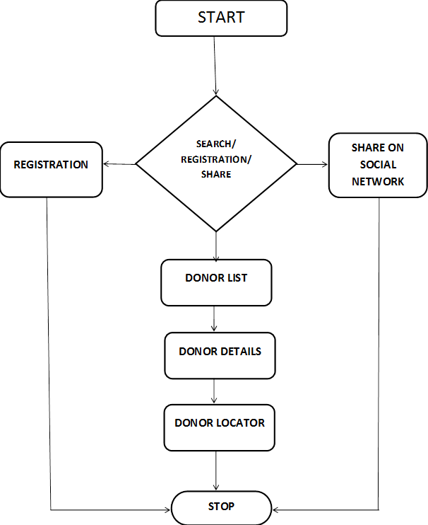

Fig 5.1data flow diagram

5.2 E-R DIAGRAM
E-R modeling is a data modeling technique used in software engineering to produce a conceptual data model of an information system. Diagrams created using this E-Rmodeling technique are called Entity-Relationship Diagrams, or E-R diagrams or ERDs. So you can say that Entity Relationship Diagrams illustrate the logical structure of databases. Entity–relationship model (E-R model) in software engineering is an abstract way to describe a database. However, variants of the idea existed previously, and have been devised subsequently such as super type and subtype data entitiesand commonality relationships.
An entity may be defined as a thing which is recognized as being capable of an independent existence and which can be uniquely identified. An entity is an abstraction from the complexities of a domain. When we speak of an entity, we normally speak of some aspect of the real world which can be distinguished from other aspects of the real world.
An entity may be a physical object such as a house or a car, an event such as a house sale or a car service, or a concept such as a customer transaction or order. Although the term entity is the one most commonly used, following Chen we should really distinguish between an entity and an entity-type. An entity-type is a category. An entity, strictly speaking, is an instance of a given entity-type. There are usually many instances of an entity-type. Because the term entity-type is somewhat cumbersome, most people tend to use the term entity as a synonym for this term.

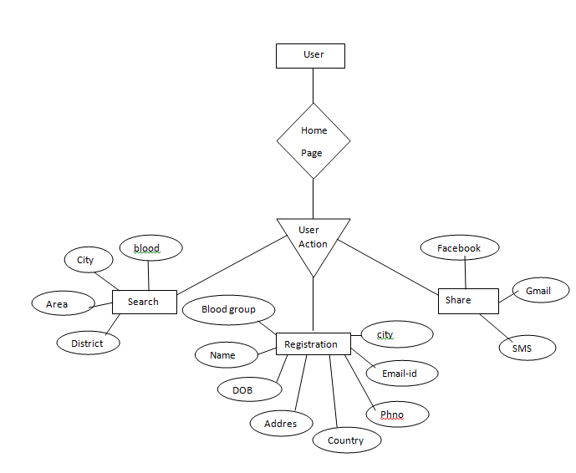
Fig: 5.2 E-RDiagram

5.2.1 USE CASE DIAGRAM
A use case diagram at its simplest is a representation of a user's interaction with the system and depicting the specifications of a use case. A use case diagram can portray the different types of users of a system and the various ways that they interact with the system. This type of diagram is typically used in conjunction with the textual use case and will often be accompanied by other types of diagrams as well. It is a very well-known adage that "A picture is worth a thousand words". With regards to use case diagrams, that is exactly what they are meant to do. While use case itself might drill into a lot of detail about every possibility, a use case diagram can help provide a higher-level view of the system. It has been said before that "Use case diagrams are the blueprints for your system”. They provide the simplified and graphical representation of what the system must actually do. Here the proposed system use case diagram is as follows
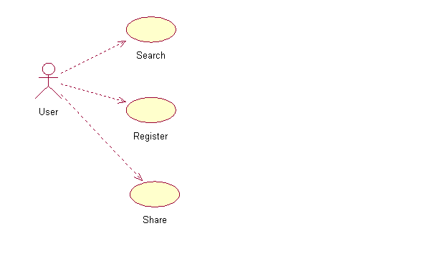
Fig:5.2.1 Use Case Diagram
5.2.2CLASS DIAGRAM
In software engineering, a class diagram in the Unified Modeling Language (UML) is a type of static structure diagram that describes the structure of a system by showing the system's classes, their attributes, operations (or methods), and the relationships among the classes.
The class diagram is the main building block of object oriented modeling. It is used both for general conceptual modeling of the systematic of the application, and for detailed modeling translating the models into programming code. Class diagrams can also be used for data modeling. The classes in a class diagram represent both the main objects, interactions in the application and the classes to be programmed.

In the diagram, classes are represented with boxes which contain three parts:
- The upper part holds the name of the class
- The middle part contains the attributes of the class
- The bottom part gives the methods or operations the class can take or undertake
In the design of a system, a number of classes are identified and grouped together in a class diagram which helps to determine the static relations between those objects. With detailed modeling, the classes of the conceptual design are often split into a number of subclasses.
In order to further describe the behavior of systems, these class diagrams can be complemented by state diagram or UML state machine.

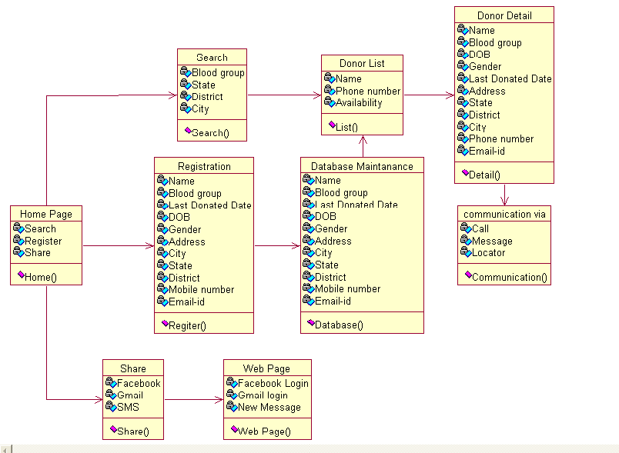
Fig: 5.2.2 Class Diagram

5.2.3 SEQUENCE DIAGRAM
A sequence diagram is a kind of interaction diagram that shows how processes operate with one another and in what order. It is a construct of a Message Sequence Chart. A sequence diagram shows object interactions arranged in time sequence. It depicts the objects and classes involved in the scenario and the sequence of messages exchanged between the objects needed to carry out the functionality of the scenario. Sequence diagrams are typically associated with use case realizations in the Logical View of the system under development. Sequence diagrams are sometimes called event diagrams, event scenarios, and timing diagrams.
A sequence diagram shows, as parallel vertical lines, different processes or objects that live simultaneously, and, as horizontal arrows, the messages exchanged between them, in the order in which they occur. This allows the specification of simple runtime scenarios in a graphical manner. Here the sequence diagram for the proposed system is as follows
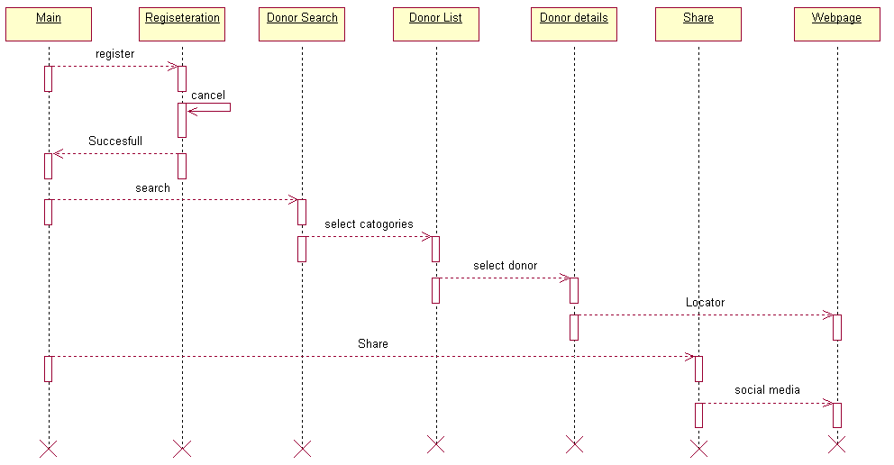
Fig: 5.2.3 Sequence Diagram

5.2.4 ACTIVITY DIAGRAM
Activity diagrams are graphical representations of workflows of stepwise activities and actions with support for choice, iteration and concurrency. In the Unified Modeling Language, activity diagrams can be used to describe the business and operational step-by-step workflows of components in a system. An activity diagram shows the overall flow of control.The activity diagram of this proposed system which describes about the workflow which takes place in the proposed system. The workflow means same as coming to college and going to home but it includes the each steps which takes place at each steps.
In this proposed system the user is getting logged into the system if the user is unable to log in to the system then the user unable to gain access to the system at this time the error page will be displayed. In this proposed system each and every user will be having their own user page in which then can user the system. Once the user is getting logged into the system means then only the user can able to view his/her user page. In this activity diagram it have completely mentioned the activity that a user can be done in the proposed system have shown from the time of login to time of logout. In this activity diagram the solid ball is used to indicate the login action and the bull’s eye is used to represent the termination of the system in this user login in which the system activity gets started and the logoff which is the termination part of the company.
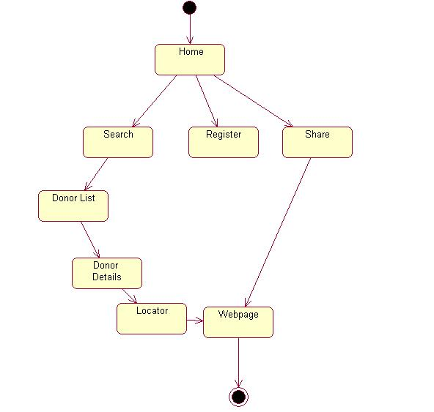
Fig: 5.2.4 Activity Diagram

5.2.5 COLLABORATION DIAGRAM
Collaboration is UML, Collaboration Diagrams show the interactions between objects participating in a specific situation. It is more or less the same information shown in sequence diagrams, but here the emphasis is put on how interactions take place over time, while collaboration diagrams show close relations between objects and their topology.
In collaboration diagrams messages sent from one object to another are represented by arrows, showing the name, parameters, and the sequence of the message. Collaboration Diagrams are specially adapted to show a particular stream or situation of the program and are one of the best diagram types to quickly demonstrate or explain a process in program logic.
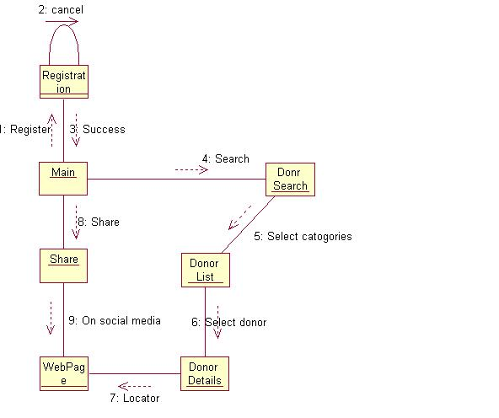
Fig: 5.2.5 Collaboration diagram

5.3 SYSTEM ARCHITECTURE
System architecture is the conceptual model that defines the structure, behavior, and more views of a system.An architecture description is a formal description and representation of a system, organized in a way that supports reasoning about the structures of the system, which comprise system components, the externally visible properties of those components, the relationships (e.g. the behavior) between them, and provides a plan from which products can be procured, and systems developed, that will work together to implement the overall system. More recently, there have been efforts to formalize languages to describe system architecture; collectively these are called architecture (ADLs).
This proposed system is all about an android application in which the user can able to interact with the system through any android devices above 2.2 versions. Once user startup the apps at the time interaction gets started up.
The user interaction will be given directly towards the server.The server is one of standalone computer system which will provide the service to the users request and provide the service to the user. In this the server will be one of the most important systems in any network because the user only will get service only with the help of the server.

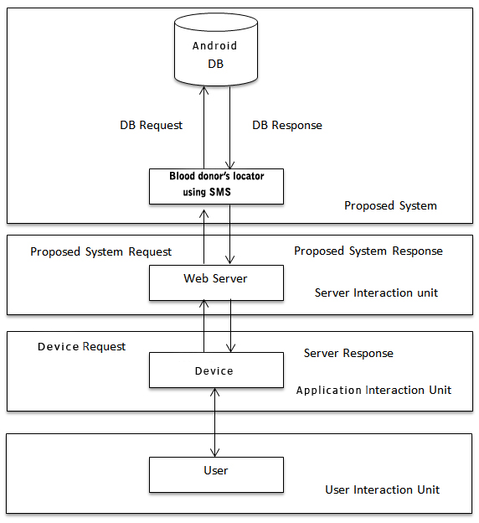

Fig: 5.3.1 System Architecture

5.4 INPUT DESIGN
In this module the input which is given to the system will be clearly described which makes the system to get completely user input operation to the proposed system. While getting started with this proposed system the can able to search blood ,register for donating blood and share. If the user wants to register to this system in which the user have to provide the certain important information to the system such as user name, blood group,emailid,address,availability,etc….Then if the user needs a bood he can able to search the blood with certain criteria like blood group,state,district and city.And if the user can able to share the information about the application through social media.
5.5 OUTPUT DESIGN
In this proposed system the user will get the response for each and every action which is performed by the user.The user can get the list of donors based on the searched criteria and He can get the entire details about the particular donor.If the user wants to communicate the donor he can get him through call,message and location in the form of google map.

5.6 DATABASE DESIGN
In this proposed system the SQLite database is used which is in build android mobile database. In this free database is one of the most efficient databases which have the capability to handle large amount of database easily. For this proposed system each and every single data will get stored in the database only there by the entire proposed system will made to be more efficient enough. In this database design which helps to know about the design of the database which is used in the proposed system. In this project the snapshot of the system database is given below in which it have following databases. The snapshoot given below is the SQLite Database Browser window console in which the developer can able to create database and use the database for the project.

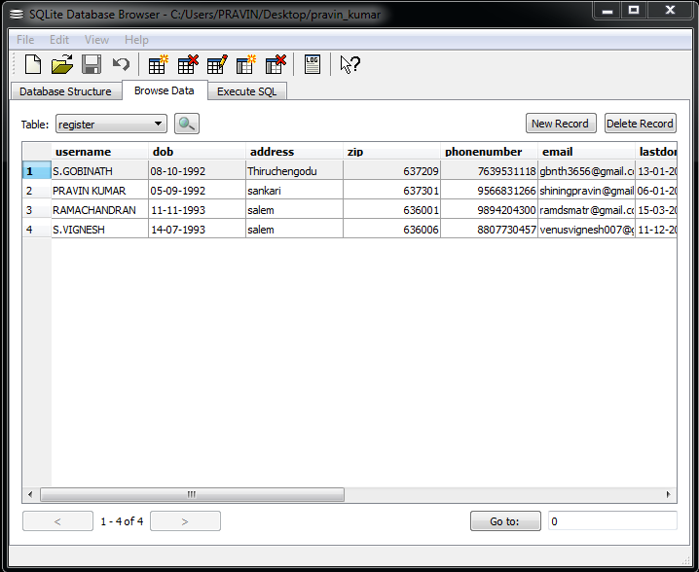

Fig: 5.6.1 Database Design

DATABASE TABLE FOR USER

S.NO | USER NAME | CONTACT NO | MAIL ID | AVAILABILITY
1 | S.Gobinath | 7639531118 | Gbnth3656@gmail.com | YES
2 | S.Pravin Kumar | 9566831266 | shiningpravin@gmail.com | YES
3 | V.Ramachandran | 9894204300 | ramdsmart@gmail.com | NO
4 | S.Vignesh | 8807730457 | venusvignesh@gmail.com | YES

Table: 5.6.2 Database Table for User
CHAPTER 6
SYSTEM TESTING& IMPLEMENTATION

6.1 TESTING
Testing is an investigation conducted to provide stakeholders with information about the quality of the product or service under test. Software testing can also provide an objective, independent view of the software to allow the business to appreciate and understand the risks of software implementation. Software testing can be stated as the process of validating and verifying that a computer program/application/product:
- Meets the requirements that guided its design and development.
- Works as expected.
- Can be implemented with the same characteristics.
- Satisfies the needs of stakeholders.
Software testing, depending on the testing method employed, can be implemented at any time in the development process. Traditionally most of the test effort occurs after the requirements have been defined and the coding process has been completed, but in the agile approaches most of the test effort is on-going. As such, the methodology of the test is governed by the chosen software development methodology.Different software development models will focus the test effort at different points in the development process.Newer development models, such as Agile, often employ test-driven development and place an increased portion of the testing in the hands of the developer, before it reaches a formal team of testers. In a more traditional model, most of the test execution occurs after the requirements have been defined and the coding process has been completed.

6.1.1 OBJECTIVE OF TESTING
The objective of the testing is that the goals of the software testing some of them are listed as following.
- Testing helps to makes good software
- Testing make the developer to visualize the defects in the system
- The risk that is present in the project can able to be visualized.
- If a bug is detected in the testing zone then the software development cycle will be repeated once again.
- In testing we not only check the code in the project but also testing will be done on several factors such as performance, load, stress, etc...
- At certain conditions the testing also make cause hike in the cost estimation of the system.
- Testing will improve the quality of the software.
- Testing will ensure the company that it meets the company standards are not will be verified.

6.2 TESTING METHODS

6.2.1 UNIT TESTING
Unit testing involves the design of test cases that validate that the internal program logic is functioning properly, and that program inputs produce valid outputs. All decision branches and internal code flow should be validated. It is the testing of individual software units of the application .it is done after the completion of an individual unit before integration. This is a structural testing, that relies on knowledge of its construction and is invasive. Unit tests perform basic tests at component level and test a specific business process, application, and/or system configuration. Unit tests ensure that each unique path of a business process performs accurately to the documented specifications and contains clearly defined inputs and expected results.

6.2.2INTEGRATION TESTING
Integration tests are designed to test integrated software components to determine if they actually run as one program. Testing is event driven and is more concerned with the basic outcome of screens or fields. Integration tests demonstrate that although the components were individually satisfaction, as shown by successfully unit testing, the combination of components is correct and consistent. Integration testing is specifically aimed at exposing the problems that arise from the combination of components.

6.2.3FUNCTION TESTING
Functional tests provide systematic demonstrations that functions tested are available as specified by the business and technical requirements, system documentation, and user manuals.
Functional testing is centred on the following items:
Valid Input : Identified classes of valid input must be accepted.
Invalid Input :Identified classes of invalid input must be rejected.
Functions : Identified functions must be exercised.
Output : Identified classes of application outputs must be exercised.
Systems/Procedures :interfacing systems or procedures must be invoked.
Organization and preparation of functional tests is focused on requirements, key functions, or special test cases. In addition, systematic coverage pertaining to identify Business process flows; data fields, predefined processes, and successive processes must be considered for testing. Before functional testing is complete, additional tests are identified and the effective value of current tests is determined.

6.2.4 SYSTEM TESTING
System testing ensures that the entire integrated software system meets requirements. It tests a configuration to ensure known and predictable results. An example of system testing is the configuration oriented system integration test. System testing is based on process descriptions and flows, emphasizing pre-driven process links and integration points

6.2.5 WHITE BOX TESTING
White Box Testing is a testing in which in which the software tester has knowledge of the inner workings, structure and language of the software, or at least its purpose. It is purpose. It is used to test areas that cannot be reached from a black box level.

6.2.6 BLACK BOX TESTING
Black Box Testing is testing the software without any knowledge of the inner workings, structure or language of the module being tested. Black box tests, as most other kinds of tests, must be written from a definitive source document, such as specification or requirements document, such as specification or requirements document. It is a testing in which the software under test is treated, as a black box .you cannot “see” into it. The test provides inputs and responds to outputs without considering how the software works.

6.2.7 USER ACCEPTANCE TESTING
User Acceptance Testing is a critical phase of any project and requires significant participation by the end user. It also ensures that the system meets the functional requirements.

6.3 SYSTEM IMPLEMENTATION
Implementation is the stage of the project when the theoretical design is turned out into a working system. Thus it can be considered to be the most critical stage in achieving a successful new system and in giving the user, confidence that the new system will work and be effective.The implementation stage involves careful planning, investigation of the existing system and it’s constraints on implementation, designing of methods to achieve changeover and evaluation of changeover methods.In this proposed system the implementation is done through the hosting. The hosting make the proposed system to be available over the internet there by the entire system can be available to the user easily. When the hosting gets completed then the proposed system can be able to access the proposed system easily anywhere at any time through web browser. The response time of the proposed system is completely depends on the internet connectivity speed. It is very important for this proposed system this is because if the users try to access the system then user needed to have a good internet connectivity. The implementation of this proposed system can done easily because the system is mainly a android based application. The android based application can able to be implemented easily than the other android system.

CHAPTER 7
CONCLUSION

The proposed system reduces the manual work and provide easy access to the user to search the blood donor and enrol himself for donating blood by registering. There are no specific exiting system/apps for blood donation in android helps the user to find the location of the blood donor. The system will be more secured than the existing system and The important good factor about this proposed system is its database and extension in database which is used in this proposed system is SQLite which have the capability of storing and perform all kind of database oriented operations easily. This database has the capacity to store the large database efficiently without any fault. The user data will be managed by the database administrator there by the user data security is achieved easily. The privacy of the user is maintained properly in this proposed system.

CHAPTER 8
FUTURE ENHANCEMENT

The future enhancement of this proposed system to make the system to be more efficient than proposed. This proposed system was developed for a single country(India), in future we have planned to make this system as more secure and make this system to universal usage and it is more flexible and efficient And the system can be accessed anywhere in the world effectively and more user friendly.
The user can able to chat with the donor through online. And we planned to make the application as web based.

CHAPTER 9
APPENDIX

9.1 SOURCE CODE
9.1.1 MAIN PAGE MODULE

FORM
<RelativeLayout xmlns:android="http://schemas.android.com/apk/res/android"
android:layout_width="fill_parent"
android:layout_height="fill_parent"
android:layout_marginBottom="5dp"
android:background="@drawable/background"
android:gravity="bottom" >

<ImageView
android:id="@+id/imageView3"
android:layout_width="wrap_content"
android:layout_height="wrap_content"
android:layout_alignParentBottom="true"
android:layout_alignParentLeft="true"
android:src="@drawable/bottom" />
<ImageView
android:id="@+id/imageView4"
android:layout_width="wrap_content"
android:layout_height="wrap_content"
android:layout_alignLeft="@+id/imageView1"
android:layout_marginTop="22dp"
android:src="@drawable/box" />

<ImageView
android:id="@+id/imageView2"
android:layout_width="wrap_content"
android:layout_height="wrap_content"
android:layout_alignParentLeft="true"
android:layout_alignParentTop="true"
android:src="@drawable/top" />

<ImageView
android:id="@+id/imageView5"
android:layout_width="wrap_content"
android:layout_height="wrap_content"
android:layout_alignLeft="@+id/imageView4"
android:layout_below="@+id/imageView2"
android:layout_marginTop="16dp"
android:src="@drawable/box" />

<Spinner
android:id="@+id/spinner4"
android:layout_width="120dp"
android:layout_height="25dp"
android:layout_alignLeft="@+id/textView5"
android:layout_below="@+id/textView4"
android:background="@drawable/textbox"
android:paddingStart="15dp"/>

<TextView
android:id="@+id/textView1"
android:layout_width="wrap_content"
android:layout_height="wrap_content"
android:layout_below="@+id/imageView5"
android:layout_centerHorizontal="true"
android:layout_marginTop="14dp"
android:text="Search Blood Donor"
android:textAppearance="?android:attr/textAppearanceLarge" />

<ImageButton
android:id="@+id/imageButton3"
android:layout_width="80dp"
android:layout_height="30dp"
android:layout_below="@+id/spinner4"
android:layout_centerHorizontal="true"
android:layout_marginTop="15dp"
android:src="@drawable/search" />

<Spinner
android:id="@+id/spinner1"
android:layout_width="120dp"
android:layout_height="25dp"
android:layout_alignLeft="@+id/textView2"
android:layout_below="@+id/textView2"
android:background="@drawable/textbox"
android:paddingStart="15dp"/>

<Spinner
android:id="@+id/spinner3"
android:layout_width="120dp"
android:layout_height="25dp"
android:layout_alignLeft="@+id/textView4"
android:layout_below="@+id/spinner1"
android:layout_marginTop="39dp"
android:background="@drawable/textbox"
android:paddingStart="15dp" />

<TextView
android:id="@+id/textView4"
android:layout_width="wrap_content"
android:layout_height="wrap_content"
android:layout_alignLeft="@+id/spinner1"
android:layout_below="@+id/spinner1"
android:layout_marginTop="15dp"
android:text="District"
android:textAppearance="?android:attr/textAppearanceMedium" />

<TextView
android:id="@+id/textView5"
android:layout_width="wrap_content"
android:layout_height="wrap_content"
android:layout_above="@+id/spinner4"
android:layout_marginLeft="43dp"
android:layout_toRightOf="@+id/spinner3"
android:text="City"
android:textAppearance="?android:attr/textAppearanceMedium" />

<TextView
android:id="@+id/textView3"
android:layout_width="wrap_content"
android:layout_height="wrap_content"
android:layout_above="@+id/spinner2"
android:layout_alignLeft="@+id/textView5"
android:text="State"
android:textAppearance="?android:attr/textAppearanceMedium" />

<Spinner
android:id="@+id/spinner2"
android:layout_width="120dp"
android:layout_height="25dp"
android:layout_above="@+id/spinner3"
android:layout_alignLeft="@+id/textView3"
android:background="@drawable/textbox"
android:paddingStart="15dp" />

<TextView
android:id="@+id/textView2"
android:layout_width="wrap_content"
android:layout_height="wrap_content"
android:layout_below="@+id/textView1"
android:layout_marginTop="16dp"
android:layout_toLeftOf="@+id/imageButton3"
android:text="Blood Group"
android:textAppearance="?android:attr/textAppearanceMedium" />
<ImageButton
android:id="@+id/imageButton2"
android:layout_width="wrap_content"
android:layout_height="43dp"
android:layout_above="@+id/imageView3"
android:layout_alignParentLeft="true"
android:src="@drawable/sharebutton" />
<ImageButton
android:id="@+id/imageButton1"
android:layout_width="wrap_content"
android:layout_height="43dp"
android:layout_above="@+id/imageButton2"
android:layout_alignParentLeft="true"
android:src="@drawable/registrationbutton" />
<ImageView
android:id="@+id/imageView1"
android:layout_width="wrap_content"
android:layout_height="wrap_content"
android:layout_alignParentRight="true"
android:layout_below="@+id/imageButton3"
android:layout_marginTop="7dp"
android:src="@drawable/box" />
</RelativeLayout>

ACTION
package com.pravin.blood_donor;
import java.util.ArrayList;
import java.util.List;
import android.os.Bundle;
import android.app.Activity;
import android.content.Intent;
import android.view.Menu;
import android.view.View;
import android.view.View.OnClickListener;
import android.widget.ArrayAdapter;
import android.widget.Button;
import android.widget.EditText;
import android.widget.ImageButton;
import android.widget.Spinner;
import android.widget.Toast;
public class MainActivity extends Activity {
ImageButton sharepage;
ImageButton registration;
@Override
protected void onCreate(Bundle savedInstanceState) {
super.onCreate(savedInstanceState);
setContentView(R.layout.activity_main);
sharepage=(ImageButton)findViewById(R.id.imageButton2);
sharepage.setOnClickListener(new OnClickListener()
{
@Override
public void onClick(View v) {
// TODO Auto-generated method stub
Intent i = new Intent(MainActivity.this,Sharepage.class);
startActivity(i);
}});
registration=(ImageButton)findViewById(R.id.imageButton1);
registration.setOnClickListener(new OnClickListener()
{
@Override
public void onClick(View v) {
// TODO Auto-generated method stub
Intent i = new Intent(MainActivity.this,Registration.class);
startActivity(i);
}});
String BloodGroup[] = {"A+","A-","B+","B-","AB+", "AB-","O+","O-","A1+","A1-","A2-","A1B+","A1B-","A2B+","A2B-"};
Spinner spinner1 = (Spinner) findViewById(R.id.spinner1);
ArrayAdapter<String> spinnerArrayAdapter = new ArrayAdapter<String>(this,
android.R.layout.simple_spinner_item, BloodGroup);
spinnerArrayAdapter.setDropDownViewResource(android.R.layout.simple_spinner_
dropdown_item); // The drop down view
spinner1.setAdapter(spinnerArrayAdapter);
String State[] = {"Tamil Nadu"};
Spinner spinner2 = (Spinner) findViewById(R.id.spinner2);
ArrayAdapter<String> spinnerArrayAdapter1 = new ArrayAdapter<String>(this,
android.R.layout.simple_spinner_item, State);
spinnerArrayAdapter1.setDropDownViewResource(android.R.layout.simple_spinner_
dropdown_item); // The drop down view
spinner2.setAdapter(spinnerArrayAdapter1);

StringDistrict[]= {"Ariyalur","Chennai","Coimbatore","Cuddalore","Dharmapuri","Dindigul","Erode","Kanchipuram","Kanyakumari","karur","Madurai","Nagapattinam","Namakkal","Perambalur","Pudukkottai","Ramanathapuram","Salem","Sivaganga","Thanjavur","Nilgiris","Theni","Tiruvallur","Tiruvarur","Thoothukudi","Tiruchirappalli","Tirunelveli","Tiruvannamalai","Vellore","Viluppuram","Virudhunagar","Krishnagiri","Dhalai","North Tripura","South Tripura","West Tripura","Almora"};
Spinner spinner3 = (Spinner) findViewById(R.id.spinner3);
ArrayAdapter<String> spinnerArrayAdapter2 = new ArrayAdapter<String>(this,
android.R.layout.simple_spinner_item, District);
spinnerArrayAdapter2.setDropDownViewResource(android.R.layout.simple_spinner_
dropdown_item); // The drop down view
spinner3.setAdapter(spinnerArrayAdapter2);
StringCity[]={"Ariyalur","Jayankondam","Udayarpalayam","Varadarajanpettai","Chennai"Coimbatore","Achipatti","Alanthurai","Anaimalai","Andipalayam"Manapparai,"Tiruch irappalli", "Srirangam" , "Tiruchirappalli", "Uthangarai"};
Spinner spinner4 = (Spinner) findViewById(R.id.spinner4);
ArrayAdapter<String> spinnerArrayAdapter3 = new ArrayAdapter<String>(this,
android.R.layout.simple_spinner_item, City);
spinnerArrayAdapter3.setDropDownViewResource(android.R.layout.simple_spinner_
dropdown_item); // The drop down view
spinner4.setAdapter(spinnerArrayAdapter3);
}
}

9.1.2 REGISTRATION MODULE

FORM
<?xml version="1.0" encoding="utf-8"?>
<ScrollView xmlns:android="http://schemas.android.com/apk/res/android"
android:id="@+id/scrollView1"
android:layout_width="match_parent"
android:layout_height="wrap_content">
<RelativeLayout
android:layout_width="wrap_content"
android:layout_height="wrap_content"
android:background="@drawable/background" >

<RelativeLayout
android:id="@+id/linearLayout1"
android:layout_width="wrap_content"
android:layout_height="55dp"
android:layout_alignParentLeft="true"
android:layout_alignParentTop="true"
android:background="@drawable/background" >
<TextView
android:id="@+id/textView1"
android:layout_width="wrap_content"
android:layout_height="wrap_content"
android:layout_centerHorizontal="true"
android:layout_centerVertical="true"
android:text="Registration"
android:textAppearance="?android:attr/textAppearanceMedium"
android:textColor="#ffffff"
android:textSize="18sp"
android:textStyle="bold" />

</RelativeLayout>

<ScrollView
android:id="@+id/scrollView1"
android:layout_width="wrap_content"
android:layout_height="wrap_content"
android:layout_alignParentBottom="true"
android:layout_alignParentLeft="true"
android:layout_alignParentRight="true"
android:layout_below="@+id/linearLayout1" >
<LinearLayout
android:layout_width="match_parent"
android:layout_height="match_parent"
android:orientation="vertical" >

<TextView
android:id="@+id/textView2"
android:layout_width="wrap_content"
android:layout_height="wrap_content"
android:layout_marginBottom="4dp"
android:layout_marginLeft="10dp"
android:layout_marginTop="15dp"
android:text="Full Name *"
android:textColor="#000000" />

<EditText
android:id="@+id/firstname"
android:layout_width="297dp"
android:layout_height="25dp"
android:layout_marginLeft="10dp"
android:background="@drawable/textbox"
android:paddingLeft="10dp"
android:ems="10"
android:textSize="14dp"
android:singleLine="true"
android:inputType="textCapCharacters" >
</EditText>

<TextView
android:id="@+id/textView2"
android:layout_width="wrap_content"
android:layout_height="wrap_content"
android:layout_marginBottom="4dp"
android:layout_marginLeft="10dp"
android:layout_marginTop="15dp"
android:text="Blood Group *"
android:textColor="#000000" />

<Spinner
android:id="@+id/lname"
android:layout_width="297dp"
android:layout_height="25dp"
android:layout_marginLeft="10dp"
android:background="@drawable/textbox"
android:paddingLeft="10dp"
android:ems="10"
android:textSize="14dp"
android:singleLine="true"
android:inputType="textPersonNa
</Spinner>
<TextView
android:id="@+id/textView2"
android:layout_width="wrap_content"
android:layout_height="wrap_content"
android:layout_marginBottom="4dp"
android:layout_marginLeft="10dp"
android:layout_marginTop="15dp"
android:text="Gender *"
android:textColor="#000000" />

<Spinner
android:id="@+id/gender"
android:layout_width="297dp"
android:layout_height="25dp"
android:layout_marginLeft="10dp"
android:background="@drawable/textbox"
android:ems="10"
android:paddingLeft="10dp"
android:textSize="14dp">

</Spinner>

<TextView
android:id="@+id/textView2"
android:layout_width="wrap_content"
android:layout_height="wrap_content"
android:layout_marginBottom="4dp"
android:layout_marginLeft="10dp"
android:layout_marginTop="15dp"
android:text="Date of Birth *"
android:textColor="#000000" />

<EditText
android:id="@+id/dob"
android:layout_width="297dp"
android:layout_height="25dp"
android:layout_marginLeft="10dp"
android:background="@drawable/textbox"
android:ems="10"
android:paddingLeft="10dp"
android:textSize="14dp"
android:clickable="true"
android:inputType="date">

</EditText>
<TextView
android:id="@+id/textView2"
android:layout_width="wrap_content"
android:layout_height="wrap_content"
android:layout_marginBottom="4dp"
android:layout_marginLeft="10dp"
android:layout_marginTop="15dp"
android:text="Address *"
android:textColor="#000000" />

<EditText
android:id="@+id/address"
android:layout_width="297dp"
android:layout_height="80dp"
android:layout_marginLeft="10dp"
android:background="@drawable/textbox"
android:ems="10"
android:paddingLeft="10dp"
android:textSize="14dp"
android:singleLine="true">

</EditText>

<TextView
android:id="@+id/textView2"
android:layout_width="wrap_content"
android:layout_height="wrap_content"
android:layout_marginBottom="4dp"
android:layout_marginLeft="10dp"
android:layout_marginTop="15dp"
android:text="Country *"
android:textColor="#000000" />
<Spinner
android:id="@+id/city"
android:layout_width="297dp"
android:layout_height="35dp"
android:layout_marginLeft="10dp"
android:background="@drawable/textbox"
android:ems="10"
android:paddingLeft="10dp"
android:textSize="14dp">
</Spinner>
<TextView
android:id="@+id/textView2"
android:layout_width="wrap_content"
android:layout_height="wrap_content"
android:layout_marginBottom="4dp"
android:layout_marginLeft="10dp"
android:layout_marginTop="15dp"
android:text="State *"
android:textColor="#000000" />
<Spinner
android:id="@+id/state"
android:layout_width="297dp"
android:layout_height="25dp"
android:layout_marginLeft="10dp"
android:background="@drawable/textbox"
android:ems="10"
android:paddingLeft="10dp"
android:textSize="14dp" >
</Spinner>
<TextView
android:id="@+id/textView2"
android:layout_width="wrap_content"
android:layout_height="wrap_content"
android:layout_marginBottom="4dp"
android:layout_marginLeft="10dp"
android:layout_marginTop="15dp"
android:text="City *"
android:textColor="#000000" />

<Spinner
android:id="@+id/cityname"
android:layout_width="297dp"
android:layout_height="25dp"
android:layout_marginLeft="10dp"
android:background="@drawable/textbox"
android:ems="10"
android:paddingLeft="10dp"
android:textSize="14dp" >

</Spinner>

<TextView
android:id="@+id/textView2"
android:layout_width="wrap_content"
android:layout_height="wrap_content"
android:layout_marginBottom="4dp"
android:layout_marginLeft="10dp"
android:layout_marginTop="15dp"
android:text="Zip *"
android:textColor="#000000" />
<EditText
android:id="@+id/zip"
android:layout_width="297dp"
android:layout_height="25dp"
android:layout_marginLeft="10dp"
android:background="@drawable/textbox"
android:ems="10"
android:paddingLeft="10dp"
android:textSize="14dp"
android:singleLine="true"
android:inputType="phone">
</EditText>

<TextView
android:id="@+id/textView2"
android:layout_width="wrap_content"
android:layout_height="wrap_content"
android:layout_marginBottom="4dp"
android:layout_marginLeft="10dp"
android:layout_marginTop="15dp"
android:text="Phone Number *"
android:textColor="#000000" />

<EditText
android:id="@+id/phno"
android:layout_width="297dp"
android:layout_height="25dp"
android:layout_marginLeft="10dp"
android:background="@drawable/textbox"
android:ems="10"
android:paddingLeft="10dp"
android:textSize="14dp"
android:singleLine="true"
android:inputType="phone" >
</EditText>
<TextView
android:id="@+id/textView2"
android:layout_width="wrap_content"
android:layout_height="wrap_content"
android:layout_marginBottom="4dp"
android:layout_marginLeft="10dp"
android:layout_marginTop="15dp"
android:text="EMail *"
android:textColor="#000000" />

<EditText
android:id="@+id/email"
android:layout_width="297dp"
android:layout_height="25dp"
android:layout_marginLeft="10dp"
android:background="@drawable/textbox"
android:ems="10"
android:paddingLeft="10dp"
android:textSize="14dp"
android:singleLine="true"
android:inputType="textEmailAddress" >
</EditText>
<TextView
android:id="@+id/textView2"
android:layout_width="wrap_content"
android:layout_height="wrap_content"
android:layout_marginBottom="4dp"
android:layout_marginLeft="10dp"
android:layout_marginTop="15dp"
android:text="Last Donated Date(Optional) *"
android:textColor="#000000" />

<EditText
android:id="@+id/prefpahar"
android:layout_width="297dp"
android:layout_height="25dp"
android:layout_marginLeft="10dp"
android:background="@drawable/textbox"
android:ems="10"
android:paddingLeft="10dp"
android:textSize="14dp"
android:singleLine="true"
android:inputType="date">
</EditText>
<TextView
android:id="@+id/textView2"
android:layout_width="wrap_content"
android:layout_height="wrap_content"
android:layout_marginBottom="4dp"
android:layout_marginLeft="10dp"
android:layout_marginTop="15dp"
android:text="Donate Status *"
android:textColor="#000000" />

<Spinner
android:id="@+id/prefpaharph"
android:layout_width="297dp"
android:layout_height="25dp"
android:layout_marginLeft="10dp"
android:background="@drawable/textbox"
android:ems="10"
android:paddingLeft="10dp"
android:textSize="14dp"
android:singleLine="true"
android:inputType="phone">
</Spinner>

<LinearLayout
android:layout_width="match_parent"
android:layout_height="match_parent"
android:layout_gravity="center"
android:layout_marginBottom="15dp"
android:layout_marginTop="15dp"
android:orientation="horizontal" >

<Button
android:id="@+id/submit"
android:layout_width="150dp"
android:layout_height="50dp"
android:layout_marginLeft="80dp"
android:text="Submit"
/>
</LinearLayout>
</LinearLayout>
</ScrollView>

</RelativeLayout>
</ScrollView>
ACTION
package com.pravin.blood_donor;
import java.io.Serializable;
import android.app.Activity;
import android.content.Intent;
import android.os.Bundle;
import android.view.View;
import android.view.View.OnClickListener;
import android.widget.AdapterView;
import android.widget.AdapterView.OnItemSelectedListener;
import android.widget.ArrayAdapter;
import android.widget.Button;
import android.widget.EditText;
import android.widget.Spinner;
import android.widget.Toast;
public class Registration extends Activity implements OnItemSelectedListener {
@Override
protected void onCreate(Bundle savedInstanceState) {
super.onCreate(savedInstanceState);
setContentView(R.layout.registration);
final Button reg = (Button)findViewById(R.id.submit);
final EditText name = (EditText)findViewById(R.id.firstname);
final EditText dob = (EditText)findViewById(R.id.dob);
final EditText address = (EditText)findViewById(R.id.address);
final EditText zip = (EditText)findViewById(R.id.zip);
final EditText mobileno = (EditText)findViewById(R.id.phno);
final EditText emailid = (EditText)findViewById(R.id.email);
final EditText lddate = (EditText)findViewById(R.id.prefpahar);
final DataHelper dh = new DataHelper(this);
String State[] = {"Tamil Nadu","kerla","karnataka"};
// Selection of the spinner
final Spinner state = (Spinner) findViewById(R.id.state);
// Application of the Array to the Spinner
ArrayAdapter<String> spinnerArrayAdapter1 = new ArrayAdapter<String>(this, android.R.layout.simple_spinner_item, State);
spinnerArrayAdapter1.setDropDownViewResource(android.R.layout.simple_spinner_dropdown_item); // The drop down view
state.setAdapter(spinnerArrayAdapter1);
String Country[] = {"India"};
// Selection of the spinner
final Spinner country = (Spinner) findViewById(R.id.city);
// Application of the Array to the Spinner
ArrayAdapter<String> spinnerArrayAdapter2 = new ArrayAdapter<String>(this, android.R.layout.simple_spinner_item, Country);
spinnerArrayAdapter2.setDropDownViewResource(android.R.layout.simple_spinner_dropdown_item); // The drop down view
country.setAdapter(spinnerArrayAdapter2);
String BloodGroup[] = {"A+","A-","B+","B-","AB+", "AB-","O+","O-","A1+","A1-","A2-","A1B+","A1B-","A2B+","A2B-"};
// Selection of the spinner
final Spinner lname = (Spinner) findViewById(R.id.lname);
// Application of the Array to the Spinner
ArrayAdapter<String> spinnerArrayAdapter3 = new ArrayAdapter<String>(this, android.R.layout.simple_spinner_item, BloodGroup);
spinnerArrayAdapter3.setDropDownViewResource(android.R.layout.simple_spinner_dropdown_item); // The drop down view
lname.setAdapter(spinnerArrayAdapter3);
String Gender[] = {"Male","Female","Others"};
// Selection of the spinner
final Spinner gender = (Spinner) findViewById(R.id.gender);
// Application of the Array to the Spinner
ArrayAdapter<String> spinnerArrayAdapter4 = new ArrayAdapter<String>(this, android.R.layout.simple_spinner_item, Gender);
spinnerArrayAdapter4.setDropDownViewResource(android.R.layout.simple_spinner_dropdown_item); // The drop down view
gender.setAdapter(spinnerArrayAdapter4);

String Status[] = {"Available","later"};
// Selection of the spinner
final Spinner prefpaharph = (Spinner) findViewById(R.id.prefpaharph);
// Application of the Array to the Spinner
ArrayAdapter<String> spinnerArrayAdapter5 = new ArrayAdapter<String>(this,
android.R.layout.simple_spinner_item, Status);
spinnerArrayAdapter5.setDropDownViewResource(android.R.layout.simple_spinner
_dropdown_item); // The drop down view
prefpaharph.setAdapter(spinnerArrayAdapter5);
final String city1[] =
{"Ariyalur" , "Jayankondam", "Udayarpalayam", "Varadarajanpettai", "Chennai",
"Coimbatore", Achipatti", "Alanthurai", "Anaimalai", "Andipalayam", "Annur",
"Ashokapuram", "Chettipalayam", "Chinnavedampatti", "Chinniampalayam",
"Dhali","Dhaliyur", "Ettimadai","Ganapathy", "Gandhipuram”,
"Maniyakarampalayam","Uthangarai"};
// Selection of the spinner
final Spinner cityname = (Spinner) findViewById(R.id.cityname);
// Application of the Array to the Spinner
ArrayAdapter<String> spinnerArrayAdapter6 = new ArrayAdapter<String>(this,
android.R.layout.simple_spinner_item, city1);
spinnerArrayAdapter6.setDropDownViewResource(android.R.layout.simple_spinner
_dropdown_item); // The drop down view
cityname.setAdapter(spinnerArrayAdapter6);
final Intent main = new Intent(Registration.this,MainActivity.cl reg.setOnClickListener(new OnClickListener() {
@Override
public void onClick(View v) {
// TODO Auto-generated method stub
Register register = new Register();
String State = state.getSelectedItem().toString();
String Country = country.getSelectedItem().toString();
String blood = lname.getSelectedItem().toString();
String Gender = gender.getSelectedItem().toString();
String Status = prefpaharph.getSelectedItem().toString();
String City = cityname.getSelectedItem().toString();
register.setName(name.getText().toString());
register.setDob(dob.getText().toString());
register.setAddress(address.getText().toString());
register.setZip(zip.getText().toString());
register.setPhno(mobileno.getText().toString());
register.setEmail(emailid.getText().toString());
register.setLddate(lddate.getText().toString());
register.setState(State);
register.setCountry(Country);
register.setBlood(blood);
register.setGender(Gender);
register.setStatus(Status);
register.setCity(City);
dh.regis(register);
Toast.makeText(getApplicationContext(), "Registration Complete..!",
Toast.LENGTH_SHORT).show();
startActivity(main);
}
});
}
@Override
public void onItemSelected(AdapterView<?> arg0, View arg1, int arg2,
long arg3) {
// TODO Auto-generated method stub
}
@Override
public void onNothingSelected(AdapterView<?> arg0) {
// TODO Auto-generated method stub

}

9.1.3 SHARE PAGE MODULE

FORM
<RelativeLayout xmlns:android="http://schemas.android.com/apk/res/android"
android:layout_width="fill_parent"
android:layout_height="fill_parent"
android:layout_marginTop="-5dp"
android:background="@drawable/background" >

<ImageButton
android:id="@+id/imageButton3"
android:layout_width="wrap_content"
android:layout_height="wrap_content"
android:layout_alignLeft="@+id/imageButton2"
android:layout_alignTop="@+id/textView3"
android:layout_marginEnd="10dp"
android:layout_marginTop="-10dp"
android:src="@drawable/emailbutton" />

<ImageButton
android:id="@+id/imageButton2"
android:layout_width="wrap_content"
android:layout_height="wrap_content"
android:layout_alignParentRight="true"
android:layout_alignTop="@+id/textView2"
android:layout_marginEnd="10dp"
android:layout_marginTop="-10dp"
android:src="@drawable/smsbutton" />

<ImageButton
android:id="@+id/imageButton1"
android:layout_width="wrap_content"
android:layout_height="wrap_content"
android:layout_alignParentRight="true"
android:layout_alignTop="@+id/textView1"
android:layout_marginEnd="10dp"
android:layout_marginTop="-10dp"
android:src="@drawable/facebookbutton" />

<ImageView
android:id="@+id/imageView2"
android:layout_width="wrap_content"
android:layout_height="wrap_content"
android:layout_alignParentBottom="true"
android:layout_alignParentLeft="true"
android:src="@drawable/bottom" />

<TextView
android:id="@+id/textView2"
android:layout_width="wrap_content"
android:layout_height="wrap_content"
android:layout_below="@+id/imageButton1"
android:layout_marginTop="47dp"
android:layout_toLeftOf="@+id/imageButton2"
android:text="Share Friends Via SMS"
android:textAppearance="?android:attr/textAppearanceLarge" />

<TextView
android:id="@+id/textView1"
android:layout_width="wrap_content"
android:layout_height="wrap_content"
android:layout_alignLeft="@+id/textView2"
android:layout_below="@+id/imageView1"
android:layout_marginTop="80dp"
android:text="Share Us On Facebook"
android:textAppearance="?android:attr/textAppearanceLarge" />

<TextView
android:id="@+id/textView3"
android:layout_width="wrap_content"
android:layout_height="wrap_content"
android:layout_alignLeft="@+id/textView2"
android:layout_below="@+id/imageButton2"
android:layout_marginTop="45dp"
android:text="Invite Friends Via Mail"
android:textAppearance="?android:attr/textAppearanceLarge" />

<ImageView
android:id="@+id/imageView1"
android:layout_width="wrap_content"
android:layout_height="wrap_content"
android:layout_alignParentLeft="true"
android:layout_alignParentTop="true"
android:layout_marginBottom="2dp"
android:src="@drawable/top" />
<WebView
android:id="@+id/webviewactivity_webview"
android:layout_width="fill_parent"
android:layout_height="fill_parent"
android:visibility="invisible" />

</RelativeLayout>
ACTION
package com.pravin.blood_donor;
import android.app.Activity;
import android.content.Intent;
import android.net.Uri;
import android.os.Bundle;
import android.view.View;
import android.view.View.OnClickListener;
import android.webkit.WebView;
import android.webkit.WebViewClient;
import android.widget.Button;
import android.widget.ImageButton;
public class Sharepage extends Activity {
ImageButton facebook;
ImageButton Email;
@Override
protected void onCreate(Bundle savedInstanceState) {
super.onCreate(savedInstanceState);
setContentView(R.layout.sharepage);
final WebView wb = (WebView) findViewById(R.id.webviewactivity_webview);
wb.setVisibility(View.INVISIBLE);
final ImageButton ib = (ImageButton) findViewById(R.id.imageButton1);
ib.setOnClickListener(new View.OnClickListener(){
@Override
public void onClick(View v) {
wb.loadUrl("https://www.facebook.com/");
}
});
wb.setWebViewClient(new WebViewClient(){
public void onPageFinished(WebView view, String url){
ib.setVisibility(View.INVISIBLE);
wb.setVisibility(View.VISIBLE);
}
});
final WebView wb1 = (WebView) findViewById(R.id.webviewactivity_webview);
wb.setVisibility(View.INVISIBLE);
final ImageButton ib1 = (ImageButton) findViewById(R.id.imageButton2);
ib.setOnClickListener(new View.OnClickListener(){

@Override
public void onClick(View v)
wb.loadUrl("https://mail.google.com/mail/u/0/?shva=1#inbox");

}
});
wb.setWebViewClient(new WebViewClient(){
public void onPageFinished(WebView view, String url){
ib.setVisibility(View.INVISIBLE);
wb.setVisibility(View.VISIBLE);
}
});
}
}

9.2 SCREEN SHOTS
9.2.1 APP ICON

Fig: 9.2.1 App Icon

9.2.2 MAIN PAGE

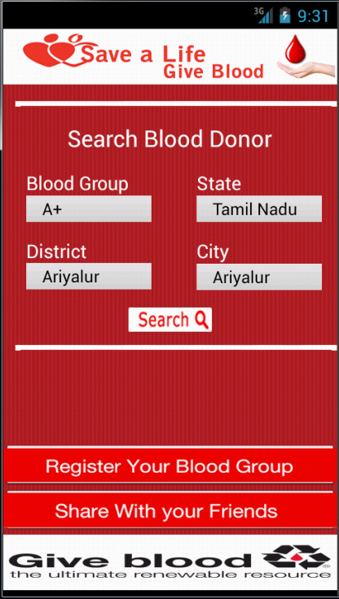

Fig: 9.2.2 Main Page

9.2.3 USER REGISTRATION

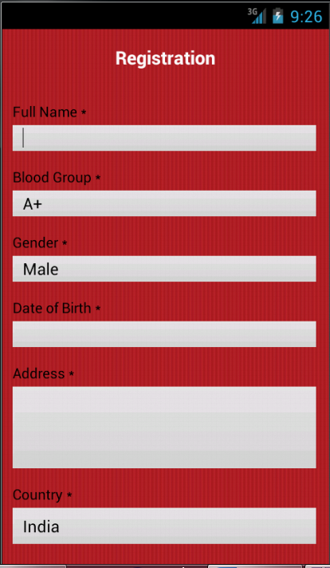

Fig: 9.2.3 Registration

9.2.4 SHARE PAGE

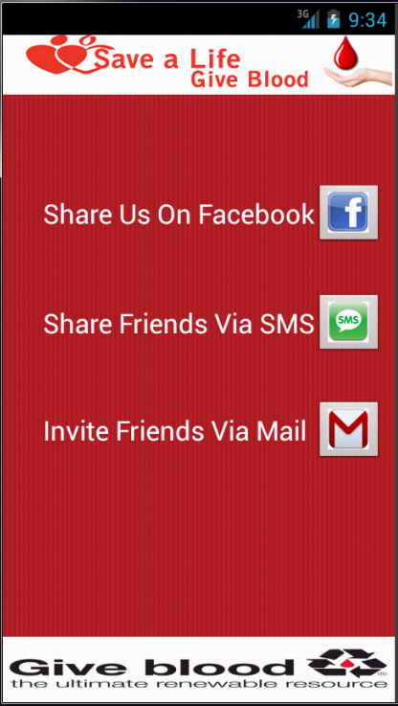

Fig: 9.2.4 Share Page

CHAPTER 10
REFERENCES

- JAVA THE COMPLETE REFERENCE BOOK BY STEVEN HOLZNER.
- XML THE COMPLETE REFERENCE BOOK BY WILLIAMSON
- HEAD FIRST JAVA BY BERT BATES.
- LEARN JAVA FOR ANDROID DEVELOPMENT BY JEFF FRIESEN.
- GOOGLE.ANDROID.EBOOKS.COLLECTION.
- https://www. developer.android.com
- http://stackoverflow.com/questions/tagged/android

