Android App- “E-Sankalp”
[Rural Development through Technology]

Dr. Chitra G. Desai,
Prof.Vikrant V. Shaga,
Mr.Yogesh Lakhole
Remote Center: 1098

Introduction
This project aims to develop the rural India with the help of technology. Features include information of agriculture techniques, use of natural resources, about the education for different age group people, different techniques for income generation, Health related information , women empowerment etc. According to us, users will find the various advantages and initial way for learning and using Technologies for enhancing the quality of Rural India population.

Application Users
The users of the system are the Villagers, NGO’s or any other App Users. Language strictly used Marathi Language as it’s for rural Maharashtrian people. May be NGO’s can use this app for training or guiding villagers in understanding or using the apps and their contents.

Objective:
- Increase the income generation by some percentage with minimum number of resources
- Make them aware about Education & Technology
- Providing knowledge about different techniques of Agriculture
- Health awareness
- To aware them about use of Natural Resources

Functional Requirements
As a user of the app, he/she can only view the information and view the videos related to different pillars of the application.

Pillars of the app are as follows:
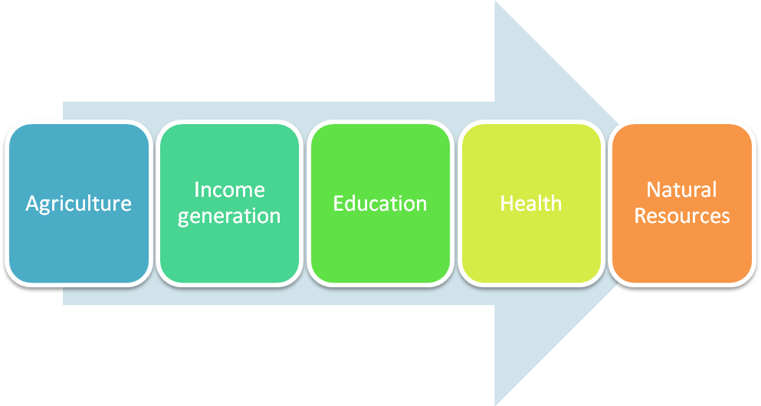

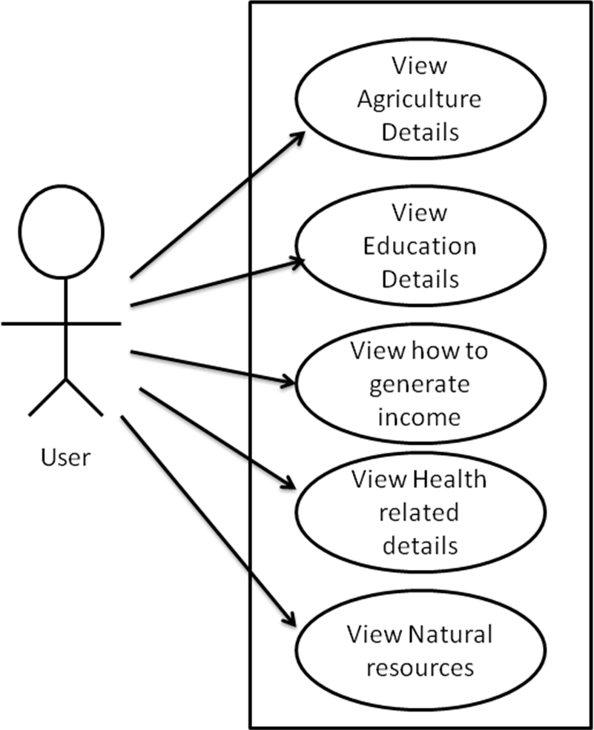

Figure: Use Case Diagram for Viewing information

5. Software and Hardware Requirements
We develop the app using following Softwares:
- Java SE 7 Software Development Kit
- Eclipse 3.8.2 (Android Development Toolkit) IDE
- Android SDK Version 4.4
- ADT v22.3.0
App supports on Android OS HoneyComb to KitKat versions on Screen Size 7” or above (Tablet)

Screen Shots
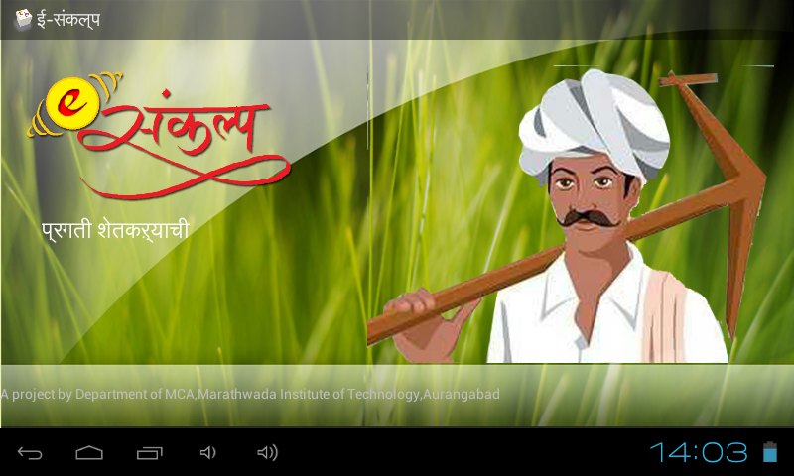
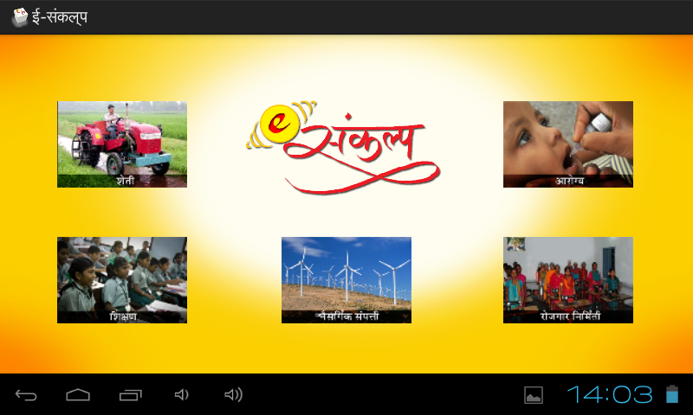

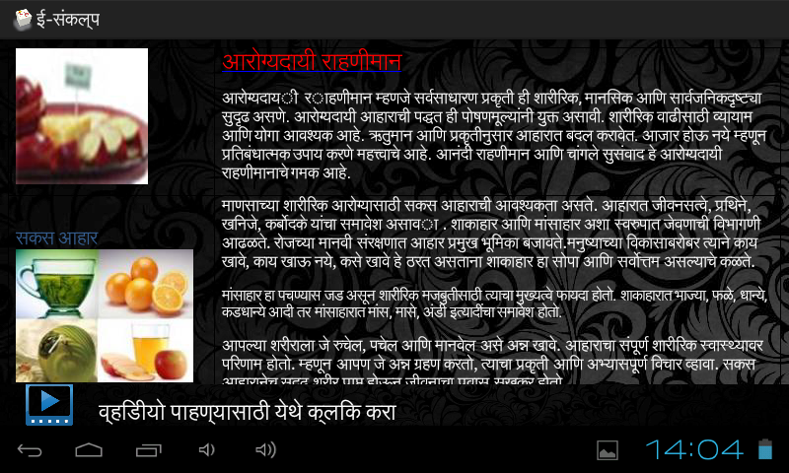

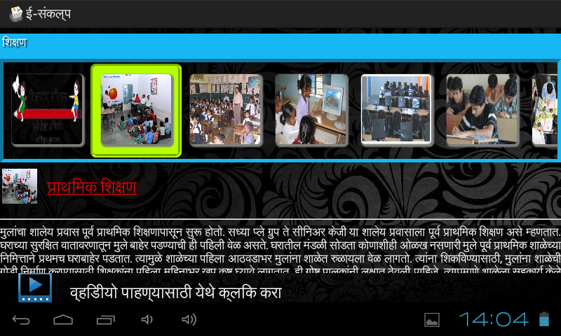

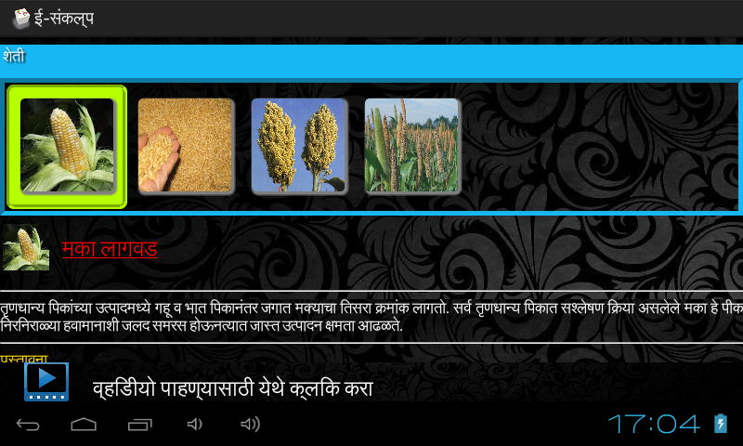

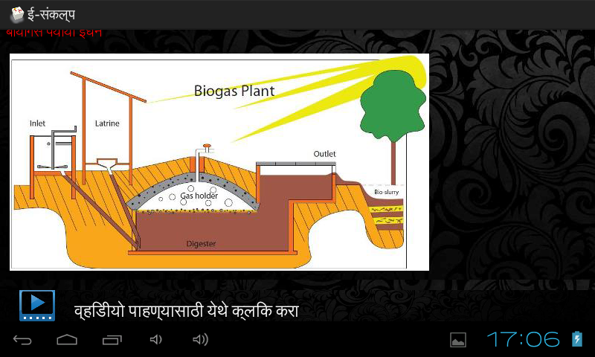

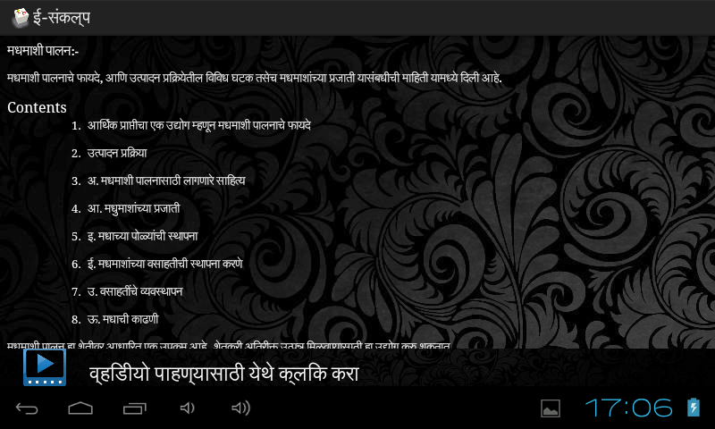

References
- developer.android.com
- Tutorialspoint.com/android
- Stackoverflow.com

Steps to Install E-Sankalp application

TO INSTALL ANDROID APPLICATION:

1. Download sankalp.apk file
2. Copy this file to Tablet.
3. Open sankalp.apk file on tablet (it will ask for installation of application)

TO PLAY VIDEOS IN APPLICATION:

1. Download SankalpVideo.rar file.
2. Extract this RAR file, it gives video files (name as agri.mp4,health.mp4,ig.mp4,ns.mp4 & edu.mp4 ).
3. Copy this videos to Tablets's sankalp folder (folder is created by default on app installation ).

