Acknowledgement

There are numerous persons to whom we owe our thanks for their help, support, advice and suggestions during the various stages of this project.
We thank profusely our academic guide Miss. Reshma Lakhani, Assistant Professor to render us fit to achieve excellence besides providing a positive work environment. Under her able guidance at every step, it is made possible to complete this project within the stipulated period.
We would like to express our deep sense of gratitude to Prof. Dhaval Jadhav, Head of Department of Computer Science for enlightening us with constructive suggestions by attending to our problems patiently and to improve the quality of work. With out whose whole hearted support, this project would not have been a reality.
We are grateful to our able and beloved principal Dr. Jayesh Shah for his blessings in the successful completion of this project. He has been a continuous source of inspirations with his cheerful countenance.
Last but not least, we consider it our duty to take this opportunity to thank our entire faculty members who have extended their unstinted cooperation during this project work. We feel amply rewarded if the project is found useful.

SONI DARSHAN S. (090490131007)

NAIK JAY R. (090490131041)

PATEL MAYUR S. (090490131058)

Abstract

The SmartDiary is a Diary application that is designed and developed to capture all the Events, Moments, Memos, Pictures etc. and to Store them for Future Reference. SmartDiary is one type of Interactive Diary that can be used at any Place and at anywhere right from our Smart phone. Now a days Smart phones are easily available at a low prices so this application will be going to be very useful for features like adding Text, Memos, Photos, Places, Books, Urls, Music, Password Protected entries , Backup and Restore etc. with one single device. There is no need of taking pen and paper or any other different devices to keep with us for different purpose. It will be going to be all in one.

Sr No |  | Topic | Page No
 |  | ACKNOWLEDGEMENT | 1
 |  | ABSTRACT | 2
 |  | TABLES
 |  | 1. List of Figures | 5
 |  | 2. List of Tables | 6
1 | INTRODUCTION |  | 7
 | 1.1 | Project Detail: Broad specifications of the work entrusted to you | 8
 | 1.2 | Purpose | 8
 | 1.3 | Scope | 8
 | 1.4 | Technology and Literature | 9
2 | SYSTEM REQUIREMENT STUDY |  | 13
 | 2.1 | User Characteristics | 14
 | 2.2 | Hardware and Software Requirements | 14
 | 2.3 | Software requirement Specifications | 15
 | 2.4 | Assumptions and Dependencies | 16
3 |  | PROJECT MANAGEMENT | 18
 | 3.1 | Feasibility Study | 19
 | 3.2 | Project Planning | 20
 | 2.3 | Projects scheduling chart | 21
4 | SYSTEM ANALYSES |  | 24
 | 4.1 | Study of Current System | 25
 | 4.2 | Problem and Weakness of Current System | 25
 | 4.3 | Features of New System | 25
 | 4.4 | Activity Diagram | 26
 | 4.5 | Class Diagram | 27
 | 4.6 | Use Case Diagram | 28
 | 4.7 | Sequence Diagram | 29
 | 4.8 | Data Flow Diagram | 31
 | 4.9 | Database Table | 36
5 | APPLICATION FEATURES |  | 37
 | 5.1 | System Architecture Diagram | 38
 | 5.2 | System Module | 39
6 | IMPLEMENTATION |  | 41
 | 6.1 | User Interface | 42
7 | TESTING |  | 48
 | 7.1 | Testing Plan | 48
 | 7.2 | Testing Strategy | 50
 | 7.3 | Testing Methods | 50
8 | LIMITATIONS & FUTURE ENHANCEMENTS |  | 52
 | 8.1 | LIMITATIONS | 53
 | 8.2 | FUTURE ENHANCEMENTS | 53
9 | CONCLUSION& DISCUSSION |  | 54
 | 9.1 | Self Analysis of Project Viabilities | 55
 | 9.2 | Summary of Project Work | 55
 |  | Conclusion | 56
 |  | BIBILIOGRAPHY | 57
 |  | EXPERIENCE | 58

- List of Figures

Figure No Figure Description Page No

Figure 3.1 | - SDLC Life cycle | 20
Figure 4.1  Figure 4.2  Figure 4.3  Figure 4.4  Figure 4.5  Figure 5.1  Figure 6.1  Figure 6.2  Figure 6.3  Figure 6.4  Figure 6.5  Figure 6.6  Figure 7.1 | - Activity Diagram  - Class Diagram  - Use case Diagram  - Sequence Diagram  - DFD Diagram  - Design  - Text Entry  - Image Capture  - Maps  - Video  - Music  - Voice Recording  - Testing Plan | 26  27  28  30  31  38  42  43  44  45  46  47  49

- List of Tables

Table No Table Description Page No

Table 2.1  Table 4.1  Table 4.2 | Hardware/Software Requirement  Database Table – Notes  Database Table - Photos | 14  36  36

Chapter 1

Introduction

  - Project Detail: Broad specifications of the work entrusted to you
This application can be used by anybody who have an android phone. This application provide very simple user interface, so user can easily access and use the application to store the memorable moments of their life. Our application can be used at any place to store notes, videos, images and many other things. There is no need of have note, pen, Camera or other devices to store all the things discussed above.
  - Purpose
The purpose to develop this application is to provide user a better way to store the events at a single place without the using different devices. All the features which user need is provided by this application. The main goal is to provide simple user interface and easy accessibility of all the features. So this application stores Memos, Images, Videos, Voice Recordings, Location, and many other things that are useful to us.
  - Scope
Now a day’s most of the people use android phones. This application can run on almost by any android phone that is using Gingerbread or higher version of the android operating system. So it will be going to be very useful to users to store events. The user interface is much easy so that user can easily access it efficiently.

1.4 Technology and Literature
- Introduction to Android O.S.
Android is a Linux-based operating system for mobile devices such as smart phones and tablet computers. It is developed by the Open Handset Alliance led by Google. A software stack for mobile devices that includes an operating system, middleware and key applications. The Android SDK provides the tools and APIs necessary to begin developing applications on the Android platform using the Java programming language . The Android Open Source Project (AOSP) is led by Google, and is tasked with the maintenance and development of Android. According to the project "The goal of the Android Open Source Project is to create a successful real-world product that improves the mobile experience for end users." AOSP also maintains the Android Compatibility Program, defining an "Android compatible" device " as one that can run any application written by third-party developers using the Android SDK and NDK", to prevent incompatible Android implementations. The compatibility program is also optional and free of charge, with the Compatibility Test Suite also free and open-source. Android has seen a number of updates since its original release, each fixing bugs and adding new features. Each version is named, in alphabetical order, after a dessert.

- Android Fundamentals
Many authors described Android application development fundamentals, which
include setting up Android development environment on the machine, AndroidManifest.xml
file, Activities, Intents, and XML layouts. Jackson (2011) outlines “three major components
of an Android development environment: Java, Eclipse, Android” and provides instructions
on how to download and install necessary files to establish this environment. Felker (2011)
does not explicitly state the components but rather points out that Java JDK, Android SDK,
Eclipse IDE, and Android ADT need to be installed and configured on a machine. The steps
Provided by these two authors are standard. They appear in many books written on Android
development and are also presented on official Android website (“Installing the SDK”, n.d.).
Ableson, King, and Sen (2011) present “four primary components of Android
applications”: Activity, Service, BroadcastReceiver, and ContentProvider. It is noted that “a
particular Android application might not contain all of these elements, but will have at least
one of these elements” (Ableson, King, and Sen, 2011). Since Activity “displays a UI (user
interface) and responds to system and user initiated events” (Ableson, King, and Sen, 2011),
it is used very frequently for Android applications. These Activities are declared in
AndroidManifest.xml file, which provides “the foundation for any Android application”
(Murphy, 2010). Activities present their views through XML layouts and “communicate”
with each other through Intents. Clear understanding of these concepts and Java programming language is a prerequisite to start implementing the development techniques used in Android applications.
- Different versions of Android:-

- 2.1 Eclair
Android 2.1 is a minor platform release deployable to Android-powered handsets starting in January 2010. This release includes new API changes and bug fixes.

- 2.3 Gingerbread
Refined the user interface, improved the soft keyboard and copy/paste features, improved gaming performance, added SIP support (VoIP calls), and added support for Near Field Communication.

- 3.0 Honeycomb
Was a tablet-oriented release which supports larger screen devices and introduces many new user interface features, support for multi-core processors, hardware acceleration for graphics and full system encryption. The first device featuring this version, the Motorola Xoom tablet, went on sale in February 2011.

- 3.1 Honeycomb
Released in May 2011, added support for extra input devices, USB host mode for transferring information directly from cameras and other devices, and the Google Movies and Books apps.

- 3.2 Honeycomb
Released in July 2011, added optimization for a broader range of screen sizes, new "zoom-to-fill" screen compatibility mode, loading media files directly from SD card, and an extended screen support API. Huawei Media Pad is the first 7 inch tablet to use this version.

- 4.0 Ice Cream Sandwich
Announced on October 19, 2011, brought Honeycomb features to smart phones and added new features including facial recognition unlock, network data usage monitoring and control, unified social networking contacts, photography enhancements, offline email searching, app folders, and information sharing using NFC. Android 4.0.4 Ice Cream Sandwich is the latest Android version that is available to phones. The source code of Android 4.0.1was released on November 14, 2011.
- Eclipse
Eclipse is a multi-language software development environment comprising an integrated development environment (IDE) and an extensible plug-in system. It is written mostly in Java programming Languages including Ada, C, C++, COBOL, Fortran, Haskell, Perl, PHP, Python, R, Ruby (including Ruby on Rails framework), Scala, Clojure, Groovy, Android and Scheme. It can also be used to develop packages for the software Mathematica. Development environments include the Eclipse Java development tools (JDT) for Java, Eclipse CDT for C/C++ and Eclipse PDT for PHP, among others.
- Use of XML
The Android platform is an open source mobile development platform. It gives you access to all aspects of the mobile device that it runs on, from low level graphics, to hardware like the camera on a phone. With so many things possible using Android, you might wonder why you need to bother with XML. It is not that working with XML is so interesting; it is working with the things that it enables. XML is commonly used as a data format on the Internet. If you want to access data from the Internet, chances are that the data will be in the form of XML. If you want to send data to a Web service, you might also need to send XML. In short, if your Android application will leverage the Internet, then you will probably need to work with XML. Luckily, you have a lot of options available for working with XML on Android. Android provides a straightforward XML vocabulary that corresponds to the View classes and subclasses, such as those for widgets and layouts.

Chapter 2
SYSTEM REQUIREMENT STUDY

2.1 User Characteristics

User must have characteristic as given below.

- The one of the most required thing is that user must have the android phones.

- The access of this application is so easy that user don’t required any prior knowledge to use this application, as user already use the android phones so they are smart enough to use this application efficiently.

2.2 Hardware and Software Requirements

Hardware requirements  For SmartDiary | PC | Cell Phone
Processor
Minimum | 1 GHz | 600 MHz
Recommended | 1 GHz | 800 MHz
RAM
Minimum | 512 MB | 256 MB
Recommended | 1 GB | 512 MB
Disk space (minimum)
32-bit | 850 MB | 15 MB
64-bit | 2 GB | NA
Table 2.1
2.3 SRS [Software Requirement Specification]

R.1 Splash Screen
The application will be initiated with splash screen.
Input: Click on the SD icon.
Output: Application will start with splash screen.
R.2 Entry screen
The entry screen will be displayed, where new entry can be added and older one are displayed.
Input: User enters the home screen.
Output: Older entries are displayed.
R.2.1 Entry
The buttons is used to add different types data entries.
Input: Buttons clicked for new entry.
Output: Different buttons are clicked and new entry entered.

R.2.1.1 Text Entry
New Text, Notes or Memo entry will be added to store Text.
Input: User enter the text that he/she has to note down and save it.
Output: The new entry will be stored in a database and displayed on home screen.

R.2.1.2 Image tagging
User can take a picture using cellphone’s camera or choose existing one from gallery and enters description.
Input: The image will choose for tagging.
Output: The image tagging information will store in a database and displayed on
home screen as new entry.

R.2.1.3 Music
User can select music from android music library and stores it’s detail along with its album cover.
Input: User select the required song from music library.
Output: Music details will be saved.

R.2.1.4 Places
User can tag himself at any place and saves its location using google maps.
Input: The user searches for required place or gps can be used to get current
location.
Output: User’s current location will be stored with gps coordinates and saved into
database.

R.2.1.5 URL
User can paste url from the clipboard and store it.
Input: User pastes the URL that he/she would like to store.
Output: The URL link will be stored.

R.2.1.6 Voice Recording
User can record the voice by this functionality and store into this.
Input: User record the voice by button clicking.
Output: The recorded voice as audio file can store into this.

R.3 Setting screen
The settings menu will be display as user clicks on settings button.
Input: User clicks on the settings button.
Output: The settings menu will be displayed.

R.3.1 SNS
Here user can share data with social networking sites.
Input: User clicks on SNS_Account button.
Output: Different Social Networking accounts will be displayed.
R.3.2 SYCHRONISATION
User can synchronize and take backup on the drop box.
Input: User clicks on the backup button.
Output: The data backup will be stored to drop box account.

R.3.3 Information
The information about the application is displayed here.
Input: User clicks on the information button.
Output: The information about application will be displayed.

2.4 Assumptions and Dependencies

Assumption:-

The assumption is made while developing this application is that user can easily known how to use android phones. They have the basic knowledge to use the android phones with different features.
The all user upgrade their mobile operating system to at least Gingerbread.

Dependency:-

The whole application is run on the mobile, so it is dependent on the mobile.
The another dependency is android operating system, that is must.

Chapter 3
PROJECT MANAGEMENT

3.1 Feasibility study

An important outcome of the preliminary investigation is the determination that the system requested is feasible. The feasibility study is carried out to examine the like hood that the system will be useful to organization.
The feasibility of our project has been judged on the basis of time, technology, resources available and project length.
- Time :-
  - Project is initiated with specified deadlines.
  - The duration allotted to complete the project is 12 weeks which is enough time to build this system, so as far as the time is concerned this project is feasible.
- Technology:-
  - This project is built on Android operating system. As far as the technical risk is negligible, so problem is feasible.
- Resources:-
  - We need trained software engineers for Android. We need Internet Network connection, Internet Information Services, and android version 2.3.1 or beyond it.
  - We have all the resources in the desired amount.
- Project Size:-
  - The Project size might be around 7500 LOC. This is just the rough assumption because we don’t have any basis of this type of past projects.
- Finance:
  - No budgetary contains were imposed on software. So finance is not the problem.

Thus the project is normally feasibly and therefore we have undertaken this project.
3.2 Project Planning

INCREMENTAL MODEL
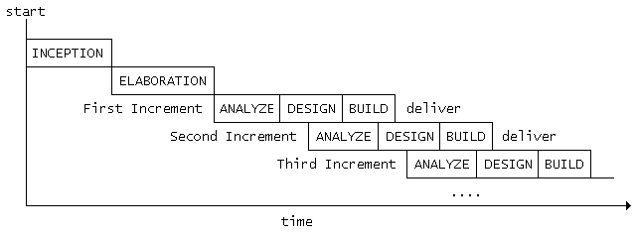

Figure 3.1
We are using incremental model to develop software. The incremental approach attempts to combine the waterfall sequence with some of the advantages of prototyping. This approach is favored by many object-oriented practitioners. It basically divides the overall project into a number of increments. Then it applies the waterfall model to each increment. The system is put into production when the first increment is delivered. As time passes additional increments are completed and added to the working system.

Incremental Phases
- Inception
During the inception phase, the purpose, business rationale, and scope of the project is determined. This is similar to the feasibility analysis that is done in other life cycles.

- Elaboration
During the elaboration phase, more detailed requirements are collected, high level analysis is performed, and a general architecture is determined. This phase divides the requirements into increments that can be built separately. As we will see, each increment consists of a subset of high level use cases that capture the user's requirements.

- Construction
The construction phase builds increments of the system. Each increment is developed using a waterfall approach. This includes detailed analysis and design for the use cases in the increment and coding and testing of the event processors that implement the sequence of events defined by the use cases. The result is production quality software that satisfies a subset of the requirements and is delivered to the end users. Work on different increments may be done in parallel.

- Transition
The transition phase (not shown in the figure) is the last phase in the project. This may include such things a performance tuning and rollout to all users.

3.3 SCHEDULING PROJECT CHART
Software project scheduling is an activity that distributes estimated effort across the planed project duration by allocating the effort to specific software engineering tasks.
- All task appear in network
- Effort and timing are intelligently allocated to each task
- Interdependencies between task are properly indicated
- Resources are allocated for the work to be done
3.3.1 Interdependency
Interdependency of each compartmentalized activities were found out. Some task must occur in sequence where as some occur in parallel.
3.3.2 Time allocation
Each task to be schedule must be allocated some number of work units. In our system we start date and completion date is noted in activity charts as well as we also note the working day in our chart.
3.3.3 Task set
A task set is a collection of software engineering work
    - Tasks, milestones, and deliverables.
Tasks sets are designed to accommodate different types of projects and different degrees of rigor.

← Sept08 →← Oct 08 →← Nov08 → ←Dec08→

Week | 3 | 4 | 1 | 2 | 3 | 4 | 1 | 2 | 3 | 4 | 1 | 2
Define Problem
Problem Analysis
Requirement Gathering
Learned
Eclipse
Implementation Eclipse

← Jan09→← Feb09 →← March09 →←Apr09→
Week | 2 | 3 | 4 | 1 | 2 | 3 | 4 | 1 | 2 | 3 | 4 | 1 | 2
Learned Java for Android
Learned XML for Android
Learned run on different AVD’s
Implementation all task on devices
Check all the implementation and bug.

CHAPTER – 4

SYSTEM ANALYSIS

4.1 Study of Current System

- Currently users are using simple note and pen for store their data. To store their day to day activity.
- User using digital camera for storing images and videos.
- In mobile phone also they this type of activity but not store all the information at one place with all the details with it.

4.2 Problem and Weakness of Current System

- Currently in market there are so many application that provides features like this, but they are not providing all the features we are going to provide in one application. So it will going to be very useful, that all task are performed in one application.

4.3 Features of New System

- The new features in our features are that we are going to provide all features in one application.
- There are so many other features that it will going to provide like books, music, URL.

4.4 Activity Diagram
Activity Diagram represents computational activities from the source to destination. Source is at the top and destination is at the bottom of the diagram. There can be more than one Activity Diagrams of the system.
For our system, it represents the view as shown in the figure. When client up it will starts timer and when timer elapsed at the given time interval it will start gathering the information and it will dump information to database.
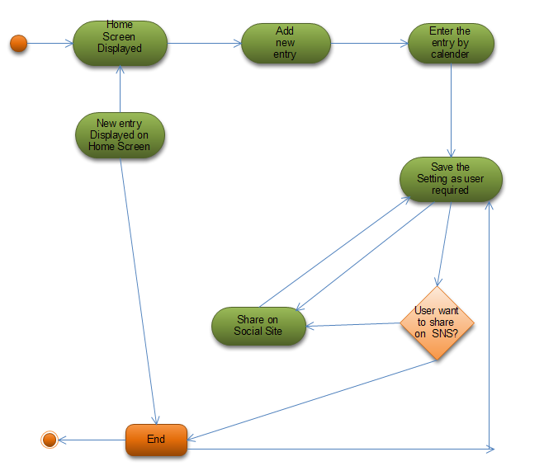

Figure 4.1

4.5 Class Diagram
Class View Diagram represents static behavior of the system. It will have application domain as well as relationship. There can be only one class diagram of the system. It is similar to E-R (Entity-Relationship) diagram. The main components are class and relationship like association generalization and dependency.
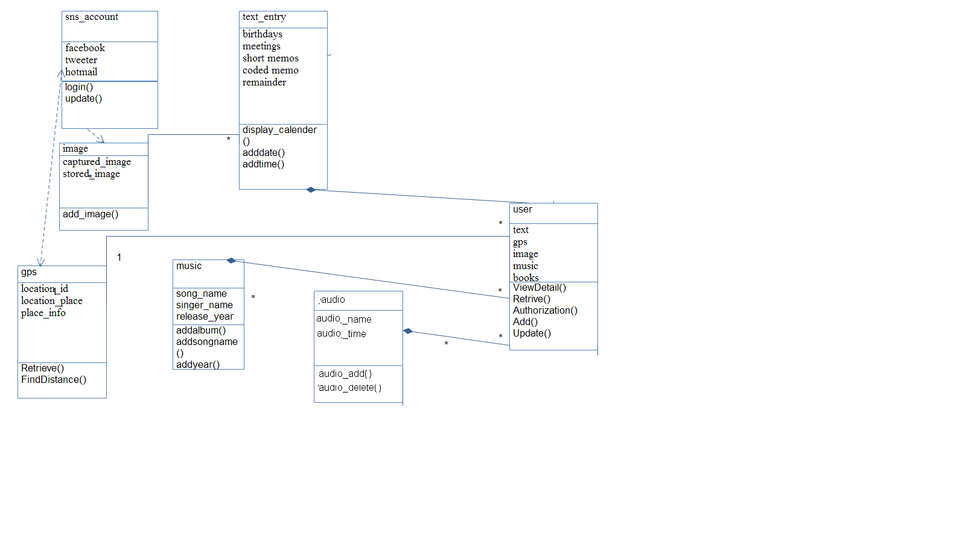

Figure 4.2

4.6 Use Case Diagram
A use case diagram in the Unified Modeling Language (UML) is a type of behavioral diagram defined by and created from a Use-case analysis. Its purpose is to present a graphical overview of the functionality provided by a system in terms of actors, their goals (represented as use cases), and any dependencies between those use cases.
The main purpose of a use case diagram is to show what system functions are performed for which actor. Roles of the actors in the system can be depicted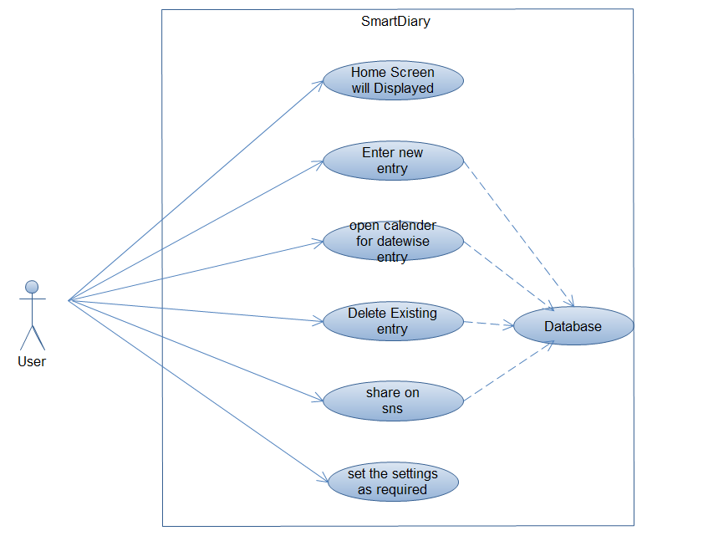
Figure 4.3

4.7 Sequence Diagram

Sequence diagrams describe interactions among classes in terms of an exchange of messages over time.UML sequence diagrams model the flow of logic within your system in a visual manner, enabling you both to document and validate your logic, and are commonly used for both analysis and design purposes.
Sequence diagrams are the most popular UML artifact for dynamic modelling, which focuses on identifying the behaviour within your system. Other dynamic modelling techniques include activity diagramming, communication diagramming, timing diagramming, and interaction overview diagramming. Sequence diagrams, along with class diagrams and physical data models are in my opinion the most important design-level models for modern business application development.

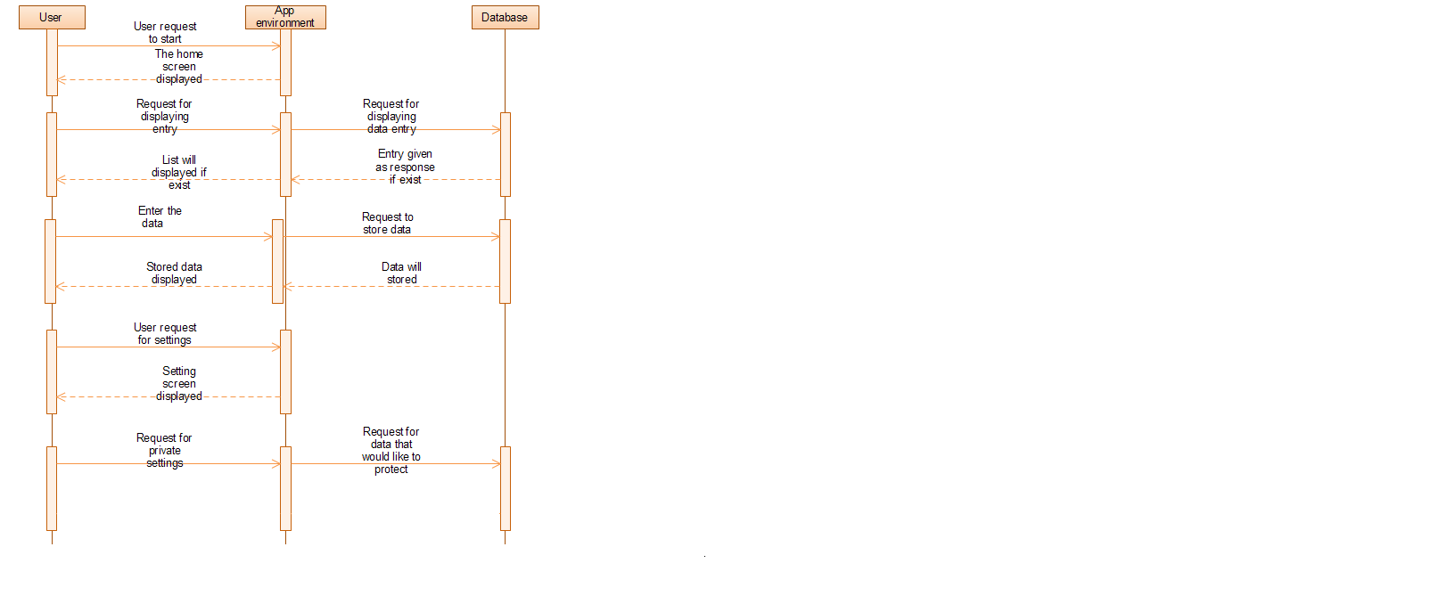

Figure 4.4

4.8 Data Flow Diagram

A data flow diagram (DFD) is a graphical representation of the "flow" of data through an information system. DFDs can also be used for the visualization of data processing (structured design).On a DFD, data items flow from an external data source or an internal data store to an internal data store or an external data sink, via an internal process.
A DFD provides no information about the timing of processes, or about whether processes will operate in sequence or in parallel. It is therefore quite different from a flowchart, which shows the flow of control through an algorithm, allowing a reader to determine what operations will be performed, in what order, and under what circumstances, but not what kinds of data will be input to and output from the system, nor where the data will come from and go to, nor where the data will be stored (all of which are shown on a DFD).
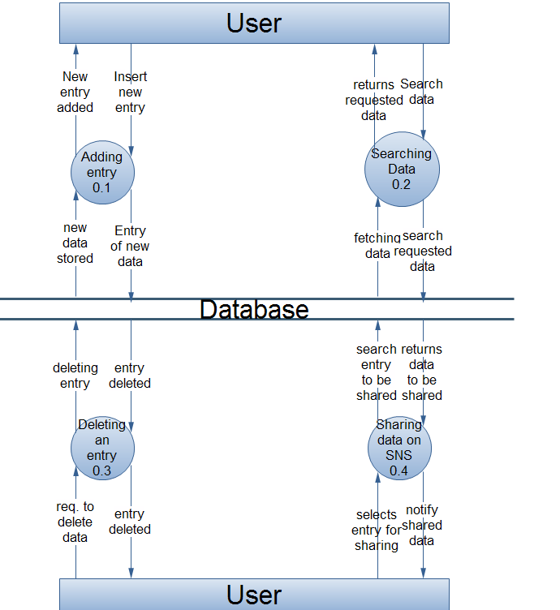

Figure 4.5

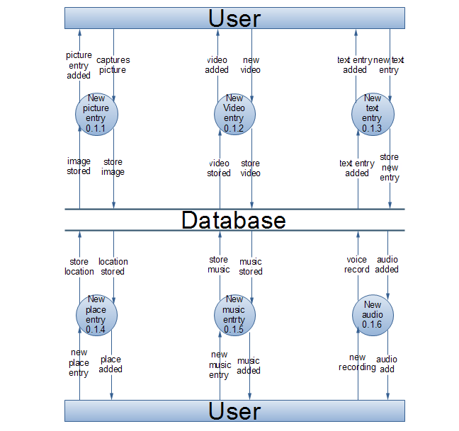

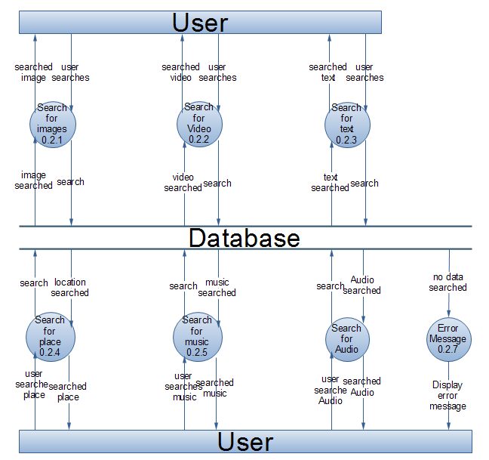

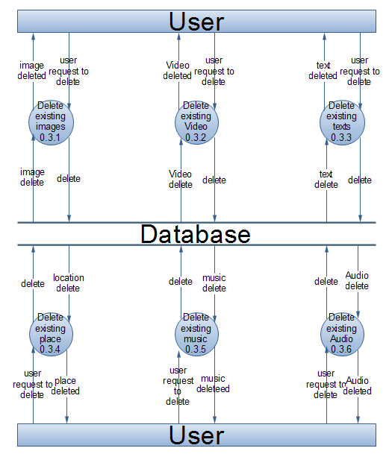

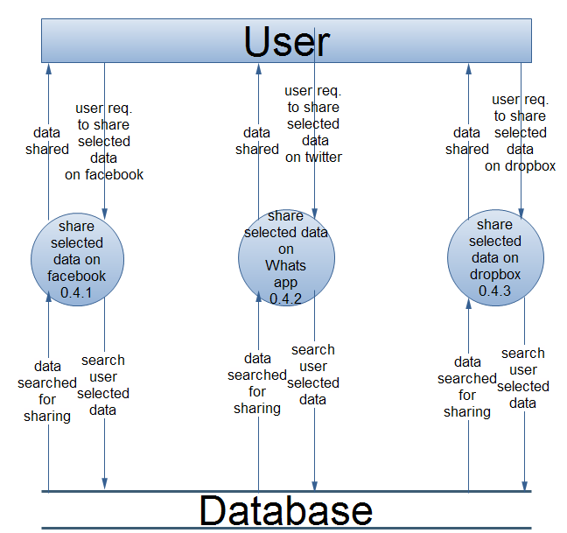

4.9 Database Table:-

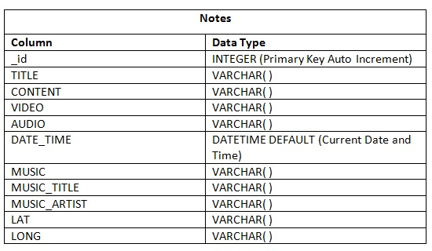
Table 4.1 Notes Table

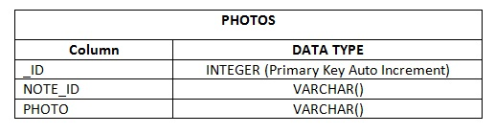

Table 4.2 Photos Table

Chapter 5
APPLICATION FEATURES

5.1 System Architecture Design

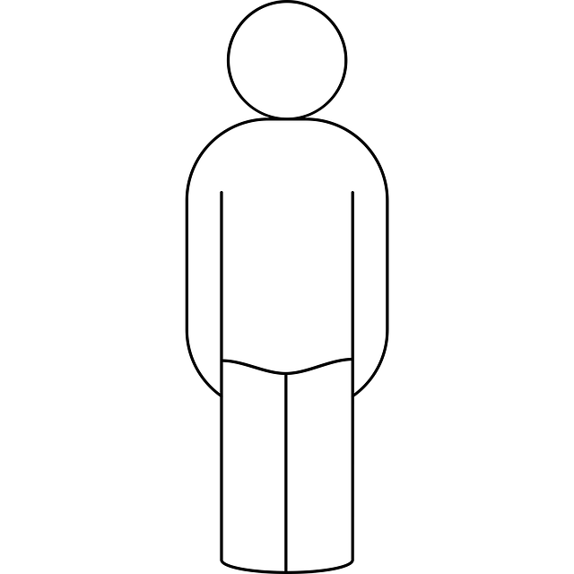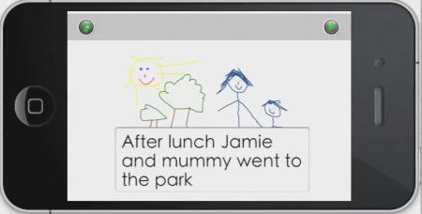

User Cell Phone 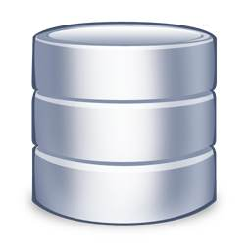 Database

Figure 5.1

5.2 System Modules
  - User module
User can Access various functionalities provided by the application. This module includes user interface to home screen of our application from where user can see previous entries and insert new entries.
- Text
User can insert new text entries, notes and store memos along with their date and time stamps.
- Photo
User can click new picture using phone’s camera or choose existing photo from android’s image gallery provide description of the photo and store it.
- Places
User can search places from google maps drop pin and save it along with its description.
- Music
User can select song from native android music library and store its name and singer name.
- Voice Recording
User can record their voice and any other amazing audio they want to record.
- Video Recording
User can record the video at any memorable place and add it to diary. User can also see the list at home page of video along with its time date and place.

  - Backup module
This Module allows user to backup his or her data entries to a drop box account to keep it safe and secure for future reference. for example user changes cell phone or loses data due to some reason user need to install the application again and just link his/her drop box account and restore all the entries back intact with a single click. This Module makes use of user module to fetch all the data entries in order to backup them.

  - Sharing Module
This module allows the user to link their social networking site accounts like facebook , twitter etc and allows user to share picture, text, places, music, books etc with their friends on this social networks. This module interacts with user module to access data entries.

Chapter 6
IMPLEMENTATION

  - USER INTERFACE
TEXT:-
User can insert new text entries, notes and store memos along with their date and time stamps.
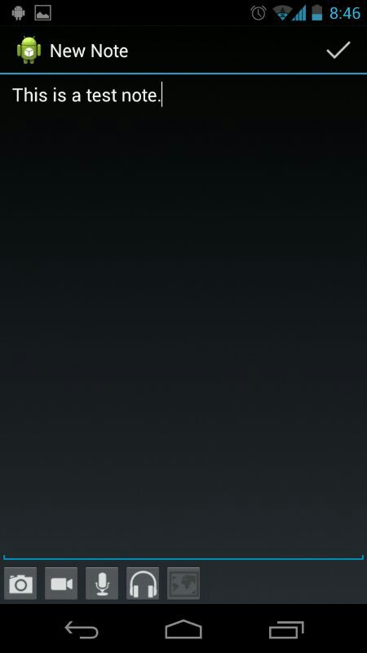
Figure 6.1
IMAGE CAPTURE:-
User can click new picture using phone’s camera or choose existing photo from android’s image gallery provide description of the photo and store it.
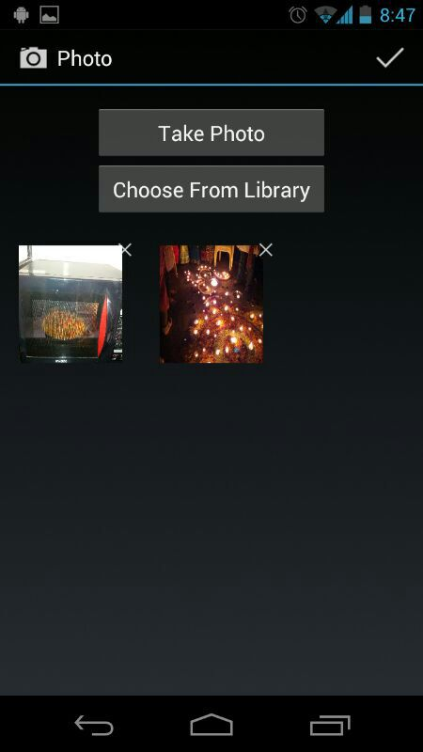
Figure 6.2

MAPS:-
User can search places from google maps drop pin and save it along with its description.
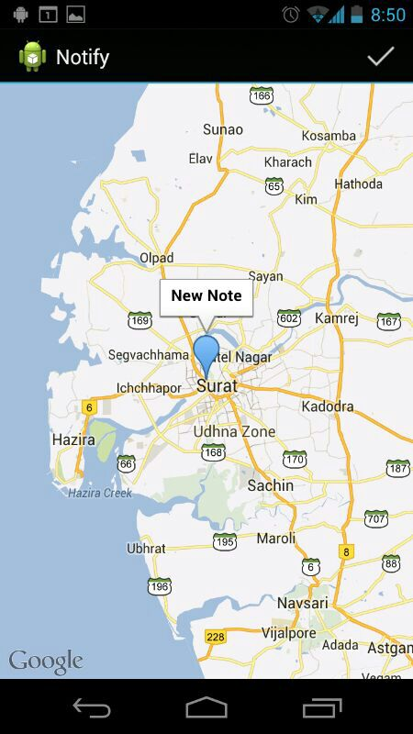
Figure 6.3

VIDEO:-
User can record the video at any memorable place and add it to diary. User can also see the list at home page of video along with its time date and place.
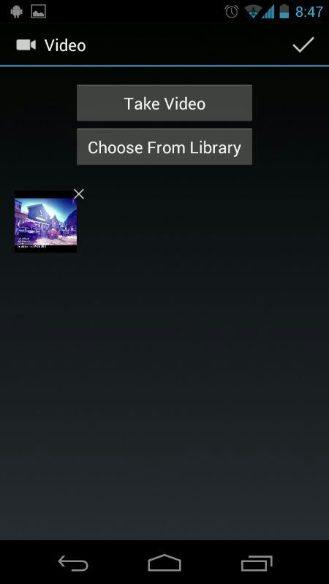
Figure 6.4

MUSIC:-
User can select song from native android music library and store its name and singer name.
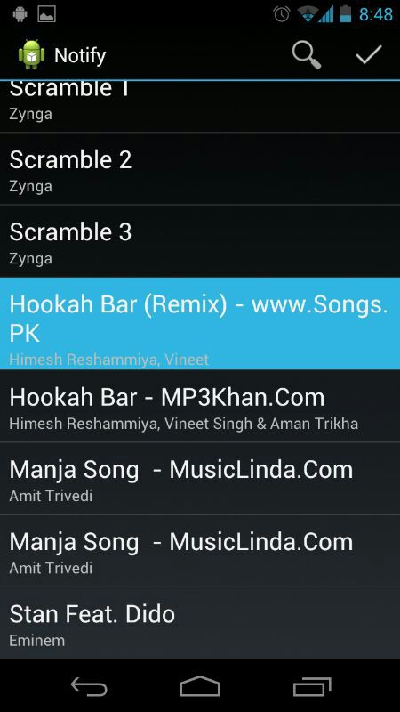
Figure 6.5

VOICE RECORDING:-
User can record their voice and any other amazing audio they want to record.
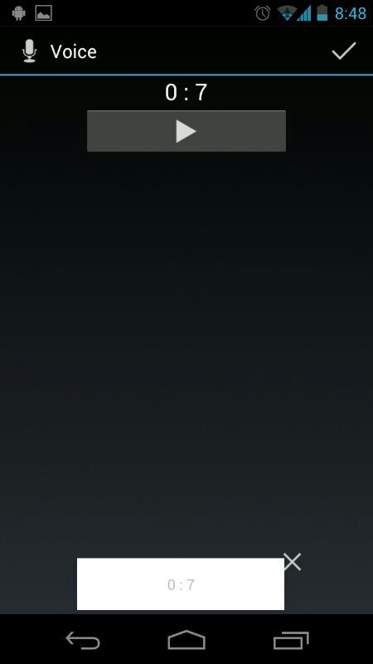

Figure 6.6

CHAPTER 7
TESTING

7.1 Testing plan
“Correctness is the degree to which the software system performs its required functions.”

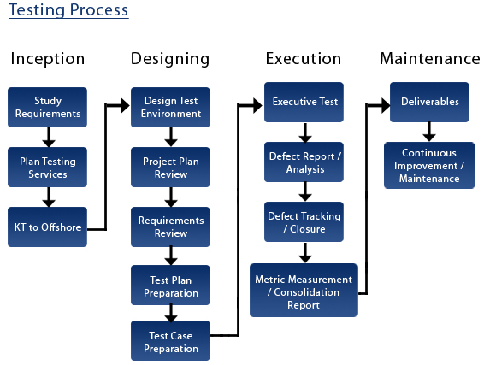
Figure 7.1

“Correctness is the extend to which a software system is free from any faults.”
Software testing is a critical element of software quality assurance and represents ultimate review of specifications, design and coding. Testing represent an interesting analogy for the software .the testing face involves testing of the system using various test data. Preparation of test data plays a vital role in the system testing. After preparing the test data, the system under study is tested using those data. Errors found where corrected and corrections were recorded for future references. Thus a series of testing is performed on the system before it is ready for implementation.

7.2 Testing strategy
Testing strategies is a general approach to the testing process rather than a method of devising particular system or components test. Different testing strategies may be adopted depending on the type of the system to be tested and the development process used. So considering functional oriented nature of this software we adopted following strategy.
- Top down testing
Where testing starts with most abstract components and work downwards. The higher level of our system we checked before testing its detailed components.The program is represented as a single abstracted component with sub component represented by stubs. So we develop some basic stubs with having same interface as the component but with very less functionalities. After the top level components have been tested, its sub components are implemented and tested in the same way. We carry this process recursively until the bottom level is implemented.
7.3 Testing methods
7.3.1 Unit testing-module testing
In this testing individual components and modules are tested to ensure that they are operating correctly. we have tested each and every module such as point in connection class via GPRS.

7.3.2 Integration testing
This testing is systematic technique for constructing the program structure while at the same time conducting test to uncover errors associated with interfacing.
All the modules testing in unit testing are integrated and are tested for their inter decency.

7.3.3 White box testing
As per our project we have used white box testing model because independent paths of modules and loops are the cornerstones of the vast majority of all algorithms implemented in the software.

7.3.4 Black box testing
Black box testing attempts to find errors in the following categories
- Incorrect or missing function
- Interface errors
- Errors in fetching external data
- Behaviour or performance error
- Initialization and termination error
Black box testing is implementing on our project through paste each and every independent module in VC.

CHAPTER 8
LIMITATIONS & FUTURE ENHANCEMENTS

8.1 Limitations

To use some Features of our application like accessing maps, sharing, synchronising we need to have Internet connection.

8.2 Future Enhancements

Adding More Features like accessing google books and storing their
Links.
Adding Setting screen to Manage the application.

CHAPTER 9
CONCLUSION& DISCUSSION

9.1 Self Analysis of Project Viabilities
Whatever we had decided at the time of analysis, we have approximately completed our project accordingly. This application is created in android operating system, so it provides all facility for android mobile.

9.1.1 Project viabilities
- It provides all facility requiring for user.
- To run this project need to install application on android mobile.

9.2 Summary of project work
- Front End : Eclipse IDE
- Language : Java, XML
- Back End : SQlite
- Platform : Android OS

Conclusion
Now a days of the technical world this will going to provide easy way to store memorable moments for the future.

Journal, where you can record events from everyday life. Date book, where you can record what happened on the date with your lover or friends. Scrapbook for famous restaurants, where you can record the location and photos of famous restaurants. Scrap book, where you can save YouTube links and link of your favorite singer or entertainer that you’ve collected from Web. Memoir, where you can record impromptu ideas or memorable phrases from reading. Self-shot photo album, where you can save your own self–shot photos with pretty stickers. Place to record and keep photos, place information, music, Voice Recording, Web-links, and texts for specific subjects. This app provides backup and restore features so you can store all your Data Safe and Secure.

BIBILIOGRAPHY
Web Resource:-
- Developers.android.com
- Androidhive.info

Books:-
- Apress.Pro.Android.Jun.2009
- Professional_Android_Application_Development
- The Android Developer_s Cookbook (7Summits)
- Android.for.Work.Productivity.for.Professionals
- Android_howto-hellowidget
- Connecting-to-web-services-on-android-4577

EXPERIENCE
I achieve lots of support from our Guide. My guide and as well as also sir of my collage are always ready to provide any kind of help. I also got lot support from programming department in which i was working. I also grasp some minor thing but which is vary major part of the project development like to put comment wherever and when necessary, use special naming convection for coding, how to do optimized coding which required less memory and provide fast processing, how to debug code for different bugs etc. which are very useful for me and i have follow it during my project.

