Chapter 1
INTRODUCTION
  - Overview
Android is a Linux-based operating system for mobile devices such as smartphones and tablet computers. It is developed by the Open Handset Alliance, led by Google, Linux V2.6 kernel with a Java programming interface. Google releases the Android code as open-source, under the Apache License. The Android Open Source Project (AOSP) is tasked with the maintenance and further development of Android. The Android Software Development Kit (Android SDK) provides all necessary tools to develop Android applications, SDK tools are platform independent and are required no matter which Android platform you are developing on. They have to be periodically updated. The most important SDK tools include the Android SDK Manager, the AVD Manager, the emulator, and the Dalvik Debug Monitor Server (ddms). Android allows background processing, provides a rich user interface library, supports 2-D and 3-D graphics using the OpenGL libraries, access to the file system and provides an embedded SQLite database. Android's full ranges of computing services and rich functional support have the potential to extend beyond the mobile-phone market. In this project, we get exposure to the Android platform and develop an android based application. Android applications employ a component based approach leading to reusability and flexible development.
  - Problem Definition
Most of the users use their computers for entertainment purposes such as watching a movie, sharing photos, browsing music or playing games. Sitting on a particular spot is never a fun especially when viewing an entertaining media. It can be very impractical to be confined to the keyboard and mouse while sitting 5 or 10 feet from the computer. Therefore, remote controls or wireless mouse and keyboards are also available for computers to solve the limitation mentioned above. However, these remote controls or wireless keyboard and mouse have a fixed set of buttons attached to the device it has been attached and designed to control .

  - Scope of the Project
To develop an android based application, Aim-To control the PC using wireless wifi network..Remote control of a desktop computer is a convenient feature that could be performed by handheld devices. The solution provided relies on a smart device running Android OS (smart phone or tablet) and a Windows-based PC and offers a virtual touchpad and virtual keyboard that send commands to the desktop OS in real time. Such application bundle could ease the use of many application giving the user the ability to control them from any place in the room without having to bring a keyboard and a mouse with himself. It is suitable for virtual reality laboratories where a wireless mouse is not enough to implement advanced interaction techniques. Furthermore the touch screen is comfortable to use as a mouse substitution when a person is standing in front of the audience giving a presentation..
  - Proposed System
The aim of this application is to address the stress of an uncomfortable moment with the use of computer. It enables the user to search for files, click on the desktop applications, play with media such as forward, rewind, pause, run, increase or reduce the volume of a media file. It also allows the user to do multi-touch scrolling and pinch gesture for zoom in and out. This could be achieved by installing the proposed application that emerges to the computer network via Wi-Fi which then connects both system together, then comes with the command from the mobile phone that remotely controls the computer.
Here in this project the client application was implemented. Based on the platform using Android Software Development Kit, this application was written using the Java Programming Language and was designed to run on a customized Linux-based virtual machine called Dalvik. The developed client application has an .apk extension the interested users can download from the developer and installed directly to their mobile phone devices.
Application program starts by checking the Wi-Fi connection. The embedded server runs in parallel once the application starts. The application pulls the xml file from the .apk file to generate the main screen and moves ahead to generate also the application Graphical User Interface (also known as GUI). The application GUI awaits an input from the user and when the action has been performed, it sends a command to the Server which then processes the action sent from the GUI.
  - Modules
Client:
The client application is distributed through a standard Android application package file (APK). The user interface provides an superb user experience, making the Android device (no matter if a smart phone with small screen or a large tablet) an excellent touchpad with keyboard input ability. The multi-touch capabilities of the devices are also utilized to full extent. The minimal Android version required is 2.2. (API level 8).
Server:
The server application is distributed as executable JAR file and is intended for silently running in the background.
Connecting through Wi-Fi:
The mobile application uses the same communication package as the desktop one - java. So the automatic discovery logic mirrors the server-side. A socket is created which listens on a predefined client port. Then it sends echo request to the predefined multicast IP address and waits for response. When automatic discovery is not available for some reason (e.g. prohibited by the system administrator of the wireless network), the user could manually enter the IP of the server and connect to it.
Remote control:
The remote control is straight-forward to implement using it offers methods for simulating press and release of keyboard keys, full mouse control and function to delay sending of events.

  - Flow Daigram
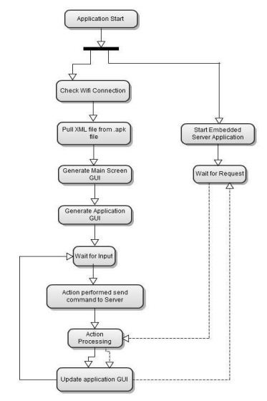
Fig 1.6 Flow daigram for android application

Chapter 2
Literature survey

  - Introduction to Android
Android is an open source mobile operating system that is developed on top of Linux kernel with java programming interface. Google has also pulled together a large group of companies (called the Open Handset Alliance) that both contribute to and use the Android OS in their hardware devices. Android software development kit (SDK) provides are necessary tools to develop android based applications. ADT is a set of components (plug-ins) which extend the Eclipse IDE with Android development capabilities.
  - The Android platform
Android is a layered environment that include UI subsystem includes: Windows,Views,Widgets for displaying common elements such as edit boxes, lists, and drop-down lists.ADT contains all required functionality to create, compile, debug and deploy Android applications from the Eclipse IDE and from the command line. ADT also provides an Android device emulator, so that android applications can be tested without a real Android phone. The Android system uses a special virtual machine, i.e. the Dalvik Virtual Machine to run Java based applications. Dalvik uses special bytecode which is different from Java bytecode. Therefore you cannot run standard Java bytecode on Android. An Android application consists of one or more of the following classifications:
Activities: An application that has a visible UI is implemented with an activity. When a user selects an application from the home screen or application launcher, an activity is started.
Services: A service should be used for any application that needs to persist for a long time, such as a network monitor or update-checking application.

Content providers: A content provider's job is to manage access to persisted data, such as a SQLite database. Applications that make data available to multiple activities or applications, a content provider is the means of accessing your data.
Broadcast receivers: An Android application may be launched to process an element of data or respond to an event, such as the receipt of a text message.
An Android application, along with a file called AndroidManifest.xml, is deployed to a device. AndroidManifest.xml contains the necessary configuration information to properly install it to the device. It includes the required class names and types of events the application is able to process, and the required permissions the application needs to run. The Android system controls the lifecycle of the application. The Android system defines a lifecycle for Activities via predefined methods.
2.3 Application programming interface (API)
The following standard packages are supported in Android.
Table 2.3 Application Program Interface
android.hardware | Provides support for hardware features, such as the camera and other sensors.
android.location | Contains classes that define Android location-based and related services.
android.media | Provides classes that manage various media interfaces in audio and video.
android.net | Classes that help with network access, beyond the normal java.net.* APIs.
android.os | Provides basic operating system services, message passing, and inter-process communication on the device.
android.preference | Provides classes that manage application preferences and implement the preferences UI.
android.provider | Provides convenience classes to access the content providers supplied by Android.
android.sax | A framework that makes it easy to write efficient and robust SAX handlers.
android.support.v4.app | Support android.app classes to assist with development of applications for android API level 4 or later.
android.support.v4.content | Support android.content classes to assist with development of applications for android API level 4 or later.
android.support.v4.database | Support android.database classes to assist with development of applications for android API level 4 or later.
android.support.v4.util | Support android.util classes to assist with development of applications for android API level 4 or later.
android.support.v4.view | Support android.util classes to assist with development of applications for android API level 4 or later.
android.support.v4.view.accessibility | Support classes to access some of the android.view.accessibility package features introduced after API level 4 in a backwards compatible fashion.
android.support.v4.widget | Support android.widget classes to assist with development of applications for android API level 4 or later.

Chapter 3
SYSTEM REQUIREMENT SPECIFICATION

3.1 Software Requirements
Table 3.1 Software Requirements

Minimum Requirements
Operating system | Microsoft Windows XP or above version
Other Softwares | - Android 2.3.3 ( gingerbread) software development kit (SDK)  - JDK1.6 or above version installed and configured on class path  - Eclipse indigo version integrated with android SDK coupled with emulator.  - Google APIs installed with android SDK to check compatibility with other versions of android.

3.2 Hardware Requirements
Table 3.2 Hardware Requirements

Minimum Requirements
Processor | 133-MHz Intel Pentium-class processor
Memory and Hard Disk | 1GB of RAM, 20GB hard disk
Android device | Android mobile phone with gingerbread or higher version of android installed.

Chapter 4
IMPLEMENTATION

4.1 Coding

4.1.1 RemoteControl.java

package com.joshsera;

import java.util.ArrayList;
import java.util.HashMap;
import java.util.LinkedList;
import java.util.List;
import java.util.Map;

import android.app.Activity;
import android.content.Intent;
import android.os.Bundle;
import android.util.Log;
import android.view.Menu;
import android.view.MenuItem;
import android.view.View;
import android.view.ViewGroup;
import android.view.Window;
import android.widget.Button;
import android.widget.EditText;
import android.widget.ImageButton;
import android.widget.ListView;
import android.widget.SimpleAdapter;
import android.widget.TextView;
import android.widget.Toast;

/*
* To-do
*
* DNS lookup
* arrow keys, esc, win key
*/

public class RemoteDroid extends Activity {
private static final String TAG = "RemoteDroid";
// menu item(s)
public static final int MENU_PREFS = 0;
public static final int MENU_HELP = 1;

//
private EditText tbIp;
//
private HelpDialog dlHelp;
private ListView mHostlist;

public RemoteDroid() {
super();
}

/** Called when the activity is first created. */
@Override
public void onCreate(Bundle savedInstanceState) {
super.onCreate(savedInstanceState);

requestWindowFeature(Window.FEATURE_NO_TITLE); // added to save screen space, the Title was shown twice, in Standard Android bar, then below in Bolder larger text, this gets rid of the standard android bar

setContentView(R.layout.main);
// set some listeners
Button but = (Button)this.findViewById(R.id.btnConnect);
but.setOnClickListener(new View.OnClickListener() {
public void onClick(View v) {
onConnectButton();
}
});

// check SharedPreferences for IP
Settings.init(this.getApplicationContext());

mHostlist = (ListView) findViewById(R.id.lvHosts);
populateHostList();

//
this.tbIp = (EditText)this.findViewById(R.id.etIp);
if (Settings.ip != null) {
this.tbIp.setText(Settings.ip);
}
//
if (this.dlHelp == null) {
this.dlHelp = new HelpDialog(this);
}
// goes to onStart
}

private void populateHostList() {
// populates the host list with saved hosts from the settings
LinkedList<String> ips = Settings.savedHosts;
String[] from = new String[]{"hostip"};
int[] to = new int[]{R.id.hostEntry};
List<Map<String,String>> data = new ArrayList<Map<String, String>>();
for (String s:ips){
Map<String, String> map = new HashMap<String, String>();
map.put("hostip", s);
data.add(map);
}

/**
* in order to be able to hook up the onclick listeners for
* the children of the simple adapter, we have to override the
* getView() method to set the listeners we want, so callbacks
* can function correctly
*/

SimpleAdapter adapter = new SimpleAdapter(this,data,R.layout.savedhost,from,to){
@Override
public View getView(int position, View convertView, ViewGroup parent){
View v = super.getView(position, convertView, parent);
TextView text = (TextView) v.findViewById(R.id.hostEntry);
final CharSequence str = text.getText();
ImageButton b = (ImageButton) v.findViewById(R.id.hostbutton);

// set the listener for clicking on the text
text.setOnClickListener(new View.OnClickListener() {

public void onClick(View v) {
onSavedHost(str);
}
});

// set the listener for clicking on the delete button
b.setOnClickListener(new View.OnClickListener() {

public void onClick(View v) {
onRemoveSavedHost(str);
}
});

return v;
}
};

mHostlist.setAdapter(adapter);

}

/** OS kills process */
public void onDestroy() {
super.onDestroy();
}

/** App starts anything it needs to start */
public void onStart() {
super.onStart();
}

/** App kills anything it started */
public void onStop() {
super.onStop();
}

/** App starts displaying things */
public void onResume() {
super.onResume();
}

/** App goes into background */
public void onPause() {
super.onPause();
}

// menu

public boolean onCreateOptionsMenu(Menu menu) {
super.onCreateOptionsMenu(menu);
//
menu.add(0, MENU_PREFS, 0, R.string.txt_preferences).setShortcut('0', 'p').setIcon(R.drawable.icon_prefs);
menu.add(0, MENU_HELP, 0, R.string.txt_help).setShortcut('1', 'h').setIcon(R.drawable.icon_help);
//
return true;
}

public boolean onOptionsItemSelected(MenuItem item) {
//
switch (item.getItemId()) {
case MENU_PREFS:
//
this.onPrefs();
break;
case MENU_HELP:
//
this.onHelp();
break;
}
//
return super.onOptionsItemSelected(item);
}

//

private void onConnectButton() {
String ip = this.tbIp.getText().toString();
if (ip.matches("^[0-9]{1,4}\\.[0-9]{1,4}\\.[0-9]{1,4}\\.[0-9]{1,4}$")) {
try {
Settings.setIp(ip);
//
Intent i = new Intent(this, PadActivity.class);
this.startActivity(i);
this.finish();
} catch (Exception ex) {
//this.tvError.setText("Invalid IP address");
//this.tvError.setVisibility(View.VISIBLE);
Toast.makeText(this, this.getResources().getText(R.string.toast_invalidIP), Toast.LENGTH_LONG).show();
Log.d(TAG, ex.toString());
}
} else {
//this.tvError.setText("Invalid IP address");
//this.tvError.setVisibility(View.VISIBLE);
Toast.makeText(this, this.getResources().getText(R.string.toast_invalidIP), Toast.LENGTH_LONG).show();
}
}

private void onRemoveSavedHost(CharSequence str) {
try {
Settings.removeSavedHost(str);
populateHostList();
// TODO: we should be able to just call _below_ to update the view
// however, the DataSetObserver is locked onto a copy of the data,
// not a reference (from Settings). This needs to be changed...
//((SimpleAdapter)mHostlist.getAdapter()).notifyDataSetChanged();

} catch (Exception e) {
Log.d(TAG,"couldnt remove "+str.toString()+" from list: "+e.toString());
}

}

private void onSavedHost(CharSequence s) {
try {
tbIp.setText(s);
} catch (Exception e) {
Log.d(TAG,e.toString());
}

}

private void onHelp() {
this.dlHelp.show();
}

private void onPrefs() {
Intent i = new Intent(RemoteDroid.this, PrefsActivity.class);
this.startActivity(i);
}

}

4.1.2 Main.xml

<?xml version="1.0" encoding="utf-8"?>
<RelativeLayout xmlns:android="http://schemas.android.com/apk/res/android"
android:layout_width="fill_parent" android:layout_height="fill_parent">
<TextView android:text="@string/app_name" android:id="@+id/tvTitle"
android:layout_width="wrap_content" android:layout_height="wrap_content"
android:textSize="20dp" android:textStyle="bold"
android:layout_centerHorizontal="true"></TextView>
<Button android:layout_width="wrap_content"
android:layout_height="wrap_content" android:text="@string/txt_connect"
android:layout_marginLeft="0dp" android:layout_marginTop="5dp"
android:layout_marginRight="5dp" android:layout_marginBottom="5dp"
android:id="@+id/btnConnect" android:layout_gravity="left"
android:layout_alignParentRight="true" android:layout_below="@id/tvInstructions" />
<EditText android:layout_height="wrap_content"
android:focusable="true" android:enabled="true" android:id="@+id/etIp"
android:layout_marginLeft="5dp" android:layout_marginTop="5dp"
android:layout_marginRight="0dp" android:layout_marginBottom="5dp"
android:layout_width="fill_parent" android:layout_below="@id/tvInstructions"
android:text="192.168.255.255" android:layout_toLeftOf="@id/btnConnect" />

<TextView android:id="@+id/tvPrefs" android:layout_width="wrap_content"
android:layout_height="wrap_content" android:text="@string/txt_prefs_copy"
android:layout_marginLeft="5px" android:layout_marginRight="5px"
android:layout_marginTop="0px" android:layout_marginBottom="5px"
android:layout_below="@id/etIp" />

<TextView android:id="@+id/tvRecentHosts"
android:layout_width="wrap_content" android:layout_height="wrap_content"
android:layout_marginLeft="5px" android:text="@string/txt_recentlyUsedHosts"
android:layout_marginTop="5px" android:layout_marginBottom="5px"
android:textStyle="bold" android:layout_centerHorizontal="true"
android:layout_below="@id/tvPrefs" />
<ListView android:id="@+id/lvHosts" android:layout_width="fill_parent"
android:layout_height="fill_parent" android:layout_alignParentBottom="true"
android:layout_below="@id/tvRecentHosts"/>

</RelativeLayout>

4.1.3 AndroidManifest.xml

<?xml version="1.0" encoding="utf-8"?>
<manifest xmlns:android="http://schemas.android.com/apk/res/android"
package="com.joshsera" android:versionCode="8" android:versionName="1.4.1">

<application android:icon="@drawable/icon" android:label="@string/app_name">
<activity android:name=".RemoteDroid" android:label="@string/app_name"
android:screenOrientation="user">
<intent-filter>
<action android:name="android.intent.action.MAIN" />
<category android:name="android.intent.category.LAUNCHER" />
</intent-filter>
</activity>

<activity android:name="PadActivity"
android:screenOrientation="user" android:windowSoftInputMode="stateVisible|adjustPan">
</activity>
<activity android:name="PrefsActivity"
android:screenOrientation="portrait"></activity>

</application>
<uses-sdk android:minSdkVersion="3" android:targetSdkVersion="5"/>

<support-screens android:largeScreens="true"
android:normalScreens="true" android:smallScreens="true" android:anyDensity="true"
/>

<uses-permission android:name="android.permission.INTERNET"></uses-permission>
<uses-permission android:name="android.permission.STATUS_BAR"></uses-permission>
<uses-permission android:name="android.permission.WAKE_LOCK"></uses-permission>
</manifest>

Chapter 5
Results
5.1 Snapshots
5.1.1 User interface to enable the application
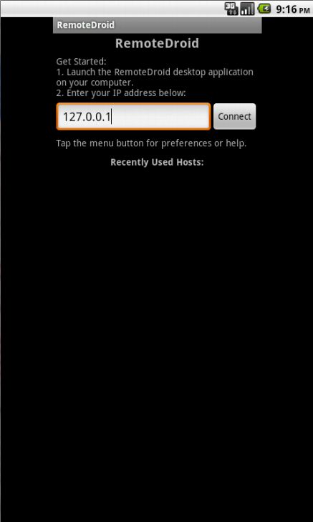
Fig 5.1.1 User interface providing IP address to the application

5.1.2 Mouse pad and Keyboard layout
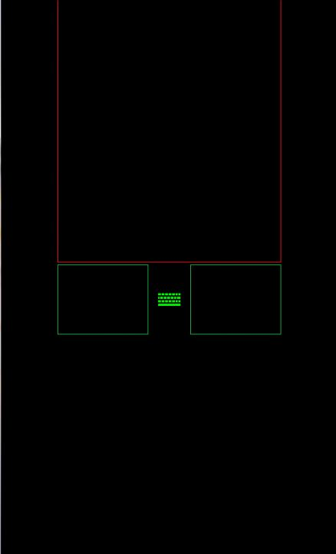

Fig 5.1.2 Mouse pad and keyboard enabler icon

Chapter 6
CONCLUSION
This project explores the possibility of controlling the computer remotely using an Android phone device. The proposed prototype is able to control a lot of operations a normal computer keyboard and mouse would perform. It practically turns a mobile phone into a wireless keyboard and mouse using a wireless network via a portable mobile device running under an Android Platform Operating System. It helps mobile phone users on facilitating their work in study life, home life or working life, where the use of the prototype helps in easing the device control.
It is proven that this prototype would relieve a pain in the neck and also the normal back ache due to constantly sitting at a particular place. With the help of this prototype, these stressful moments will be minimized as users will be having a very relaxed position as intended. This is a convenient application for simple operations and for manipulating such computer without the keyboard and mouse been connected.
.

REFERENCES

- Hello Android with TelephonyManager By Ed Burnette, Published by Pragmatic Book shelf, 2nd.Edition.Nov.2009.
- Android Application Development By Rick Rogers, John Lombardo, Pub by O'Reilly1st Edition. 2009
- A Java Developer’s Guide By Steve Holzner Published by O'Reilly – Eclipse ,April.2004.
- Wrox.Professional.Android.2.Application.Development.

- Anderson, P., Mobile and PDA Technologies: Looking around the corner. JISC Technology and Standards Watch. Available at: www.jisc.ac.uk/uploaded_documents/jisctsw_05_04.doc, October (2005).
- http://sites.google.com/site/myremoteandroid/

- A. Livingston. Smartphones and other Mobile Devices: the Swiss army knives of the 21st Century. Educase Quarterly (EQ), 2004, 27(2).

- Remote Desktop Services. Retrieved from: http://msdn.microsoft.com/en-us/library/windows/desktop/bb892075(v=vs.85).aspx

- Android Developers. The Guilde. Retrieved from http://developer.android.com/training/basics/firstapp/building-ui.html

- Hossein Falaki, Ratul Mahajan Srikanth Kandula, Dimitrios Lymberopoulos, Ramesh Govindan,
Deborah Estrin: Diversity in smartphone usage, Proceedings of the 8th international conference on Mobile systems, applications, and services, ISBN: 978-1-60558-985-5

