**Object Detection**

*A*

***Project Report***

*submitted in partial fulfillment of the*

*requirements for the award of the degree of*

**BACHELOR OF TECHNOLOGY**

in

**COMPUTER SCIENCE & ENGINEERING**

Specialization

**BUSINESS ANALYTICS AND OPTIMISATION**

by

|  |  |
| --- | --- |
| **Student Name** | **Roll Number** |
| **TUSHAR GOYAL** | **R103218163** |
| **VINAY** | **R103218167** |
| **SOURABH VERMA** | **R103218156** |
| **SHIVAM SAHU** | **R103218140** |

*under the guidance*

*of*

**Dr. Bhupesh Kumar Dewangan**



**Department of Informatics**

**School of Computer Science**

**University of Petroleum & Energy Studies**

**Bidholi, Via Prem Nagar, Dehradun, UK**

**November – 2020**



**DECLARATION**

We hereby certify that the project work entitled **“Object Detection”**in partial fulfilment of the requirements for the award of the Degree of BACHELOR OF TECHNOLOGY in COMPUTER SCIENCE AND ENGINEERING specialization (BUSINESS ANALYTICS AND OPTIMIZATION) and submitted to the Department of Informatics, School of Computer Science, University of Petroleum & Energy Studies, Dehradun, is an authentic record of  our work carried out during a period from **Jan., 2021**to **May., 2021** under  the  supervision of **Dr. Bhupesh Kumar Dewangan .**

The matter presented in this project has not been submitted by me/ us for the award of any other degree of this or any other University.

**Tushar Goyal Vinay Sourabh Verma Shivam Sahu**

**R103218163 R103218167 R103218156 R103218140**

This is to certify that the above statement made by the candidate is correct to the best of my knowledge.

**Date: ________2021 Dr. Bhupesh kumar Dewangan**

**(Project mentor)**

**Dr. Thipendra Pal Singh**

Head**,**Department of Informatics

School of Computer Science

University of Petroleum & Energy Studies

Dehradun – 248 001 (Uttarakhand)



**ACKNOWLEDGEMENT**

We wish to express our deep gratitude to Bhupesh Kumar Dewangan , for all advice, encouragement and

constant support he has given us throughout our project work. This work would not have been

possible without his support and valuable suggestions.

We sincerely thank to our respected Head of Department, Informatics, **Dr. Thipendra Pal**

**Singh,** for his guidance and support as and when required.

We are also grateful to **Dr. Priyadarsan Patra, Dean SCS**, for providing the necessary facilities

to carry out our project work successfully.

We would like to thank all our friends for their help and constructive criticism during us

project work. Finally, we have no words to express our sincere gratitude to our **parents** who

have shown us this world and for everything they have given to us.

Tushar Goyal Vinay Sourabh Verma Shivam Sahu

R103218163 R103218167 R103218156 R103218140

**Table of Contents**

**ABSTRACT** 5

**1.** **INTRODUCTION** 6

1.1) Problem statement 7

1.2) Objective 8

**1.2.1) Sub-Objectives:** 8

1.3) Requirements 9

**1.3.1) Software requirements** 9

**1.3.2) Hardware requirements** 9

**2.** **Related work** 10

2.1) Literature review 10

**3.** **System Analysis** 12

3.1) Existing Analysis 12

3.2) Motivation 12

**4) Design** 13

4.1) Methodology 13

4.2) Algorithm 18

4.3) Standard lung CT images 19

**5.** **Implementation** 20

5.1) Pseudo code: 20

5.2) Flowchart 23

23

5.3) Output Screen & Result analysis: 24

**6.** **Conclusion** 28

**7.** **References** 29

# **ABSTRACT**

Object detection is a well-known computer technology connected with computer vision and image processing that focuses on detecting objects or its instances of a certain class (such as humans, flowers, animals) in digital images and videos. There are various applications of object detection that have been well researched including face detection, and character recognition. The most often complications that comes under the Object detection is that sometimes the results we get is not 100% accurate and there are object localization error. Object detection technology has been driven by an increasing processing power available in software and hardware. In this work we present a developed application for multiple objects detection based on OpenCV libraries. The aim is to get more accurate results by using various enhancement and segmentation techniques.

***Keywords:*** Object Detection***,*** Image processing, computer vision, edge detector.

# **INTRODUCTION**

Today, images and video are everywhere. Online photo sharing sites and social networks have them in the billions. The field of vision research has been dominated by machine learning and statistics. With the advancement in the video surveillance and image processing, object detection has known a rising interest in the computer visualization industry. However, achieving high performance and a near-real-time object detection is a key concern in both large-scale systems and embedded platforms. Therefore, a reliable and accurate near real-time object detection application, running on an embedded system, is crucial, due to the rising security concerns in different fields. The application can be deployed in different platforms.

The mortality rate of lung cancer is the highest among all other types of cancer. Lung cancer is one of the most serious cancers in the world, with the smallest survival rate after the diagnosis, with a gradual increase in the number of deaths every year. Survival from lung cancer is directly related to its growth at its detection time. But people do have a higher chance of survival if the cancer can be detected in the early stages [7].

Lung cancer can be divided into two main groups, non-small cell lung cancer and small cell lung cancer. These assigned of the lung cancer types are depends on their cellular characteristics. As for the stages, in general there are four stages of lung cancer; I through IV. Staging is based on tumour size and tumour and lymph node location. Presently, CT are said to be more effective than plain chest x-ray in detecting and diagnosing the lung cancer. The earlier the detection is, the higher the chances of successful treatment. An estimated 85% of lung cancer cases in males and 75% in females are caused by cigarette smoking. Therefore, we will be doing predictive analysis of lung cancer using image processing and computer vision which will help in detecting the nodules causing cancer inside the human body based on the given data set (data is primarily CT image of lung) [9].

## Problem statement

1. The early detection and diagnosis of nodules in CT image are among the most challenging clinical tasks performed by radiologists.
2. Radiologists can miss up to 25% of lung nodules in chest radiographs due to the background anatomy of the lungs which can hide the nodules.
3. Although the filter can detect the lung edge, unfortunately, the final edges lines produce is still unsatisfied.
4. Object detection from a complex background is a challenging application in image processing.

## Objective

To develop a computer aided diagnosis system for finding the early cancer nodules using the lung CT images and find the number of nodules and area of nodules.

### **1.2.1) Sub-Objectives:**

1. To collect a data set as a standard for processing of other images.
2. To pass the image that is to be analyzed through the image processing in OpenCV for further diagnosis.
3. A lung cancer detection system using image processing is used to classify the present of lung cancer in an CT- images.
4. In order to examine the performance lung cancer detection system by using image processing to extract features like length of tumor, size of tumor and maximum area of a tumor.

## Requirements

### **1.3.1) Software requirements**

1.3.1.1) Language: C++

1.3.1.2) Operating system: Windows 7,8,10 or Mac

1.3.1.3) Compiler: Visual Studio

### **1.3.2) Hardware requirements**

1.3.2.1) RAM: 8GB or above

1.3.2.2) Processor: Intel platinum

1.3.2.3) Hard Disk Size: 16GB for 32-bit OS or 20GB for 64-bit OS

# **Related work**

## 2.1) Literature review

Object detection and location in digital images has become one of the most important applications for industries to ease user, save time and to achieve parallelism. This is not a new technique but improvement in object detection is still required in order to achieve the targeted objective more efficiently and accurately.

The process of object detection analysis is to determine the number, location, size, position of the objects in the input image. Object detection is the basic concept for tracking and recognition of objects, which affects the efficiency and accuracy of object recognition. The common object detection method is the colour-based approach, detecting objects based on their colour values [4]. The method is used because of its strong adaptability and robustness, however, the detection speed needs to be improved, because it requires testing all possible windows by exhaustive search and has high computational complexity [1].

Lung segmentation is the most crucial and challenging task in a CAD system as it provides the search space for detecting nodules. Lung segmentation is a challenging task due to non-uniformity present in the lung region. In the first step, the images are pre-processed. Pre-processing involves removal of noise from the image, improving the quality of the image by using filters and separating the lung region from the CT slice. In the nodule detection stage, the candidate nodules are identified by enhancing the suspected areas and suppressing the other structures like blood vessels. This step reduces the search space for nodule detection [2].

The detection and diagnose of lung cancer can be processed on three basic stages which are pre-processing, segmentation and finally followed by post-processing. The CT scan image is pre-processed to remove Gaussian white noise using non- local mean filter technique [3].

Table 1. Comparative Analysis of Object Detection Techniques

|  |  |  |
| --- | --- | --- |
| **Techniques** | **Applications** | **References** |
| Image Processing and Classification | Remove Gaussian white noise | Malik et. al. |
| Layer Separation | Used to separate layer of image | Rani |
| Enhancement | Used to sharpen the image | Patiland Jain |
| Edge detection-based methods | Canny algorithm | Yan and Li |
| Thresholding | Deep learning algorithms and convolutional networks | Talukdar et. al |
| Image segmentation | Labelling | Berahim et. al. |
| Gray scale Image | Used to convert color in gray | Gajdhaneand Deshpande |

Layer Separation- There are many imaging models like RGB (Red, Green, Blue) HSV (Herpes Simplex Virus), HIS (Humane Society International), YCbCr (Luminance; Chroma: Blue; Chroma: Red) and Lab model. In RGB model, RGB are also called colour Channels. Sometime we take single channel which is consistent in different situation or distortion during the imaging process. The separation of a channel from other channels is called layer separation, which is key step to produce the satisfactory results [2].

Edge Based Segmentation Methods- In edge-based segmentation we try to find edges of digital objects found in an image on the basis of abruptly change found in intensity values of a pixel (Fig. 5). Many digital objects have cloudy and broken edges. To remove such effects from the image we usually perform morphological operations which are discussed in next section and linear filters to give more distance and remove distance which is closed to the digital object. Because tumour has no regular shape and intensity range so it is challenging task for CAD (Computer Aided Design).

# **System Analysis**

## 3.1) Existing Analysis

There are two main methodology used to detect breast cancer i.e., Breast self-examination (BSE) and clinical breast examination (CBE). This method provides specificity rate of 97.11% and 57.14% sensitive. This method has a major drawback of detecting malignancy as it only detects suspicious lesions to the tissue [1].

Mammography is common type of breast imaging and has a true positive rate of 83-95% and false positive rate of 0.9-6.5%.

MRI (Magnetic Resonance Imaging) is another detection method used for creation of 2-D or 3-D images which too have trade-offs depending upon the style of acquisition. According to the researchers and past studies suggest that MRIs have high detection rate for visually invasive cancer and sensitivity rate higher than mammography and it offers better resolution [3].

X-RAY mammography misses the presence 15% of the time. Many techniques have been introduced but all have some limitations and it requires better pre-processing methods to increase the quality of image while preserving important information.

Various ML models like decision trees, support vector machines, K-nearest neighbours etc. have been used for breast cancer prediction through tissue images.

## 3.2) Motivation

Since cancer is one the main cause of death worldwide nowadays and getting cured early and prominent diagnosis is often sought.

The motivation behind this project is to locate the beginning phase of lung cancer with high precision. In this project we will learn more about image processing and object detection OpenCV. About 85% male and 75% females are suffering from lung cancer due to cigarette smoking. The general survival rate of people suffering from lung cancer is 63%. In spite of the fact that surgery, radiation treatment, and chemotherapy have been utilized as a part of the treatment of lung tumour, the five-year survival rate for all stages consolidated is just 14%. This has not changed in the previous three decades.

# **4) Design**

## 4.1) Methodology

The proposed solution to segment the lung from the CT images was based on the shape of the lung. In order to decompose the region, canny operator is used as the edge detection algorithm to detect the structure of the lung shape. This edge detection algorithm serves to simplify the analysis of images by drastically reducing the amount of data to be processed, at the same time preserving useful structural information about object boundaries. Once the edge detection completed. In this project we are basically using OpenCV is used as an image processing library in many computer vision real-time applications.

#### **Dataset**

We take different set of features to detect the lung cancer with different methodology with different available dataset but still there is no any method which can automatically segment and classify the malignant and benign area in the Lung cancer image. We have collected the dataset of lung CT images from “Cancer image archive”. The location of each tumor was annotated by five academic thoracic radiologists with expertise in lung cancer to make this dataset a useful tool and resource for developing algorithms for medical diagnosis. Each study comprised one CT volume, one PET volume and fused PET and CT images: the CT resolution was 512 × 512 pixels at 1mm × 1mm, the PET resolution was 200 × 200 pixels at 4.07mm × 4.07mm, with a slice thickness and an interslice distance of 1mm. Both volumes were reconstructed with the same number of slices. Three-dimensional (3D) emission and transmission scanning were acquired from the base of the skull to mid femur (https://wiki.cancerimagingarchive.net/pages/viewpage.action?pageId=70224216).

#### **Pre-Processing of Lung Cancer**

Pre-processing is an improvement of the image data that suppresses unwanted distortions or enhances some image features for further processing. It is needed to minimizing the effects of distortion found in imaging device such as light fluctuation, to remove blueness and in the same

time pre-processing is required to remove unwanted areas from the images and some time, it is used for enhancing the image features like lines, boundaries and textures of image so that we can easily divide the contents of images in two parts, wanted and un-wanted contents of image.

For removing noise from the image, many researchers use different filtering techniques which depends on type of noise. In medical imaging all types of filtering techniques may be used depending on noise present in image.

(a) **Gaussian Noise**: Outside the Normal distribution

values, usually we cannot see in the image.

#### **Canny Edge Detection**

Canny Edge Detection is a popular edge detection algorithm. It is a multi-stage algorithm and we will go through each stage.

##### **1.Noise Reduction**

Since edge detection is susceptible to noise in the image, first step is to remove the noise in the image with a 5x5 Gaussian filter. We have already seen this in previous chapters.

##### **2. Finding Intensity Gradient of the Image**

Smoothened image is then filtered with a **Sobel kernel** in both horizontal and vertical direction to get first derivative in horizontal direction (Gx) and vertical direction (Gy). From these two images, we can find edge gradient and direction for each pixel.

##### **3.Non-maximum Suppression**

After getting gradient magnitude and direction, a full scan of image is done to remove any unwanted pixels which may not constitute the edge. For this, at every pixel, pixel is checked if it is a local maximum in its neighbourhood in the direction of gradient.

In short, the result you get is a binary image with "thin edges".

**4. Hysteresis Thresholding**

This stage decides which are all edges are really edges and which are not. For this, we need two threshold values, minVal and maxVal. Any edges with intensity gradient more than maxVal are sure to be edges and those below minVal are sure to be non-edges, so discarded. Those who lie between these two thresholds are classified edges or non-edges based on their connectivity. If they are connected to "sure-edge" pixels, they are considered to be part of edges. Otherwise, they are also discarded.

*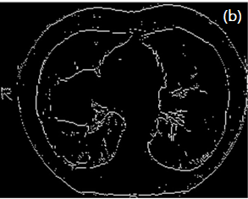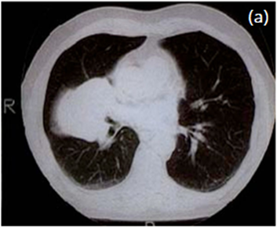Fig.1. CT scan image, (a) Original Lungs, (b) Edged*

**Image Segmentation**

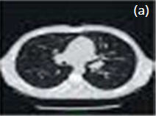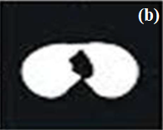The process of subdividing the image into two parts one is wanted and other is unwanted parts. Wanted part is also called ROI. In the case of lung cancer our target is to identify the tumour present in the Lung image (Fig. 4.1.3(a-b)). So, tumour is our ROI and other part is unwanted area. It is crucial task for machine to automatically detect the tumour because of variant texture properties of Lung tissue in abnormal region such as reactive of tumours or level of cancer malignancy. For segment the image there are two strategies found in various literature such as edge-based segmentation and region-based segmentation.

*Fig. 2. CT scan image, (a) Original Lung, (b) Segmented*

**Feature extraction**

In the process of features extraction from the image it is necessary that all properties of an object present in the image should be clear. So, for growing the digital objects we need image enhancement. Image enhancement is divided into two categories.

First one is spatial domain and other is frequency domain. In spatial domain, operations are performed on the pixel values directly so it is easy to understand and analysis. While in frequency domain the methods are used to explain the analysis of signals and mathematical formulas with respect to frequency and function. Image enhancement is achieved when we are able to interpret and threshold the image into two parts, one is known as ROI (Region of Interest) and second is compliment of it [3].

**GRAY CONVERSION**

Medical image datasets are found in number of different formats. For the simplicity we divide images in three

following types:

(i) Colour image

(ii) Gray image

(iii) Binary image

Colour image has three channels each channel has 256variant intensity values ranging 0-255. In RGB if RGB have zero value then colour is black while all channel values equal to 255 then colour is white. Computer can easily distinguish each colour shade while human vision is limited as compare to machine vision. In colour image there are almost 16777216 different shade. In Gray image there are 256 shades in the form of black and white where0 represents black colour and 256 represents white colour (Fig. 4.1.3).

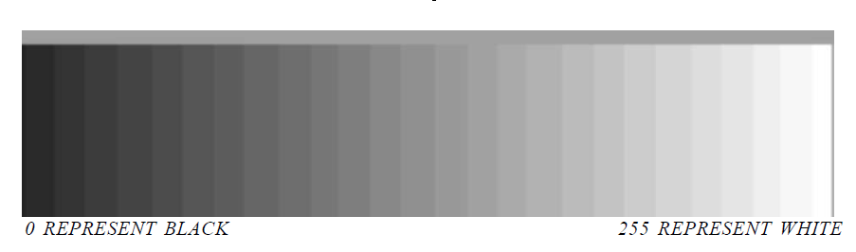

*Fig.3. Gray Level of Gray Images [2]*

**Thresholding**

A value which is able to segment the ROI is called threshold value. In lung cancer case we convert our image into Gray image and then decide the threshold value on the basis of tumour properties. For example, we found that tumour has intensity values 115-255 then we can convert all values which are less than 115 into 0 and all other values between 115-255 is equal to 1 in binary image. In this way all unwanted area become black and wanted area become white region.

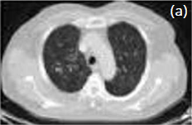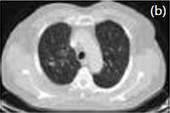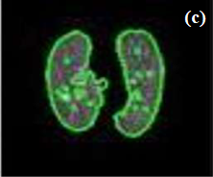

*Fig. 4. lung images, (a) Input, (b) Output of Gaussian filter, (c) Segmented*

## 4.2) Algorithm

#### **STEPS INVOLVED:**

Start: Gathering required dataset in form of images.

Step-2: Processing and enhancing the dataset obtained.

Step-3: OpenCV for detecting an object present in an image.

Step-4: Canny edge detector algorithm used as a multi stage algorithm to detect a wide range of edges in images.

Step-5: By the use of image processing in computer vision for detection of tumor that may be present in any individual lung.

Step-6: Making an application for general use by the people for detecting the presence of lung cancer inside the human body.

End: The application will then give necessary information based upon the results obtained.

#### **Canny edge detection algorithm**

Step-1: Apply Gaussian Filter to smooth the image in order to remove the noise

Step-2: Find the intensity gradients of the image

Step-3: Apply gradient magnitude thresholding or lower bound cut-off suppression to get rid of spurious response to edge detection

Step-4: Apply double threshold to determine potential edges

Step-5: Track edge by hysteresis: Finalize the detection of edges by suppressing all the other edges that are weak and not connected to strong edges.

**Time complexity of canny edge detection algorithm is “O(mn log mn).”**

## 4.3) **Standard lung CT images**

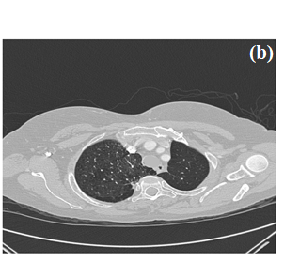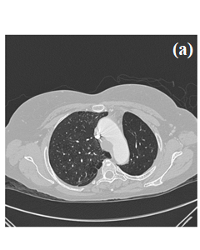

*Fig.6. (a), (b) Benign CT Images*

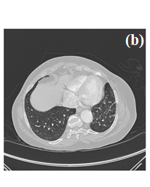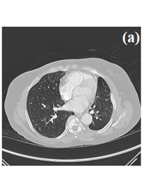

*Fig .7. (a), (b) Malignant CT images*

# **Implementation**

## 5.1) Pseudo code:

1. START
2. Matrix to Store Image Pixels. Its datatype used to store fixed size array matrix
3. Mat src; Mat src_gray; Mat image_roi;
4. void thresh_callback (int, void*);
5. Main Function Starts Here
6. int main (int argc, char** argv)
7. Load Image Pixels
8. src = imread("../Images/Normal_01.jpg");
9. Convert Image into Gray
10. cvtColor (src, src_gray, CV_BGR2GRAY);
11. Applying Filter, it blurs the image using Normalized box filter
12. blur (src_gray, src_gray, Size (3,3));
13. Keeping our Focus on Lung Only
14. Rect rectangle (60,180, src_gray. cols-150,src_gray.rows-260);
15. image_roi = src_gray(rectangle);
16. named Window (“Segmentation Focus",CV_WINDOW_AUTOSIZE );
17. imshow (“Segmentation Focus", image_roi );
18. Detects Edges
19. Canny (InputArray image, OutputArray edges, double threshold1, double threshold2, int apertureSize=3) , apertureSize – aperture size for the Sobel() operator.
20. Canny (image_roi, canny_output, thresh, thresh*2, 3 );
21. Applying Canny
22. End of Canny
23. imshow("Segmented Lung",canny_output);
24. Find Contours (Tumors in our case)
25. findContours(InputOutputArray image, OutputArrayOfArrays contours, OutputArray hierarchy, int mode, int method, Point offset=Point())
26. findContours( canny_output, contours, hierarchy, CV_RETR_TREE, CV_CHAIN_APPROX_SIMPLE, Point(0, 0) );
27. Mat drawing = Mat::zeros( canny_output.size(), CV_8UC3 );
28. Categorizing Tumors
29. double area;
30. double clength;
31. for (int i=0; i<contours. size();i++)
32. if(hierarchy[i][2]!=-1)
33. Tumor_Total=Tumor_Total+1;
34. area=contourArea(contours[i]);
35. if(area>Max_Tumor_Area)
36. Max_Tumor_Area=area ;
37. Total_Tumor_Area=Total_Tumor_Area+area;
38. if(area<=35)
39. Tumor_Lessthan_25=Tumor_Lessthan_25+1;
40. else if(area>35)
41. Tumor_Greaterthen_25=Tumor_Greaterthen_25+1;
42. clength = arcLength(contours [i],true);
43. Total_Tumor_Length=Total_Tumor_Length+clength;
44. Scalar color = Scalar (rng.uniform(0, 255), mrng.uniform(0,255), rng.uniform(0,255) );
45. drawContours(drawing, contours, i, color, 2, 8, hierarchy, 0, Point() );
46. Printing On CMD
47. cout "Total Tumor :
48. cout “Total Tumot Area : "
49. cout “Total Tumor Length : “
50. cout "Tumor Area less than 35 : “
51. cout “Tumor Area Greater than 35: “
52. cout <<"Maximum Tumor Area : "
53. Writing into Textfile
54. ofstream myfile;
55. myfile.open("Tumorfile.txt");
56. myfile
57. myfile.close();
58. Displaying Tumors
59. namedWindow( "Tumors", CV_WINDOW_AUTOSIZE );
60. imshow(“Tumors", drawing );
61. END

**CANNY EDGE DETECTION Pseudocode:**

1. START
2. Input image to be processed.
3. Load the Opencv library for the canny process.
4. Reads the image from the file and saves it to the matrix object.
5. Read the image.
6. Create an empty matrix to save the processed image.
7. Apply the canny function to detect edges.
8. Imgproc.Canny (source, dest, 100, 200, 3);
9. Imgproc.Canny (an object representing the source (input image) for this operation, a Mat
10. object representing the destination (edge) for this operation, a double type variable
11. representing the first threshold for a hysteration procedure, a double type variable
12. representing a second threshold for a hysterization procedure);
13. Create and save image processing results.
14. END

## 5.2) Flowchart

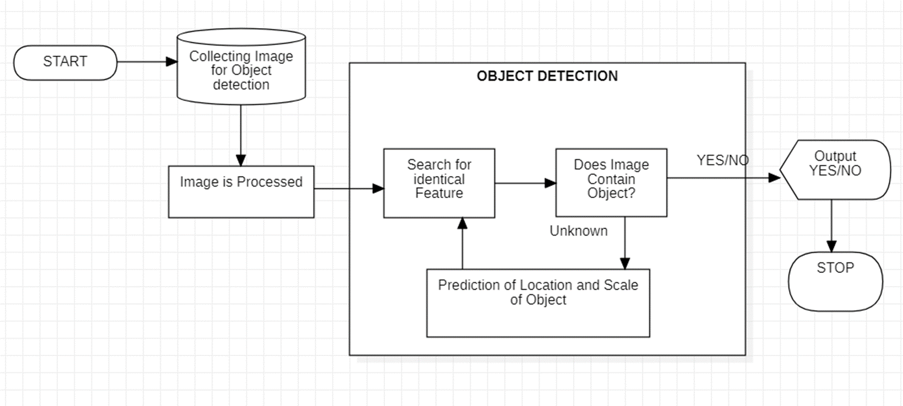

*Fig. 8(a) Object Detection Work Flow Model*

## 

*Fig.8(b) Flowchart of Lung Cancer Detection*

## 5.3) Output Screen & Result analysis:

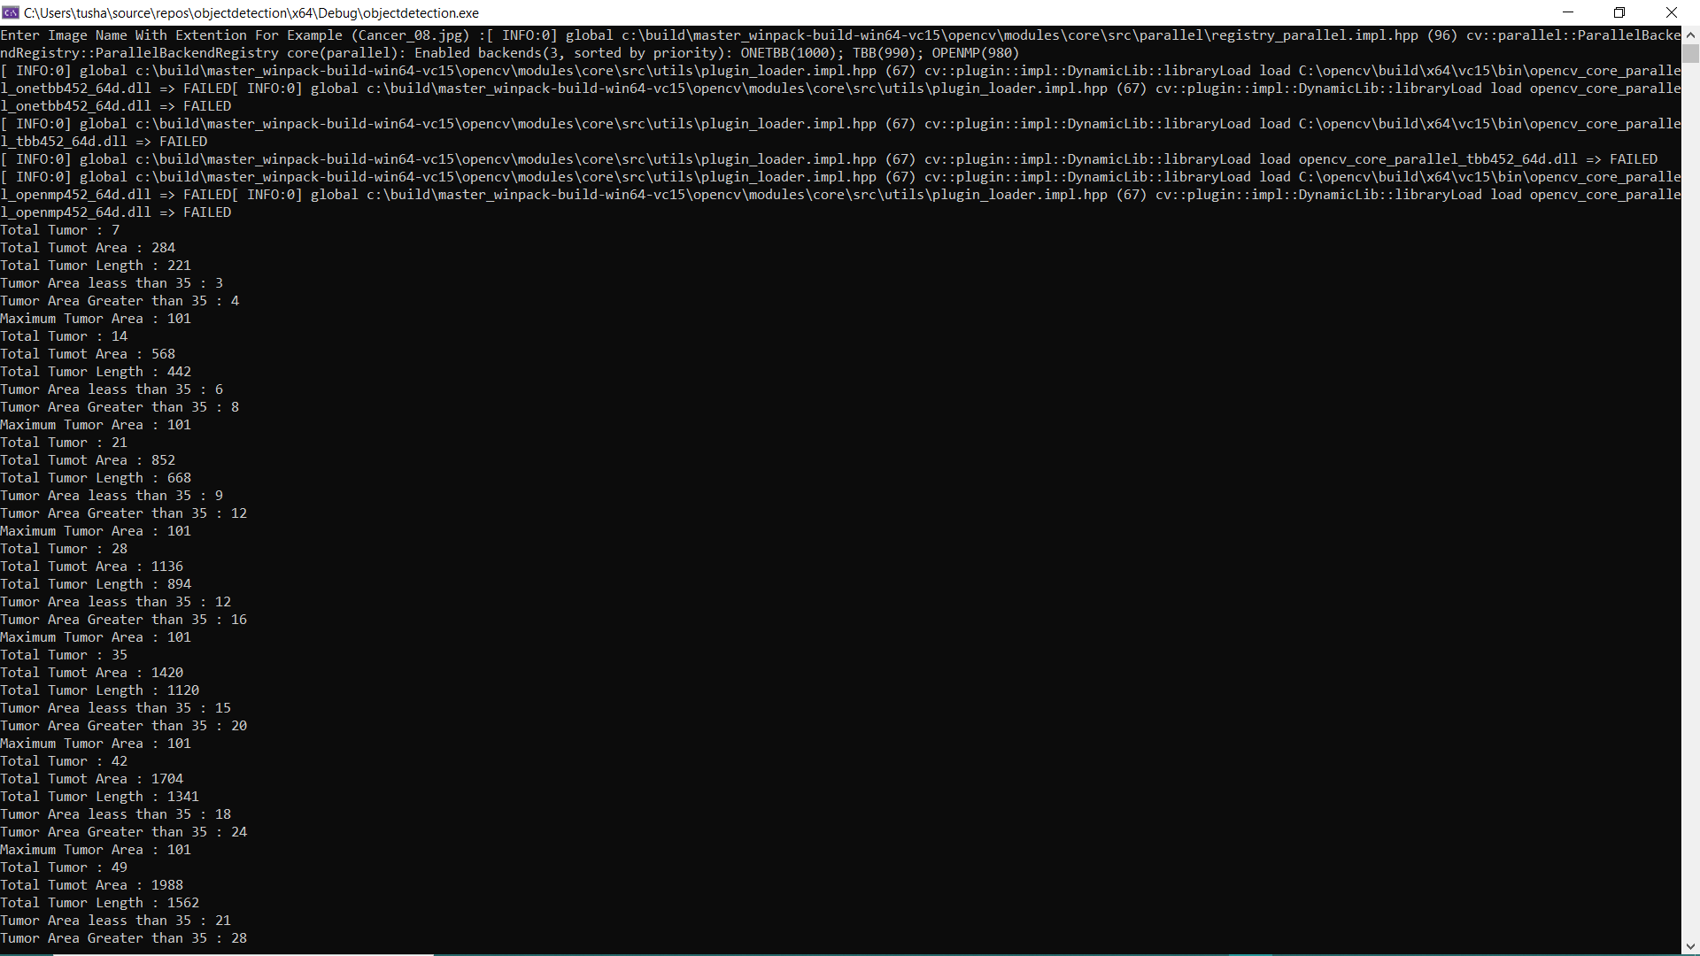

*Fig. 9. Output screen*

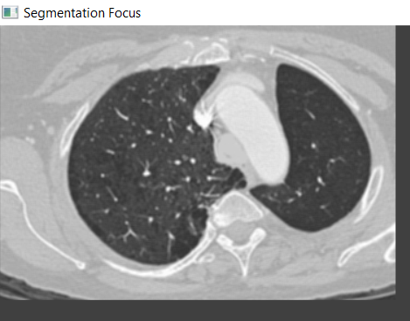

*Fig.10. Segmentation Focus*

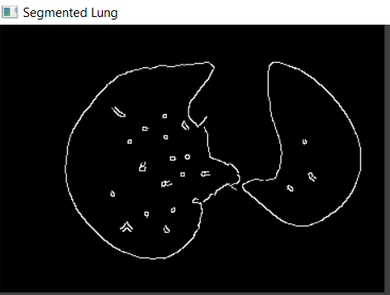

*Fig. 11. Segmented Lung*

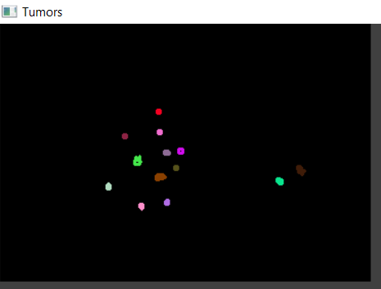

*Fig.12. Tumour Detection*

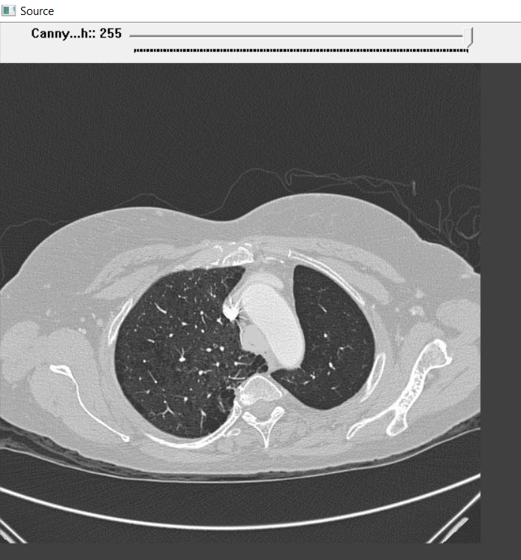

*Fig. 13. Canny edge detector and source image*

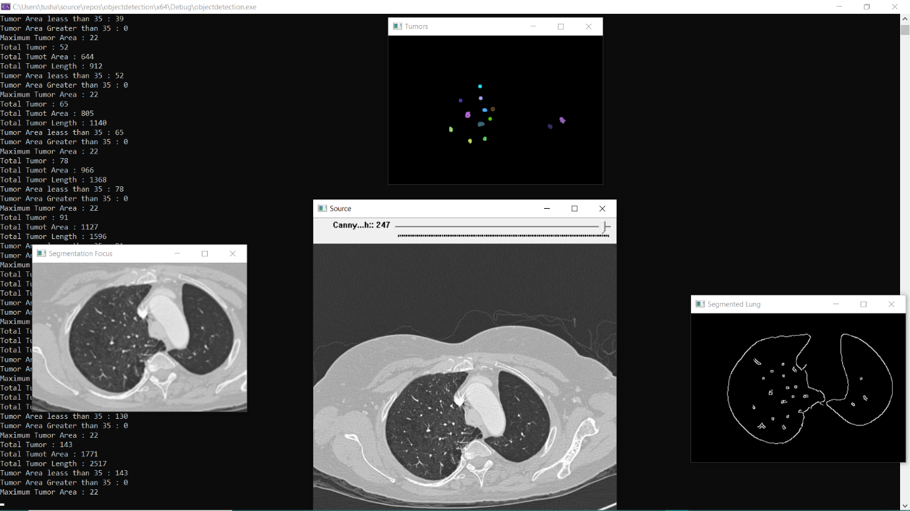

*Fig.14. Final results*

# **Conclusion**

Collection of proper data set which contains cancerous nodules that are benign and malignant which can be easily detected using image processing technique for further processing to obtain required image. Thus, evaluating the scenario that we came across by following the data set after using computer vision technology in which image processing is applied and object detection that identifies and locates the tumors in an image.By using Open-CV we can easliy find out important parameters from image like Count of tumours , Size of tumours , and Maximum size of tumours.We can easily begin the treatment in the right direction which will target the correct tissue of the affected person.

# **References**

[1] G.Niranjana, Dr.M.Ponnavaikko,” A Review on Image Processing Methods in Detecting Lung Cancer using CT Images”, 2017 International Conference on Technical Advancements in Computers and Communications, 978-1-5090-4797-0/17-2017 IEEE.

[2] MUTIULLAH, MEHWISH BARI, ADEEL AHMED, MUHAMMAD SABIR, AND SAJID NAVEED,” Lung Cancer Detection Using Digital Image Processing Techniques“Mehran University Research Journal of Engineering & Technology Vol. 38, No. 2, 351-360 April 2019 p-ISSN: 0254-7821.

[3] Sowjanya M. N., Stafford Michahial, Mahanthesha , Nagalakshmi T. S. ,” Lung Cancer Detection in Chest X - Ray Image”, G.S.S.S.I.E.T.W., Mysuru, Karnataka, VOLUME 3 I ISSUE 4 I OCT. – DEC. 2016.

[4] Chandan G, Ayush Jain, Harsh Jain,” Real Time Object Detection and Tracking Using Deep Learning and OpenCV”, R. V. College of Engineering Bengaluru, India, Proceedings of the International Conference on Inventive Research in Computing Applications (ICIRCA 2018) IEEE Xplore Compliant Part Number:CFP18N67-ART; ISBN:978-1-5386-2456-2.

[5] Fares Jalled, Ilia Voronkov,” Object Detection Using Image Processing”, Moscow Institute of Physics & Technology, Department of Radio Engineering & Cybernetics, arXiv:1611.07791v1 [cs.CV] 23 Nov 2016.

[6] Kartik Umesh Sharma and Nileshsingh V. Thakur,” A review and an approach for object detection in images”, A review and an approach for object detection in images.

[7] Bariqi Abdillah, Alhadi Bustamam, and Devvi Sarwinda,” Image processing based detection of lung cancer on CT scan images”, IOP Conf. Series: Journal of Physics: Conf. Series 893 (2017) 012063.

[8] Bhumika Gupta, Ashish Chaube, Ashish Chaube, Umang Goel,” Study on Object Detection using Open CV - Python”, International Journal of Computer Applications (0975 – 8887) Volume 162 – No 8, March 2017.

[9] Anita Chaudhary, Sonit Sukhraj Singh,” LUNG CANCER DETECTION ON CT IMAGES BY USING IMAGE PROCESSING”, 2012 International Conference on Computing Sciences.

[10] Souhail Guennouni, Anass Mansouri, Ali Ahaitouf,” Multiple Object Detection using OpenCV on an Embedded Platform”, Sidi Mohammed Ben Abdellah University School of Science and Technology Signals Systems and Components Laboratory B.P. 2202, 30000 Fez, Morocco.

https://wiki.cancerimagingarchive.net/pages/viewpage.action?pageId=70224216