RAYAT BAHRA INTERNATIONAL SCHOOL, MOHALI

TERM–I EXAMINATION SESSION-(2025-2026)

SUBJECT: SOCIAL SCIENCE

CLASS- IX

TIME:-3 Hrs. M.M: 80

General Instructions:

1. There are 39 questions in the Question paper. All questions are compulsory.

2. The question paper has Four Sections – A-History, B-Geography C- Political Science, and D- Economics.

3. Each Section is of 20 Marks.

4. Very Short Answer Type Questions (VSA), carry 2 marks each. Answers to each question should not exceed 40 words.

5. Short Answer Type Questions (SA), carry 3 marks each. Answers to each question should not exceed 60 words.

6. Long answer type questions (LA), carry 5 marks each. Answers to each question should not exceed 120 words.

7. There are case based questions (CBQ) of 4 marks each. Answers to each question should not exceed 100 words.

8. The map-based questions, carry 5 marks with two parts- Section A-History (2 marks) and Section B -Geography (3 marks)

9. There is no overall choice in the question paper. However, an internal choice has been provided in few questions. Only one of the choices in such questions must be attempted.

**SECTION A**

**History (20 Marks)**

**A – Multiple Choice Questions (1 × 4 = 4 marks)**

1. The Reign of Terror under Robespierre ended with:
   1. The rise of Napoleon Bonaparte
   2. The execution of Louis XVI
   3. Robespierre’s execution
   4. The storming of Bastille
2. Which slogan did Lenin popularise during the Russian Revolution?
3. “Peace, Land and Bread”
4. “Liberty, Equality, Fraternity”
5. “Workers of the world unite”
6. “All power to the Tsar”
7. Which event is known as the Night of the Broken Glass (Kristallnacht)?
   * 1. The burning of the Reichstag building
     2. The mass killing of Jews in concentration camps
     3. The organised attack on Jewish homes, shops and synagogues in 1938
     4. The assassination of a German diplomat in Paris
8. In Nazi ideology, the Swastik symbol represented:
   1. World peace and prosperity
   2. Victory of Aryan race and purity of blood
   3. Unity of workers and peasants
   4. Expansion of living space (Lebensraum)

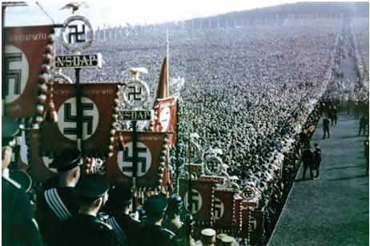

1. Why can 14 July 1789 be considered both a political and a symbolic event? (2)
2. Compare the aims and achievements of the Russian Revolution with the French Revolution. (3)
3. “The rise of Hitler was not just due to his leadership but also due to the failures of the Weimar Republic.” Discuss. (5)

OR

How did Nazi ideology transform German society and culture in the 1930s?

1. Read the passage below and answer the questions that follow:

At the beginning of the 20th century, Russia was still a vast empire ruled by an autocratic monarch. While many European countries had introduced constitutional governments, Russia’s ruler refused to share power. Discontent grew among different social groups, and revolutionary parties became active. The events of 1917 completely transformed the Russian state and society.

(i) Name the autocratic monarch of Russia in the early 20th century. (1 mark)

(ii) Which two main social groups played a decisive role in bringing about the Russian Revolution? (1 mark)

(iii) Mention any two major changes brought about in Russia after the October Revolution. (2 marks)

1. Map-Based Questions (2 Marks)

Outline political map of the World. Locate/label/identify Major

Countries of First World War:

1 Central Powers and 1 Allied Powers

**SECTION – B**

**GEOGRAPHY (20 Marks)**

B- Multiple Choice Questions

1. Which one of the following correctly matches the landform and its formation process?

a) Bhabar – deposition of silt by rivers in delta

b) Khadar – old alluvium deposited in upland areas

c) Bhangar – older alluvium forming terraces

d) Doab – marshy wetland caused by tectonic activity

11. The east–west extent of India is shorter than the

north–south extent because:

a) India is closer to the Tropic of Cancer

b) Longitudes converge towards the poles

c) Latitudes remain parallel to each other

d) India is widest at its southern tip

12. Identify the image given below :-

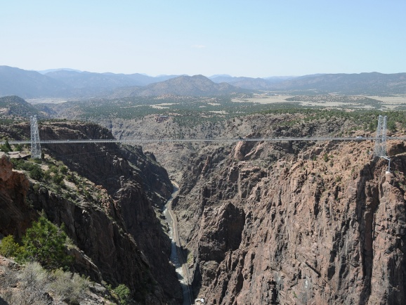

* 1. Valley
  2. Gorge
  3. Ox- Bow Lake
  4. Trough

13. Match the Following:-

Column A Column B

1. Himadri (Greater Himalaya) a) Kashmir Valley

2. Himachal (Lesser Himalaya) b) World’s highest peaks

3. Shiwalik c) Composed of unconsolidated sediments

4. Aravalli Hills d) Oldest fold mountains

14. The Himalayas have been formed due to the convergence of which two plates?

a) Indo-Australian Plate and Eurasian Plate

b) African Plate and Eurasian Plate

c) Pacific Plate and Indo-Australian Plate

d) North American Plate and Eurasian Plate

15. Which of the following is a peninsular river that forms an estuary?

a) Godavari

b) Mahanadi

c) Narmada

d) Krishna

16. Why are the Shiwalik ranges prone to landslides and earthquakes? (2)

17. Discuss the features of the Northern Plains and their importance for agriculture.(5)

18. Some rivers in India flow from the mountains and create wide fertile plains, while others flow through hard rock areas forming waterfalls and rapids. These rivers are used for irrigation, drinking water, transport, and power generation. Certain rivers also form deltas at their mouths, which are important for agriculture.

Answer the following questions:

* + - 1. Name one river that creates fertile plains.(1)
      2. Name one river that forms waterfalls or rapids.(1)
      3. Mention any two benefits of rivers to humans. (2)

19. MAP SKILL-BASED QUESTION (3 marks)

On the physical map of India, locate and label:

* + 1. Deccan Plateau
    2. Brahmaputra River
    3. Godavari River

**SECTION – C**

**POLITICAL SCIENCE (20 Marks)**

**Multiple Choice Questions (1 × 4= 4 marks)**

20. Democracy is preferred over other forms of government because:

a) It promotes equality and accountability

b) It limits people’s participation

c) Decisions are taken by a single ruler

d) It ignores individual freedoms

21. Consider this statement: “Democracy provides scope for negotiation, compromise, and peaceful resolution of conflicts.” Which feature of democracy does it highlight?

a) Political equality

b) Liberty

c) Tolerance and negotiation

d) Majority rule

22. Which of the following is true about the relationship between Fundamental Rights and Directive Principles?

a) Fundamental Rights and Directive Principles often contradict each other

b) Fundamental Rights are enforceable in court, Directive Principles are guidelines

c) Directive Principles override Fundamental Rights in all cases

d) Both are purely symbolic

23. In a federal system like India, which of the following powers is exercised only by the Union government?

a) Agriculture and irrigation

b) Defence and foreign affairs

c) Education and health

d) Local government administration

**Assertion–Reason Questions (2 marks)**

**Options:**

**a) Both A and R are true, and R is the correct explanation of A.**

**b) Both A and R are true, but R is not the correct explanation of A.**

**c) A is true, but R is false.**

**d) A is false, but R is true.**

24. **Assertion**: Democracy is not just about government of the people but also about government for the people.

**Reason**: Democracy ensures that the government is responsive to the needs and aspirations of the people.

25. **Assertion** : The Constitution of India was adopted on January 26, 1950.

**Reason**: The Indian Constitution was adopted to provide a framework for a democratic government.

26. What are constitutional amendments? (2)

27. How does democracy allow us to correct its own mistakes?(3)

28. Democracy is all about political competition and powerplay. There is no scope for morality’. Justify the statement by giving arguments against democracy. (5)

Or

**What are the exclusive features of the Indian constitution?**

**29. Case based question:**

**Read the passage and answer the questions: (4)**

In Pakistan, General Pervez Musharraf led a military coup in October 1999. He overthrew a democratically elected government

and declared himself the ‘Chief Executive’ of the country. Later he changed his designation to President and in 2002 held a

referendum in the country that granted him a five-year extension. Pakistani media, human rights organisations and democracy

activists said that the referendum was based on malpractices and fraud. In August 2002 he issued a ‘Legal Framework Order’

that amended the Constitution of Pakistan. According to this Order, the President can dismiss the national and provincial

assemblies. The work of the civilian cabinet is supervised by a National Security Council which is dominated by military

officers. After passing this law, elections were held to the national and provincial assemblies. So Pakistan has had elections,

elected representatives have some powers. But the final power rested with military officers and General Musharraf himself.

Clearly, there are many reasons why Pakistan under General Musharraf should not be called a democracy. People may have

elected their representatives to the national and provincial assemblies but those elected representatives were not really the rulers.

They cannot take the final decisions. The power to take final decision rested with army officials and with General Musharraf,

and none of them were elected by the people. This happens in many dictatorships and monarchies. They formally have an

elected parliament and government but the real power is with those who are not elected. In a few countries, the real power was

with some external powers and not with locally elected representatives. This cannot be called people’s rule.

1. What is the meaning of Referendum?

a. Direct vote in which the entire electorate is asked to either accept or reject a particular proposal

b. A form of government in which the rulers are elected by the people

c. A system where the majority or elected representatives are allowed to take decisions on behalf of all the people

d. All of these

2. Assertion (A): Pakistan not considered a democratic country even after having elections

Reason (R): Despite elections to the national and provincial assemblies, the final powers rested with General Musharraf

and military officers.

a. Both A and R are true and R is the correct explanation of A.

b. Both A and R are true but R is not the correct explanation of A.

c. A is true but R is false.

d. A is false but R is true.

3. After the passage of the ________, elections were held to the national and state assemblies.

a. Referendum

b. Legal Framework Order

c. Both (Military rule) and (Legal Framework Order)

d. Military rule

4. Does the given source explain the significance of the which feature of democracy?

a. Democracy must be based on a free and fair election

b. In a democracy, the final decisionmaking power must rest with those elected by the people

c. In a democracy, each adult citizen must have one vote

d. Democratic government rules within limits set by constitutional law and citizens' rights

**SECTION – D**

**ECONOMICS (20 Marks)**

Q:- Multiple Choice Questions (1 × 5= 5 marks)

30. Human capital is different from human resource because:

a) Human capital refers to population size, human resource refers to skills

b) Human capital refers to education, skills, and health that increase productivity

c) Human capital is only physical labour, human resource is mental labour

d) There is no difference

31. Which of the following best describes the contribution of education to human resource development?

a) It only provides employment opportunities

b) It improves skills, productivity, and decision-making abilities

c) It ensures political equality

d) It increases population

32. Which of the following situations reduces the quality of human resources in a country?

a) Better healthcare facilities

b) High illiteracy rate and malnutrition

c) Skill development programs

d) Universal education

33. The statement “A healthy population is more productive than an unhealthy one” primarily reflects which concept?

a) Human capital

b) Demographic dividend

c) Natural resource

d) Economic growth

34. In India, human resource is considered an asset rather than a liability because:

a) People can be taxed by the government

b) With proper education, skill, and health, they contribute to economic development

c) Population size always increases GDP automatically

d) Only working population counts as human resource

35. Give two reasons why uneducated and unskilled population is a burden on the economy.(2)

36. Mention any two ways in which education improves the quality of human resources.(2)

37. Explain why population can sometimes be a liability rather than an asset.(3)

38 Describe three benefits of skill development programs in India. (3)

39. Explain the role of government policies in enhancing the quality of human resources. (5)

Or

Describe the challenges faced by India in utilizing its human resources effectively.