Tushar R Jadhav

210943120113

Question 1:

Write script to reverse digits in a given number. Take input from user..                             **[10 Marks]**

echo Enter the number u want to Reverse

read n

num=0

while [ $n -gt 0 ]

do

num=$(expr $num \* 10)

k=$(expr $n % 10)

num=$(expr $num + $k)

n=$(expr $n / 10)

done

echo number is $Reverse number is $num

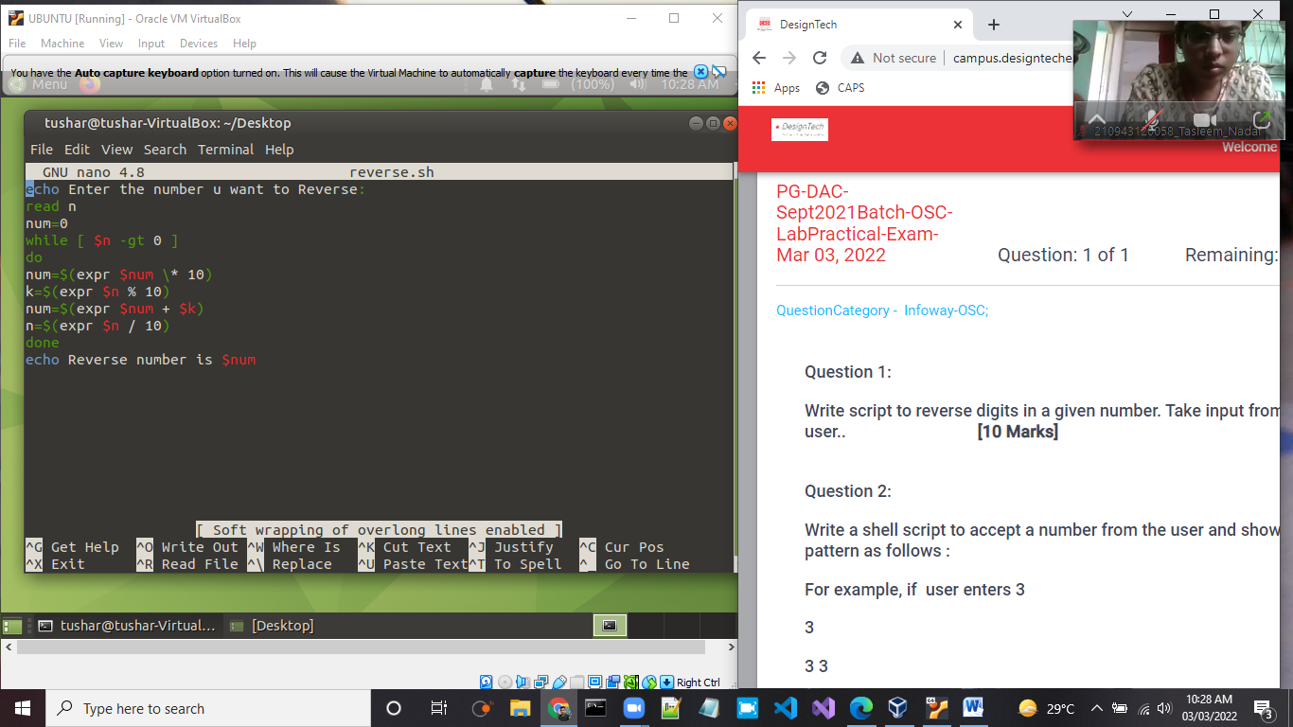

Output

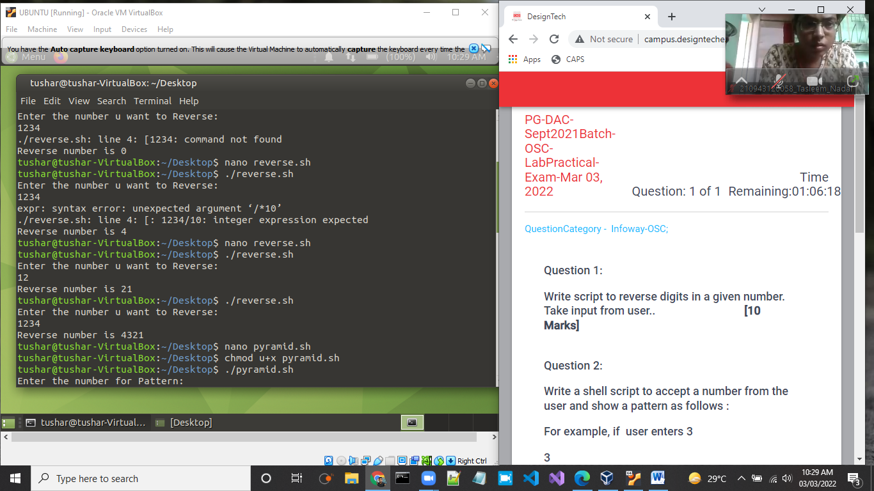

Question 2:

Write a shell script to accept a number from the user and show a pattern as follows :

For example, if  user enters 3

3

3 3

3 3 3

3 3 3 3

3 3 3 3 3                                                                                                            **[10 Marks]**

Echo Enter the number for Patter:

Read n

Echo Your Pyramid is…

rows=4

for((i=1; i<=rows; i++))

do

for((j=1; j<=i; j++))

do

echo -n "$n "

done

echo

done

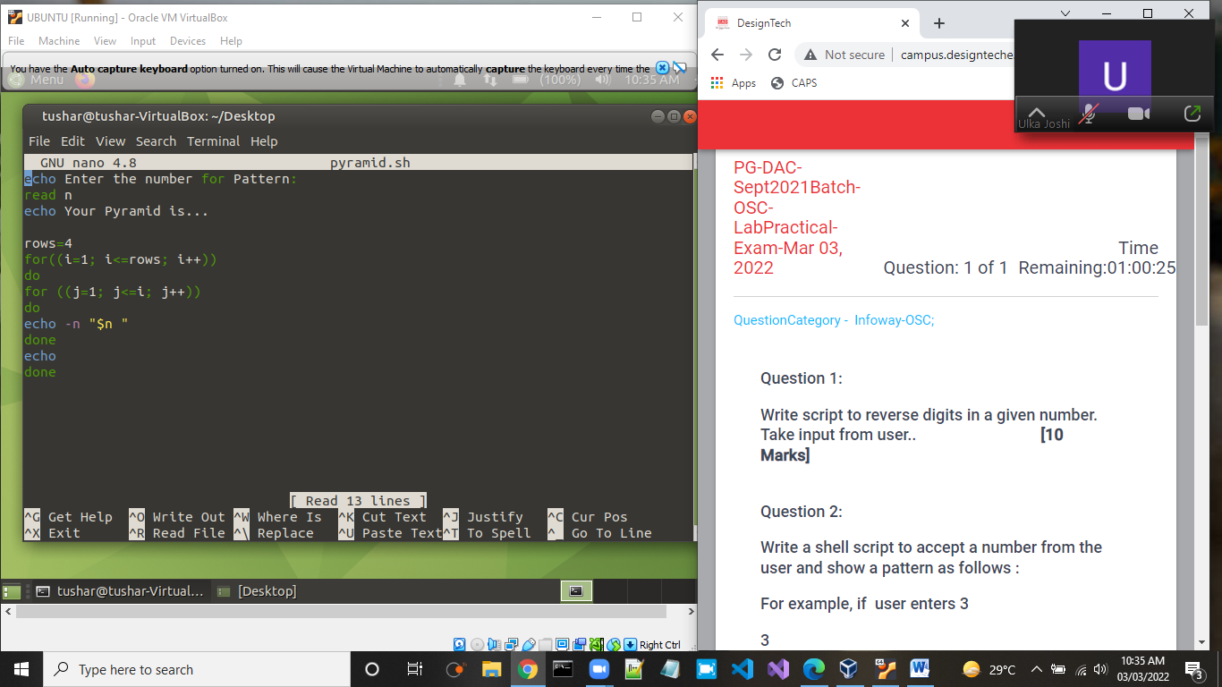

Output

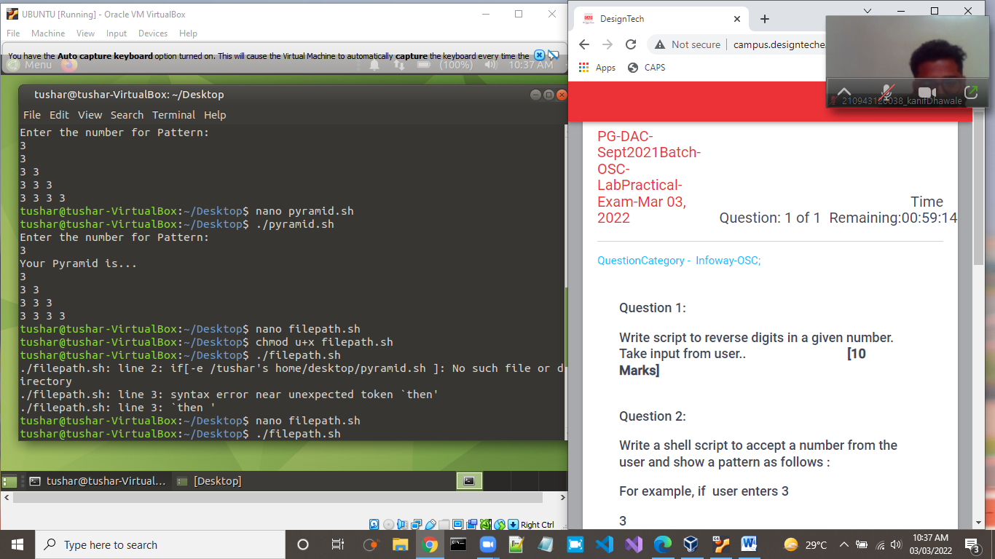

Question 3:

Write a shell script to check to see if the file “file_path” exists. If it does exist, display “file_path passwords are enabled.” Next, check to see if you can write to the file. If you can, display “You  have permissions to edit “file_path.””If you cannot, display “You do NOT have  permissions to edit “file_path””

**[10 Marks]**

#!/bin/bash

file=”/home/tushar/Desktop/pyramid.sh”

if [ -e “$file” ]; then

echo “$file passwords are enabled”

fi

if [ -x “$file” ]

then

echo “You have permission to edit $file”

else

echo “You do Not have permissions to edit $file”

fi

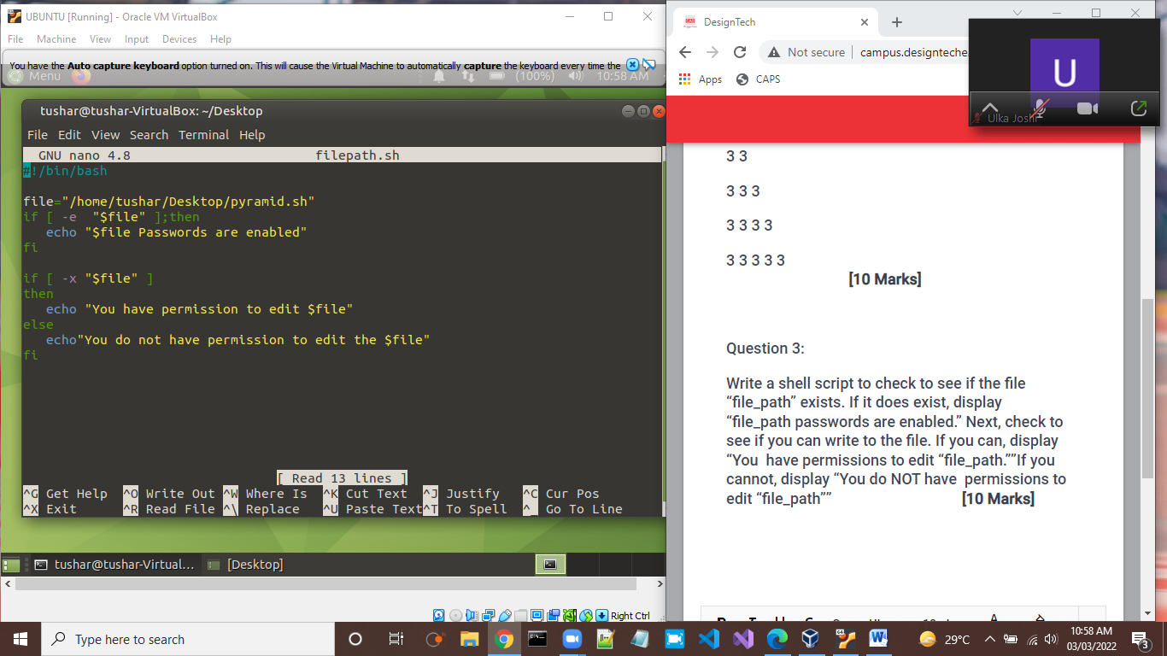

Output

