**Software Requirements Specification**

**for**

**Supermarket Billing System**

**Version 1.0 approved**

**Prepared by Tushar Kadam**

**15IT121**

**09 Jan 2018**

**Table of Contents**

**Table of Contents i**

**Revision History i**

**1. Introduction 1**

1.1 Purpose 1

1.2 Document Conventions 1

1.3 Intended Audience and Reading Suggestions 1

1.4 Product Scope 1

1.5 References 2

**2. Overall Description 2**

2.1 Product Perspective 2

2.2 Product Functions 2

2.3 User Classes and Characteristics 2

2.4 Operating Environment 2

2.5 Design and Implementation Constraints 3

2.6 User Documentation 3

2.7 Assumptions and Dependencies 3

**3. External Interface Requirements 3**

3.1 User Interfaces 3

3.2 Software Interfaces 4

3.3 Hardware Interfaces 4

**4. System Features 5**

4.1 System Feature 1 5

**5. Other Nonfunctional Requirements 6**

5.1 Performance Requirements 6

5.2 Safety Requirements 6

5.3 Security Requirements 6

5.4 Software Quality Attributes 6

5.5 Business Rules 6

**6. Other Requirements 6**

**Appendix A: Glossary 6**

**Appendix B: Analysis Models 7**

**Appendix C: To Be Determined List 7**

**Revision History**

|  |  |  |  |
| --- | --- | --- | --- |
| **Name** | **Date** | **Reason For Changes** | **Version** |
| **Tushar Kadam** | 09/01/18 | Initial Draft | 1.0 |

# Introduction

## Purpose

The software intends to build databases to store and retrieve data about the inventory, the finances and the administration of a supermarket store. Since a supermarket typically offers a wide range of products of varying prices and demand, managing the inventory becomes complicated without the help of databases. Moreover the billing needs to be computerized so that the store can effectively deal with a large number of customers at a time. Further the bills need to be managed to keep track of the finances of the store and the taxes incurred by the store. Therefore the purpose of the software is to manage databases that store data about the stocks of various items, bills with date stamps, credit given to customers and so on.

## Document Conventions

The document is prepared using Microsoft Word 2016 and has used the font type 'Arial' . The fixed font size that has been used to type this document is 12pt with 1.15 line spacing. It has used the bold property to set the headings of the document. UML diagrams have been created according to UML 2.0 standards. Standard IEEE template is the template used to organize the appearance of the document and its flow.

## Intended Audience and Reading Suggestions

The intended audience of this document would be owner and specific employees like Manager and Staff, and project team with the objective to refer and analyze the information. The SRS document can be used in any case regarding the requirements of the project and the solutions that have been taken. The document would final provide a clear idea about the system that is building.

Brief outline of the document is,

1. Overall Description

2. System Features

3. External Interface Requirements

4. Non Functional Requirements

## Product Scope

This software can be deployed at any supermarket. Considering the recent reforms introduced in the form of a nationwide GST, the software is well equipped to handle any and every such change

in the tax regime.

## References

Development has not reached the stage yet due to which details have not been mentioned TBD.

# Overall Description

## Product perspective

The product is intended to be deployed in a typical supermarket environment. The customer will find it easy to pay for their purchases. The staff’s job will be made easier as the software will have a friendly user interface. From the owner’s perspective, they will be able to view the amount of sales in various time periods and also pay the appropriate taxes in time.

## Product functions

The application will be built on a database which would include tables like Inventory, Sales, Bills, Customers, Tax and Staff. These tables would be manipulated through various options in the user interface. Several operations like creating bill, updating customer history, recording daily sales and updating inventory every time stocks are replenished or purchase is made, will be incorporated into the software to fulfill its purpose.

## User classes and characteristics

Two user class owner and staff are included. The staff needs to be computer literate and able to understand how customers are billed. The owner also needs to be computer literate and able to keep track of the stocks and also interpret the sales.

## Operating Environment

Hardware and software requirements

Hardware**:-**

1. **Operating System** Supports all known operating systems, such as Windows, Linux
2. **Computer**512MB+ RAM, monitor with minimum resolution of 1024x768, keyboard, and mouse
3. **Hard Drive** should be in NTFS file-system formatted with minimum 10 GB of free space
4. **A Laser printer** will need to be used to print these reports and notes

Software**:-**

1. Software is designed to run on any platform above Microsoft Windows 7 (32bit).
2. Microsoft .NET Frameworks 4.0 or above.
3. Microsoft SQL Server

## Design and Implementation Constraints

Software development crew provides their best effort in developing the system. In order to maintain the reliability and durability of system, some design and implementation constraints are applied. Availability of an android app for hotel management system could make the system portable. System will need a minimum memory of 512MB. But it is recommended to have a memory of 1GB.

## User Documentation

Project Documentation section reveals the all the details about documents created by the project team so far of this project. It includes project charter and project proposal.

     Project charter: - This document provides the basic information about the background of the client and the nature of the main problem identified

       Project Proposal: - The proposal of the project consists with the problems that are identified with the client, and the solutions that are going to implement using the proposed system.

## Assumptions and Dependencies

User manual provide to the client will give a clear idea in interacting with the system. It will be written in a simple understandable language concealing the inner complexity of the system. A hard copy of the user manual will be delivered to the client with the delivery of system.

# External Interface Requirements

## User interface

We plan to use JAVA as our programming language and Eclipse IDE to create a GUI based application. The Swing framework can be used to build the GUI components. The application will have a menu which will contain all the various functions that a user can make use of.

## Software interface

* MySQL Database
* Swing framework in Eclipse IDE

## Hardware Interfaces

Development has not reached the stage yet due to which details have not been mentioned TBD.

# System Features

**System Feature 1:**

**Functional Requirements**

* Log In: Two types of Log in met are provided here, namely, staff login and Administrator login. A person has to enter their Log in ID and password.
* Change Password: The staff members can change their password through this functionality. They enter their ID, old password and new password.
* Create Bill: The staff needs to select this function to create a new bill. This would open a window where they will continuously add items purchased and their quantities until the whole list of items to be purchased is exhausted. While adding the items, the inventory gets updated on a real time basis.
* View Bill: The admin can view the bills created by the staff members. They only need to know the bill number.
* Add or Remove Staff:The administrator has the exclusive right to add or remove staffs. Adding a staff means creating a unique ID and password. Removing a staff means removing a particular ID and password.
* Check/add Inventory: The administrator is tasked with updating the inventory whenever stock of an item is replenished or if some item remains unsold beyond its expiry date.
* Update Quantity: The staff is responsible for updating the quantity of items in the inventory.
* Sales Report:The administrator can generate a sales report for any time period using this feature.

# Other Nonfunctional Requirements

## Performance Requirements

The software should run smoothly on a system with Windows 7 or later with a decent clock speed 1.5 GHz and at least 512 MB RAM.

## Safety Requirements

The software is expected to be running at all times during the business hours of the supermarket. Hence the reliability of the application must be up to the mark.

## Security Requirements

Certain critical functions like adding/removing users can be done only with administrator privileges. Hence security is guaranteed through compartmentalising the different functions offered by the application.

## Software quality Requirements

This software is intended to be deployed in a typical supermarket environment.

## Business Rules

Development has not reached the stage yet due to which details have not been mentioned TBD.

# Other Requirements

**Appendix A: Glossary**

GST: Goods and Services Tax

TBD: To Be Decided

1. USE CASE DIAGRAM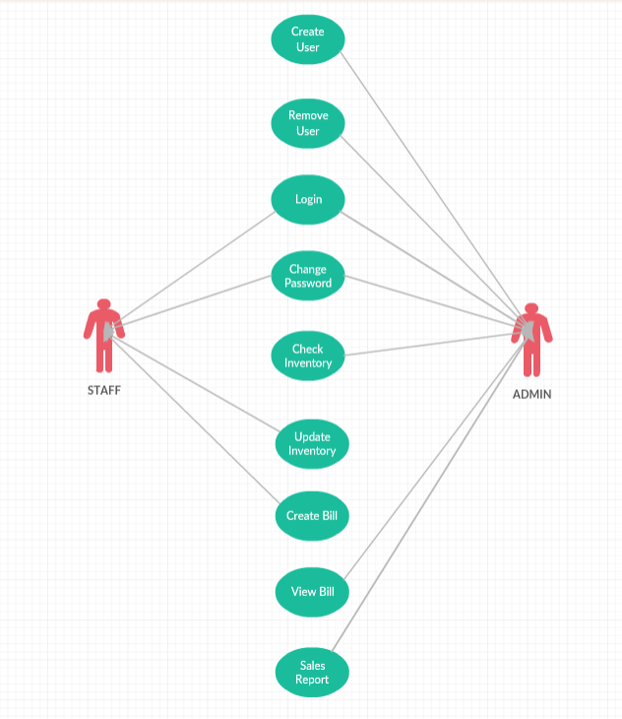
2. ENTITY RELATIONSHIP DIAGRAM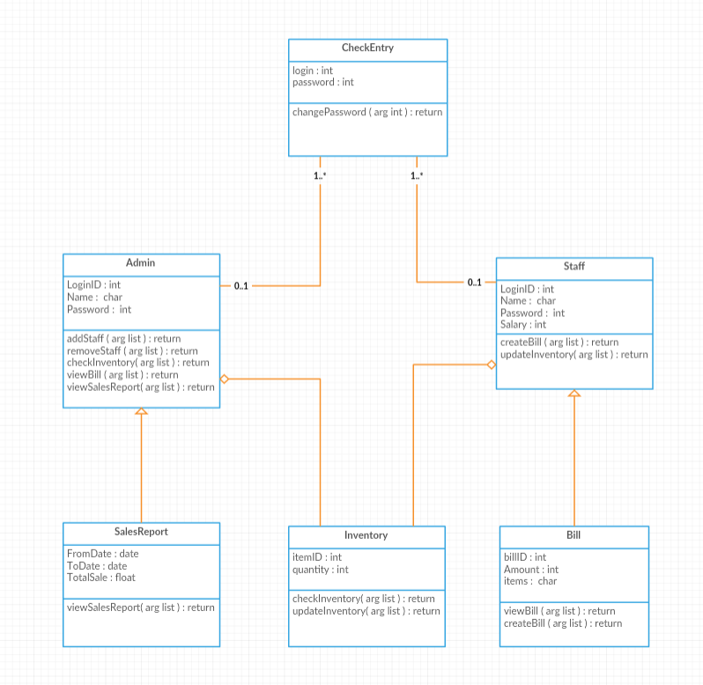
3. CLASS DIAGRAM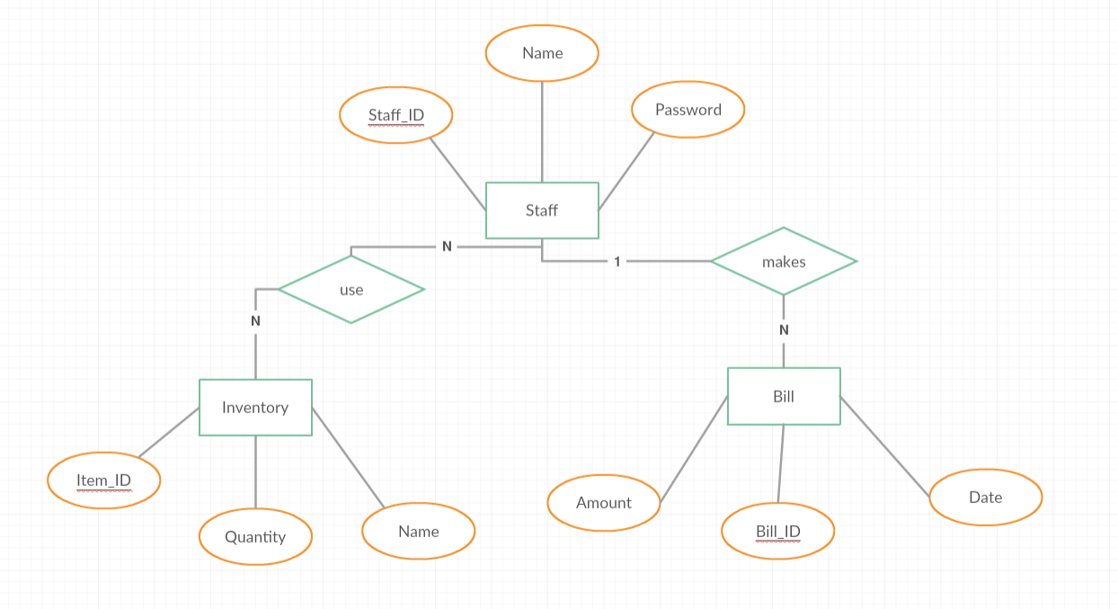
4. SEQUENCE DIAGRAMS

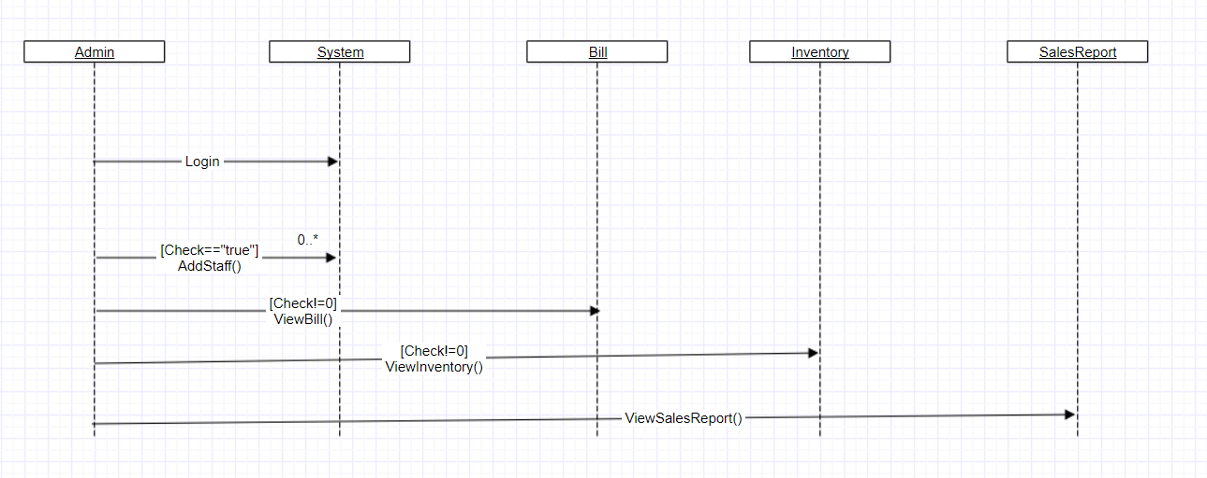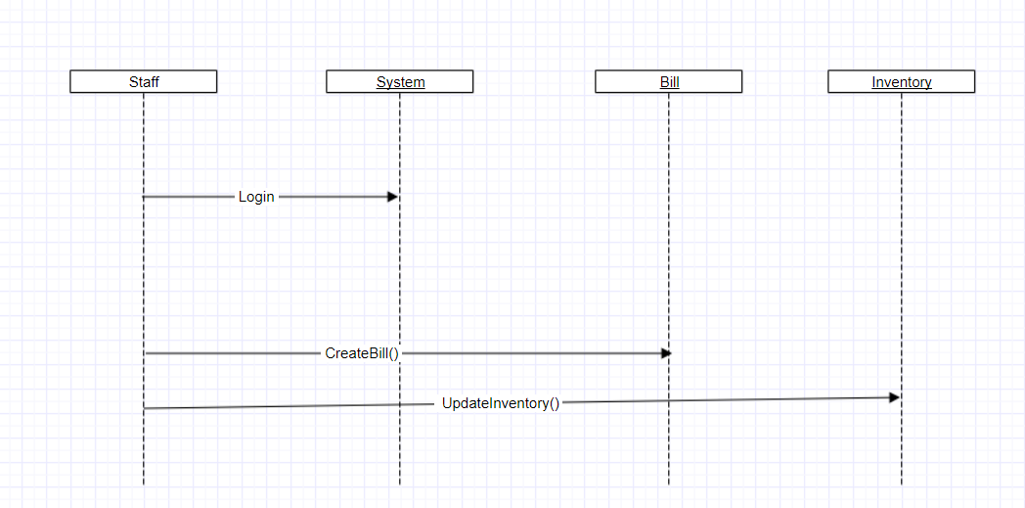

**Appendix B: Analysis Models**

Details are TBD in due course

**Appendix C: To Be Determined List**

1. System Features
2. Performance Requirements
3. Safety Requirements
4. Security Requirements
5. Business Rules