IT350: Software Engineering

Assignment 4

SE Diagrams



Submitted to:

Course Mentor : Biju R Mohan

Course Instructor : Ms. Raksha R Nadigar

Submitted by:

                         Tushar Kadam

                         15IT121 3rd year IT

23rd January, 2018

             National Institute Of Technology Karnataka

1. USE CASE DIAGRAM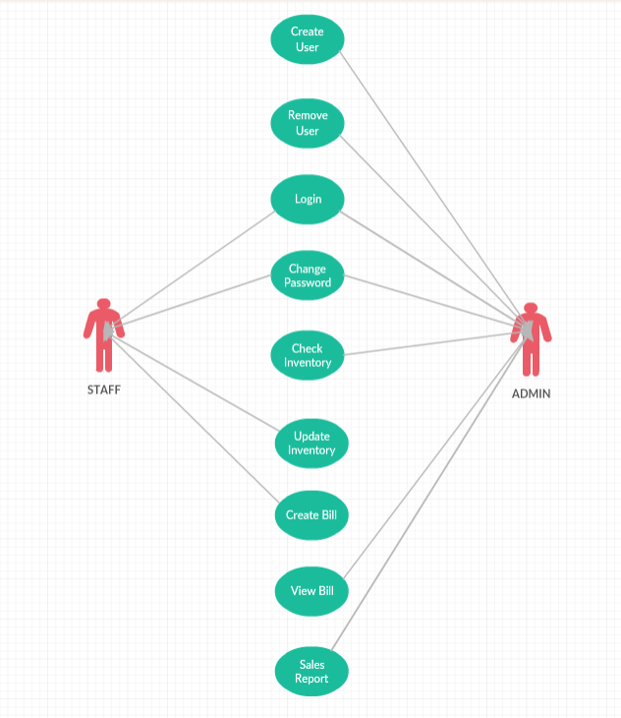
2. ENTITY RELATIONSHIP DIAGRAM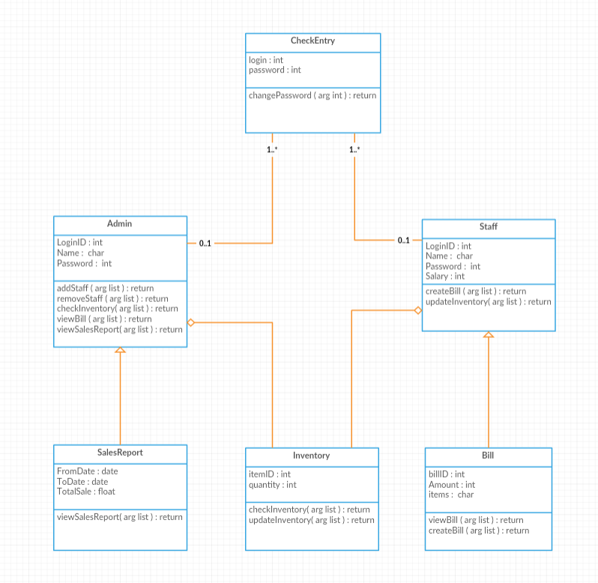
3. CLASS DIAGRAM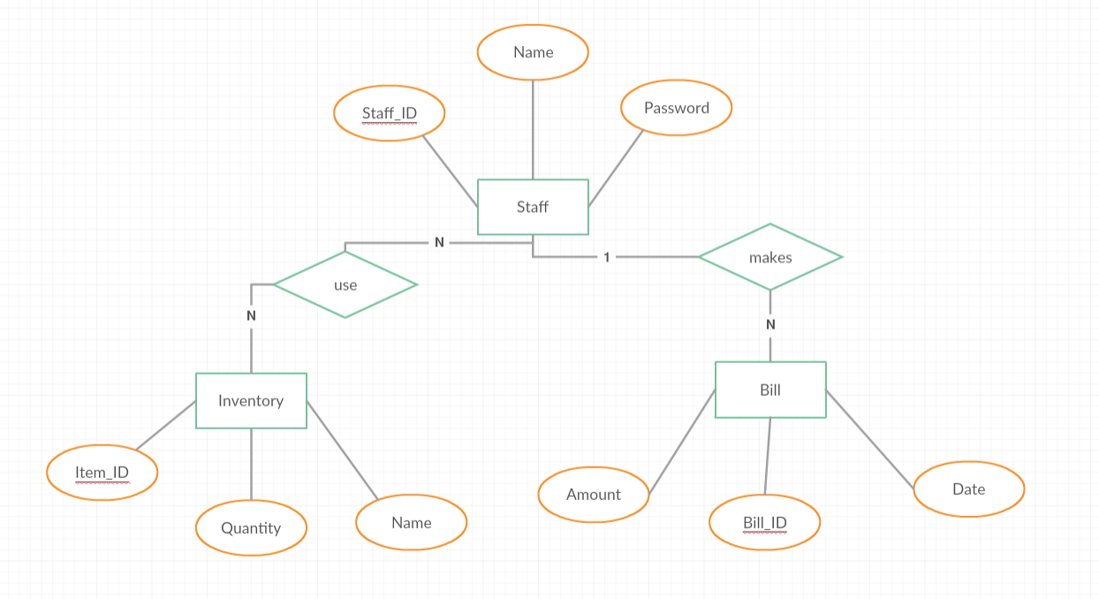
4. SEQUENCE DIAGRAMS

